CSc 8980 Spring 2020 - Dr. Daniel Takabi

Secure and Private AI Project

AbdulHaseeb Ahmed, Harnoor Singh, Naman Kanwar, Kushagra Patel

Georgia State University

Table of Contents

Attacks on Victim Model 3

Notes 3

Threshold Attack 4

HopSkipJump Attack 6

Pixel Attack 8

Projected Gradient Descent Method 10

NewtonFool Method 12

Elastic Net Method 14

Spatial Transformation Method 16

Query Efficient Black Box Estimation Method 18

Attack 8 Zeroth-Order 20

Adversarial Patch Attack 22

Carlini LInf Method 24

Carlini L2 Method 26

Basic Iterative Method 28

Jacobian Saliency Method 30

Universal Perturbation Method 32

DeepFool Method 34

Virtual Adversarial Method 36

Fast Gradient Sign Method 37

Defenses 40

Overview 40

Problems 40

Results 40

Attacks on Text Data 43

Attack Transferability 45

Threshold Attack Method 45

Pixel Attack Method 45

HopSkipJump Attack 46

Elastic Net Method 47

Query Efficient Black Box Estimation Method 48

Adversarial Patch Attack 49

Carlini LInf Mthod 50

Carlini L2 Mthod 50

Basic Iterative Method 50

Jacobian Saliency Map 51

Universal Perturbation Method 52

DeepFool Method 53

Virtual Adversarial Method 54

Fast Gradient Sign Method 55

Zoo Attack Method 56

Extraction Attack 57

Functionally Equivalent Extraction 57

Copycat CNN 58

Knockoff Nets 60

Attack Results Appendix 63

Threshold Attack Method 63

Pixel Attack Method 75

Elastic Net Method 96

Adversarial Patch Attack 118

Carlini LInf Method 140

Carlini L2 Method 162

Basic Iterative Method 185

Universal Perturbation Method 208

Jacobian Saliency Method 231

DeepFool Method 254

Fast Gradient Sign Method 277

Transfer Attack Results Appendix 300

Threshold Attack Method 300

Pixel Attack Method 300

HopSkipJump Attack 301

Elastic Net Method 323

Adversarial Patch Attack 345

Carlini LInf Mthod 367

Carlini L2 Mthod 367

Basic Iterative Method 367

Universal Perturbation Method 368

Jacobian Saliency Map 390

DeepFool Method 412

Fast Gradient Sign Method 413

**Imdb Attack: End**

# Attacks on Victim Model

## Notes

In this part of the project, we were able to implement nearly all the attacks described in the project rubric but due to attack specifics some of the attacks were not able to be implemented. These attacks include:

* Adversarial patch
  + The reason why this attack was not implemented is because we could not figure out how to properly generate the patch and place it on top of the image. We did go through the limited resources online as well as within the ART toolbox, but we were still unable to properly implement this attack.
* Virtual Adversarial Method
  + After countless hours and attempts with different parameters, the attack never converged. We had ran the attack several times for hours, i.e. 5-8 hours, at a time but it never converged. Our code was exactly the same as all the other attacks, but it just kept running and never converged. We even made sure to add a softmax layer to the victim model because this attack implemented in the art toolbox requires probabilities in the range of 0 to 1.
* HopSkipJump Attack
  + After countless hours and attempts with different parameters, the attack never converged. We had ran the attacks several times for hours, i.e. 5-8 hours, at a time but it never converged. Our code was exactly the same as all the other attacks but it just kept running and never converged. The attack couldn’t complete even with minimum number of iterations.
* Boundary Attack
  + After countless hours and attempts with different parameters, the attack never converged.

IMPORTANT NOTE:

As per our question in class, when we applied some attacks, we noticed that some images were not visually perturbed while the rest were. When we attacked our own model, which had an accuracy of 54% we found that all instances of the adversarial samples were perturbed (visible to naked eye). However, when we used the required victim model which had an accuracy of 94.5%, we found that a select few samples after being perturbed showed no visual sign of being perturbed. We consulted with Robert and he also did not find a reason to why this was happening. We tested single samples to make sure it was not a one-off incident, yet still, the problem was present. We assume that there might be some images with little to no loss when computed by the victim model that when any change is to be added to the image, the calculation results in a “value of 0” therefore the image was not altered.

## Threshold Attack

|  |  |
| --- | --- |
| Average Accuracy Over 10 Runs | |
| Benign Samples | 94.52% |
| th = 0.01 | 10.0% |
| th = 0.05 | 10.0% |
| th = 0.1 | 10.0% |
| th = 10 | 10.0% |

|  |  |  |  |  |  |  |  |  |  |  |
| --- | --- | --- | --- | --- | --- | --- | --- | --- | --- | --- |
| Average Accuracy per Class Over 10 Runs | | | | | | | | | | |
|  | Airplane | Car | Bird | Cat | Deer | Dog | Frog | Horse | Ship | Truck |
| Benign Samples | 90% | 100% | 80% | 80% | 100% | 70% | 80% | 100% | 90% | 100% |
| th = 0.01 | 0% | 100% | 0% | 0% | 0% | 0% | 0% | 0% | 0% | 0% |
| th = 0.05 | 0% | 100% | 0% | 0% | 0% | 0% | 0% | 0% | 0% | 0% |
| th = 0.1 | 0% | 100% | 0% | 0% | 0% | 0% | 0% | 0% | 0% | 0% |
| th = 10 | 0% | 100% | 0% | 0% | 0% | 0% | 0% | 0% | 0% | 0% |

**Sample Output of the Threshold Attack**

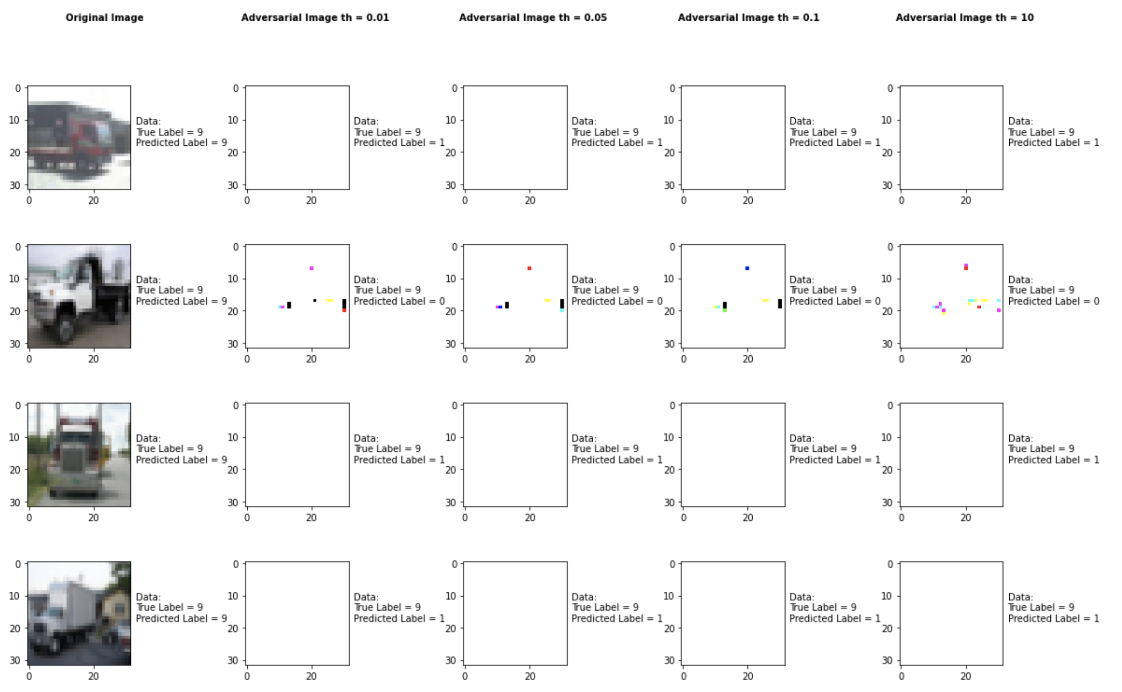

**Metric 1: Is it targeted or not?**

We decided not to do a targeted attack with this attack because we were altering all 10 classes.

**Metric 2: What is the minimum modification that you need to introduce to achieve**

**misclassification?**

After experimenting with different parameters, we found that th (threshold) was the one that actually needed to be adjusted with this attack. We can alter one parameter both together make a bigger impact. Whether th = 0.01 to th=10 the output remains consistent with similar results.

**Metric 3: How do you judge the visual impact of the modifications?**

When th=1 we see image disappeared in the adversarial

**Metric 4: Is the attack consistent across all classes?**

No it shows the same result for th=0.01 to th =15

**Metric 5: Is there a specific class the classifier tends to predict when it misclassifies the adversarial image?**

There is no specific class the classifier predicts when it misclassifies an adversarial example, it is pretty random when it comes to the class that the classifier predicts.

**Metric 6: How does varying the parameter of the attack effect both the accuracy and perceptibility of the adversarial example?**

Theta impacts it consistently without variation. Whether th=0.01 or 15 it shows similar result.

## HopSkipJump Attack

|  |  |
| --- | --- |
| Average Accuracy Over 10 Runs | |
| Benign Samples | 94.52% |
| Max_eval = 100 Samples | 91.0% |
| Max_eval = 1000 Samples | 30.9% |
| Max_eval = 2500 Samples | 30.9% |
| Max_eval = 5000 Samples | 30.9% |

|  |  |  |  |  |  |  |  |  |  |  |
| --- | --- | --- | --- | --- | --- | --- | --- | --- | --- | --- |
| Average Accuracy per Class Over 10 Runs | | | | | | | | | | |
|  | Airplane | Car | Bird | Cat | Deer | Dog | Frog | Horse | Ship | Truck |
| Benign Samples | 90% | 90% | 100% | 70% | 90% | 80% | 100% | 100% | 100% | 100% |
| Max_eval = 100 Samples | 90% | 90% | 90% | 70% | 90% | 80% | 100% | 100% | 100% | 100% |
| Max_eval = 1000 Samples | 10% | 30% | 60% | 10% | 40% | 40% | 40% | 20% | 40% | 20% |
| Max_eval = 2500 Samples | 10% | 30% | 60% | 10% | 40% | 40% | 40% | 20% | 40% | 20% |
| Max_eval = 5000 Samples | 10% | 30% | 60% | 10% | 40% | 40% | 40% | 20% | 40% | 20% |

**Sample Output of the HopSkipJump Attack**

## 

**Metric 1: Is it targeted or not?**

We decided not to do a targeted attack with this attack because we were altering all 10 classes.

**Metric 2: What is the minimum modification that you need to introduce to achieve**

**misclassification?**

After experimenting with different parameters, we found that max_eval was the one that actually needed to be adjusted with this attack.

**Metric 3: How do you judge the visual impact of the modifications?**

When th=1 we see image disappeared in the adversarial

**Metric 4: Is the attack consistent across all classes?**

No it shows the same result for th=0.01 to th =15

**Metric 5: Is there a specific class the classifier tends to predict when it misclassifies the adversarial image?**

There is no specific class the classifier predicts when it misclassifies an adversarial example, it is pretty random when it comes to the class that the classifier predicts.

**Metric 6: How does varying the parameter of the attack effect both the accuracy and perceptibility of the adversarial example?**

Theta impacts it consistently without variation. Whether th=0.01 or 15 it shows similar result.

## Pixel Attack

|  |  |
| --- | --- |
| Average Accuracy Over 10 Runs | |
| Benign Samples | 94.52% |
| th = 1 | 9.0% |
| th = 5 | 6.0% |
| th = 10 | 5.0% |
| th = 15 | 3.0% |

|  |  |  |  |  |  |  |  |  |  |  |
| --- | --- | --- | --- | --- | --- | --- | --- | --- | --- | --- |
| Average Accuracy per Class Over 10 Runs | | | | | | | | | | |
|  | Airplane | Car | Bird | Cat | Deer | Dog | Frog | Horse | Ship | Truck |
| Benign Samples | 100% | 100% | 80% | 100% | 100% | 100% | 100% | 100% | 100% | 90% |
| th = 1 | 0% | 100% | 0% | 0% | 0% | 0% | 0% | 0% | 0% | 0% |
| th = 5 | 0% | 90% | 0% | 0% | 0% | 0% | 0% | 0% | 0% | 0% |
| th = 10 | 0% | 90% | 0% | 0% | 0% | 0% | 0% | 0% | 0% | 0% |
| th = 15 | 0% | 70% | 0% | 0% | 0% | 0% | 0% | 0% | 0% | 0% |

**Sample Output of the Pixel Attack**

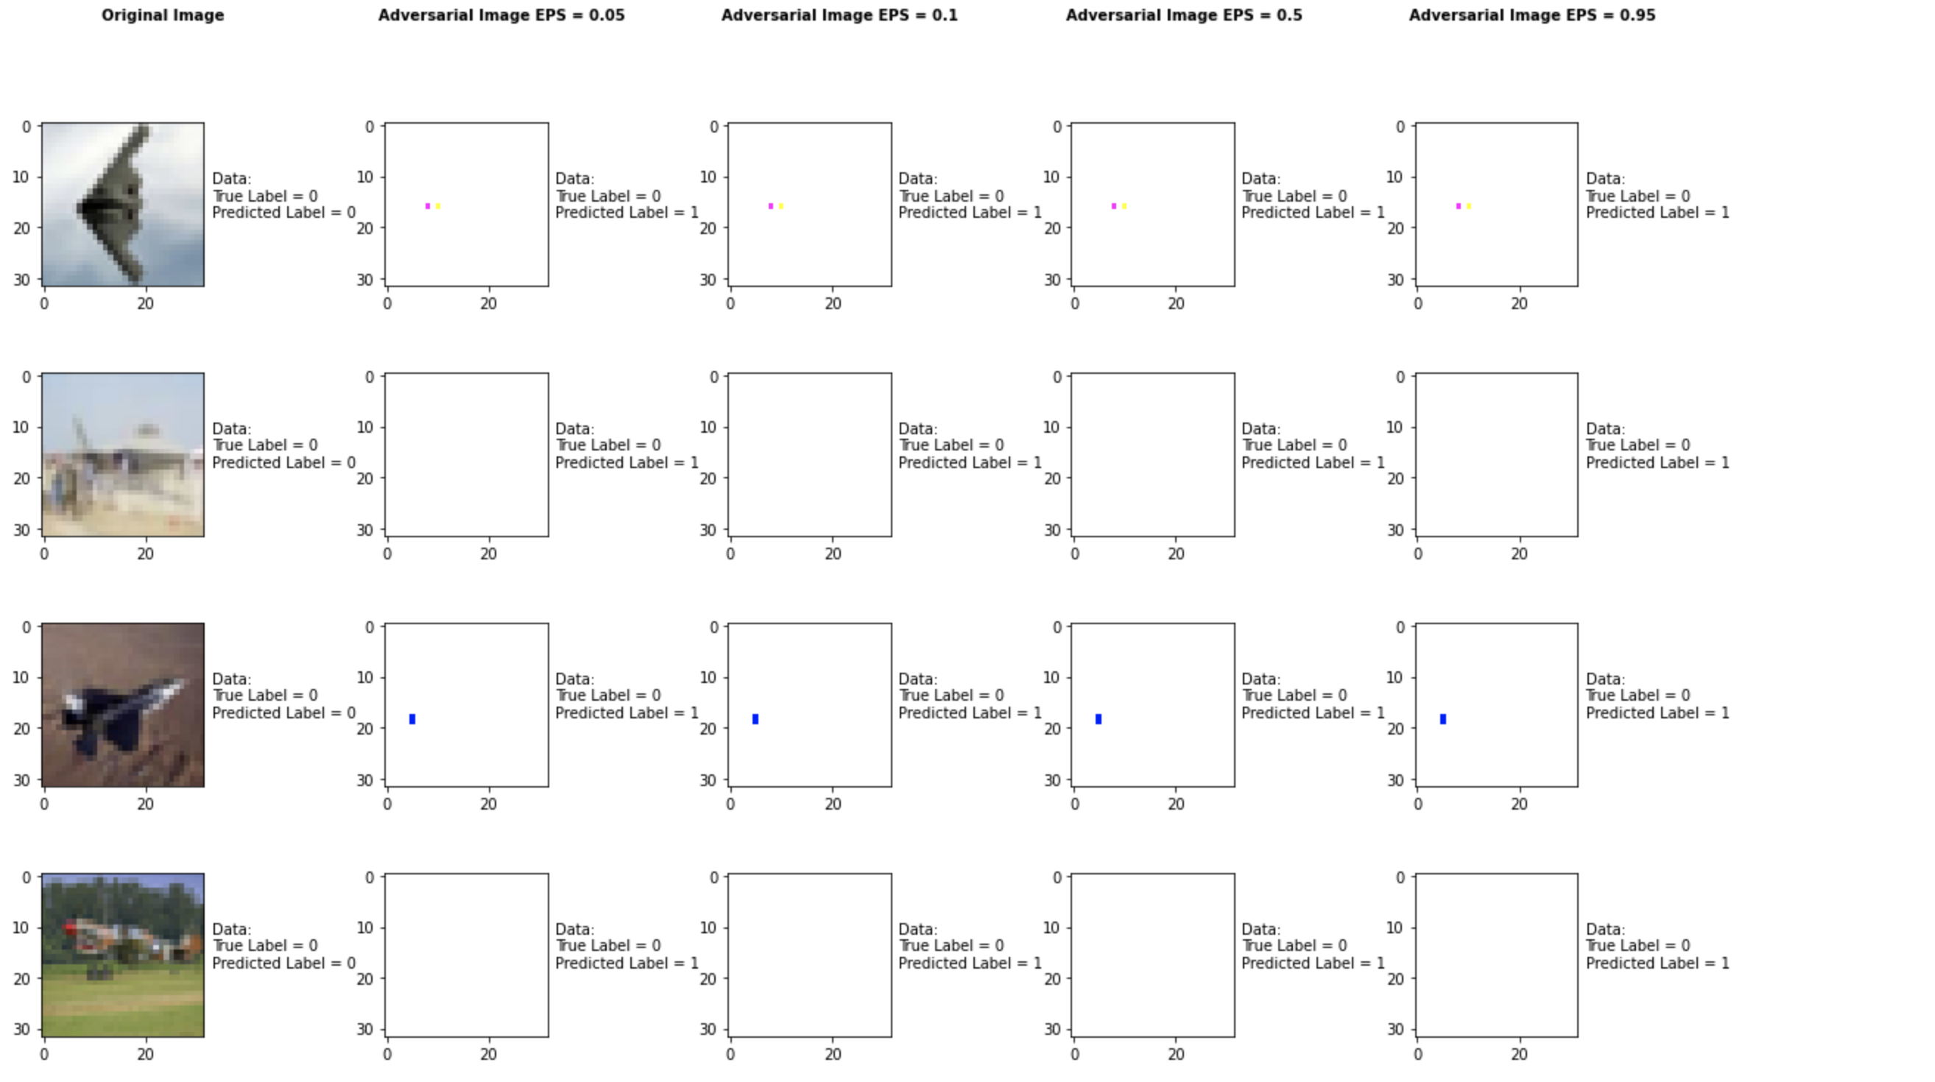

**Metric 1: Is it targeted or not?**

We decided not to do a targeted attack with this attack because we were altering all 10 classes.

**Metric 2: What is the minimum modification that you need to introduce to achieve**

**misclassification?**

After experimenting with different parameters, we found that th (threshold) was the one that actually needed to be adjusted with this attack. We can alter one parameter both together make a bigger impact.

**Metric 3: How do you judge the visual impact of the modifications?**

When th=1 we see image disappeared in the adversarial

**Metric 4: Is the attack consistent across all classes?**

No it shows the same result for th=1 to th =15

**Metric 5: Is there a specific class the classifier tends to predict when it misclassifies the adversarial image?**

There is no specific class the classifier predicts when it misclassifies an adversarial example, it is pretty random when it comes to the class that the classifier predicts.

**Metric 6: How does varying the parameter of the attack effect both the accuracy and perceptibility of the adversarial example?**

Theta impacts it consistently without variation. Whether th=1 or 15 it shows similar result.

## Projected Gradient Descent Method

|  |  |
| --- | --- |
| Average Accuracy Over 10 Runs | |
| Benign Samples | 94.52% |
| Epsilon = 0.1 Samples | 91.0% |
| Epsilon = 0.25 Samples | 30.9% |
| Epsilon = 0.5 Samples | 30.9% |
| Epsilon = 0.99 Samples | 30.9% |

|  |  |  |  |  |  |  |  |  |  |  |
| --- | --- | --- | --- | --- | --- | --- | --- | --- | --- | --- |
| Average Accuracy per Class Over 10 Runs | | | | | | | | | | |
|  | Airplane | Car | Bird | Cat | Deer | Dog | Frog | Horse | Ship | Truck |
| Benign Samples | 90% | 90% | 100% | 70% | 90% | 80% | 100% | 100% | 100% | 100% |
| Epsilon = 0.1 Samples | 90% | 90% | 90% | 70% | 90% | 80% | 100% | 100% | 100% | 100% |
| Epsilon = 0.25 Samples | 10% | 30% | 60% | 10% | 40% | 40% | 40% | 20% | 40% | 20% |
| Epsilon = 0.5 Samples | 10% | 30% | 60% | 10% | 40% | 40% | 40% | 20% | 40% | 20% |
| Epsilon = 0.99 Samples | 10% | 30% | 60% | 10% | 40% | 40% | 40% | 20% | 40% | 20% |

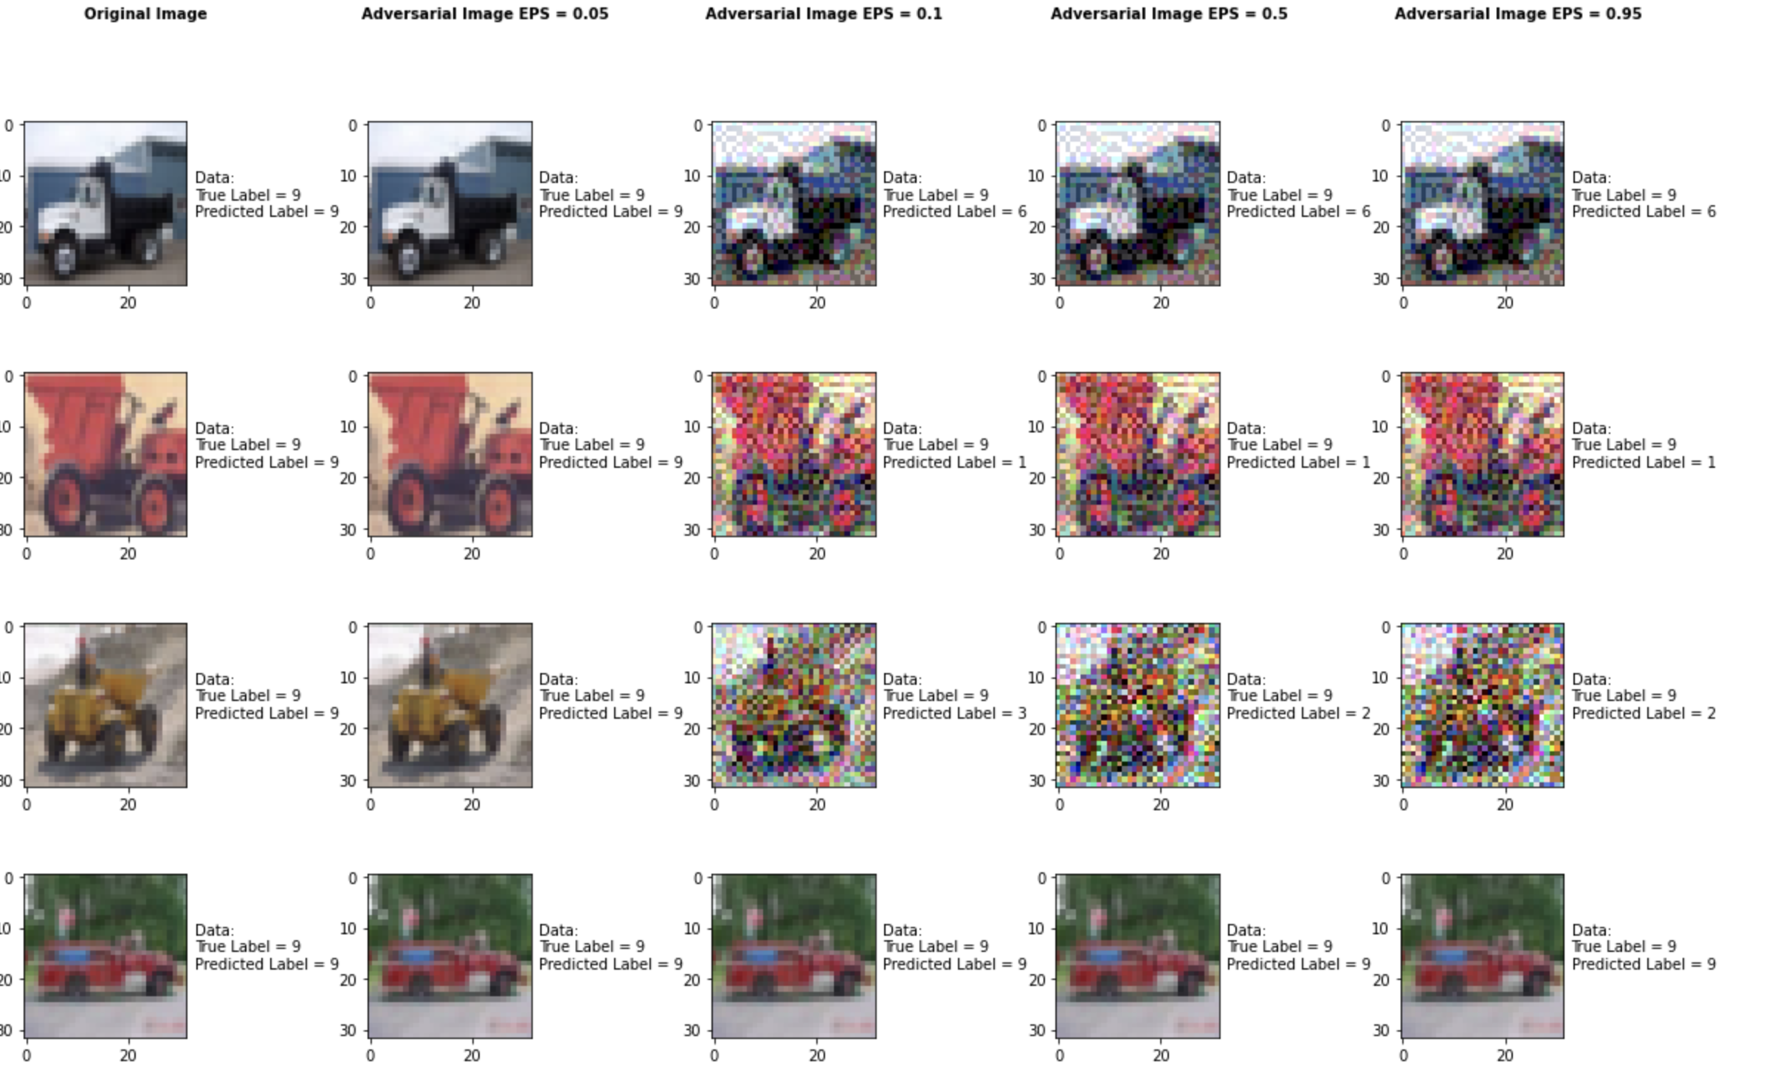

**Sample Output of the Projected Gradient Descent Attack**

**Metric 1: Is it targeted or not?**

We decided not to do a targeted attack with this attack because we were altering all 10 classes.

**Metric 2: What is the minimum modification that you need to introduce to achieve**

**misclassification?**

After experimenting with different parameters, we found that the epsilon parameter was the one that actually needed to be adjusted with this attack. The epsilon parameter is the value that is used to set the “Attack step size (input variation)”. We found by adjusting epsilon, we got accuracies in the range of 35% - 50%. Setting epsilon close to 0 like 0.1, will be the minimum modification that needs to be introduced to achieve misclassification.

**Metric 3: How do you judge the visual impact of the modifications?**

The attack produced images that are nearly imperceptible to the naked eye for epsilon values < 0.1 and very perceptible for epsilon values > 0.25.

**Metric 4: Is the attack consistent across all classes?**

This attack, as an average, was pretty consistent across all classes.

**Metric 5: Is there a specific class the classifier tends to predict when it misclassifies the adversarial image?**

There is no specific class the classifier predicts when it misclassifies an adversarial example, it is pretty random when it comes to the class that the classifier predicts.

**Metric 6: How does varying the parameter of the attack effect both the accuracy and perceptibility of the adversarial example?**

When epsilon is increasing the accuracy diminishes as does the integrity of the image, i.e. very noticeable to the human eye. Smaller values of epsilon also produce low accuracy but are not as apparent to the human eye.

## NewtonFool Method

|  |  |
| --- | --- |
| Average Accuracy Over 10 Runs | |
| Benign Samples | 94.52% |
| Max_iter = 90 | 2.0% |
| Max_iter = 100 | 2.0% |
| Max_iter = 110 | 2.0% |
| Max_iter = 120 | 2.0% |

|  |  |  |  |  |  |  |  |  |  |  |
| --- | --- | --- | --- | --- | --- | --- | --- | --- | --- | --- |
| Average Accuracy per Class Over 10 Runs | | | | | | | | | | |
|  | Airplane | Car | Bird | Cat | Deer | Dog | Frog | Horse | Ship | Truck |
| Benign Samples | 90% | 100% | 100% | 90% | 90% | 90% | 100% | 100% | 100% | 100% |
| Max_iter = 90 | 10% | 0% | 0% | 10% | 0% | 0% | 0% | 0% | 0% | 0% |
| Max_iter = 100 | 10% | 0% | 0% | 10% | 0% | 0% | 0% | 0% | 0% | 0% |
| Max_iter = 110 | 10% | 0% | 0% | 10% | 0% | 0% | 0% | 0% | 0% | 0% |
| Max_iter = 120 | 10% | 0% | 0% | 10% | 0% | 0% | 0% | 0% | 0% | 0% |

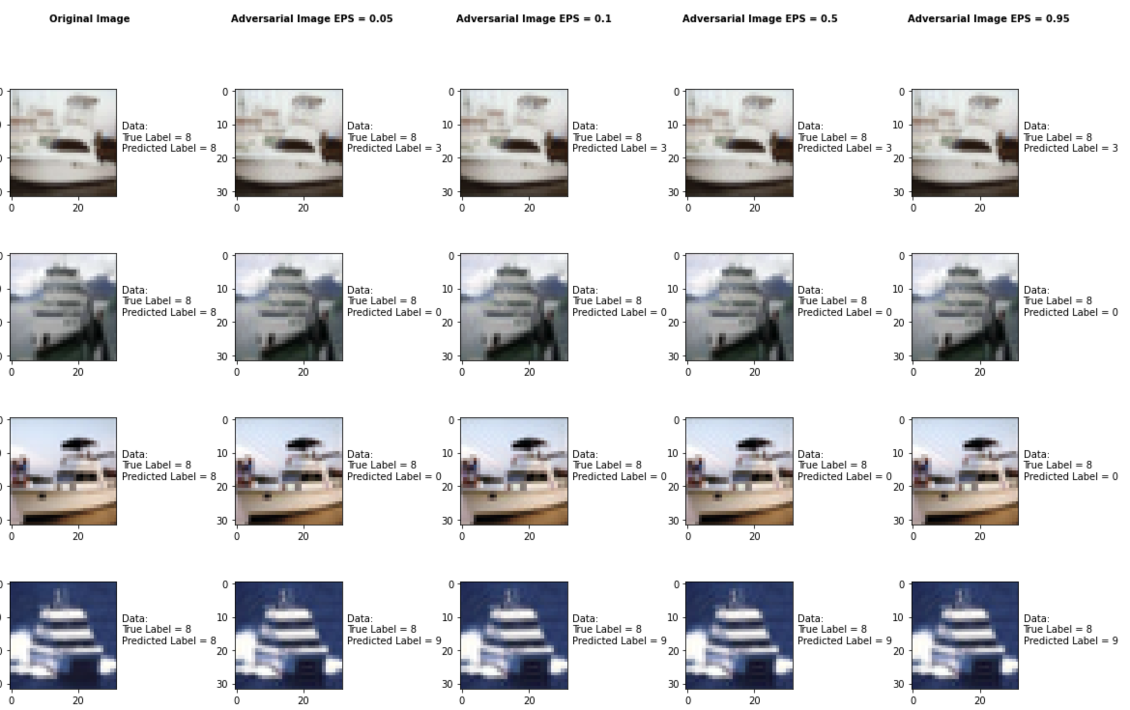

**Sample Output of the NewtonFool Attack**

**Metric 1: Is it targeted or not?**

We decided not to do a targeted attack with this attack because we were altering all 10 classes.

**Metric 2: What is the minimum modification that you need to introduce to achieve**

**misclassification?**

After experimenting with different parameters, we found that the max_iter parameter is the best to make the attack go through. Just by default it makes a massive difference so that’s why we had to limit the number of iterations.

**Metric 3: How do you judge the visual impact of the modifications?**

The attack doesn’t visually modify the image but with just 90 iterations or even less it changes the accuracy to exact 2% (adversarial samples)

**Metric 4: Is the attack consistent across all classes?**

This attack, as an average, was pretty consistent across all classes.

**Metric 5: Is there a specific class the classifier tends to predict when it misclassifies the adversarial image?**

There is no specific class the classifier predicts when it misclassifies an adversarial example, it is pretty random when it comes to the class that the classifier predicts.

**Metric 6: How does varying the parameter of the attack effect both the accuracy and perceptibility of the adversarial example?**

Parameters doesn’t make a large impact on the samples. It just reduces the accuracy to exact 2%

## Elastic Net Method

|  |  |
| --- | --- |
| Average Accuracy Over 1 Run with max_iter = 100 | |
| Benign Samples | 94.52% |
| Confidence = 0.05 Samples | 2.0% |
| Confidence = 0.10 Samples | 2.0% |
| Confidence = 0.50 Samples | 2.0% |
| Confidence = 0.95 Samples | 2.0% |

|  |  |  |  |  |  |  |  |  |  |  |
| --- | --- | --- | --- | --- | --- | --- | --- | --- | --- | --- |
| Average Accuracy per Class Over 1 Run with max_iter = 100 | | | | | | | | | | |
|  | Airplane | Car | Bird | Cat | Deer | Dog | Frog | Horse | Ship | Truck |
| Benign Samples | 100% | 100% | 90% | 80% | 90% | 100% | 100% | 100% | 100% | 90% |
| Confidence = 0.05 Samples | 0% | 0% | 10% | 0% | 10% | 0% | 0% | 0% | 0% | 0% |
| Confidence = 0.10 Samples | 0% | 0% | 10% | 0% | 10% | 0% | 0% | 0% | 0% | 0% |
| Confidence = 0.50 Samples | 0% | 0% | 10% | 0% | 10% | 0% | 0% | 0% | 0% | 0% |
| Confidence = 0.95 Samples | 0% | 0% | 10% | 0% | 10% | 0% | 0% | 0% | 0% | 0% |

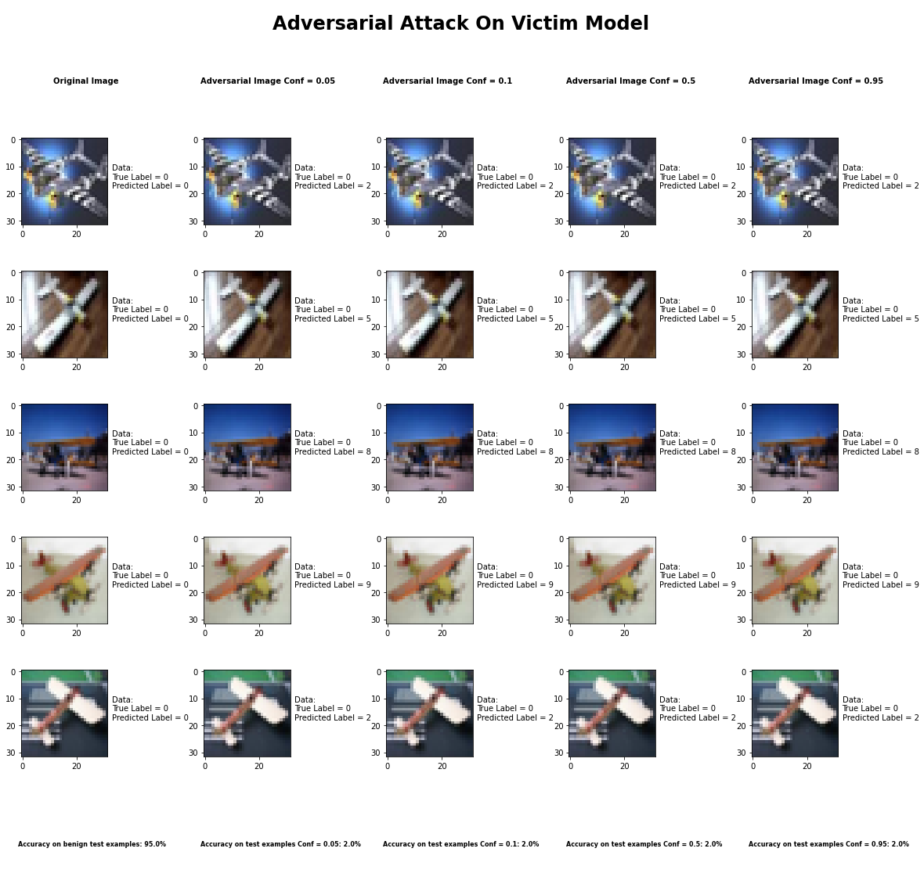

**Sample Output of the Elastic Net Attack**

**Metric 1: Is it targeted or not?**

We decided not to do a targeted attack with this attack because we were altering all 10 classes.

**Metric 2: What is the minimum modification that you need to introduce to achieve**

**misclassification?**

After experimenting with different parameters, it seemed like no matter what value we chose for the confidence parameter, the accuracy of the classifier remained the same. We decided to adjust the confidence parameter because a higher value produces examples that are farther away, from the original input, but classified with higher confidence as the target class. So, to answer the question, we would say that it is safe to say that any value for the confidence parameter will drastically reduce the accuracy of the classifier.

**Metric 3: How do you judge the visual impact of the modifications?**

The attack produced images that are completely imperceptible to the naked eye yet very good at causing misclassification.

**Metric 4: Is the attack consistent across all classes?**

For the most part the attack is consistent across all classes, however, the two classes where it the accuracy was better for the classifier was Birds and Deer.

**Metric 5: Is there a specific class the classifier tends to predict when it misclassifies the adversarial image?**

There is no specific class the classifier predicts when it misclassifies an adversarial example, for the most part it is a random class that the classifier predicts. It also depends on the true label of the class.

**Metric 6: How does varying the parameter of the attack effect both the accuracy and perceptibility of the adversarial example?**

As mentioned earlier, in this attack the confidence parameter was adjusted, however, no matter the change in the confidence parameter the results were the same. Also, it is worth mentioning that the max_iter was set to 100. Also, the confidence parameter always produced the same image perceptibility no matter the value of the confidence parameter.

## Spatial Transformation Method

|  |  |
| --- | --- |
| Average Accuracy Over 10 Runs | |
| Benign Samples | 94.52% |
| num_rotations=1, max_rotation=0.0 | 92.0% |
| num_rotations=30, max_rotation=5.0 | 83.0% |
| num_rotations=60, max_rotation=90.0 | 31.0% |
| num_rotations=100, max_rotation=180.0 | 22.0% |

|  |  |  |  |  |  |  |  |  |  |  |
| --- | --- | --- | --- | --- | --- | --- | --- | --- | --- | --- |
| Average Accuracy per Class Over 10 Runs | | | | | | | | | | |
|  | Airplane | Car | Bird | Cat | Deer | Dog | Frog | Horse | Ship | Truck |
| Benign Samples | 90% | 100% | 100% | 100% | 90% | 70% | 100% | 100% | 70% | 100% |
| num_rotations=1, max_rotation=0.0 | 90% | 100% | 100% | 100% | 90% | 70% | 100% | 100% | 70% | 100% |
| num_rotations=30, max_rotation=5.0 | 60% | 90% | 100% | 90% | 80% | 50% | 80% | 90% | 80% | 90% |
| num_rotations=60, max_rotation=90.0 | 60% | 40% | 50% | 20% | 0% | 50% | 40% | 30% | 10% | 10% |
| num_rotations=100, max_rotation=180.0 | 50% | 40% | 30% | 30% | 0% | 40% | 30% | 0% | 0% | 0% |

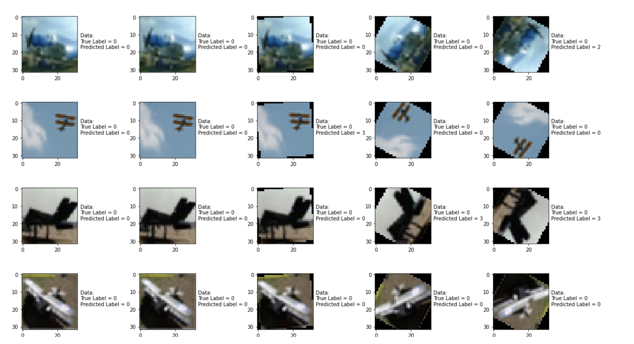

**Sample Output of the Spatial Transformation Method**

**Metric 1: Is it targeted or not?**

We decided not to do a targeted attack with this attack because we were altering all 10 classes.

**Metric 2: What is the minimum modification that you need to introduce to achieve**

**misclassification?**

After experimenting with different parameters, we found that the rotation angle and the number of rotations were the one that actually needed to be adjusted with this attack. We can alter one parameter both together make a bigger impact. And more the angle of rotation better the attack becomes.

**Metric 3: How do you judge the visual impact of the modifications?**

The attack produced images that are nearly imperceptible to the naked eye for rotation >60 degrees.

**Metric 4: Is the attack consistent across all classes?**

This attack, as an average, was pretty consistent across all classes.

**Metric 5: Is there a specific class the classifier tends to predict when it misclassifies the adversarial image?**

There is no specific class the classifier predicts when it misclassifies an adversarial example, it is pretty random when it comes to the class that the classifier predicts.

**Metric 6: How does varying the parameter of the attack effect both the accuracy and perceptibility of the adversarial example?**

When epsilon is increasing the accuracy diminishes as does the integrity of the image, i.e. very noticeable to the human eye. More rotation e.g. 120 degree seem pretty noticeable.

## Query Efficient Black Box Estimation Method

For this attack we simply ran a single attack over 1 run. We used the predict function of the attack object and no matter what value we set sigma and num_basis to, the accuracy of the classifier on the adversarial examples always remained approximately 93%. We are not entirely sure why but that is what we kept getting even after trying different values. We also were not able to visually see the effect of the attack because of what the predict function outputted.

THE CODE FOR THIS ATTACK:

from __future__ import absolute_import, division, print_function, unicode_literals

import keras

import numpy as np

import matplotlib.pyplot as plt

from art.wrappers import QueryEfficientBBGradientEstimation

from art.classifiers import KerasClassifier

from art.utils import load_dataset

import tensorflow as tf

import tensorflow_hub as hub

tf.compat.v1.disable_eager_execution()

# Step 1: Load the CIFAR-10 Dataset

(x_train, y_train), (x_test, y_test), min_, max_ = load_dataset(str("cifar10")) # Original Dataset

# Step 2: Load the victim model

classifier_url ="https://tfhub.dev/deepmind/ganeval-cifar10-convnet/1" #@param {type:"string"} # model is downloaded from this site

IMAGE_SHAPE = (32, 32) # the image shape is needed so that the model knows the input-shape and since we are working with the CIFAR-10 all the images are 32 x 32 color images

classifier = KerasClassifier(model=tf.keras.Sequential([hub.KerasLayer(classifier_url, input_shape=IMAGE_SHAPE+(3,))]), clip_values=(min_, max_)) # this bascially creates a keras wrapper around the downloaded model so that we can use it with keras functions.

# Step 3: Evaluate the victim model on the benign dataset

predictions = classifier.predict(x_test) # giving the classifier the x_test of the CIFAR-10 dataset.

accuracy_benign = np.sum(np.argmax(predictions, axis=1) == np.argmax(y_test, axis=1)) / len(y_test) # calculates the accuracy of the predictions

print("Accuracy on benign test examples: {}%\n".format(accuracy_benign * 100))

# Step 4: Collect 10 instances of each class from test set

def exract_ten_classes(data, labels, classes=(0, 1, 2, 3, 4, 5, 6, 7, 8, 9), no_instance=10):

x_pre = [] # list to collect the x_test set

y_pre = [] # list to collect the y_test set

for class_label in range(0, 10): # loop through each of the classes

index = random.randint(0, 5000) # choose an index from the x_test

iteration = no_instance # number of instance of each class to collect

while (iteration != 0):

if np.argmax(labels[index]) == classes[class_label]: # check if the current index label matches the specified class label we are looking for

x_pre.append(data[index]) # add the image to the x_test set

y_pre.append(int(class_label)) # add the image label to the y_test set

iteration = iteration - 1 # reduce # of instances by 1

index = index + 1 # go to next index till next label is of the current class

x = np.asarray(x_pre) # append all 100, 10 of each class, images together

y = keras.utils.to_categorical(np.asarray(y_pre), 10) # append all 100, 10 of each class, labels together and do one hot encoding

return x, y

x_test_adv_pre, y_test_adv = exract_ten_classes( x_test, y_test ) # call the above function to extract 100 instances with 10 examples from each class

print("x_test_adv_pre shape: " + str(x_test_adv_pre.shape) + "\n" + "x_test_adv_pre size: " + str(x_test_adv_pre.size) + "\n" + # print statement just shows what the extracted set looks like

"y_test_adv_pre shape: " + str(y_test_adv.shape) + "\n" + "y_test_adv_pre size: " + str(y_test_adv.size) + "\n")

# Step 5: Generate adversarial test examples

attack = QueryEfficientBBGradientEstimation(classifier=classifier, num_basis=10000, sigma=0.95) # Call the attack function and pass it the victim classifier, and for FGSM set the epsilon value

x_test_adv = attack.predict(x=x_test_adv_pre) # generate the adversarial examples from our extracted set. Creates 100 adversarial examples

print(x_test_adv.shape)

accuracy = np.sum(np.argmax(x_test_adv, axis=1) == np.argmax(y_test_adv, axis=1)) / len(y_test) # calculates the accuracy of the predictions

print("Accuracy on adversarial test examples: {}%\n".format(accuracy * 100))

## Attack 8 Zeroth-Order

|  |  |
| --- | --- |
| Average Accuracy Over 10 Runs | |
| Benign Samples | 94.52% |
| Max_iter = 20 | 95.0% |
| Max_iter = 40 | 81.0% |
| Max_iter = 70 | 56.0% |
| Max_iter = 100 | 24.0% |

|  |  |  |  |  |  |  |  |  |  |  |
| --- | --- | --- | --- | --- | --- | --- | --- | --- | --- | --- |
| Average Accuracy per Class Over 10 Runs | | | | | | | | | | |
|  | Airplane | Car | Bird | Cat | Deer | Dog | Frog | Horse | Ship | Truck |
| Benign Samples | 90% | 100% | 100% | 100% | 90% | 70% | 100% | 100% | 70% | 100% |
| Max_iter = 20 | 90% | 100% | 100% | 100% | 90% | 70% | 100% | 100% | 70% | 100% |
| Max_iter = 40 | 60% | 90% | 100% | 90% | 80% | 50% | 80% | 90% | 80% | 90% |
| Max_iter = 70 | 60% | 40% | 50% | 20% | 0% | 50% | 40% | 30% | 10% | 10% |
| Max_iter = 100 | 50% | 40% | 30% | 30% | 0% | 40% | 30% | 0% | 0% | 0% |

**Sample Output of the ProjectedGradientDescent Attack**

**Original max_iter =20 max_iter =40 max_iter =70 max_iter=100**

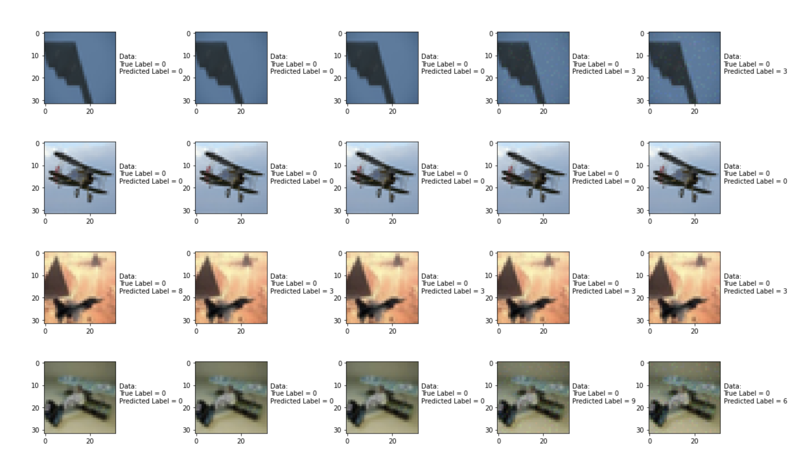

**Metric 1: Is it targeted or not?**

We decided not to do a targeted attack with this attack because we were altering all 10 classes.

**Metric 2: What is the minimum modification that you need to introduce to achieve**

**misclassification?**

After experimenting with different parameters, we found that the rotation angle and the number of rotations were the one that actually needed to be adjusted with this attack. We can alter one parameter both together make a bigger impact. And more the angle of rotation better the attack becomes.

**Metric 3: How do you judge the visual impact of the modifications?**

The attack produced images that are nearly imperceptible to the naked eye for rotation >60 degrees.

**Metric 4: Is the attack consistent across all classes?**

This attack, as an average, was pretty consistent across all classes.

**Metric 5: Is there a specific class the classifier tends to predict when it misclassifies the adversarial image?**

There is no specific class the classifier predicts when it misclassifies an adversarial example, it is pretty random when it comes to the class that the classifier predicts.

**Metric 6: How does varying the parameter of the attack effect both the accuracy and perceptibility of the adversarial example?**

When epsilon is increasing the accuracy diminishes as does the integrity of the image, i.e. very noticeable to the human eye. More rotation e.g. 120 degree seem pretty noticeable.

## Adversarial Patch Attack

|  |  |
| --- | --- |
| Average Accuracy Over 10 Runs | |
| Benign Samples | 94.52% |
| learning rate = 5.0 Samples | 11.6% |
| learning rate = 10.0 Samples | 10.9% |
| learning rate = 15.0 Samples | 10.4% |
| learning rate = 20.0 Samples | 10.6% |

|  |  |  |  |  |  |  |  |  |  |  |
| --- | --- | --- | --- | --- | --- | --- | --- | --- | --- | --- |
| Average Accuracy per Class Over 10 Runs | | | | | | | | | | |
|  | Airplane | Car | Bird | Cat | Deer | Dog | Frog | Horse | Ship | Truck |
| Benign Samples | 95% | 98% | 93% | 86% | 95% | 93% | 94% | 97% | 95% | 97% |
| learning rate = 5.0 Samples | 16% | 99% | 0% | 1% | 0% | 0% | 0% | 0% | 0% | 0% |
| learning rate = 10.0 Samples | 12% | 96% | 0% | 1% | 0% | 0% | 0% | 0% | 0% | 0% |
| learning rate = 15.0 Samples | 12% | 92% | 0% | 0% | 0% | 0% | 0% | 0% | 0% | 0% |
| learning rate = 20.0 Samples | 12% | 93% | 0% | 1% | 0% | 0% | 0% | 0% | 0% | 0% |

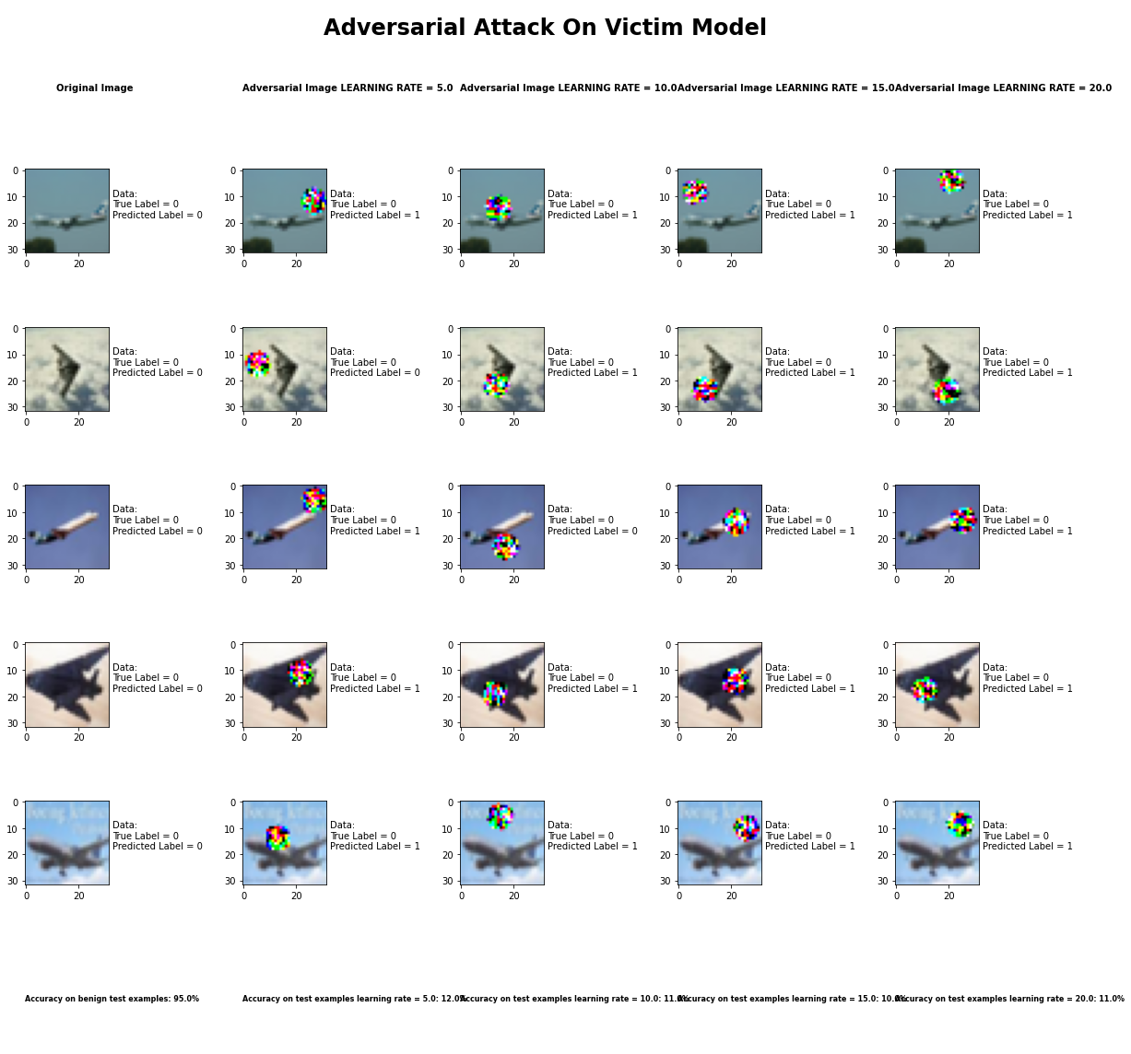

**Sample Output of the Adversarial Patch Attack**

**Metric 1: Is it targeted or not?**

We decided not to do a targeted attack with this attack because we were altering all 10 classes.

**Metric 2: What is the minimum modification that you need to introduce to achieve**

**misclassification?**

After experimenting with different parameters, we found that the learning rate was the one that actually needed to be adjusted with this attack. Any value for the learning rate caused a serious modification to the image.

**Metric 3: How do you judge the visual impact of the modifications?**

The attack produced images that are very perceptible to the naked eye.

**Metric 4: Is the attack consistent across all classes?**

This attack, as an average, was pretty consistent across all classes except airplanes and cars.

**Metric 5: Is there a specific class the classifier tends to predict when it misclassifies the adversarial image?**

It seems to predict class 1 more often than not.

**Metric 6: How does varying the parameter of the attack effect both the accuracy and perceptibility of the adversarial example?**

Perceptibility stays the same as does accuracy, around 10.9%.

## Carlini LInf Method

|  |  |
| --- | --- |
| Average Accuracy Over 10 Runs with learning_rate = 0.1 | |
| Benign Samples | 94.52% |
| Confidence = 0.05 Samples | 4.5% |
| Confidence = 0.10 Samples | 4.5% |
| Confidence = 0.50 Samples | 4.5% |
| Confidence = 0.95 Samples | 4.5% |

|  |  |  |  |  |  |  |  |  |  |  |
| --- | --- | --- | --- | --- | --- | --- | --- | --- | --- | --- |
| Average Accuracy per Class Over 10 Runs with learning_rate = 0.1 | | | | | | | | | | |
|  | Airplane | Car | Bird | Cat | Deer | Dog | Frog | Horse | Ship | Truck |
| Benign Samples | 96% | 99% | 93% | 83% | 97% | 89% | 100% | 95% | 93% | 92% |
| Confidence = 0.05 Samples | 2% | 0% | 7% | 13% | 2% | 8% | 0% | 2% | 5% | 6% |
| Confidence = 0.10 Samples | 2% | 0% | 7% | 13% | 2% | 8% | 0% | 2% | 5% | 6% |
| Confidence = 0.50 Samples | 2% | 0% | 7% | 13% | 2% | 8% | 0% | 2% | 5% | 6% |
| Confidence = 0.95 Samples | 2% | 0% | 7% | 13% | 2% | 8% | 0% | 2% | 5% | 6% |

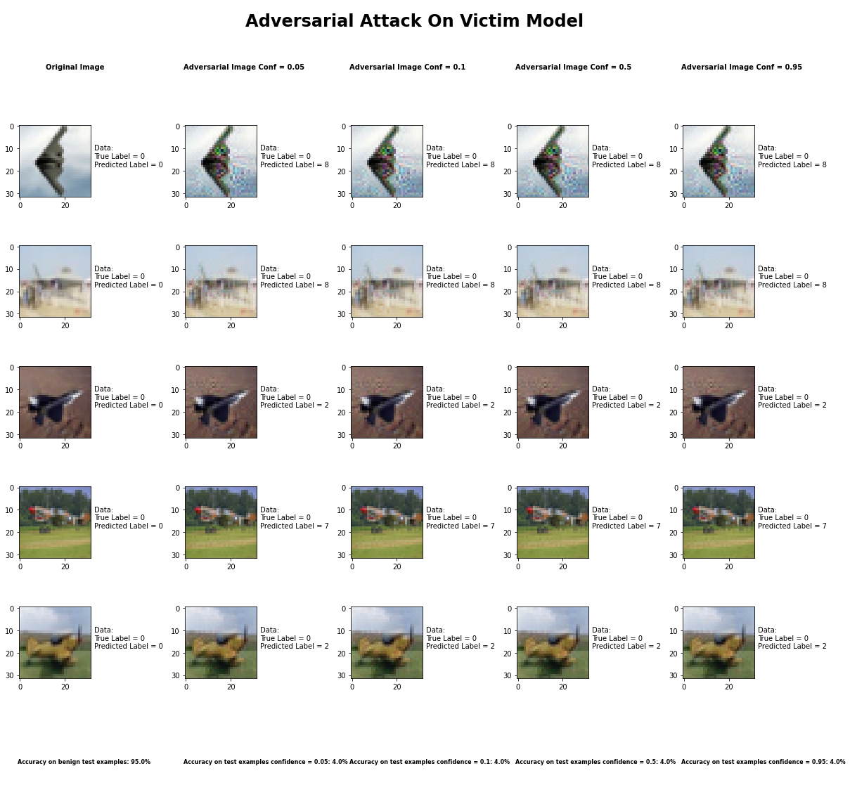

**Sample Output of the CarliniLInf Attack**

**Metric 1: Is it targeted or not?**

We decided not to do a targeted attack with this attack because we were altering all 10 classes.

**Metric 2: What is the minimum modification that you need to introduce to achieve**

**misclassification?**

After experimenting with different parameters, it seemed like no matter what value we chose for the confidence parameter, the accuracy of the classifier remained the same. We decided to adjust the confidence parameter because a higher value produces examples that are farther away, from the original input, but classified with higher confidence as the target class. So, to answer the question, we would say that it is safe to say that any value for the confidence parameter will drastically reduce the accuracy of the classifier.

**Metric 3: How do you judge the visual impact of the modifications?**

The attack produced images that have relatively little change to the image that is human perceptible. The way to describe the visual change is that it caused a slight blurring around the object in the image.

**Metric 4: Is the attack consistent across all classes?**

Within a certain degree the attack was consistent across all attacks, though it did perform exceptionally well for images labeled as cats when compared to all other classes.

**Metric 5: Is there a specific class the classifier tends to predict when it misclassifies the adversarial image?**

There is no specific class the classifier predicts when it misclassifies an adversarial example, for the most part it is a random class that the classifier predicts. It also depends on the true label of the class. Within the same class the mispredicted class are pretty consistent.

**Metric 6: How does varying the parameter of the attack effect both the accuracy and perceptibility of the adversarial example?**

As mentioned earlier, in this attack the confidence parameter was adjusted, however, no matter the change in the confidence parameter the results were the same, even after running the attack 10 times. Also, it is worth mentioning that the learning_rate was set to 0.1 in order to speed up the processing time. Also, the confidence parameter always produced the same image perceptibility no matter the value of the confidence parameter.

## Carlini L2 Method

|  |  |
| --- | --- |
| Average Accuracy Over 10 Runs with learning_rate = 0.1 | |
| Benign Samples | 94.52% |
| Confidence = 0.05 Samples | 4.8% |
| Confidence = 0.10 Samples | 4.8% |
| Confidence = 0.50 Samples | 4.8% |
| Confidence = 0.95 Samples | 4.8% |

|  |  |  |  |  |  |  |  |  |  |  |
| --- | --- | --- | --- | --- | --- | --- | --- | --- | --- | --- |
| Average Accuracy per Class Over 10 Runs with learning_rate = 0.1 | | | | | | | | | | |
|  | Airplane | Car | Bird | Cat | Deer | Dog | Frog | Horse | Ship | Truck |
| Benign Samples | 97% | 97% | 91% | 83% | 89% | 84% | 97% | 94% | 96% | 98% |
| Confidence = 0.05 Samples | 1% | 2% | 6% | 8% | 9% | 12% | 3% | 1% | 4% | 2% |
| Confidence = 0.10 Samples | 1% | 2% | 6% | 8% | 9% | 12% | 3% | 1% | 4% | 2% |
| Confidence = 0.50 Samples | 1% | 2% | 6% | 8% | 9% | 12% | 3% | 1% | 4% | 2% |
| Confidence = 0.95 Samples | 1% | 2% | 6% | 8% | 9% | 12% | 3% | 1% | 4% | 2% |

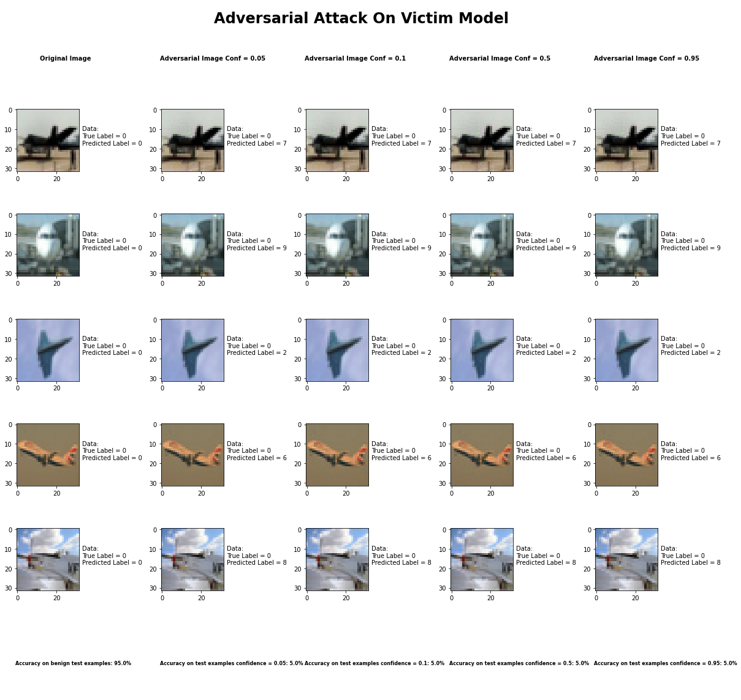

**Sample Output of the CarliniL2 Attack**

**Metric 1: Is it targeted or not?**

We decided not to do a targeted attack with this attack because we were altering all 10 classes.

**Metric 2: What is the minimum modification that you need to introduce to achieve**

**misclassification?**

After experimenting with different parameters, it seemed like no matter what value we chose for the confidence parameter, the accuracy of the classifier remained the same. We decided to adjust the confidence parameter because a higher value produces examples that are farther away, from the original input, but classified with higher confidence as the target class. So, to answer the question, we would say that it is safe to say that any value for the confidence parameter will drastically reduce the accuracy of the classifier.

**Metric 3: How do you judge the visual impact of the modifications?**

The attack produced images that have relatively little change to the image that is human perceptible. The way to describe the visual change is that it caused a slight blurring around the object in the image.

**Metric 4: Is the attack consistent across all classes?**

Within a certain degree the attack was consistent across all attacks, though it did perform exceptionally well for images labeled as dogs when compared to all other classes. This was the only real difference between the classes when compared with the Carlini LInf attack.

**Metric 5: Is there a specific class the classifier tends to predict when it misclassifies the adversarial image?**

There is no specific class the classifier predicts when it misclassifies an adversarial example, for the most part it is a random class that the classifier predicts. It also depends on the true label of the class. Within the same class the mispredicted class are pretty consistent.

**Metric 6: How does varying the parameter of the attack effect both the accuracy and perceptibility of the adversarial example?**

As mentioned earlier, in this attack the confidence parameter was adjusted, however, no matter the change in the confidence parameter the results were the same, even after running the attack 10 times. Also, it is worth mentioning that the learning_rate was set to 0.1 in order to speed up the processing time. Also, the confidence parameter always produced the same image perceptibility no matter the value of the confidence parameter.

## Basic Iterative Method

|  |  |
| --- | --- |
| Average Accuracy Over 10 Runs with max_iter = 100 | |
| Benign Samples | 94.52% |
| Epsilon = 0.10 Samples | 34.0% |
| Epsilon = 0.25 Samples | 32.3% |
| Epsilon = 0.50 Samples | 32.0% |
| Epsilon = 0.95 Samples | 32.1% |

|  |  |  |  |  |  |  |  |  |  |  |
| --- | --- | --- | --- | --- | --- | --- | --- | --- | --- | --- |
| Average Accuracy per Class Over 10 Runs with max_iter = 100 | | | | | | | | | | |
|  | Airplane | Car | Bird | Cat | Deer | Dog | Frog | Horse | Ship | Truck |
| Benign Samples | 99% | 96% | 94% | 87% | 97% | 88% | 95% | 97% | 93% | 93% |
| Epsilon = 0.10 Samples | 35% | 30% | 44% | 27% | 29% | 22% | 54% | 30% | 33% | 36% |
| Epsilon = 0.25 Samples | 35% | 28% | 41% | 27% | 28% | 22% | 47% | 30% | 31% | 34% |
| Epsilon = 0.50 Samples | 35% | 28% | 40% | 25% | 28% | 22% | 47% | 30% | 31% | 34% |
| Epsilon = 0.95 Samples | 36% | 28% | 40% | 25% | 28% | 22% | 47% | 30% | 31% | 34% |

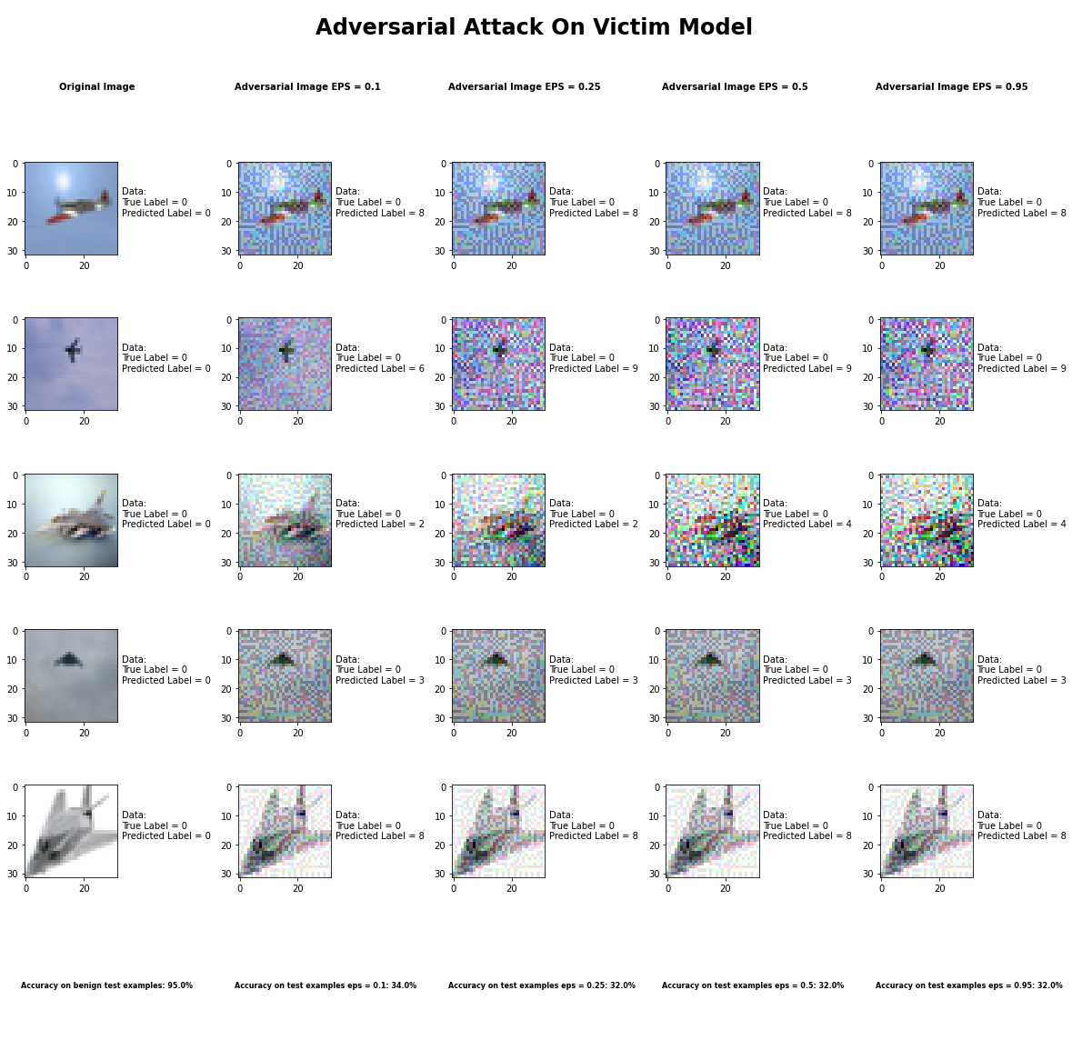

**Sample Output of the Basic Iterative Attack**

**Metric 1: Is it targeted or not?**

We decided not to do a targeted attack with this attack because we were altering all 10 classes.

**Metric 2: What is the minimum modification that you need to introduce to achieve**

**misclassification?**

After experimenting with different parameters, we found that the epsilon parameter was the one that actually caused the perturbation. The epsilon parameter is the value that is the “Maximum perturbation that the attacker can introduce”. We found that at even at a value of 0.05 for epsilon, visual modification was apparent to the naked eye. Starting at 0.1 it was without a doubt apparent. However, while adjusting the value of epsilon from 0.1 – 0.95 the accuracy of the classifier was right around 33% +- 1%.

**Metric 3: How do you judge the visual impact of the modifications?**

The attack produced images that have pretty significant alterations that are very visible. It produces a type of noise seen in old TV monitors.

**Metric 4: Is the attack consistent across all classes?**

Within a certain degree the attack was consistent across all attacks, though it did perform exceptionally well for images labeled as birds when compared to all other classes.

**Metric 5: Is there a specific class the classifier tends to predict when it misclassifies the adversarial image?**

There is no specific class the classifier predicts when it misclassifies an adversarial example, for the most part it is a random class that the classifier predicts. It also depends on the true label of the class. Within the same class the mispredicted class are pretty consistent.

**Metric 6: How does varying the parameter of the attack effect both the accuracy and perceptibility of the adversarial example?**

As mentioned earlier, in this attack the epsilon parameter was adjusted, however, no matter the change in the epsilon parameter the accuracy of the classifier was relatively the same, even after running the attack 10 times and taking the average. Also, it is worth mentioning that the max_iter was set to 100.

## Jacobian Saliency Method

|  |  |
| --- | --- |
| Average Accuracy Over 10 Runs with Theta = 0.05 | |
| Benign Samples | 94.52% |
| Gamma = 0.05 Samples | 12.5% |
| Gamma = 0.10 Samples | 2.1% |
| Gamma = 0.5 Samples | 0.2% |
| Gamma = 0.95 Samples | 0.1% |

|  |  |  |  |  |  |  |  |  |  |  |
| --- | --- | --- | --- | --- | --- | --- | --- | --- | --- | --- |
| Average Accuracy per Class Over 10 Runs with Theta = 0.05 | | | | | | | | | | |
|  | Airplane | Car | Bird | Cat | Deer | Dog | Frog | Horse | Ship | Truck |
| Benign Samples | 97% | 99% | 92% | 87% | 94% | 84% | 98% | 97% | 99% | 96% |
| Gamma = 0.05 Samples | 19% | 34% | 7% | 4% | 2% | 5% | 7% | 10% | 20% | 17% |
| Gamma = 0.10 Samples | 2% | 6% | 1% | 4% | 0% | 3% | 0% | 1% | 1% | 3% |
| Gamma = 0.5 Samples | 0% | 0% | 0% | 1% | 1% | 0% | 0% | 0% | 0% | 0% |
| Gamma = 0.95 Samples | 0% | 0% | 0% | 1% | 0% | 0% | 0% | 0% | 0% | 0% |

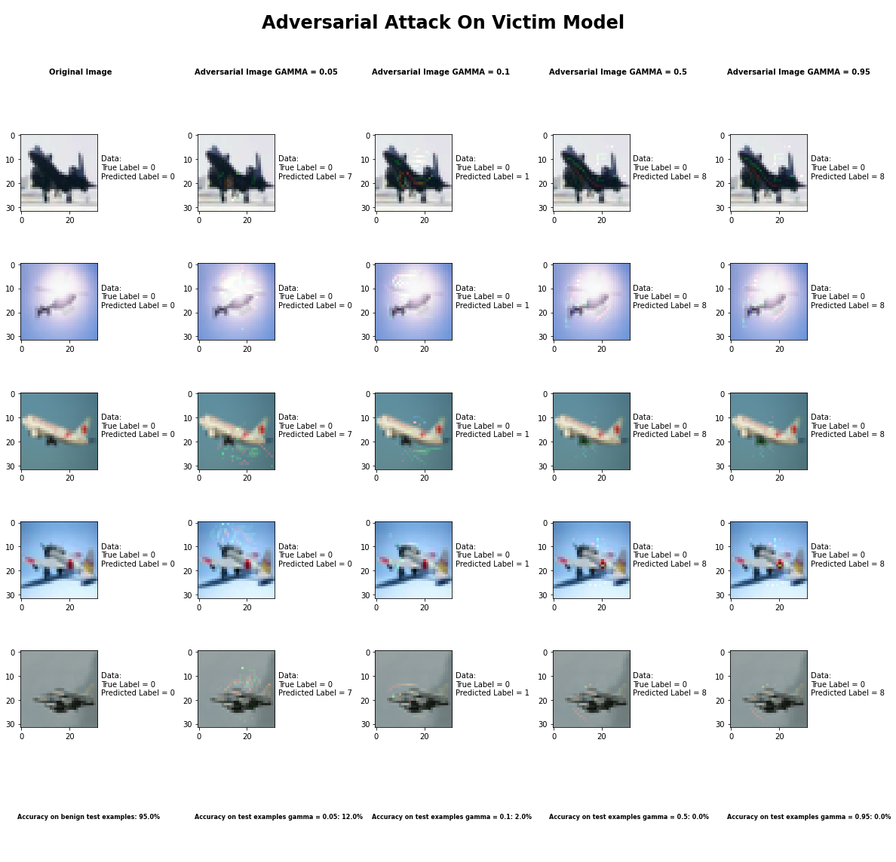

**Sample Output of the Jacobian Saliency Map Attack**

**Metric 1: Is it targeted or not?**

We decided not to do a targeted attack with this attack because we were altering all 10 classes.

**Metric 2: What is the minimum modification that you need to introduce to achieve**

**misclassification?**

After experimenting with different parameters, we found that the gamma parameter was the one that actually caused the perturbation that produced the least human perceptible changes. The gamma parameter is the value that is the “Maximum fraction of features being perturbed (between 0 and 1)”. We also found that the theta parameter is used to set the “Amount of Perturbation introduced to each modified feature per step (can be positive or negative)”.

We found that setting theta close to 0 and adjusting gamma gave the best results even though it was human perceptible in some areas of the image. The minimum modification required to drop the accuracy of the classifier was gamma = 0.05 and theta = 0.05. Increasing gamma to close to 1 gave accuracies of less than 1% even though the image itself seemed not too much more altered when gamma was close to 0.

**Metric 3: How do you judge the visual impact of the modifications?**

The attack produced images that have pretty significant alterations that are very visible but rather than being across the entire image, they are isolated in certain regions of the image. It produces a type of noise that are similar in appearance to a checkerboard.

**Metric 4: Is the attack consistent across all classes?**

This attack was pretty consistent across all classes for values of gamma greater than 0.1. However, for gamma = 0.05 the attack did better on cars when compared with other classes.

**Metric 5: Is there a specific class the classifier tends to predict when it misclassifies the adversarial image?**

There is a high correlation with a specific class that the classifier misclassifies the image with. However, it is a class by class bases as well as specific to each gamma value used.

**Metric 6: How does varying the parameter of the attack effect both the accuracy and perceptibility of the adversarial example?**

As mentioned earlier, in this attack the gamma parameter was adjusted, and adjusting it gave significant differences in accuracy. Basically:

* Keeping Gamma variable, and Theta close to 0 gave results with least perceptible changes
* Keeping Gamma variable with Theta close to abs(1) gave results with most noticeable changes
* Keeping Theta variable makes changes to image that make it seem to fade out as you get close to theta = 0
* Keeping Gamma variable increase area of changes in image, small gamma means smaller area

## Universal Perturbation Method

|  |  |
| --- | --- |
| Average Accuracy Over 10 Runs with FGSM | |
| Benign Samples | 94.52% |
| Delta = 0.05 Samples | 10.6% |
| Delta = 0.10 Samples | 9.1% |
| Delta = 0.5 Samples | 10.5% |
| Delta = 0.95 Samples | 10.4% |

|  |  |  |  |  |  |  |  |  |  |  |
| --- | --- | --- | --- | --- | --- | --- | --- | --- | --- | --- |
| Average Accuracy per Class Over 10 Runs with FGSM | | | | | | | | | | |
|  | Airplane | Car | Bird | Cat | Deer | Dog | Frog | Horse | Ship | Truck |
| Benign Samples | 94% | 97% | 93% | 95% | 97% | 90% | 96% | 98% | 94% | 96% |
| Delta = 0.05 Samples | 54% | 1% | 0% | 0% | 0% | 0% | 2% | 0% | 0% | 49% |
| Delta = 0.10 Samples | 36% | 2% | 0% | 11% | 0% | 1% | 0% | 0% | 0% | 41% |
| Delta = 0.5 Samples | 37% | 21% | 0% | 1% | 0% | 1% | 10% | 0% | 0% | 35% |
| Delta = 0.95 Samples | 56% | 5% | 0% | 2% | 0% | 1% | 3% | 9% | 0% | 28% |

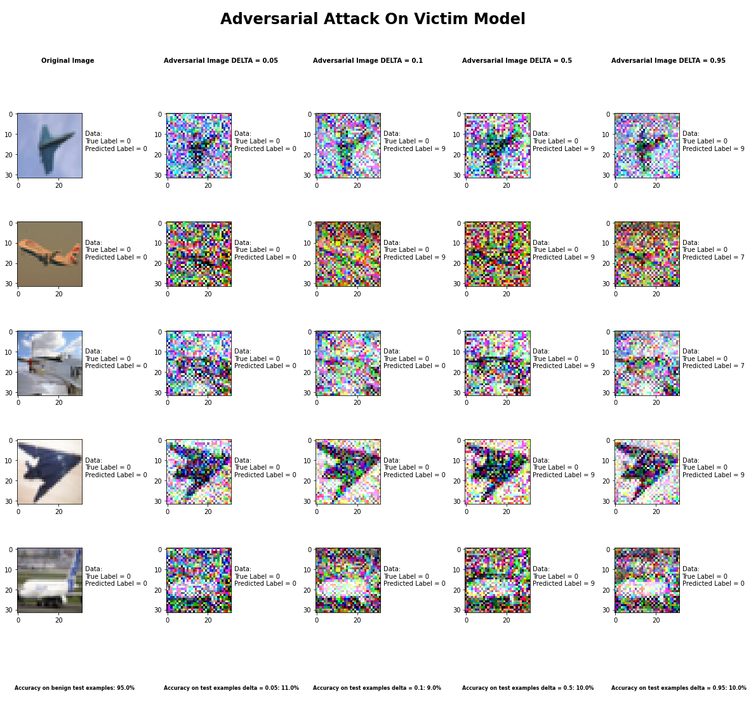

**Sample Output of the Universal Perturbation Attack**

**Metric 1: Is it targeted or not?**

We decided not to do a targeted attack with this attack because we were altering all 10 classes.

**Metric 2: What is the minimum modification that you need to introduce to achieve**

**misclassification?**

After experimenting with different parameters, we found that the delta parameter was the one that actually needed to be adjusted with this attack. This attack can use any other attack as its baseline attack therefore the parameter for the baseline attack are for the most part already predefined. The only parameter inherent with the attack itself, i.e. Universal Perturbation attack, was the delta parameter. The delta parameter is the value that is used to set the “desired accuracy”. We found that setting delta between 0 and 1 and using the FGSM as our baseline attack, we got accuracies in the range of 10% +- 1%. Since the delta value itself did not cause much change in the accuracy we would say that with FGSM as the baseline attack and any value of delta will cause the enough noise to cause a misclassification

**Metric 3: How do you judge the visual impact of the modifications?**

The attack produced images that have pretty significant alterations that are very visible and are similar to the Basic Iterative Method more so than the FGSM attack even though the baseline attack used was FGSM. This was probably the case because of the delta parameter.

**Metric 4: Is the attack consistent across all classes?**

This attack was pretty consistent across all classes except airplanes and trucks. These two classes had accuracies closer to 40-50% across all values of delta.

**Metric 5: Is there a specific class the classifier tends to predict when it misclassifies the adversarial image?**

There is no specific class the classifier predicts when it misclassifies an adversarial example, for the most part it is a random class that the classifier predicts.

**Metric 6: How does varying the parameter of the attack effect both the accuracy and perceptibility of the adversarial example?**

Varying delta did not alter the accuracy range as much. For values of 0 – 1 for delta, the accuracy of the classifier with FGSM as the baseline attack, stayed close to 10%.

## DeepFool Method

|  |  |
| --- | --- |
| Average Accuracy Over 10 Runs | |
| Benign Samples | 94.52% |
| Epsilon = 1e-6 Samples | 30.2% |
| Epsilon = 1e-3 Samples | 31.3% |
| Epsilon = 1e-1 Samples | 30.1% |
| Epsilon = 1 Samples | 31.0% |

|  |  |  |  |  |  |  |  |  |  |  |
| --- | --- | --- | --- | --- | --- | --- | --- | --- | --- | --- |
| Average Accuracy per Class Over 10 Runs | | | | | | | | | | |
|  | Airplane | Car | Bird | Cat | Deer | Dog | Frog | Horse | Ship | Truck |
| Benign Samples | 95% | 92% | 96% | 86% | 95% | 88% | 99% | 93% | 94% | 98% |
| Epsilon = 1e-6 Samples | 42% | 45% | 27% | 29% | 37% | 20% | 26% | 21% | 32% | 26% |
| Epsilon = 1e-3 Samples | 46% | 51% | 31% | 26% | 33% | 22% | 24% | 25% | 30% | 24% |
| Epsilon = 1e-1 Samples | 46% | 48% | 24% | 22% | 38% | 23% | 29% | 24% | 28% | 21% |
| Epsilon = 1  Samples | 46% | 41% | 28% | 24% | 35% | 22% | 25% | 26% | 32% | 18% |

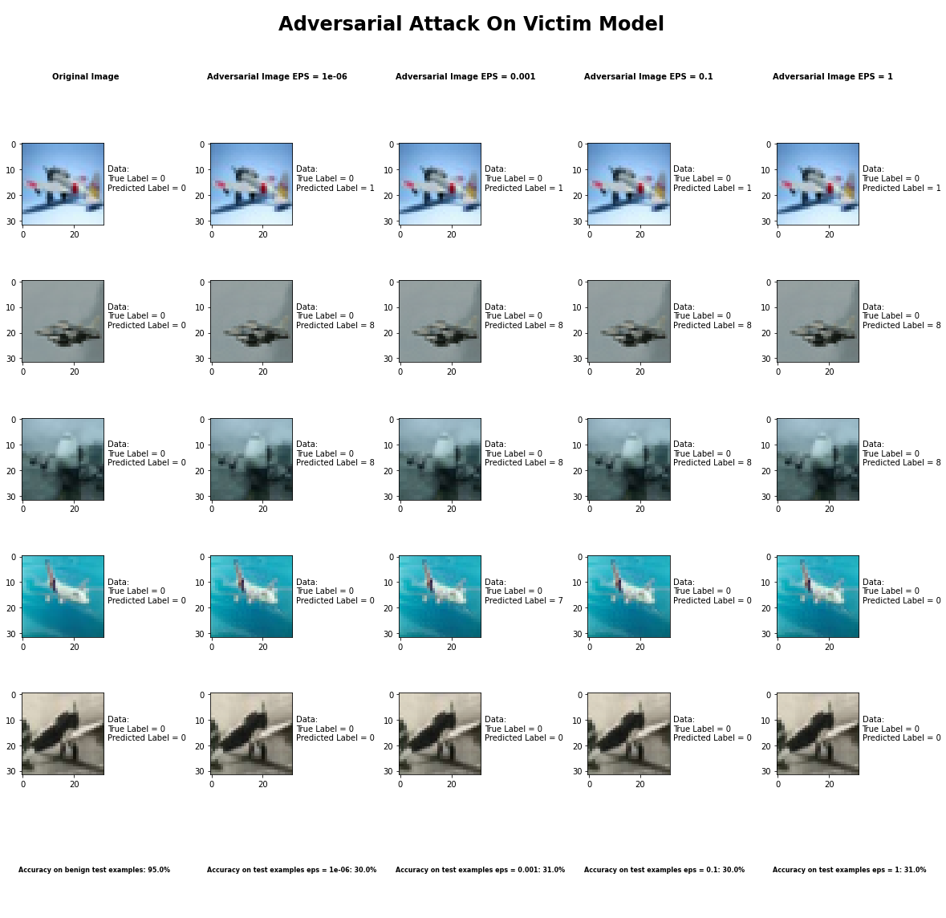

**Sample Output of the DeepFool Attack**

**Metric 1: Is it targeted or not?**

We decided not to do a targeted attack with this attack because we were altering all 10 classes.

**Metric 2: What is the minimum modification that you need to introduce to achieve**

**misclassification?**

After experimenting with different parameters, we found that the epsilon parameter was the one that actually needed to be adjusted with this attack. This attack can push the prediction to the closest hyperplane other than the true hyperplane. The epsilon parameter is the value that is used to set the “overshoot parameter”. We found by adjusting epsilon, we got accuracies in the range of 30.5% +- 1%. Since varying epsilon did not cause significant change between accuracies, any value of epsilon is enough to be consider minimum modification required to cause misclassification.

**Metric 3: How do you judge the visual impact of the modifications?**

The attack produced images that are completely imperceptible to the naked eye yet very good at causing misclassification.

**Metric 4: Is the attack consistent across all classes?**

This attack was pretty consistent across all classes though it had a high average for correctly classifying airplanes and cars across all values of epsilon.

**Metric 5: Is there a specific class the classifier tends to predict when it misclassifies the adversarial image?**

There is no specific class the classifier predicts when it misclassifies an adversarial example, for the most part it is a random class that the classifier predicts.

**Metric 6: How does varying the parameter of the attack effect both the accuracy and perceptibility of the adversarial example?**

Varying epsilon did not alter the accuracy range as much. For values of 1e-6– 1 for epsilon, the accuracy of the classifier, stayed close to 30%. Also, no matter the value of epsilon, the adversarial image always remained imperceptible.

## Virtual Adversarial Method

After countless hours and attempts with different parameters, the attack never converged. We had ran the attacks several times for hours, i.e. 5-8 hours, at a time but it never converged. Our code was exactly the same as all the other attacks, but it just kept running and never converged.

## Fast Gradient Sign Method

|  |  |
| --- | --- |
| Average Accuracy Over 10 Runs | |
| Benign Samples | 94.52% |
| Epsilon = 0.05 Samples | 48.4% |
| Epsilon = 0.10 Samples | 39.9% |
| Epsilon = 0.5 Samples | 35.3% |
| Epsilon = 0.95 Samples | 35.3% |

|  |  |  |  |  |  |  |  |  |  |  |
| --- | --- | --- | --- | --- | --- | --- | --- | --- | --- | --- |
| Average Accuracy per Class Over 10 Runs | | | | | | | | | | |
|  | Airplane | Car | Bird | Cat | Deer | Dog | Frog | Horse | Ship | Truck |
| Benign Samples | 98% | 96% | 95% | 86% | 96% | 84% | 96% | 93% | 99% | 97% |
| Epsilon = 0.05 Samples | 32% | 60% | 68% | 42% | 43% | 31% | 60% | 33% | 58% | 57% |
| Epsilon = 0.10 Samples | 30% | 40% | 70% | 34% | 28% | 23% | 68% | 24% | 45% | 37% |
| Epsilon = 0.5 Samples | 33% | 40% | 34% | 37% | 20% | 23% | 26% | 24% | 45% | 71% |
| Epsilon = 0.95 Samples | 30% | 35% | 34% | 32% | 20% | 23% | 26% | 23% | 45% | 87% |

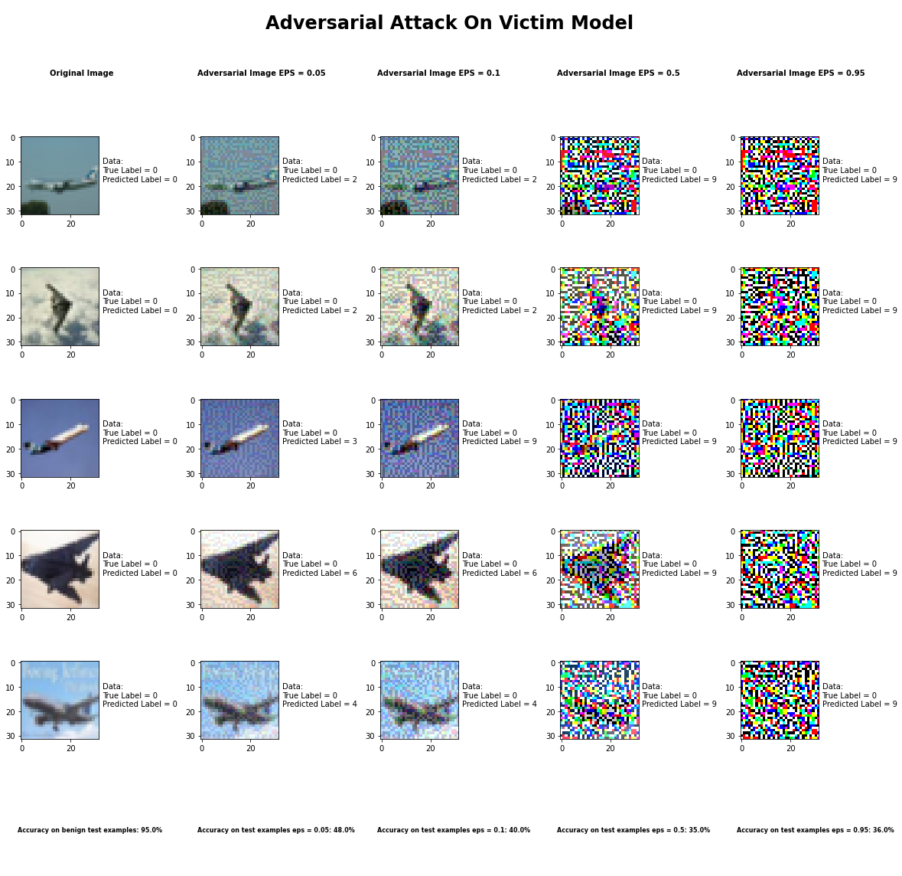

**Sample Output of the Fast Gradient Sign Method Attack**

**Metric 1: Is it targeted or not?**

We decided not to do a targeted attack with this attack because we were altering all 10 classes.

**Metric 2: What is the minimum modification that you need to introduce to achieve**

**misclassification?**

After experimenting with different parameters, we found that the epsilon parameter was the one that actually needed to be adjusted with this attack. The epsilon parameter is the value that is used to set the “Attack step size (input variation)”. We found by adjusting epsilon, we got accuracies in the range of 35% - 50%. Setting epsilon close to 0 like 0.05, will be the minimum modification that needs to be introduced to achieve misclassification.

**Metric 3: How do you judge the visual impact of the modifications?**

The attack produced images that are nearly imperceptible to the naked eye for epsilon values < 0.1 and very perceptible for epsilon values > 0.25.

**Metric 4: Is the attack consistent across all classes?**

This attack, as an average, was pretty consistent across all classes.

**Metric 5: Is there a specific class the classifier tends to predict when it misclassifies the adversarial image?**

There is no specific class the classifier predicts when it misclassifies an adversarial example, it is pretty random when it comes to the class that the classifier predicts.

**Metric 6: How does varying the parameter of the attack effect both the accuracy and perceptibility of the adversarial example?**

When epsilon is increasing the accuracy diminishes as does the integrity of the image, i.e. very noticeable to the human eye. Smaller values of epsilon also produce low accuracy but are not as apparent to the human eye.

# Defenses

## Overview

By Following the example provided in the art library we implemented the defenses on the attacks.

By applying the assigned defenses on both the original data and adversarial data we try to predict a randomly chosen image from both the samples and calculate the accuracy using imagenet.

## Problems

The Assigned Defense Algorithms include: Total Variable Minimization, Gaussian Noise, JPEG Compression, Class Label, and Pixel Defense.

Most of the models were simple to implement and test. However, issues occurred while we were implementing Pixel_Defence.

Initially, the Pixel_Defence constructor did not require any parameters, so we passed none. However, a compilation error occurred stating pixel_cnn is not applied.

AttributeError: 'PixelDefend' object has no attribute 'pixel_cnn'

Since our attack did not have a pixel_cnn, we tried initializing one and passing as an argument. Then the compiler gave another error stating about pixel_cnn not having the correct attribute. Following up with the error in the Pixel_Defence library, we discovered that an internal function _call_ did not have the pixel_cnn properly initialized. Since the function was private, we were unable to alter anything, which led us to believe that there might be a bug in the PixelDefend’s code. After discussing with another team implementing the same attack, we learned that the other team is also dealing with the same issue. Therefore, we strongly believe that there is an error with PixelDefend, preventing us from implementing the defense.

## Results

The success rate of the defense, meaning how high is success rate of attacks with and without the defense.

The following are the averaged accuracies of the defenses applied. Table 1 represents the accuracy of original samples and post attack defenses. Table 2 represents the accuracy when defenses are applied before attack.

**Table 1**

|  |  |  |  |  |  |  |  |  |
| --- | --- | --- | --- | --- | --- | --- | --- | --- |
| **Attacks** | **Total Variance Minimization** | | **JPEG Compression** | | **Gaussian Noise** | | **Class Label** | |
| **Original** | **Adversarial** | **Original** | **Adversarial** | **Original** | **Adversarial** | **Original** | **Adversarial** |
| **Spatial Transformation** | 7.02 | 7.68 | 6.12 | 7.01 | 10.42 | 5.11 | 6.70 | 6.70 |
| **Newton Fool** | 6.92 | 12.98 | 6.12 | 10.59 | 9.43 | 5.80 | 6.70 | 6.70 |
| **Projected Gradient Descent** | 6.84 | 7.38 | 6.12 | 8.74 | 10.96 | 10.36 | 6.70 | 6.70 |
| **Deep Fool** | 6.90 | 12.34 | 6.12 | 7.11 | 8.64 | 9.68 | 6.70 | 6.70 |
| **FastGradientSignMethod** | 7.05 | 5.26 | 6.12 | 5.76 | 10.57 | 10.01 | 6.70 | 6.70 |
| **UniversalPerturbation** | 7.05 | 5.21 | 6.12 | 11.08 | 7.49 | 12.60 | 6.70 | 6.70 |
| **CarliniLinf** | 6.52 | 11.60 | 6.12 | 9.23 | 8.71 | 7.93 | 6.70 | 6.70 |
| **ElasticNet** | 6.57 | 8.68 | 6.12 | 10.20 | 8.51 | 10.40 | 6.70 | 6.70 |
| **Zeroth Attack** | 6.56 | 8.11 | 6.12 | 11.29 | 8.21 | 5.54 | 6.70 | 6.70 |
| **CarLiniL2** | 6.92 | 9.66 | 6.12 | 9.36 | 12.29 | 8.68 | 6.70 | 6.70 |
| **JacobianBasedSaliencyMapMethod** | 7.68 | 9.57 | 6.12 | 9.87 | 10.77 | 10.83 | 6.70 | 6.70 |
| **Basic Iterative Method** | 6.90 | 8.57 | 6.12 | 10.28 | 6.22 | 8.18 | 6.70 | 6.70 |

**Table 2 :**

|  |  |  |  |  |
| --- | --- | --- | --- | --- |
| **Attacks** | **Total Variance Minimization** | **JPEG Compression** | **Gaussian Noise** | **Class Label** |
| **Spatial Transformation** |  |  |  |  |
| **Newton Fool** |  |  |  |  |
| **Projected Gradient Descent** |  |  |  |  |
| **Deep Fool** |  |  |  |  |
| **FastGradientSignMethod** |  |  |  |  |
| **UniversalPerturbation** |  |  |  |  |
| **CarliniLinf** |  |  |  |  |
| **ElasticNet** |  |  |  |  |
| **Zeroth Attack** |  |  |  |  |
| **CarLiniL2** |  |  |  |  |
| **JacobianBasedSaliencyMapMethod** |  |  |  |  |
| **Basic Iterative Method** |  |  |  |  |

How much computational overhead the defense introduces into the system. Does the defense impact the performance of the model if no attack is present?

Yes and No, one defense did take a long time to execute (Class Label). However, most of the attacks took less than 5 mins to execute.

# Attacks on Text Data

# Attack Transferability

For the transferability attack we took the x test set from the CIFAR10 dataset and used that as our sample set from which we would use the Jacobian data augmentation technique to generate synthetic data to train the substitute. In doing so, we had 10,000 samples to start off with, and each of these sample images was labelled by the victim model. At this point we had a sample set of size 10,000 images with 10,000 labels. In order to perform the transferability attack on a black box classifier we had to train a substitute model, but since the architecture of the victim model is unknown, we chose the substitute model’s architecture on our own. We used the basic CNN architecture from the Keras website. The idea of the Jacobian data augmentation technique is to take that sample set and find the Jacobian of your substitute model, basically a matrix of the gradients of our substitute model with respect to the inputs. Then evaluate each sample and take the matrix corresponding to the victim models predicted label. This value is added to a perturbation equation which basically adds a specified noise to each sample, thus creating a new sample. We do this for each of the samples in the subset and basically double the size of the data set. So, in the case if we start off with 10,000 samples, after going through one iteration of the Jacobian data augmentation technique we now have 20,000 samples. So  this is the basic concept of what was done, in effect what we actually did was take the first 7,500 samples of the CIFAR10’s x test set to perform the Jacobian data augmentation technique and saved the remaining 2500 samples as a test set to evaluate our substitute model. After multiple attempts to generate data four or five times the original sample size, we could not get the Jacobian data augmentation technique to run more than once, i.e. double the data rather than tripling it or quadrupling it. This was not due to the algorithm used to create the synthetic data, but the computational power provided by Colab. Even by switching to the higher RAM mode we were still unable to run the Jacobian data augmentation technique more than once. Every time we ran more than once it crashed. Therefore, we were only successfully able to double the data. So, in total we had 15000 samples to train our substitute model on and therefore the accuracy on the test set, that we set aside, was not as great even though the training accuracy was well over 80%. In terms of evaluating on the test set, we had an average accuracy of around 10%. The reason why we believe that the training set evaluated better on the substitute model was because of overfitting even though we tried methods of regularization to prevent overfitting, we still could not improve our test accuracy. After training the model we generated adversarial examples from each of the attacks on the substitute model and sent those to those to be evaluated the victim model and reported those below.

## Threshold Attack Method

## Pixel Attack Method

## HopSkipJump Attack

|  |  |
| --- | --- |
| Average Accuracy Over 10 Runs | |
| Benign Samples | 94.52% |
| Max_eval = 100 Samples | 89.0% |
| Max_eval = 1000 Samples | 89.0% |
| Max_eval = 2500 Samples | 89.2% |
| Max_eval = 5000 Samples | 88.6% |

|  |  |  |  |  |  |  |  |  |  |  |
| --- | --- | --- | --- | --- | --- | --- | --- | --- | --- | --- |
| Average Accuracy per Class Over 10 Runs | | | | | | | | | | |
|  | Airplane | Car | Bird | Cat | Deer | Dog | Frog | Horse | Ship | Truck |
| Benign Samples | 100% | 100% | 100% | 100% | 100% | 100% | 100% | 100% | 100% | 100% |
| Max_eval = 100 Samples | 88% | 89% | 90% | 90% | 93% | 83% | 97% | 87% | 84% | 89% |
| Max_eval = 1000 Samples | 86% | 91% | 94% | 90% | 89% | 79% | 99% | 88% | 83% | 91% |
| Max_eval = 2500 Samples | 85% | 93% | 90% | 89% | 91% | 84% | 99% | 91% | 80% | 90% |
| Max_eval = 5000 Samples | 82% | 91% | 94% | 91% | 86% | 74% | 99% | 90% | 89% | 90% |

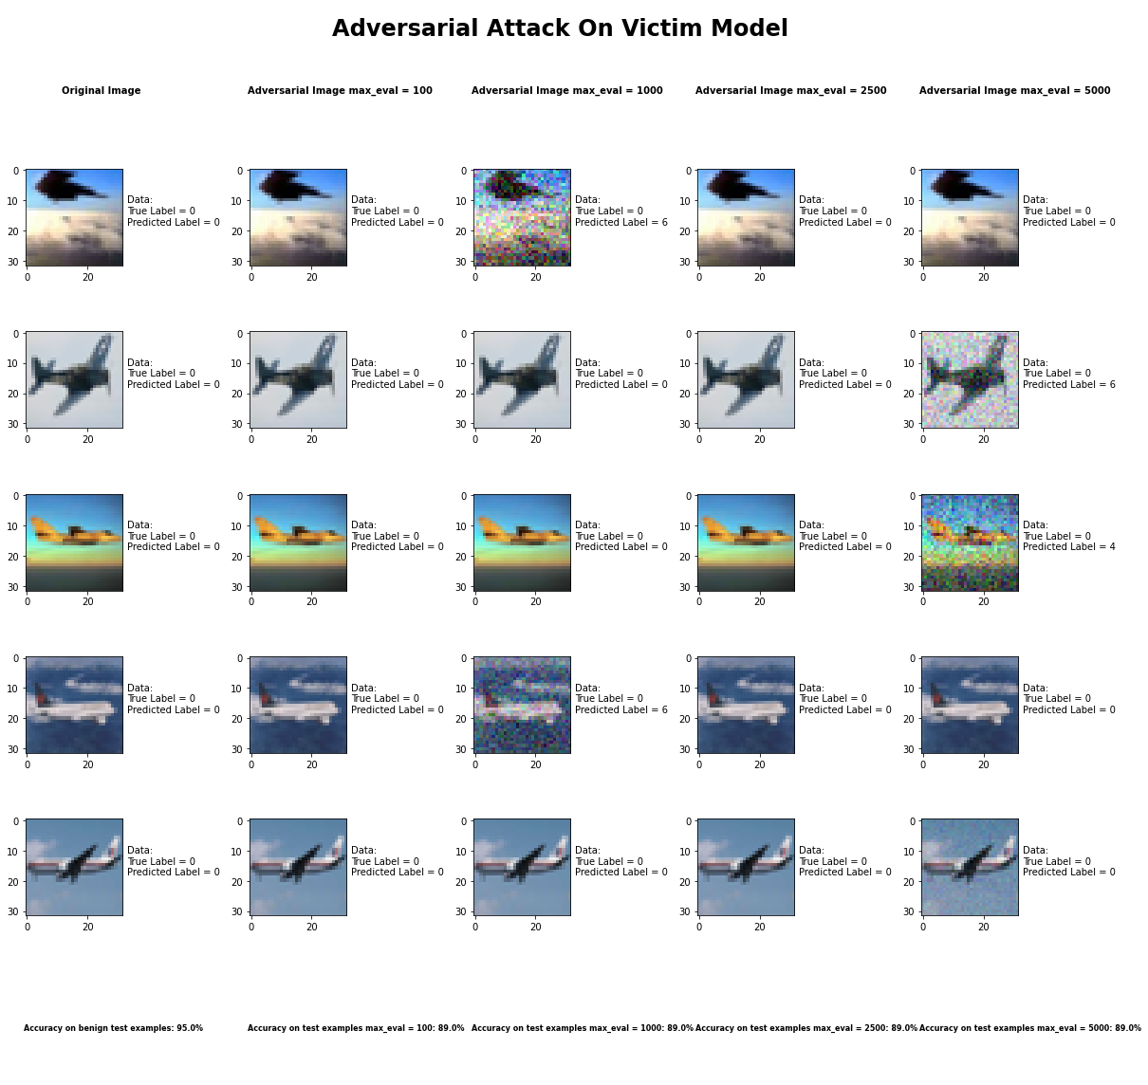

**Sample Output of the HopSkipJump Attack**

## uElastic Net Method

|  |  |
| --- | --- |
| Average Accuracy Over 1 Run with max_iter = 100 | |
| Benign Samples | 94.52% |
| Confidence = 0.05 Samples | 96.6% |
| Confidence = 0.10 Samples | 96.6% |
| Confidence = 0.50 Samples | 96.6% |
| Confidence = 0.95 Samples | 96.6% |

|  |  |  |  |  |  |  |  |  |  |  |
| --- | --- | --- | --- | --- | --- | --- | --- | --- | --- | --- |
| Average Accuracy per Class Over 1 Run with max_iter = 100 | | | | | | | | | | |
|  | Airplane | Car | Bird | Cat | Deer | Dog | Frog | Horse | Ship | Truck |
| Benign Samples | 100% | 100% | 100% | 100% | 100% | 100% | 100% | 100% | 100% | 100% |
| Confidence = 0.05 Samples | 98% | 95% | 100% | 94% | 93% | 91% | 99% | 98% | 100% | 98% |
| Confidence = 0.10 Samples | 98% | 95% | 100% | 94% | 93% | 91% | 99% | 98% | 100% | 98% |
| Confidence = 0.50 Samples | 98% | 95% | 100% | 94% | 93% | 91% | 99% | 98% | 100% | 98% |
| Confidence = 0.95 Samples | 98% | 95% | 100% | 94% | 93% | 91% | 99% | 98% | 100% | 98% |

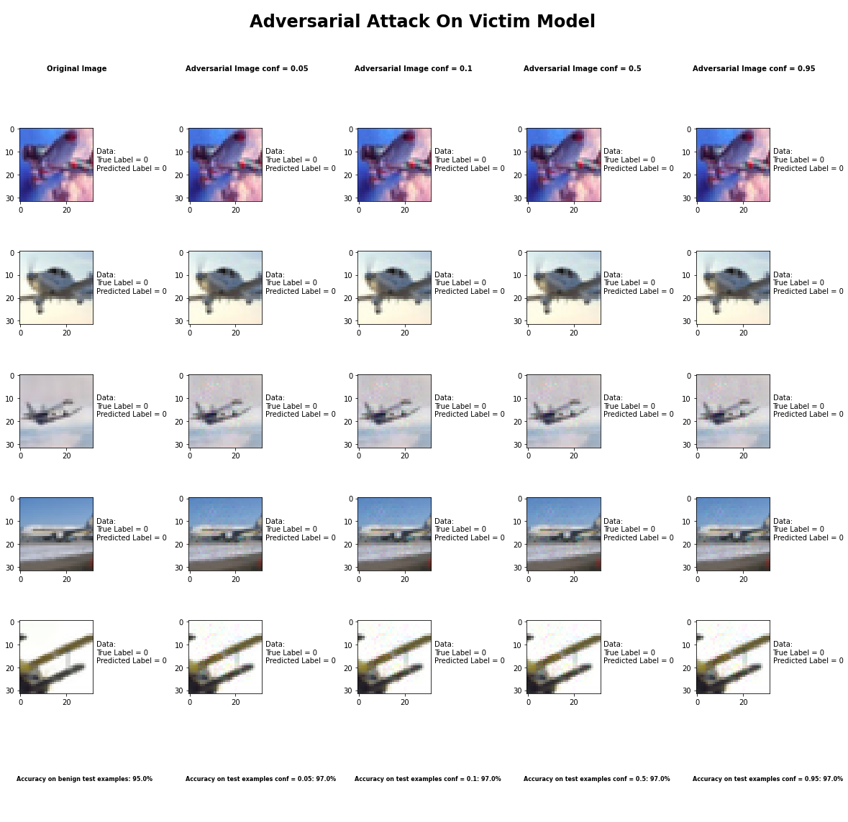

**Sample Output of the Elastic Net Attack**

For this attack, the transferability accuracy was very different from the accuracy when the adversarial examples were crafted from the victim model. This is something that we assume to be because of the inability of the substitute model to completely copy the Black Box victim model. Mainly because the accuracy of the substitute model was around 10%. In an ideal case we would have the substitute model accuracy very close to the victim model accuracy. Something even stranger was the fact that the adversarial examples were predicted with a higher accuracy than the benign examples.

## Query Efficient Black Box Estimation Method

This attack when implemented via the victim model only gave us an accuracy rather than generating any adversarial examples. Therefore, we were not able to implement this via a transferability method.

## Adversarial Patch Attack

|  |  |
| --- | --- |
| Average Accuracy Over 10 Runs | |
| Benign Samples | 94.52% |
| learning rate = 5.0 Samples | 11.1% |
| learning rate = 10.0 Samples | 11.7% |
| learning rate = 15.0 Samples | 11.1% |
| learning rate = 20.0 Samples | 11.3% |

|  |  |  |  |  |  |  |  |  |  |  |
| --- | --- | --- | --- | --- | --- | --- | --- | --- | --- | --- |
| Average Accuracy per Class Over 10 Runs | | | | | | | | | | |
|  | Airplane | Car | Bird | Cat | Deer | Dog | Frog | Horse | Ship | Truck |
| Benign Samples | 100% | 100% | 100% | 100% | 100% | 100% | 100% | 100% | 100% | 100% |
| learning rate = 5.0 Samples | 21% | 89% | 0% | 0% | 0% | 0% | 0% | 0% | 0% | 1% |
| learning rate = 10.0 Samples | 22% | 88% | 0% | 7% | 0% | 0% | 0% | 0% | 0% | 0% |
| learning rate = 15.0 Samples | 18% | 89% | 0% | 4% | 0% | 0% | 0% | 0% | 0% | 0% |
| learning rate = 20.0 Samples | 18% | 92% | 0% | 3% | 0% | 0% | 0% | 0% | 0% | 0% |

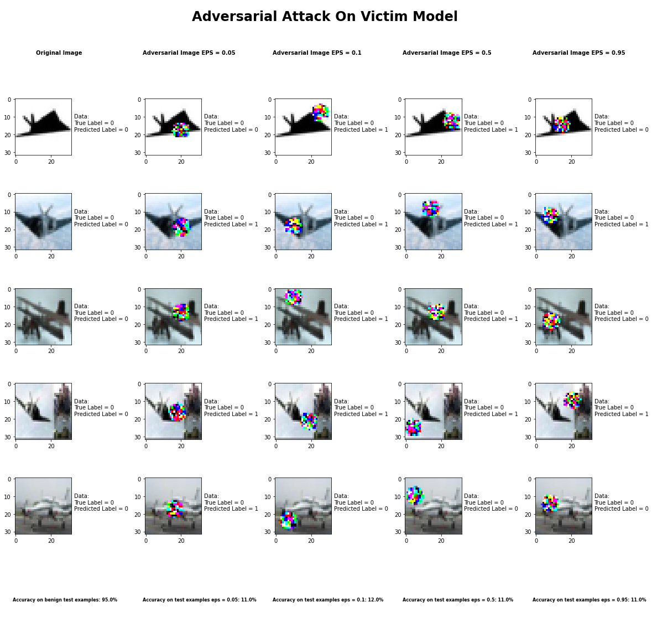

**Sample Output of the Adversarial Patch Attack**

For this attack the transferability accuracy seems about the same as the accuracy for the different learning rates when the adversarial examples were crafted from the victim model. The accuracies stayed consistent within 1% of the regular attack. What we were expecting was for the victim model to have a high accuracy with the adversarial examples because of the low accuracy of the substitute model in respect to its copy of the Black Box victim model. However, that was not the case.

## Carlini LInf Mthod

## Carlini L2 Mthod

## Basic Iterative Method

## Jacobian Saliency Map

|  |  |
| --- | --- |
| Average Accuracy Over 10 Runs with Theta = 0.05 | |
| Benign Samples | 94.52% |
| Gamma = 0.05 Samples | 91.2% |
| Gamma = 0.10 Samples | 83.6% |
| Gamma = 0.5 Samples | 80.3% |
| Gamma = 0.95 Samples | 81.2% |

|  |  |  |  |  |  |  |  |  |  |  |
| --- | --- | --- | --- | --- | --- | --- | --- | --- | --- | --- |
| Average Accuracy per Class Over 10 Runs with Theta = 0.05 | | | | | | | | | | |
|  | Airplane | Car | Bird | Cat | Deer | Dog | Frog | Horse | Ship | Truck |
| Benign Samples | 100% | 100% | 100% | 100% | 100% | 100% | 100% | 100% | 100% | 100% |
| Gamma = 0.05 Samples | 96% | 98% | 92% | 86% | 91% | 72% | 98% | 90% | 92% | 97% |
| Gamma = 0.10 Samples | 94% | 91% | 89% | 63% | 78% | 54% | 97% | 86% | 86% | 98% |
| Gamma = 0.5 Samples | 89% | 89% | 77% | 65% | 81% | 46% | 98% | 78% | 84% | 96% |
| Gamma = 0.95 Samples | 92% | 91% | 76% | 68% | 84% | 38% | 97% | 82% | 87% | 97% |

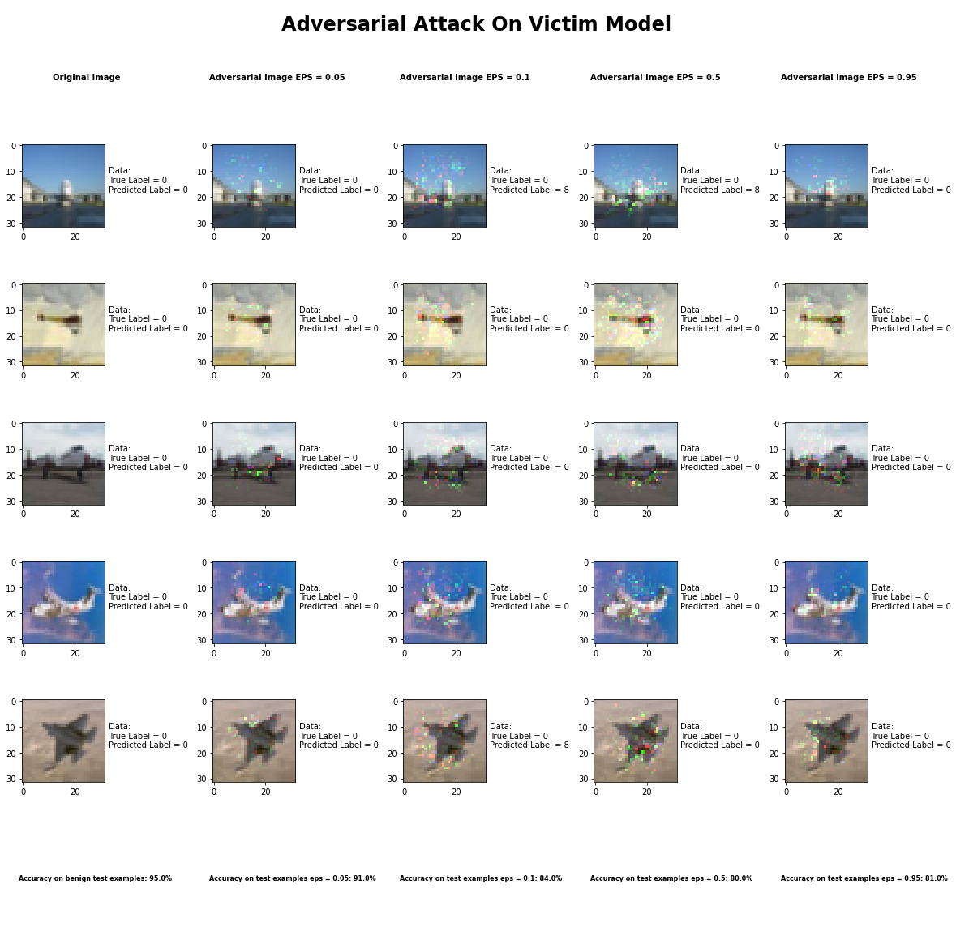

**Sample Output of the Jacobian Saliency Map Attack**

For this attack, the transferability accuracy was much higher than when the victim model was used to craft the adversarial examples. This is something that does not surprise us because the substitute model did not completely do a good job of copying the victim model as is evident by the accuracy of the substitute model which is around 10%. For the most part the accuracy of the victim model on the adversarial examples crafted by the substitute model are above 80% whereas in the regular attack they are between 0 and 12%.

## Universal Perturbation Method

|  |  |
| --- | --- |
| Average Accuracy Over 10 Runs with FGSM | |
| Benign Samples | 94.52% |
| Delta = 0.05 Samples | 11.5% |
| Delta = 0.10 Samples | 11.5% |
| Delta = 0.5 Samples | 11.5% |
| Delta = 0.95 Samples | 11.5% |

|  |  |  |  |  |  |  |  |  |  |  |
| --- | --- | --- | --- | --- | --- | --- | --- | --- | --- | --- |
| Average Accuracy per Class Over 10 Runs with FGSM | | | | | | | | | | |
|  | Airplane | Car | Bird | Cat | Deer | Dog | Frog | Horse | Ship | Truck |
| Benign Samples | 100% | 100% | 100% | 100% | 100% | 100% | 100% | 100% | 100% | 100% |
| Delta = 0.05 Samples | 14% | 2% | 8% | 5% | 0% | 0% | 86% | 0% | 0% | 0% |
| Delta = 0.10 Samples | 5% | 3% | 12% | 9% | 0% | 0% | 86% | 0% | 0% | 0% |
| Delta = 0.5 Samples | 14% | 0% | 11% | 0% | 0% | 0% | 90% | 0% | 0% | 0% |
| Delta = 0.95 Samples | 11% | 11% | 5% | 2% | 0% | 0% | 85% | 0% | 0% | 1% |

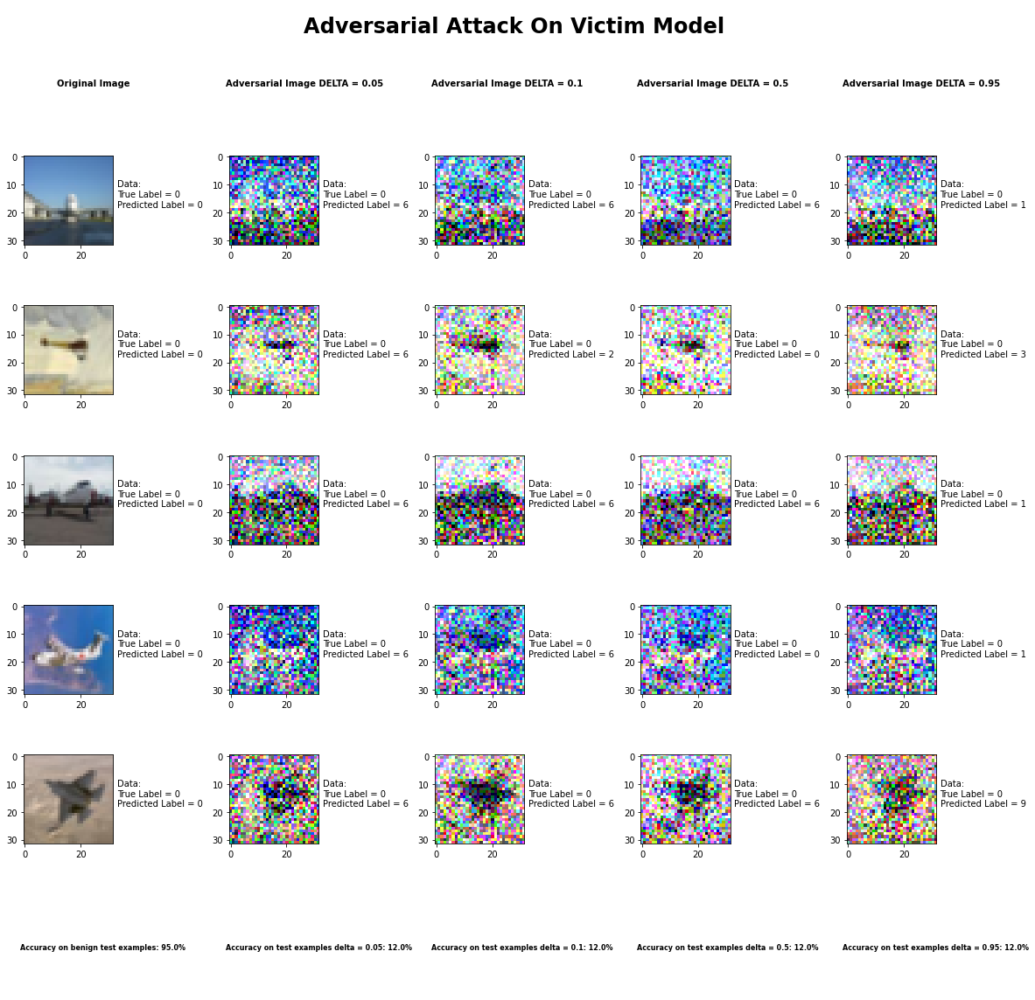

**Sample Output of the Universal Perturbation Attack**

For this attack, the transferability accuracy was relatively the same though we were expecting the accuracy of the transferability to be higher than the regular attack because of how poorly the substitute model copied the victim model. However, due to whatever reason that is not the case. The accuracy of both the transfer attack as well as the regular attack are around 10%.

## DeepFool Method

## 

## Virtual Adversarial Method

This attack was not done for the transferability concept for the same reason that this attack was not implemented for the attack section. This was due to the fact that even though everything was set up properly for the attack the attack never converged. Therefore, we never got a result when running the attack on the victim model let alone doing it as a transfer attack through a substitute model.

## Fast Gradient Sign Method

|  |  |
| --- | --- |
| Average Accuracy Over 10 Runs | |
| Benign Samples | 94.52% |
| Epsilon = 0.05 Samples | 60.8% |
| Epsilon = 0.10 Samples | 17.4% |
| Epsilon = 0.5 Samples | 11.3% |
| Epsilon = 0.95 Samples | 10.0% |

|  |  |  |  |  |  |  |  |  |  |  |
| --- | --- | --- | --- | --- | --- | --- | --- | --- | --- | --- |
| Average Accuracy per Class Over 10 Runs | | | | | | | | | | |
|  | Airplane | Car | Bird | Cat | Deer | Dog | Frog | Horse | Ship | Truck |
| Benign Samples | 100% | 100% | 100% | 100% | 100% | 100% | 100% | 100% | 100% | 100% |
| Epsilon = 0.05 Samples | 38% | 73% | 73% | 24% | 70% | 33% | 93% | 58% | 69% | 77% |
| Epsilon = 0.10 Samples | 6% | 5% | 31% | 2% | 13% | 1% | 93% | 0% | 8% | 15% |
| Epsilon = 0.5 Samples | 14% | 18% | 0% | 32% | 0% | 0% | 10% | 0% | 0% | 39% |
| Epsilon = 0.95 Samples | 4% | 26% | 0% | 5% | 0% | 0% | 0% | 0% | 0% | 65% |

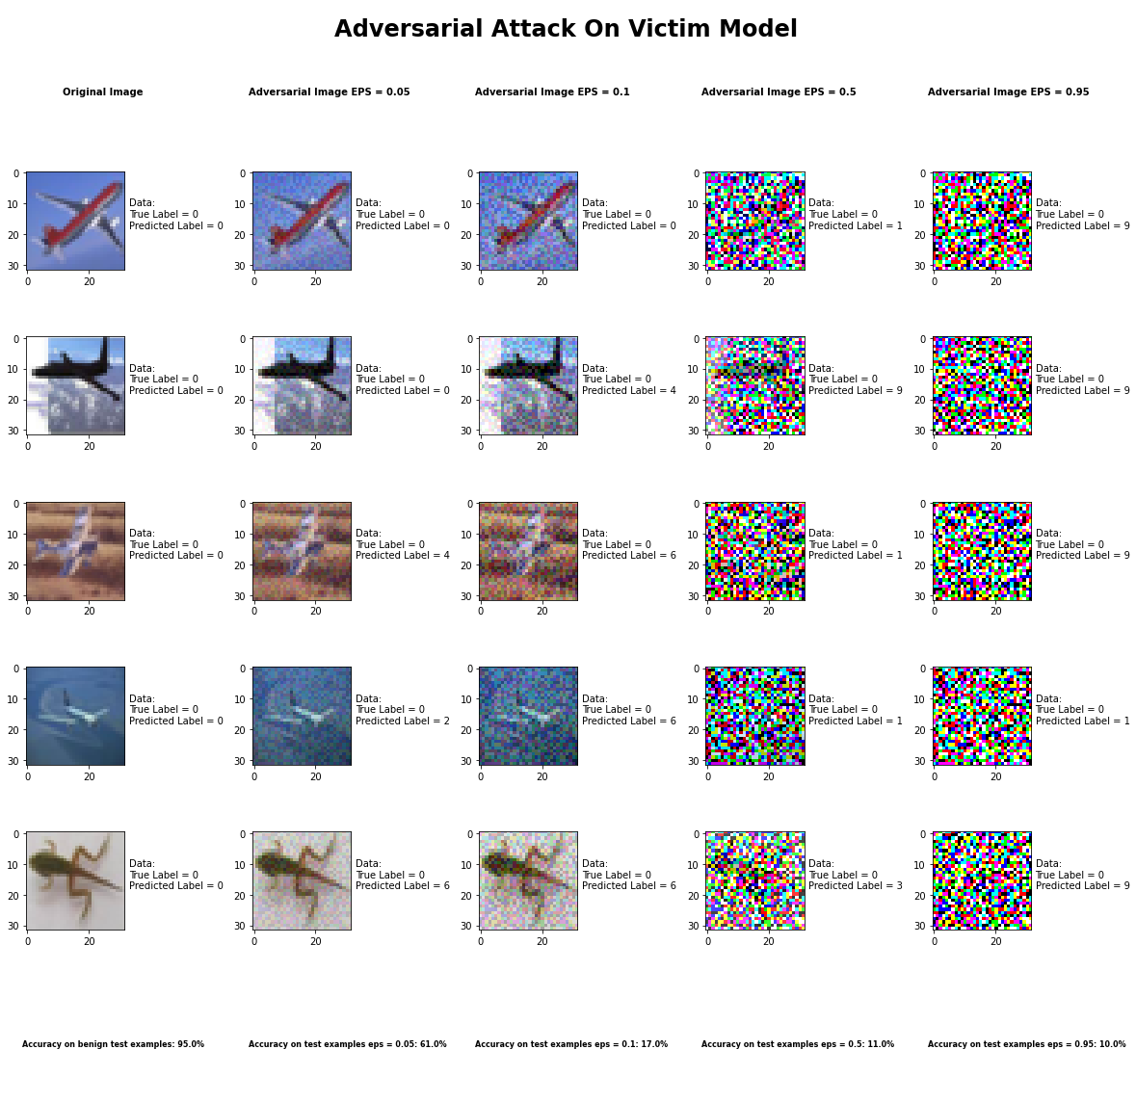

**Sample Output of the Fast Gradient Sign Method Attack**

For this attack, the transferability accuracy was lower than when the adversarial examples were crafted from the victim model. Though this is the case, when you realize that the substitute models accuracy was much lower than the victim models accuracy then that doesn't really make sense. For the most part the accuracy of the transfer attack was below 20% whereas for the regular attack it was above 30%.

## Zoo Attack Method Method: **Doesn’t Work**

## Output: Empty

## Running Time: 10 hr+

# Extraction Attack

## Functionally Equivalent Extraction

The basic idea of this extraction attack is to copy the Neural Network of a black box Neural Network, by querying the Neural Network API and learning the feature space of the target Neural Network. In addition, the uniqueness of this attack is to also accurately represent the fidelity in addition to the accuracy of the target model. Accuracy measures the correctness of predictions made by the extracted model on the test distribution. Fidelity, in contrast, measures the general agreement between the extracted and victim models on any input. Both of these objectives are desirable, but they are in conflict for imperfect victim models: a high-fidelity extraction should replicate the errors of the victim, whereas a high-accuracy model should instead try to make an accurate prediction. At the high-fidelity limit is functionally-equivalent model extraction: the two models agree on all inputs, both on and off the underlying data distribution. The way this is achieved is by extracting not only the predicted label of an input by a target model but also the one of the following: score, top-k scores, and possible the logits. The way the algorithm works is as follows: First the critical point search identifies inputs {xi} n i=1 to the neural network so that exactly one of the ReLU units is at a critical point (i.e., has input identically 0). Then weight recovery takes an input x which causes the ith neuron to be at a critical point. We use this point x to compute the difference between the two adjacent linear regions induced by the critical point, and thus the weight vector row A (0) i . By repeating this process for each ReLU we obtain the complete matrix A (0) . Then the sign recovery determines the sign of each row-vector A (0) j for all j using global information about A (0) . Then the final layer extraction uses algebraic techniques (least squares) to solve for the second layer of the network.

This attack was not implemented because our victim model was not of the type that is suitable for this attack. This attack requires a Neural Network with 2 dense layers where the first one has a ReLU activation function and the second one has a SoftMax activation function. As the authors explain, “The attack is specific to two layer neural networks; deeper networks pose multiple difficulties. In deep networks, the critical point search step of Section 6.3 will result in critical points from many different layers, and determining which layer a critical point is on is nontrivial. Without knowing which layer a critical point is on, we cannot control inputs to the neuron, which we need to do to recover the weights in Section 6.4. Even given knowledge of what layer a critical point is on, the inputs of any neuron past layer 1 are the outputs of other neurons, so we only have indirect control over their inputs. Finally, even with the ability to recover these weights, small numerical errors occur in the first layer extraction. These cause errors in every finite differences computation in further layers, causing the second layer to have even larger numerical errors than the first (and so on). Therefore, extending the attack to deeper networks will require at least solving each of the following: producing critical points belonging to a specific layer, recovering weights for those neurons without direct control of their inputs, and significantly reducing numerical errors in these algorithms.” Our victim model on the other hand has 11 convolutional layers followed by an average pooling layer on which a linear layer is applied. With all these factors considered as well as the parameter specifications outlined in the ART toolbox for this extraction attack, it is not possible for us to implement this attack on the victim model described in the project.

## Copycat CNN

The basic idea of this extraction attack is to copy the Neural Network of a black box Neural Network, by querying the Neural Network API and learning the feature space of the target Neural Network and then training a copycat model on that data. There are 3 ways to go about extracting the target Network, all of which, however, require a fake dataset to be generated. 1) network trained with the fake dataset created with random natural images not related to the problem domain, i.e., non-problem domain with stolen labels. Stolen labels means labels given to inputs by the targeted network rather than what the actual label of the input is defined by the actual dataset. 2) network trained with the fake dataset created with images from the same problem domain as the target network, i.e., network trained with problem domain and stolen labels. 3) network trained with the fake dataset (created with images from the first) and fine-tuned with images from the second. So, in a nutshell, you create a fake dataset, create a model, which doesn’t necessarily has to have the same architecture as the targeted network, and train the model on the fake dataset. And just to reiterate, the fake dataset has labels assigned to inputs by the target network and the inputs are usually non-domain problem inputs but can have inputs that are part of the problem domain. However, when the copied model is evaluated, it is evaluated on a separate dataset. This dataset comprises images from the same problem domain as the target network, but with no overlap. For best results the copycat model should be a pretrained model.

For this attack we added a SoftMax layer to the victim model because the thieved model is always trained on one-hot encoded labels as per the implementation in the ART toolbox. The copycat model/ thieved model had the following setup:

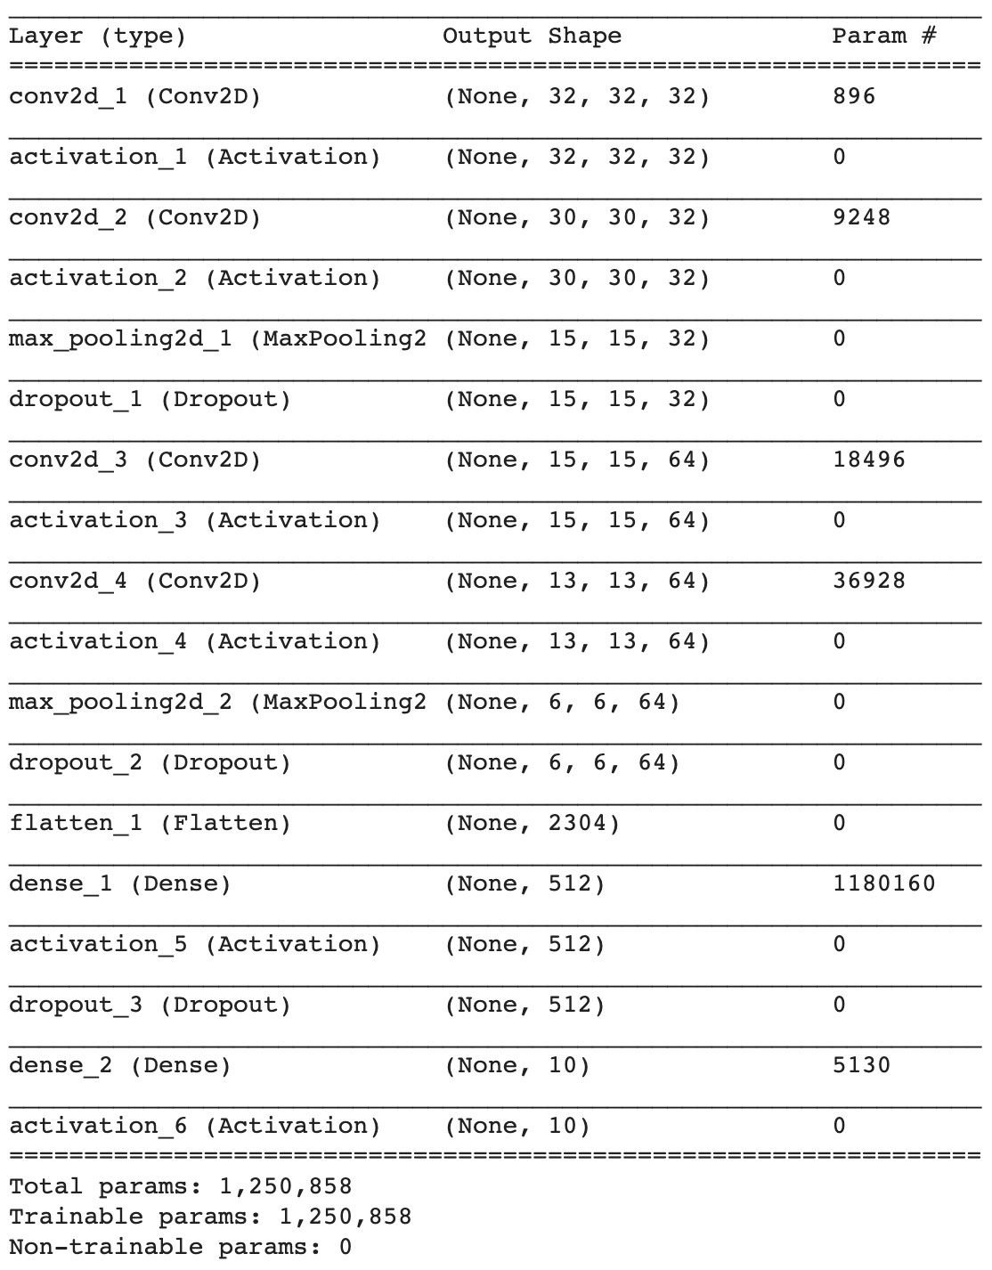

The copycat was not trained at this point because the extract function is used to do as it is responsible for querying the victim model. We ran three instances of the attack, one with 5% of victim model’s data, 10%, and 30%. We then evaluated the stolen models on the original test data of the victim mode, i.e. the test set from the CIFAR-10 dataset. Our results are summarized in the following table:

|  |  |  |  |
| --- | --- | --- | --- |
| **% of Victim Model’s Data** | **Epochs** | **Queries Made to Victim Model** | **Accuracy** |
| 5% | 10 | 2,500 | 57.99% |
| 10% | 10 | 5,000 | 60.11% |
| 30% | 10 | 15,000 | 60.19% |

Just as an experiment we also did a test where we increased the number of queries to the victim model to a constant 1,000,000 queries and we got the following results:

|  |  |  |  |
| --- | --- | --- | --- |
| **% of Victim Model’s Data** | **Epochs** | **Queries Made to Victim Model** | **Accuracy** |
| 5% | 10 | 1,000,000 | 46.95% |
| 10% | 10 | 1,000,000 | 56.60% |
| 30% | 10 | 1,000,000 | 59.14% |

We did get a warning saying that the number of queries was way past the number of samples which was understood but it was worth nothing that there is a greater accuracy difference between the runs.

## Knockoff Nets

The basic idea of this extraction attack is to copy the Neural Network of a black box Neural Network, by creating a dataset which consists of pairs of inputs with the label given by the target network. Basically, create a transfer set and train an adversarial network on that data so that it can mimic the same feature space as the target network. It is best to use a pretrained model and tune it to approximate the target network. This extraction attack can be thought of as a student in the teacher student model situation. The idea can also be thought of a 2-player game where the adversary queries the victim to collect data and then uses that transfer set data to train itself to compete against the victim model. The way the adversary queries the victim is by choosing a sample set of images to query the victim with. There are two methods to sample images, one is random where any images can be feed to the victim including duplicates, and the other is adaptive strategy where there is a feedback signal whose goal is to improve sample efficiency of queries and aiding in interpretability of the Blackbox. To train the knockoff model, it is not necessary to have the exact architecture, the authors however did use VGG models and ResNet models. For training the knockoff model, there are two phases, one is the online training where the adversary collects transfer set/ query sets from the victim and simultaneously trains on it. The other phase, the offline phase, is where the model is retrained with the transfer set so far.

For this attack it is assumed that both the victim classifier and the thieved classifier produce logit outputs as per the implementation in the ART toolbox. The knockoff model/ thieved model had the following setup:

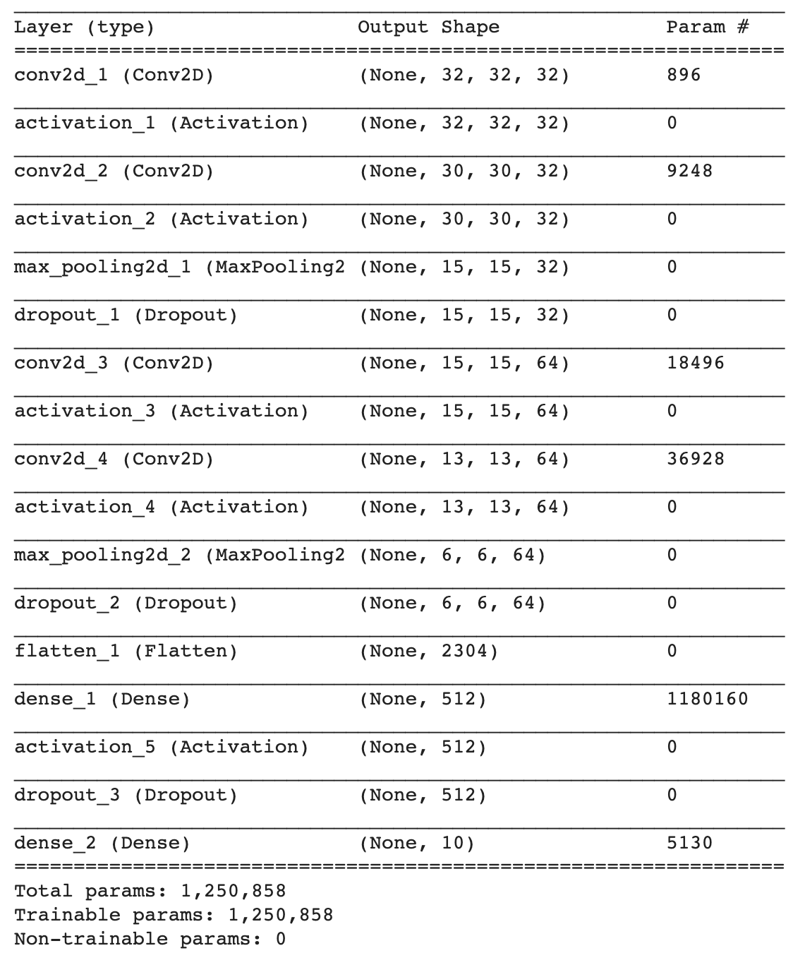

The knockoff was not trained at this point because the extract function is used to do as it is responsible for querying the victim model. We ran three instances of the attack, one with 5% of victim model’s data, 10%, and 30%. We then evaluated the stolen models on the original test data of the victim mode, i.e. the test set from the CIFAR-10 dataset. Our results are summarized in the following table:

|  |  |  |  |
| --- | --- | --- | --- |
| **% of Victim Model’s Data** | **Epochs** | **Queries Made to Victim Model** | **Accuracy** |
| 5% | 10 | 2,500 | 4.81% |
| 10% | 10 | 5,000 | 10.0% |
| 30% | 10 | 15,000 | 15.9% |

Just as an experiment we also did a test where we increased the number of queries to the victim model to a constant 1,000,000 queries and we got the following results:

|  |  |  |  |
| --- | --- | --- | --- |
| **% of Victim Model’s Data** | **Epochs** | **Queries Made to Victim Model** | **Accuracy** |
| 5% | 10 | 1,000,000 | 14.42% |
| 10% | 10 | 1,000,000 | 12.21% |
| 30% | 10 | 1,000,000 | 10.07% |

We did get a warning saying that the number of queries was way past the number of samples which was understood but it was worth nothing that as more data was queried the accuracy dropped.

# Attack Results Appendix

## Threshold Attack Method

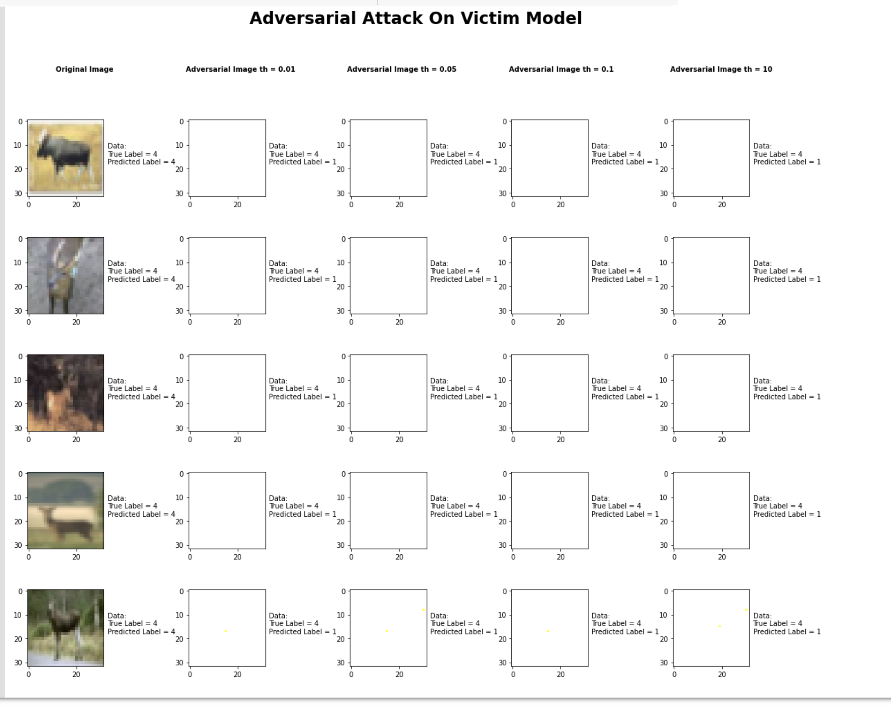

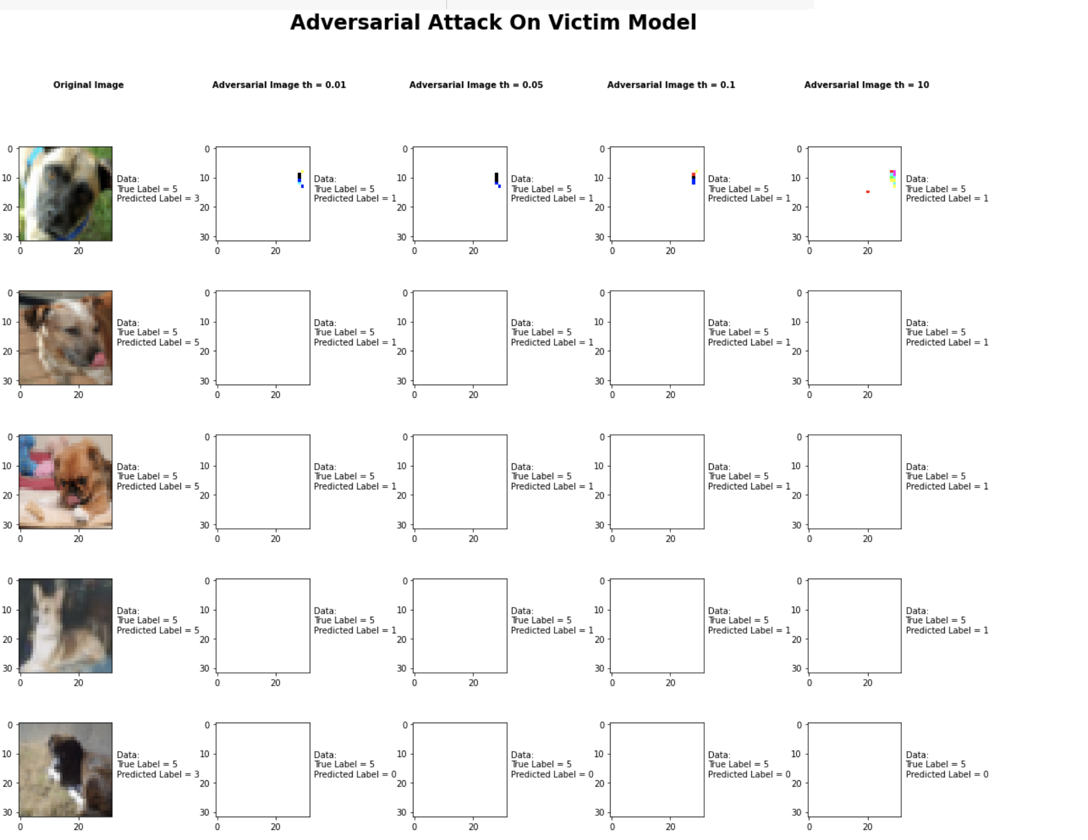

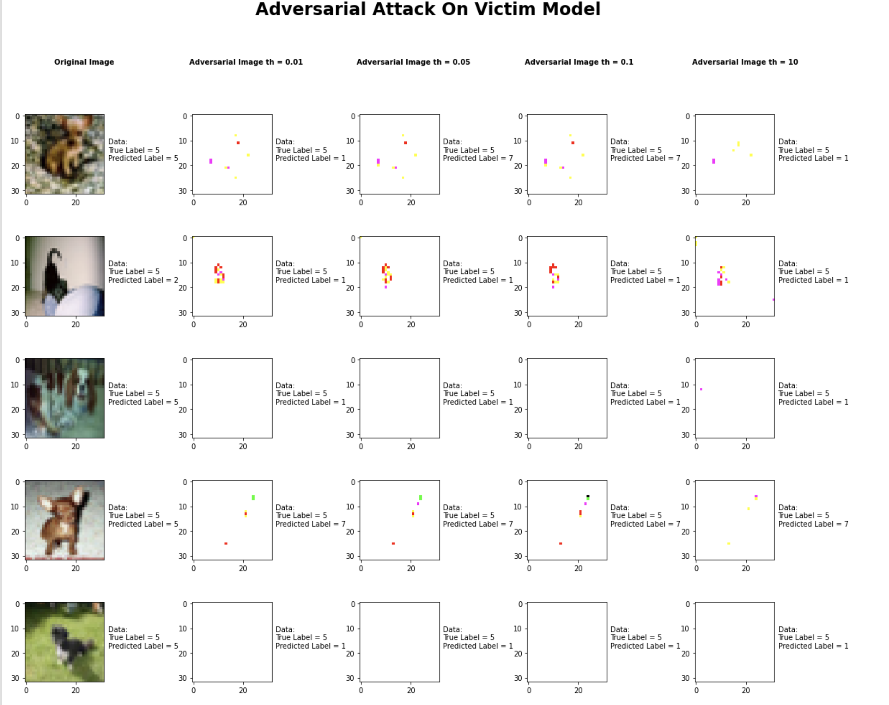

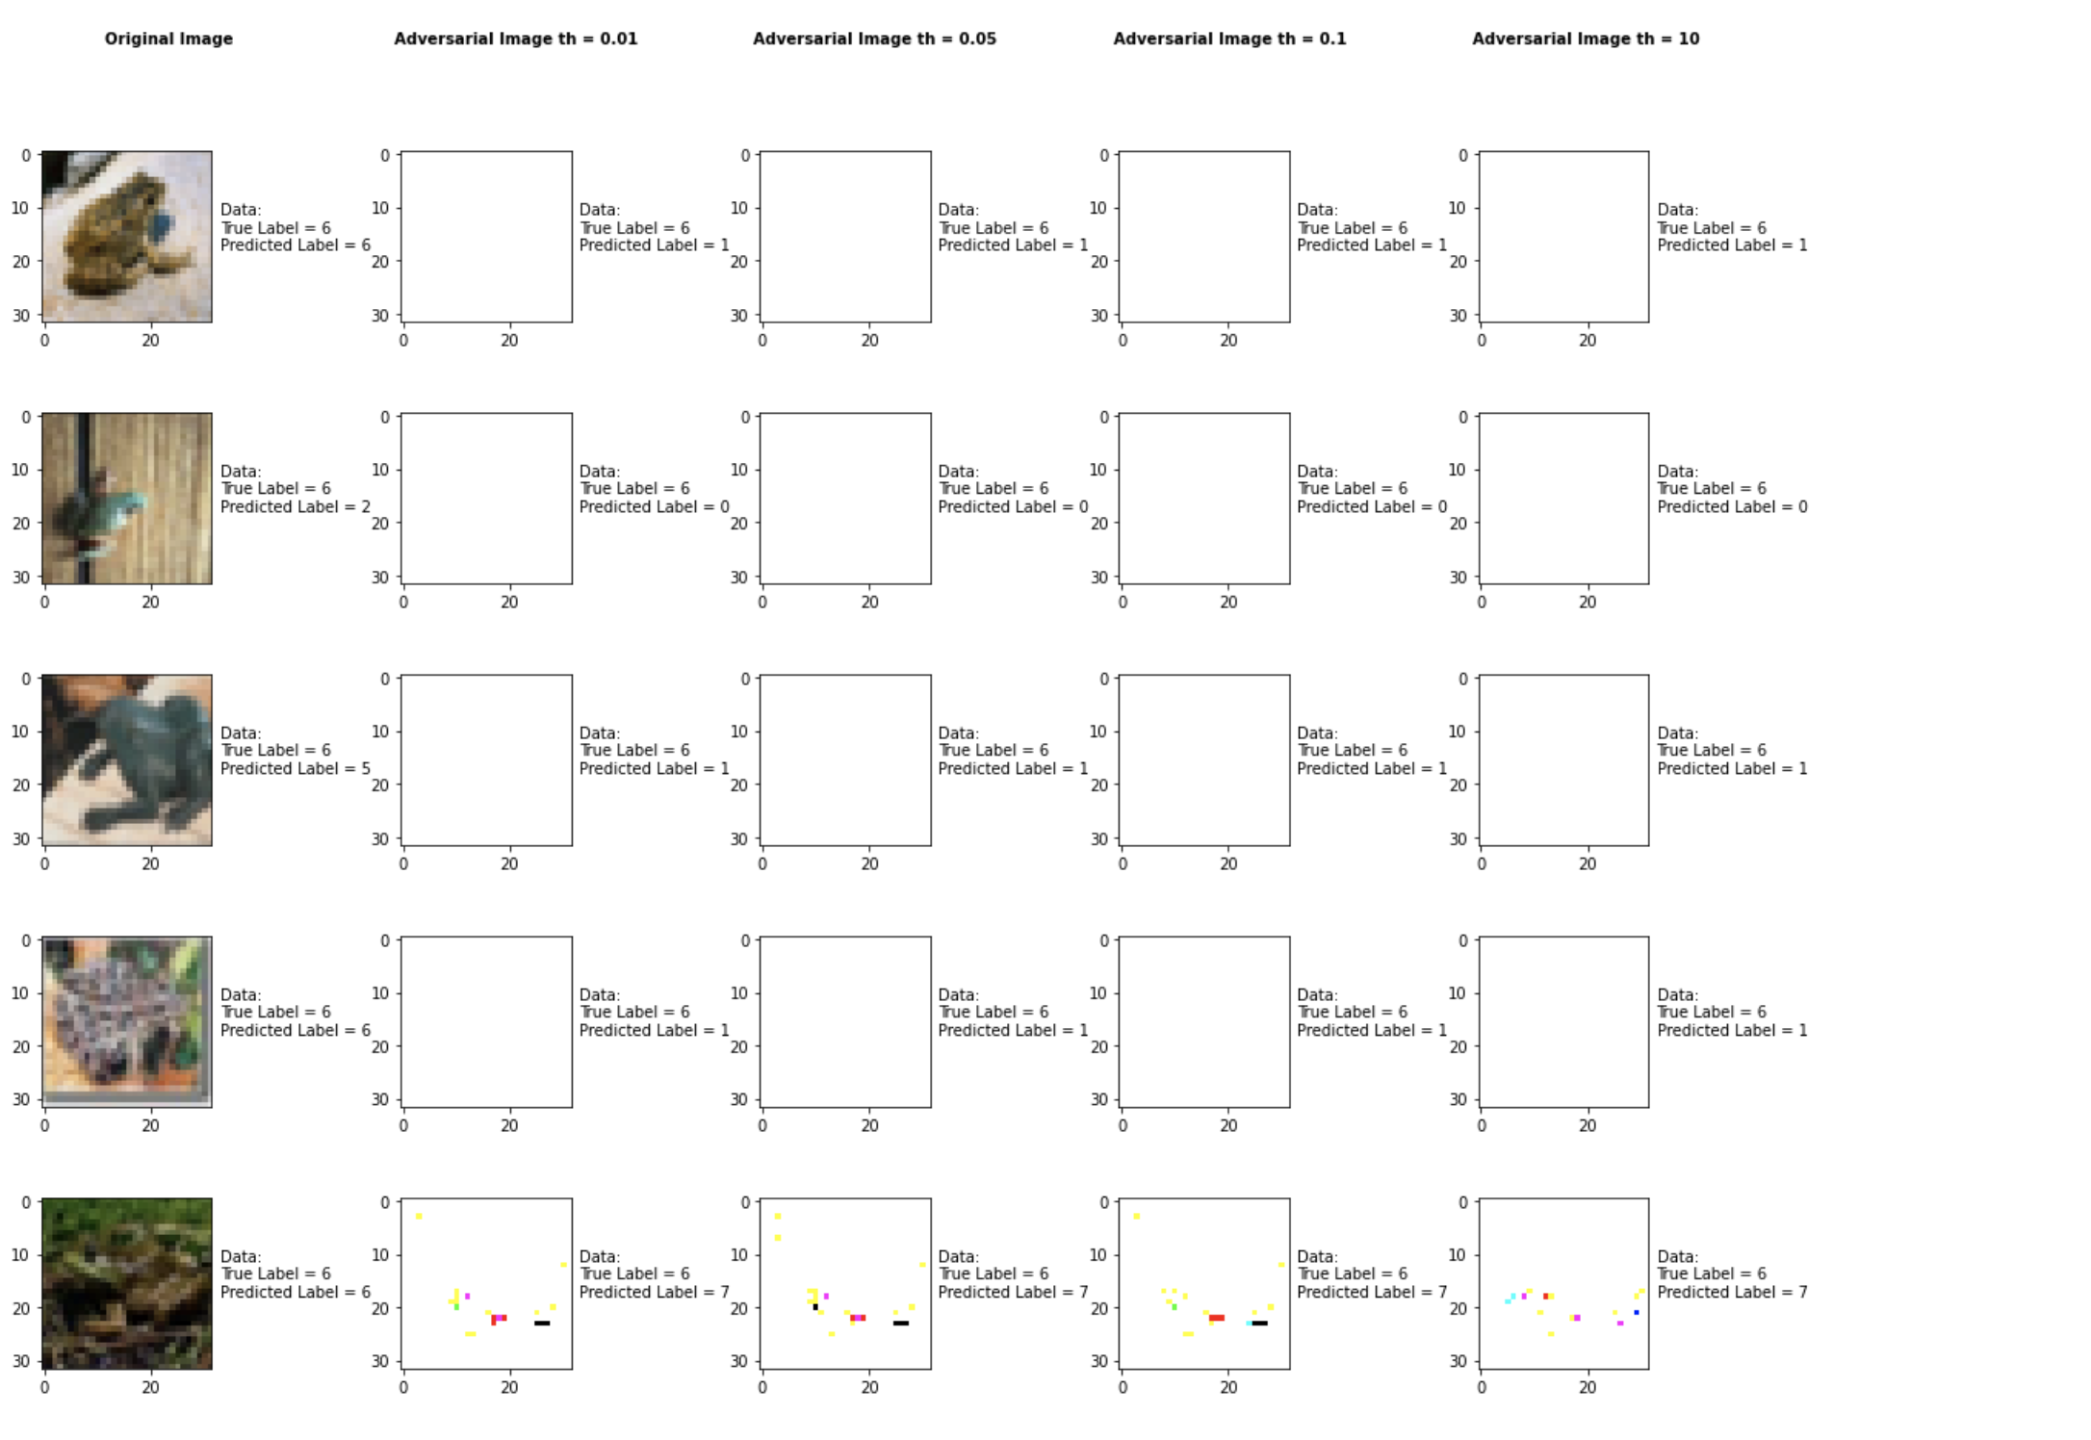

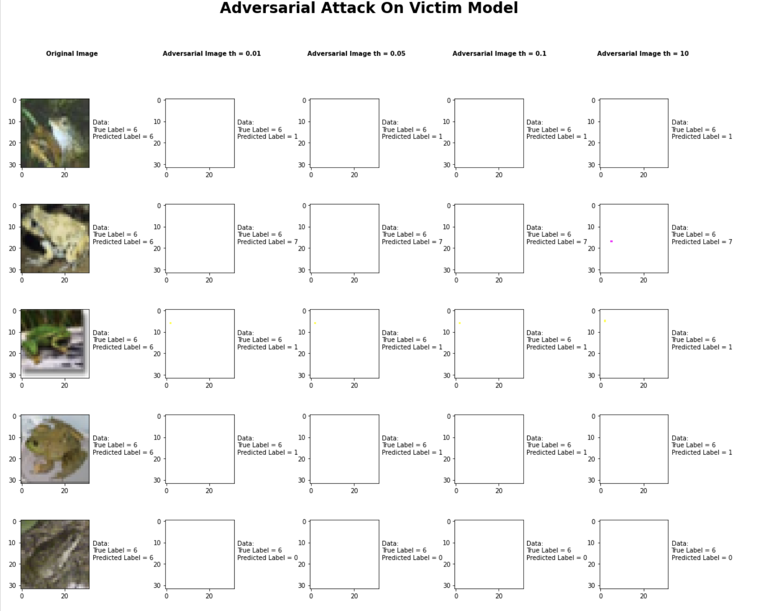

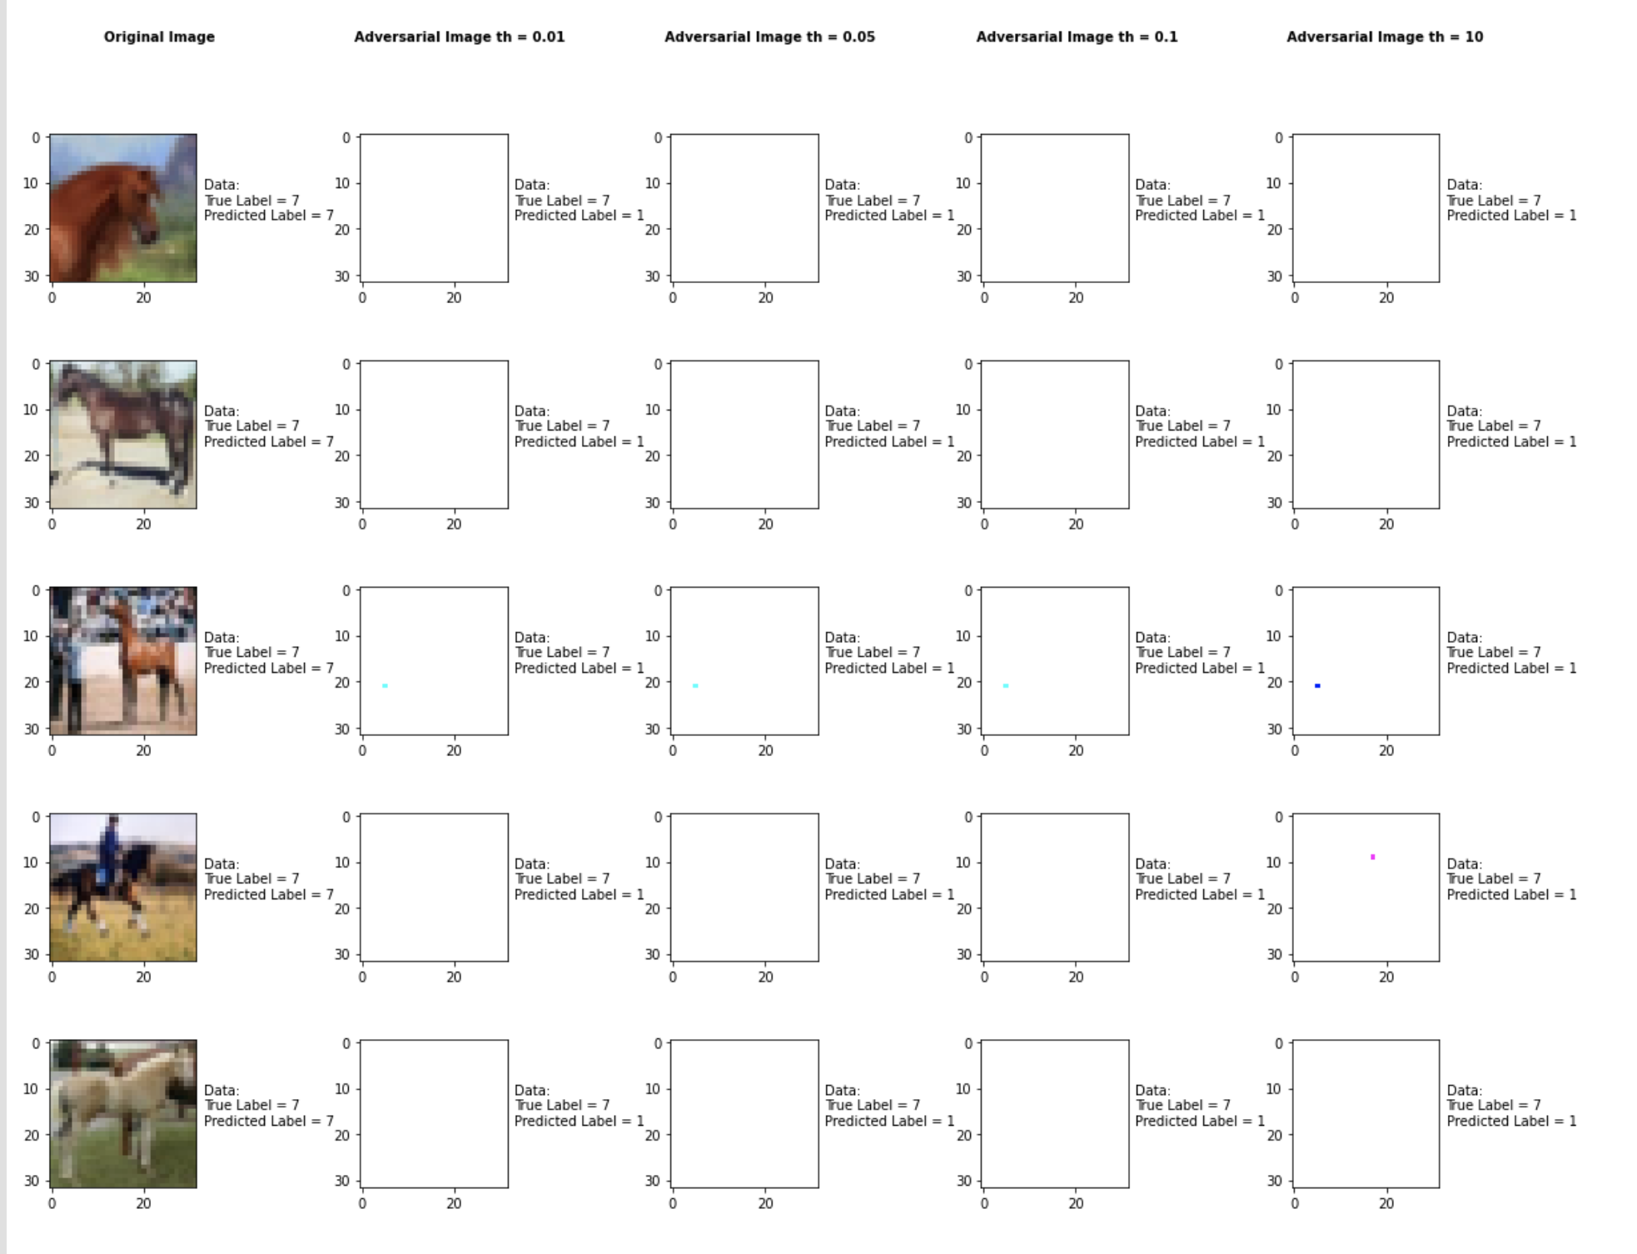

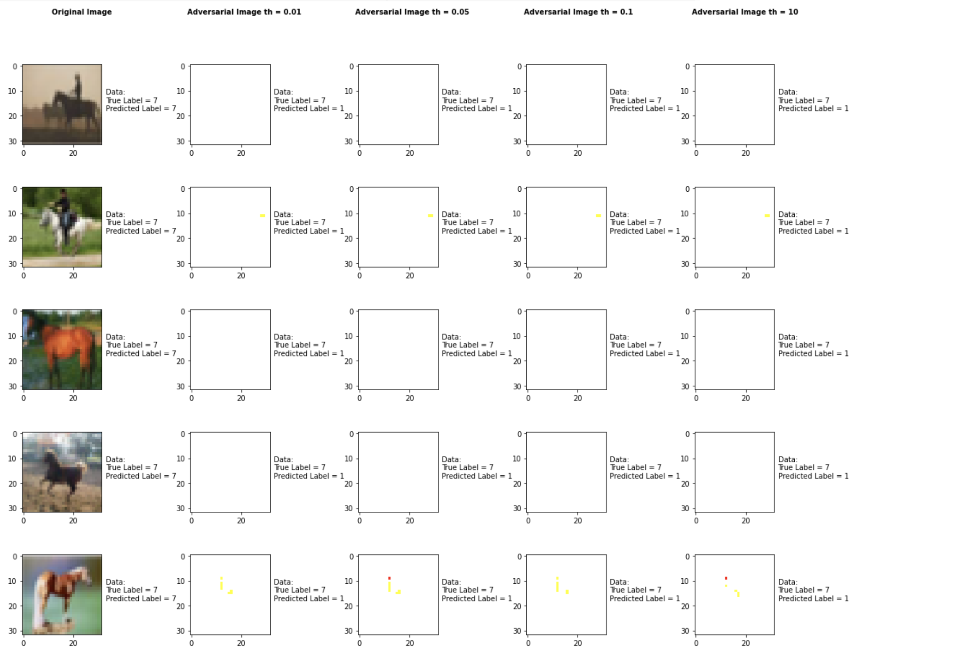

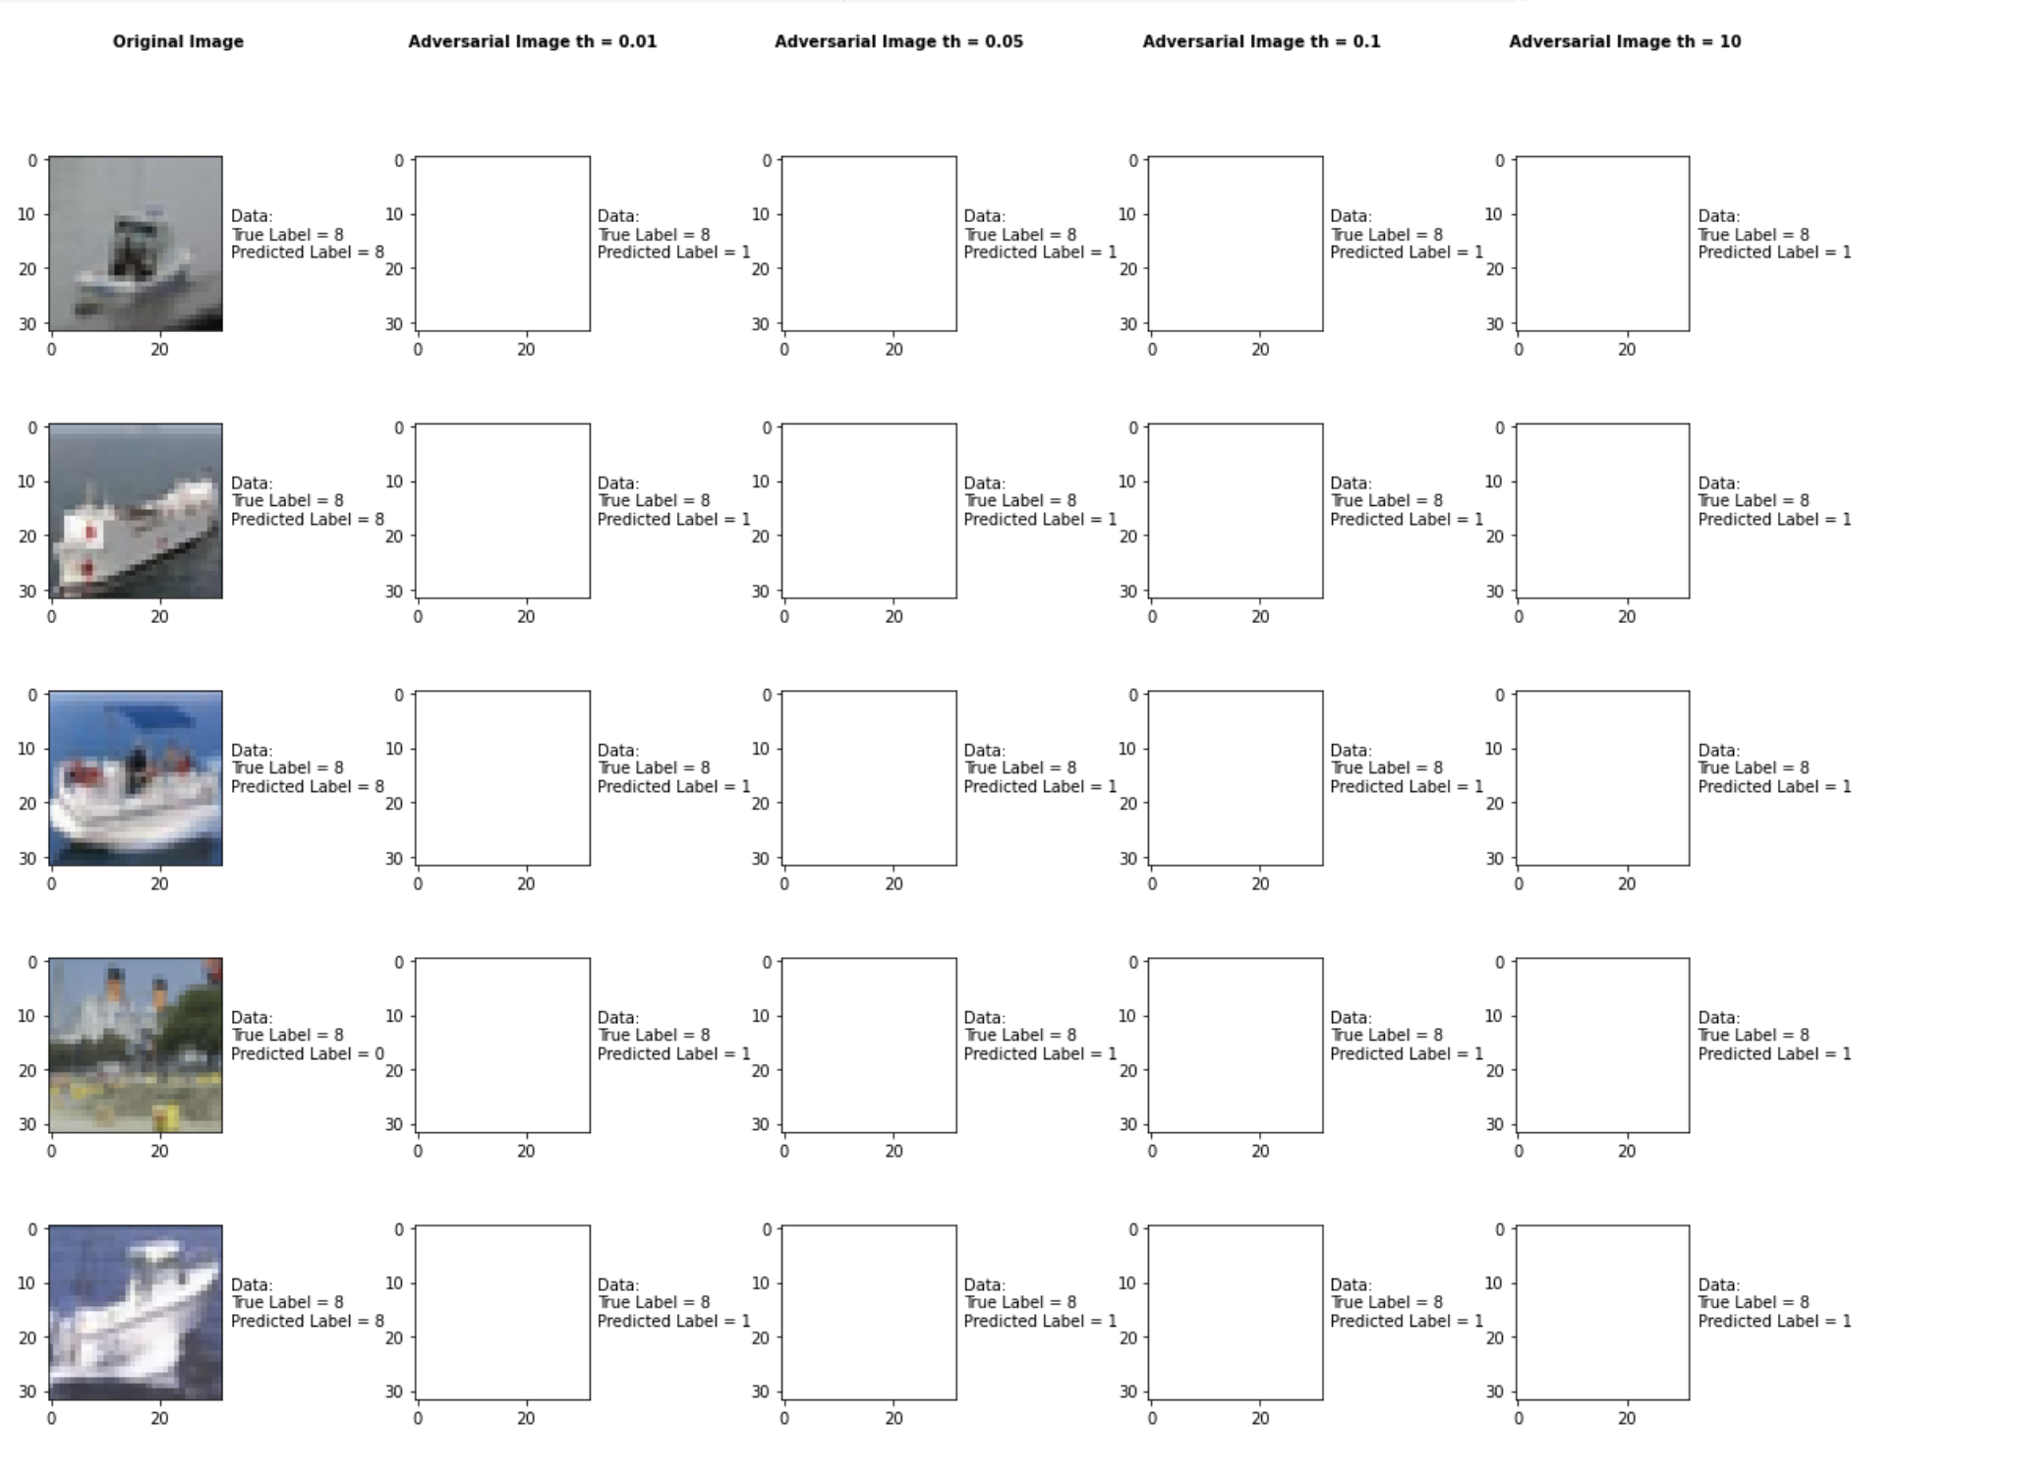

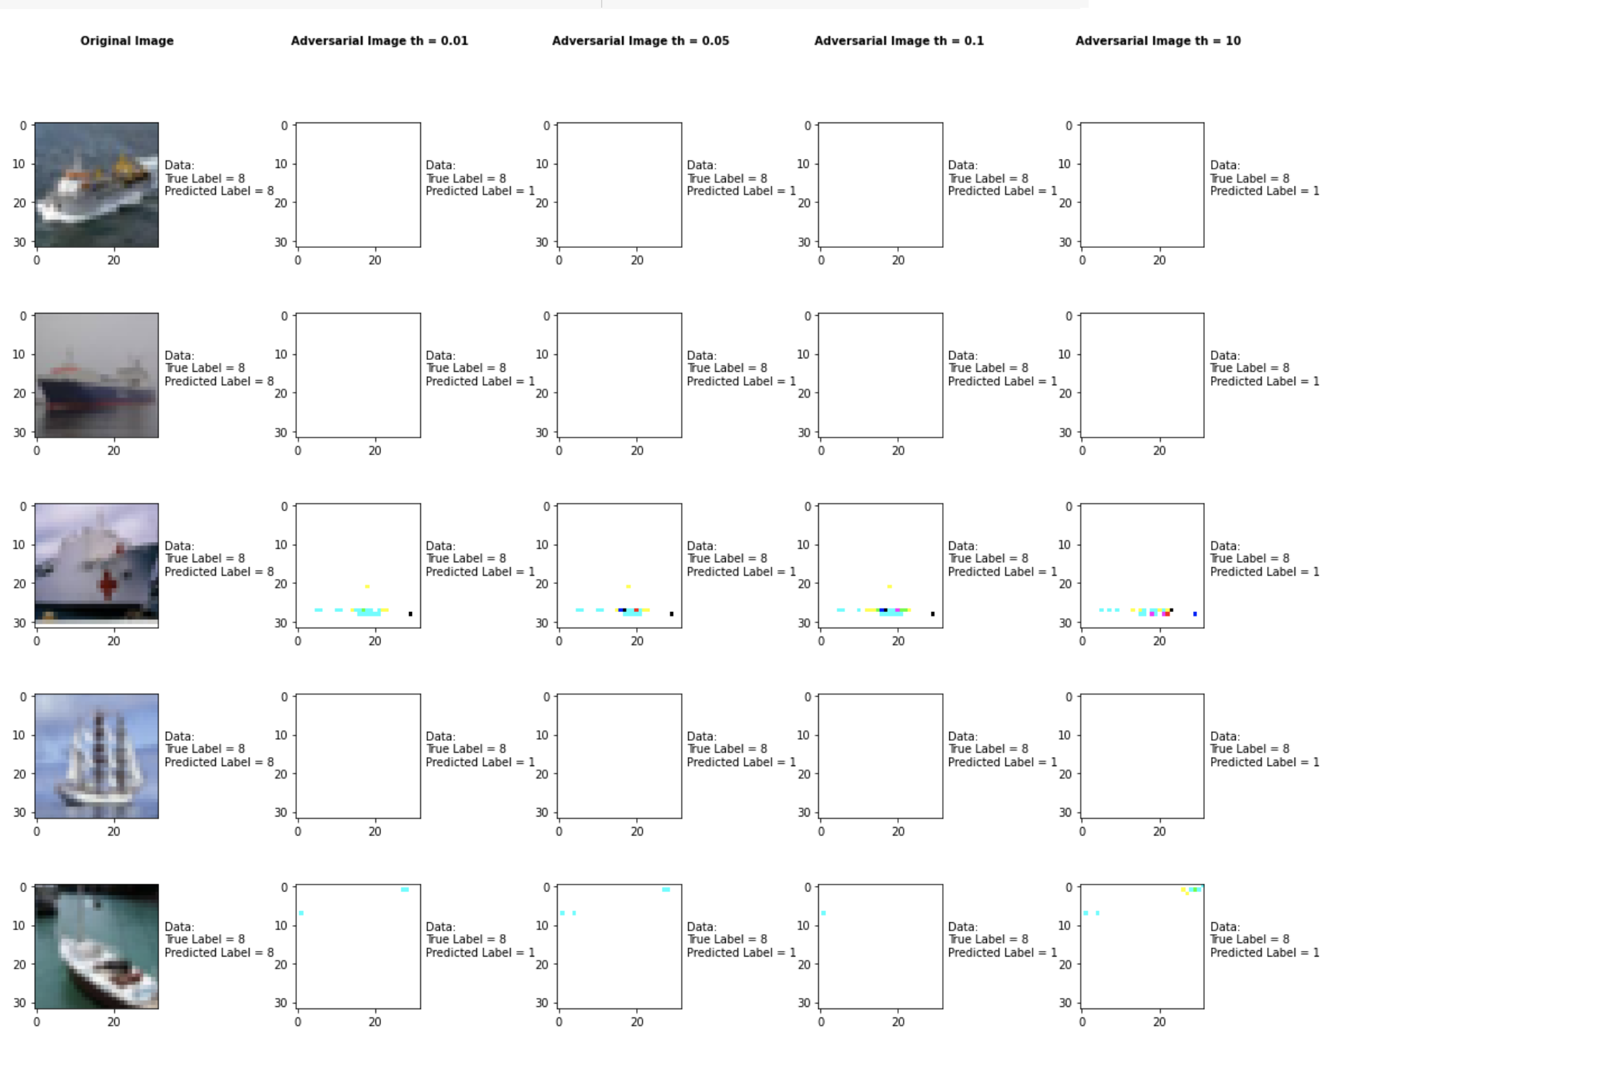

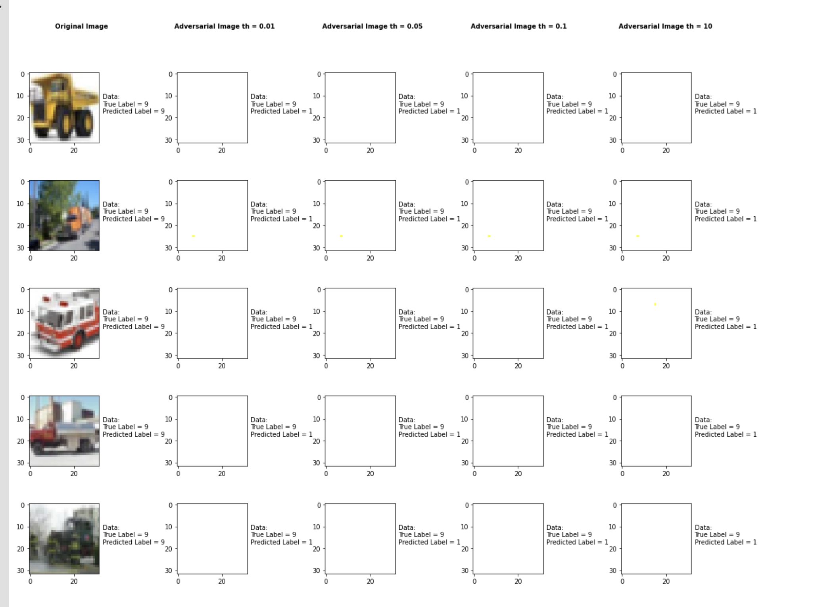

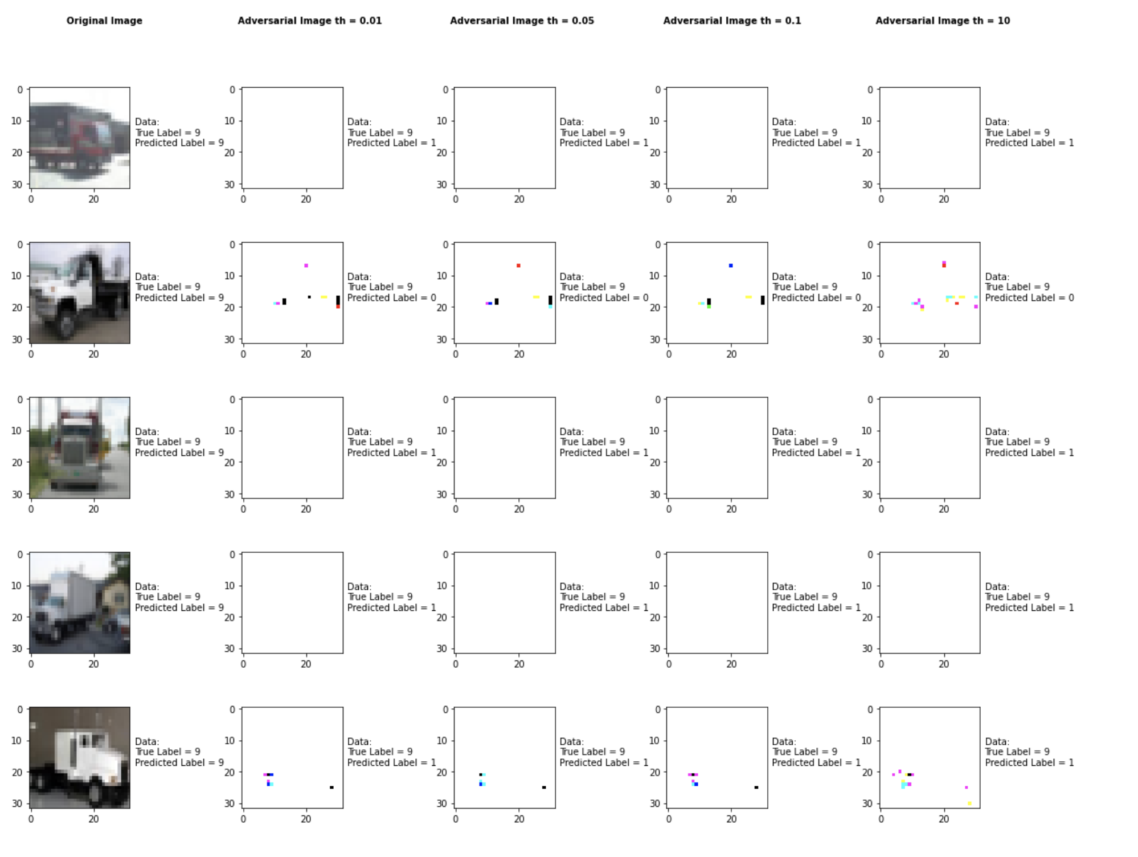

Accuracy on benign test examples: 94.52000000000001%

Accuracy on adversarial test examples with th=0.01: 10.0%

Accuracy on adversarial test examples with th=0.05: 10.0%

Accuracy on adversarial test examples with th=1: 10.0%

Accuracy on adversarial test examples with th=10: 10.0%

Classifier with benign example has Airplane recognition accuracy of = 90.0%

Fast Gradient Method with th=0.01 has Airplane recognition accuracy of = 0.0%

Fast Gradient Method with th=0.05 has Airplane recognition accuracy of = 0.0%

Fast Gradient Method with th=1 has Airplane recognition accuracy of = 0.0%

Fast Gradient Method with th=10 has Airplane recognition accuracy of = 0.0%

Classifier with benign example has Automobile recognition accuracy of = 100.0%

Fast Gradient Method with th=0.01 has Automobile recognition accuracy of = 100.0%

Fast Gradient Method with th=0.05 has Automobile recognition accuracy of = 100.0%

Fast Gradient Method with th=1 has Automobile recognition accuracy of = 100.0%

Fast Gradient Method with th=10 has Automobile recognition accuracy of = 100.0%

Classifier with benign example has Bird recognition accuracy of = 100.0%

Fast Gradient Method with th=0.01 has Bird recognition accuracy of = 0.0%

Fast Gradient Method with th=0.05 has Bird recognition accuracy of = 0.0%

Fast Gradient Method with th=1 has Bird recognition accuracy of = 0.0%

Fast Gradient Method with th=10 has Bird recognition accuracy of = 0.0%

Classifier with benign example has Cat recognition accuracy of = 80.0%

Fast Gradient Method with th=0.01 has Cat recognition accuracy of = 0.0%

Fast Gradient Method with th=0.05 has Cat recognition accuracy of = 0.0%

Fast Gradient Method with th=1 has Cat recognition accuracy of = 0.0%

Fast Gradient Method with th=10 has Cat recognition accuracy of = 0.0%

Classifier with benign example has Deer recognition accuracy of = 100.0%

Fast Gradient Method with th=0.01 has Deer recognition accuracy of = 0.0%

Fast Gradient Method with th=0.05 has Deer recognition accuracy of = 0.0%

Fast Gradient Method with th=1 has Deer recognition accuracy of = 0.0%

Fast Gradient Method with th=10 has Deer recognition accuracy of = 0.0%

Classifier with benign example has Dog recognition accuracy of = 70.0%

Fast Gradient Method with th=0.01 has Dog recognition accuracy of = 0.0%

Fast Gradient Method with th=0.05 has Dog recognition accuracy of = 0.0%

Fast Gradient Method with th=1 has Dog recognition accuracy of = 0.0%

Fast Gradient Method with th=10 has Dog recognition accuracy of = 0.0%

Classifier with benign example has Frog recognition accuracy of = 80.0%

Fast Gradient Method with th=0.01 has Frog recognition accuracy of = 0.0%

Fast Gradient Method with th=0.05 has Frog recognition accuracy of = 0.0%

Fast Gradient Method with th=1 has Frog recognition accuracy of = 0.0%

Fast Gradient Method with th=10 has Frog recognition accuracy of = 0.0%

Classifier with benign example has Horse recognition accuracy of = 100.0%

Fast Gradient Method with th=0.01 has Horse recognition accuracy of = 0.0%

Fast Gradient Method with th=0.05 has Horse recognition accuracy of = 0.0%

Fast Gradient Method with th=1 has Horse recognition accuracy of = 0.0%

Fast Gradient Method with th=10 has Horse recognition accuracy of = 0.0%

Classifier with benign example has Ship recognition accuracy of = 90.0%

Fast Gradient Method with th=0.01 has Ship recognition accuracy of = 0.0%

Fast Gradient Method with th=0.05 has Ship recognition accuracy of = 0.0%

Fast Gradient Method with th=1 has Ship recognition accuracy of = 0.0%

Fast Gradient Method with th=10 has Ship recognition accuracy of = 0.0%

Classifier with benign example has Truck recognition accuracy of = 100.0%

Fast Gradient Method with th=0.01 has Truck recognition accuracy of = 0.0%

Fast Gradient Method with th=0.05 has Truck recognition accuracy of = 0.0%

Fast Gradient Method with th=1 has Truck recognition accuracy of = 0.0%

Fast Gradient Method with th=10 has Truck recognition accuracy of = 0.0%

## Pixel Attack Method

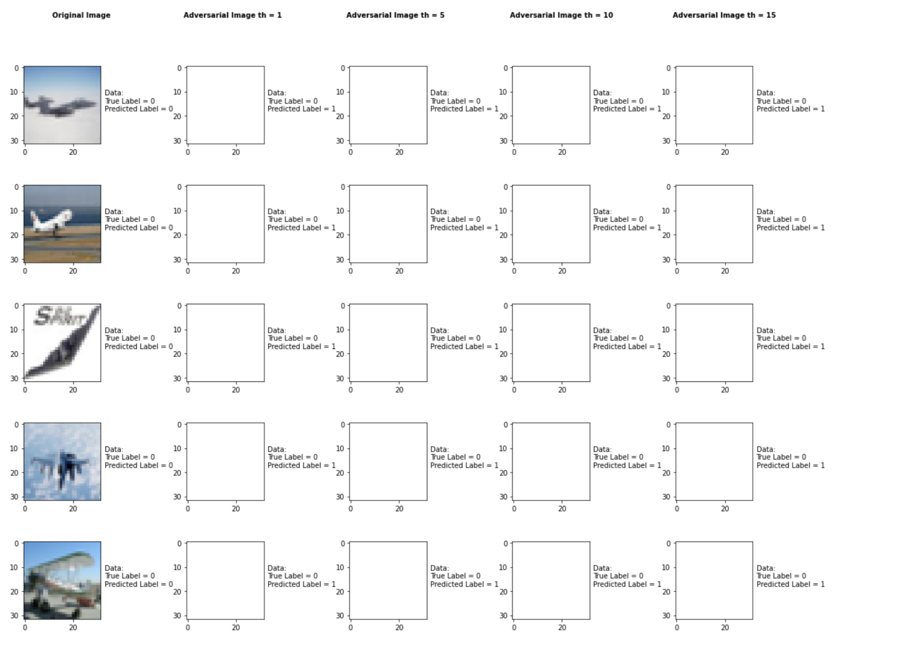

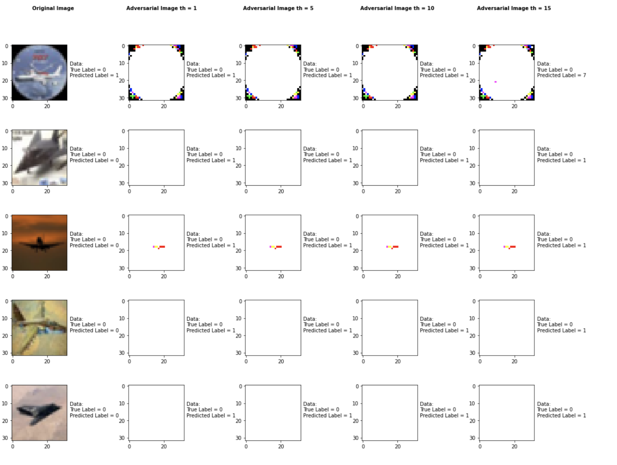

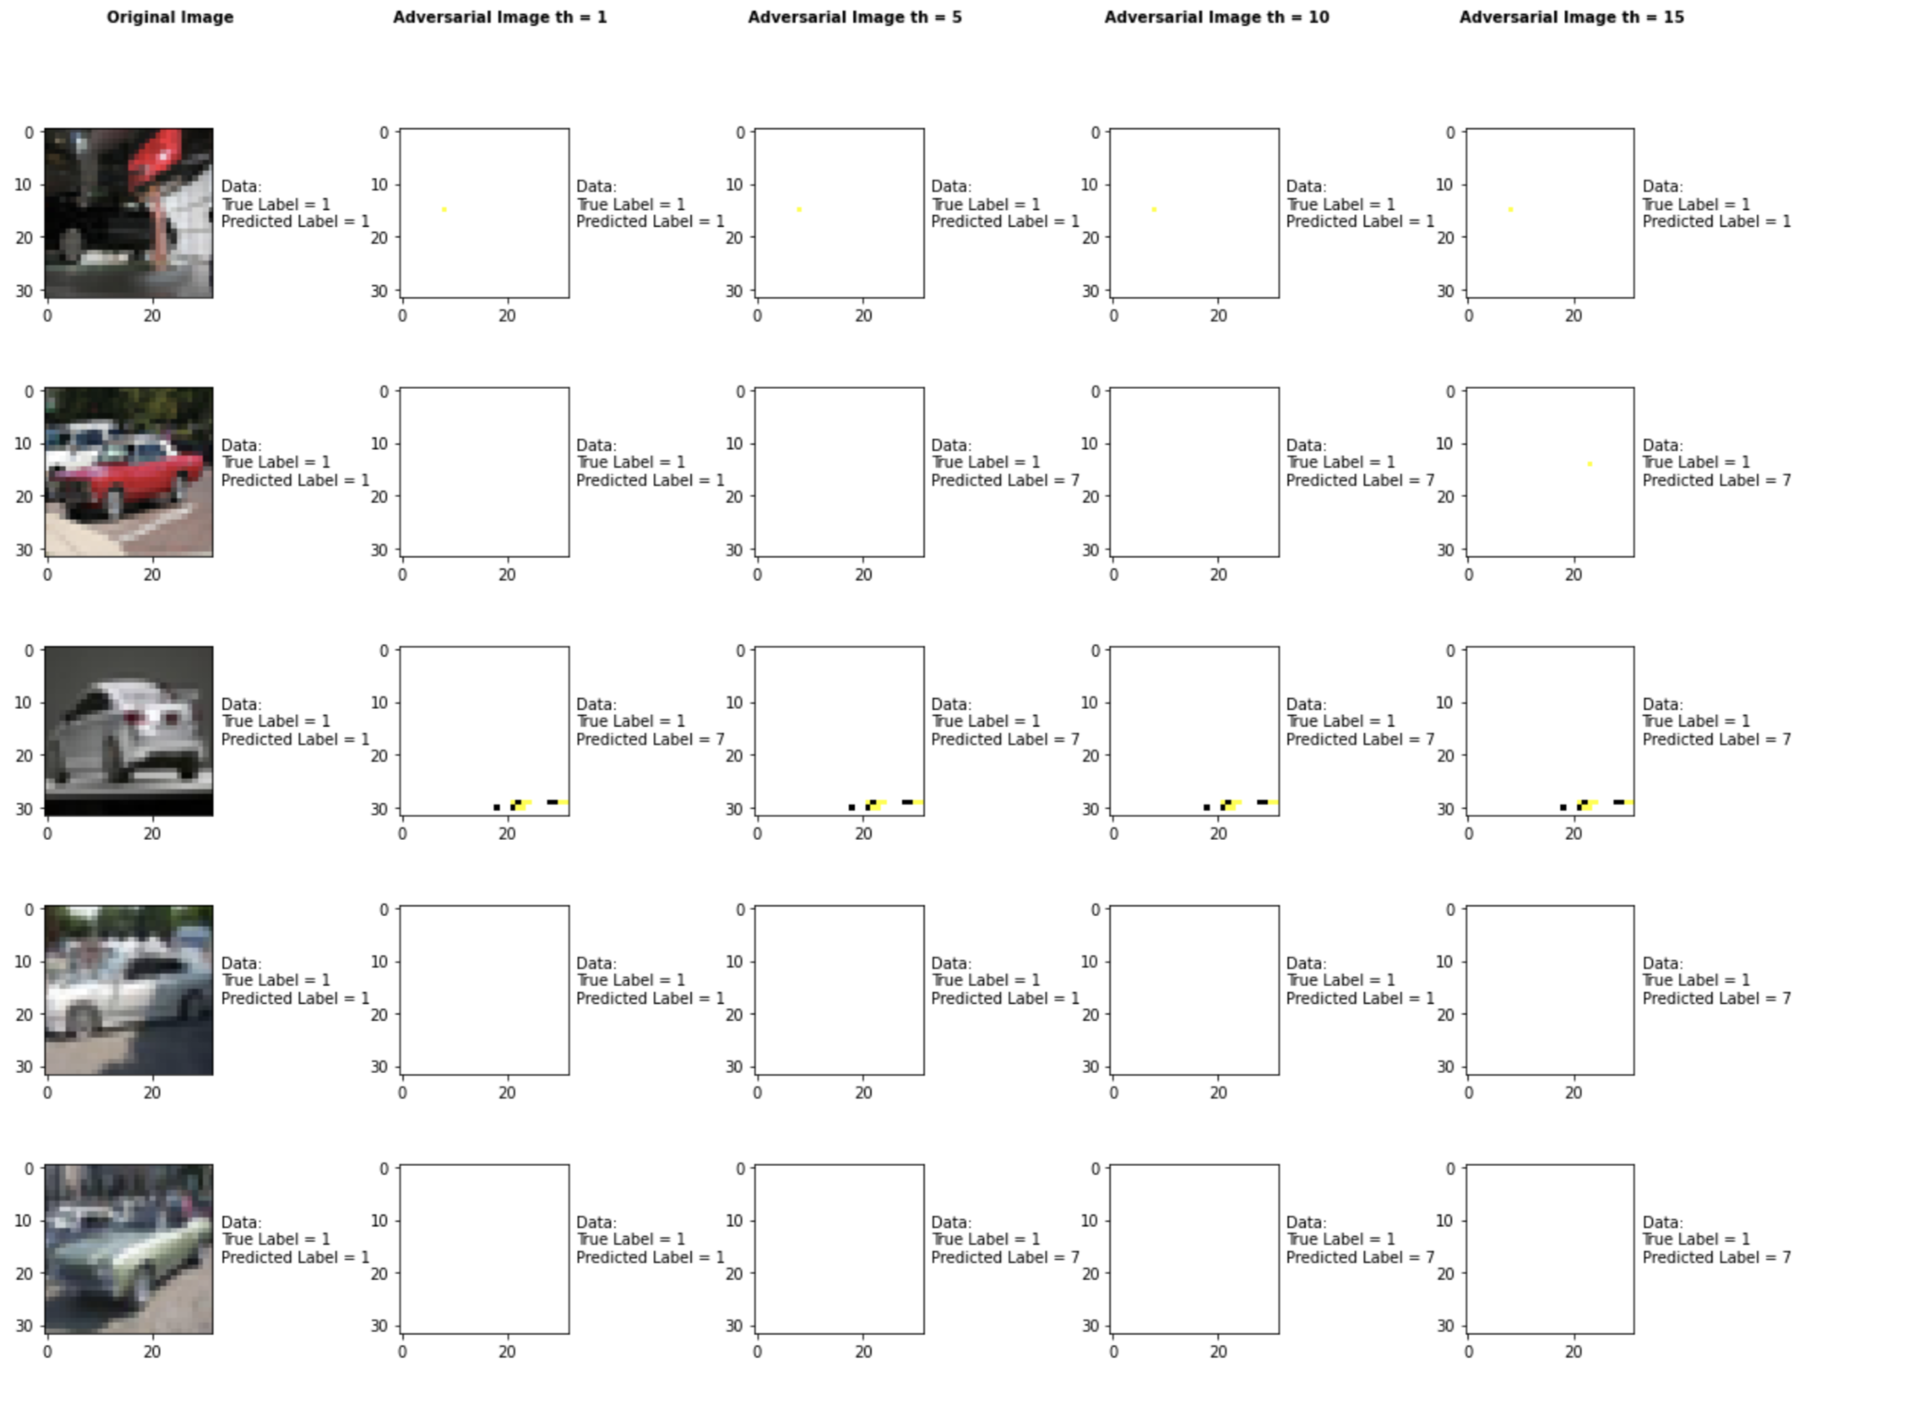

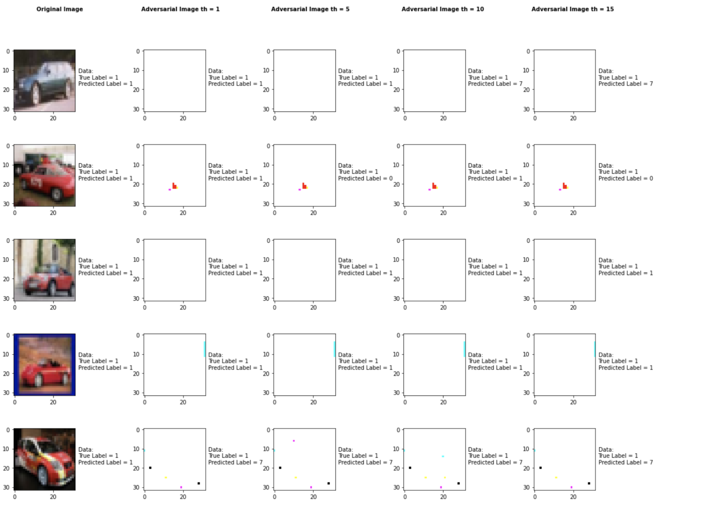

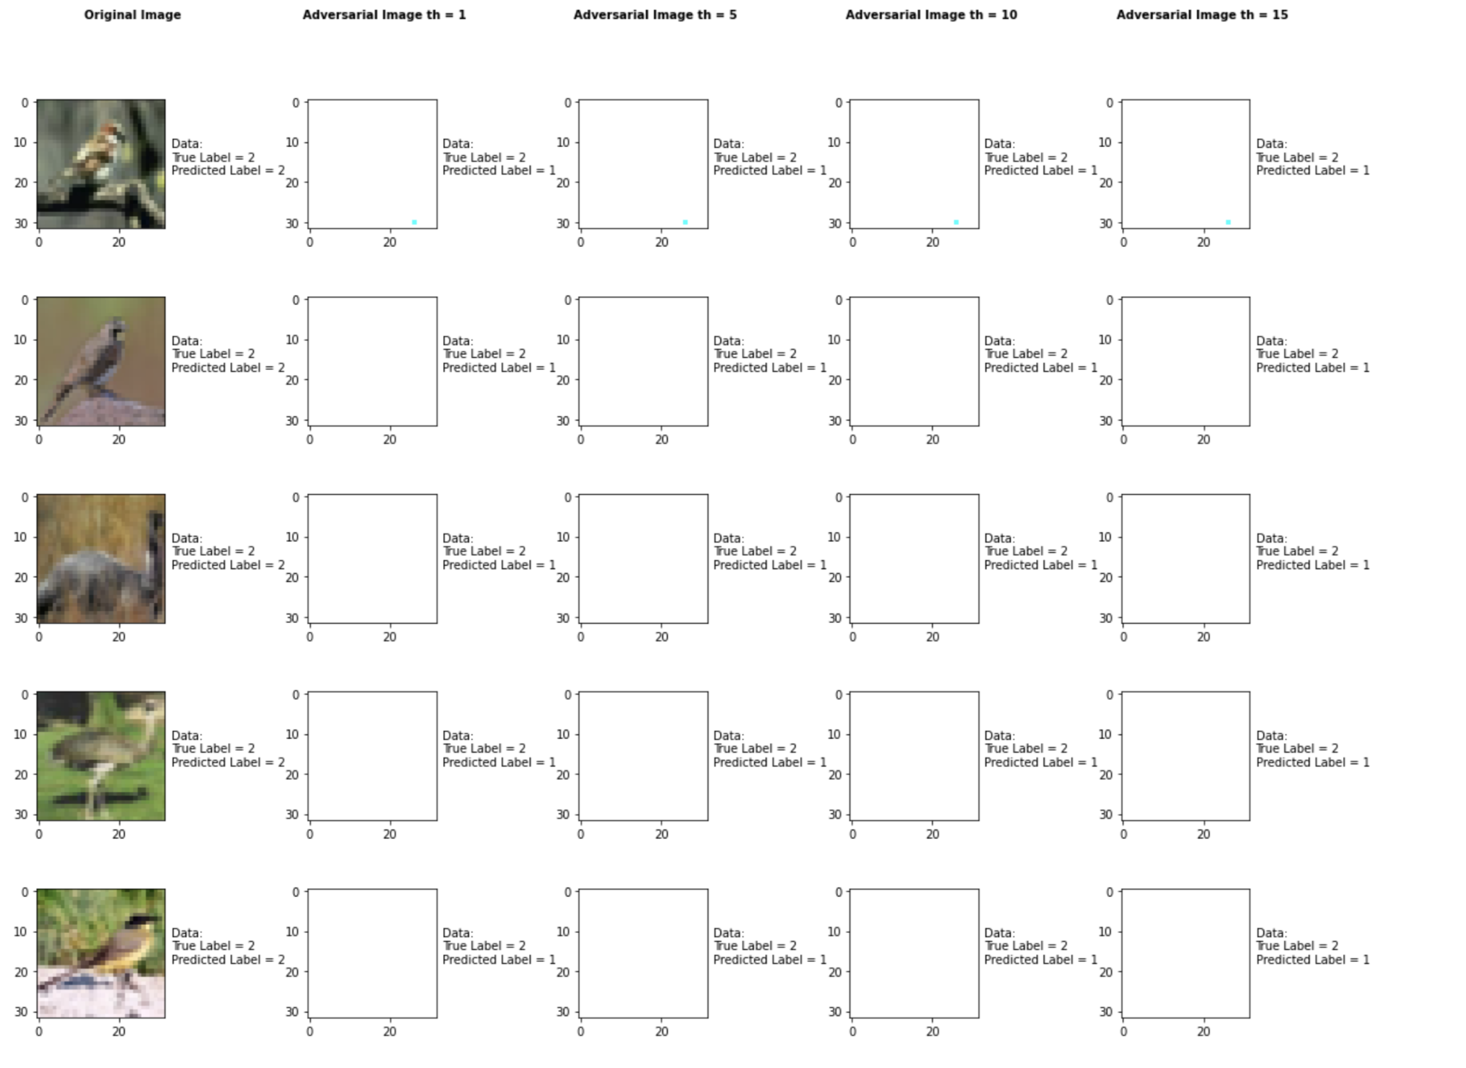

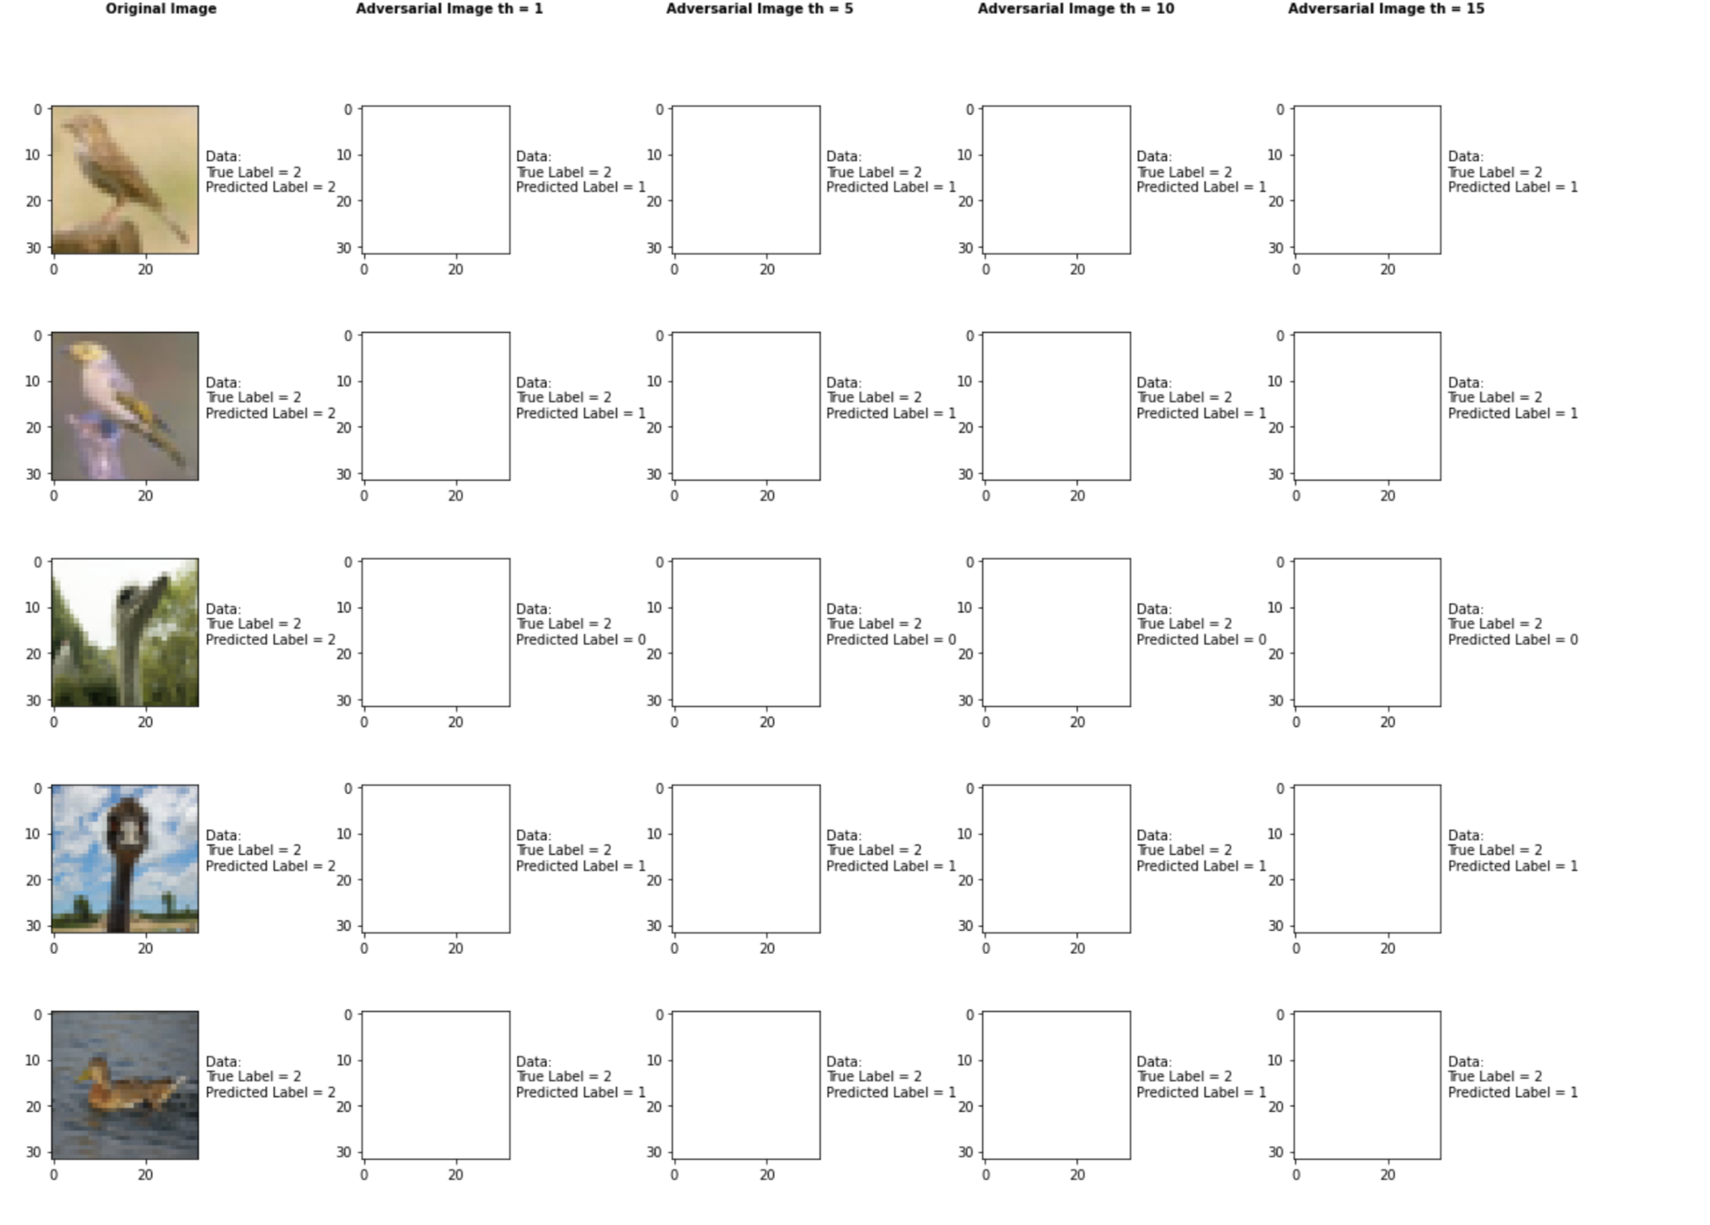

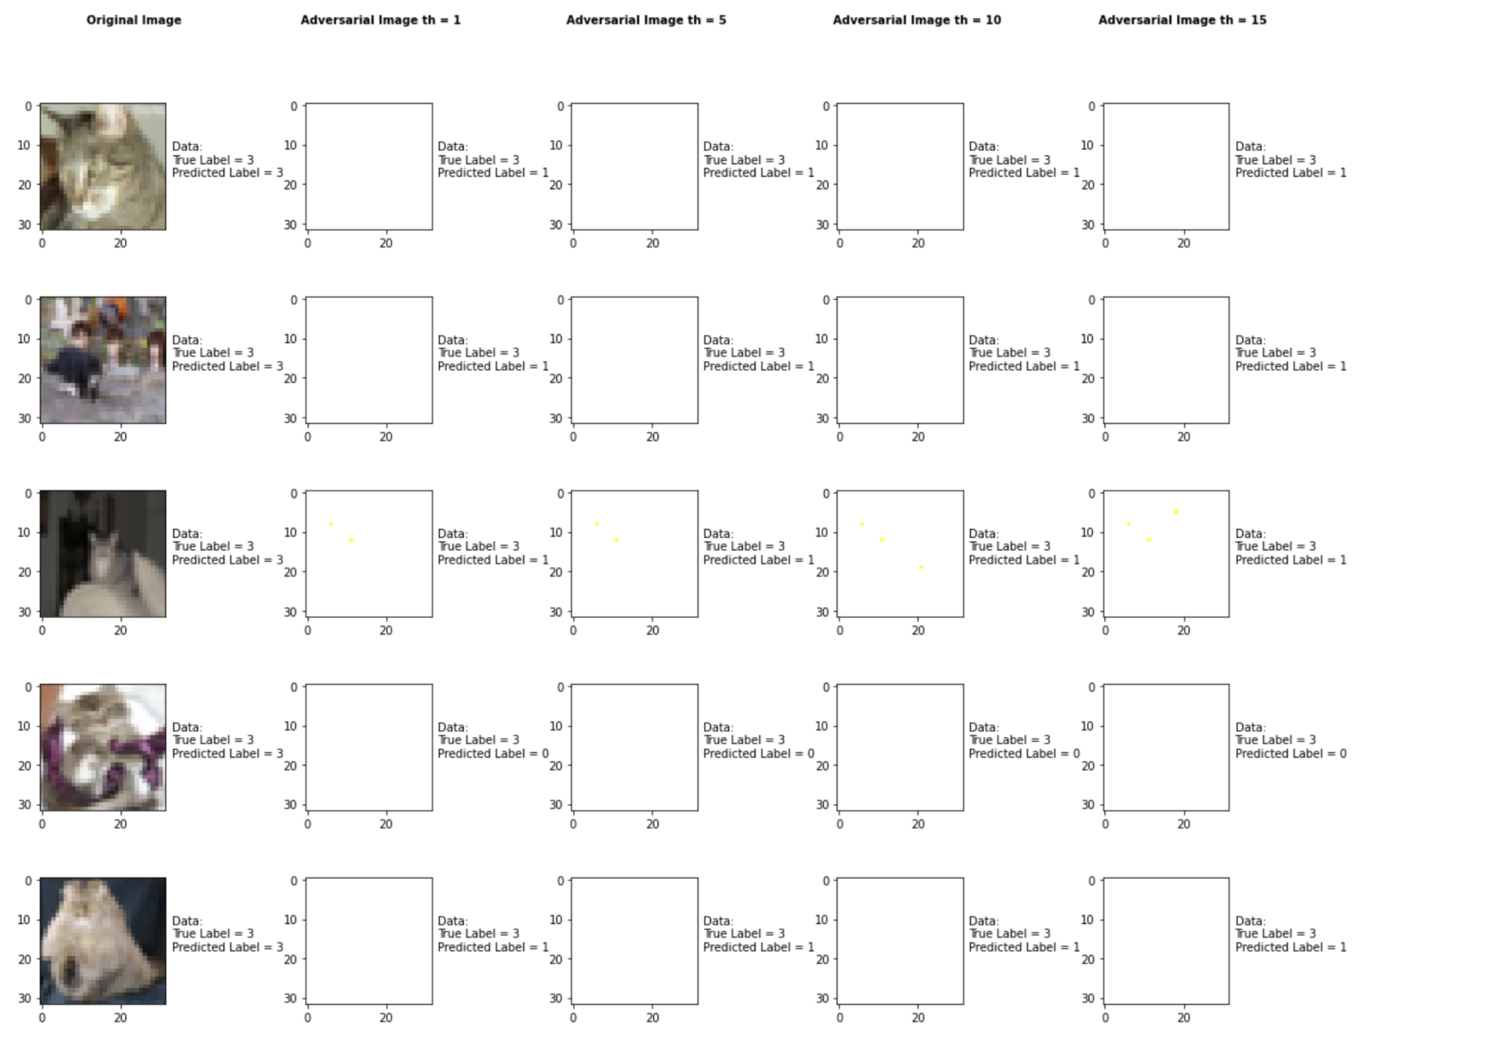

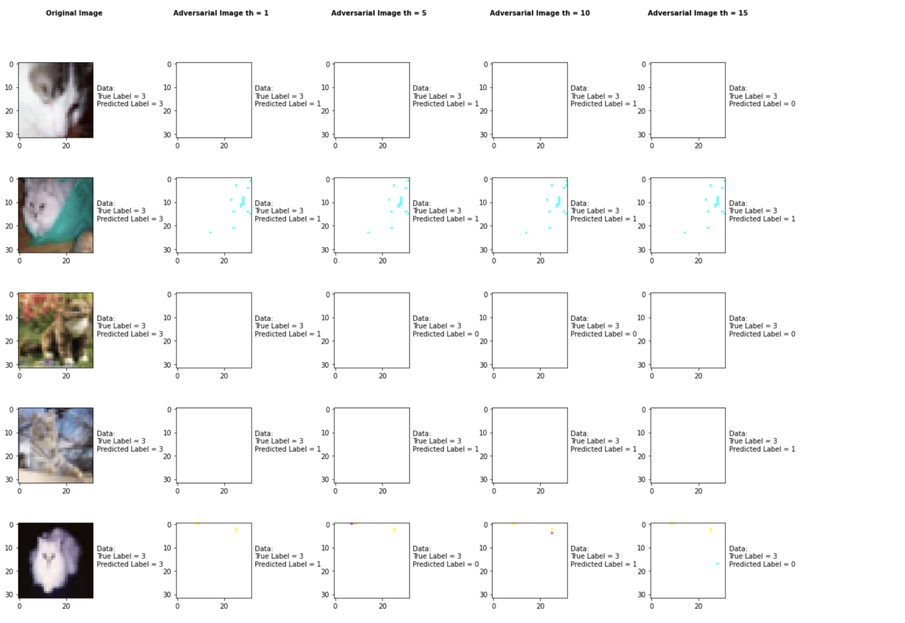

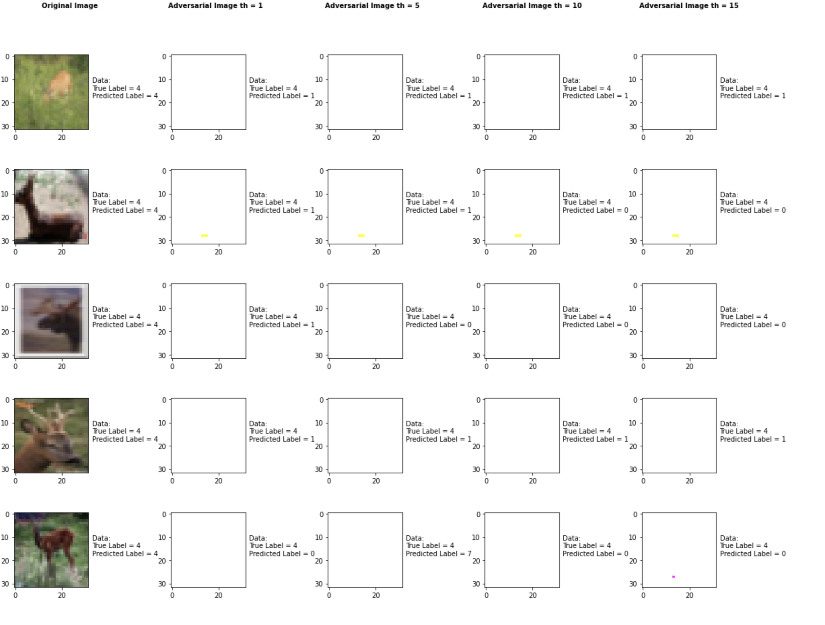

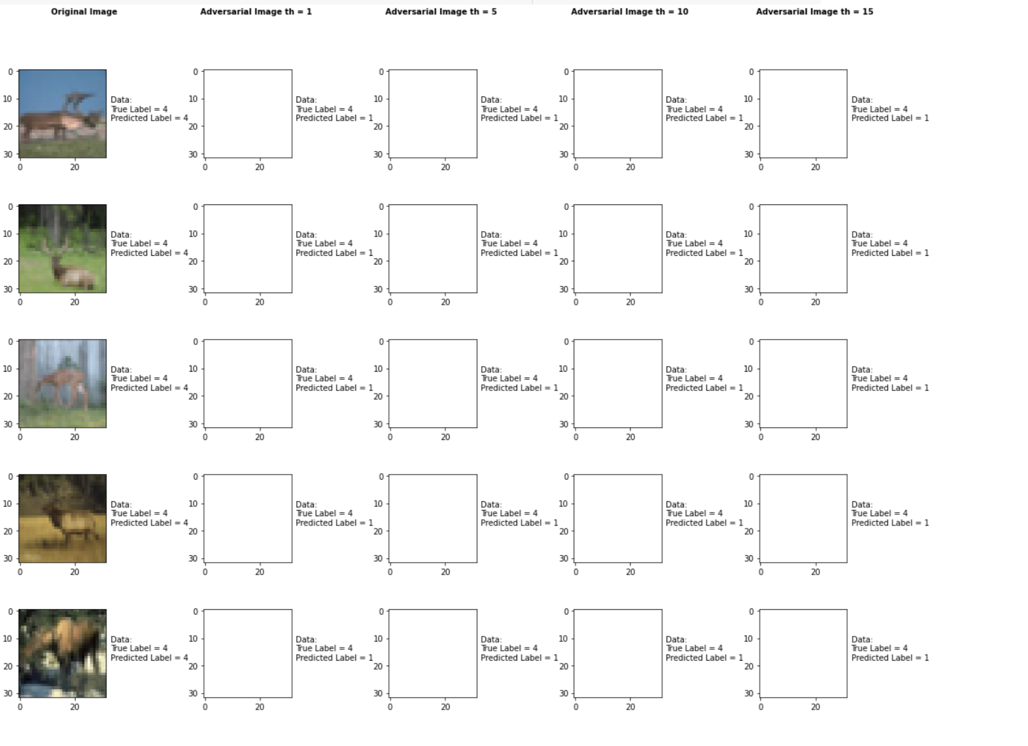

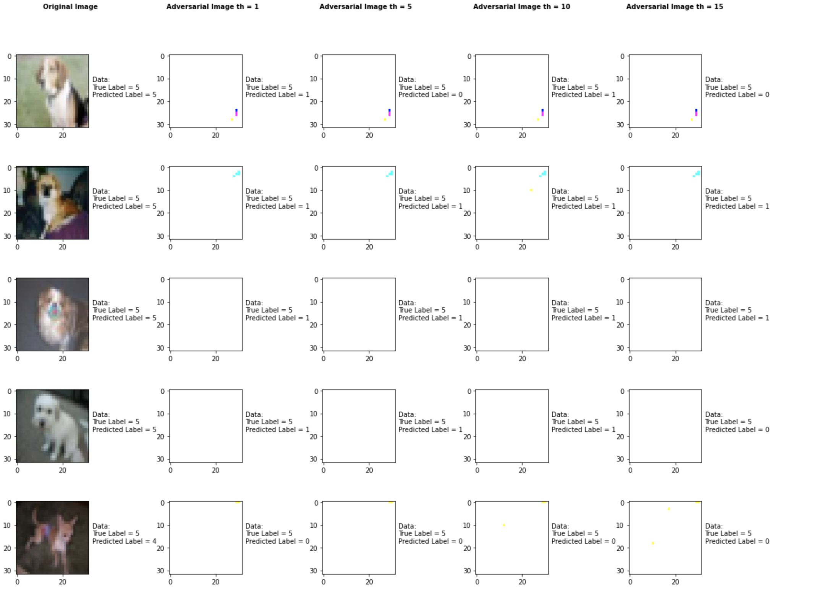

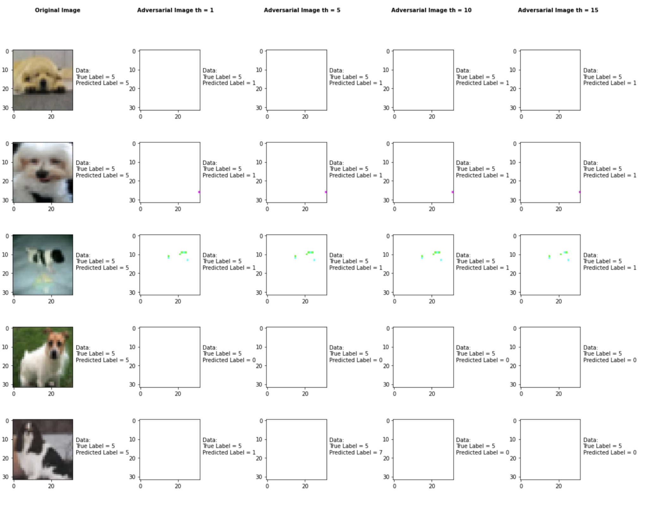

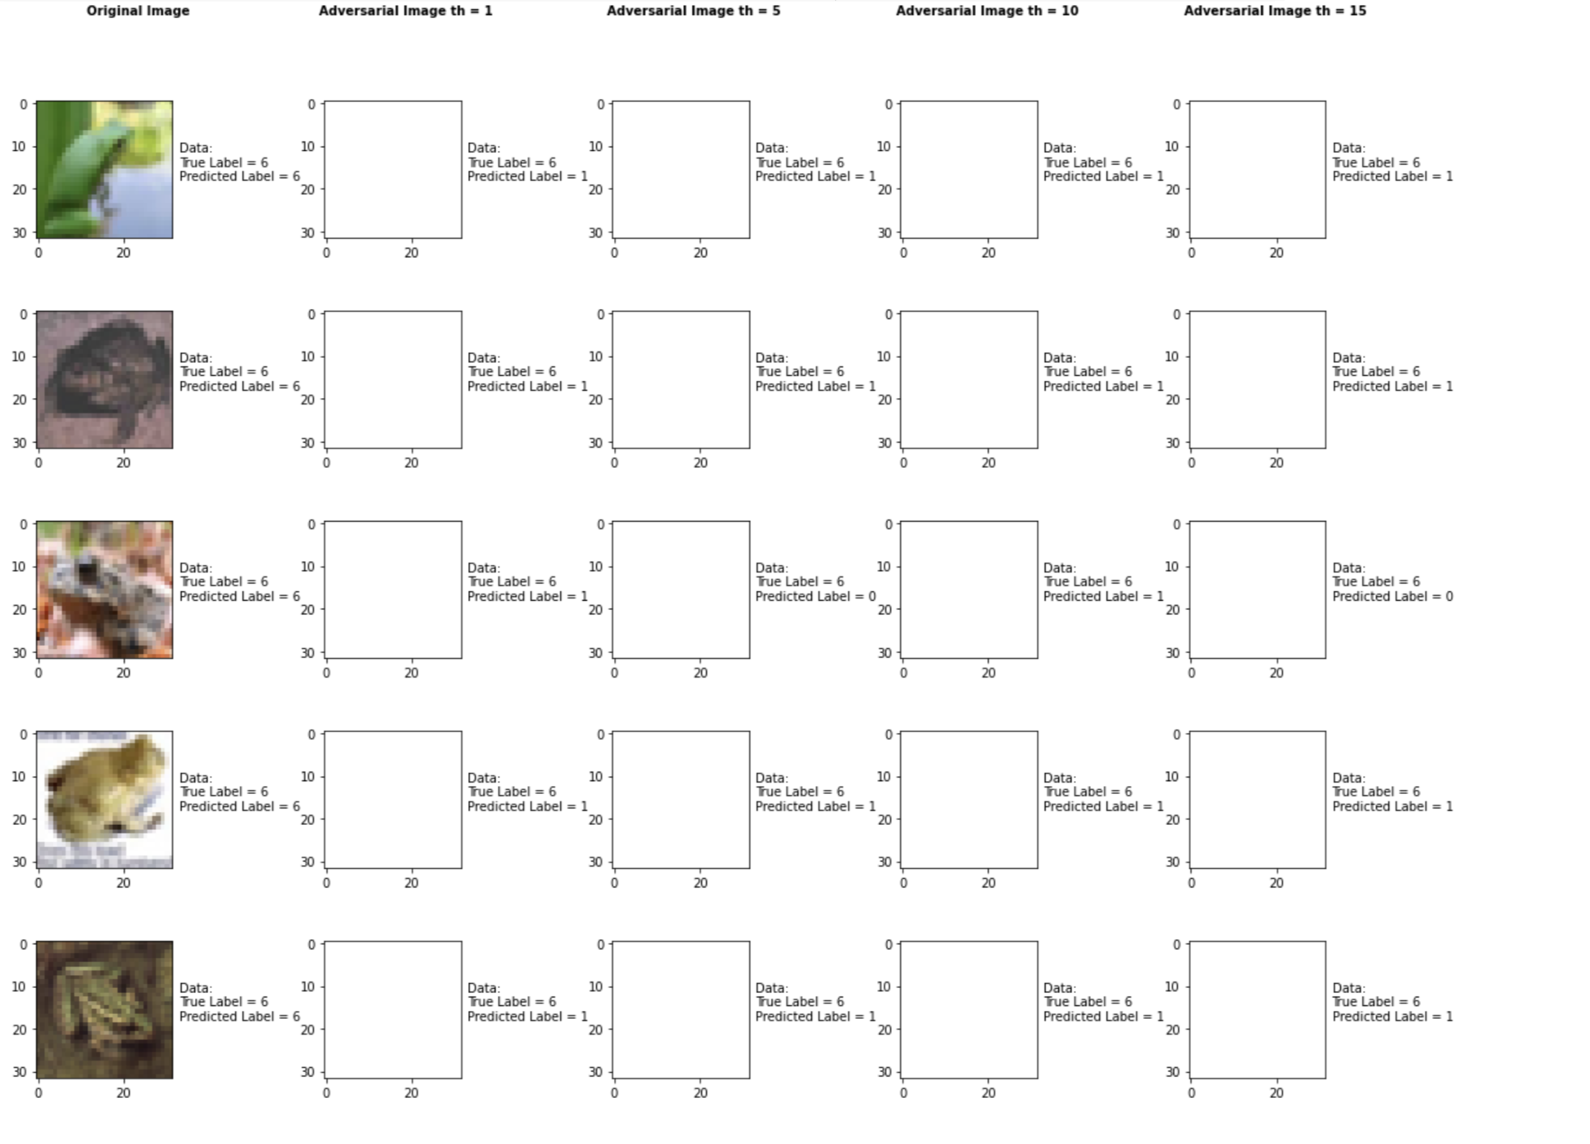

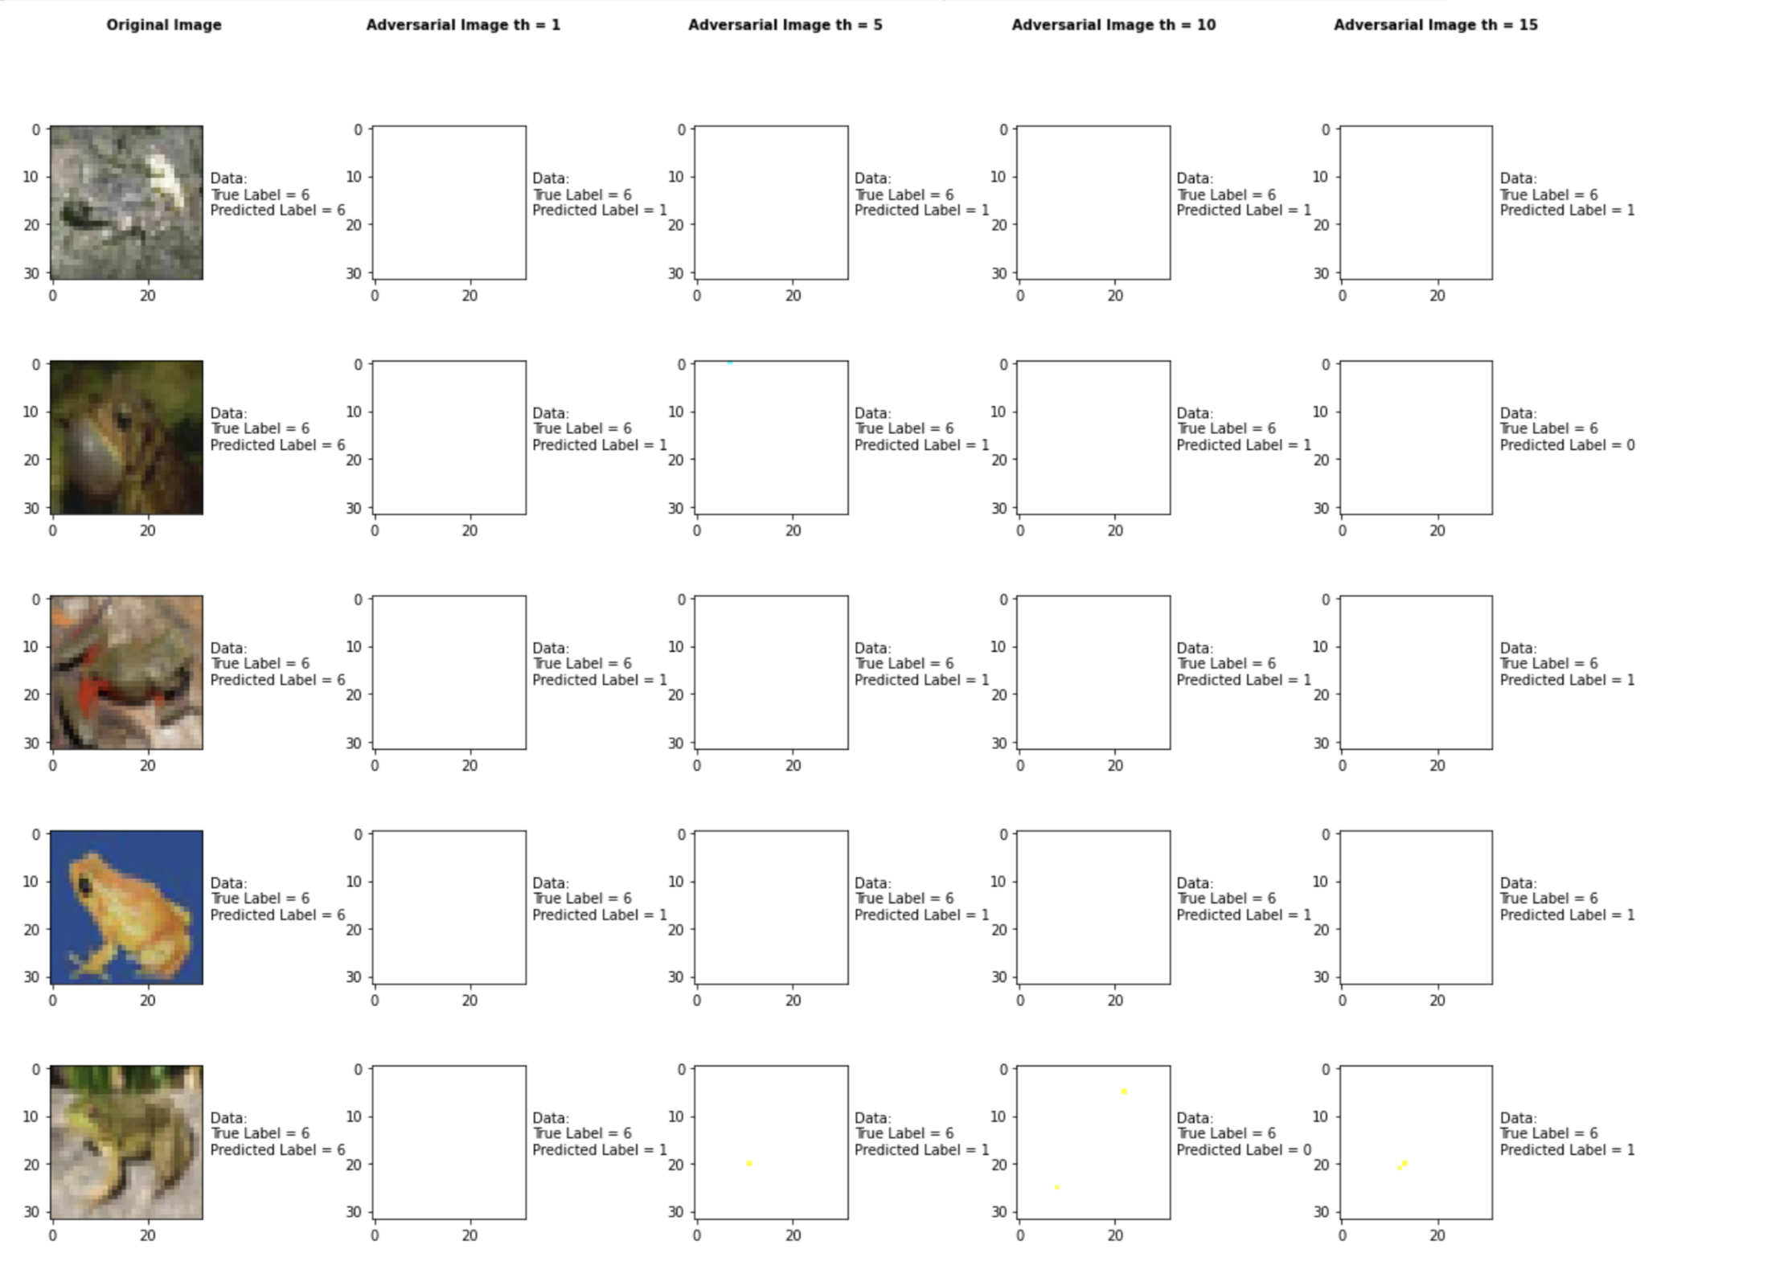

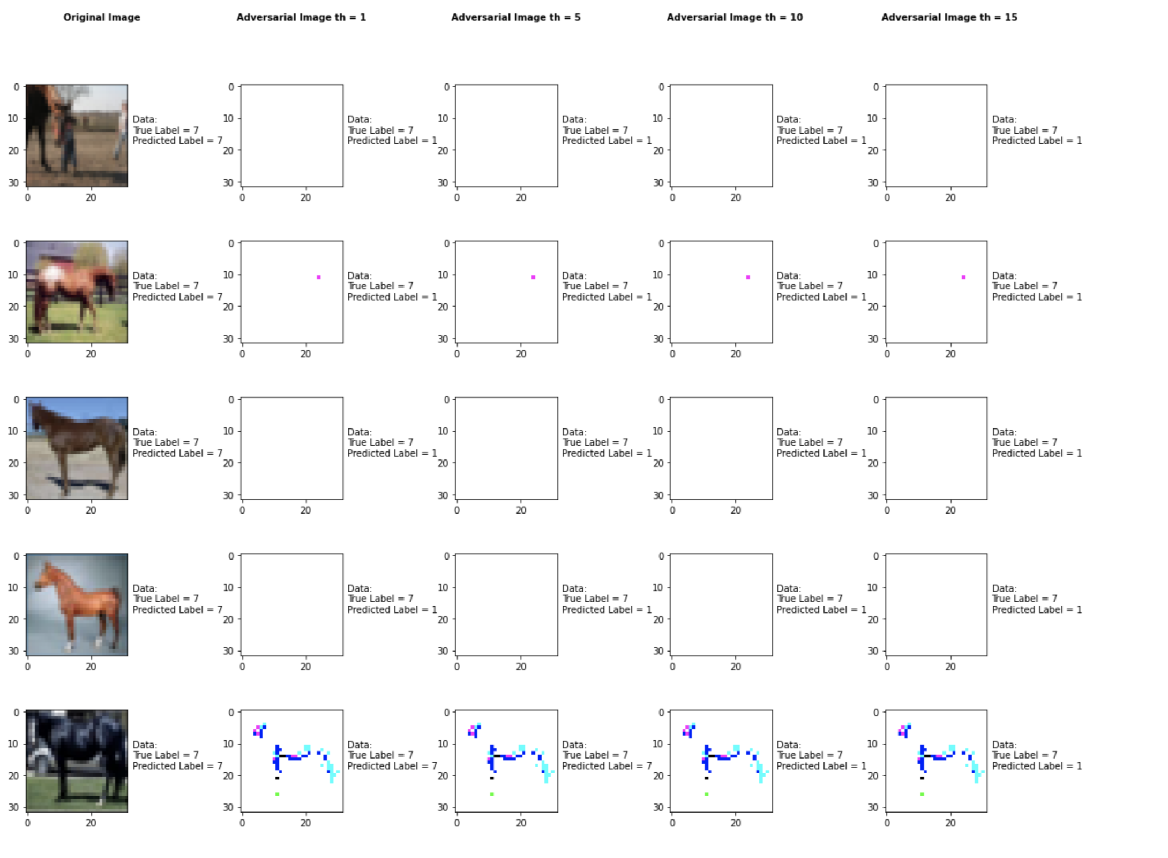

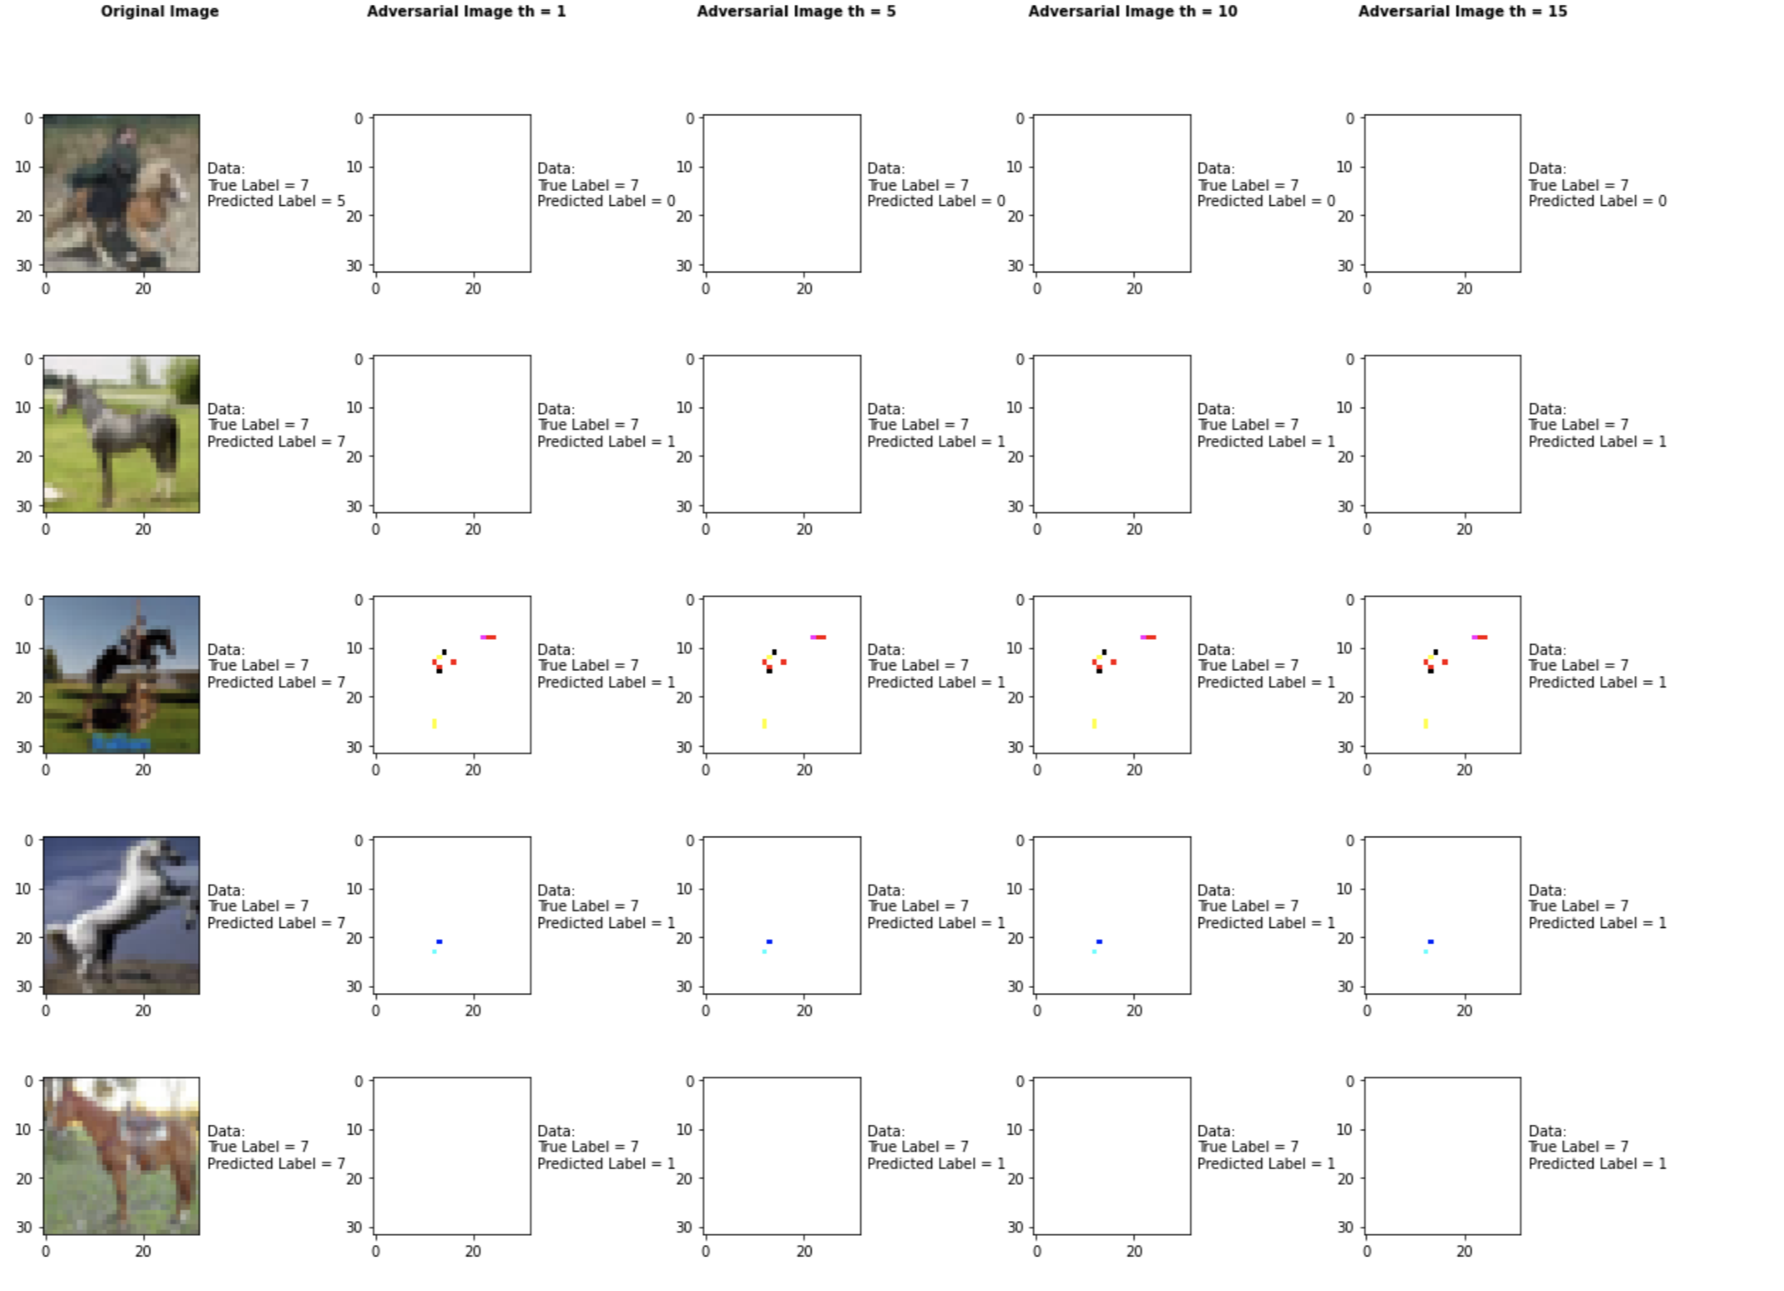

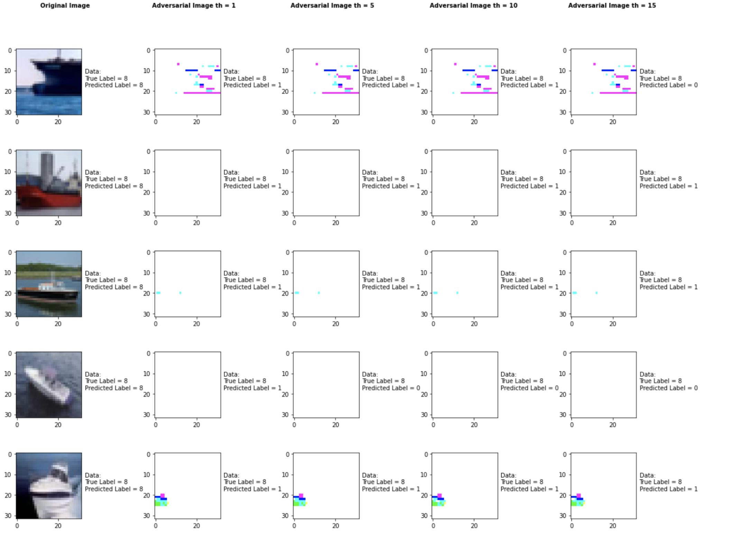

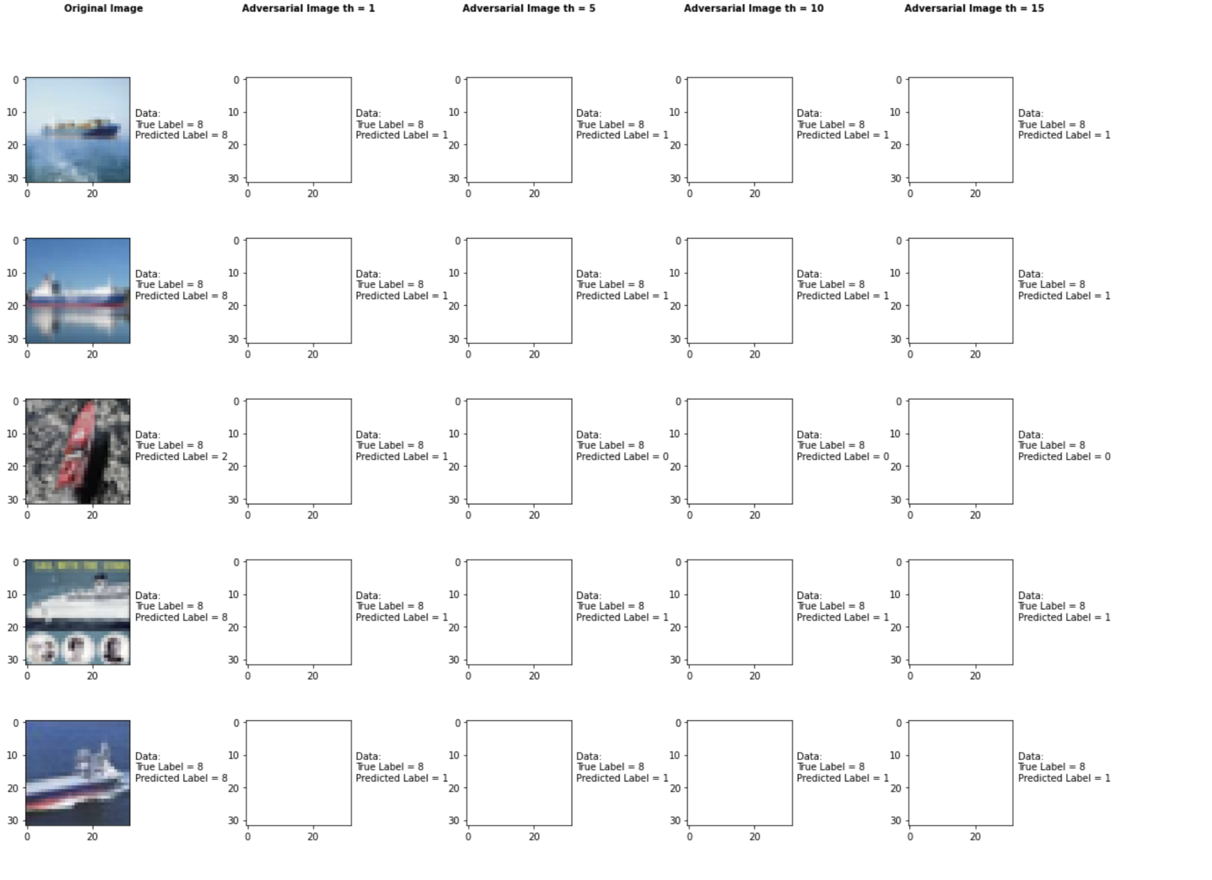

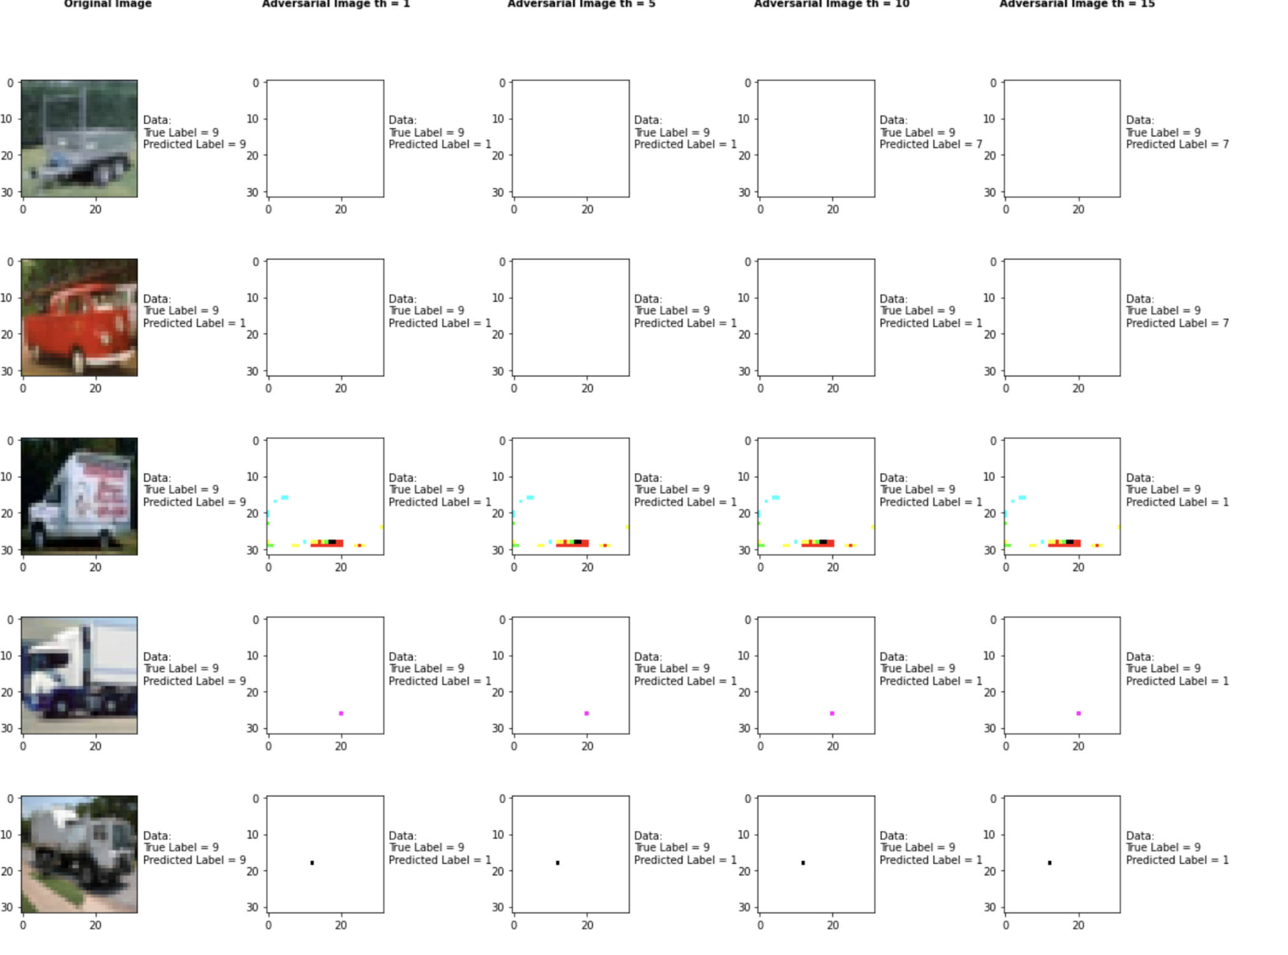

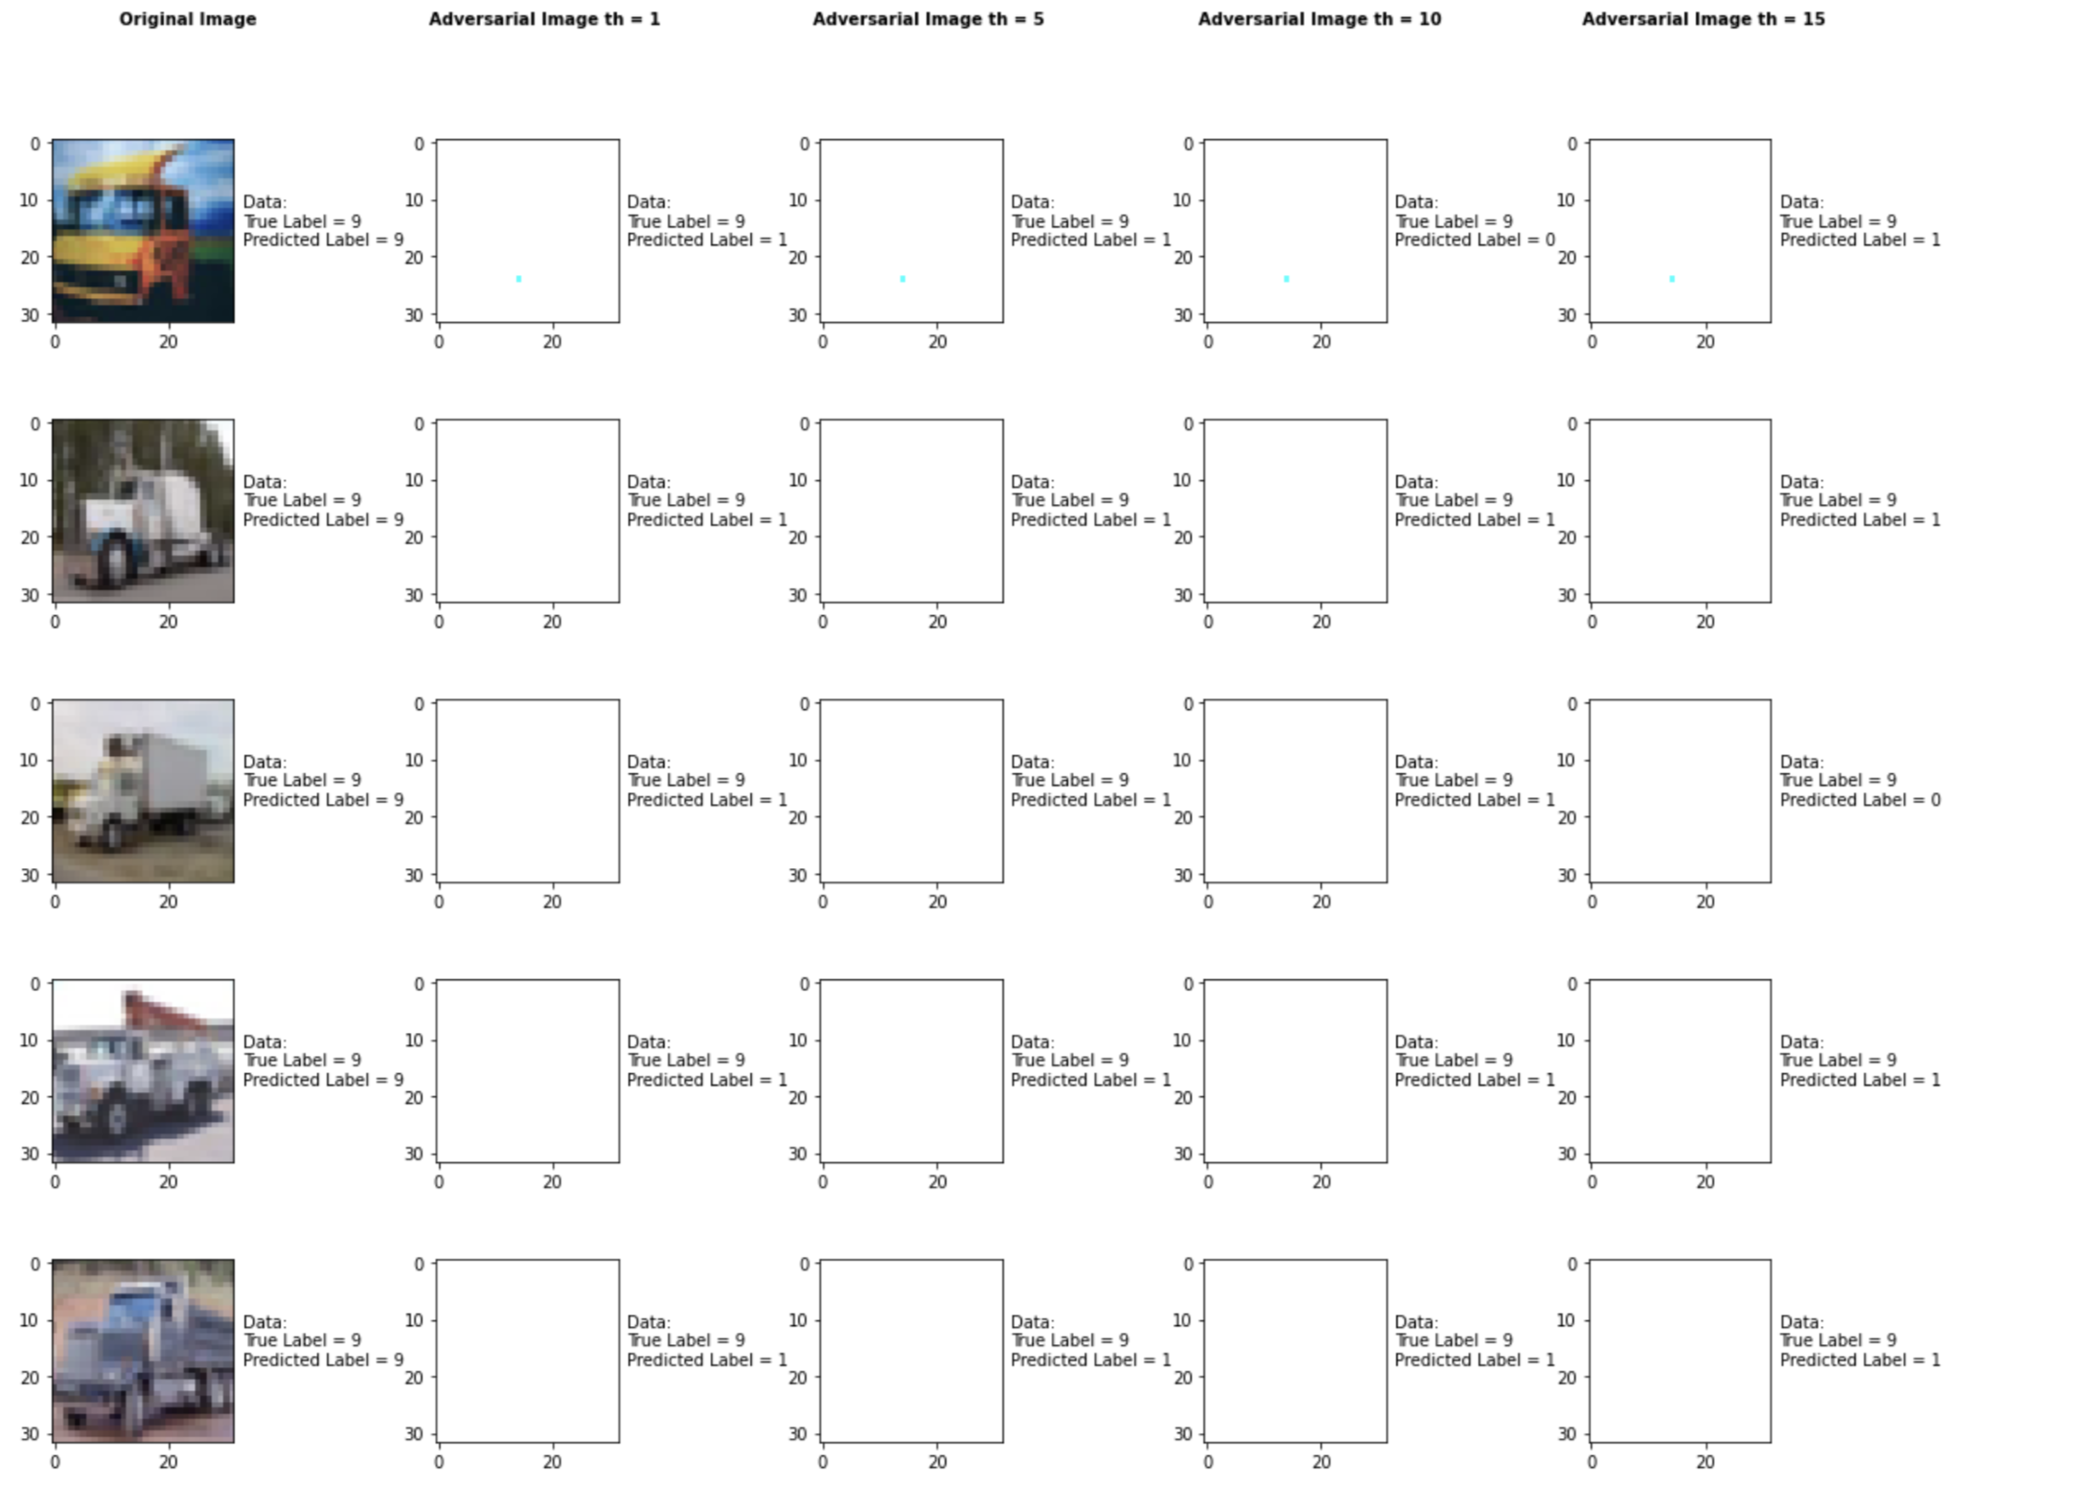

Accuracy on benign test examples: 94.52000000000001%

Accuracy on adversarial test examples with th = 1: 9.0%

Accuracy on adversarial test examples with th = 5: 6.0%

Accuracy on adversarial test examples with th = 10: 5.0%

Accuracy on adversarial test examples with th = 15: 3.0%

Classifier with benign example has Airplane recognition accuracy of = 90.0%

Fast Gradient Method with th = 1 has Airplane recognition accuracy of = 0.0%

Fast Gradient Method with th = 5 has Airplane recognition accuracy of = 0.0%

Fast Gradient Method with th = 10 has Airplane recognition accuracy of = 0.0%

Fast Gradient Method with th = 15 has Airplane recognition accuracy of = 0.0%

Classifier with benign example has Automobile recognition accuracy of = 100.0%

Fast Gradient Method with th = 1 has Automobile recognition accuracy of = 80.0%

Fast Gradient Method with th = 5 has Automobile recognition accuracy of = 50.0%

Fast Gradient Method with th = 10 has Automobile recognition accuracy of = 50.0%

Fast Gradient Method with th = 15 has Automobile recognition accuracy of = 30.0%

Classifier with benign example has Bird recognition accuracy of = 100.0%

Fast Gradient Method with th = 1 has Bird recognition accuracy of = 0.0%

Fast Gradient Method with th = 5 has Bird recognition accuracy of = 0.0%

Fast Gradient Method with th = 10 has Bird recognition accuracy of = 0.0%

Fast Gradient Method with th = 15 has Bird recognition accuracy of = 0.0%

Classifier with benign example has Cat recognition accuracy of = 100.0%

Fast Gradient Method with th = 1 has Cat recognition accuracy of = 0.0%

Fast Gradient Method with th = 5 has Cat recognition accuracy of = 0.0%

Fast Gradient Method with th = 10 has Cat recognition accuracy of = 0.0%

Fast Gradient Method with th = 15 has Cat recognition accuracy of = 0.0%

Classifier with benign example has Deer recognition accuracy of = 100.0%

Fast Gradient Method with th = 1 has Deer recognition accuracy of = 0.0%

Fast Gradient Method with th = 5 has Deer recognition accuracy of = 0.0%

Fast Gradient Method with th = 10 has Deer recognition accuracy of = 0.0%

Fast Gradient Method with th = 15 has Deer recognition accuracy of = 0.0%

Classifier with benign example has Dog recognition accuracy of = 90.0%

Fast Gradient Method with th = 1 has Dog recognition accuracy of = 0.0%

Fast Gradient Method with th = 5 has Dog recognition accuracy of = 0.0%

Fast Gradient Method with th = 10 has Dog recognition accuracy of = 0.0%

Fast Gradient Method with th = 15 has Dog recognition accuracy of = 0.0%

Classifier with benign example has Frog recognition accuracy of = 100.0%

Fast Gradient Method with th = 1 has Frog recognition accuracy of = 0.0%

Fast Gradient Method with th = 5 has Frog recognition accuracy of = 0.0%

Fast Gradient Method with th = 10 has Frog recognition accuracy of = 0.0%

Fast Gradient Method with th = 15 has Frog recognition accuracy of = 0.0%

Classifier with benign example has Horse recognition accuracy of = 90.0%

Fast Gradient Method with th = 1 has Horse recognition accuracy of = 10.0%

Fast Gradient Method with th = 5 has Horse recognition accuracy of = 10.0%

Fast Gradient Method with th = 10 has Horse recognition accuracy of = 0.0%

Fast Gradient Method with th = 15 has Horse recognition accuracy of = 0.0%

Classifier with benign example has Ship recognition accuracy of = 90.0%

Fast Gradient Method with th = 1 has Ship recognition accuracy of = 0.0%

Fast Gradient Method with th = 5 has Ship recognition accuracy of = 0.0%

Fast Gradient Method with th = 10 has Ship recognition accuracy of = 0.0%

Fast Gradient Method with th = 15 has Ship recognition accuracy of = 0.0%

Classifier with benign example has Truck recognition accuracy of = 90.0%

Fast Gradient Method with th = 1 has Truck recognition accuracy of = 0.0%

Fast Gradient Method with th = 5 has Truck recognition accuracy of = 0.0%

Fast Gradient Method with th = 10 has Truck recognition accuracy of = 0.0%

Fast Gradient Method with th = 15 has Truck recognition accuracy of = 0.0%

## Elastic Net Method



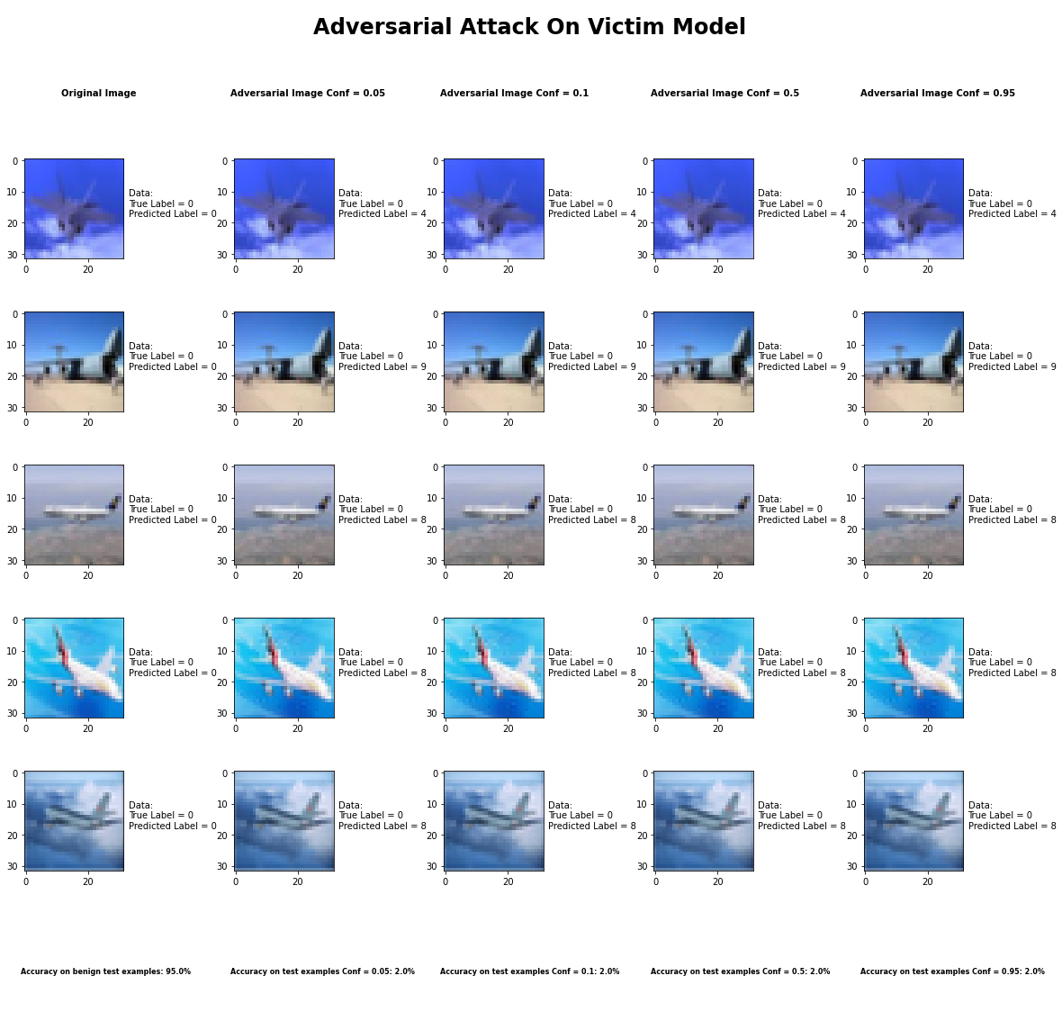

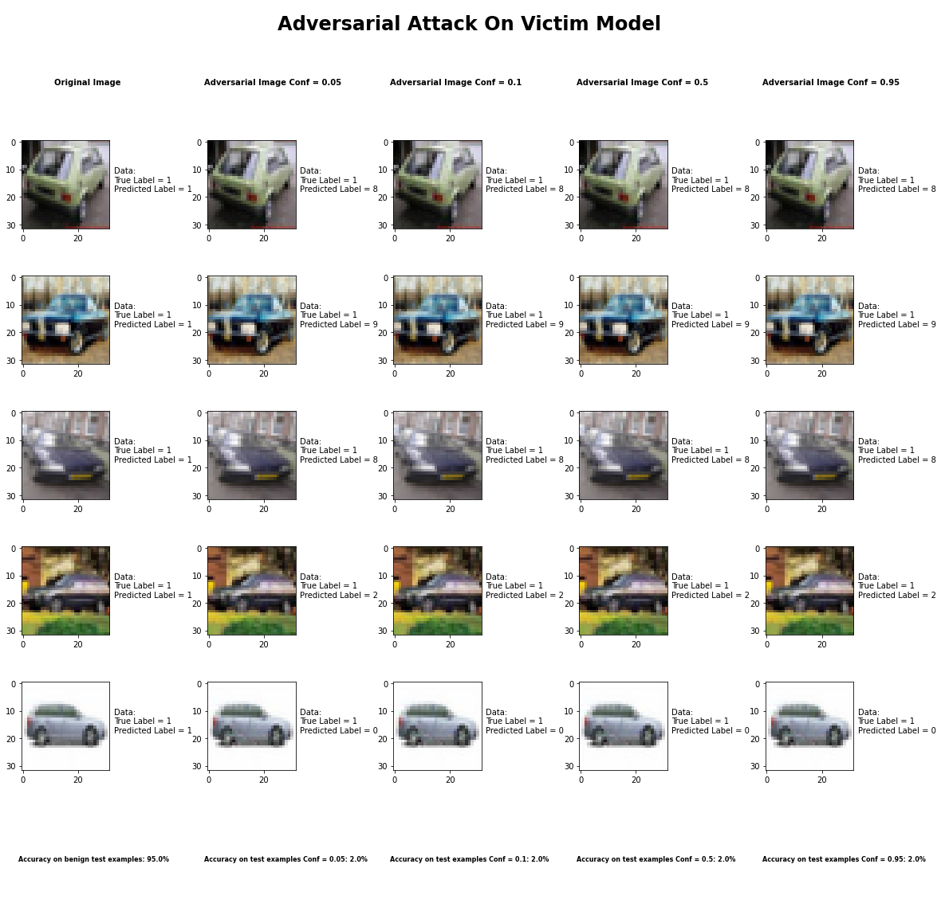

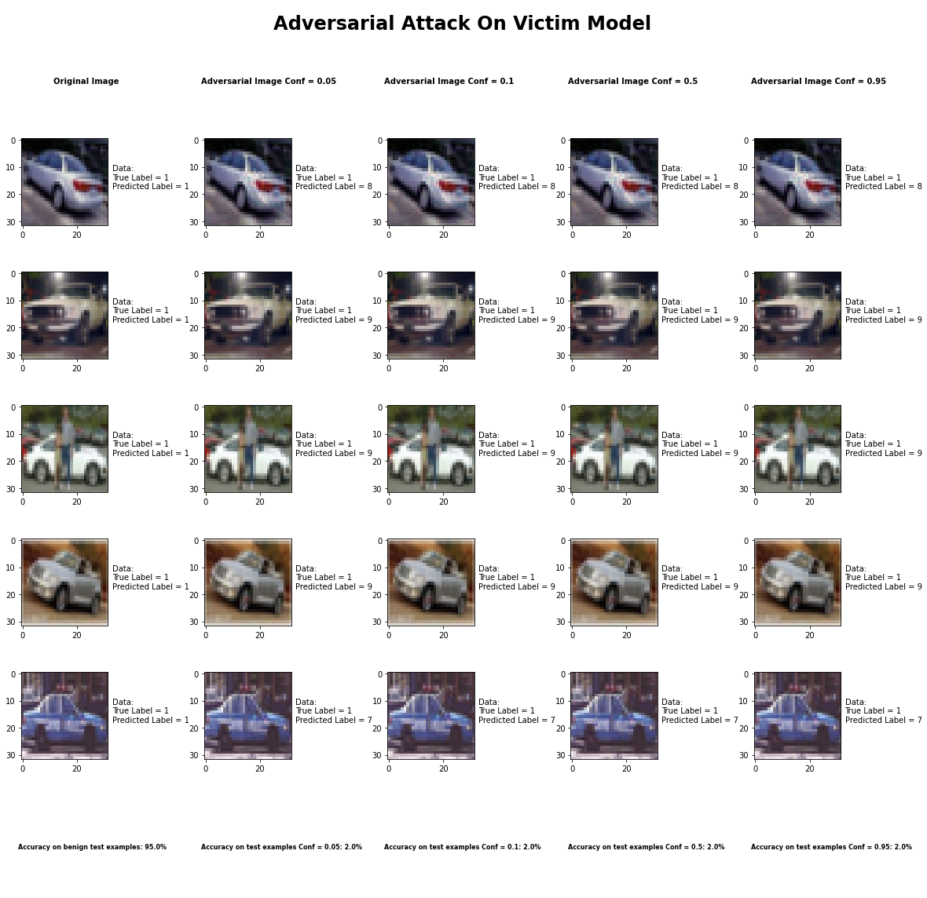

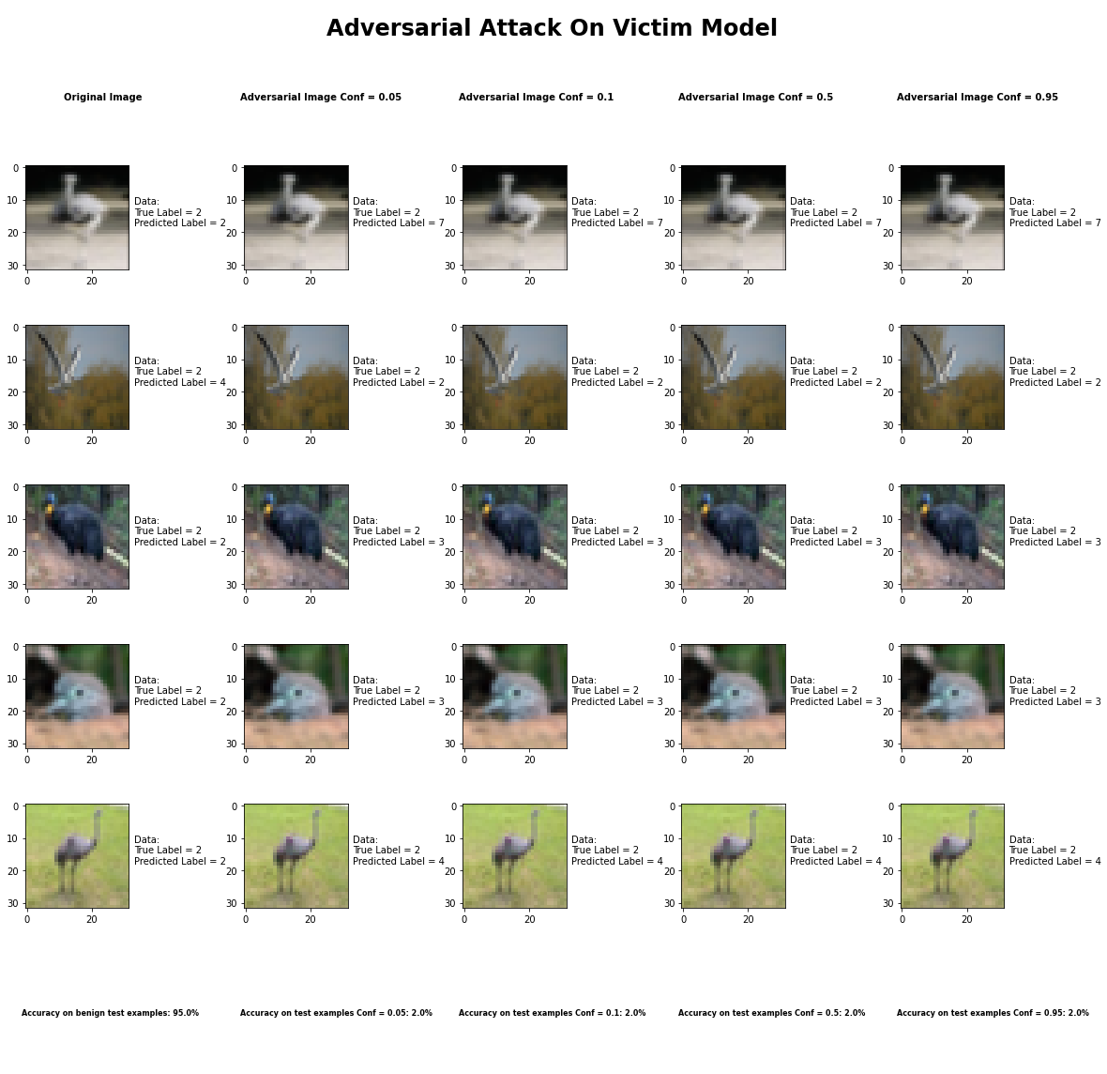

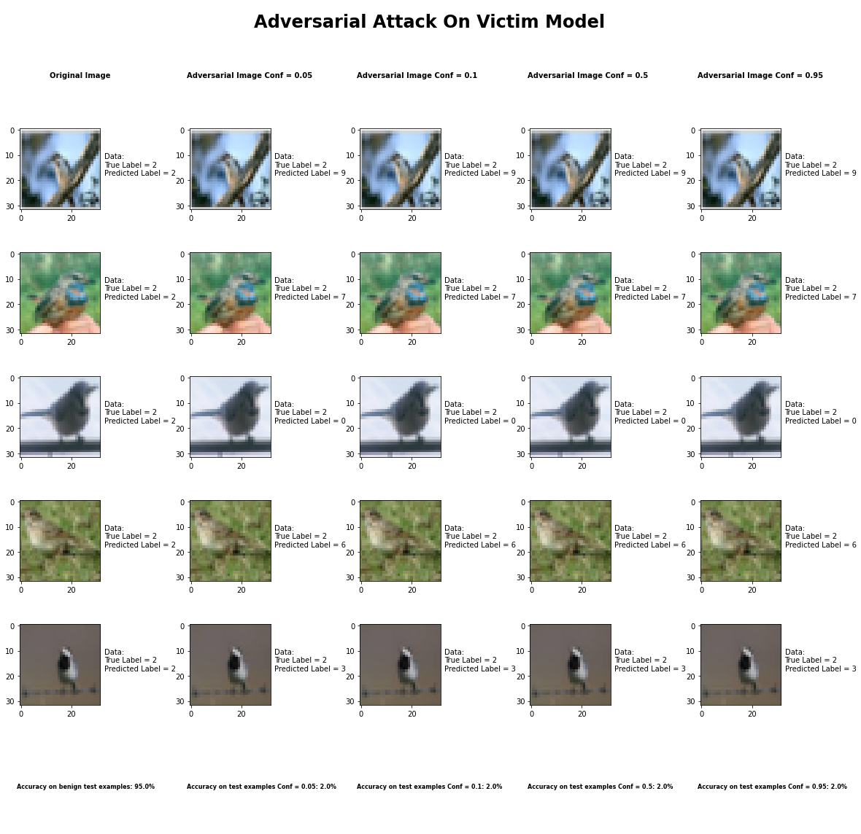

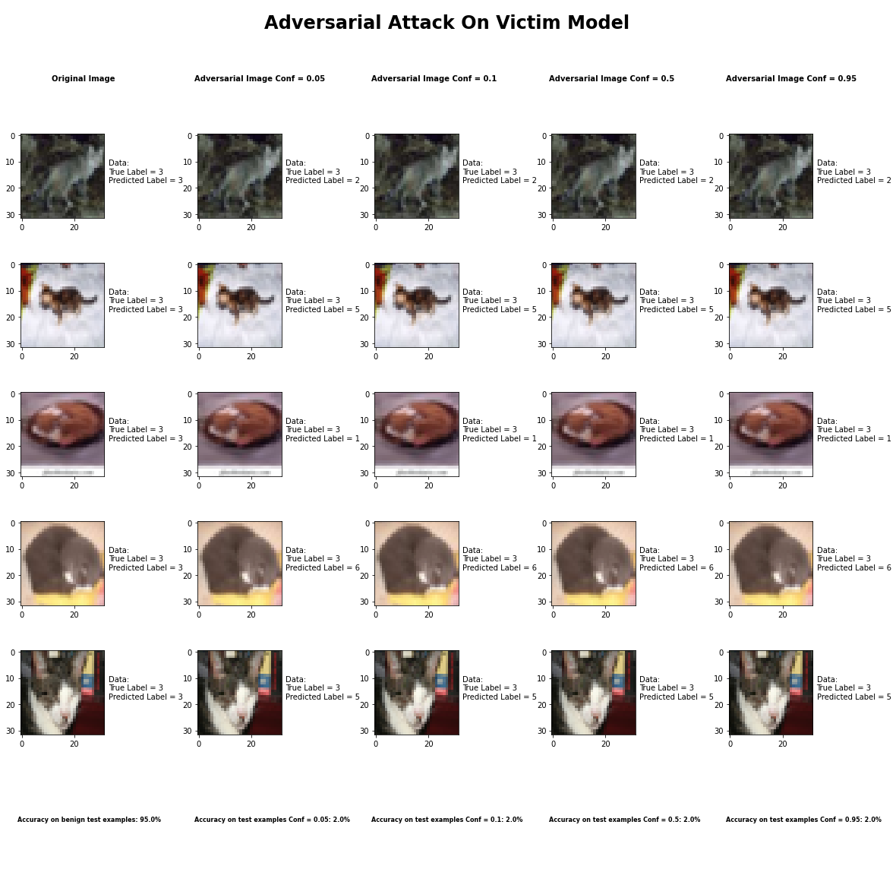

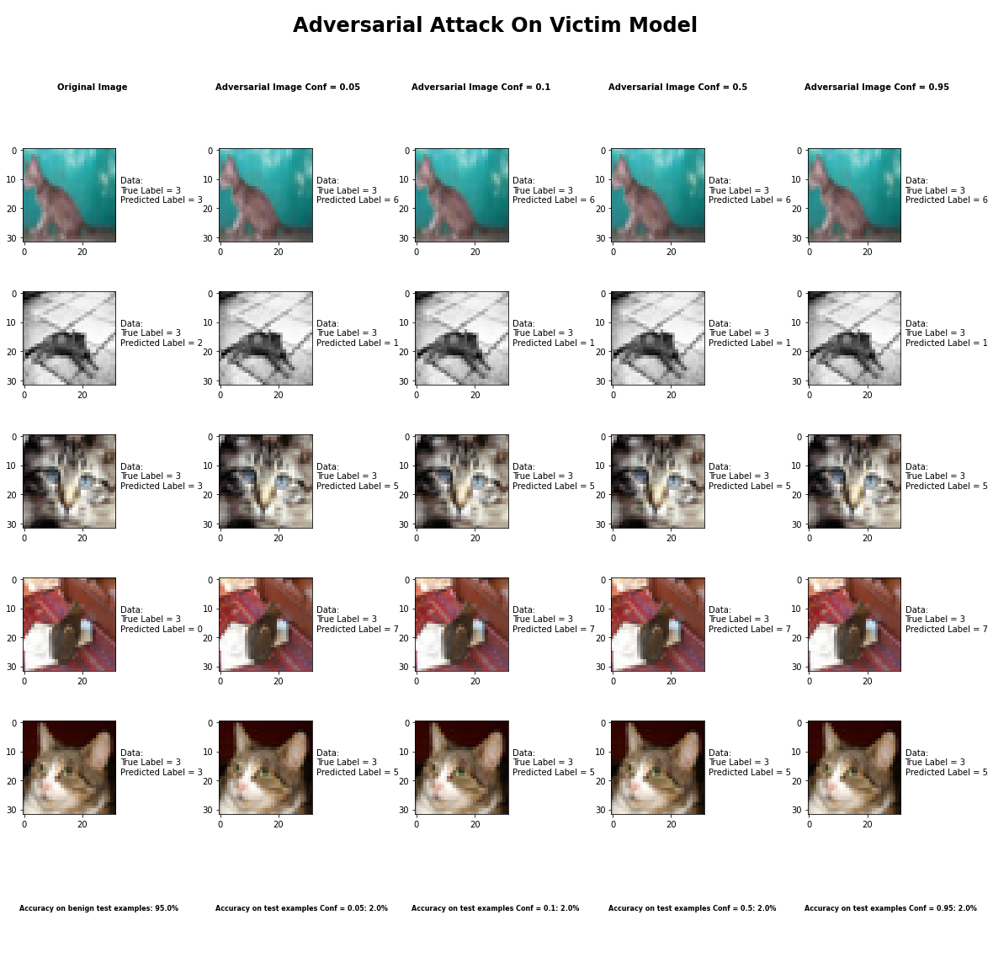

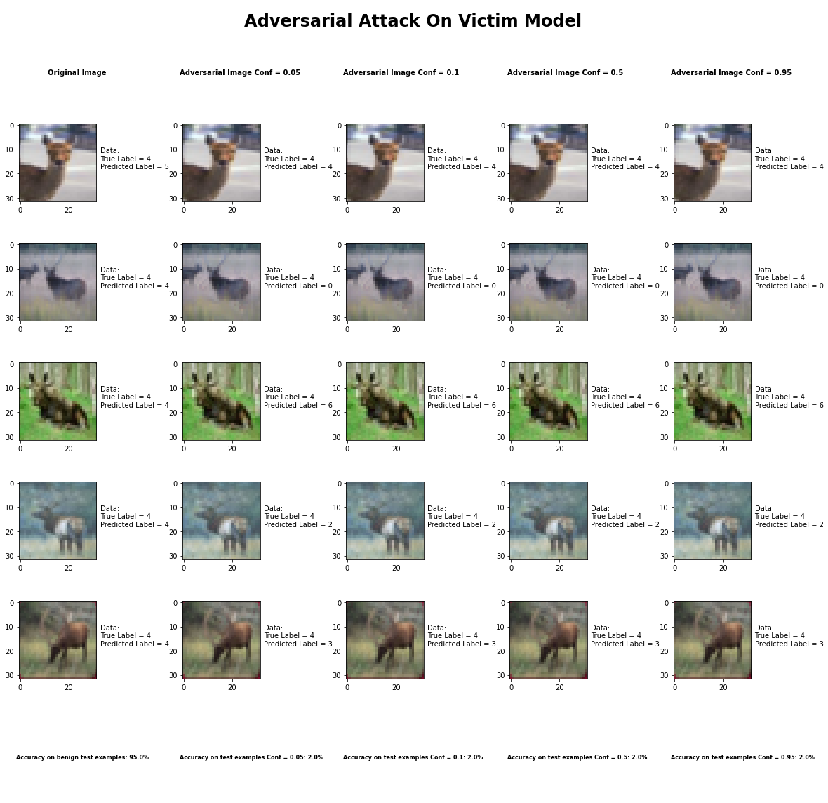

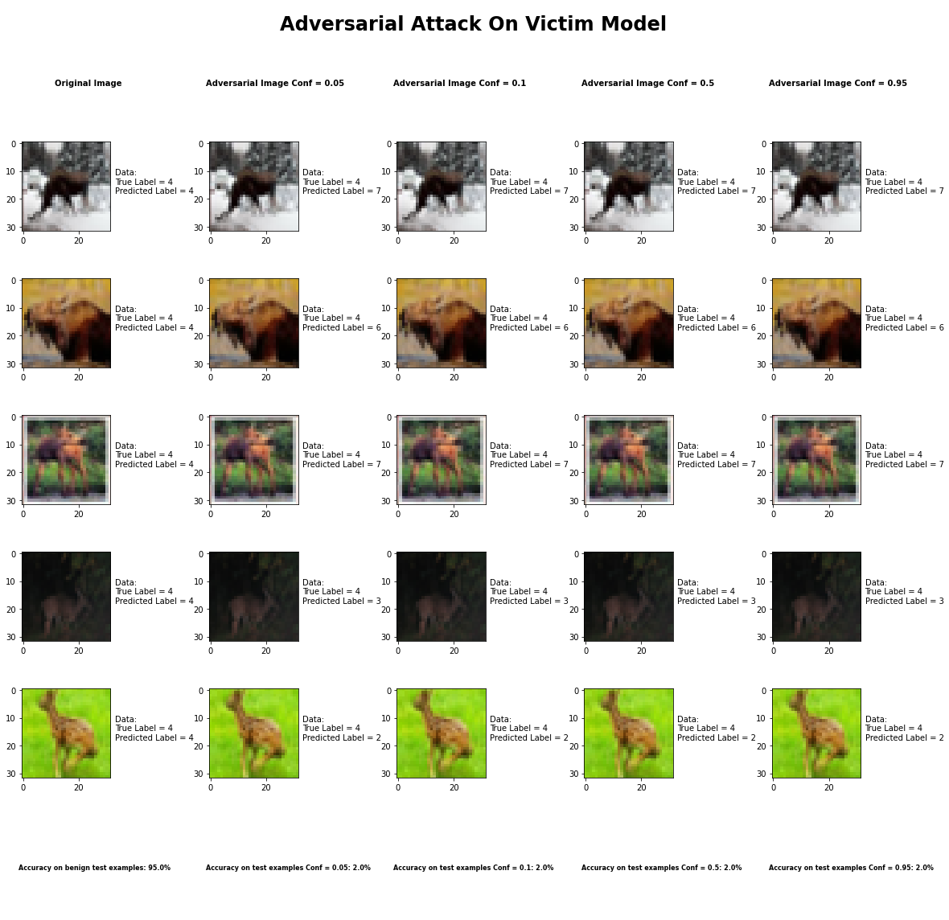

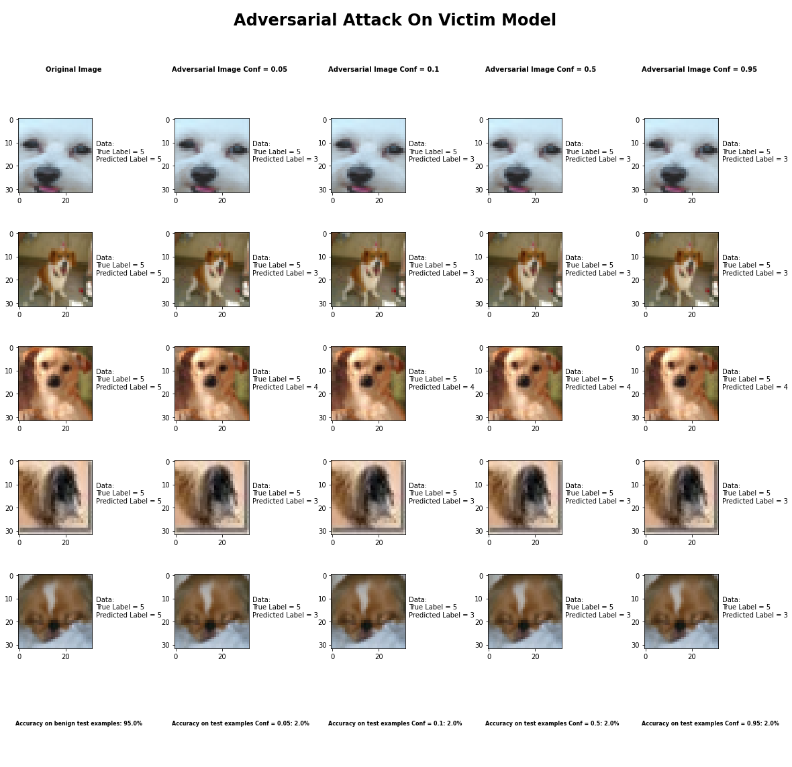

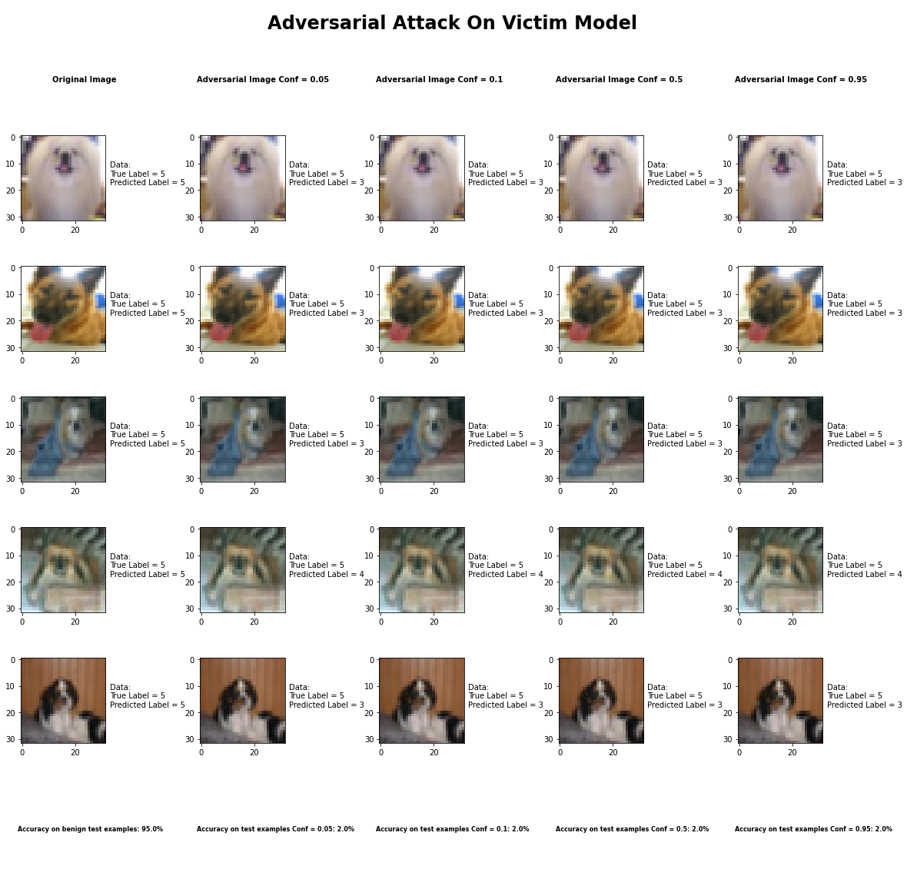

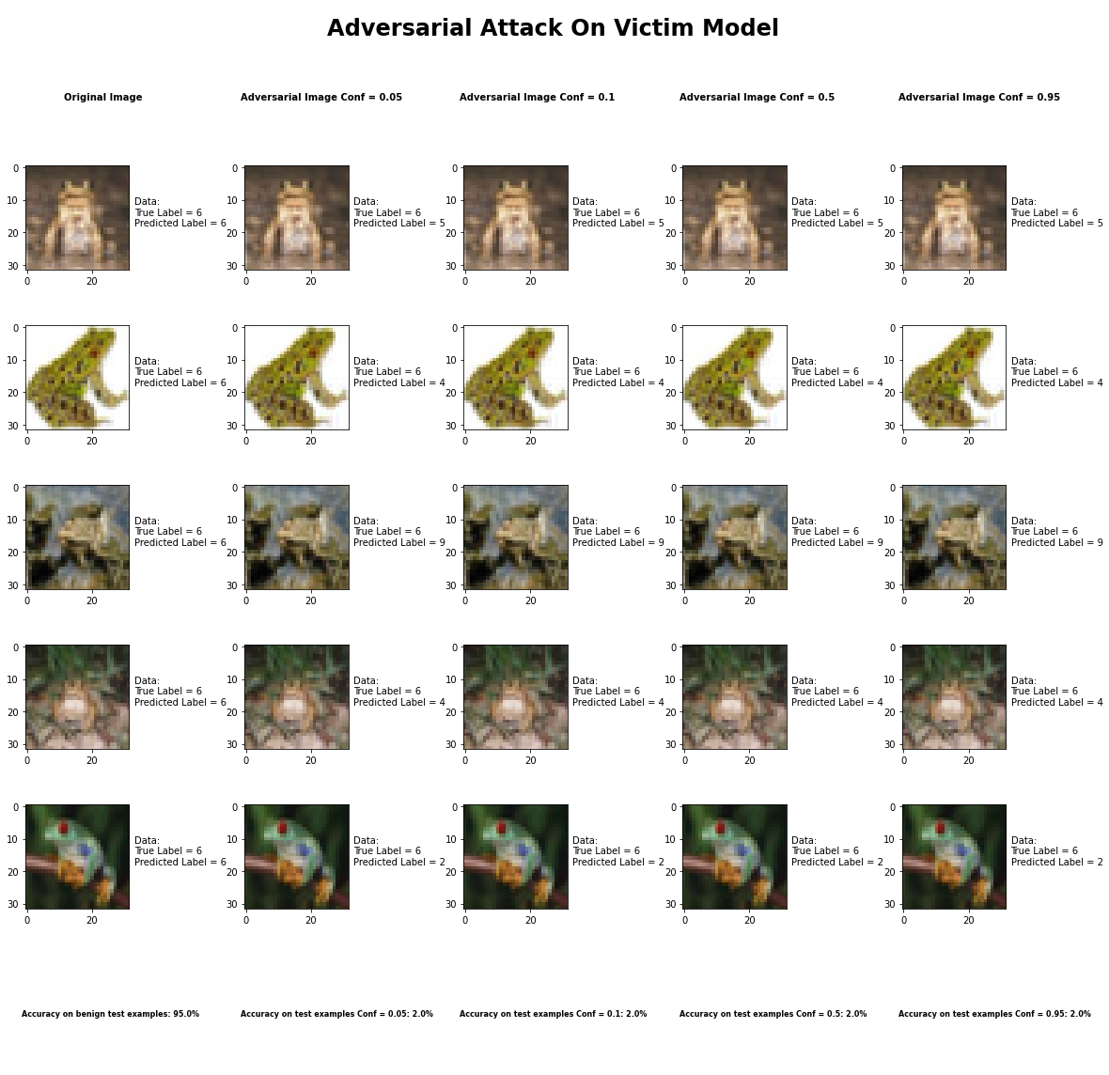

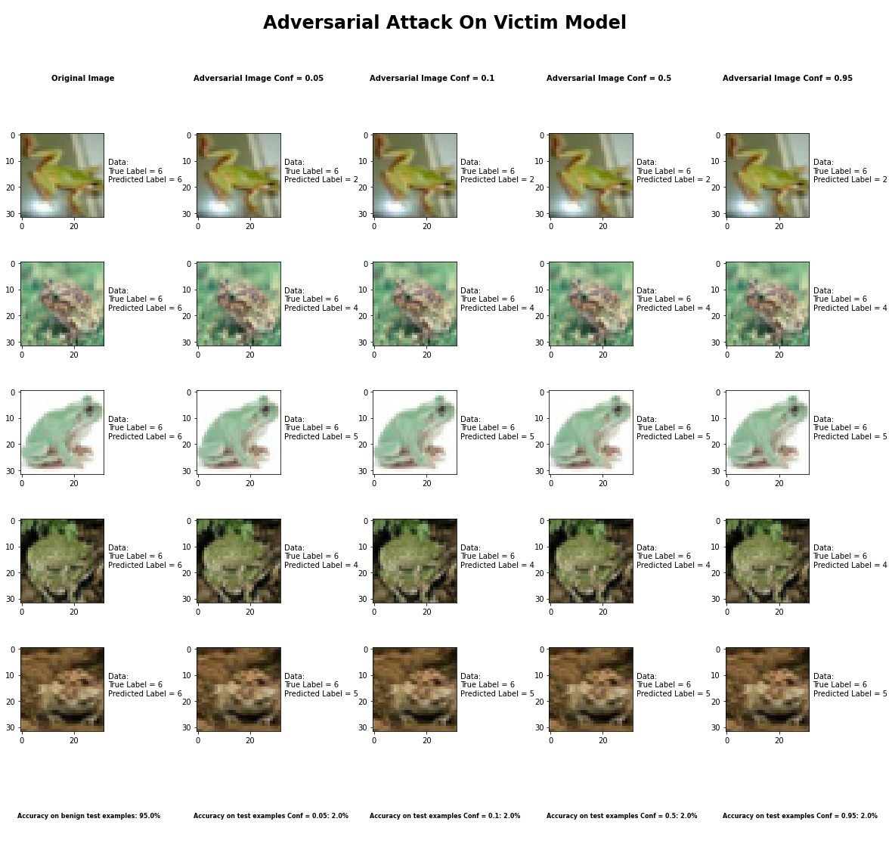

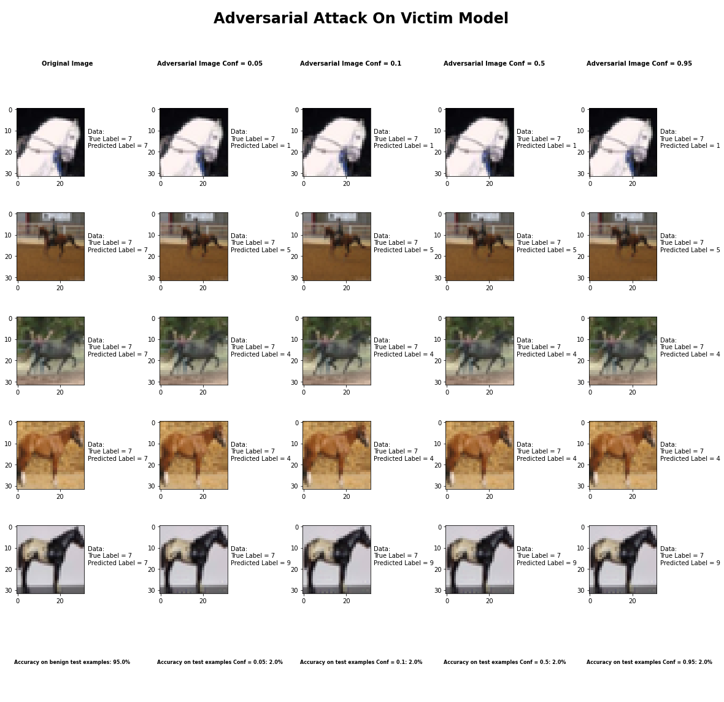

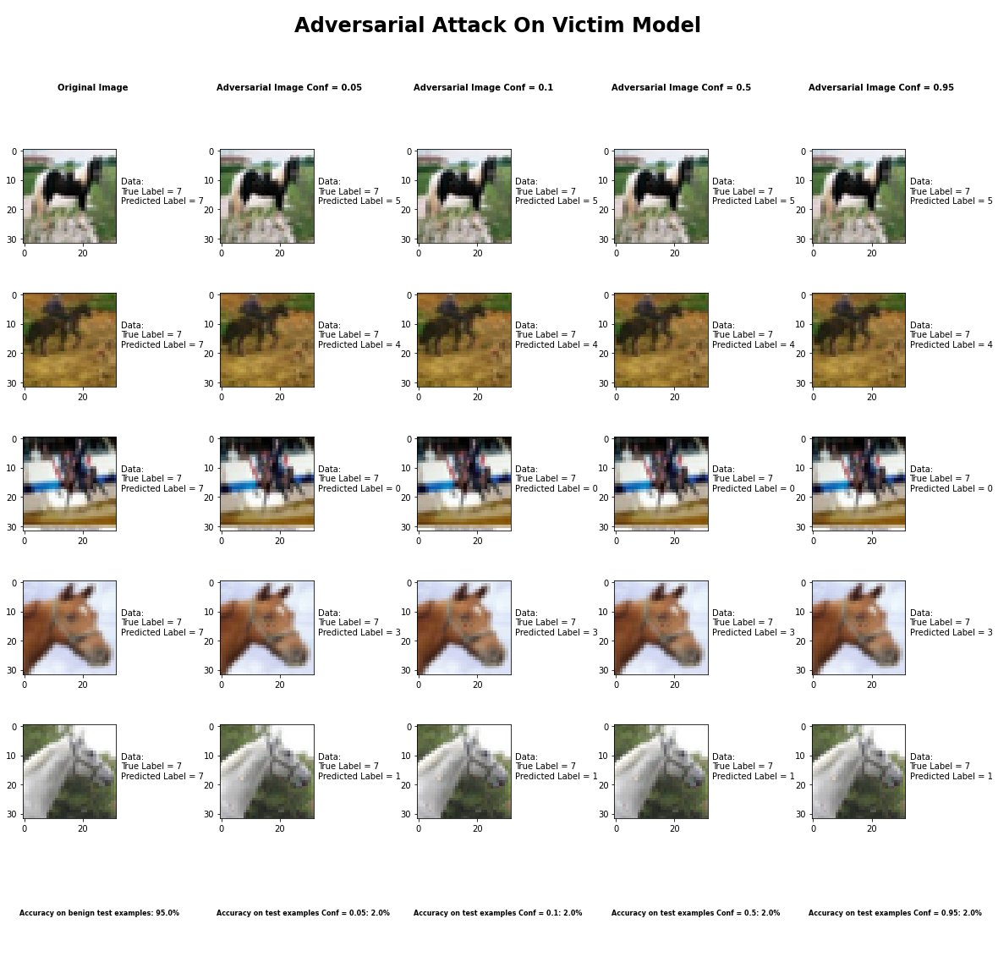



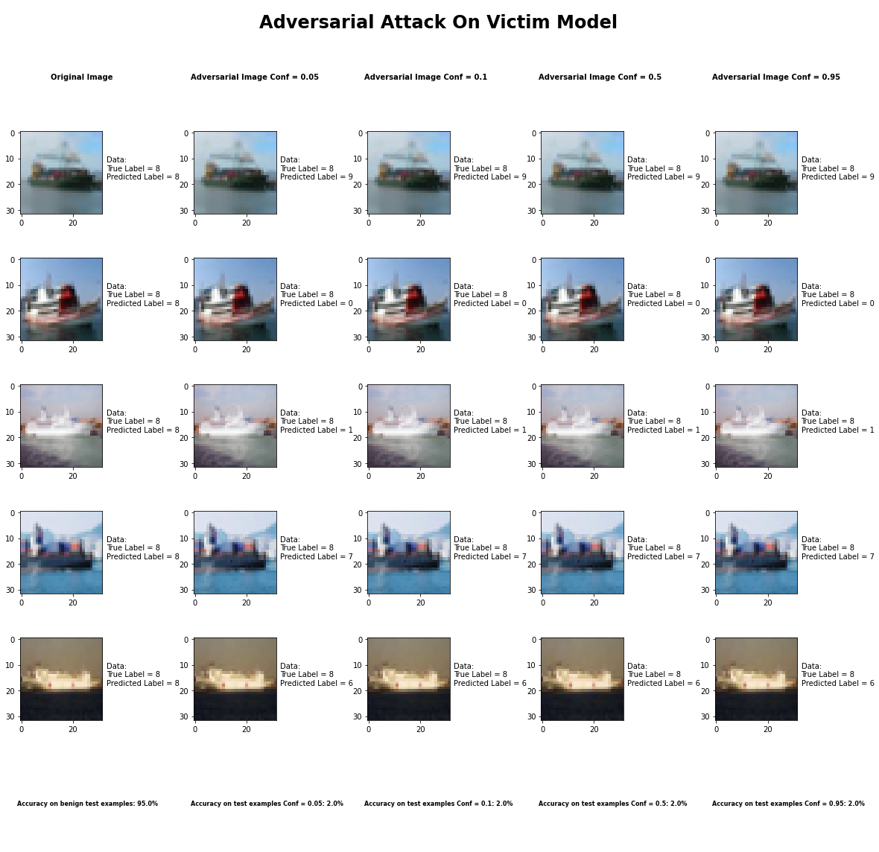

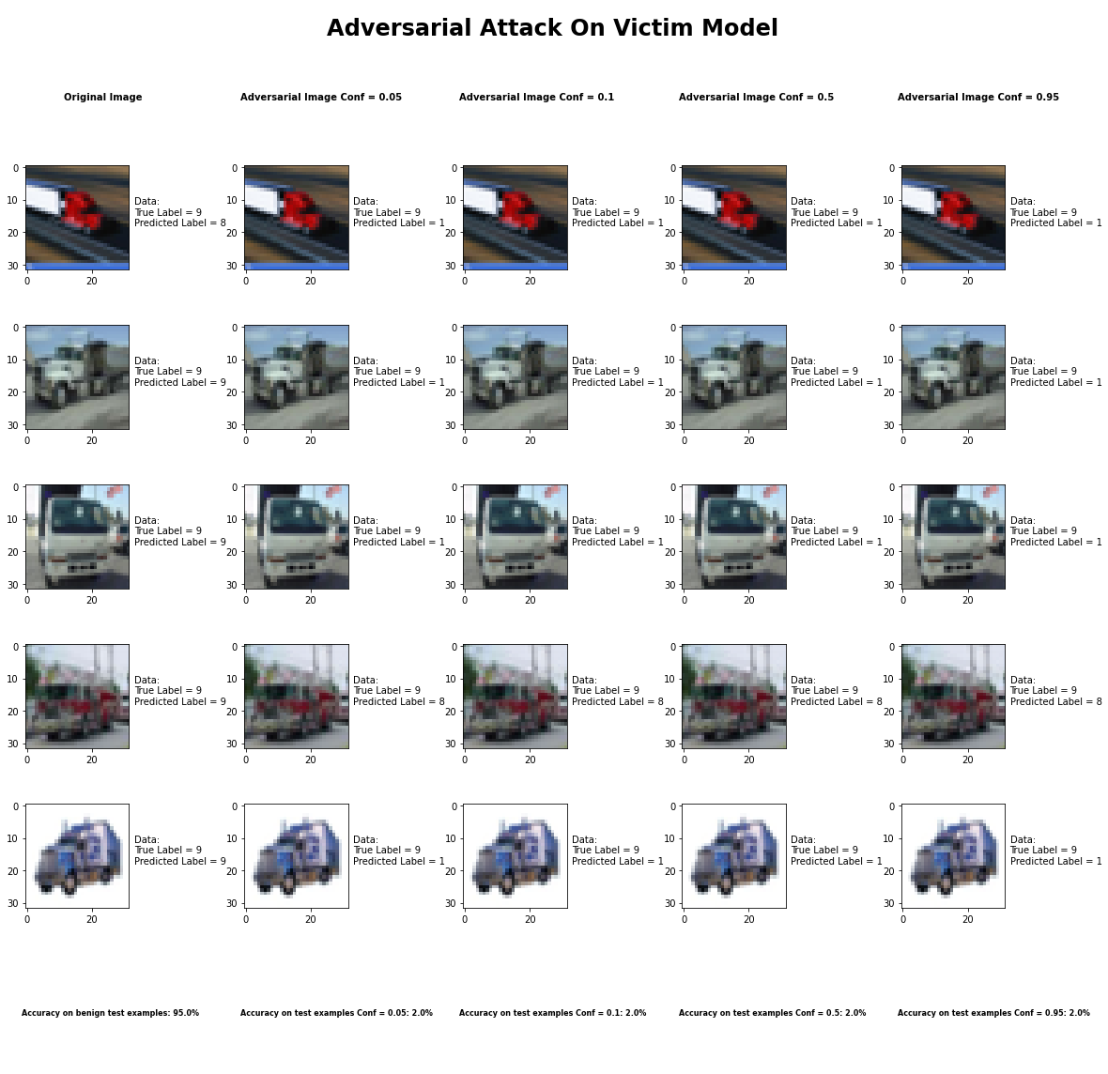

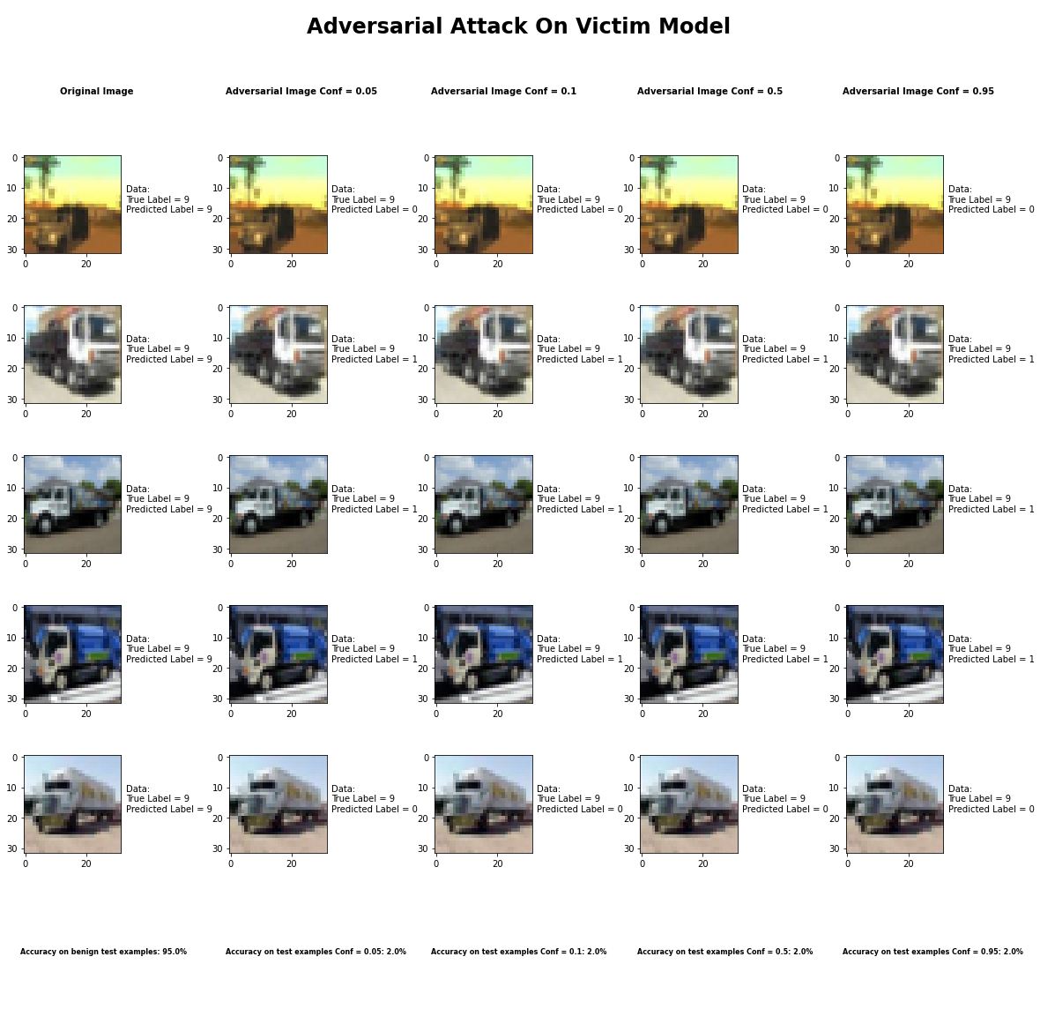

Accuracy on benign test examples: 94.52000000000001%

Accuracy on adversarial test examples with Conf = 0.05: 2.0%

Accuracy on adversarial test examples with Conf = 0.1: 2.0%

Accuracy on adversarial test examples with Conf = 0.5: 2.0%

Accuracy on adversarial test examples with Conf = 0.95: 2.0%

Classifier with benign example has Airplane recognition accuracy of = 100.0%

Elastic Net Method with Conf = 0.05 has Airplane recognition accuracy of = 0.0%

Elastic Net Method with Conf = 0.10 has Airplane recognition accuracy of = 0.0%

Elastic Net Method with Conf = 0.50 has Airplane recognition accuracy of = 0.0%

Elastic Net Method with Conf = 0.95 has Airplane recognition accuracy of = 0.0%

Classifier with benign example has Automobile recognition accuracy of = 100.0%

Elastic Net Method with Conf = 0.05 has Automobile recognition accuracy of = 0.0%

Elastic Net Method with Conf = 0.10 has Automobile recognition accuracy of = 0.0%

Elastic Net Method with Conf = 0.50 has Automobile recognition accuracy of = 0.0%

Elastic Net Method with Conf = 0.95 has Automobile recognition accuracy of = 0.0%

Classifier with benign example has Bird recognition accuracy of = 90.0%

Elastic Net Method with Conf = 0.05 has Bird recognition accuracy of = 10.0%

Elastic Net Method with Conf = 0.10 has Bird recognition accuracy of = 10.0%

Elastic Net Method with Conf = 0.50 has Bird recognition accuracy of = 10.0%

Elastic Net Method with Conf = 0.95 has Bird recognition accuracy of = 10.0%

Classifier with benign example has Cat recognition accuracy of = 80.0%

Elastic Net Method with Conf = 0.05 has Cat recognition accuracy of = 0.0%

Elastic Net Method with Conf = 0.10 has Cat recognition accuracy of = 0.0%

Elastic Net Method with Conf = 0.50 has Cat recognition accuracy of = 0.0%

Elastic Net Method with Conf = 0.95 has Cat recognition accuracy of = 0.0%

Classifier with benign example has Deer recognition accuracy of = 90.0%

Elastic Net Method with Conf = 0.05 has Deer recognition accuracy of = 10.0%

Elastic Net Method with Conf = 0.10 has Deer recognition accuracy of = 10.0%

Elastic Net Method with Conf = 0.50 has Deer recognition accuracy of = 10.0%

Elastic Net Method with Conf = 0.95 has Deer recognition accuracy of = 10.0%

Classifier with benign example has Dog recognition accuracy of = 100.0%

Elastic Net Method with Conf = 0.05 has Dog recognition accuracy of = 0.0%

Elastic Net Method with Conf = 0.10 has Dog recognition accuracy of = 0.0%

Elastic Net Method with Conf = 0.50 has Dog recognition accuracy of = 0.0%

Elastic Net Method with Conf = 0.95 has Dog recognition accuracy of = 0.0%

Classifier with benign example has Frog recognition accuracy of = 100.0%

Elastic Net Method with Conf = 0.05 has Frog recognition accuracy of = 0.0%

Elastic Net Method with Conf = 0.10 has Frog recognition accuracy of = 0.0%

Elastic Net Method with Conf = 0.50 has Frog recognition accuracy of = 0.0%

Elastic Net Method with Conf = 0.95 has Frog recognition accuracy of = 0.0%

Classifier with benign example has Horse recognition accuracy of = 100.0%

Elastic Net Method with Conf = 0.05 has Horse recognition accuracy of = 0.0%

Elastic Net Method with Conf = 0.10 has Horse recognition accuracy of = 0.0%

Elastic Net Method with Conf = 0.50 has Horse recognition accuracy of = 0.0%

Elastic Net Method with Conf = 0.95 has Horse recognition accuracy of = 0.0%

Classifier with benign example has Ship recognition accuracy of = 100.0%

Elastic Net Method with Conf = 0.05 has Ship recognition accuracy of = 0.0%

Elastic Net Method with Conf = 0.10 has Ship recognition accuracy of = 0.0%

Elastic Net Method with Conf = 0.50 has Ship recognition accuracy of = 0.0%

Elastic Net Method with Conf = 0.95 has Ship recognition accuracy of = 0.0%

Classifier with benign example has Truck recognition accuracy of = 90.0%

Elastic Net Method with Conf = 0.05 has Truck recognition accuracy of = 0.0%

Elastic Net Method with Conf = 0.10 has Truck recognition accuracy of = 0.0%

Elastic Net Method with Conf = 0.50 has Truck recognition accuracy of = 0.0%

Elastic Net Method with Conf = 0.95 has Truck recognition accuracy of = 0.0%

## Adversarial Patch Attack



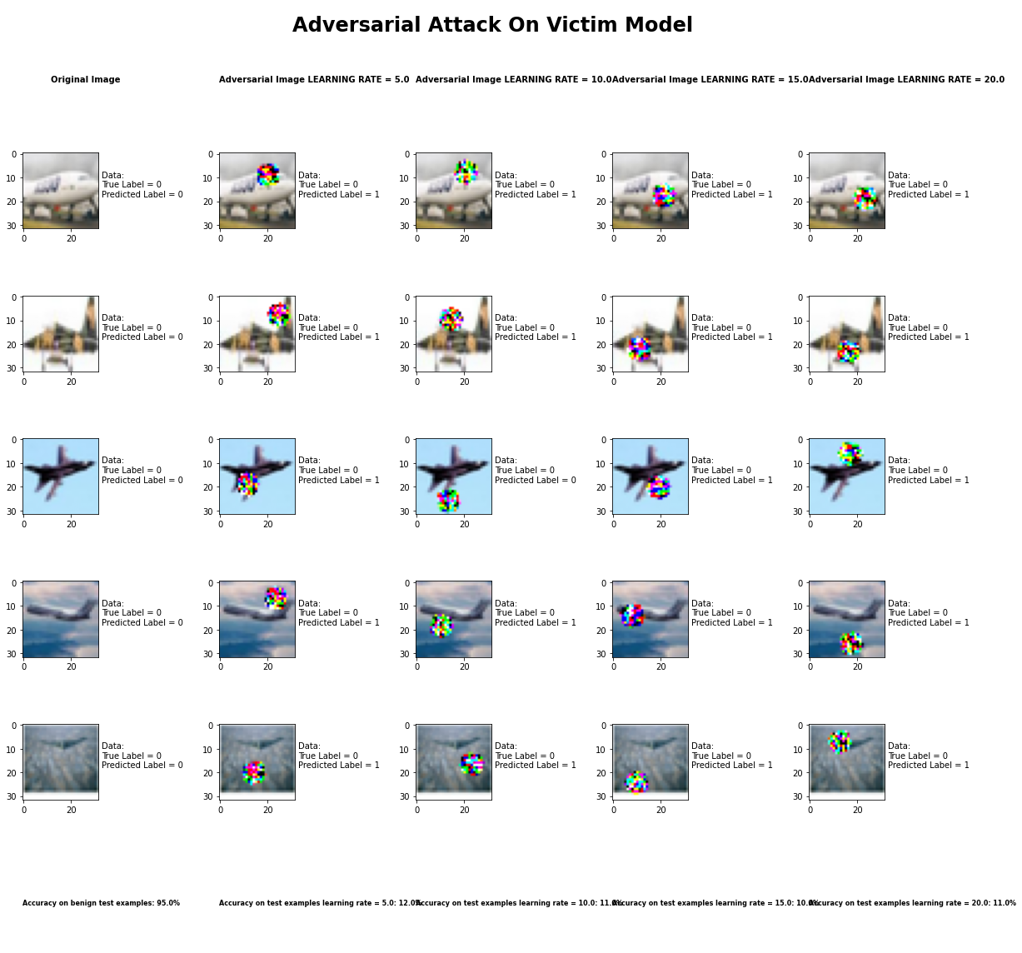

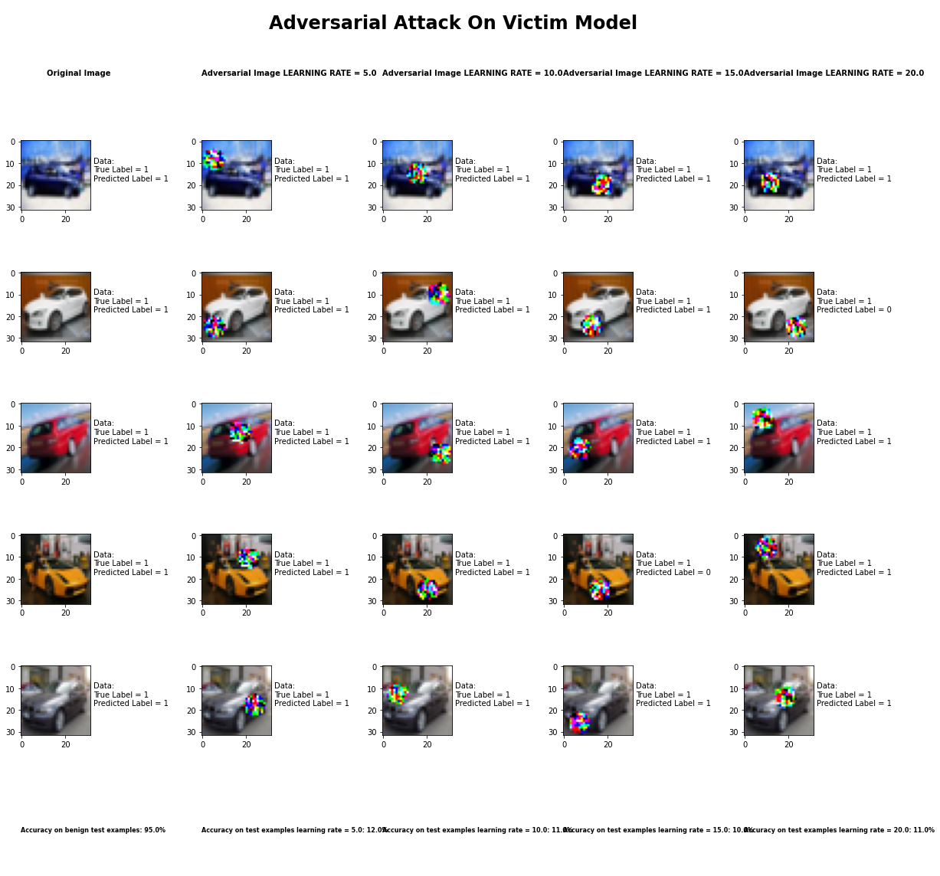

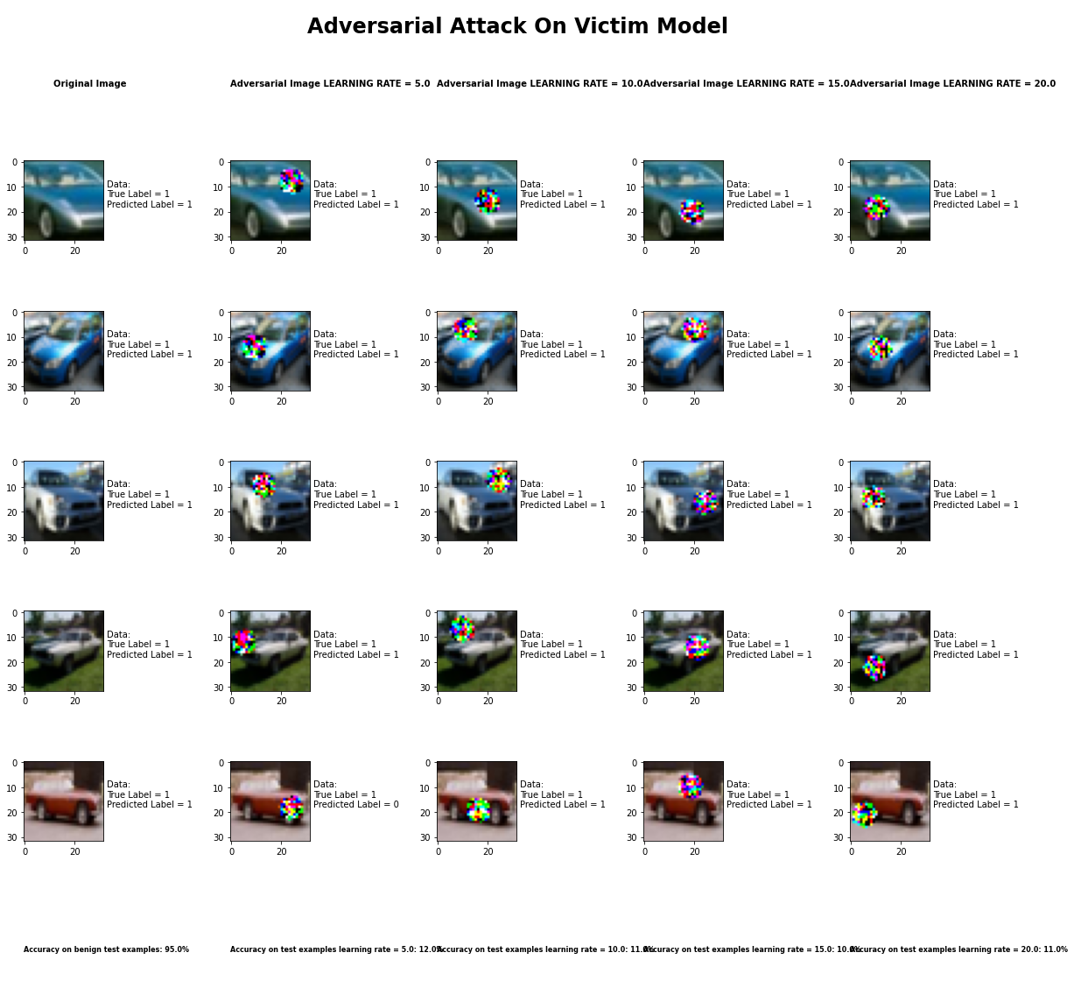

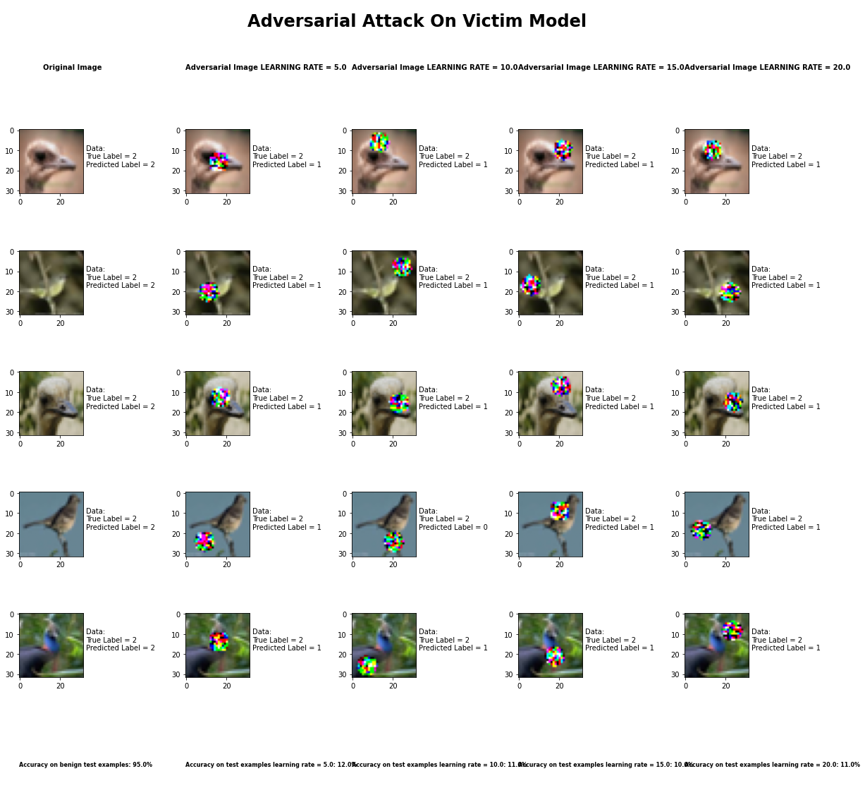

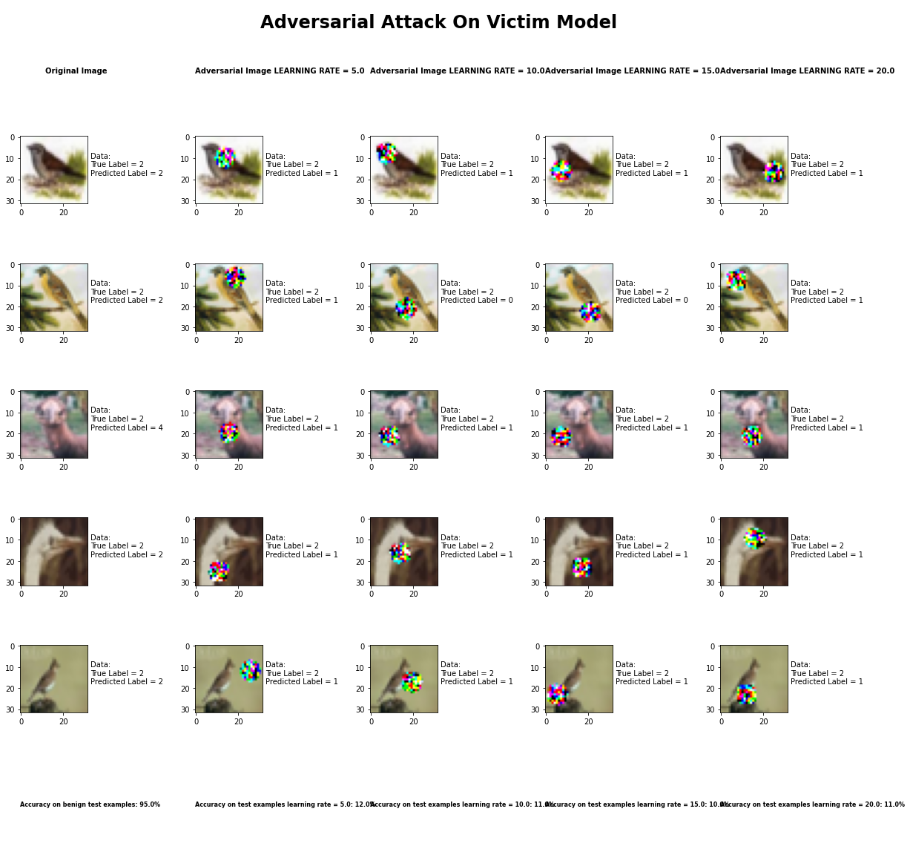

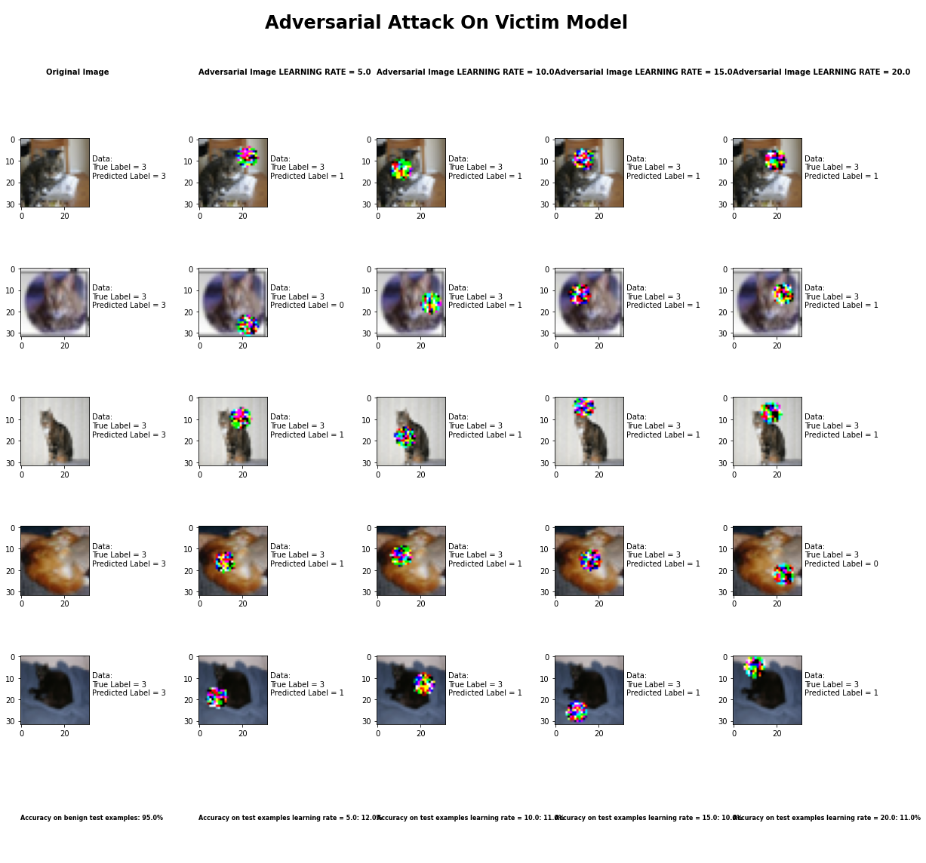

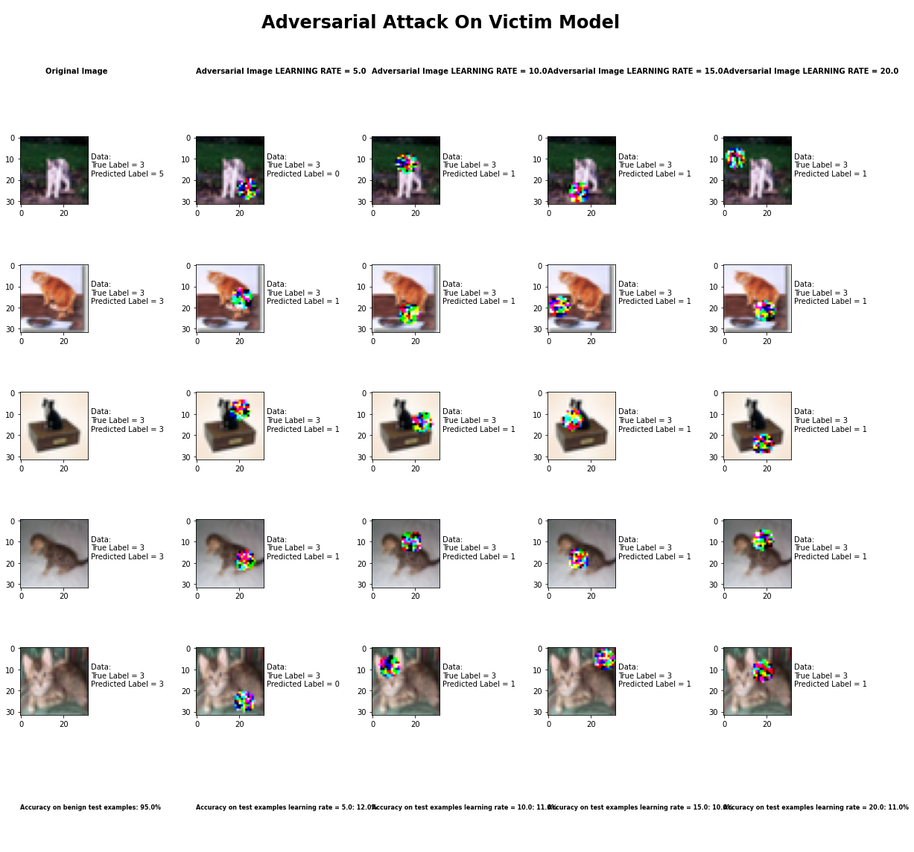

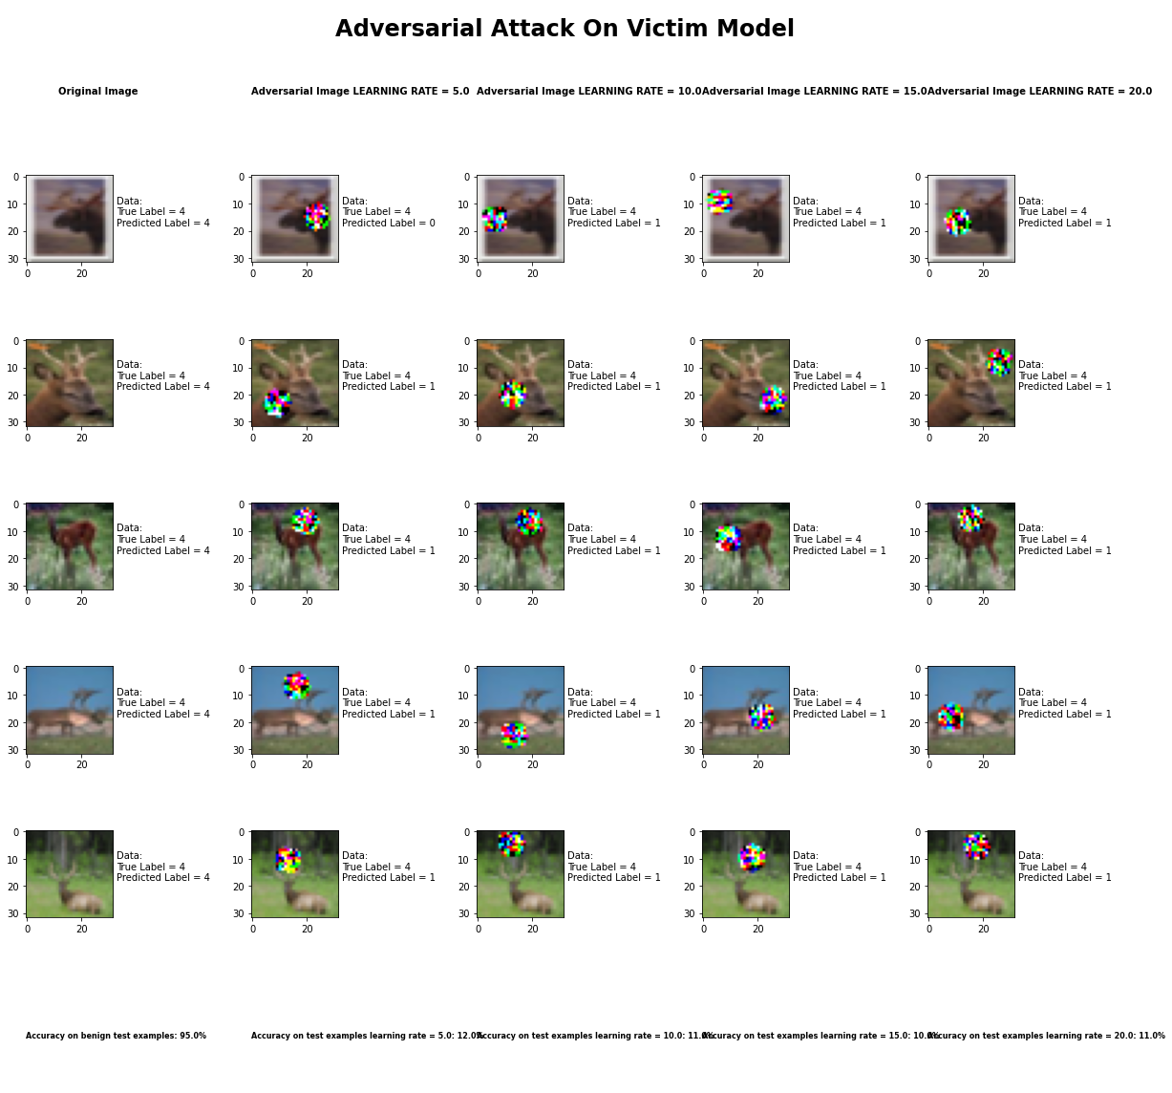

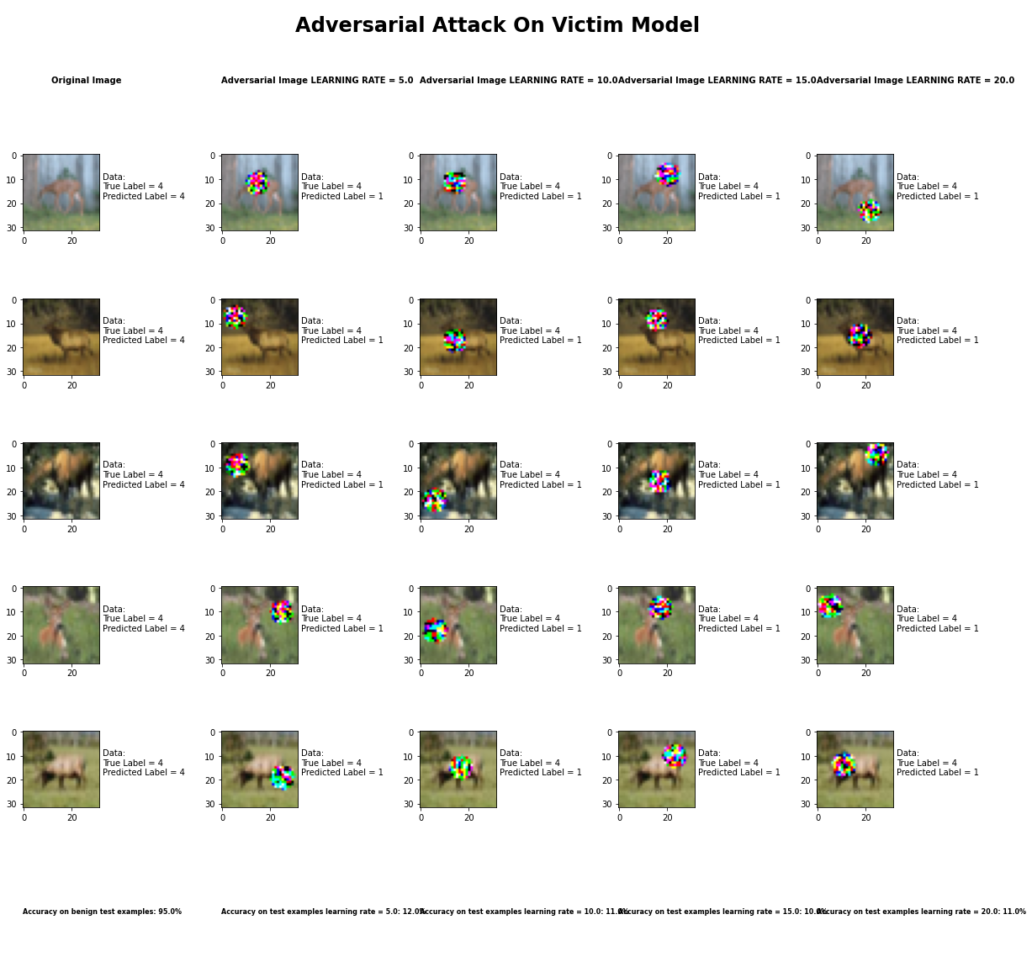

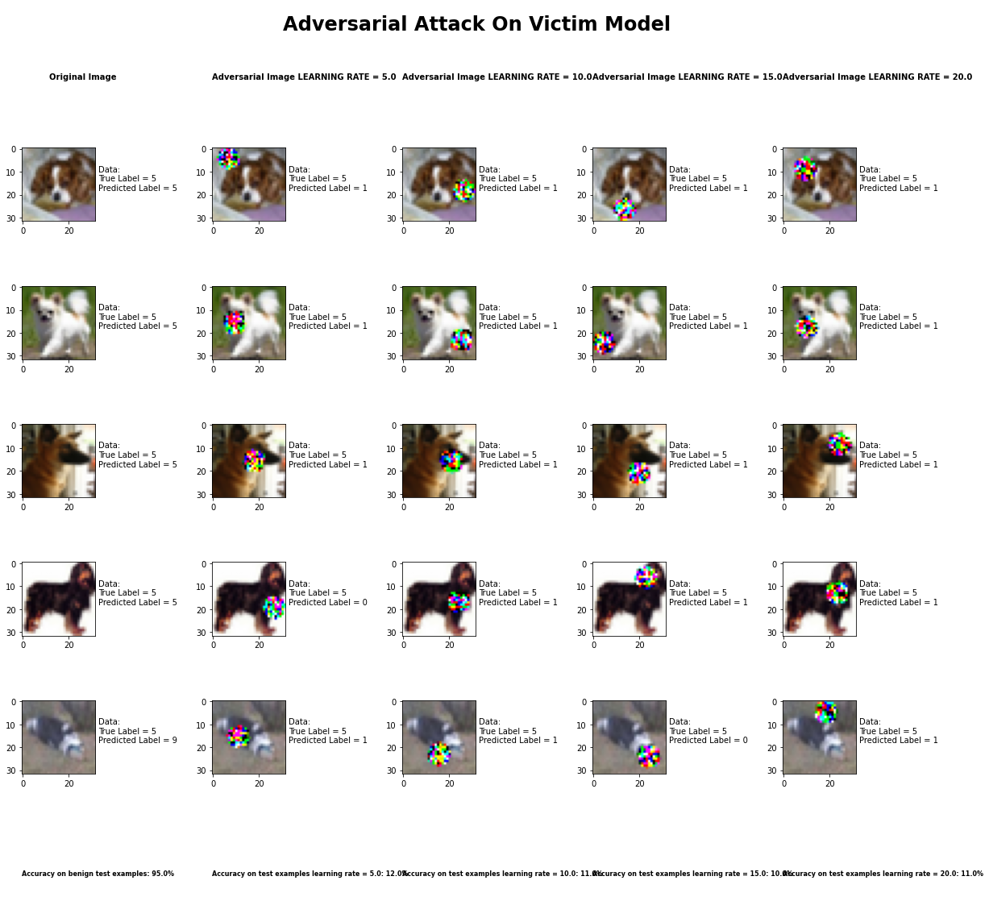

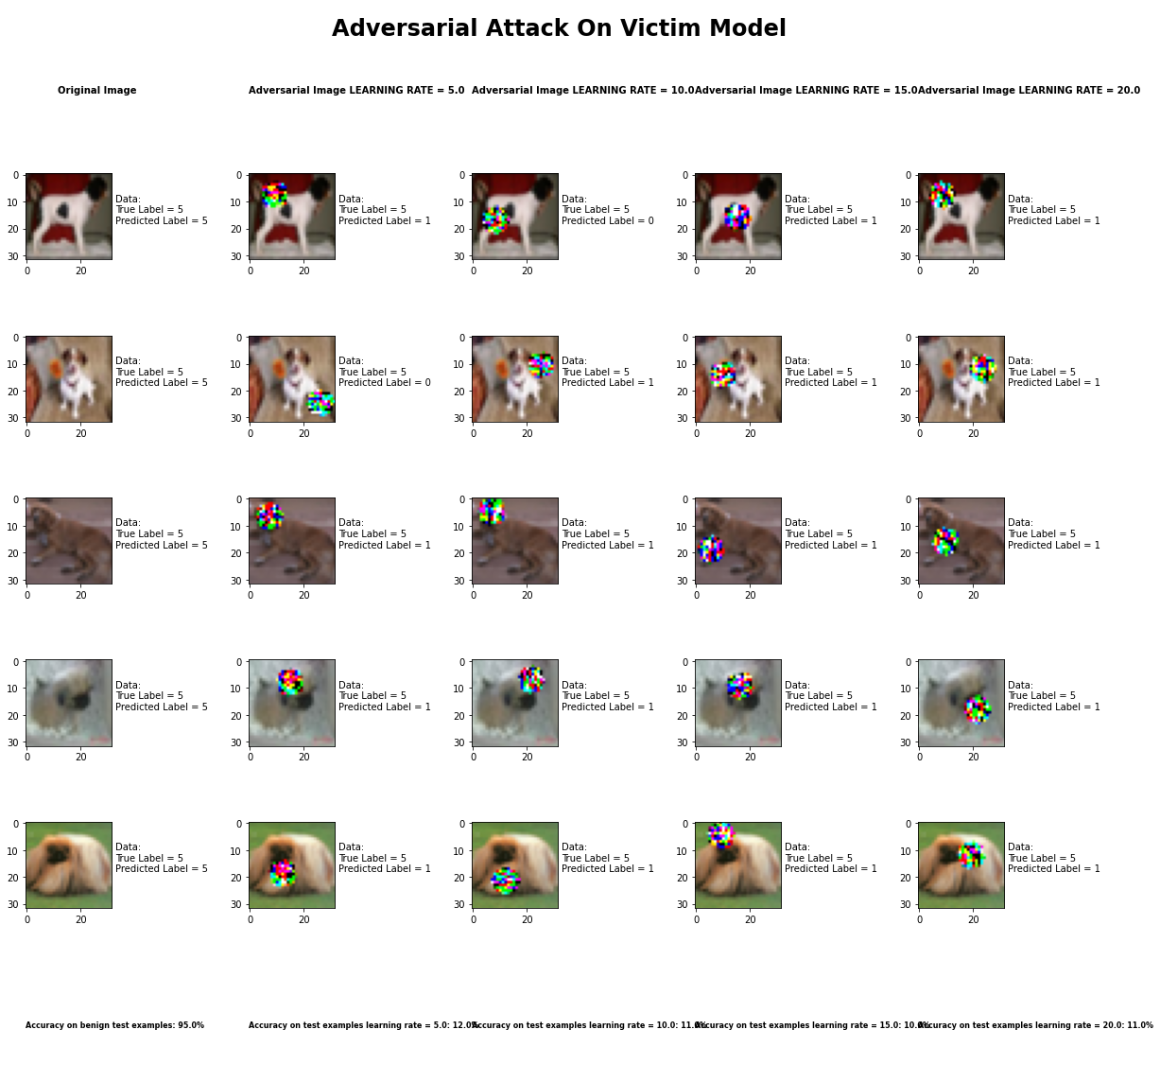

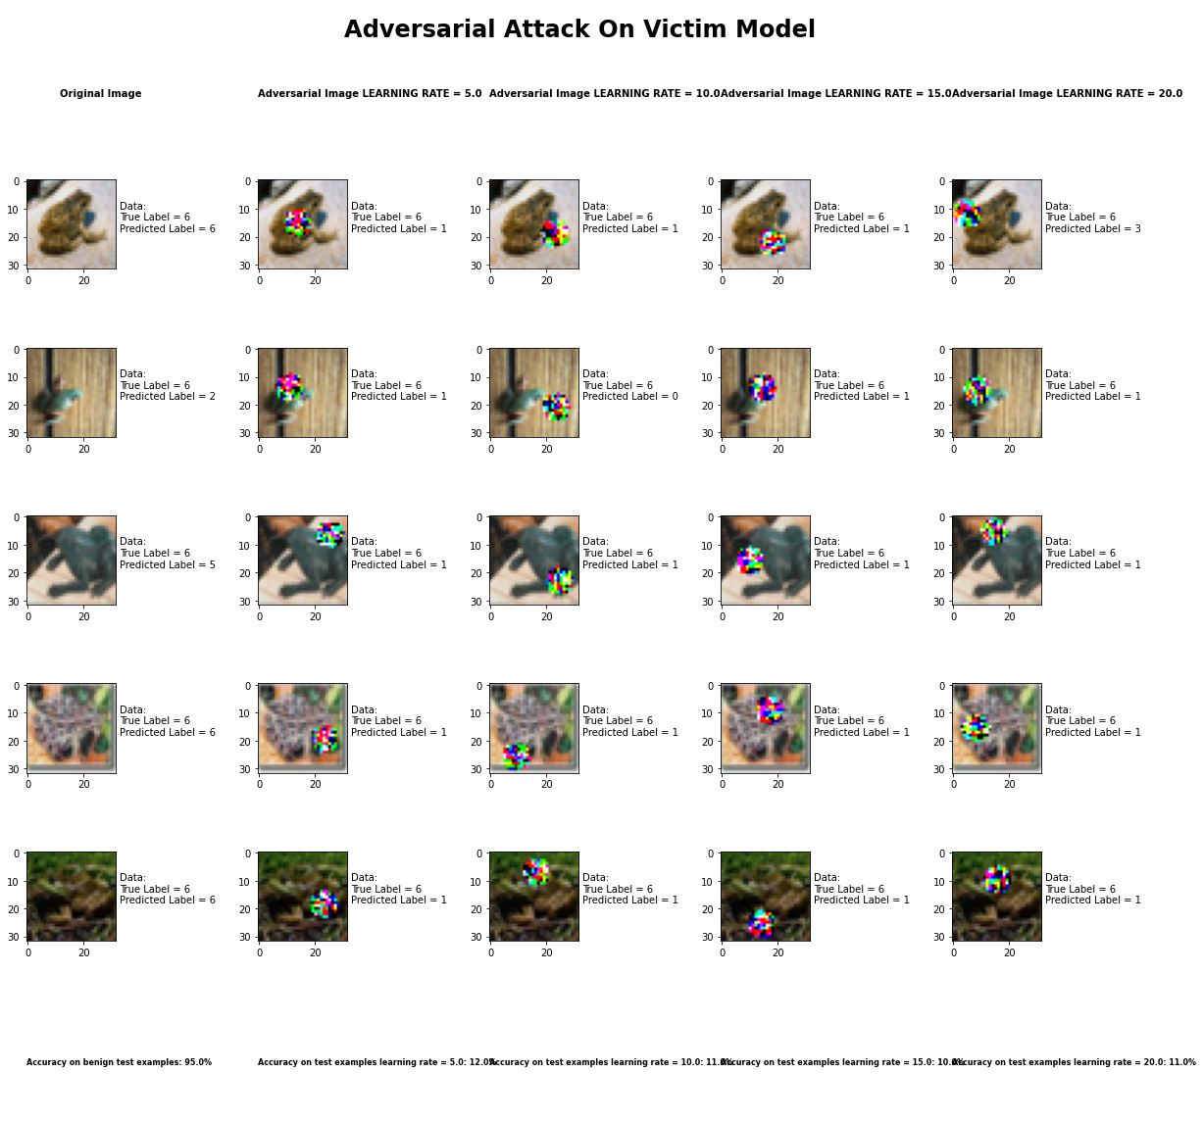

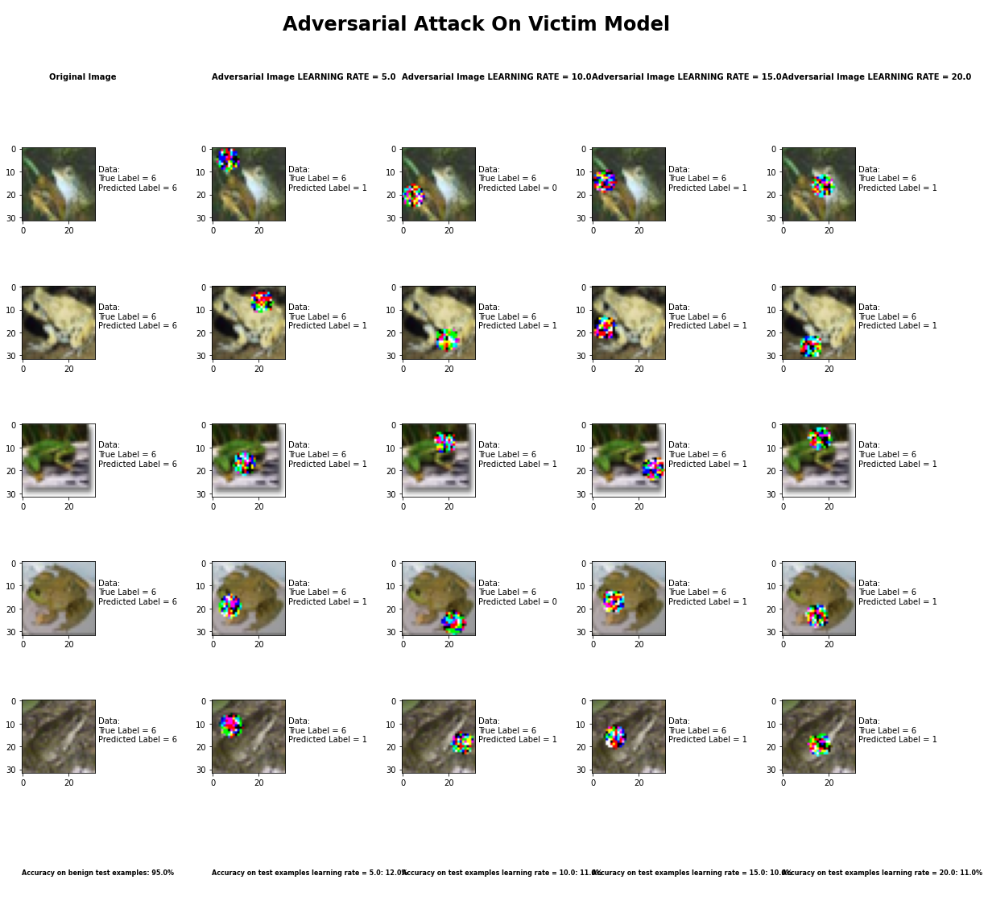

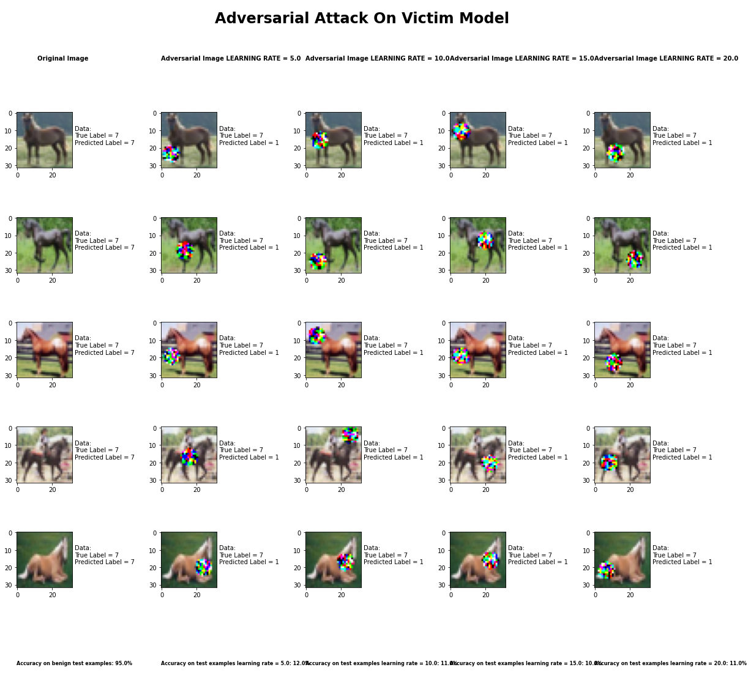

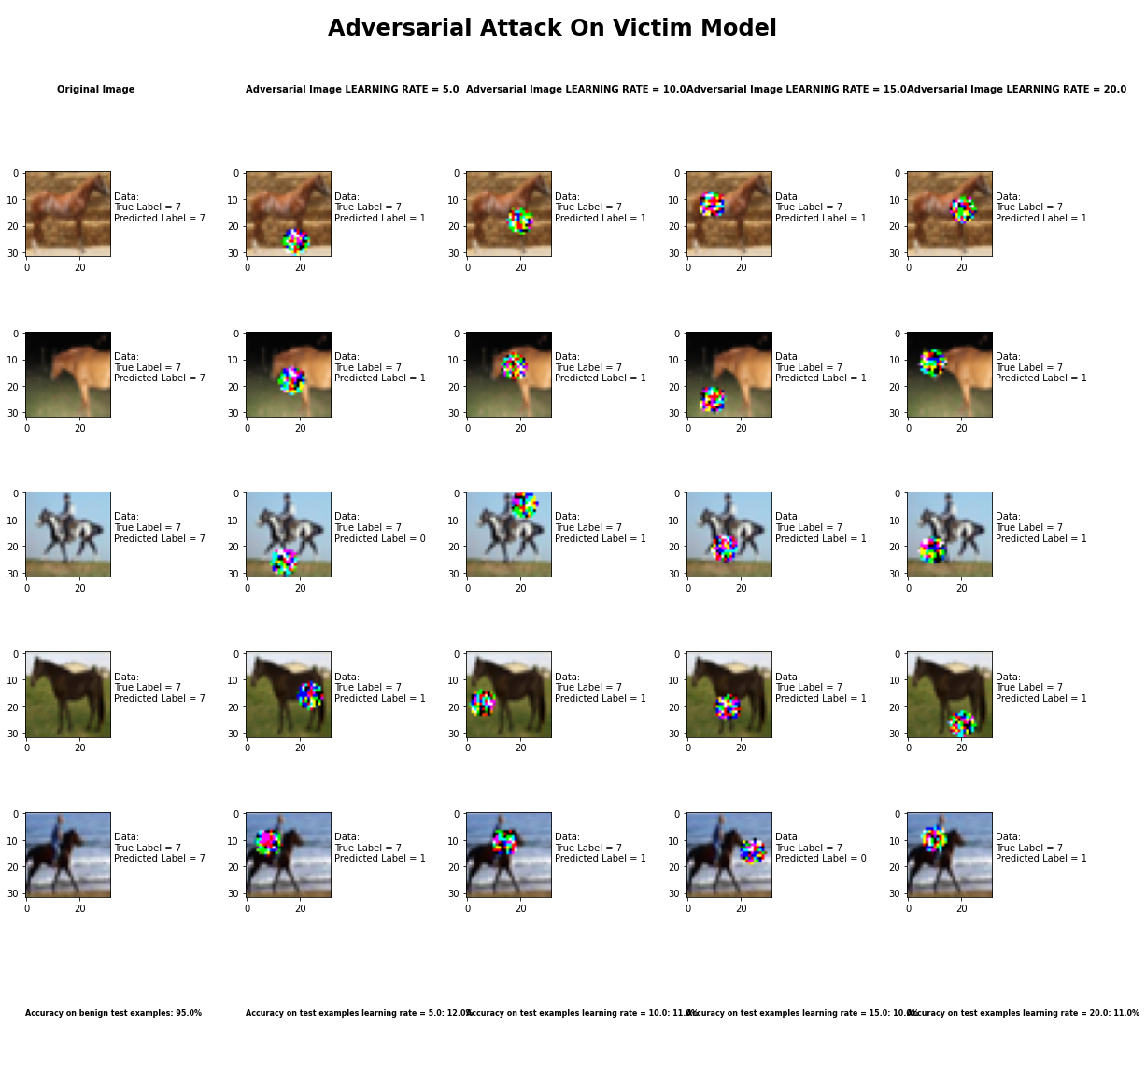

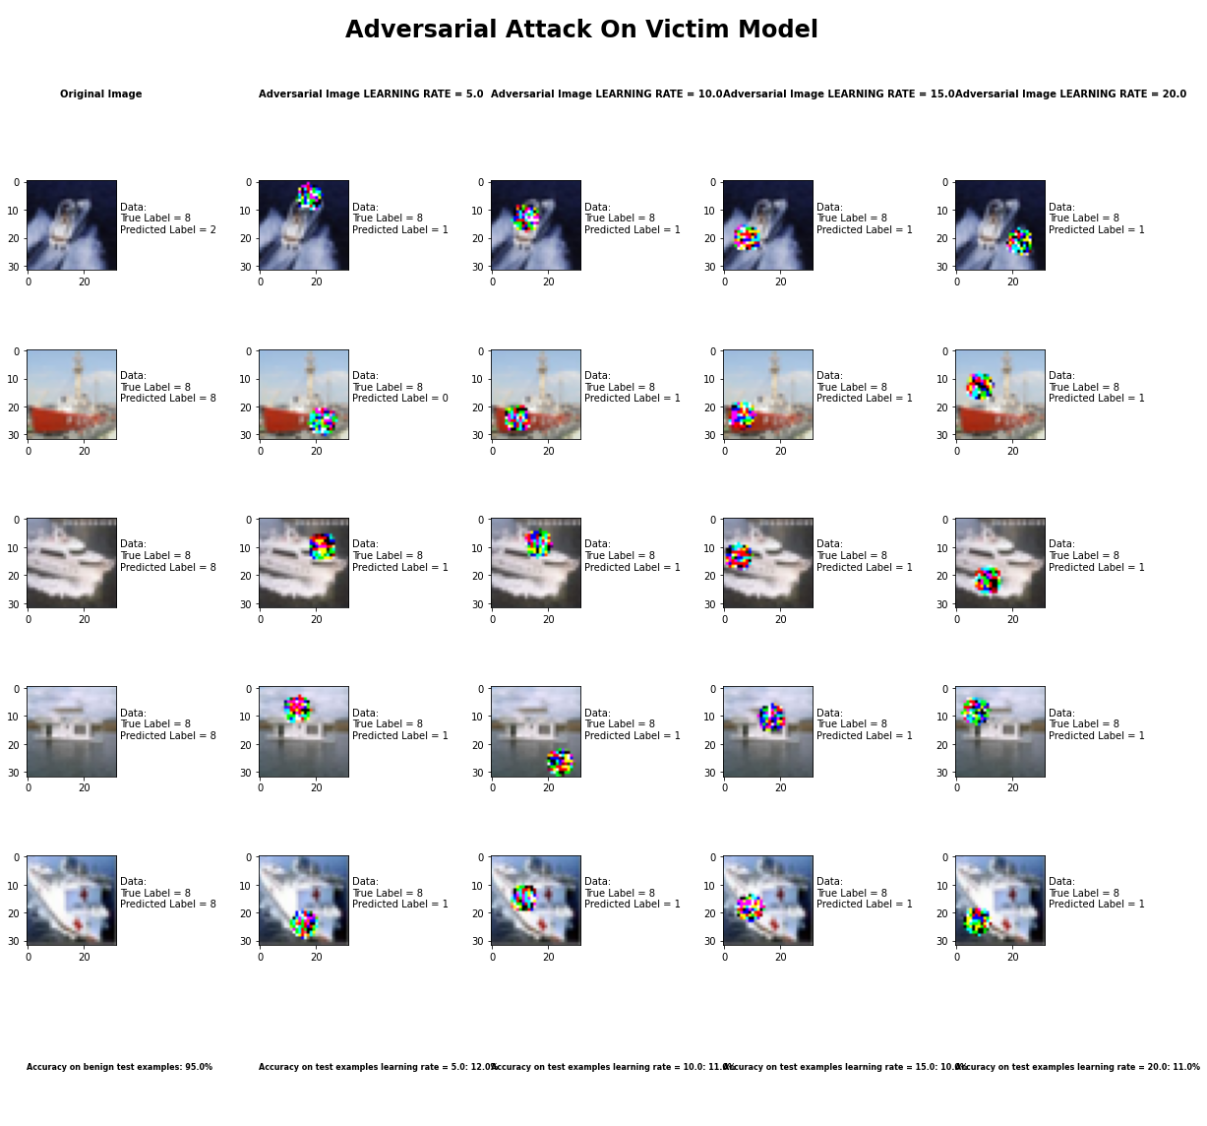

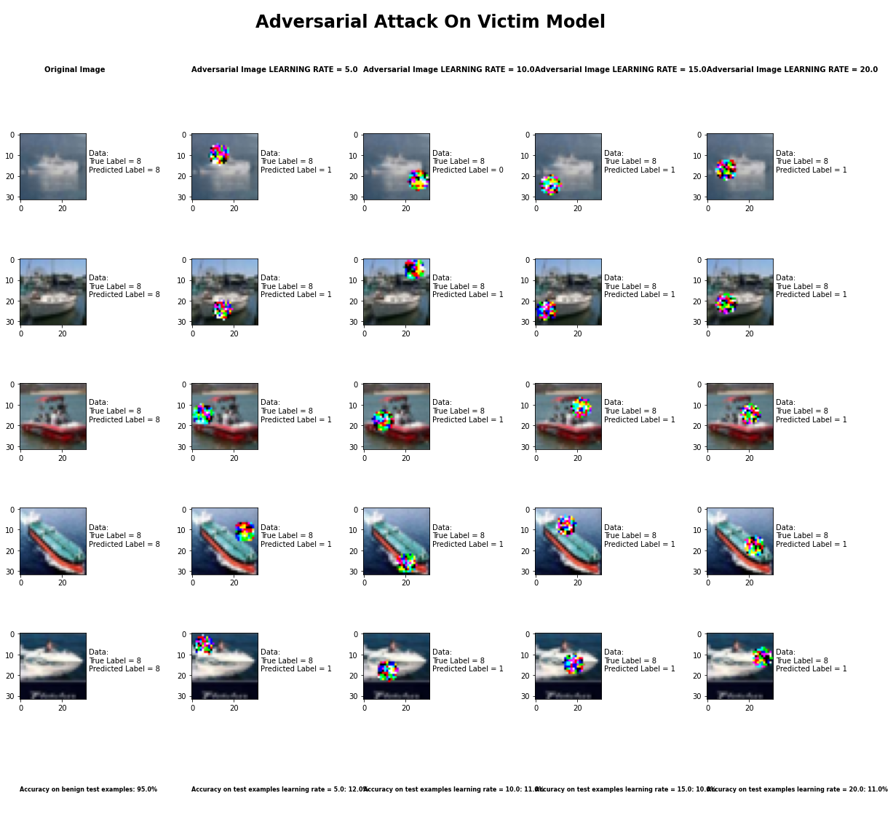

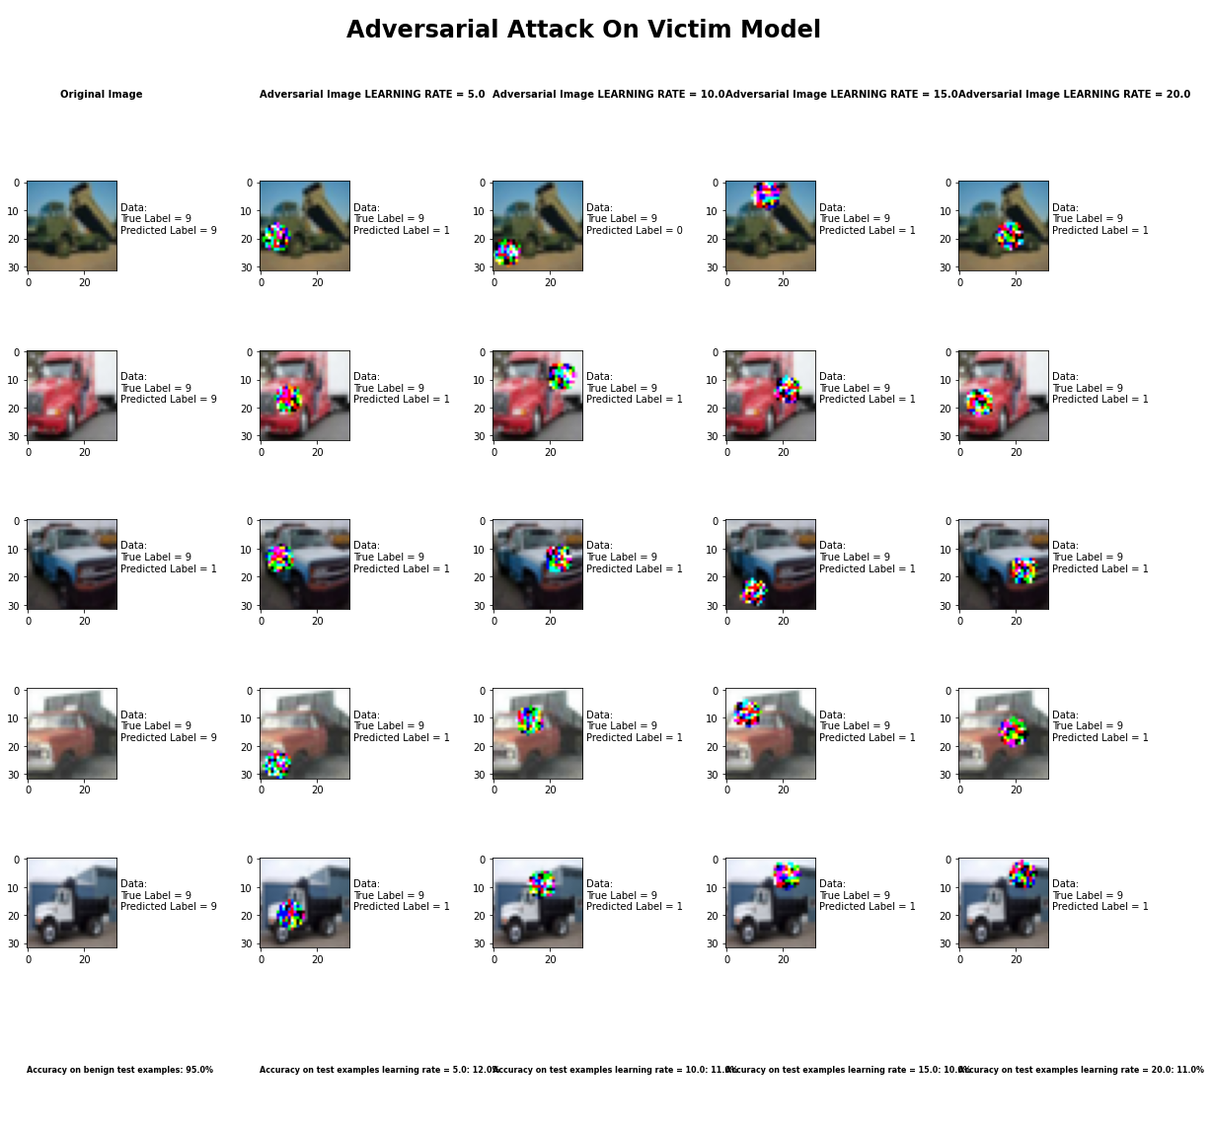

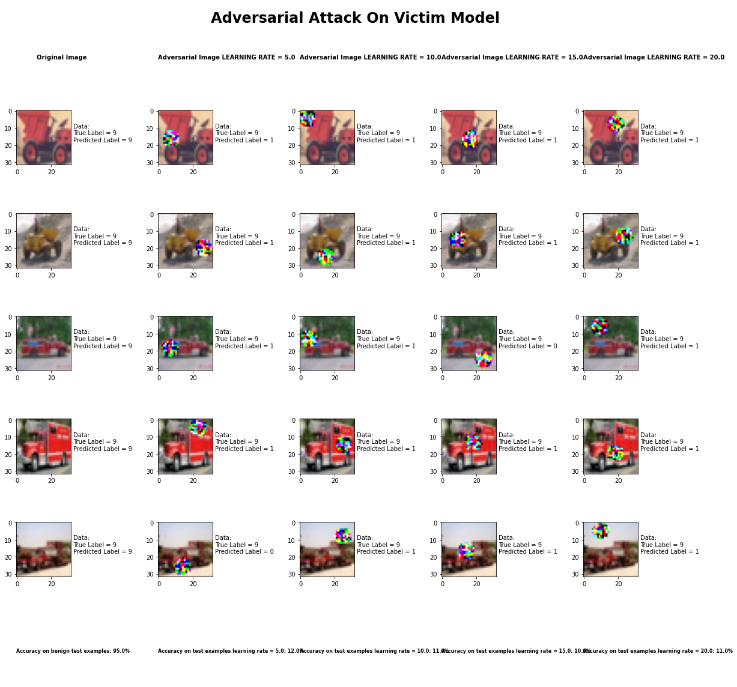

Accuracy on benign test examples: 94.52000000000001%

Average Accuracy on adversarial test examples with learning rate = 5.0: 11.6%

Average Accuracy on adversarial test examples with learning rate = 10.0: 10.9%

Average Accuracy on adversarial test examples with learning rate = 15.0: 10.4%

Average Accuracy on adversarial test examples with learning rate = 20.0: 10.6%

Classifier with benign example has Airplane recognition average accuracy of = 95%

Adversarial Patch Method with learning rate = 5.0 has Airplane recognition average accuracy of = 16%

Adversarial Patch Method with learning rate = 10.0 has Airplane recognition average accuracy of = 12%

Adversarial Patch Method with learning rate = 15.0 has Airplane recognition average accuracy of = 12%

Adversarial Patch Method with learning rate = 20.0 has Airplane recognition average accuracy of = 12%

Classifier with benign example has Automobile recognition average accuracy of = 98%

Adversarial Patch Method with learning rate = 5.0 has Automobile recognition average accuracy of = 99%

Adversarial Patch Method with learning rate = 10.0 has Automobile recognition average accuracy of = 96%

Adversarial Patch Method with learning rate = 15.0 has Automobile recognition average accuracy of = 92%

Adversarial Patch Method with learning rate = 20.0 has Automobile recognition average accuracy of = 93%

Classifier with benign example has Bird recognition average accuracy of = 93%

Adversarial Patch Method with learning rate = 5.0 has Bird recognition average accuracy of = 0%

Adversarial Patch Method with learning rate = 10.0 has Bird recognition average accuracy of = 0%

Adversarial Patch Method with learning rate = 15.0 has Bird recognition average accuracy of = 0%

Adversarial Patch Method with learning rate = 20.0 has Bird recognition average accuracy of = 0%

Classifier with benign example has Cat recognition average accuracy of = 86%

Adversarial Patch Method with learning rate = 5.0 has Cat recognition average accuracy of = 1%

Adversarial Patch Method with learning rate = 10.0 has Cat recognition average accuracy of = 1%

Adversarial Patch Method with learning rate = 15.0 has Cat recognition average accuracy of = 0%

Adversarial Patch Method with learning rate = 20.0 has Cat recognition average accuracy of = 1%

Classifier with benign example has Deer recognition average accuracy of = 95%

Adversarial Patch Method with learning rate = 5.0 has Deer recognition average accuracy of = 0%

Adversarial Patch Method with learning rate = 10.0 has Deer recognition average accuracy of = 0%

Adversarial Patch Method with learning rate = 15.0 has Deer recognition average accuracy of = 0%

Adversarial Patch Method with learning rate = 20.0 has Deer recognition average accuracy of = 0%

Classifier with benign example has Dog recognition average accuracy of = 93%

Adversarial Patch Method with learning rate = 5.0 has Dog recognition average accuracy of = 0%

Adversarial Patch Method with learning rate = 10.0 has Dog recognition average accuracy of = 0%

Adversarial Patch Method with learning rate = 15.0 has Dog recognition average accuracy of = 0%

Adversarial Patch Method with learning rate = 20.0 has Dog recognition average accuracy of = 0%

Classifier with benign example has Frog recognition average accuracy of = 94%

Adversarial Patch Method with learning rate = 5.0 has Frog recognition average accuracy of = 0%

Adversarial Patch Method with learning rate = 10.0 has Frog recognition average accuracy of = 0%

Adversarial Patch Method with learning rate = 15.0 has Frog recognition average accuracy of = 0%

Adversarial Patch Method with learning rate = 20.0 has Frog recognition average accuracy of = 0%

Classifier with benign example has Horse recognition average accuracy of = 97%

Adversarial Patch Method with learning rate = 5.0 has Horse recognition average accuracy of = 0%

Adversarial Patch Method with learning rate = 10.0 has Horse recognition average accuracy of = 0%

Adversarial Patch Method with learning rate = 15.0 has Horse recognition average accuracy of = 0%

Adversarial Patch Method with learning rate = 20.0 has Horse recognition average accuracy of = 0%

Classifier with benign example has Ship recognition average accuracy of = 95%

Adversarial Patch Method with learning rate = 5.0 has Ship recognition average accuracy of = 0%

Adversarial Patch Method with learning rate = 10.0 has Ship recognition average accuracy of = 0%

Adversarial Patch Method with learning rate = 15.0 has Ship recognition average accuracy of = 0%

Adversarial Patch Method with learning rate = 20.0 has Ship recognition average accuracy of = 0%

Classifier with benign example has Truck recognition average accuracy of = 97%

Adversarial Patch Method with learning rate = 5.0 has Truck recognition average accuracy of = 0%

Adversarial Patch Method with learning rate = 10.0 has Truck recognition average accuracy of = 0%

Adversarial Patch Method with learning rate = 15.0 has Truck recognition average accuracy of = 0%

Adversarial Patch Method with learning rate = 20.0 has Truck recognition average accuracy of = 0%

## Carlini LInf Method



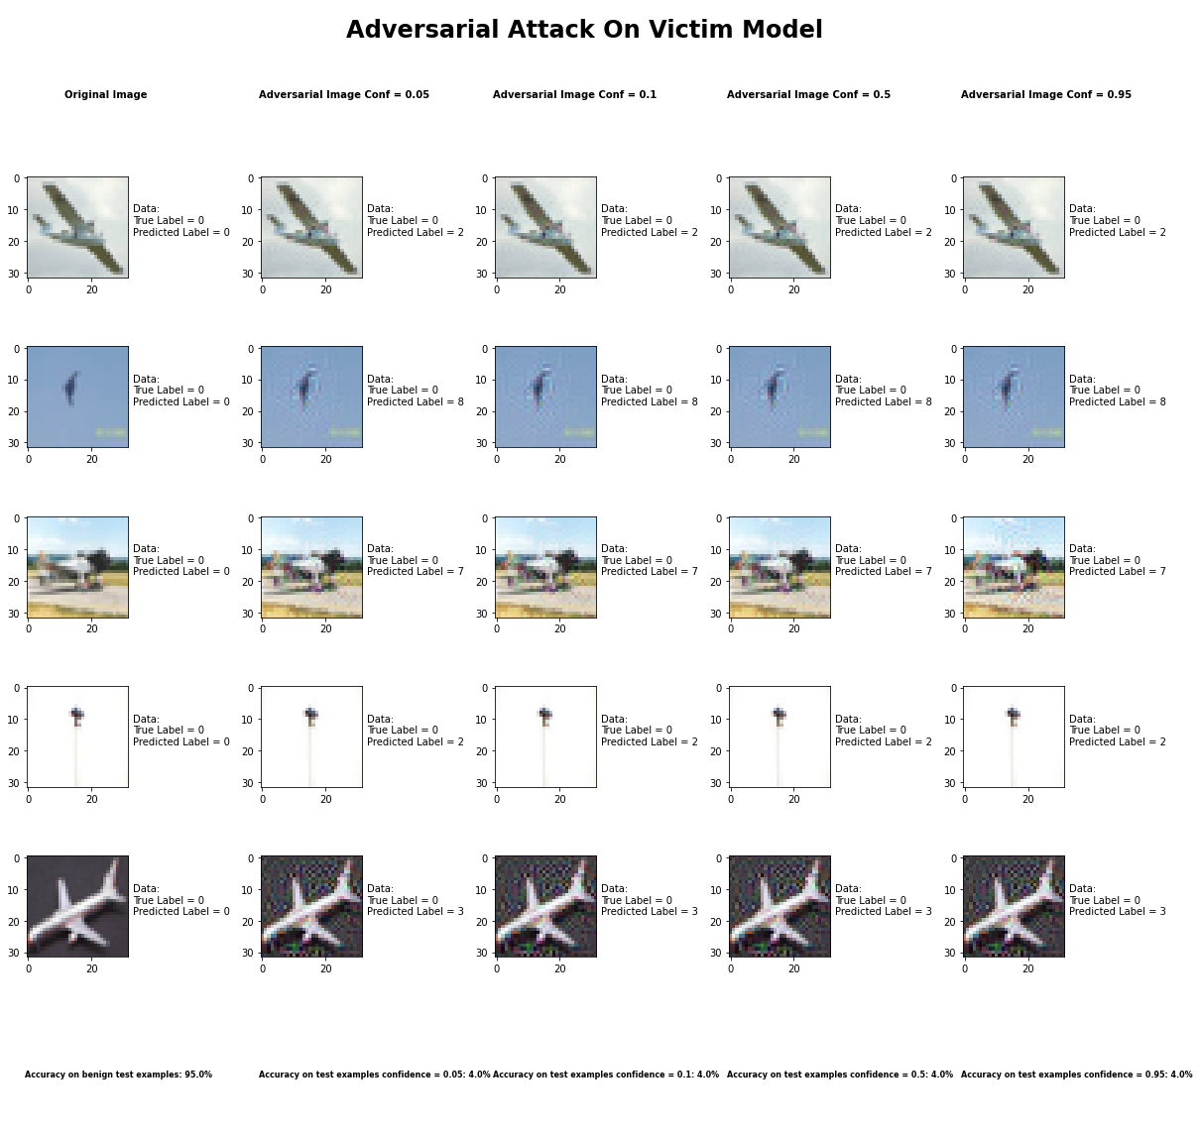

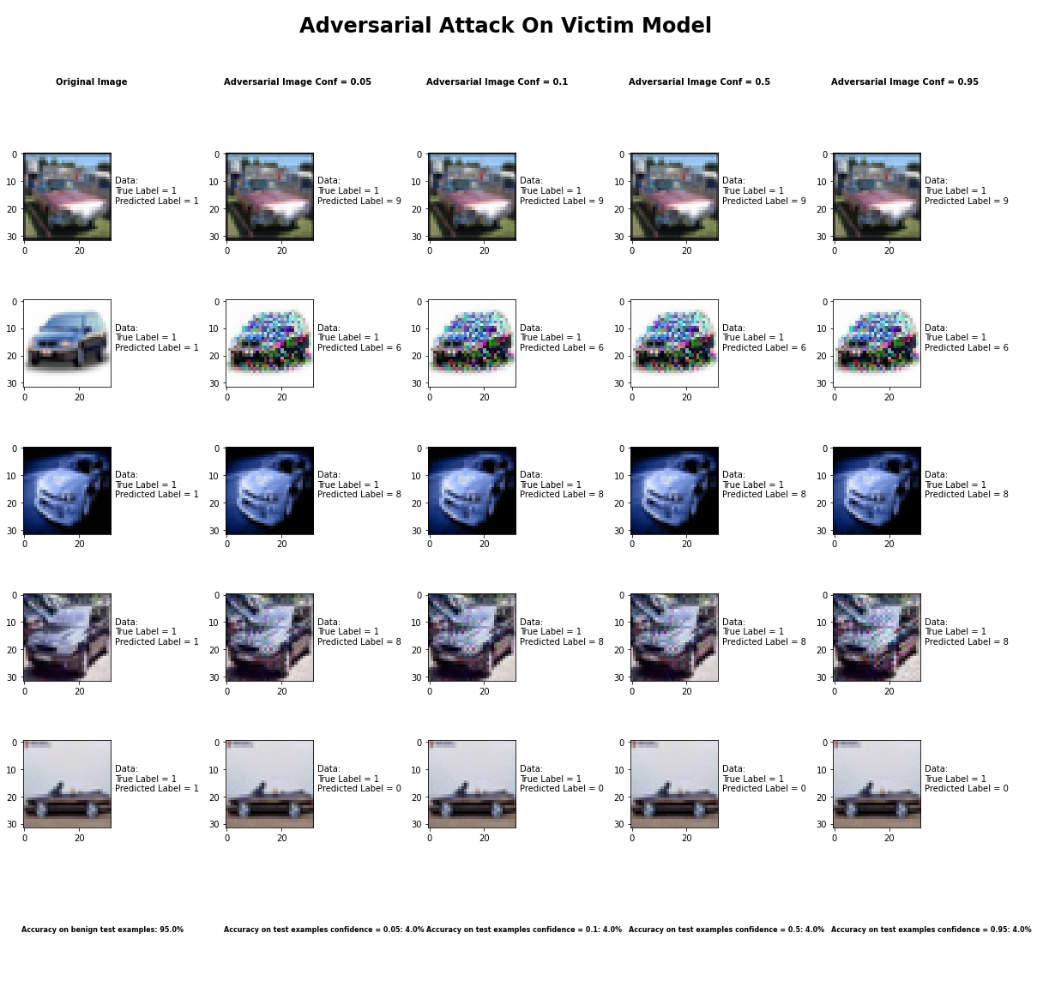

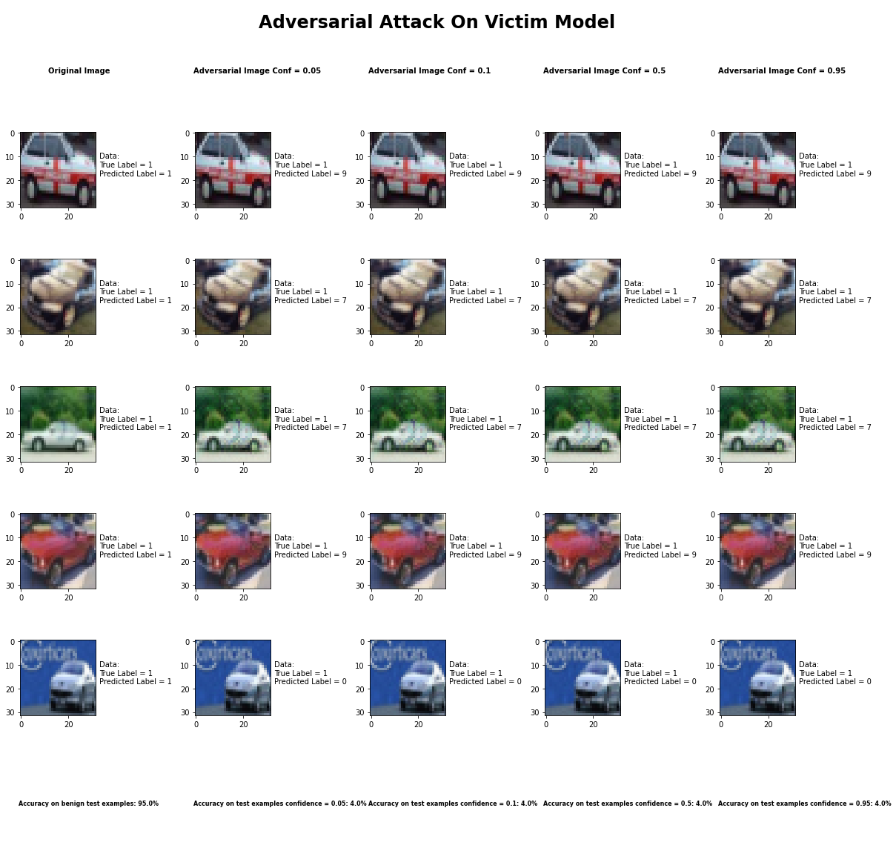

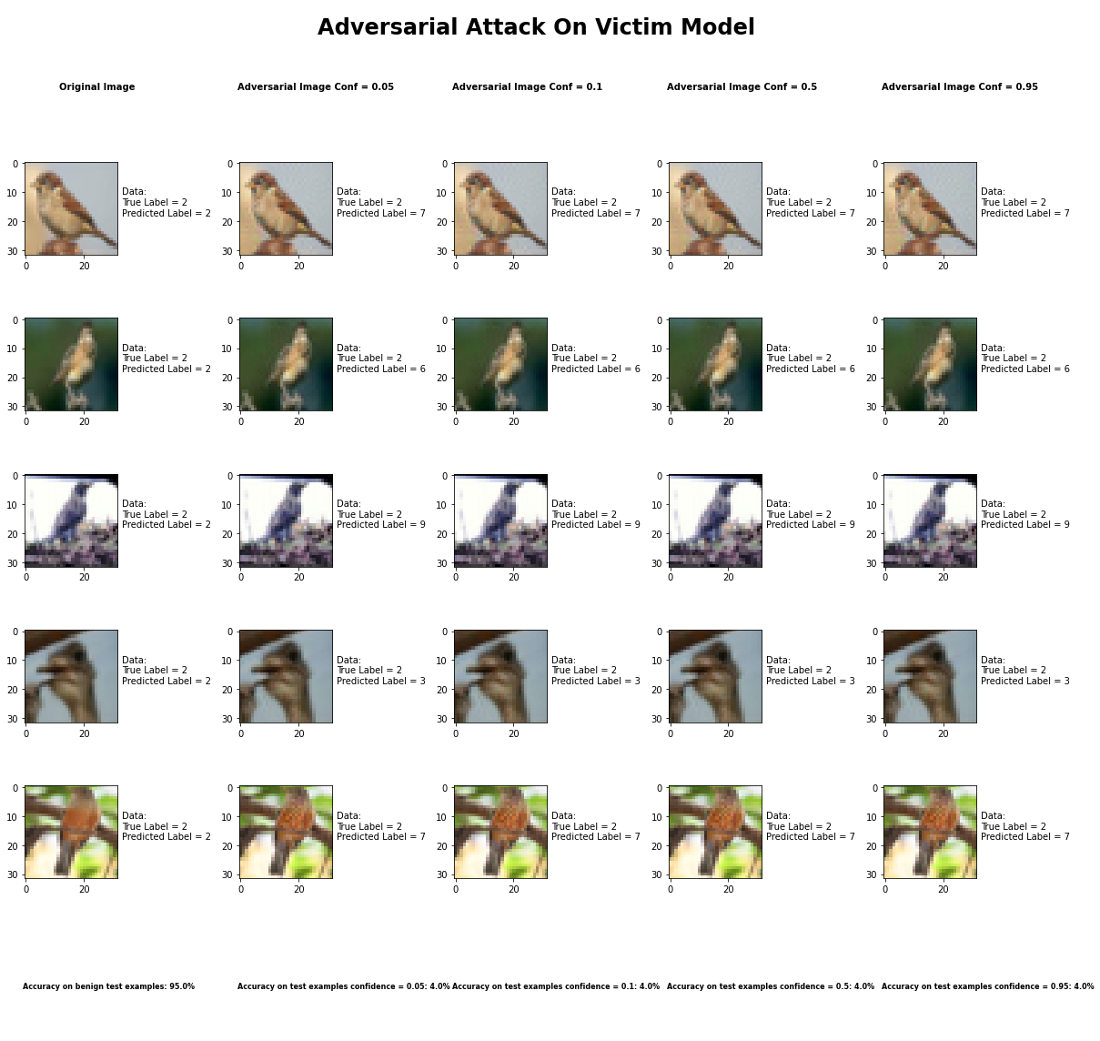

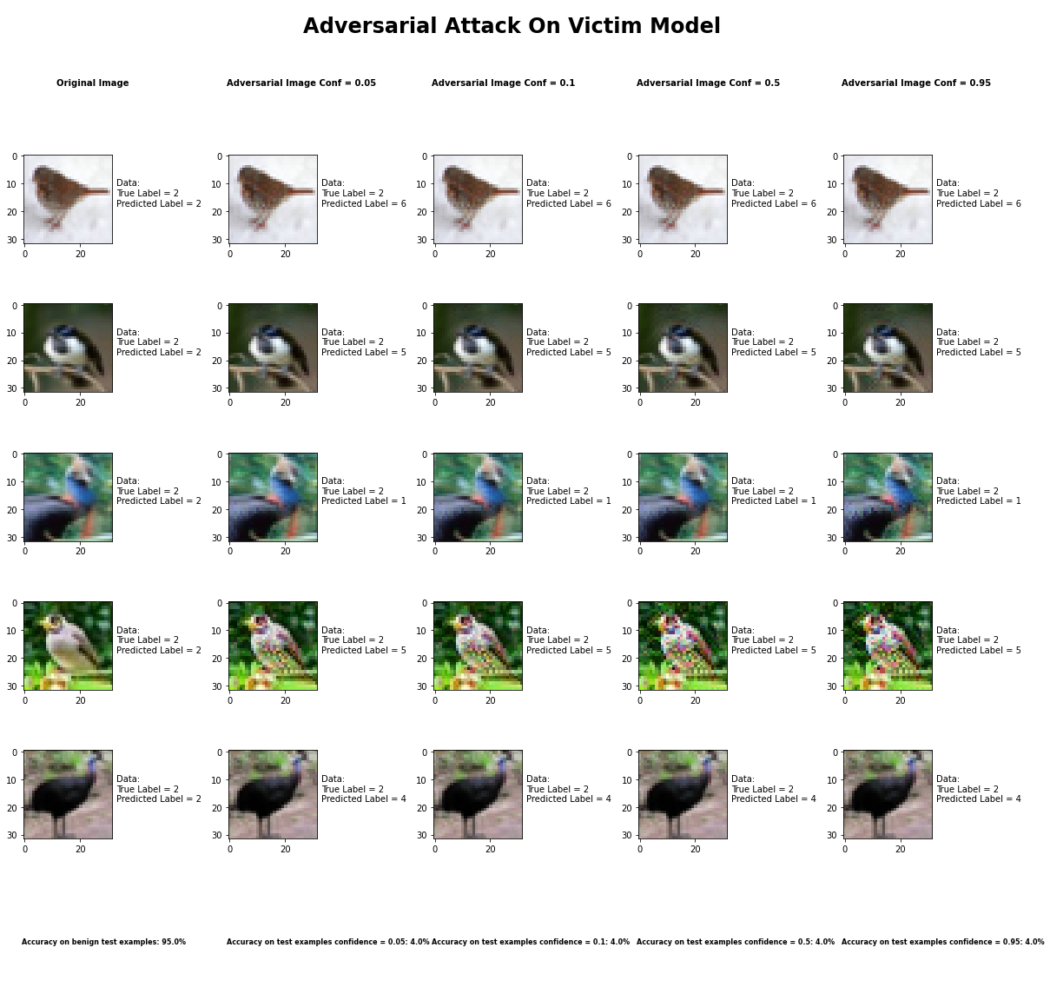

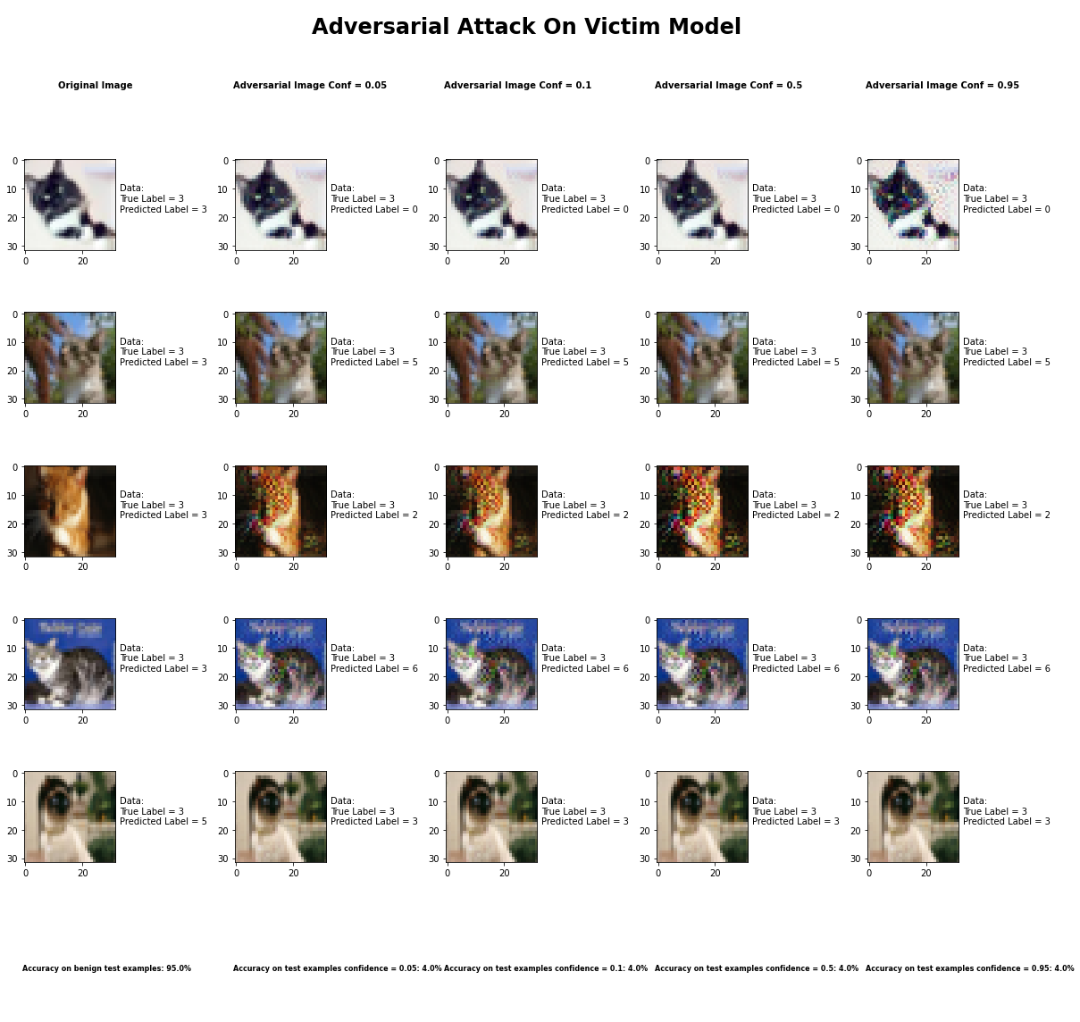

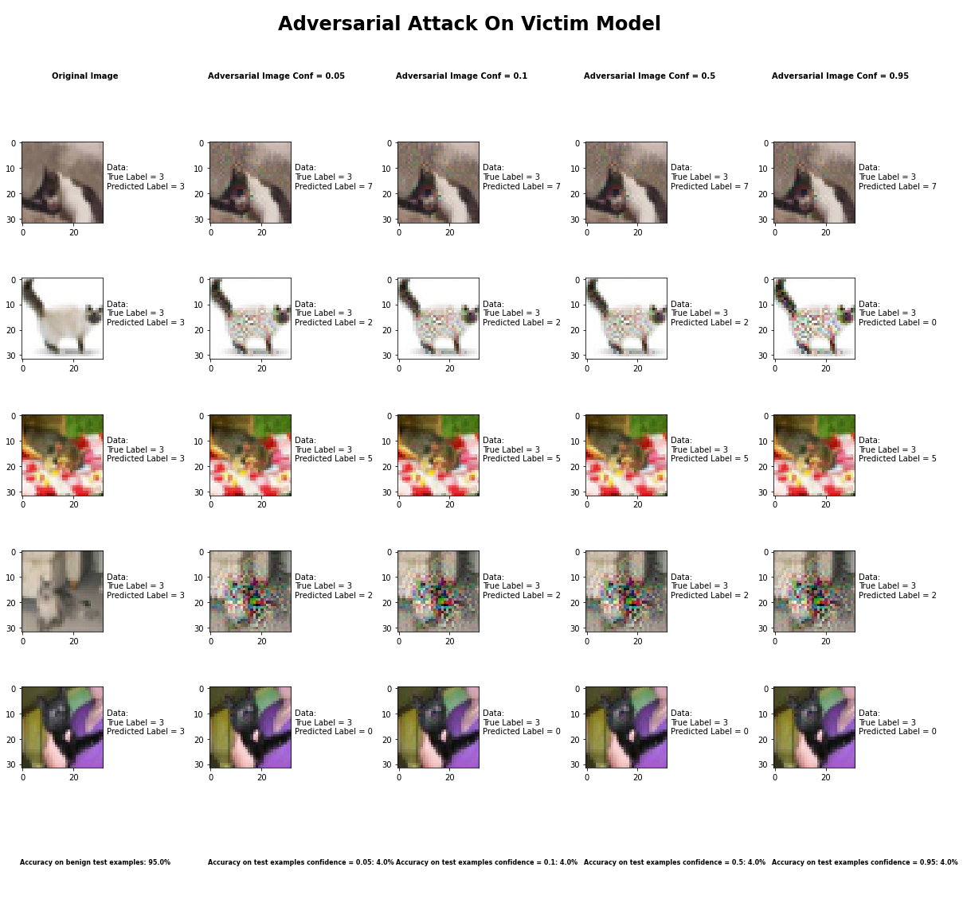

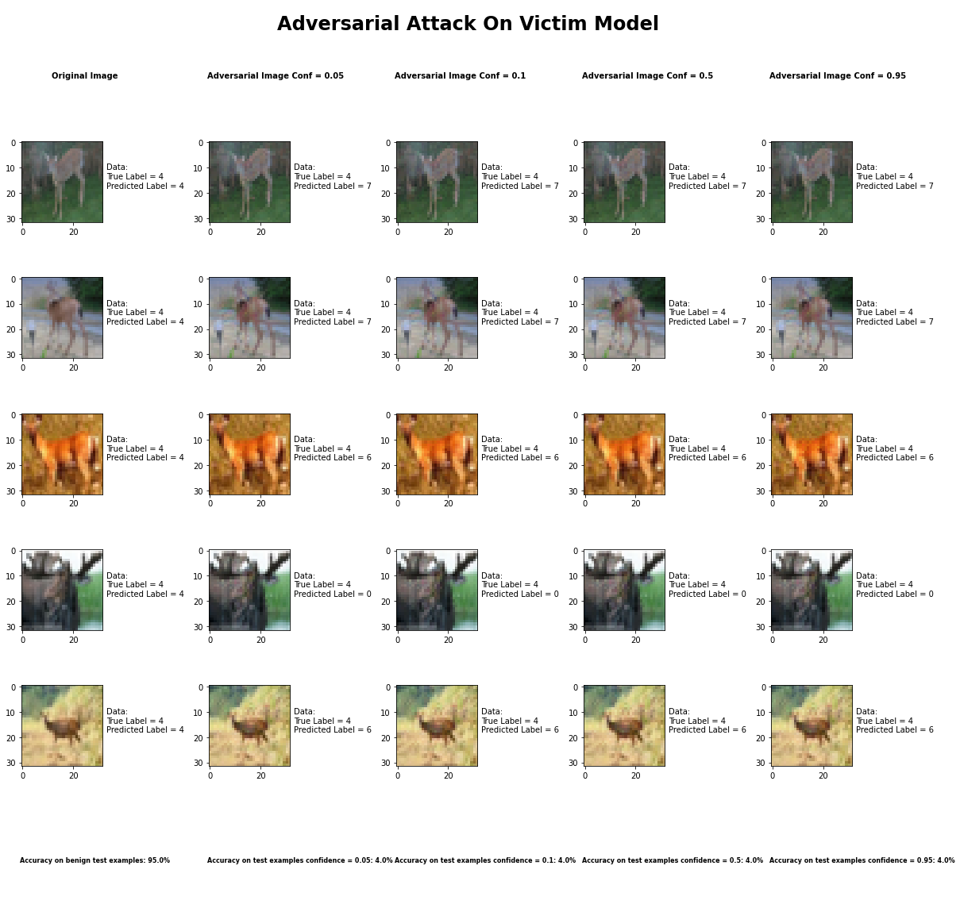

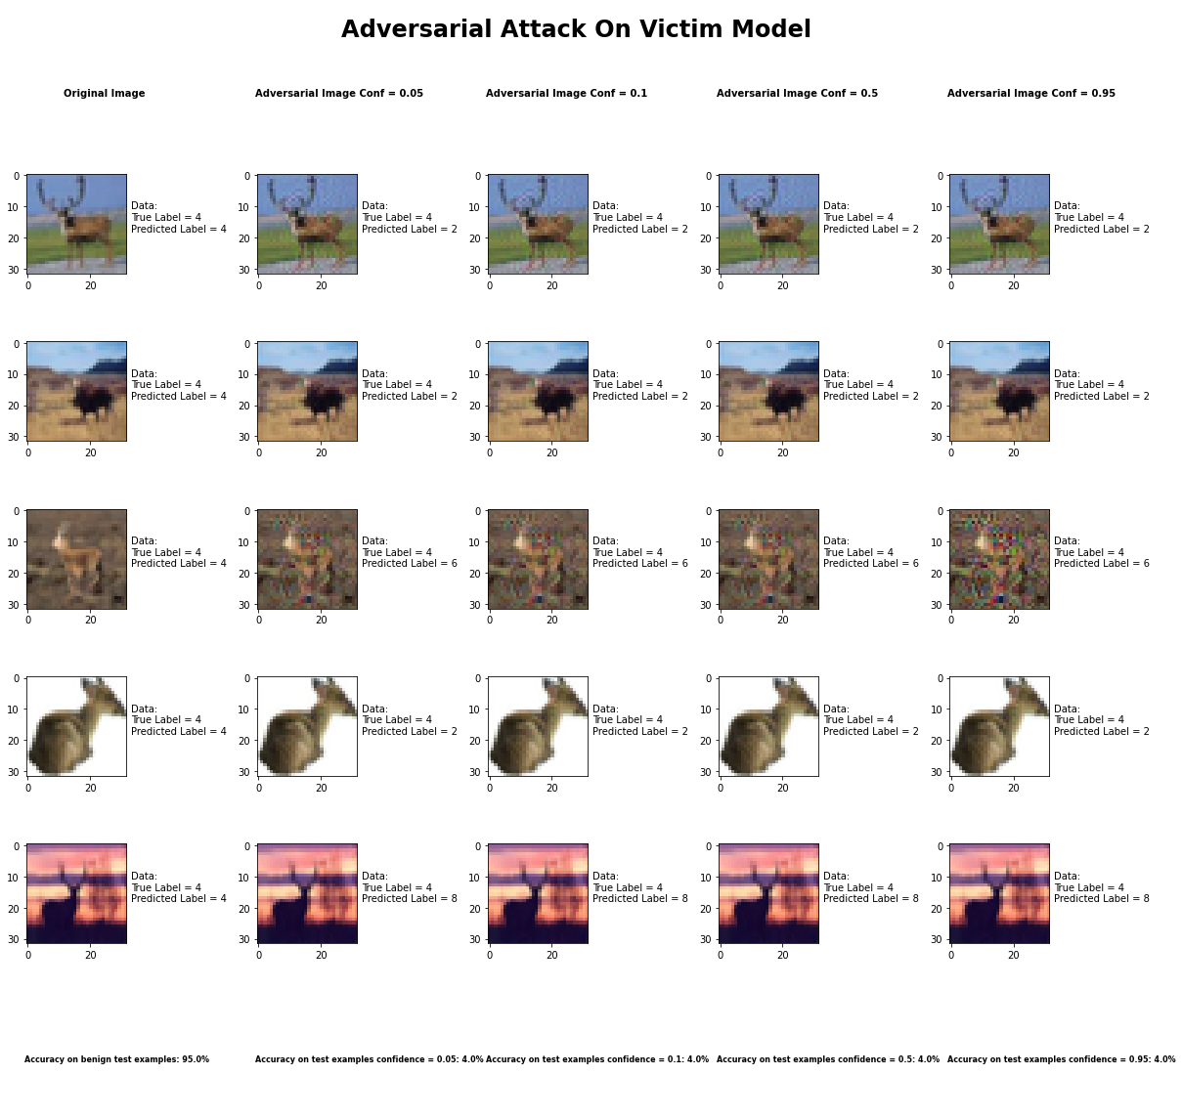

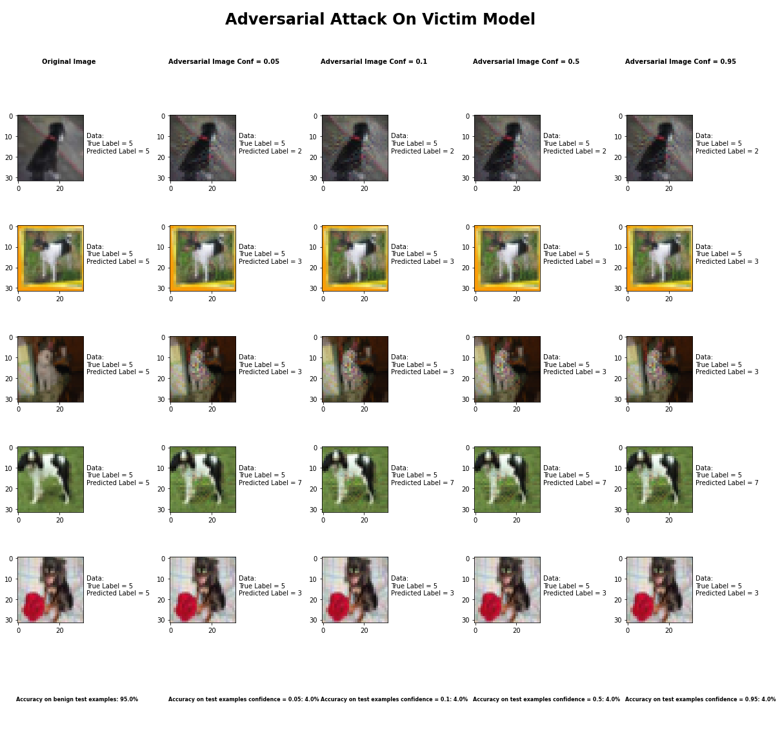

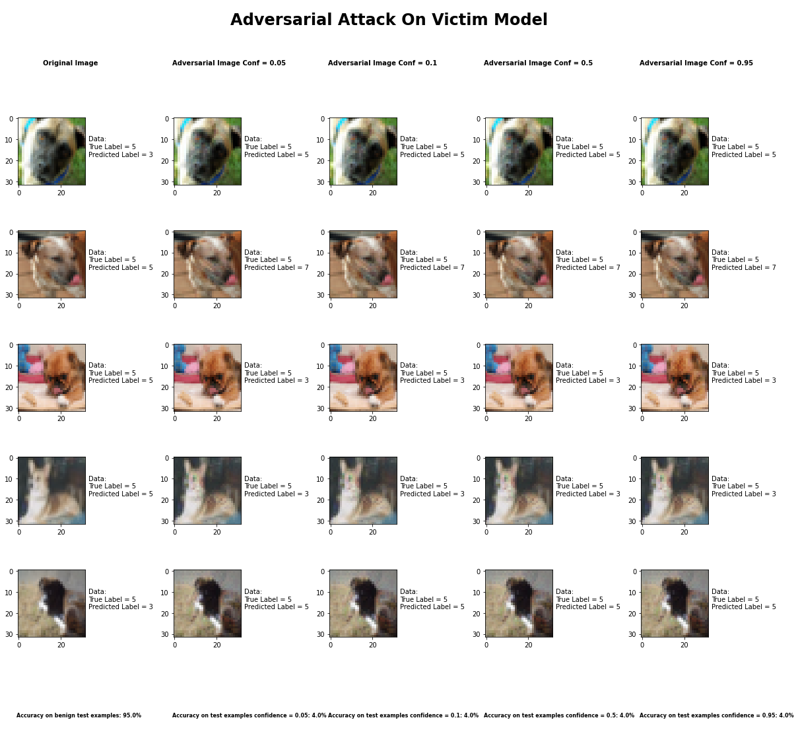

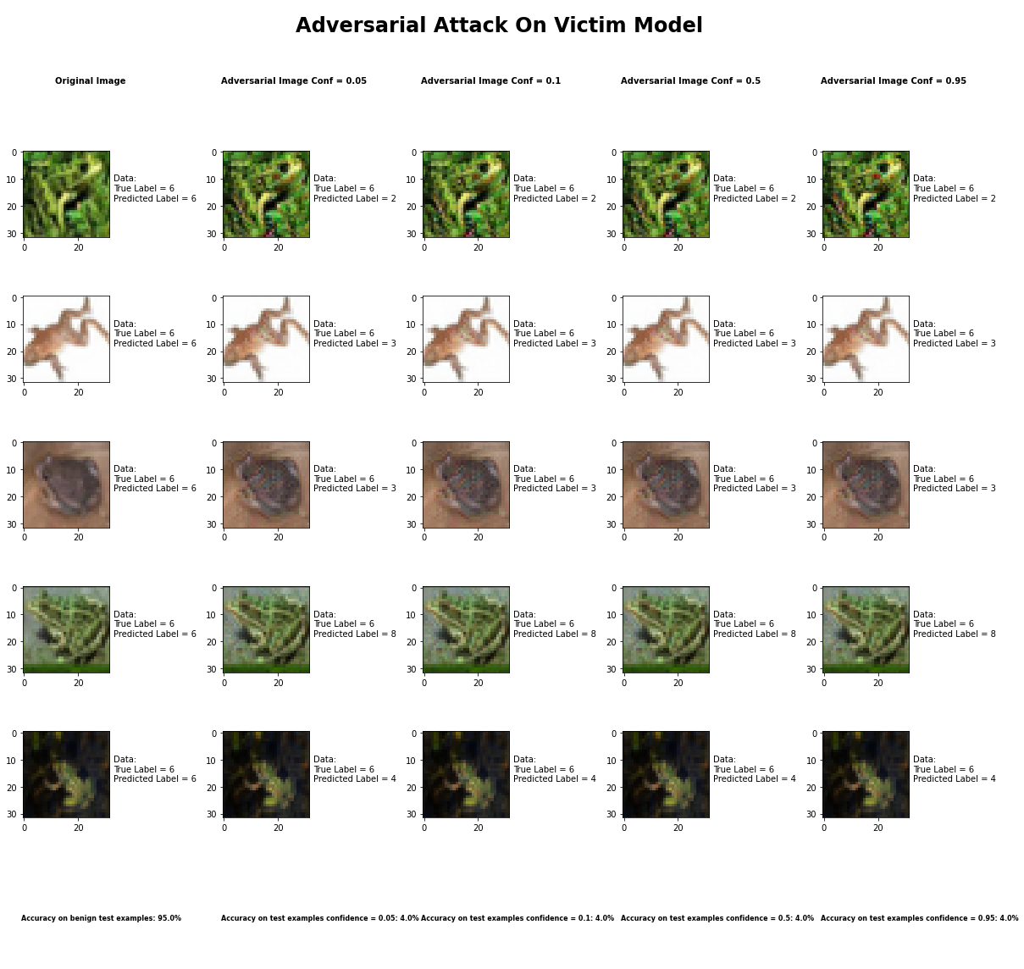

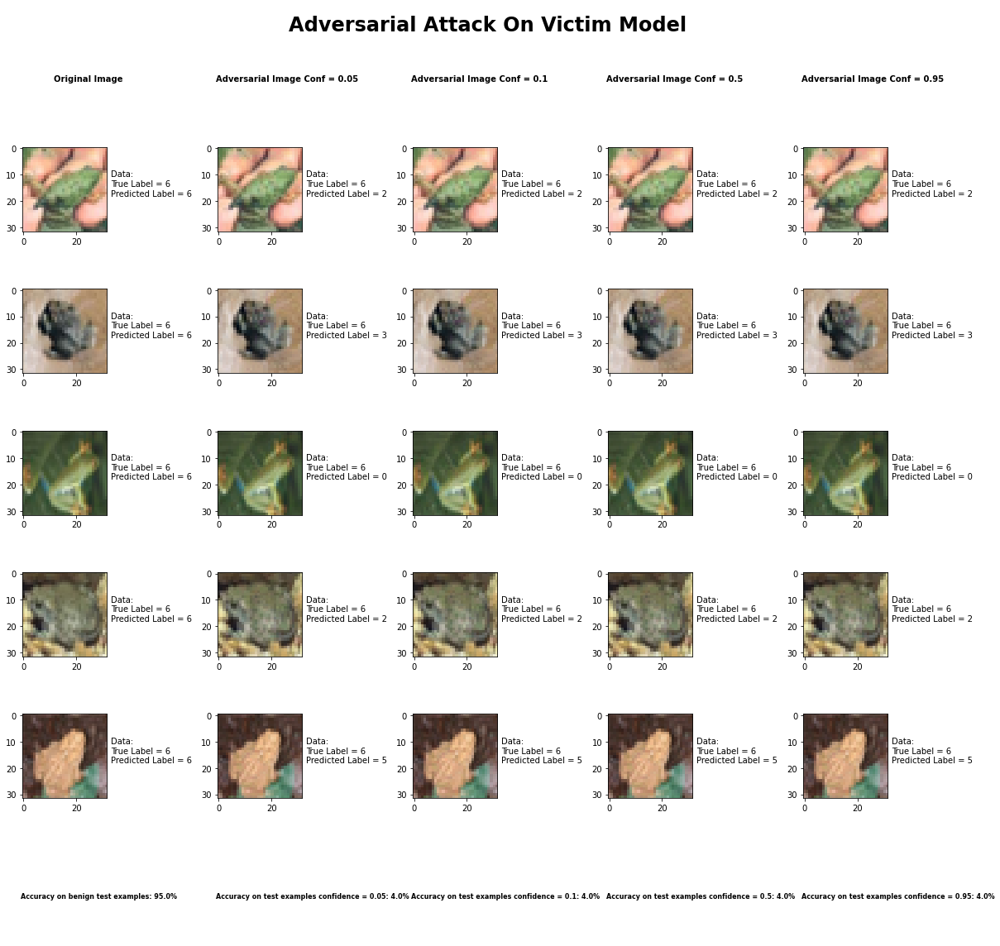

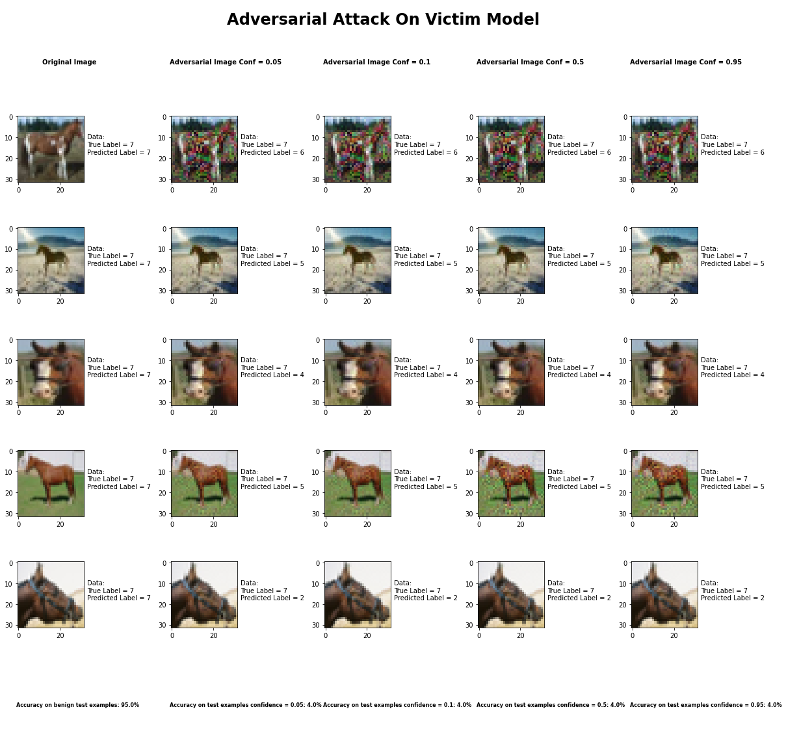

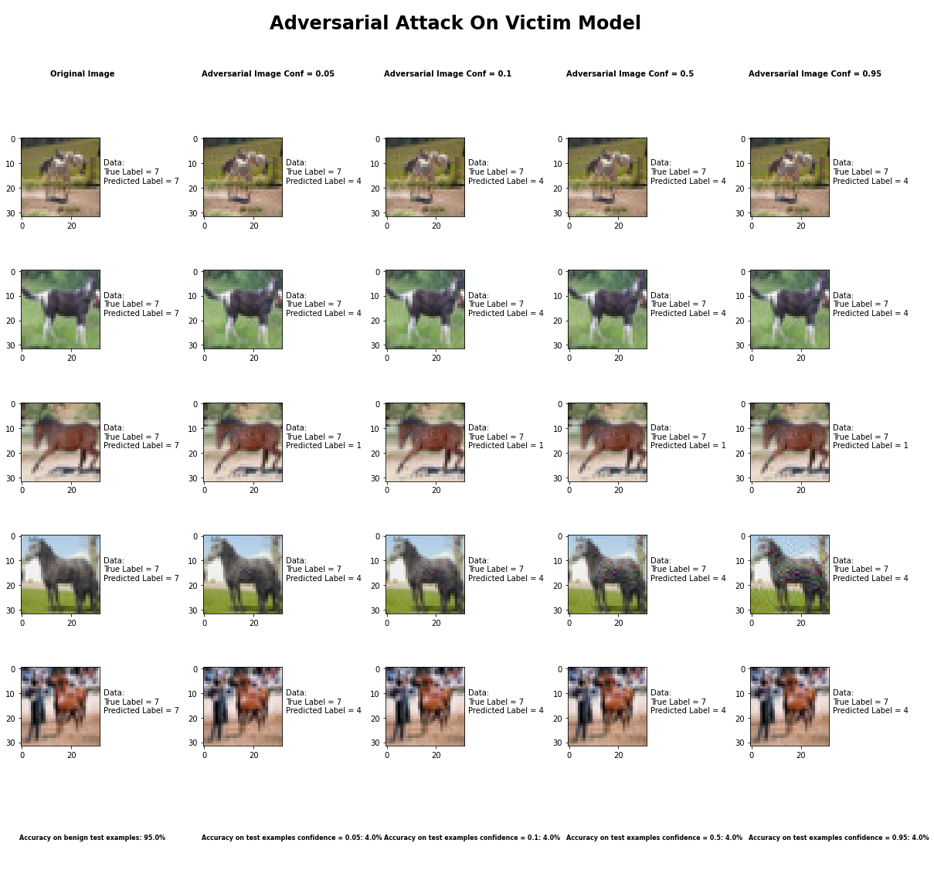

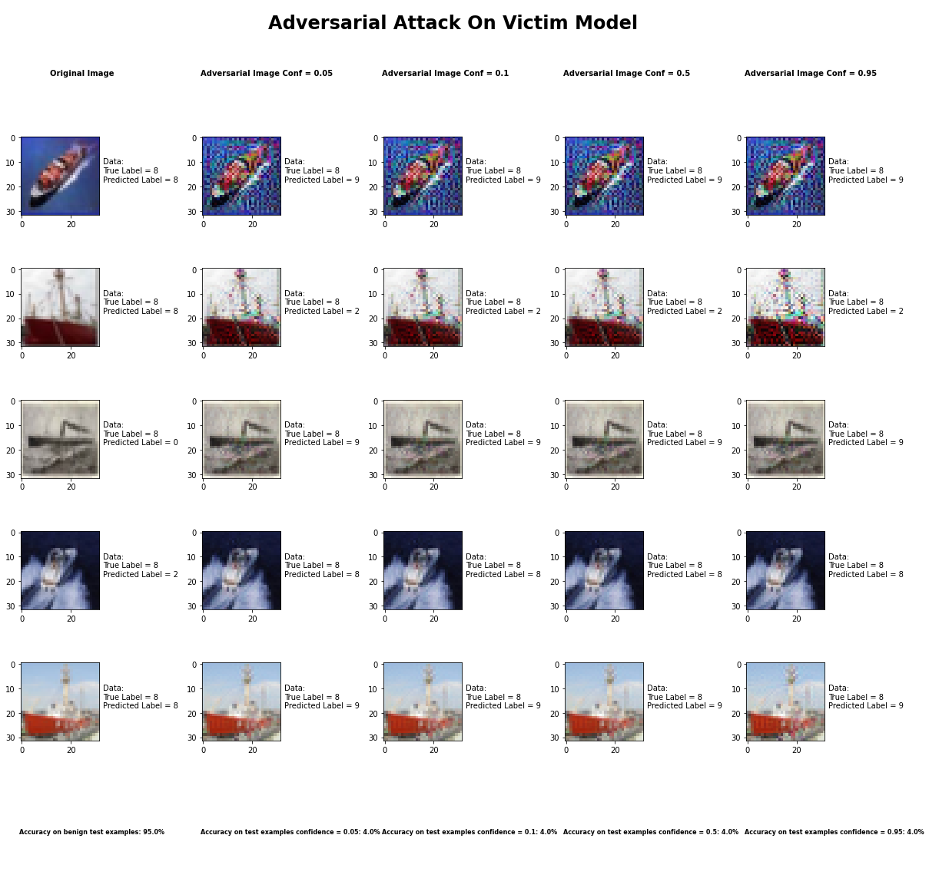

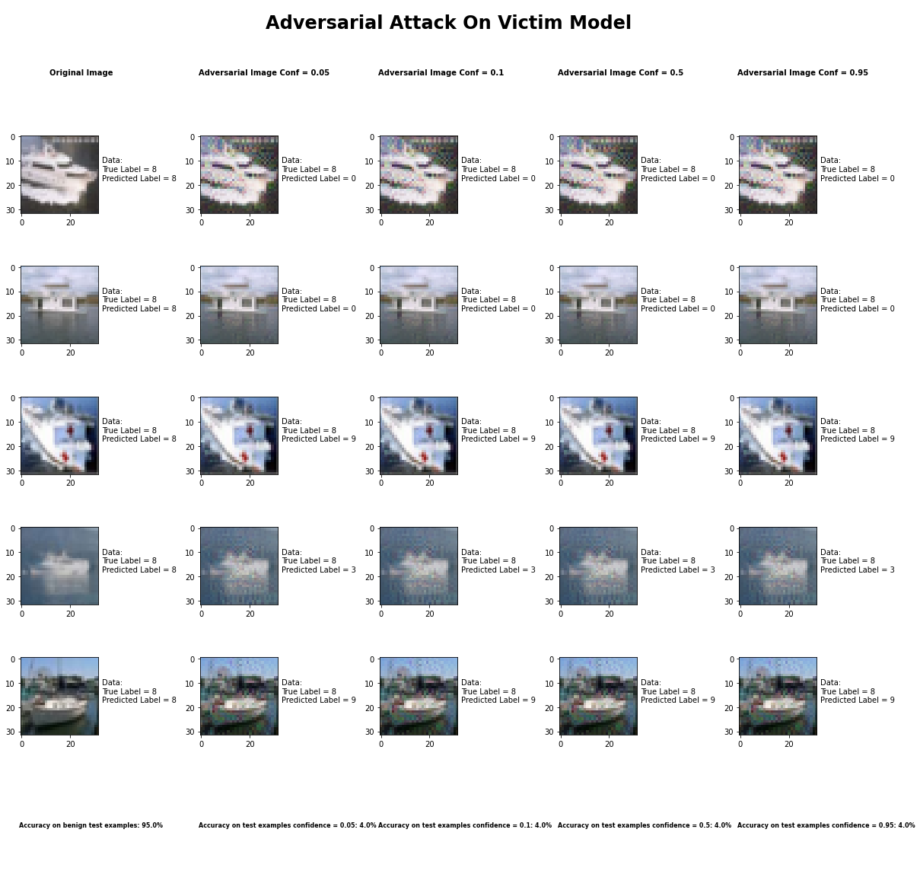

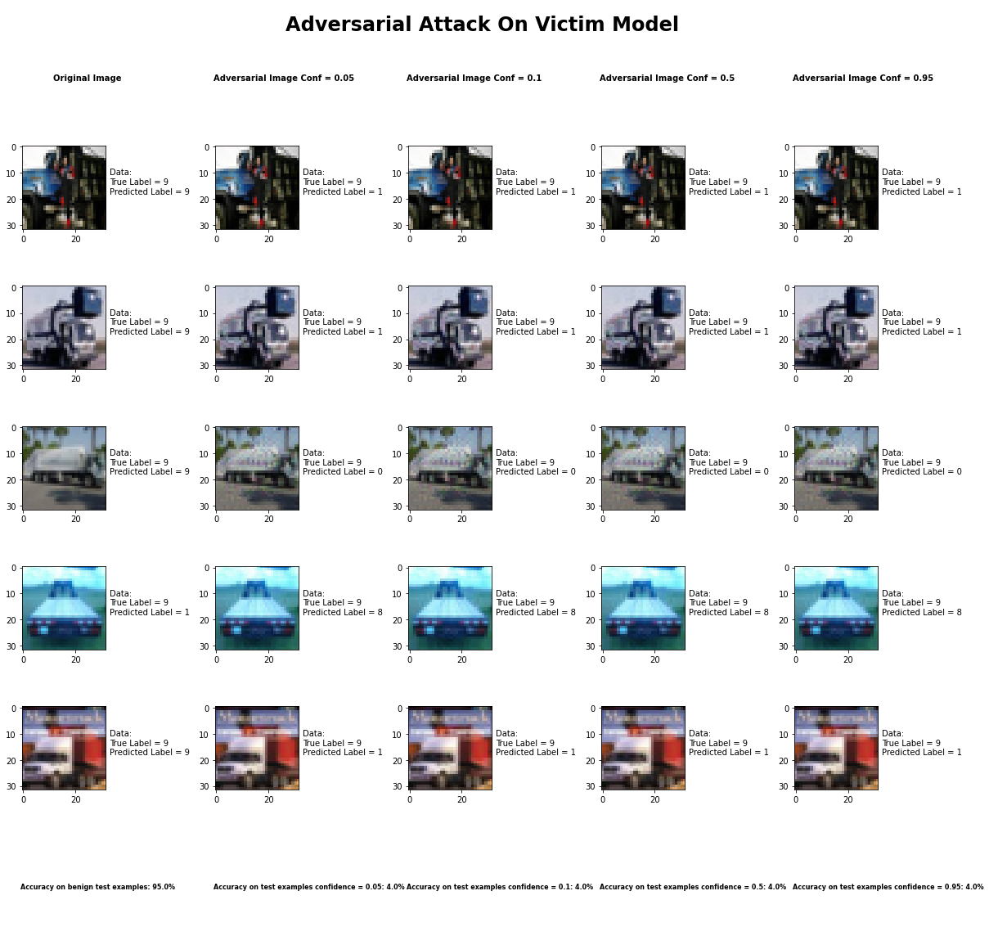

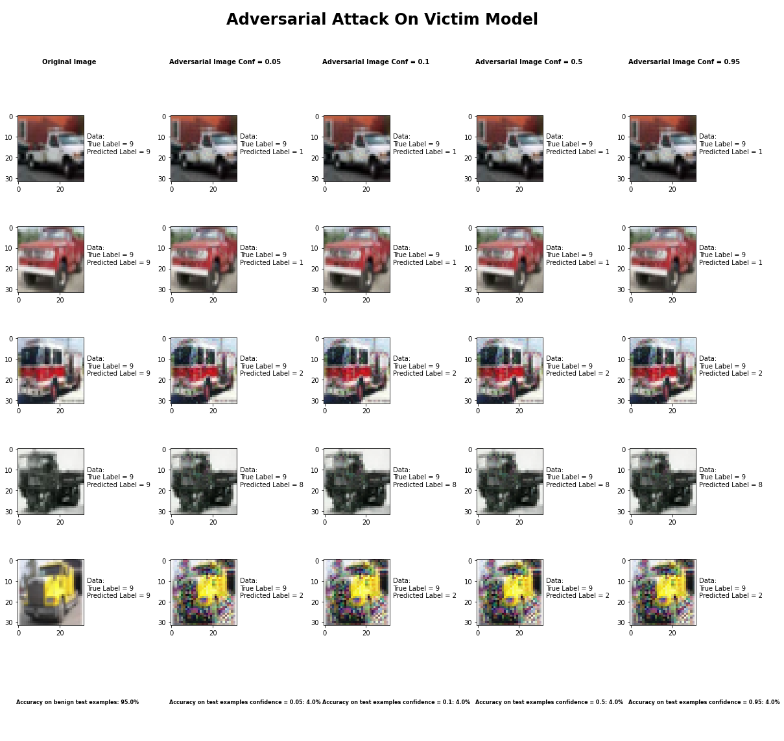

Accuracy on benign test examples: 94.52000000000001%

Average Accuracy on adversarial test examples with confidence = 0.05: 4.5%

Average Accuracy on adversarial test examples with confidence = 0.1: 4.5%

Average Accuracy on adversarial test examples with confidence = 0.5: 4.5%

Average Accuracy on adversarial test examples with confidence = 0.95: 4.5%

Classifier with benign example has Airplane recognition average accuracy of = 96%

Carlini L2 Method with confidence = 0.05 has Airplane recognition average accuracy of = 2%

Carlini L2 Method with confidence = 0.10 has Airplane recognition average accuracy of = 2%

Carlini L2 Method with confidence = 0.50 has Airplane recognition average accuracy of = 2%

Carlini L2 Method with confidence = 0.95 has Airplane recognition average accuracy of = 2%

Classifier with benign example has Automobile recognition average accuracy of = 99%

Carlini L2 Method with confidence = 0.05 has Automobile recognition average accuracy of = 0%

Carlini L2 Method with confidence = 0.10 has Automobile recognition average accuracy of = 0%

Carlini L2 Method with confidence = 0.50 has Automobile recognition average accuracy of = 0%

Carlini L2 Method with confidence = 0.95 has Automobile recognition average accuracy of = 0%

Classifier with benign example has Bird recognition average accuracy of = 93%

Carlini L2 Method with confidence = 0.05 has Bird recognition average accuracy of = 7%

Carlini L2 Method with confidence = 0.10 has Bird recognition average accuracy of = 7%

Carlini L2 Method with confidence = 0.50 has Bird recognition average accuracy of = 7%

Carlini L2 Method with confidence = 0.95 has Bird recognition average accuracy of = 7%

Classifier with benign example has Cat recognition average accuracy of = 83%

Carlini L2 Method with confidence = 0.05 has Cat recognition average accuracy of = 13%

Carlini L2 Method with confidence = 0.10 has Cat recognition average accuracy of = 13%

Carlini L2 Method with confidence = 0.50 has Cat recognition average accuracy of = 13%

Carlini L2 Method with confidence = 0.95 has Cat recognition average accuracy of = 13%

Classifier with benign example has Deer recognition average accuracy of = 97%

Carlini L2 Method with confidence = 0.05 has Deer recognition average accuracy of = 2%

Carlini L2 Method with confidence = 0.10 has Deer recognition average accuracy of = 2%

Carlini L2 Method with confidence = 0.50 has Deer recognition average accuracy of = 2%

Carlini L2 Method with confidence = 0.95 has Deer recognition average accuracy of = 2%

Classifier with benign example has Dog recognition average accuracy of = 89%

Carlini L2 Method with confidence = 0.05 has Dog recognition average accuracy of = 8%

Carlini L2 Method with confidence = 0.10 has Dog recognition average accuracy of = 8%

Carlini L2 Method with confidence = 0.50 has Dog recognition average accuracy of = 8%

Carlini L2 Method with confidence = 0.95 has Dog recognition average accuracy of = 8%

Classifier with benign example has Frog recognition average accuracy of = 100%

Carlini L2 Method with confidence = 0.05 has Frog recognition average accuracy of = 0%

Carlini L2 Method with confidence = 0.10 has Frog recognition average accuracy of = 0%

Carlini L2 Method with confidence = 0.50 has Frog recognition average accuracy of = 0%

Carlini L2 Method with confidence = 0.95 has Frog recognition average accuracy of = 0%

Classifier with benign example has Horse recognition average accuracy of = 95%

Carlini L2 Method with confidence = 0.05 has Horse recognition average accuracy of = 2%

Carlini L2 Method with confidence = 0.10 has Horse recognition average accuracy of = 2%

Carlini L2 Method with confidence = 0.50 has Horse recognition average accuracy of = 2%

Carlini L2 Method with confidence = 0.95 has Horse recognition average accuracy of = 2%

Classifier with benign example has Ship recognition average accuracy of = 93%

Carlini L2 Method with confidence = 0.05 has Ship recognition average accuracy of = 5%

Carlini L2 Method with confidence = 0.10 has Ship recognition average accuracy of = 5%

Carlini L2 Method with confidence = 0.50 has Ship recognition average accuracy of = 5%

Carlini L2 Method with confidence = 0.95 has Ship recognition average accuracy of = 5%

Classifier with benign example has Truck recognition average accuracy of = 92%

Carlini L2 Method with confidence = 0.05 has Truck recognition average accuracy of = 6%

Carlini L2 Method with confidence = 0.10 has Truck recognition average accuracy of = 6%

Carlini L2 Method with confidence = 0.50 has Truck recognition average accuracy of = 6%

Carlini L2 Method with confidence = 0.95 has Truck recognition average accuracy of = 6%

## Carlini L2 Method



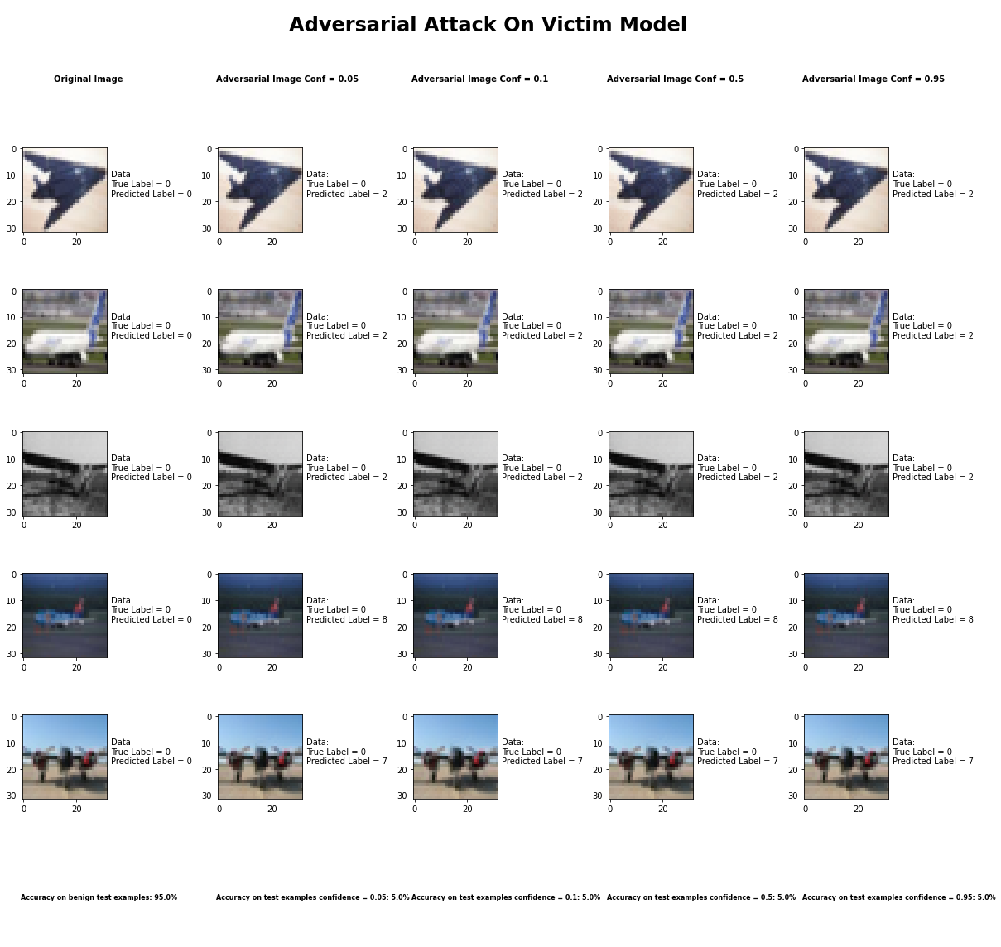

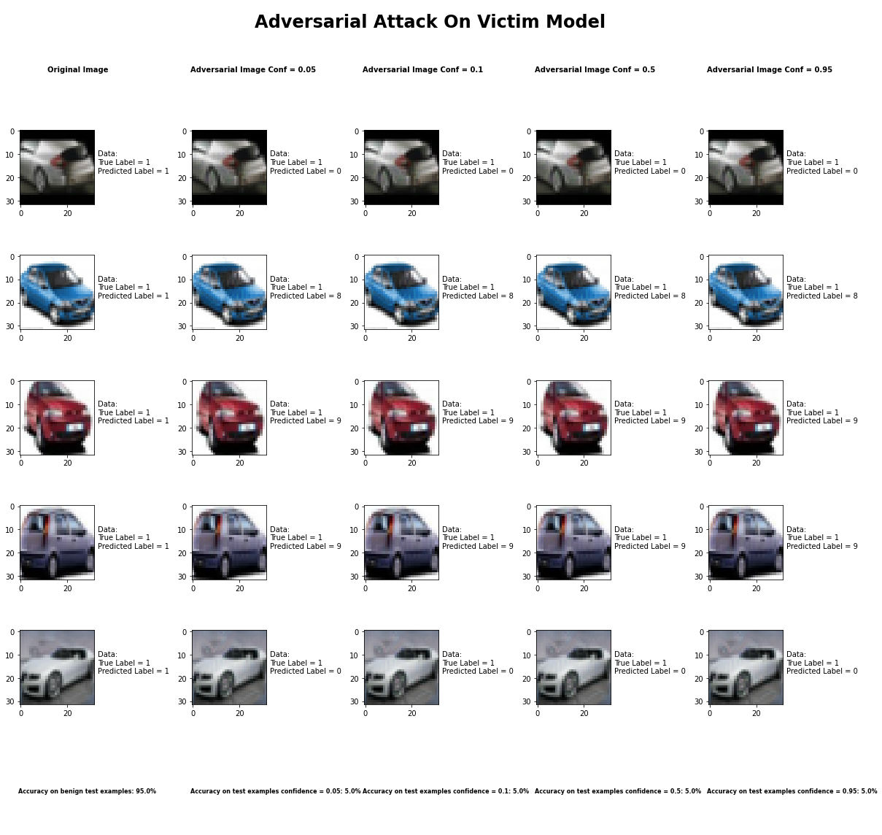

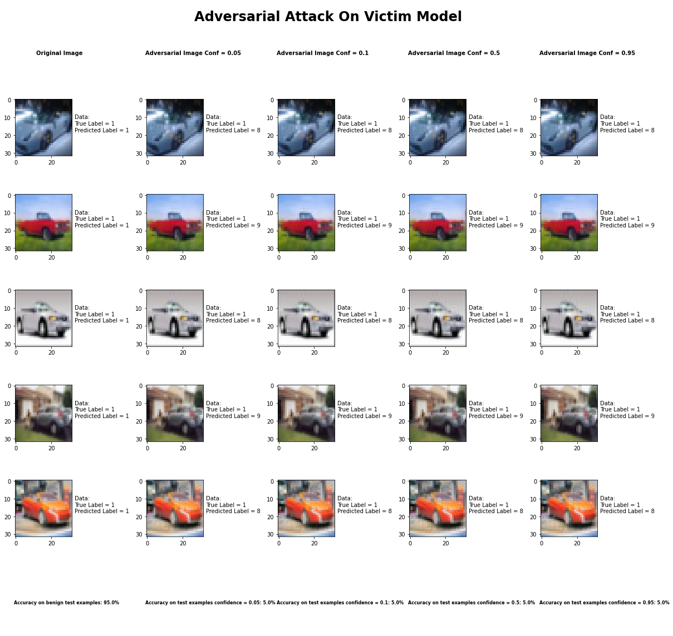

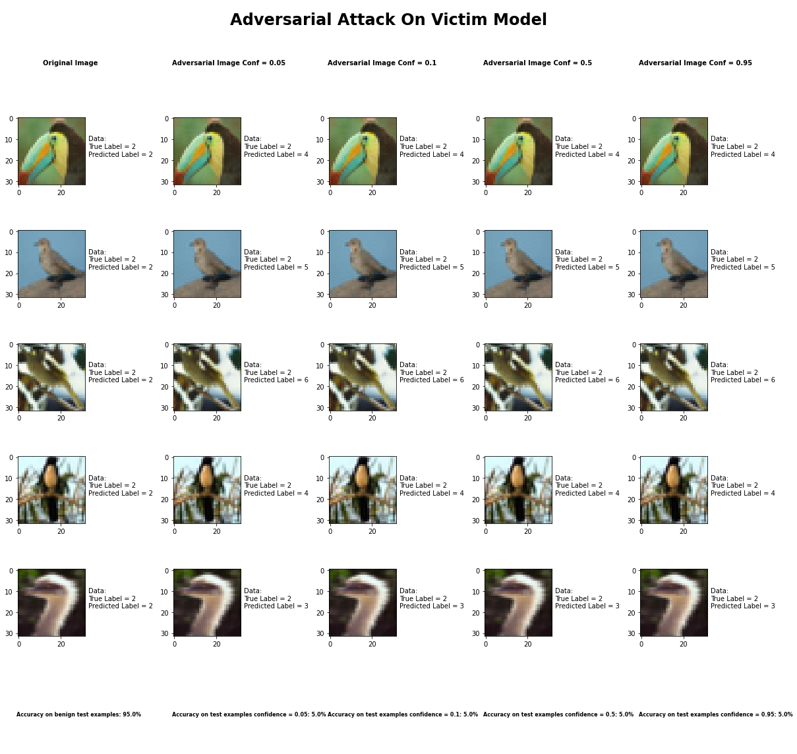

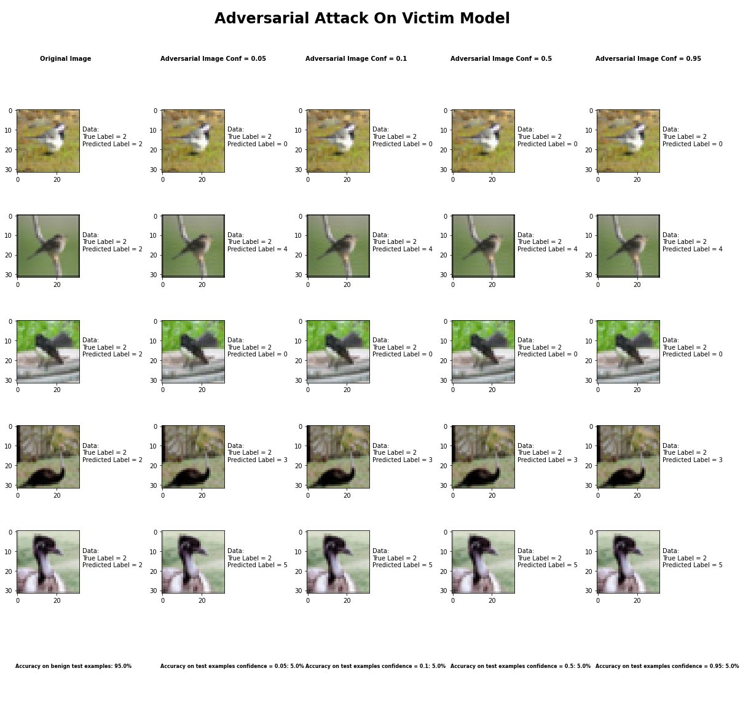

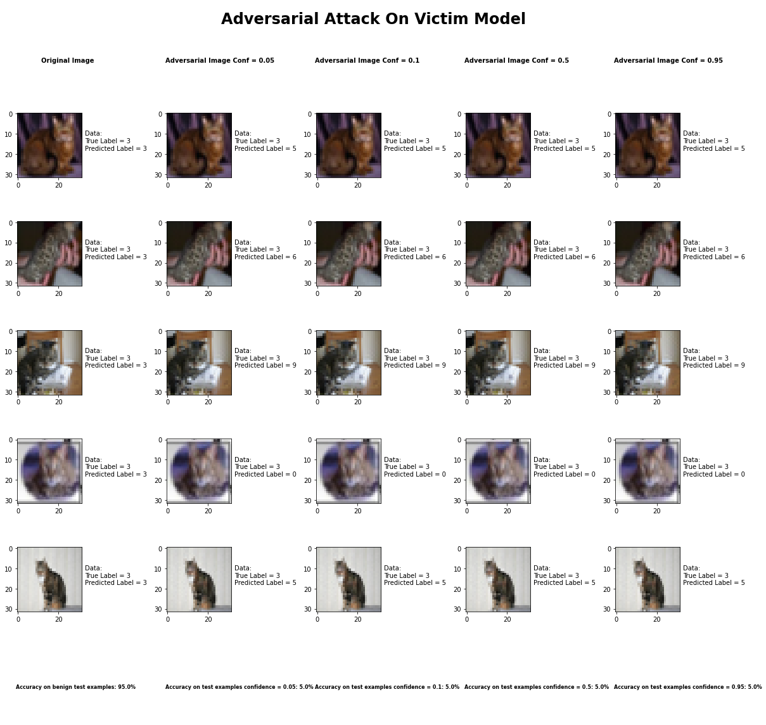

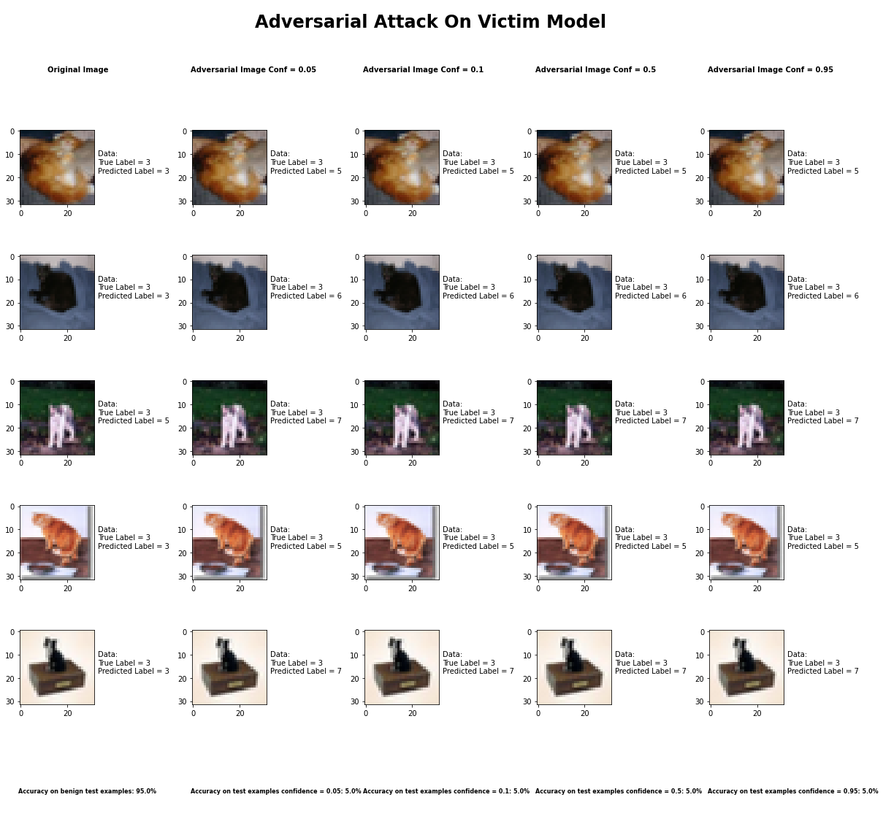

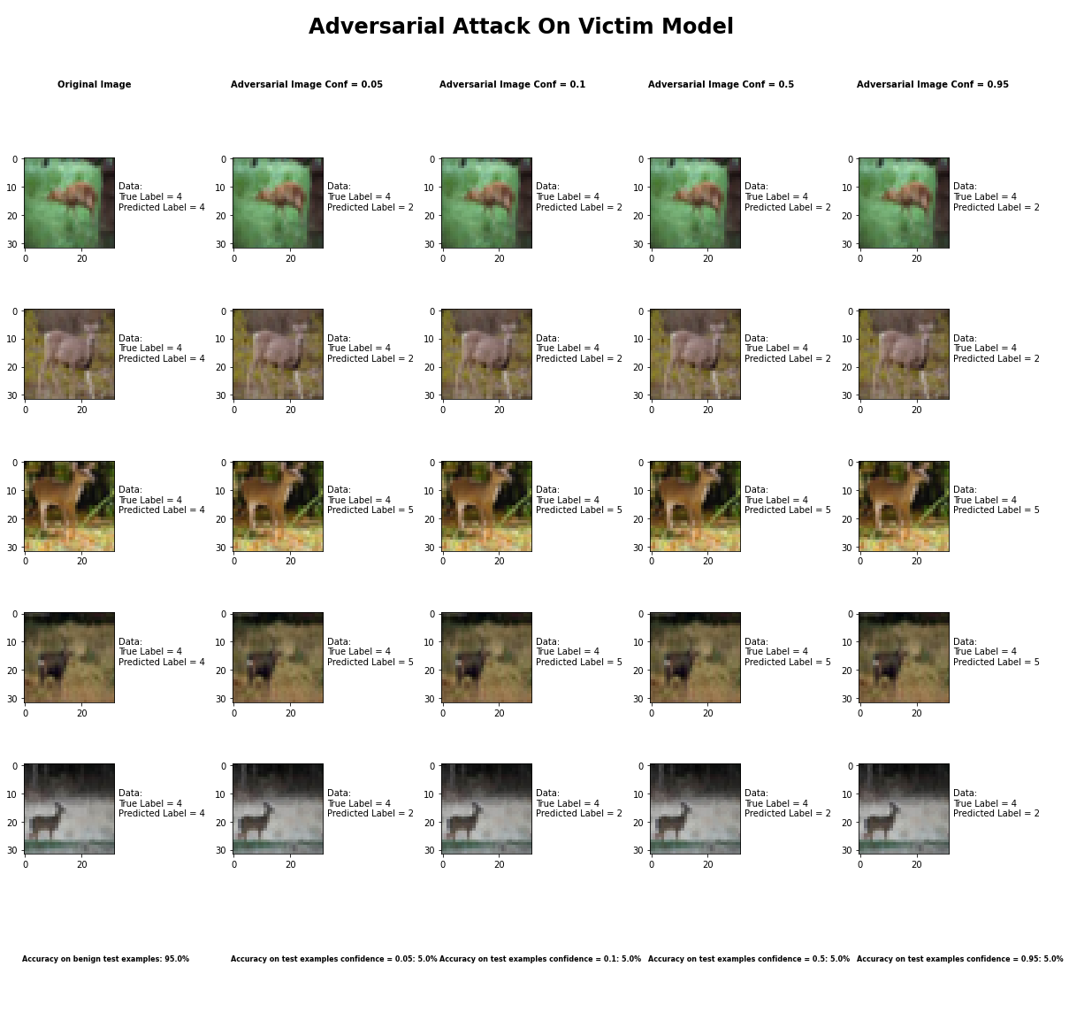

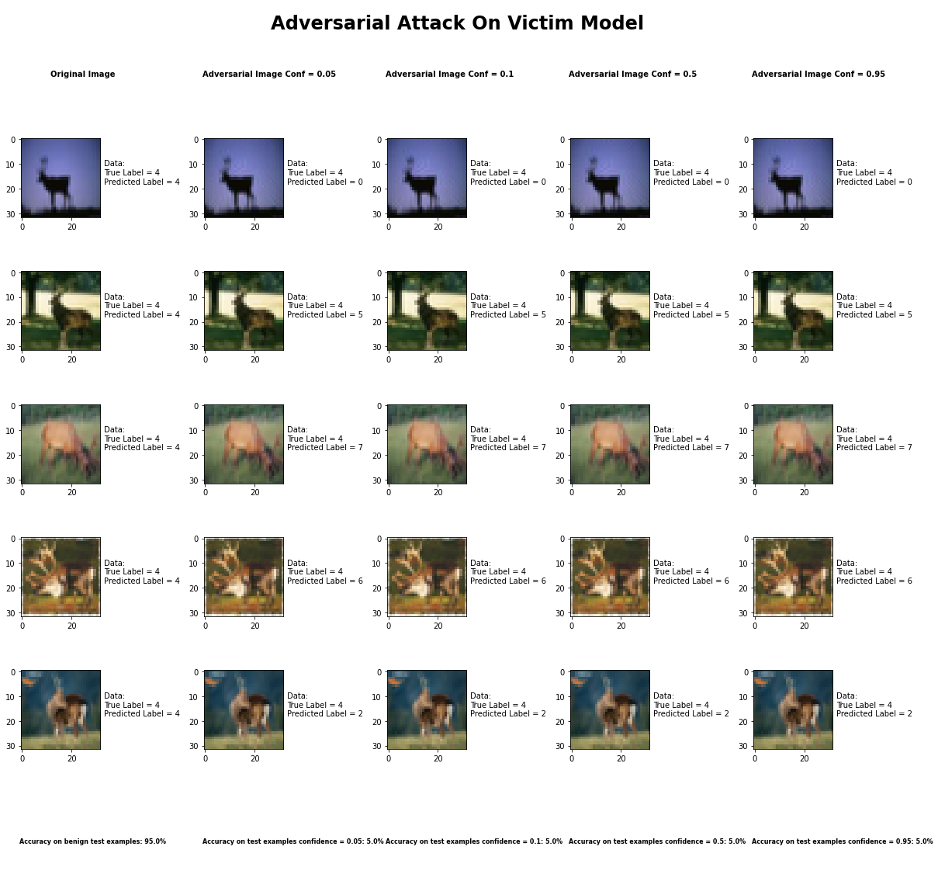

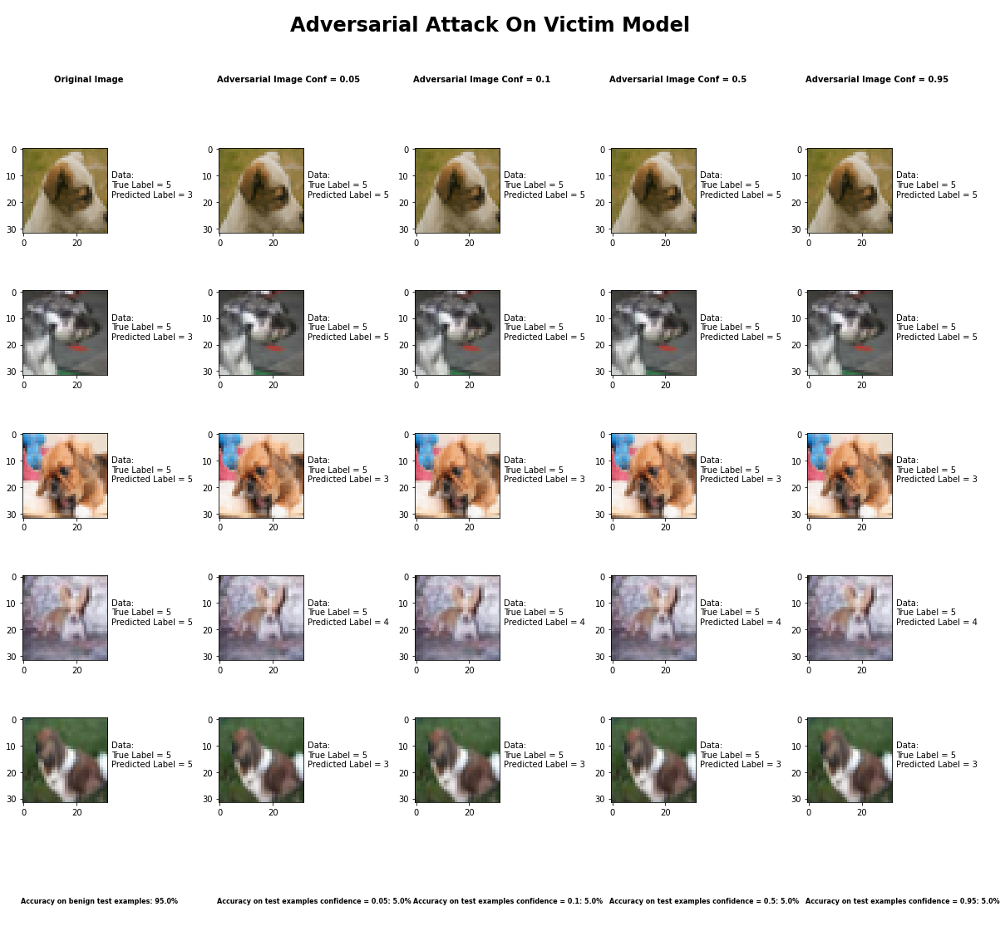

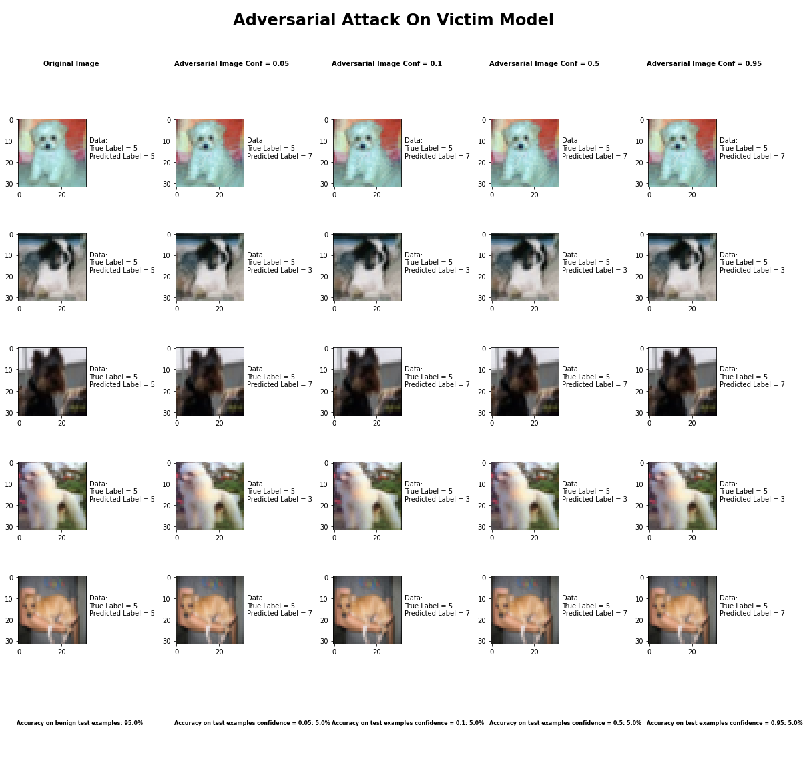

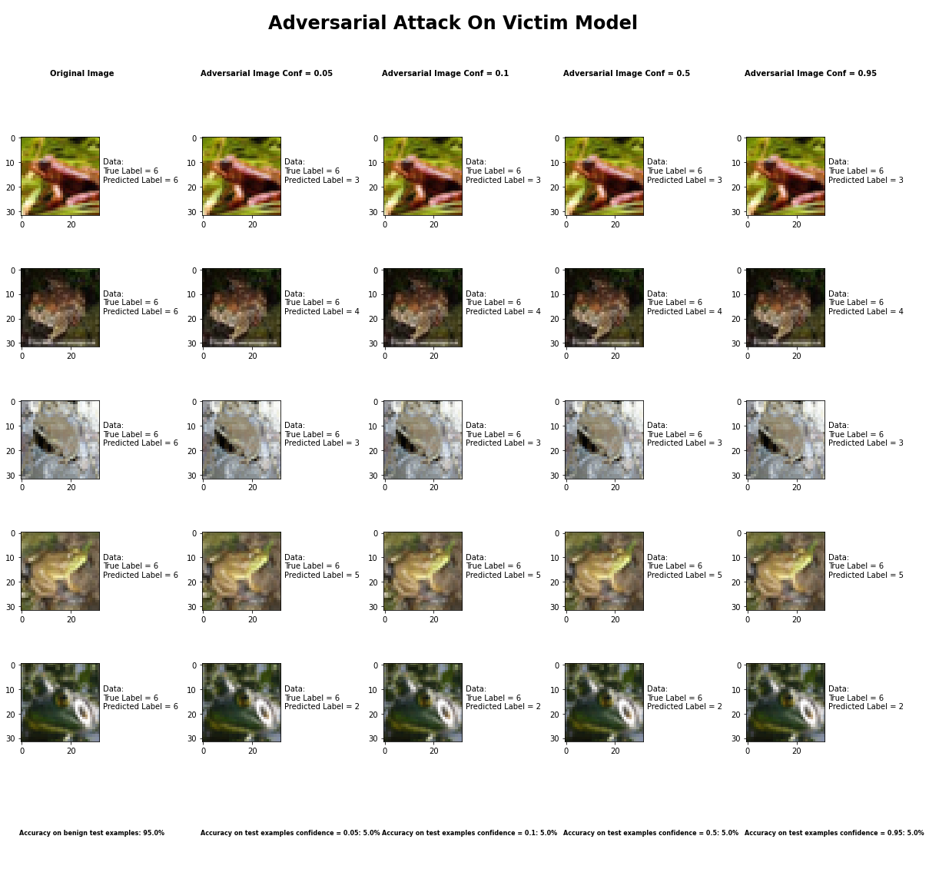

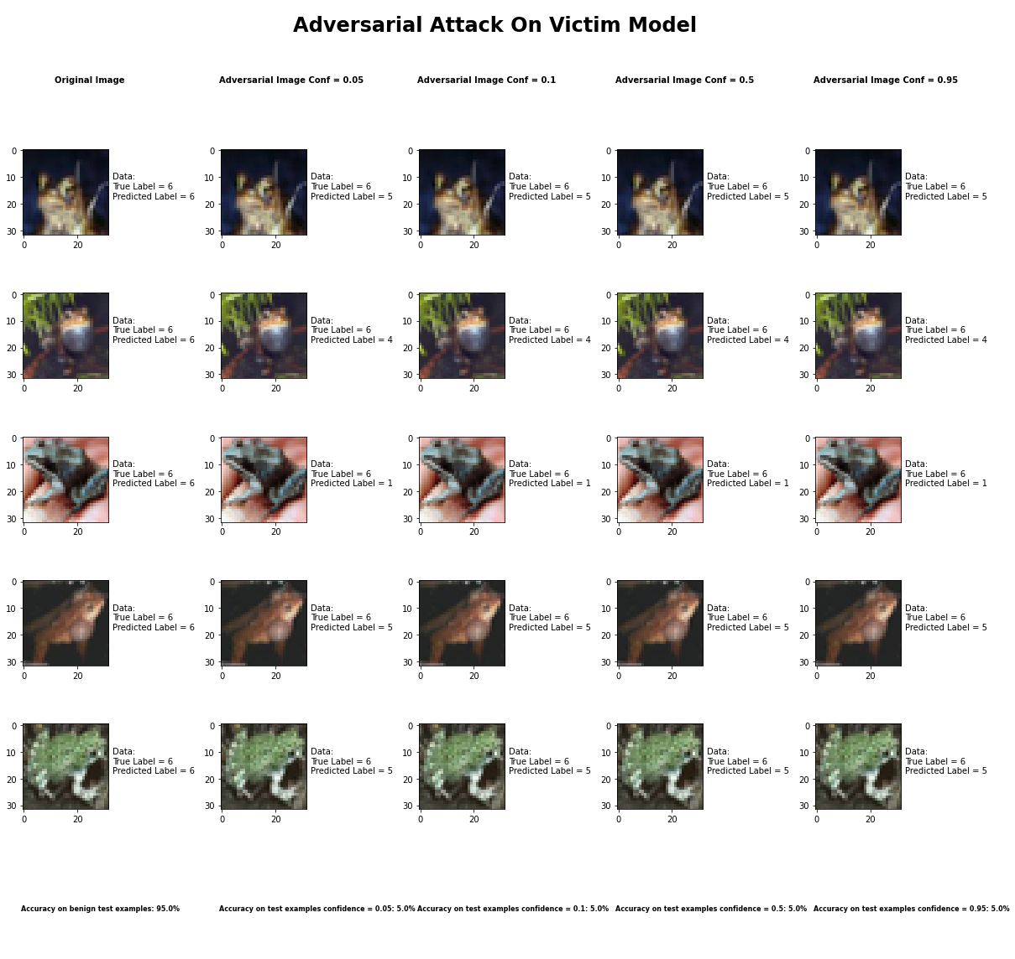

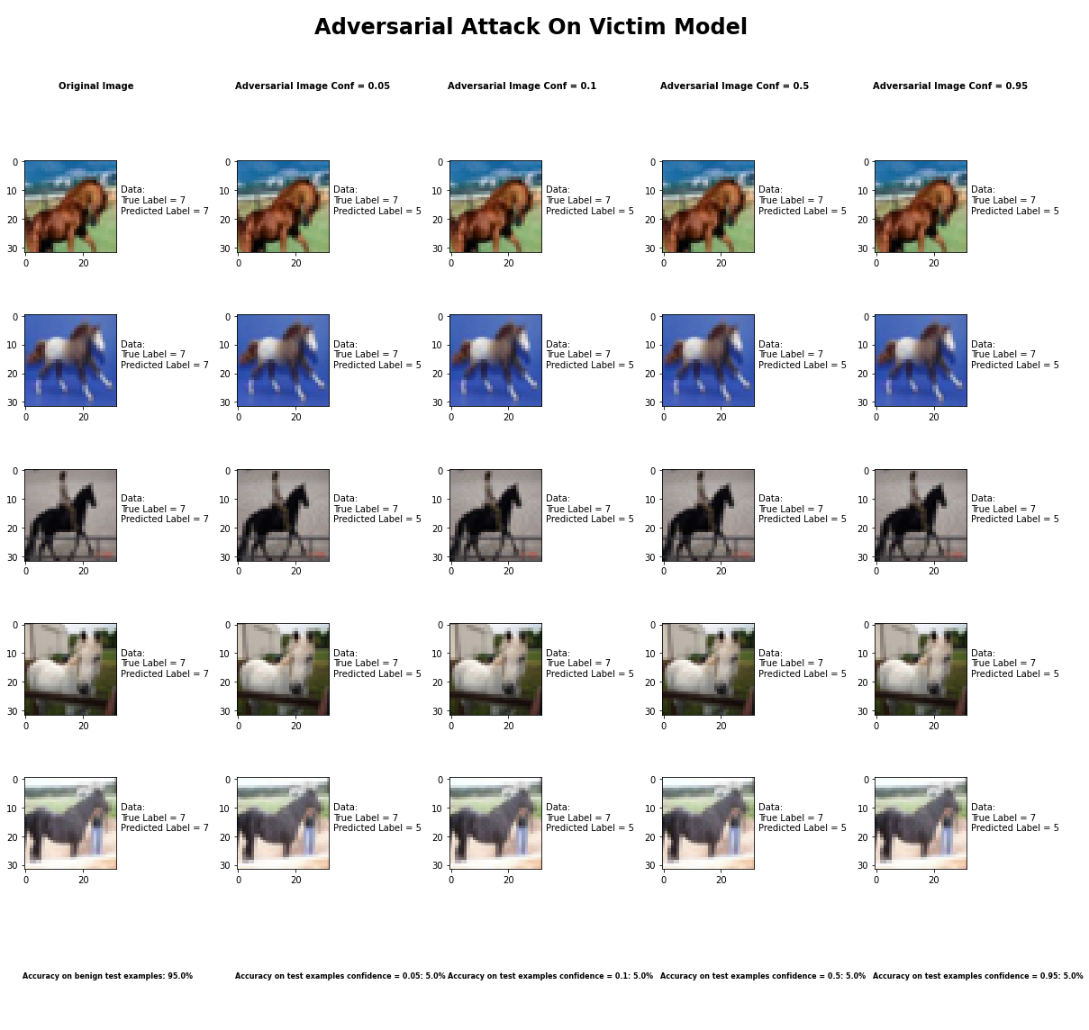

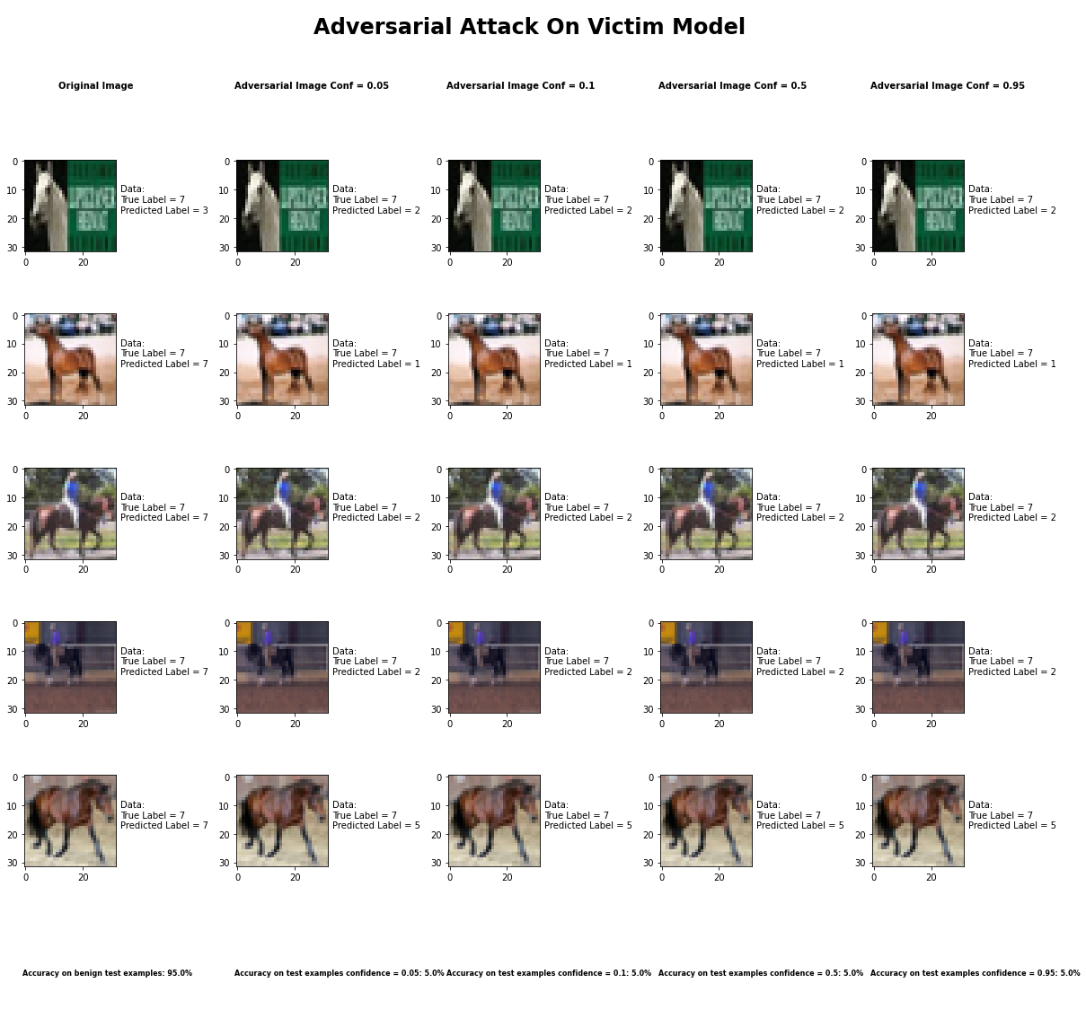

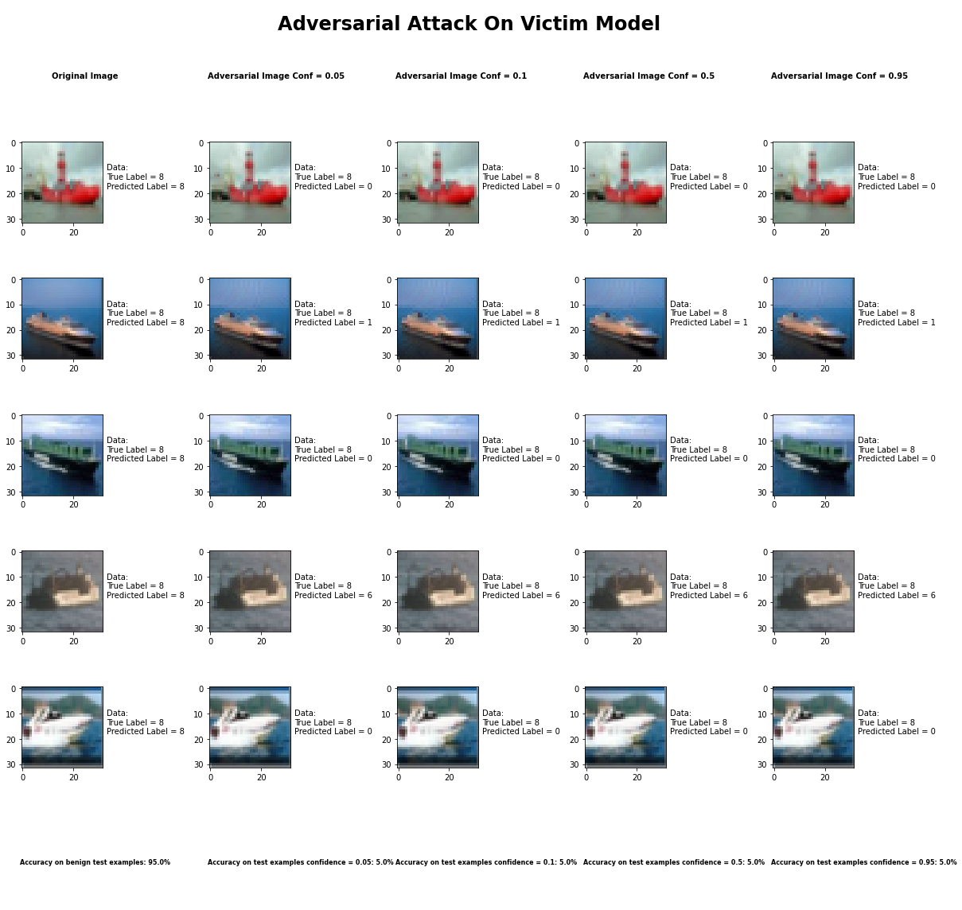

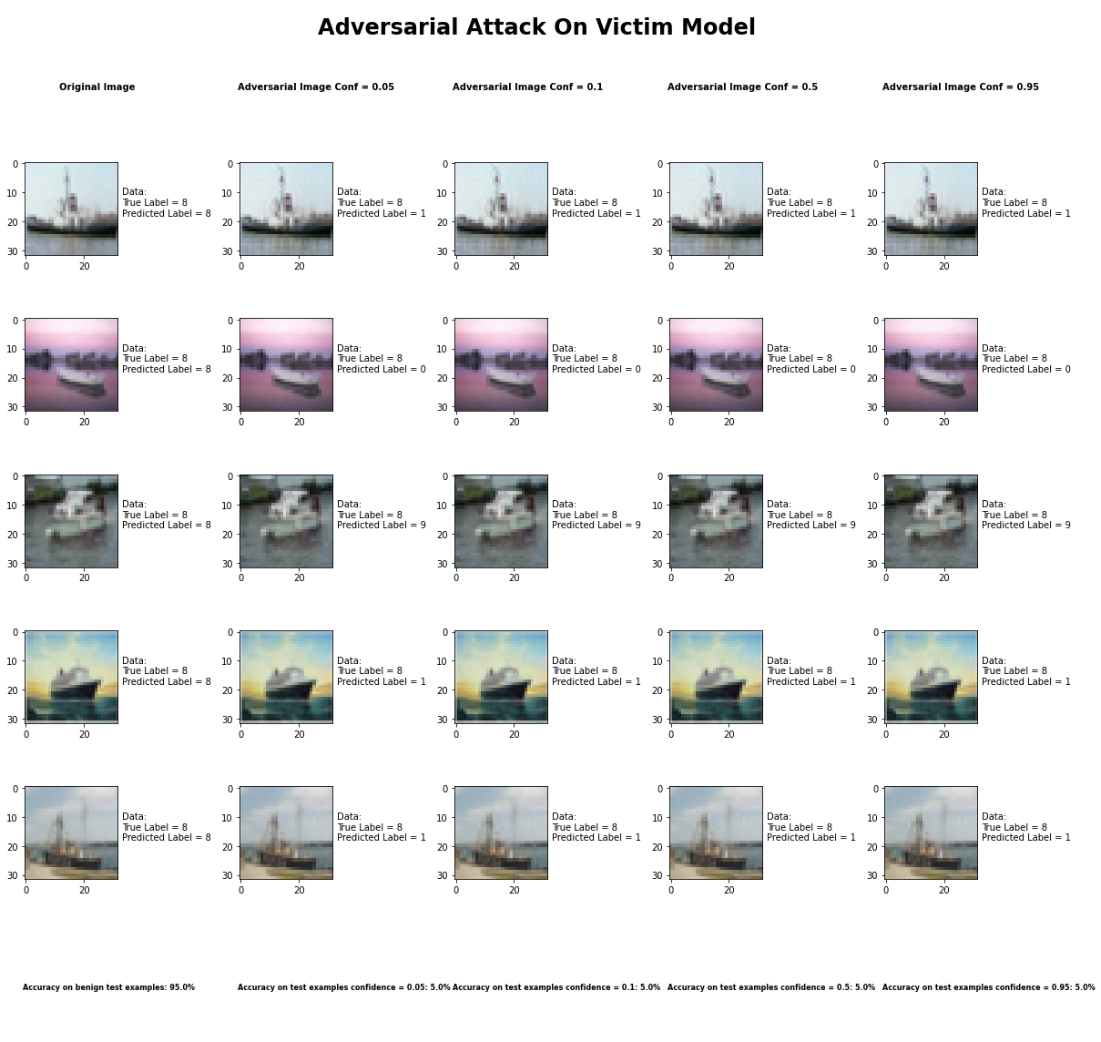

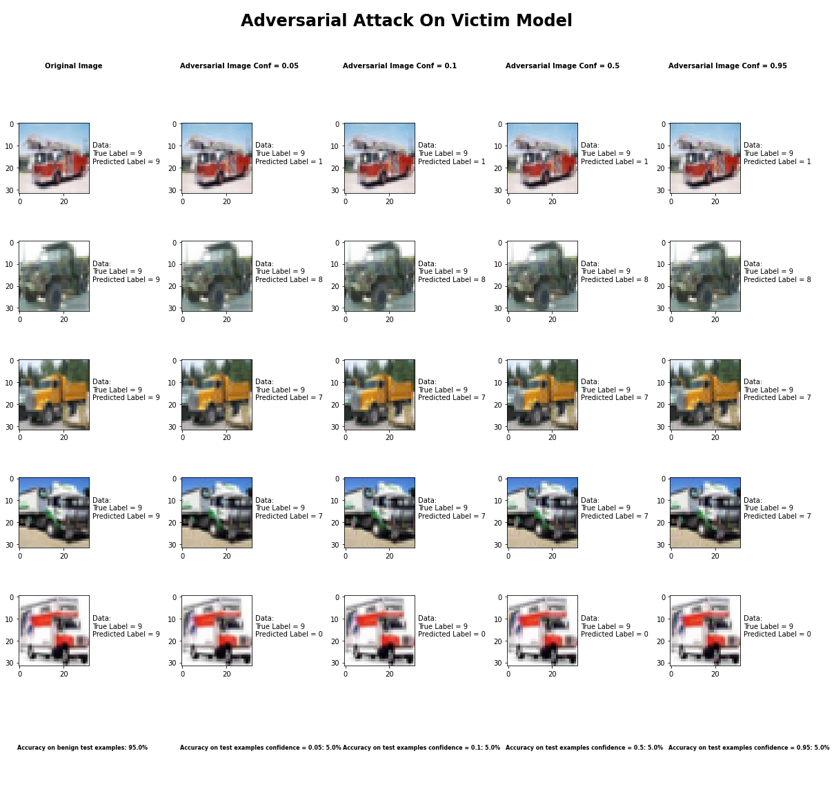

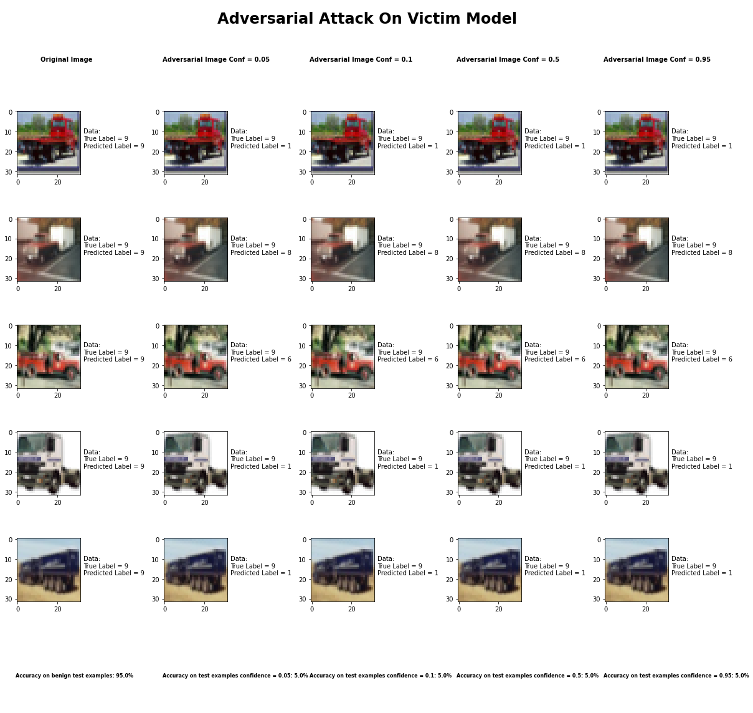

Accuracy on benign test examples: 94.52000000000001%

Average Accuracy on adversarial test examples with confidence = 0.05: 4.8%

Average Accuracy on adversarial test examples with confidence = 0.1: 4.8%

Average Accuracy on adversarial test examples with confidence = 0.5: 4.8%

Average Accuracy on adversarial test examples with confidence = 0.95: 4.8%

Classifier with benign example has Airplane recognition average accuracy of = 97%

Carlini L2 Method with confidence = 0.05 has Airplane recognition average accuracy of = 1%

Carlini L2 Method with confidence = 0.10 has Airplane recognition average accuracy of = 1%

Carlini L2 Method with confidence = 0.50 has Airplane recognition average accuracy of = 1%

Carlini L2 Method with confidence = 0.95 has Airplane recognition average accuracy of = 1%

Classifier with benign example has Automobile recognition average accuracy of = 97%

Carlini L2 Method with confidence = 0.05 has Automobile recognition average accuracy of = 2%

Carlini L2 Method with confidence = 0.10 has Automobile recognition average accuracy of = 2%

Carlini L2 Method with confidence = 0.50 has Automobile recognition average accuracy of = 2%

Carlini L2 Method with confidence = 0.95 has Automobile recognition average accuracy of = 2%

Classifier with benign example has Bird recognition average accuracy of = 91%

Carlini L2 Method with confidence = 0.05 has Bird recognition average accuracy of = 6%

Carlini L2 Method with confidence = 0.10 has Bird recognition average accuracy of = 6%

Carlini L2 Method with confidence = 0.50 has Bird recognition average accuracy of = 6%

Carlini L2 Method with confidence = 0.95 has Bird recognition average accuracy of = 6%

Classifier with benign example has Cat recognition average accuracy of = 83%

Carlini L2 Method with confidence = 0.05 has Cat recognition average accuracy of = 8%

Carlini L2 Method with confidence = 0.10 has Cat recognition average accuracy of = 8%

Carlini L2 Method with confidence = 0.50 has Cat recognition average accuracy of = 8%

Carlini L2 Method with confidence = 0.95 has Cat recognition average accuracy of = 8%

Classifier with benign example has Deer recognition average accuracy of = 89%

Carlini L2 Method with confidence = 0.05 has Deer recognition average accuracy of = 9%

Carlini L2 Method with confidence = 0.10 has Deer recognition average accuracy of = 9%

Carlini L2 Method with confidence = 0.50 has Deer recognition average accuracy of = 9%

Carlini L2 Method with confidence = 0.95 has Deer recognition average accuracy of = 9%

Classifier with benign example has Dog recognition average accuracy of = 84%

Carlini L2 Method with confidence = 0.05 has Dog recognition average accuracy of = 12%

Carlini L2 Method with confidence = 0.10 has Dog recognition average accuracy of = 12%

Carlini L2 Method with confidence = 0.50 has Dog recognition average accuracy of = 12%

Carlini L2 Method with confidence = 0.95 has Dog recognition average accuracy of = 12%

Classifier with benign example has Frog recognition average accuracy of = 97%

Carlini L2 Method with confidence = 0.05 has Frog recognition average accuracy of = 3%

Carlini L2 Method with confidence = 0.10 has Frog recognition average accuracy of = 3%

Carlini L2 Method with confidence = 0.50 has Frog recognition average accuracy of = 3%

Carlini L2 Method with confidence = 0.95 has Frog recognition average accuracy of = 3%

Classifier with benign example has Horse recognition average accuracy of = 94%

Carlini L2 Method with confidence = 0.05 has Horse recognition average accuracy of = 1%

Carlini L2 Method with confidence = 0.10 has Horse recognition average accuracy of = 1%

Carlini L2 Method with confidence = 0.50 has Horse recognition average accuracy of = 1%

Carlini L2 Method with confidence = 0.95 has Horse recognition average accuracy of = 1%

Classifier with benign example has Ship recognition average accuracy of = 96%

Carlini L2 Method with confidence = 0.05 has Ship recognition average accuracy of = 4%

Carlini L2 Method with confidence = 0.10 has Ship recognition average accuracy of = 4%

Carlini L2 Method with confidence = 0.50 has Ship recognition average accuracy of = 4%

Carlini L2 Method with confidence = 0.95 has Ship recognition average accuracy of = 4%

Classifier with benign example has Truck recognition average accuracy of = 98%

Carlini L2 Method with confidence = 0.05 has Truck recognition average accuracy of = 2%

Carlini L2 Method with confidence = 0.10 has Truck recognition average accuracy of = 2%

Carlini L2 Method with confidence = 0.50 has Truck recognition average accuracy of = 2%

Carlini L2 Method with confidence = 0.95 has Truck recognition average accuracy of = 2%

## Basic Iterative Method



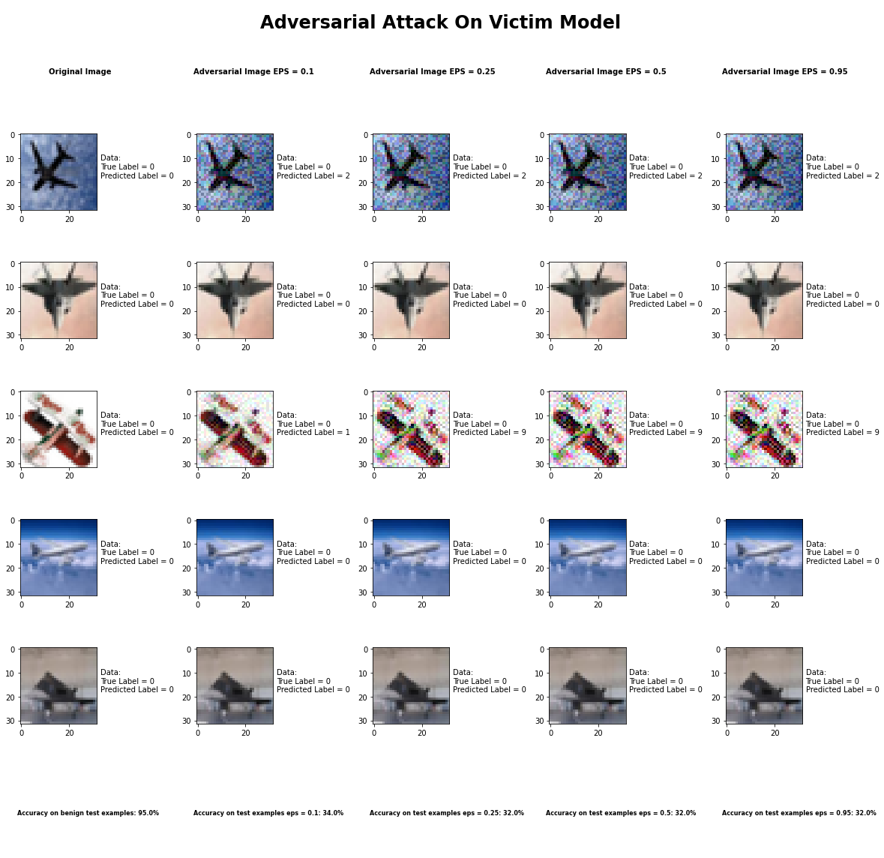

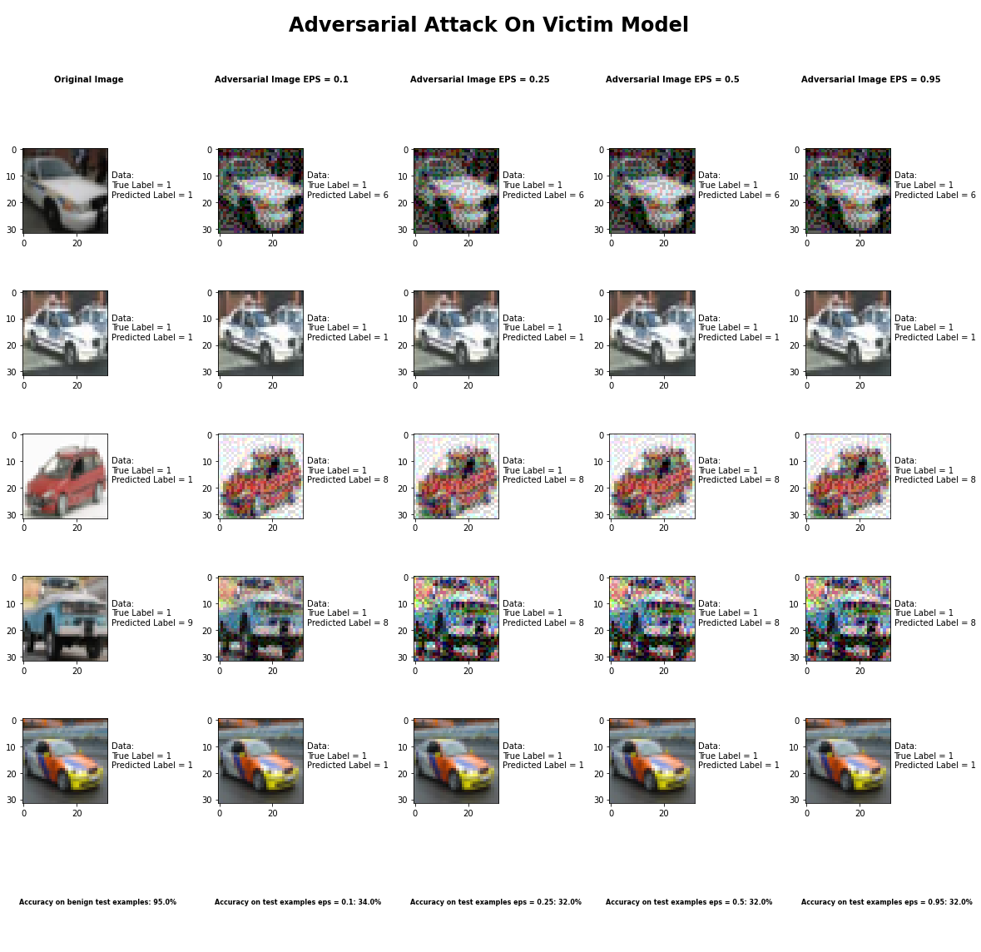

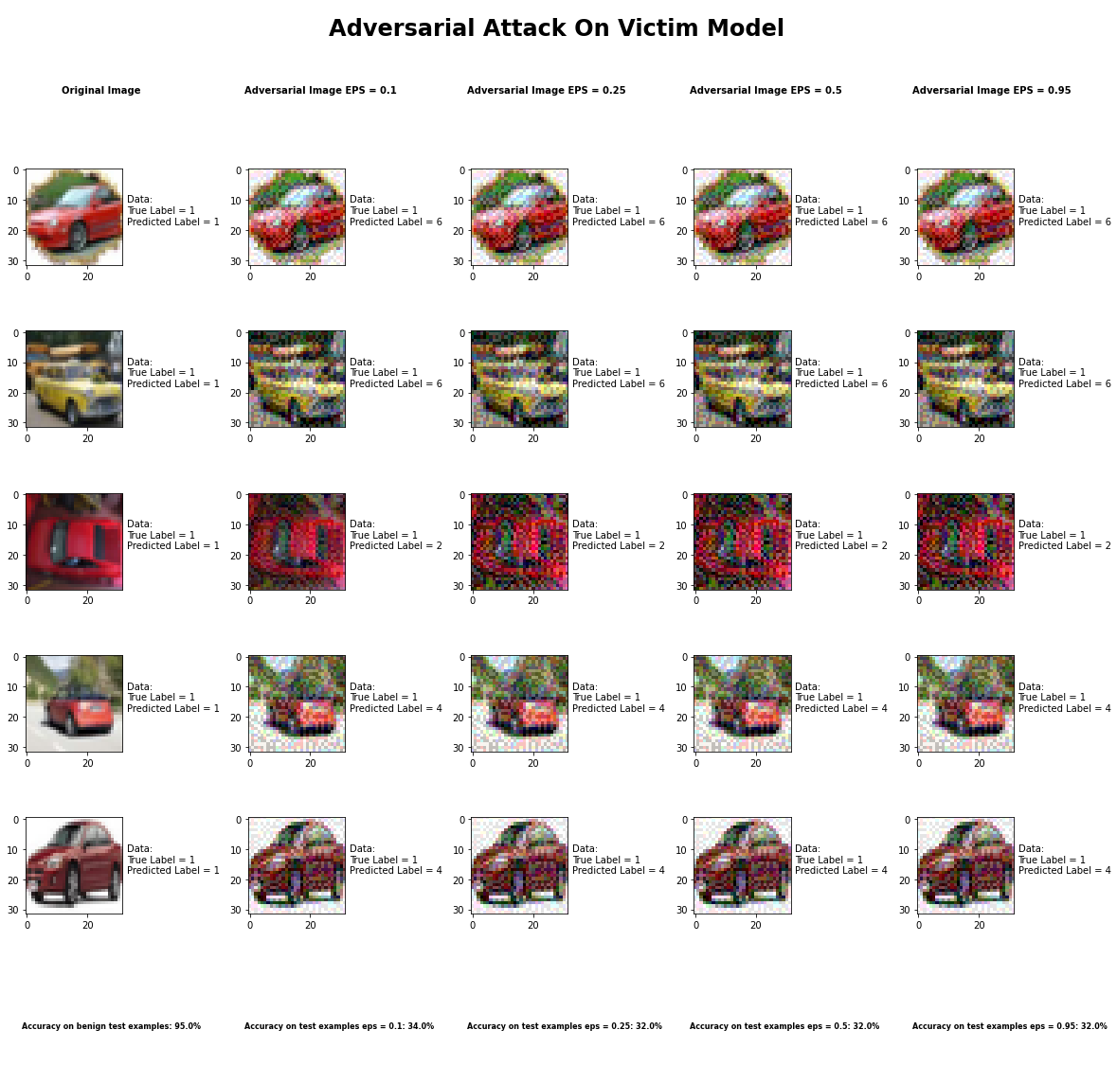

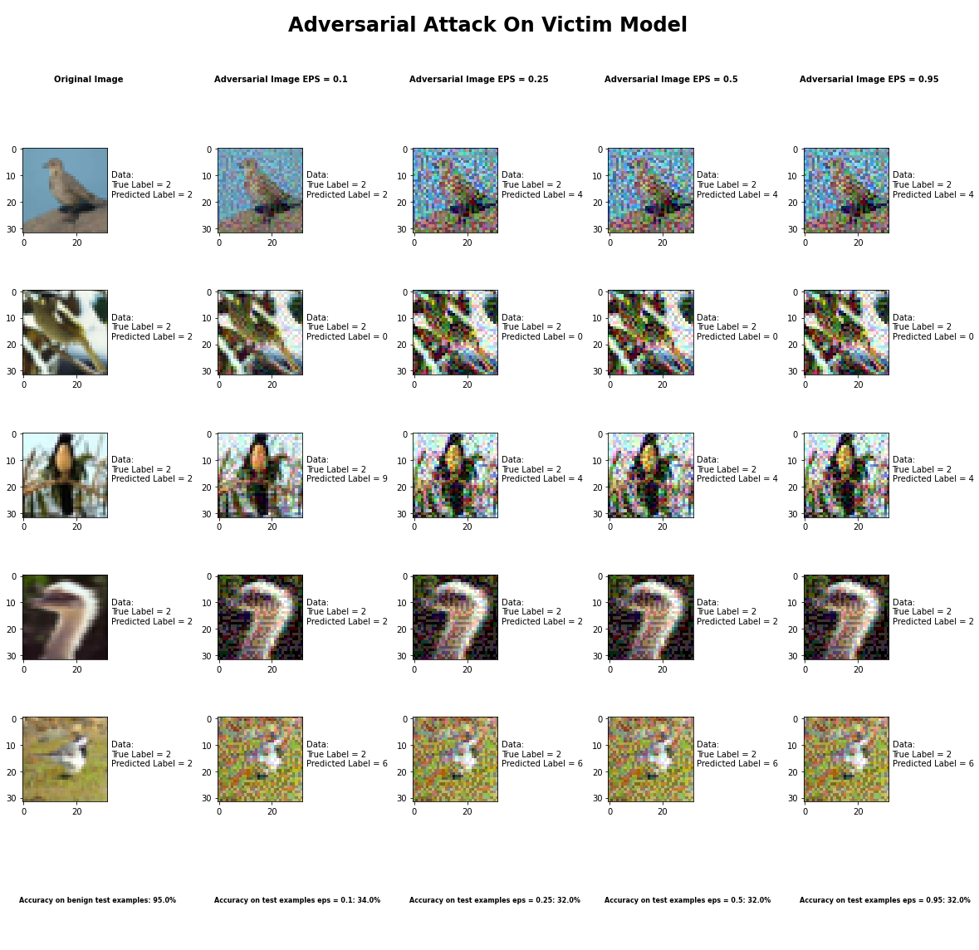

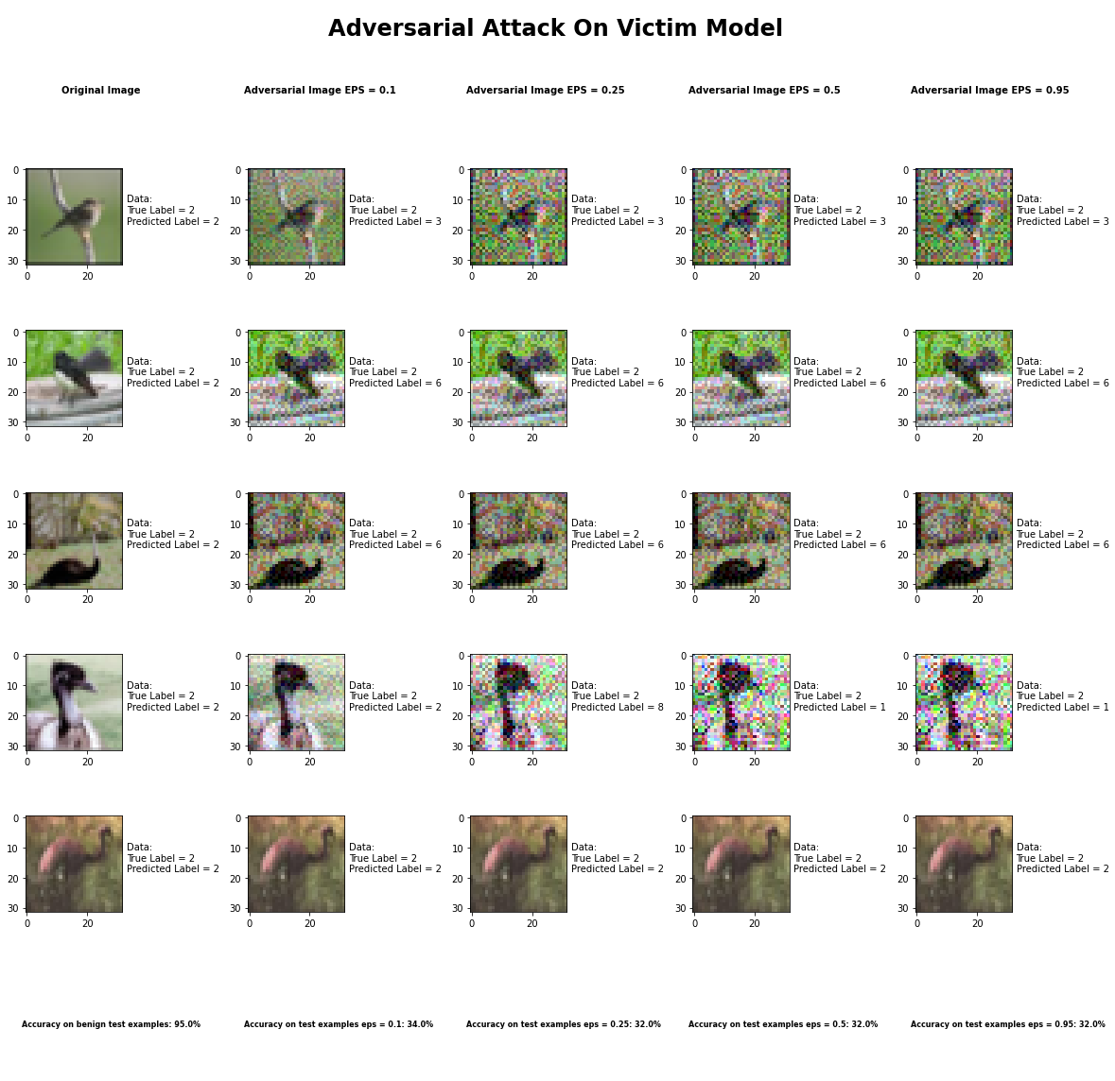

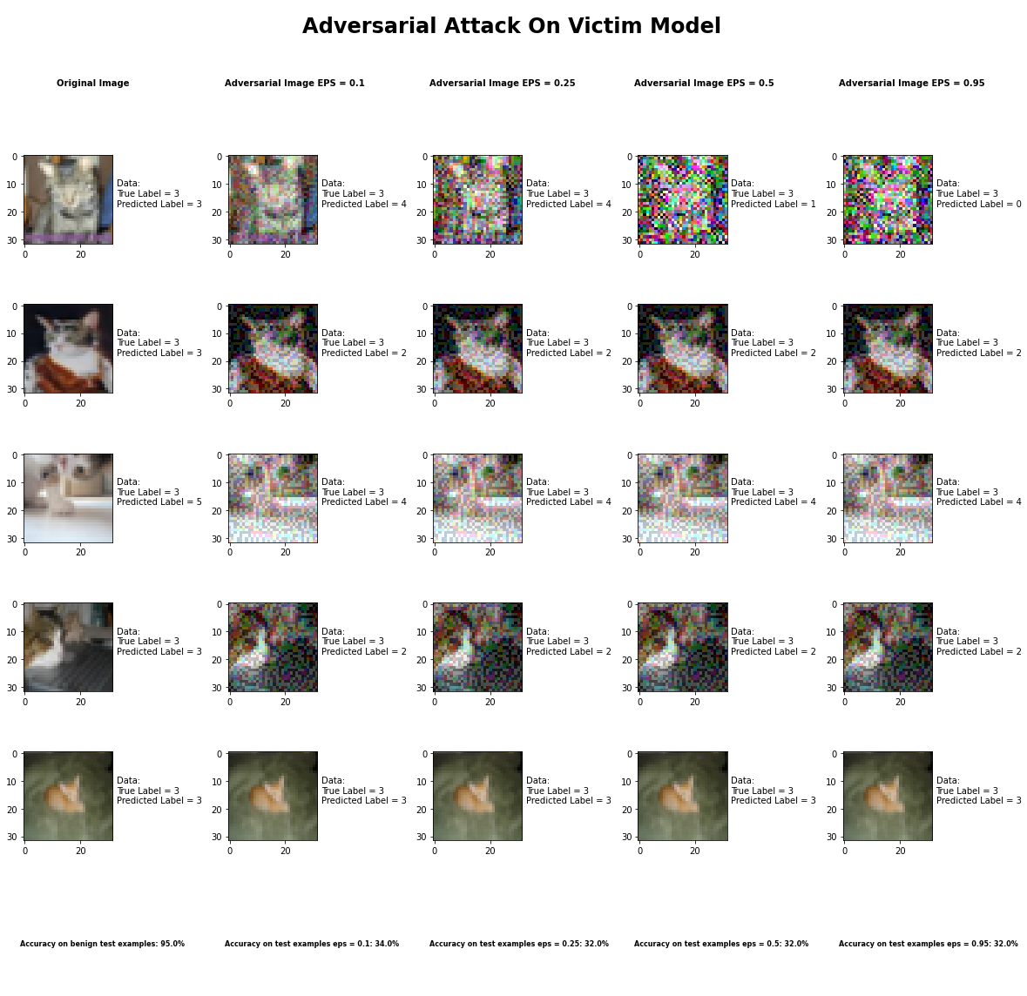

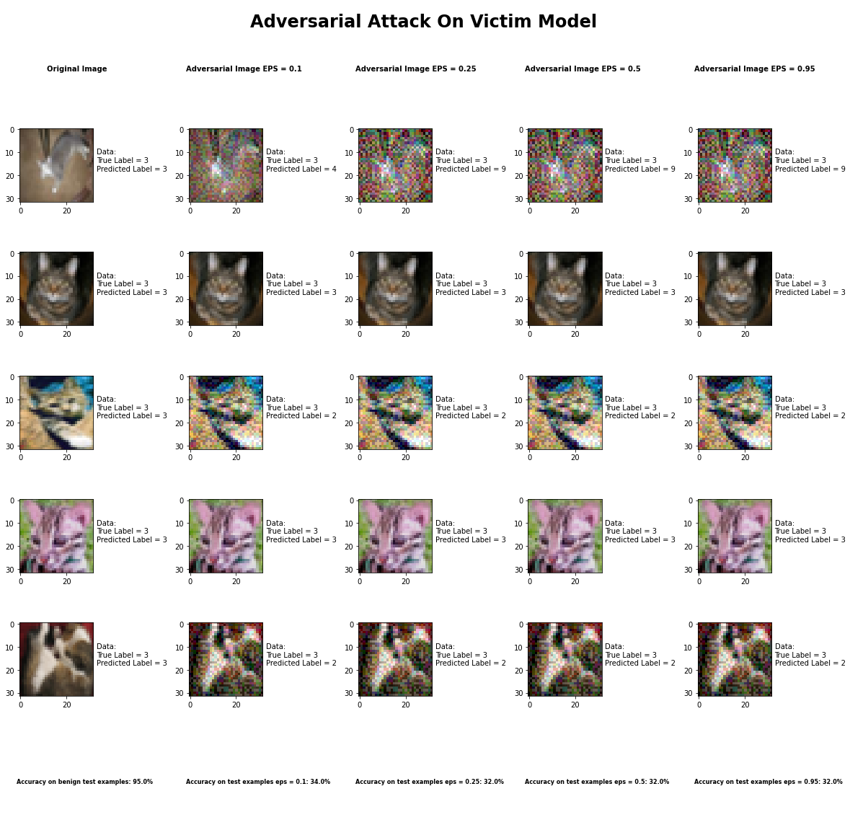

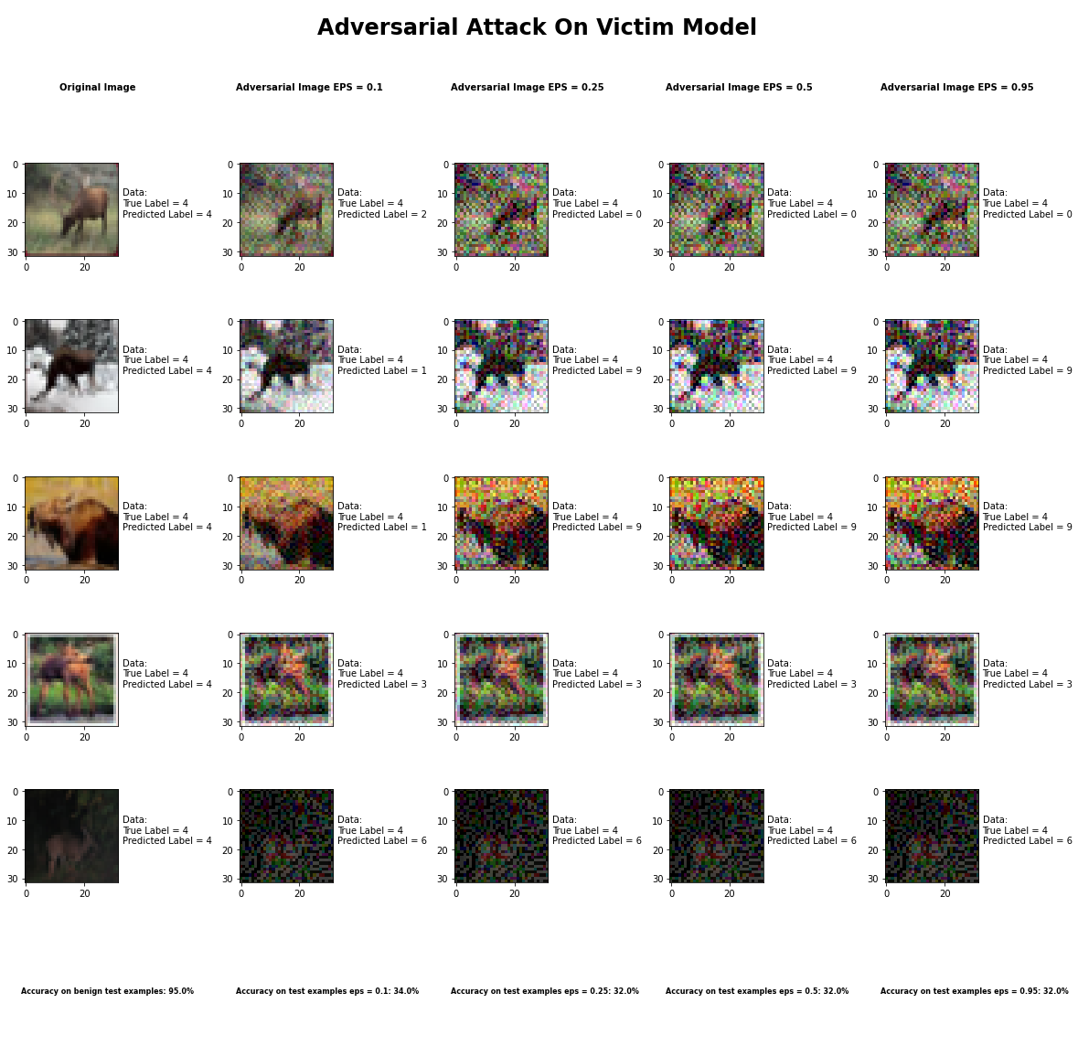

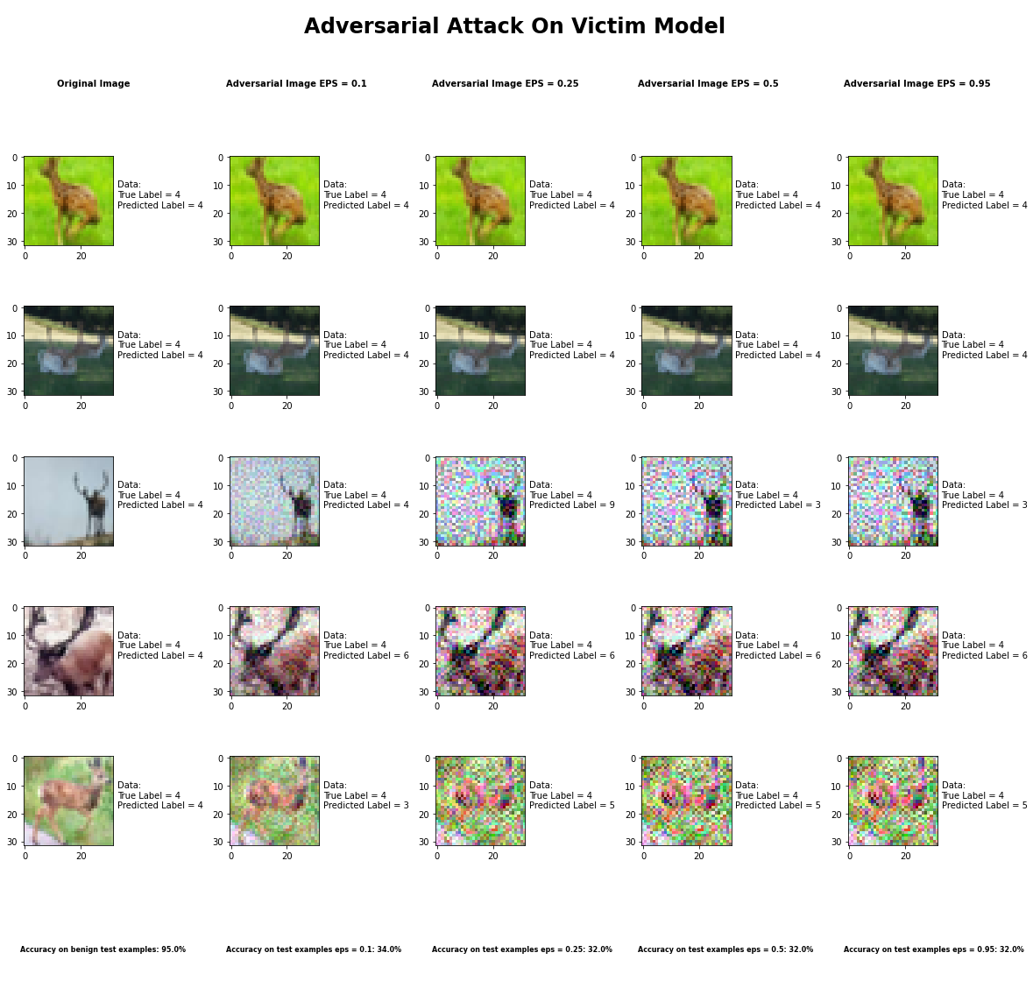

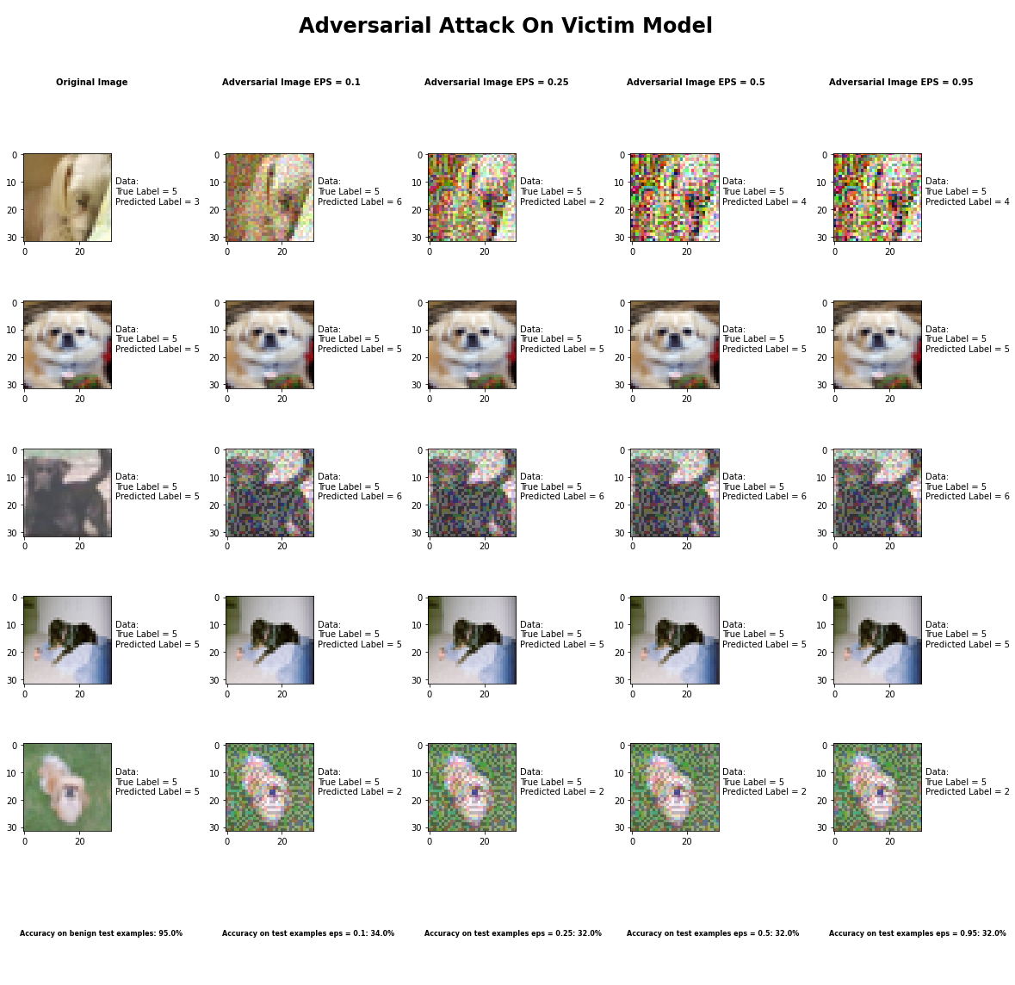

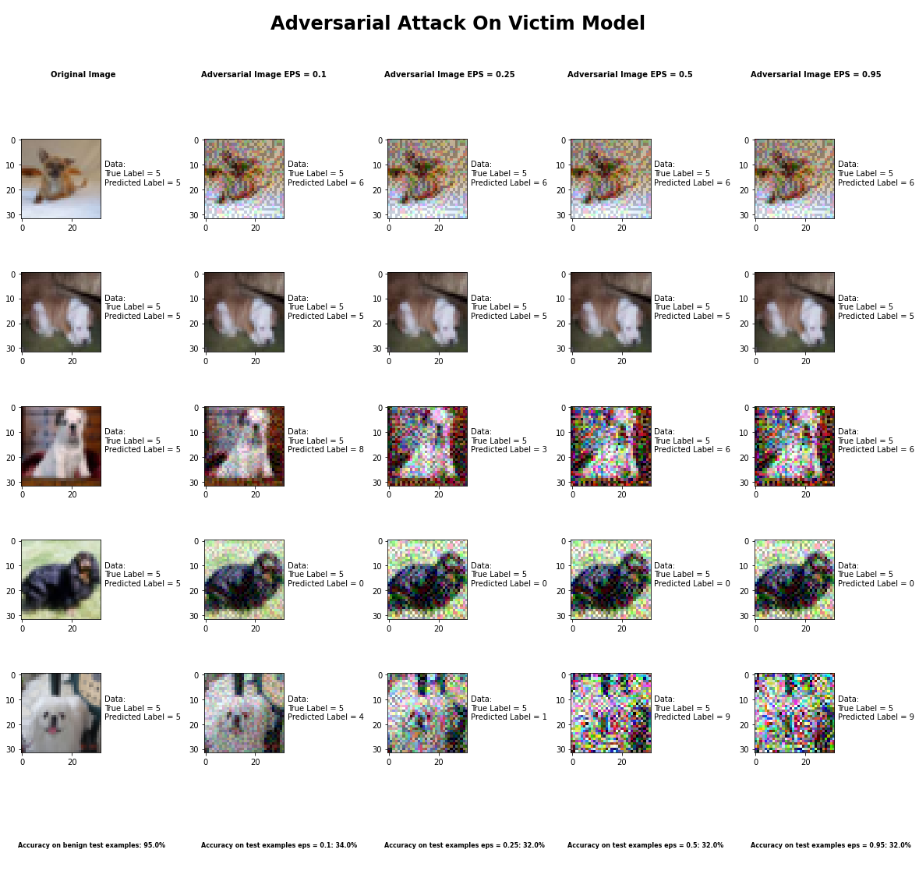

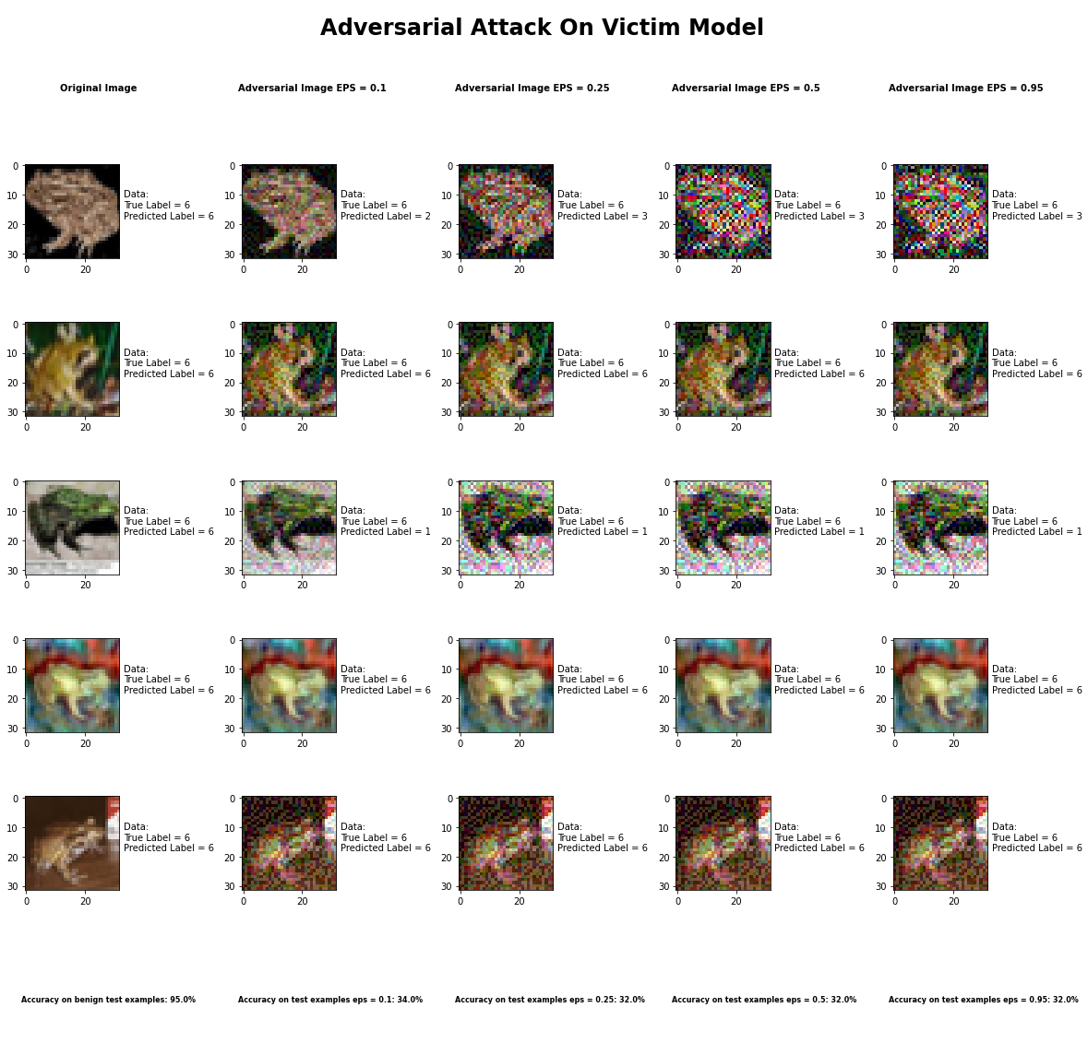

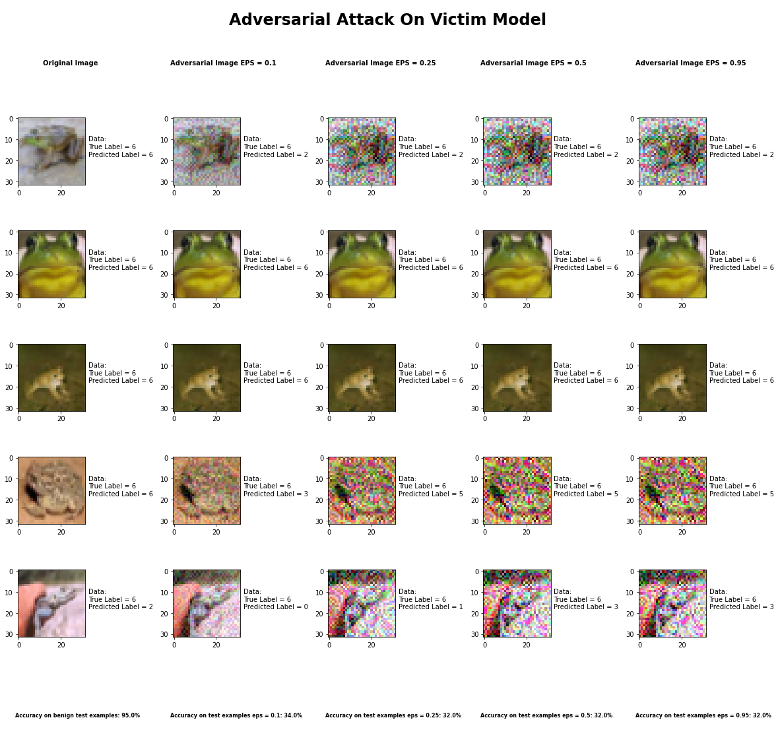

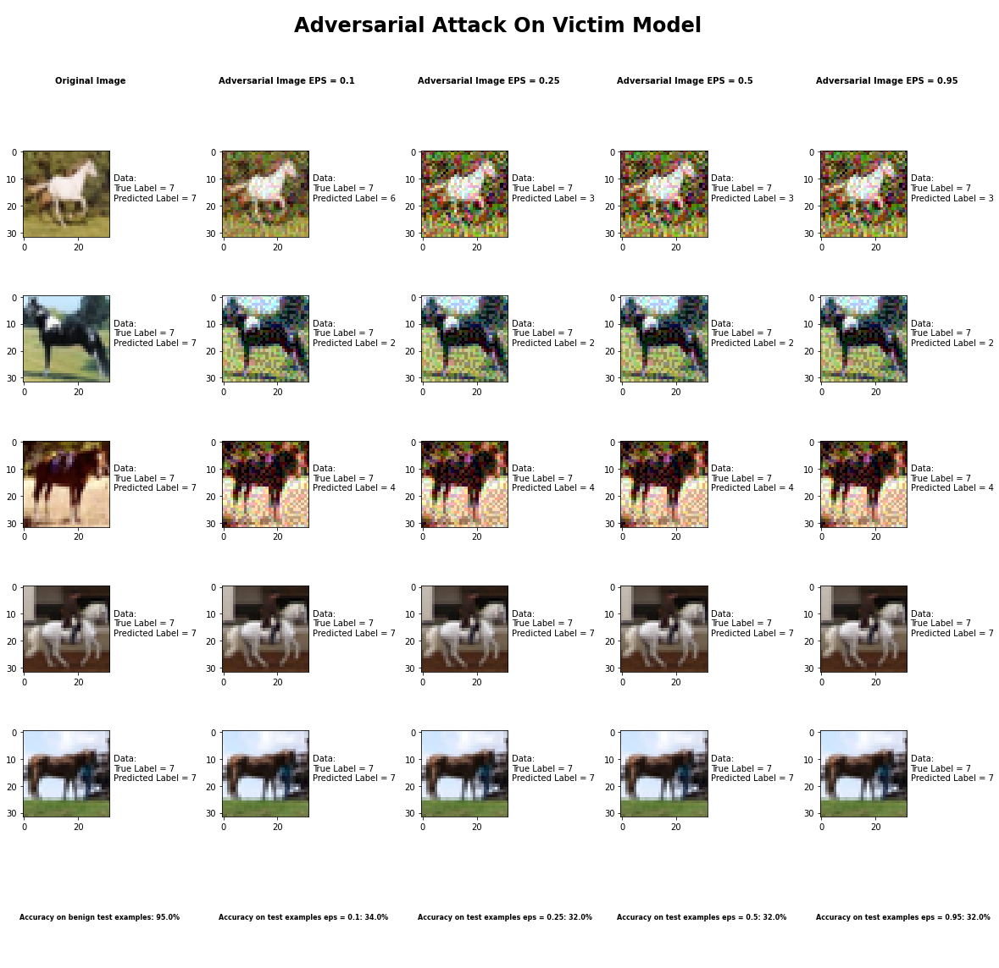

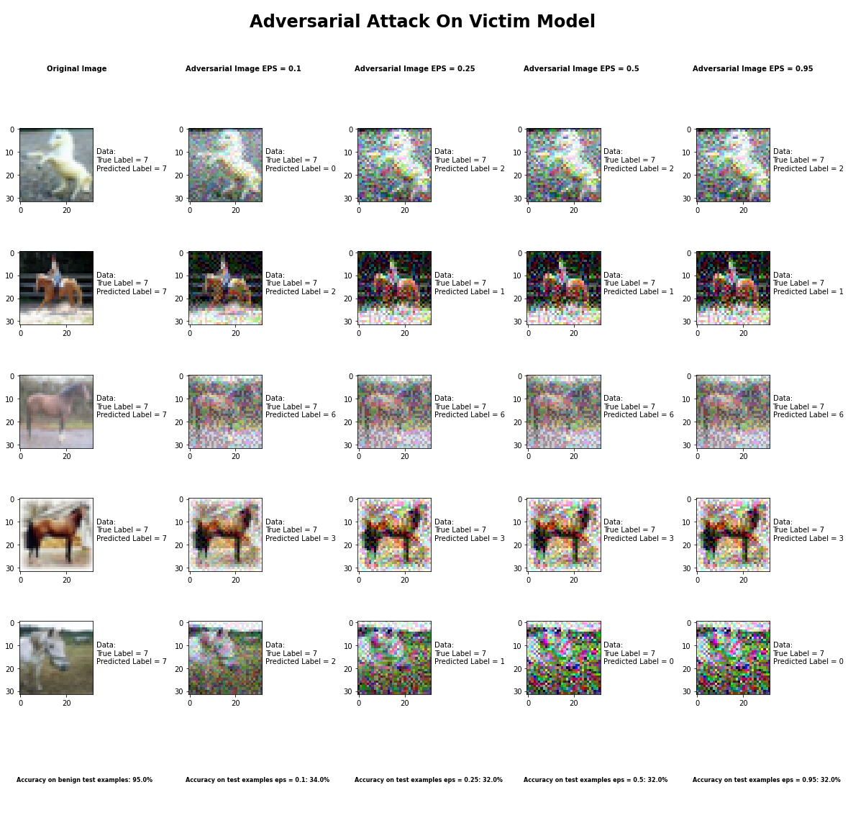

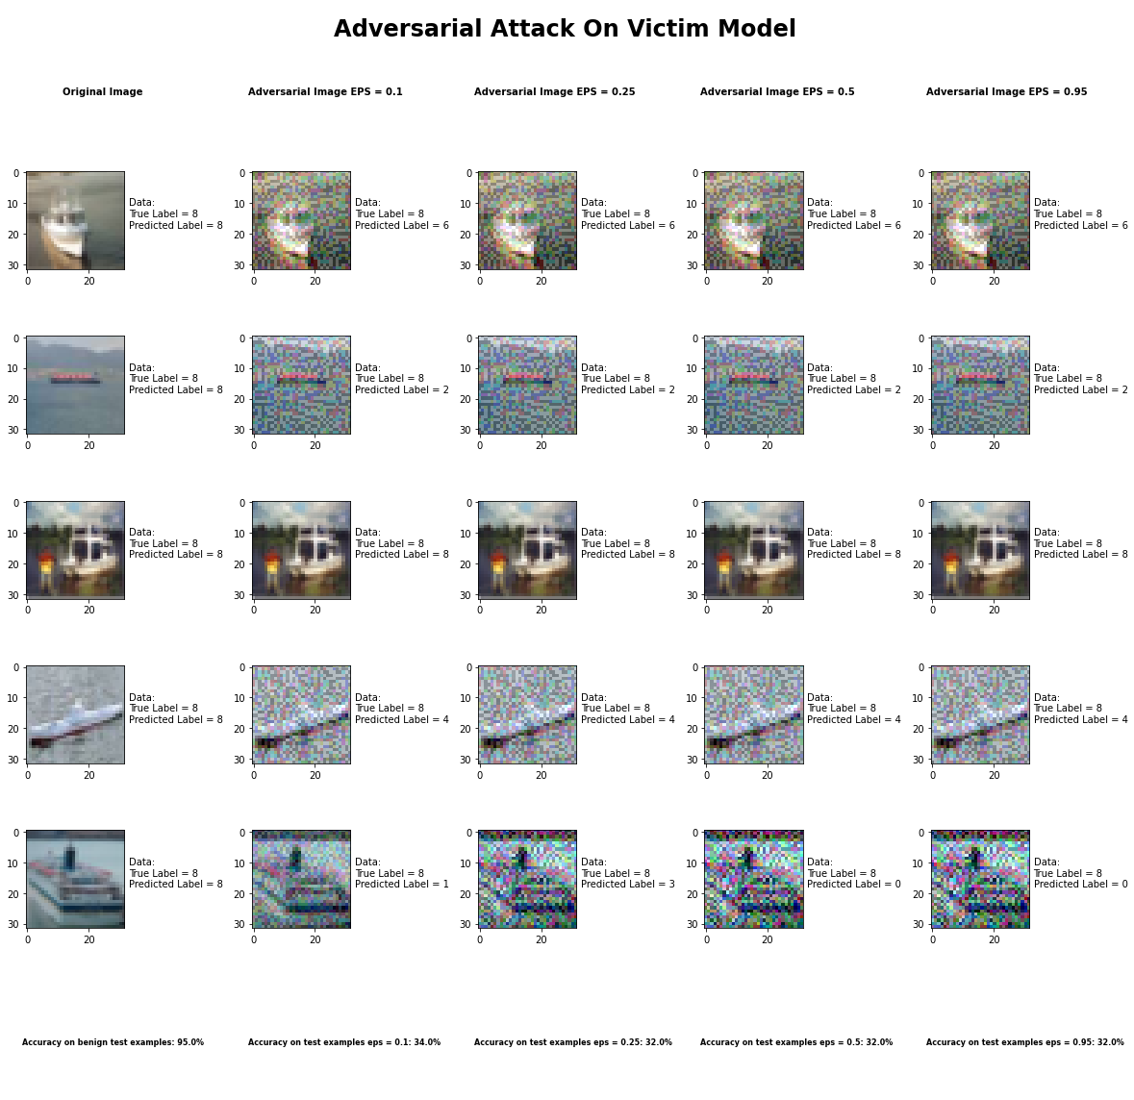

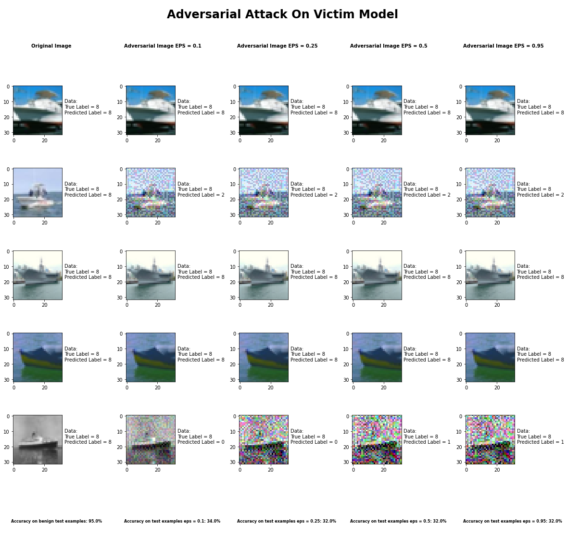

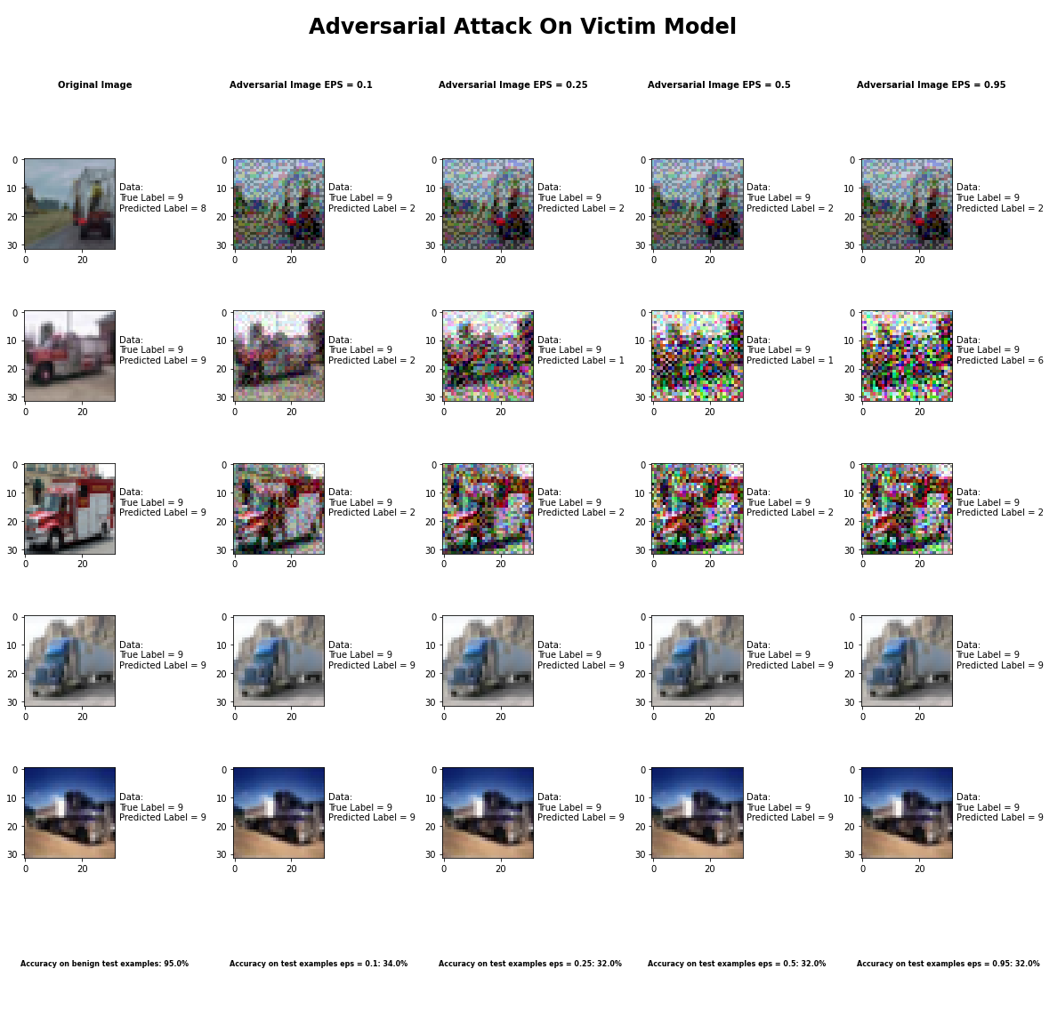

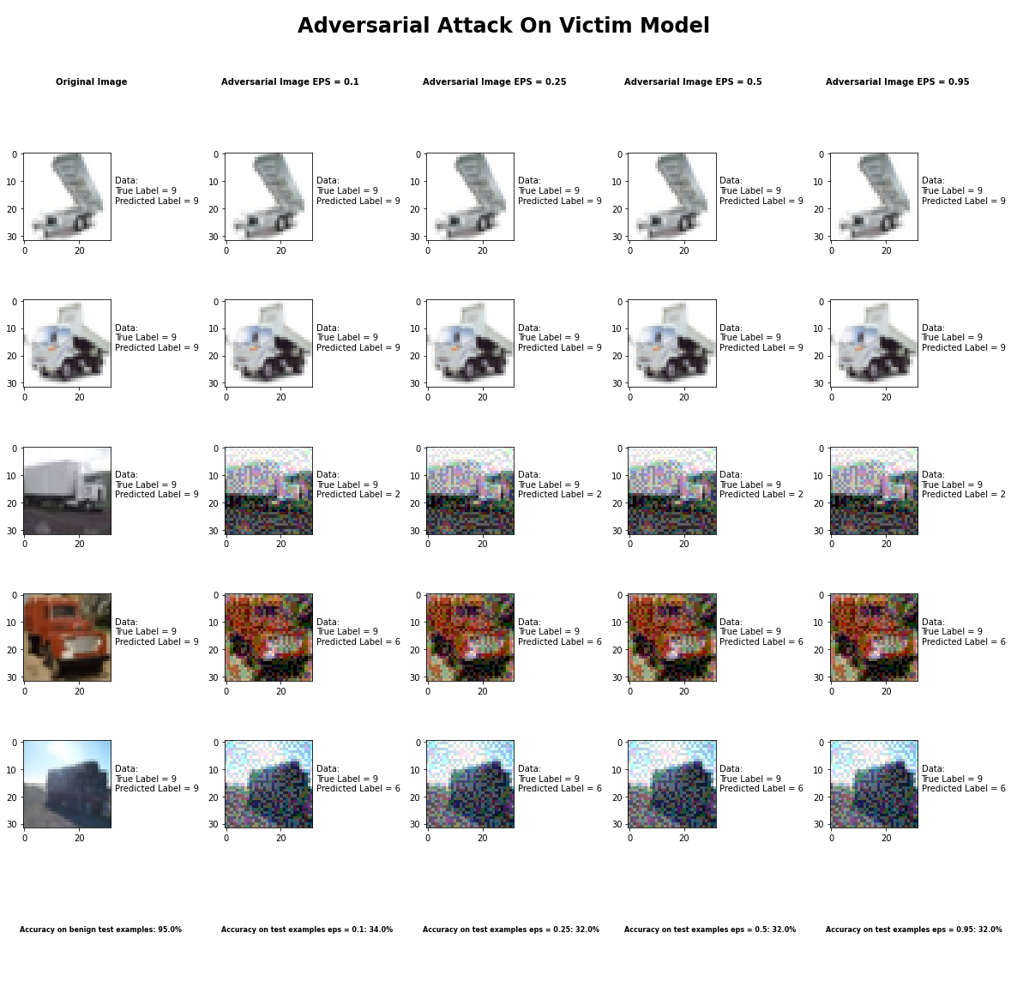 Accuracy on benign test examples: 94.52000000000001%

Average Accuracy on adversarial test examples with eps = 0.10: 34.0%

Average Accuracy on adversarial test examples with eps = 0.25: 32.3%

Average Accuracy on adversarial test examples with eps = 0.50: 32.0%

Average Accuracy on adversarial test examples with eps = 0.95: 32.1%

Classifier with benign example has Airplane recognition average accuracy of = 99%

Basic Iterative Method with eps = 0.10 has Airplane recognition average accuracy of = 35%

Basic Iterative Method with eps = 0.25 has Airplane recognition average accuracy of = 35%

Basic Iterative Method with eps = 0.50 has Airplane recognition average accuracy of = 35%

Basic Iterative Method with eps = 0.95 has Airplane recognition average accuracy of = 36%

Classifier with benign example has Automobile recognition average accuracy of = 96%

Basic Iterative Method with eps = 0.10 has Automobile recognition average accuracy of = 30%

Basic Iterative Method with eps = 0.25 has Automobile recognition average accuracy of = 28%

Basic Iterative Method with eps = 0.50 has Automobile recognition average accuracy of = 28%

Basic Iterative Method with eps = 0.95 has Automobile recognition average accuracy of = 28%

Classifier with benign example has Bird recognition average accuracy of = 94%

Basic Iterative Method with eps = 0.10 has Bird recognition average accuracy of = 44%

Basic Iterative Method with eps = 0.25 has Bird recognition average accuracy of = 41%

Basic Iterative Method with eps = 0.50 has Bird recognition average accuracy of = 40%

Basic Iterative Method with eps = 0.95 has Bird recognition average accuracy of = 40%

Classifier with benign example has Cat recognition average accuracy of = 87%

Basic Iterative Method with eps = 0.10 has Cat recognition average accuracy of = 27%

Basic Iterative Method with eps = 0.25 has Cat recognition average accuracy of = 27%

Basic Iterative Method with eps = 0.50 has Cat recognition average accuracy of = 25%

Basic Iterative Method with eps = 0.95 has Cat recognition average accuracy of = 25%

Classifier with benign example has Deer recognition average accuracy of = 97%

Basic Iterative Method with eps = 0.10 has Deer recognition average accuracy of = 29%

Basic Iterative Method with eps = 0.25 has Deer recognition average accuracy of = 28%

Basic Iterative Method with eps = 0.50 has Deer recognition average accuracy of = 28%

Basic Iterative Method with eps = 0.95 has Deer recognition average accuracy of = 28%

Classifier with benign example has Dog recognition average accuracy of = 88%

Basic Iterative Method with eps = 0.10 has Dog recognition average accuracy of = 22%

Basic Iterative Method with eps = 0.25 has Dog recognition average accuracy of = 22%

Basic Iterative Method with eps = 0.50 has Dog recognition average accuracy of = 22%

Basic Iterative Method with eps = 0.95 has Dog recognition average accuracy of = 22%

Classifier with benign example has Frog recognition average accuracy of = 95%

Basic Iterative Method with eps = 0.10 has Frog recognition average accuracy of = 54%

Basic Iterative Method with eps = 0.25 has Frog recognition average accuracy of = 47%

Basic Iterative Method with eps = 0.50 has Frog recognition average accuracy of = 47%

Basic Iterative Method with eps = 0.95 has Frog recognition average accuracy of = 47%

Classifier with benign example has Horse recognition average accuracy of = 97%

Basic Iterative Method with eps = 0.10 has Horse recognition average accuracy of = 30%

Basic Iterative Method with eps = 0.25 has Horse recognition average accuracy of = 30%

Basic Iterative Method with eps = 0.50 has Horse recognition average accuracy of = 30%

Basic Iterative Method with eps = 0.95 has Horse recognition average accuracy of = 30%

Classifier with benign example has Ship recognition average accuracy of = 93%

Basic Iterative Method with eps = 0.10 has Ship recognition average accuracy of = 33%

Basic Iterative Method with eps = 0.25 has Ship recognition average accuracy of = 31%

Basic Iterative Method with eps = 0.50 has Ship recognition average accuracy of = 31%

Basic Iterative Method with eps = 0.95 has Ship recognition average accuracy of = 31%

Classifier with benign example has Truck recognition average accuracy of = 93%

Basic Iterative Method with eps = 0.10 has Truck recognition average accuracy of = 36%

Basic Iterative Method with eps = 0.25 has Truck recognition average accuracy of = 34%

Basic Iterative Method with eps = 0.50 has Truck recognition average accuracy of = 34%

Basic Iterative Method with eps = 0.95 has Truck recognition average accuracy of = 34%

## Universal Perturbation Method



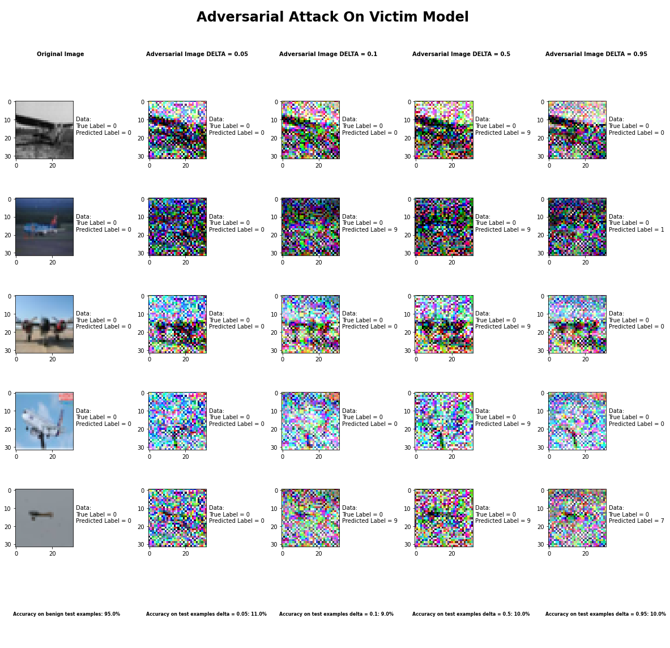

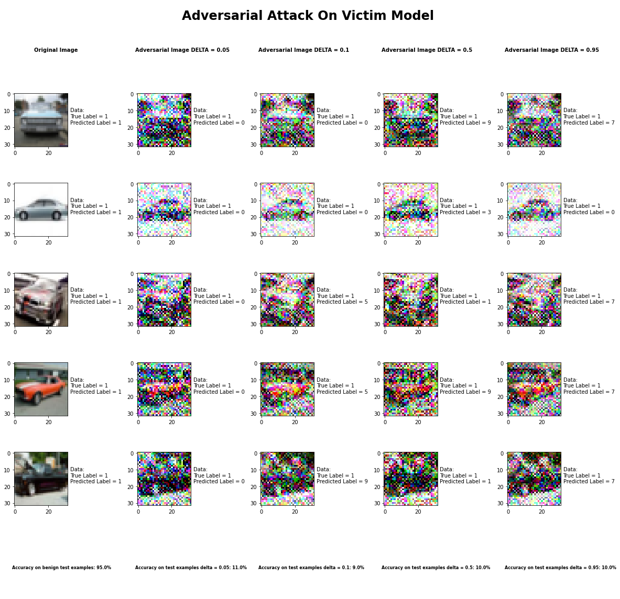

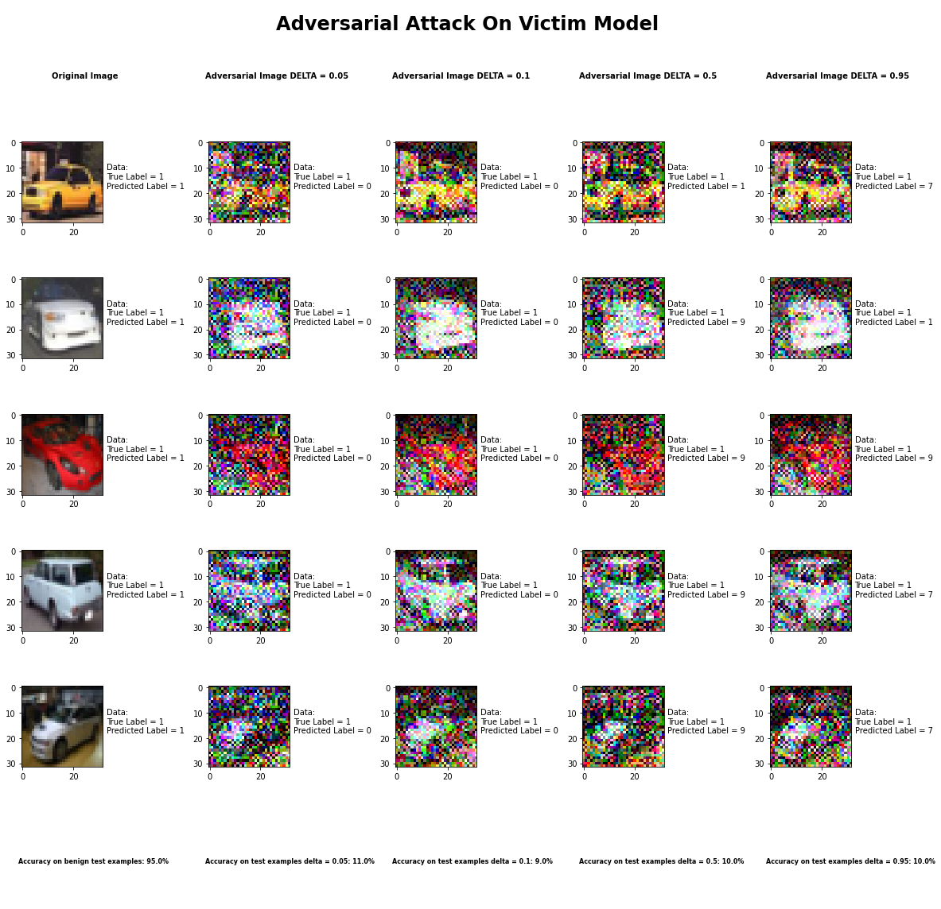

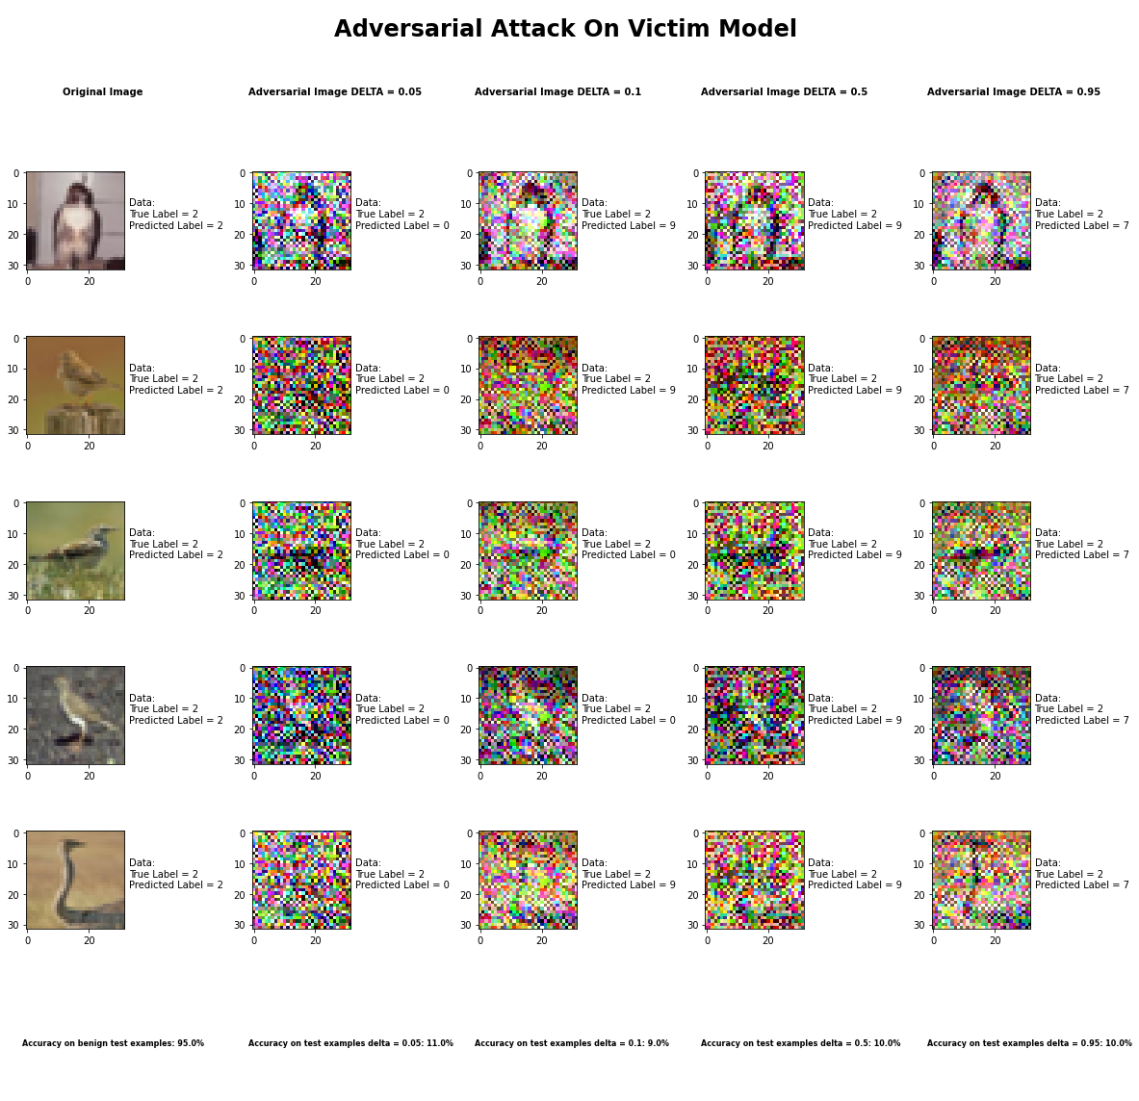

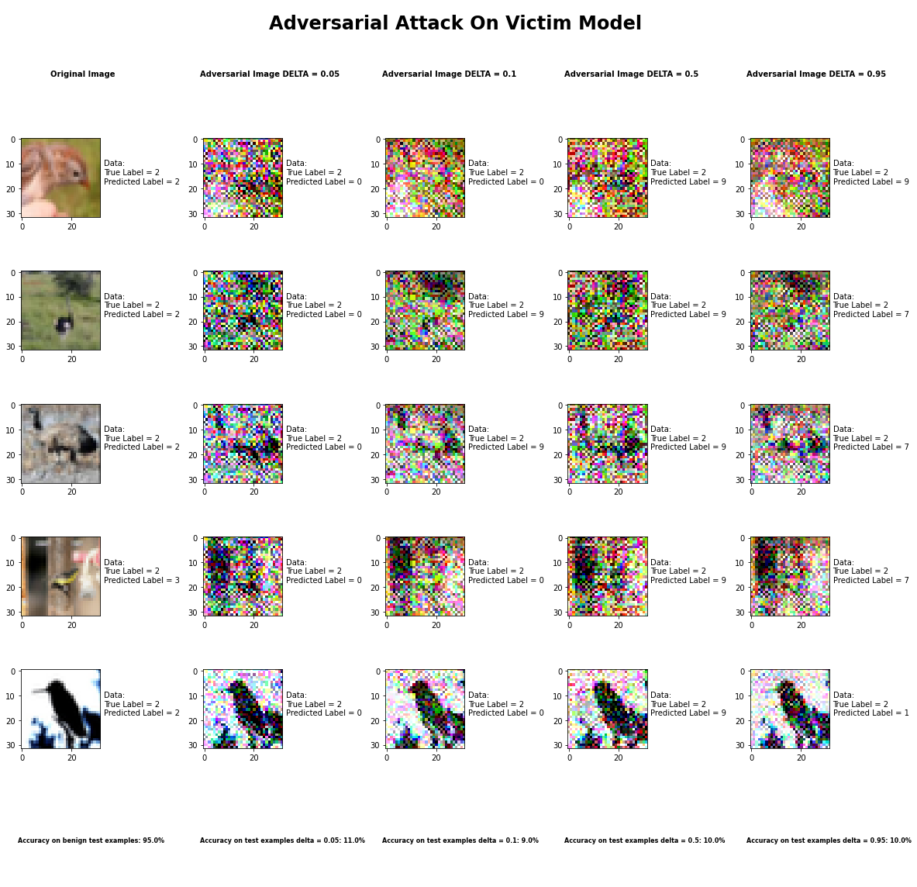

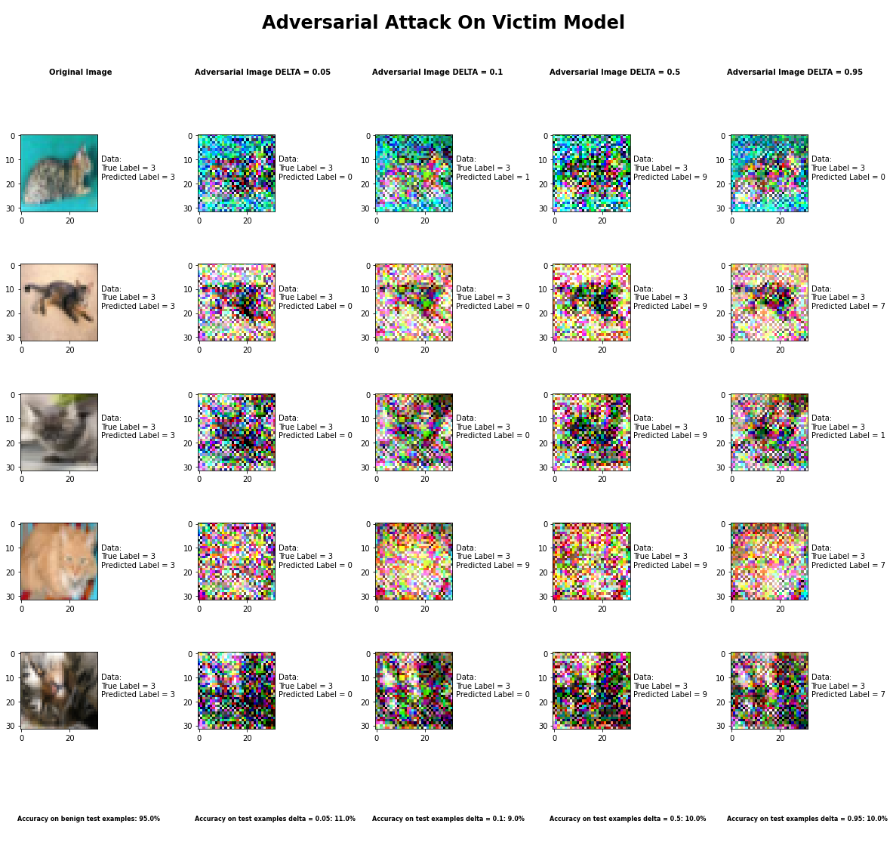

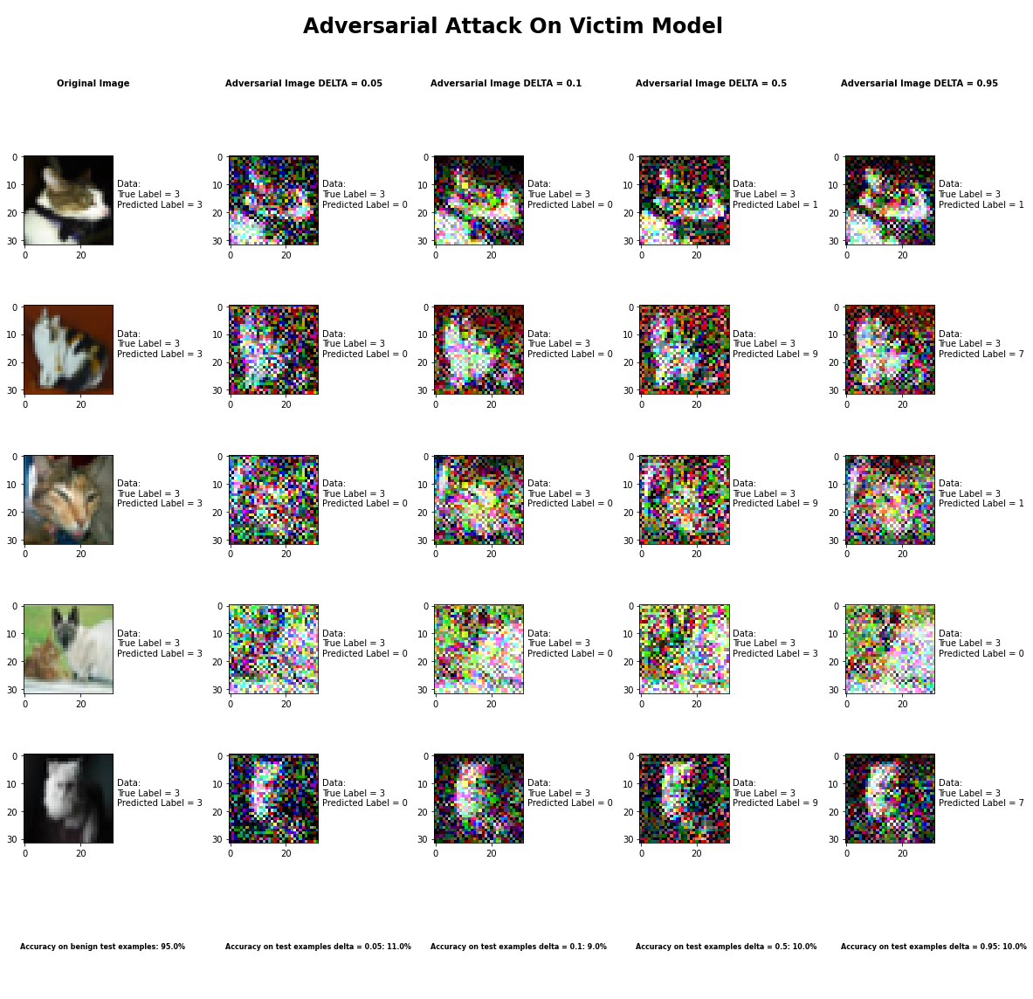

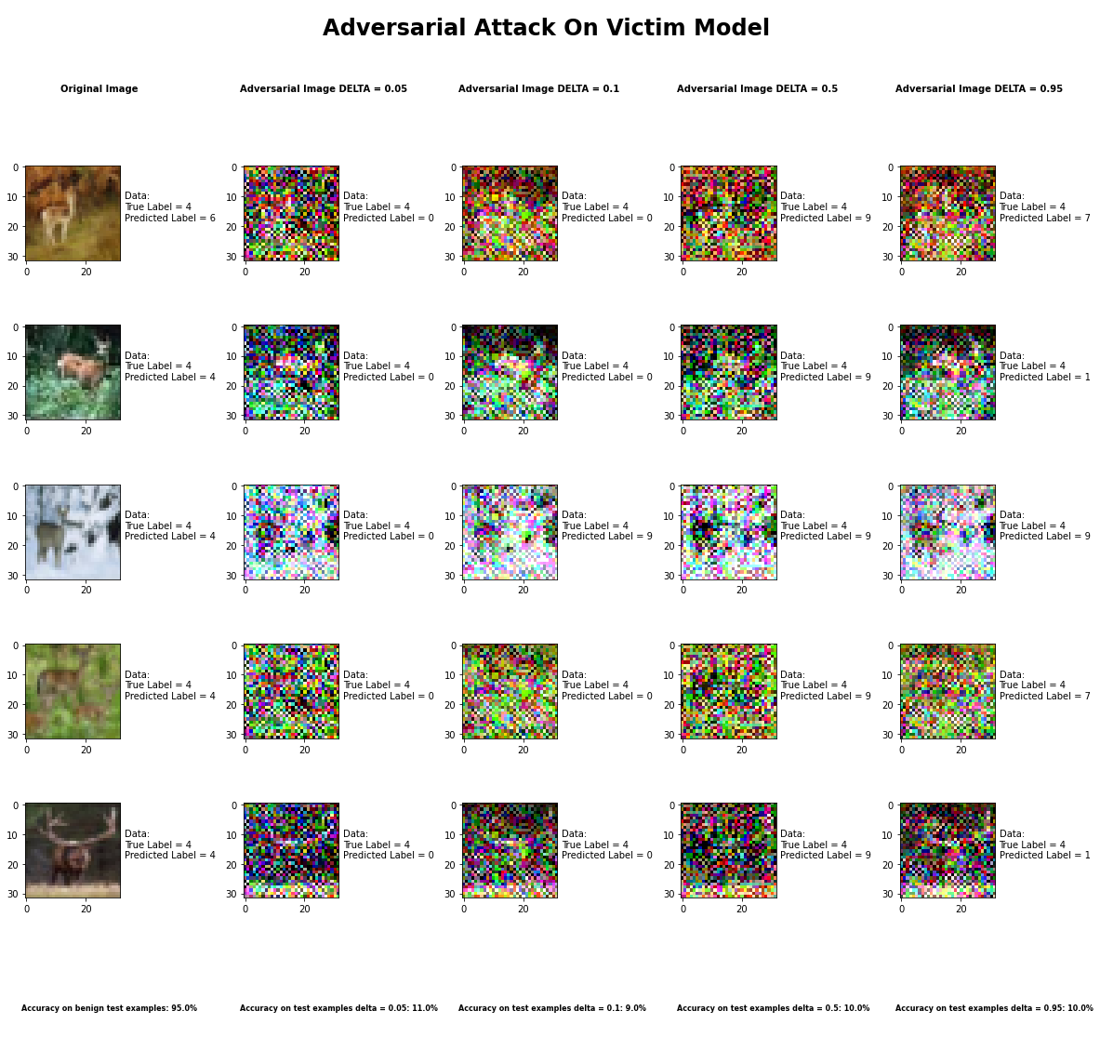

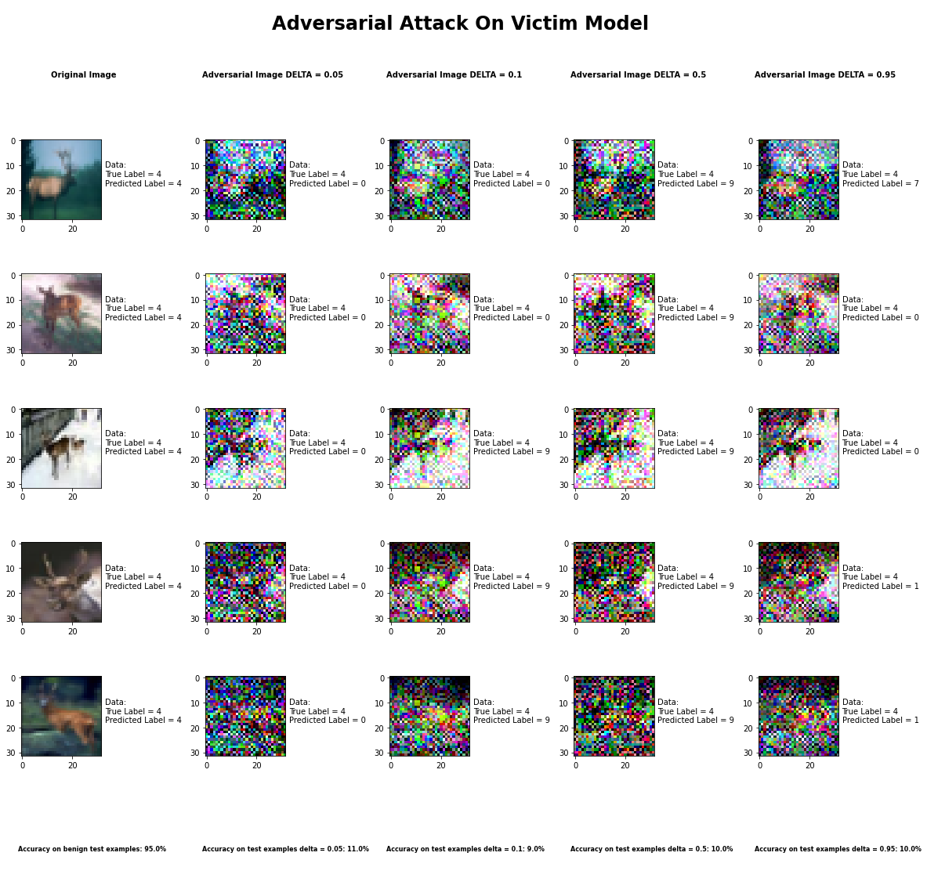

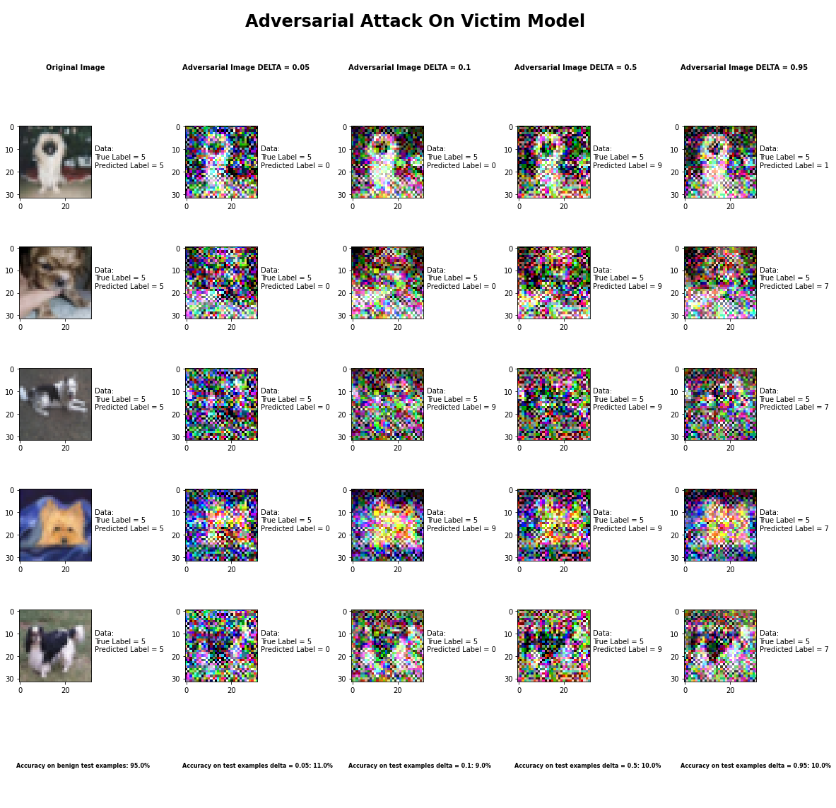

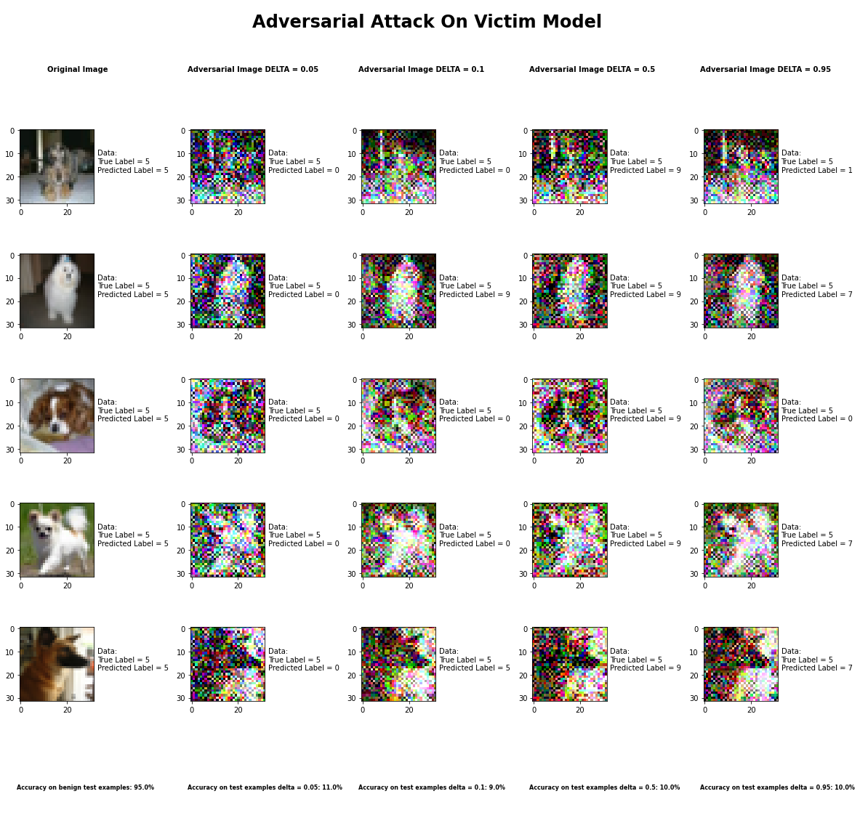

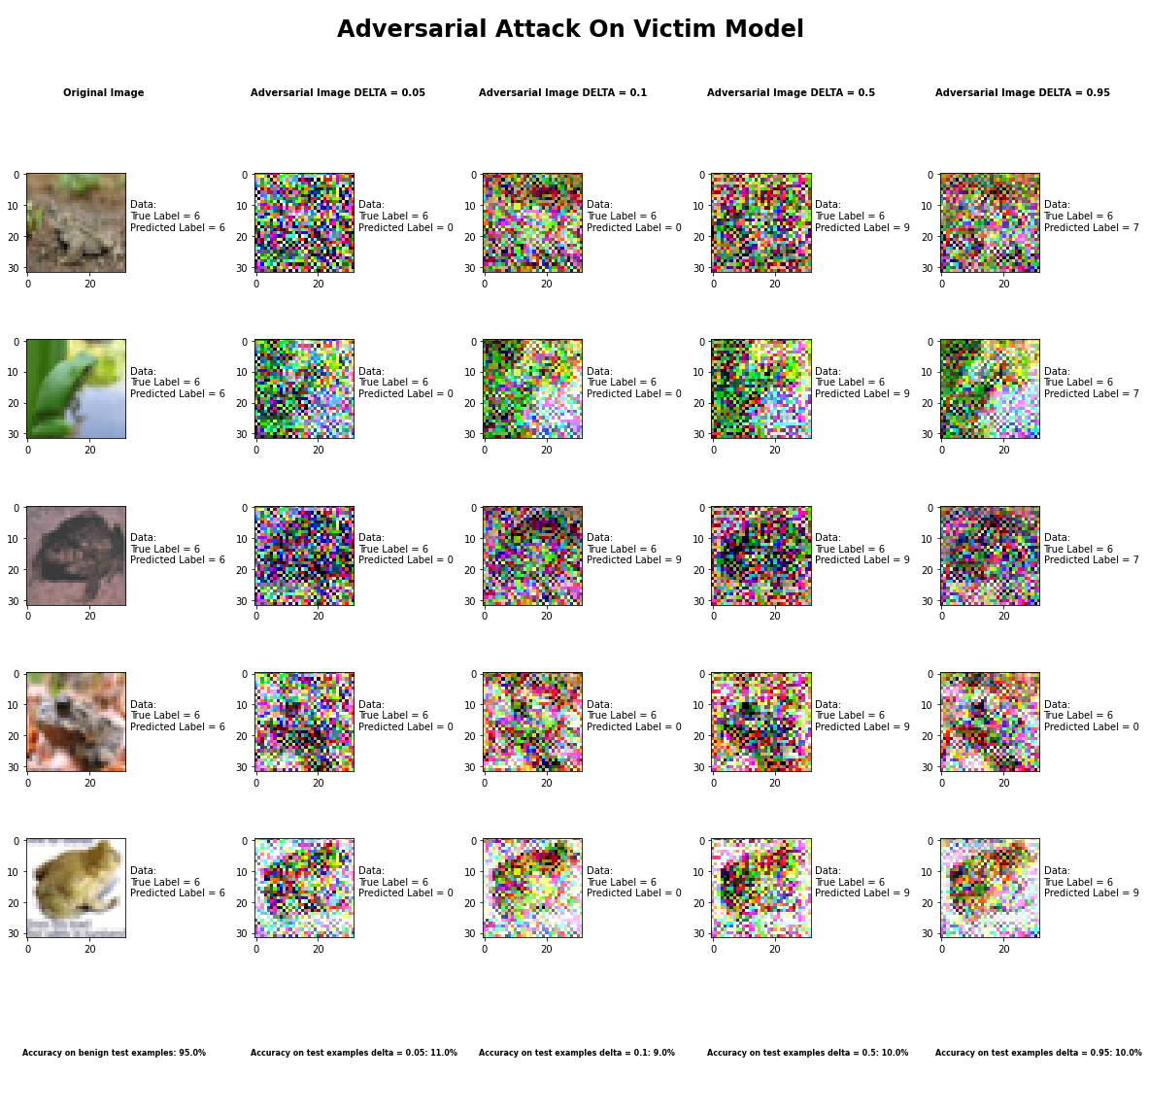

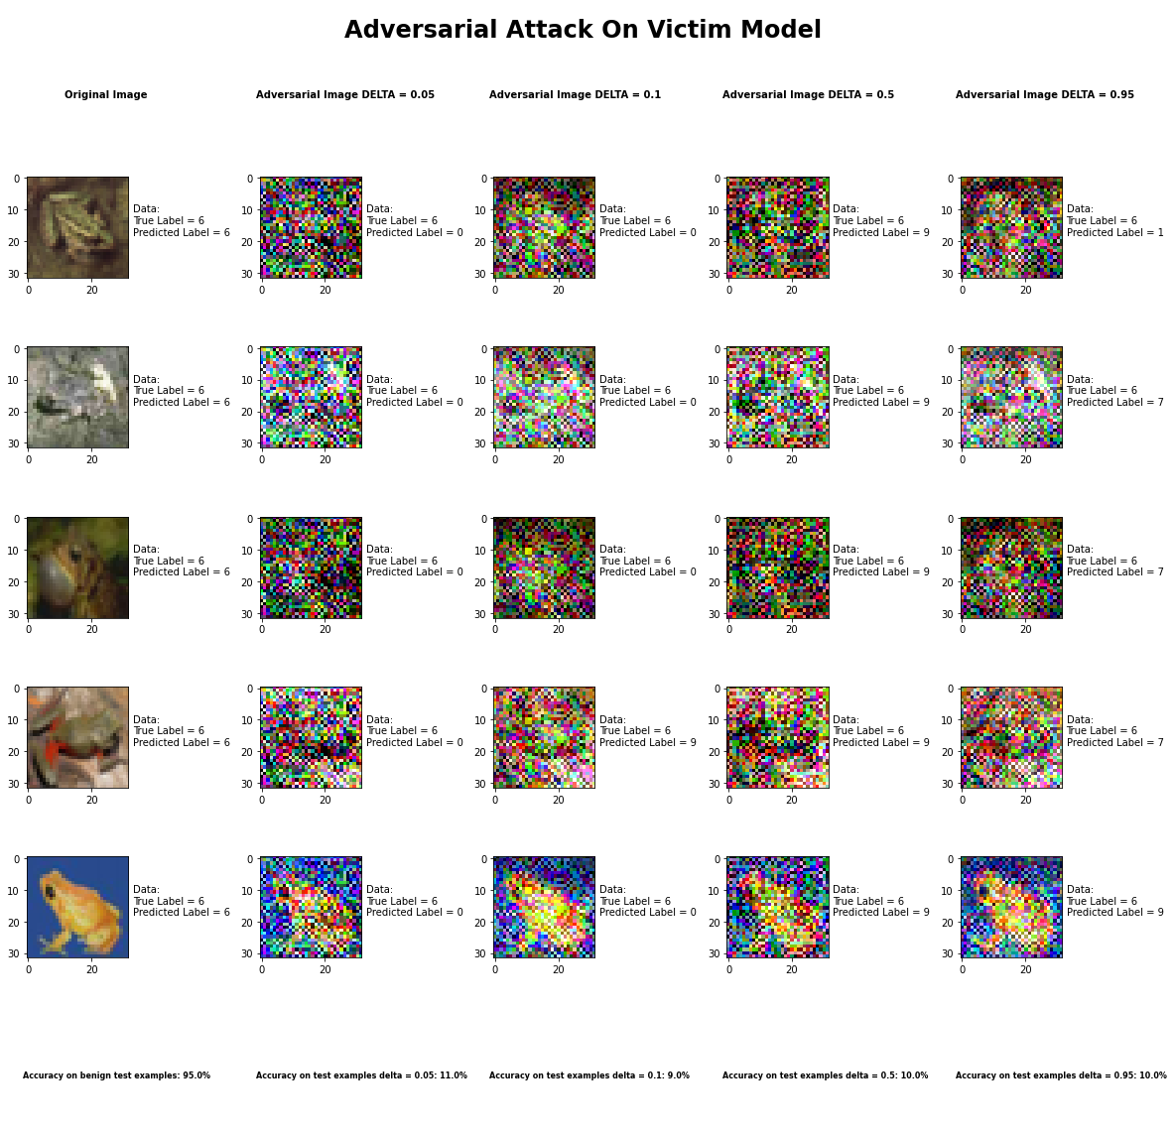

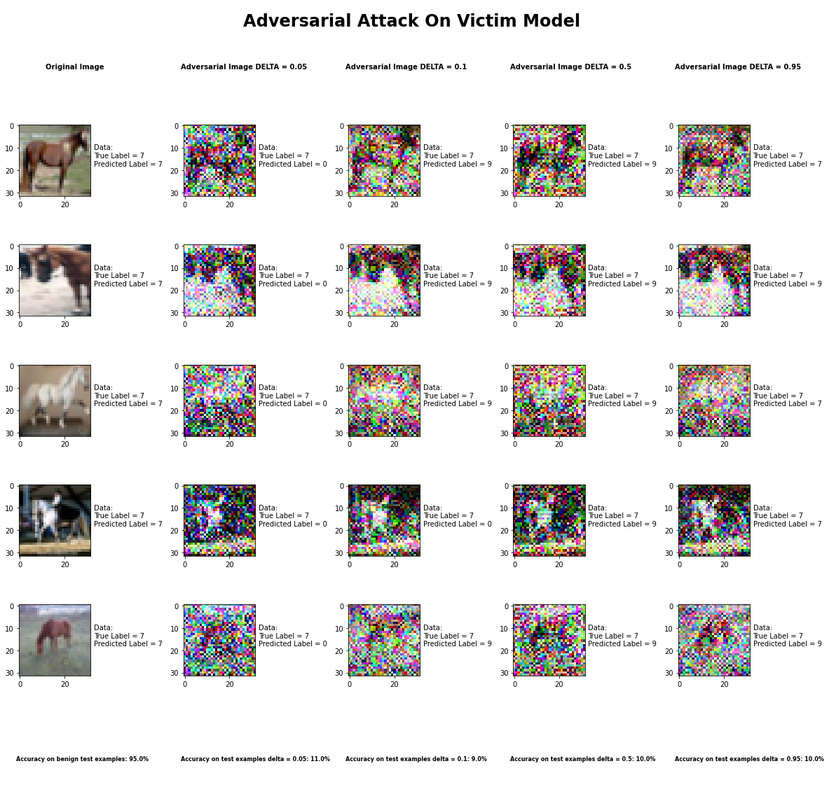

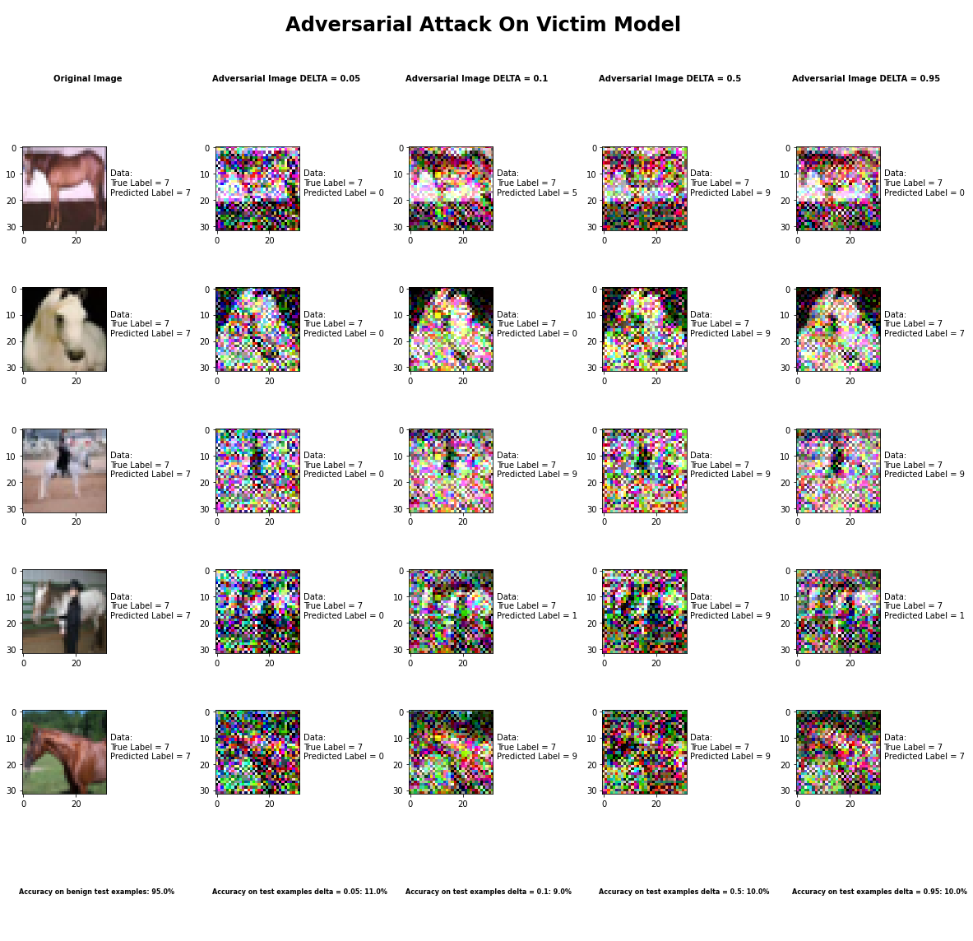

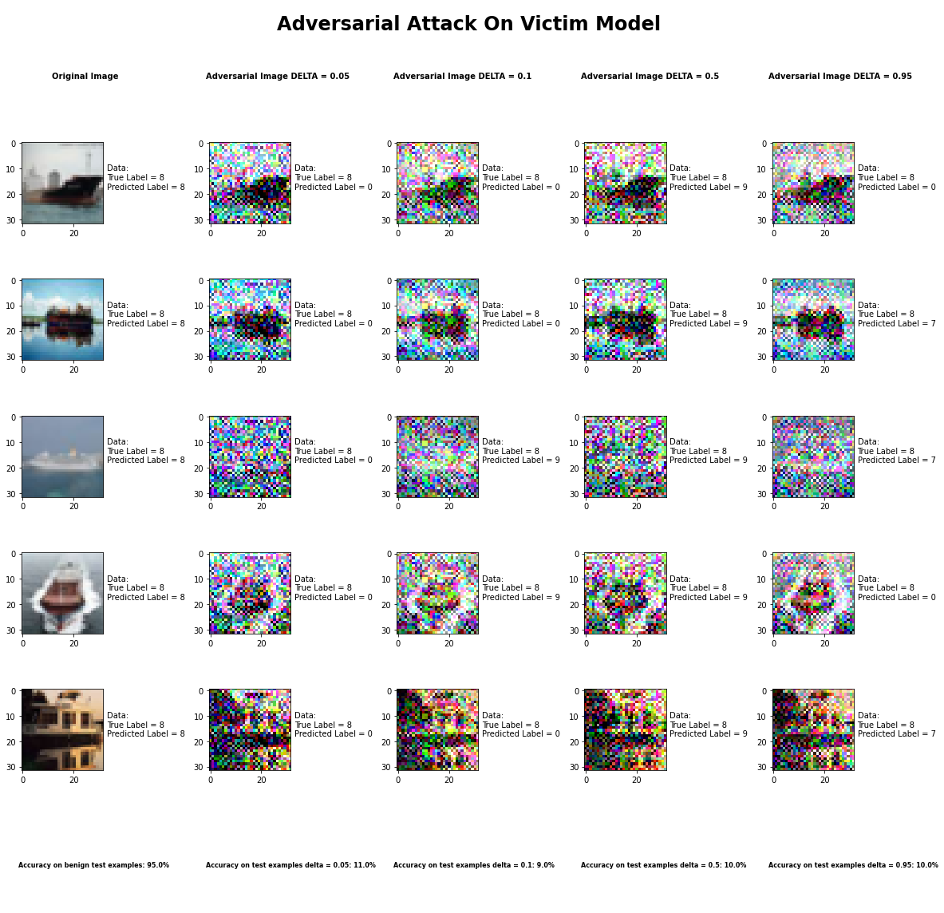

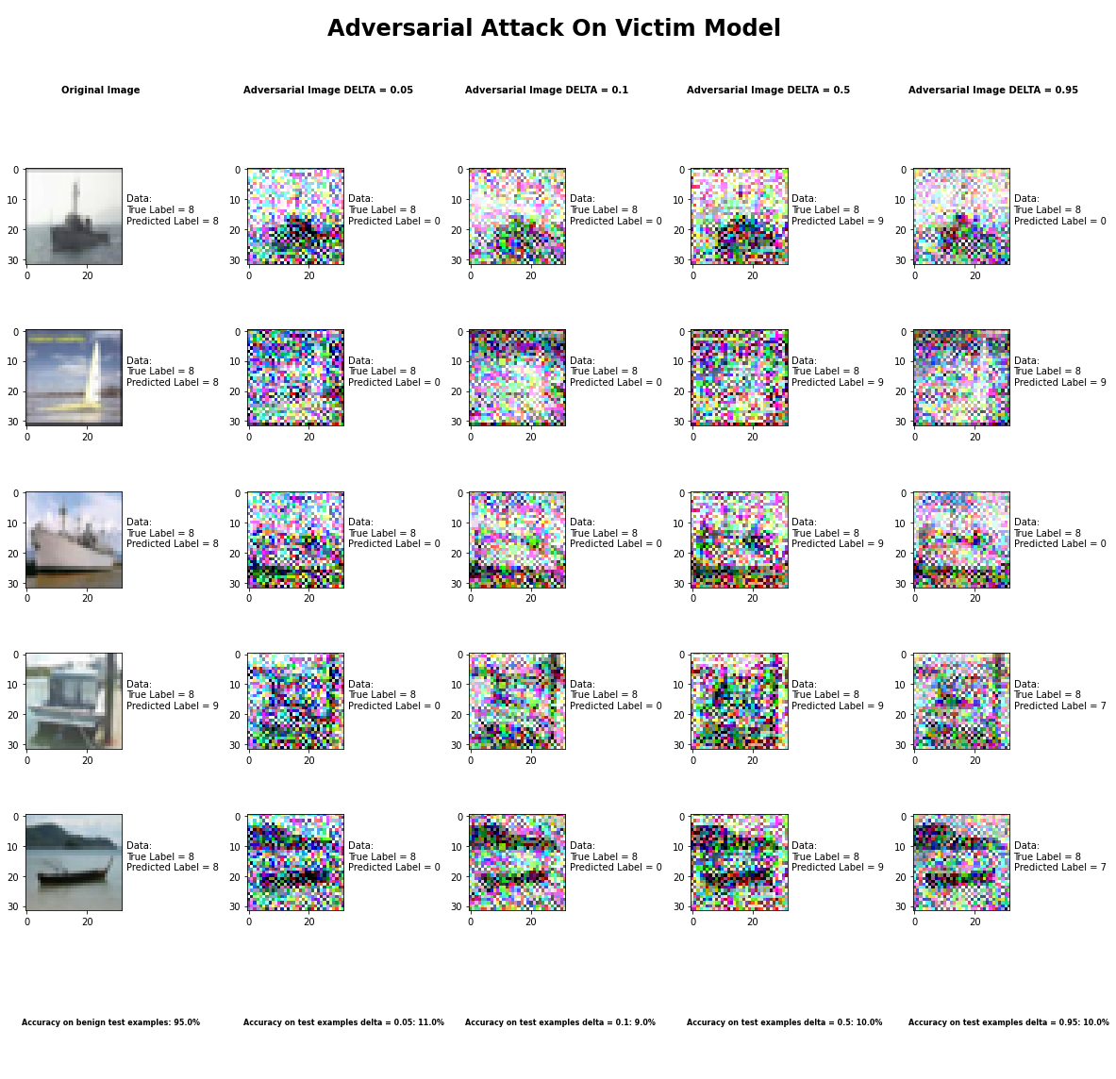

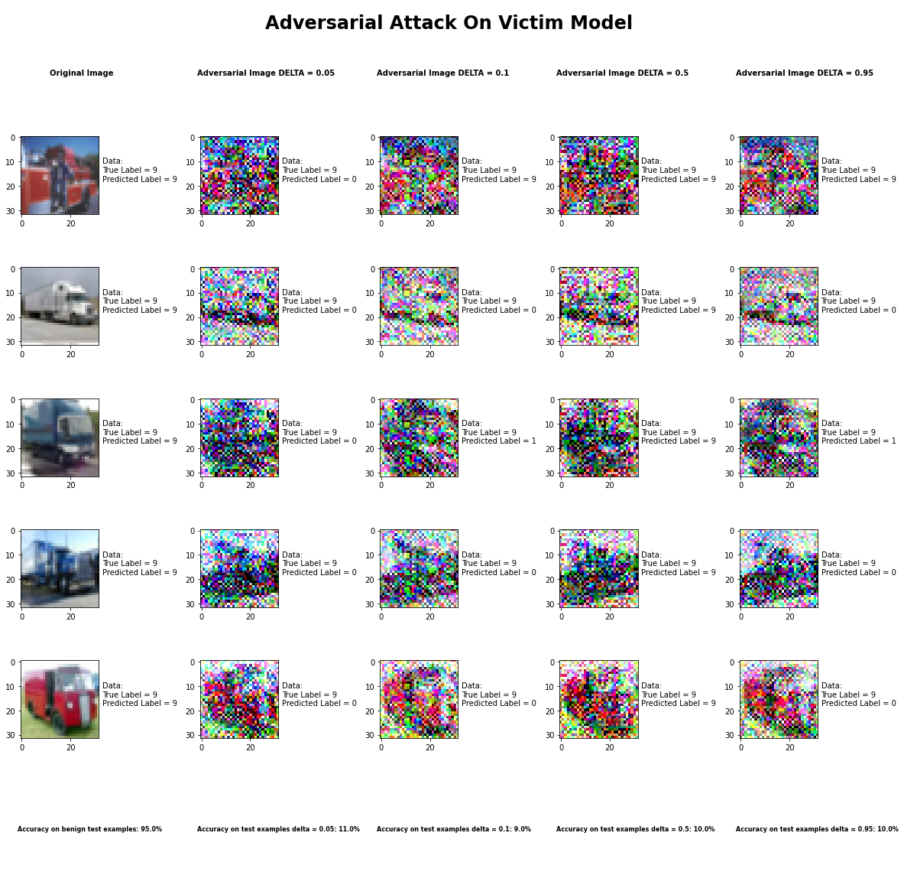

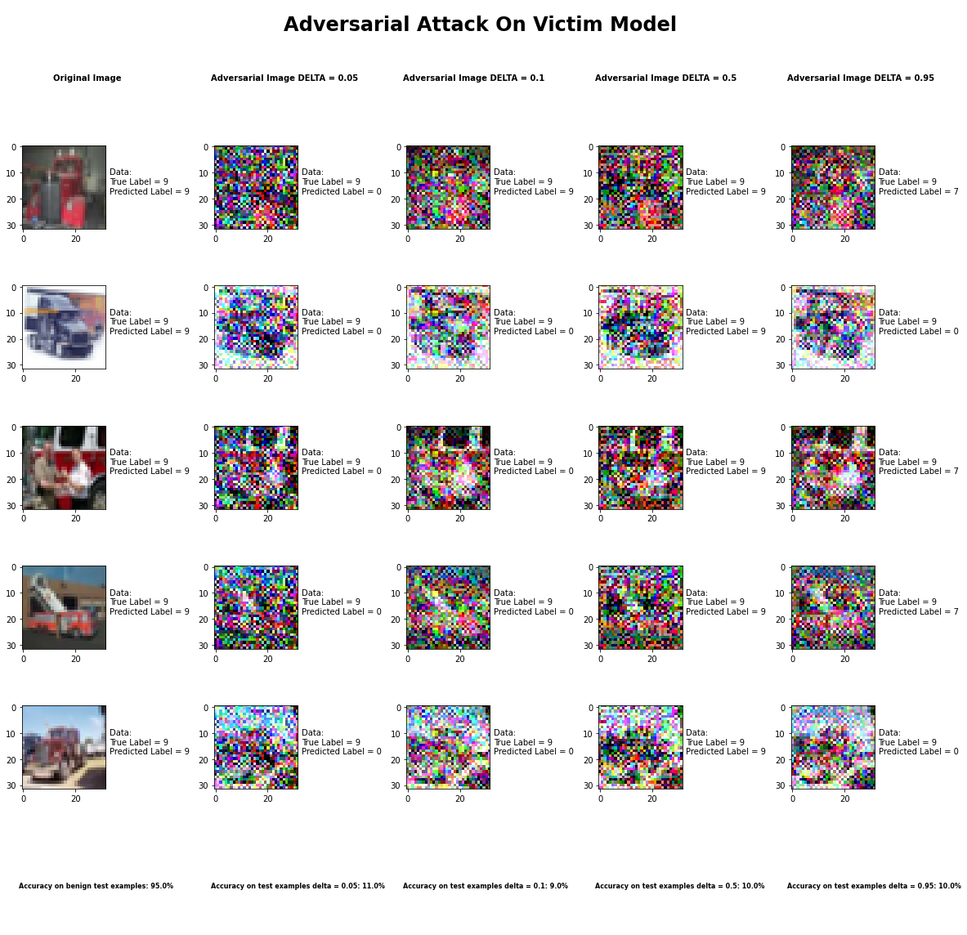

Accuracy on benign test examples: 94.52000000000001%

Average Accuracy on adversarial test examples with delta = 0.05: 10.6%

Average Accuracy on adversarial test examples with delta = 0.1: 9.1%

Average Accuracy on adversarial test examples with delta = 0.5: 10.5%

Average Accuracy on adversarial test examples with delta = 0.95: 10.4%

Classifier with benign example has Airplane recognition average accuracy of = 94%

Universal Perturbation Method with delta = 0.05 has Airplane recognition average accuracy of = 54%

Universal Perturbation Method with delta = 0.1 has Airplane recognition average accuracy of = 36%

Universal Perturbation Method with delta = 0.5 has Airplane recognition average accuracy of = 37%

Universal Perturbation Method with delta = 0.95 has Airplane recognition average accuracy of = 56%

Classifier with benign example has Automobile recognition average accuracy of = 97%

Universal Perturbation Method with delta = 0.05 has Automobile recognition average accuracy of = 1%

Universal Perturbation Method with delta = 0.1 has Automobile recognition average accuracy of = 2%

Universal Perturbation Method with delta = 0.5 has Automobile recognition average accuracy of = 21%

Universal Perturbation Method with delta = 0.95 has Automobile recognition average accuracy of = 5%

Classifier with benign example has Bird recognition average accuracy of = 93%

Universal Perturbation Method with delta = 0.05 has Bird recognition average accuracy of = 0%

Universal Perturbation Method with delta = 0.1 has Bird recognition average accuracy of = 0%

Universal Perturbation Method with delta = 0.5 has Bird recognition average accuracy of = 0%

Universal Perturbation Method with delta = 0.95 has Bird recognition average accuracy of = 0%

Classifier with benign example has Cat recognition average accuracy of = 95%

Universal Perturbation Method with delta = 0.05 has Cat recognition average accuracy of = 0%

Universal Perturbation Method with delta = 0.1 has Cat recognition average accuracy of = 11%

Universal Perturbation Method with delta = 0.5 has Cat recognition average accuracy of = 1%

Universal Perturbation Method with delta = 0.95 has Cat recognition average accuracy of = 2%

Classifier with benign example has Deer recognition average accuracy of = 97%

Universal Perturbation Method with delta = 0.05 has Deer recognition average accuracy of = 0%

Universal Perturbation Method with delta = 0.1 has Deer recognition average accuracy of = 0%

Universal Perturbation Method with delta = 0.5 has Deer recognition average accuracy of = 0%

Universal Perturbation Method with delta = 0.95 has Deer recognition average accuracy of = 0%

Classifier with benign example has Dog recognition average accuracy of = 90%

Universal Perturbation Method with delta = 0.05 has Dog recognition average accuracy of = 0%

Universal Perturbation Method with delta = 0.1 has Dog recognition average accuracy of = 1%

Universal Perturbation Method with delta = 0.5 has Dog recognition average accuracy of = 1%

Universal Perturbation Method with delta = 0.95 has Dog recognition average accuracy of = 1%

Classifier with benign example has Frog recognition average accuracy of = 96%

Universal Perturbation Method with delta = 0.05 has Frog recognition average accuracy of = 2%

Universal Perturbation Method with delta = 0.1 has Frog recognition average accuracy of = 0%

Universal Perturbation Method with delta = 0.5 has Frog recognition average accuracy of = 10%

Universal Perturbation Method with delta = 0.95 has Frog recognition average accuracy of = 3%

Classifier with benign example has Horse recognition average accuracy of = 98%

Universal Perturbation Method with delta = 0.05 has Horse recognition average accuracy of = 0%

Universal Perturbation Method with delta = 0.1 has Horse recognition average accuracy of = 0%

Universal Perturbation Method with delta = 0.5 has Horse recognition average accuracy of = 0%

Universal Perturbation Method with delta = 0.95 has Horse recognition average accuracy of = 9%

Classifier with benign example has Ship recognition average accuracy of = 94%

Universal Perturbation Method with delta = 0.05 has Ship recognition average accuracy of = 0%

Universal Perturbation Method with delta = 0.1 has Ship recognition average accuracy of = 0%

Universal Perturbation Method with delta = 0.5 has Ship recognition average accuracy of = 0%

Universal Perturbation Method with delta = 0.95 has Ship recognition average accuracy of = 0%

Classifier with benign example has Truck recognition average accuracy of = 96%

Universal Perturbation Method with delta = 0.05 has Truck recognition average accuracy of = 49%

Universal Perturbation Method with delta = 0.1 has Truck recognition average accuracy of = 41%

Universal Perturbation Method with delta = 0.5 has Truck recognition average accuracy of = 35%

Universal Perturbation Method with delta = 0.95 has Truck recognition average accuracy of = 28%

## Jacobian Saliency Method



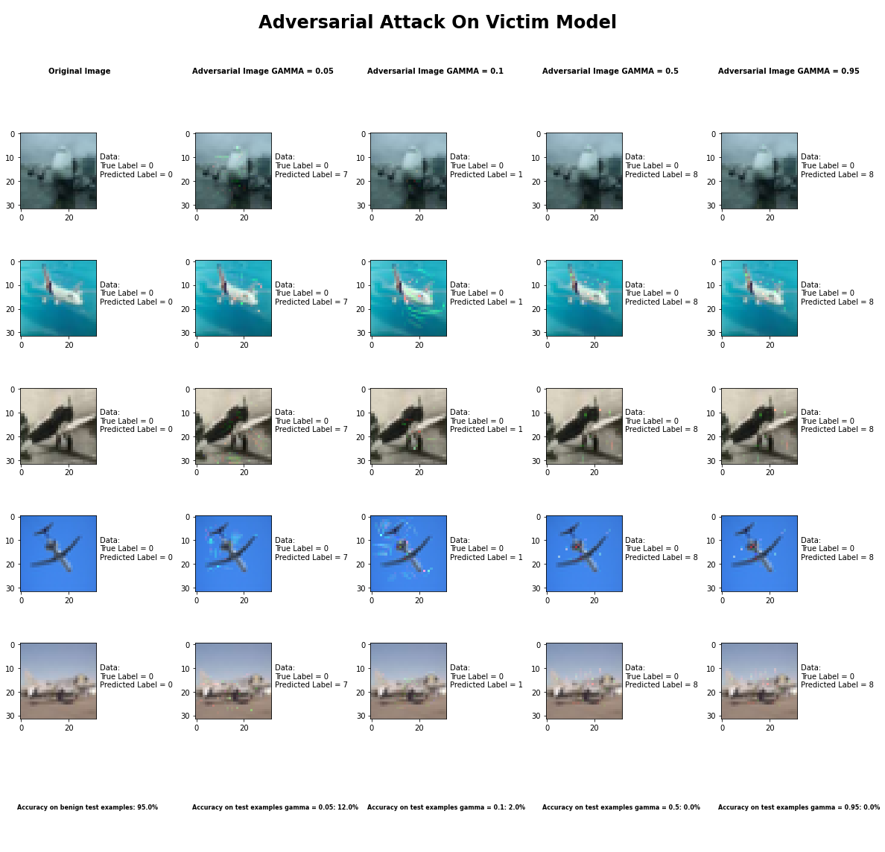

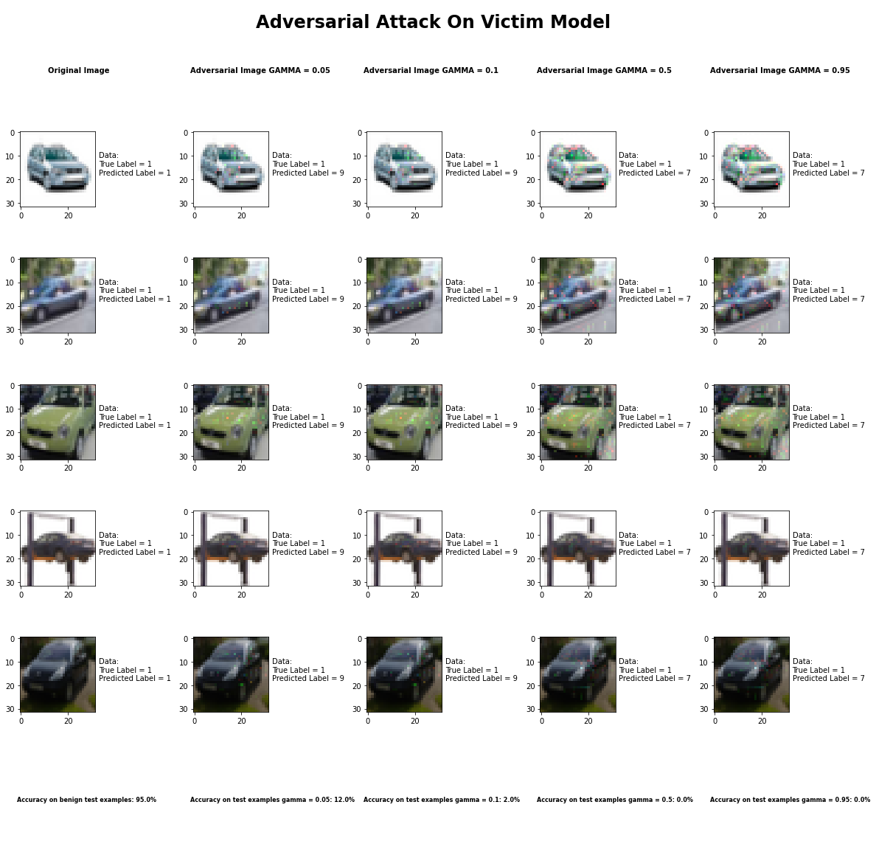

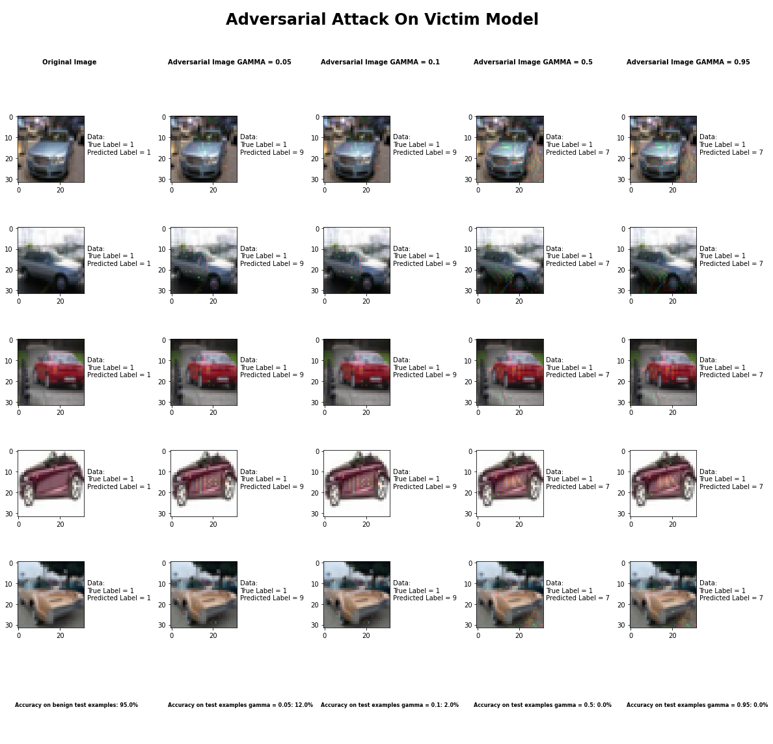

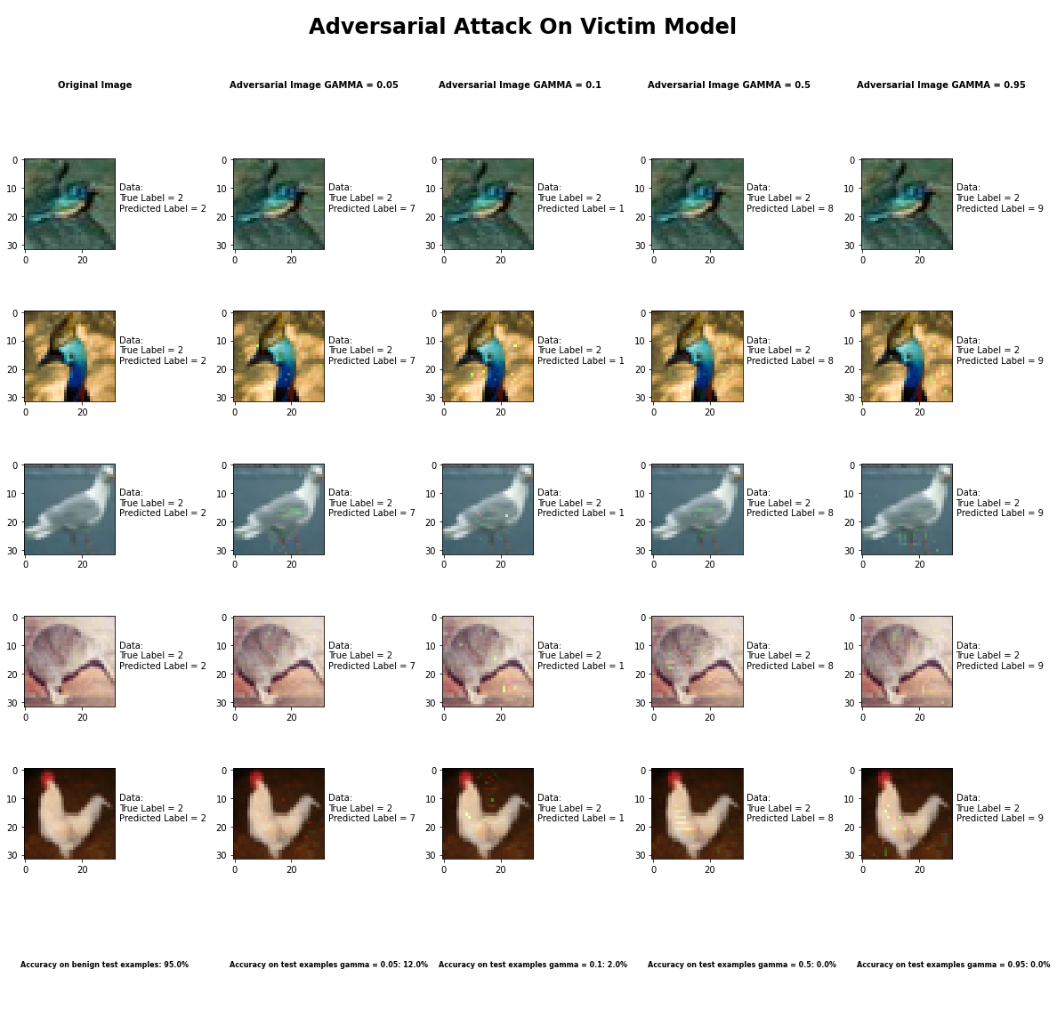

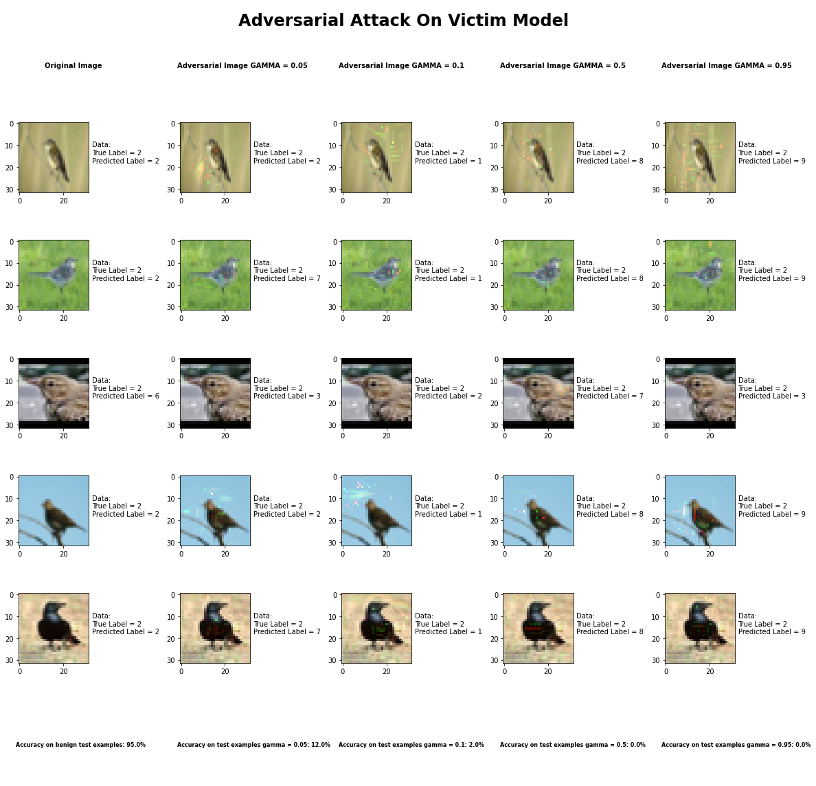

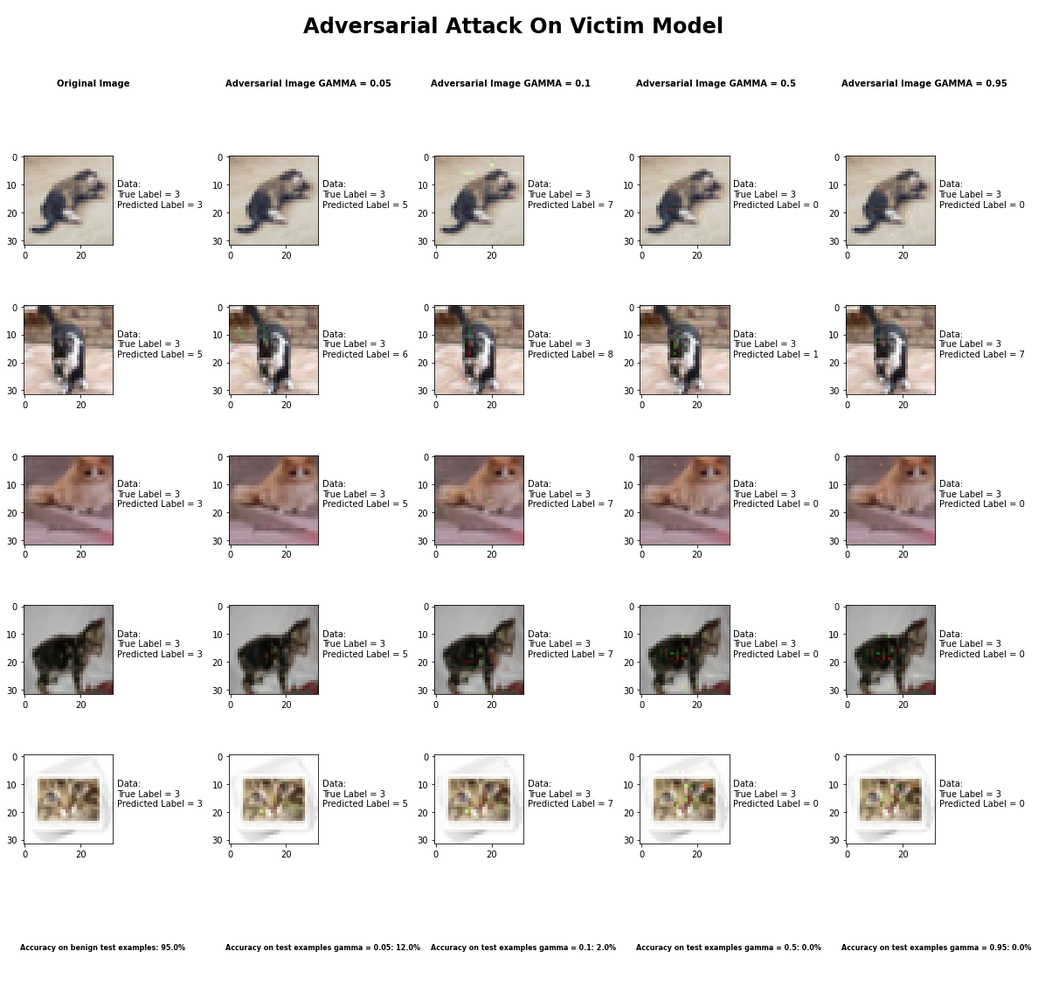

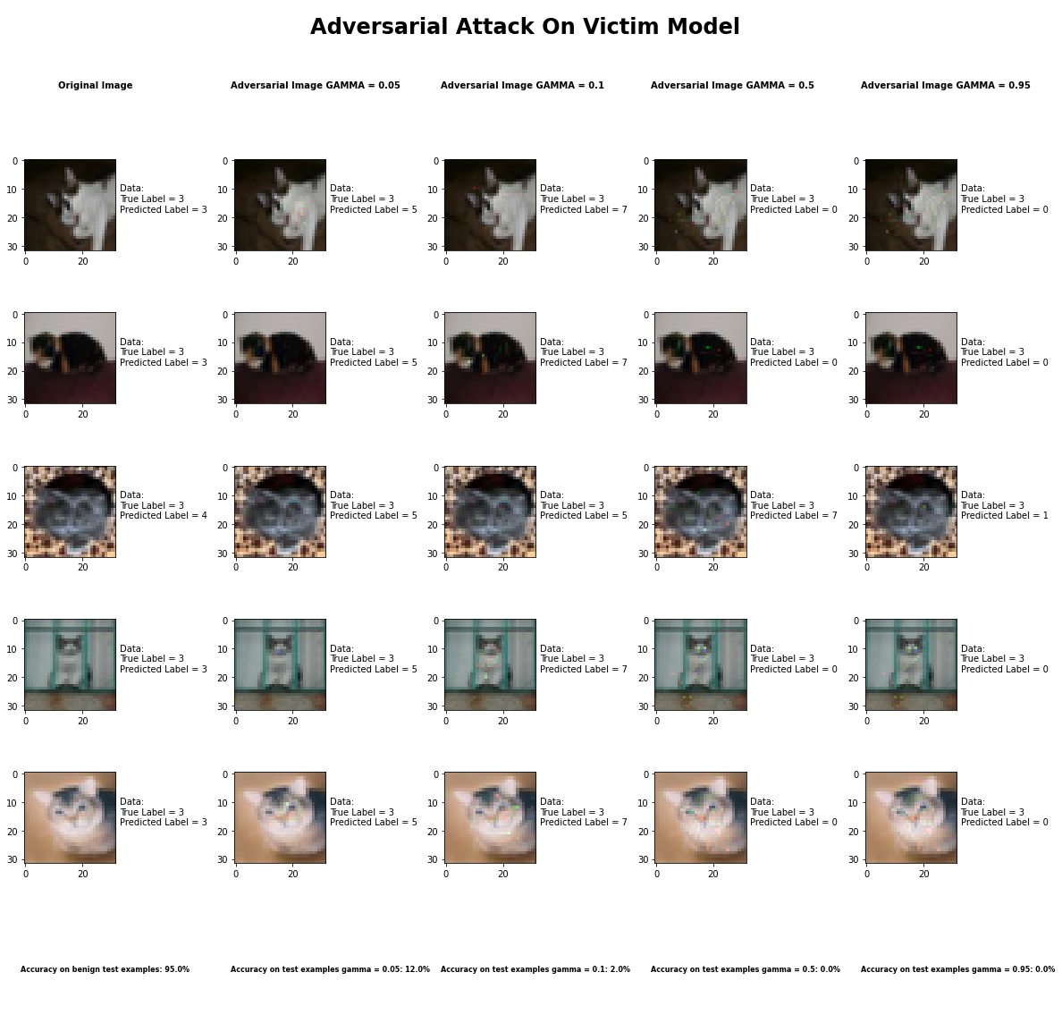

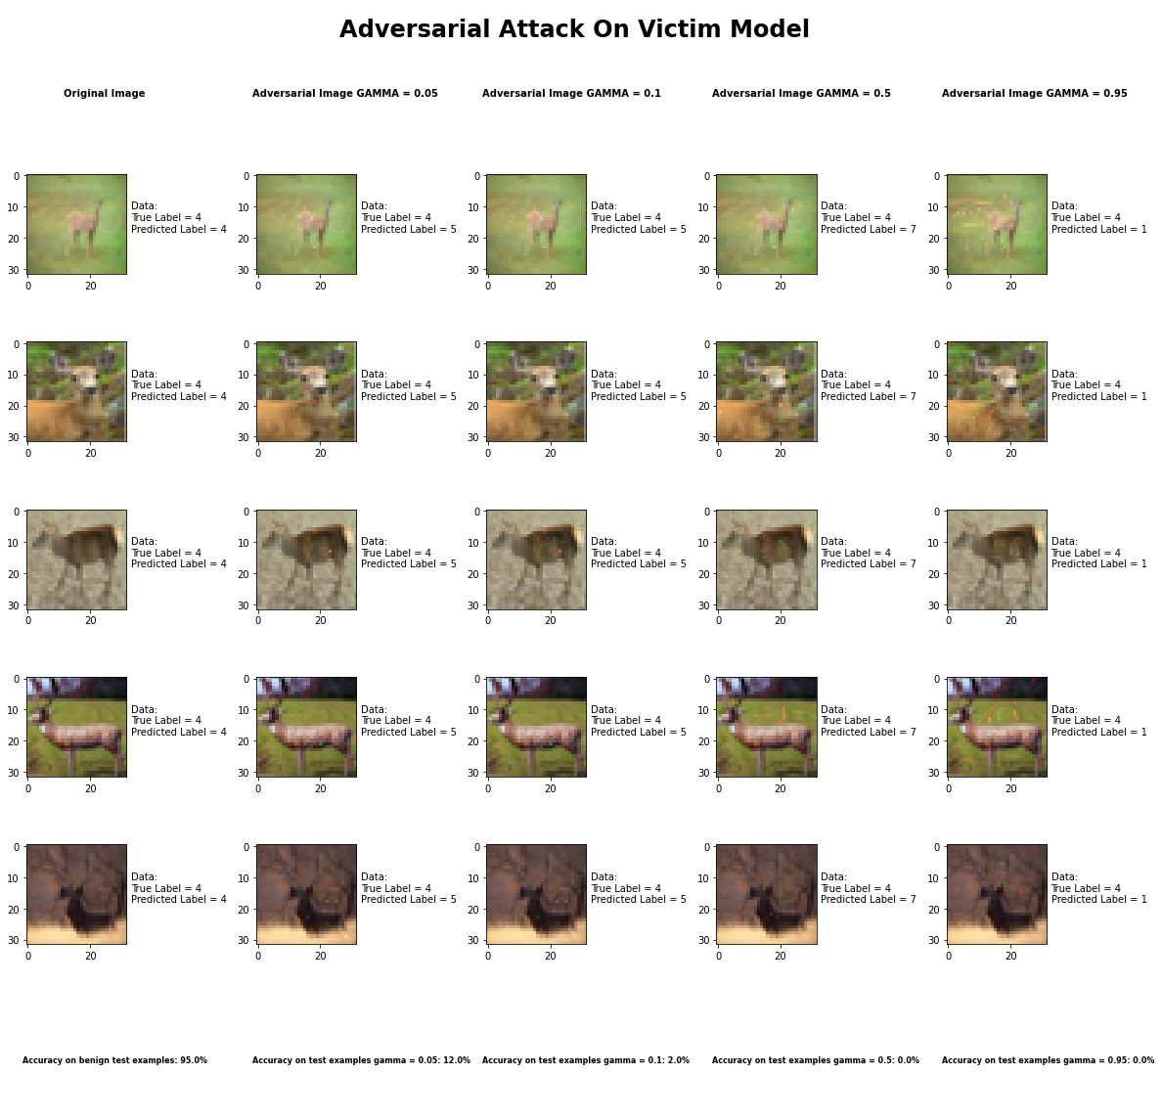

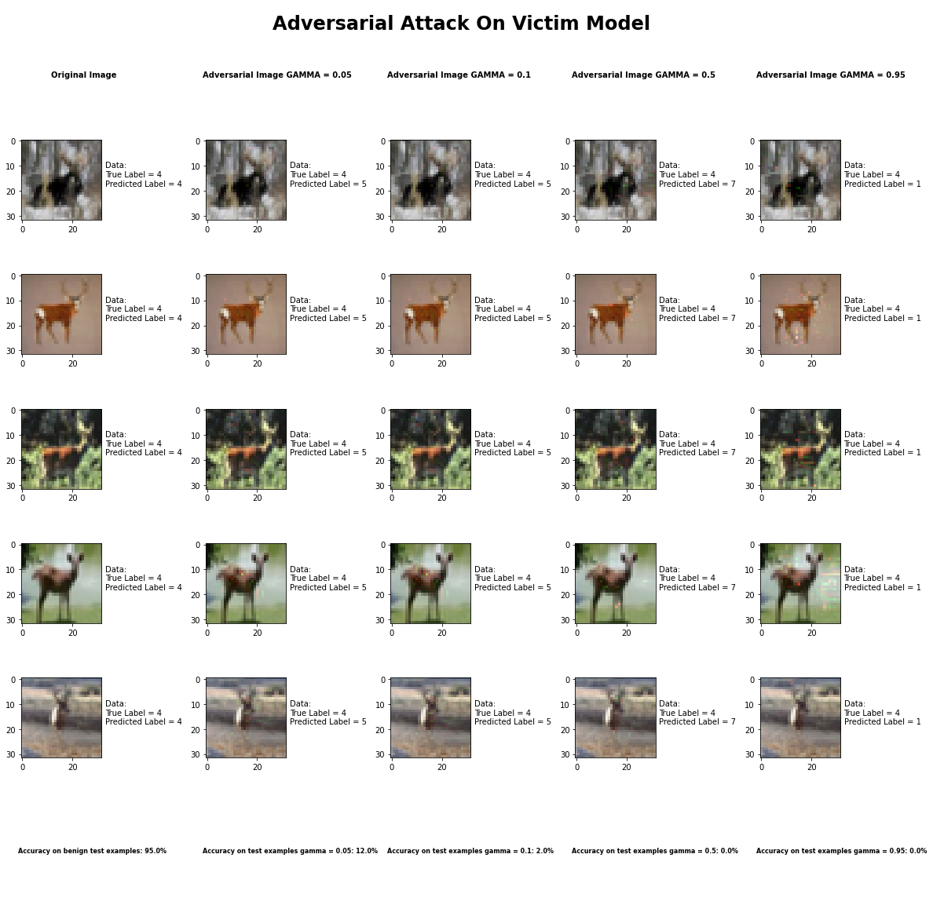

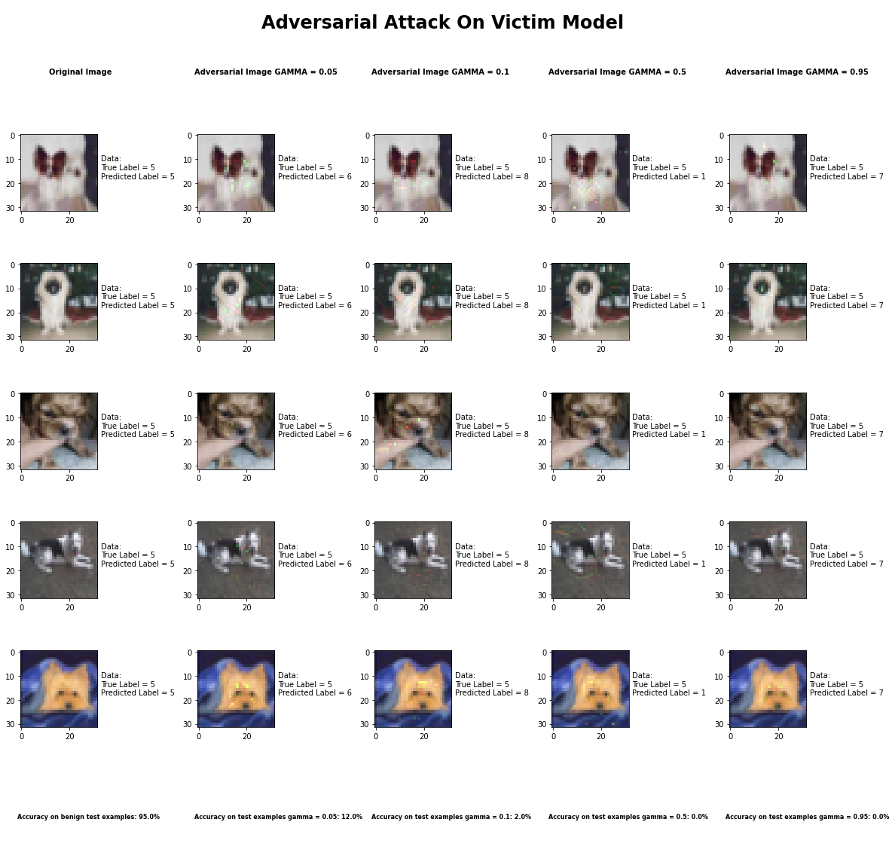

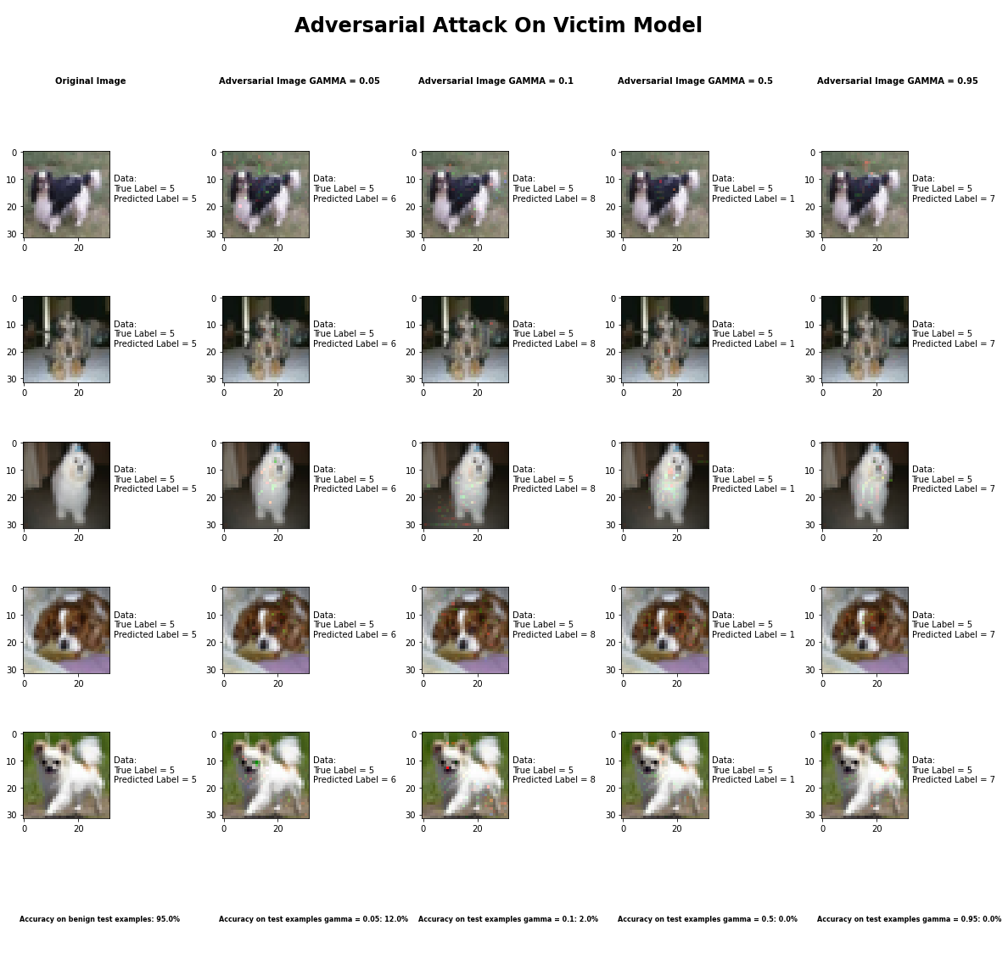

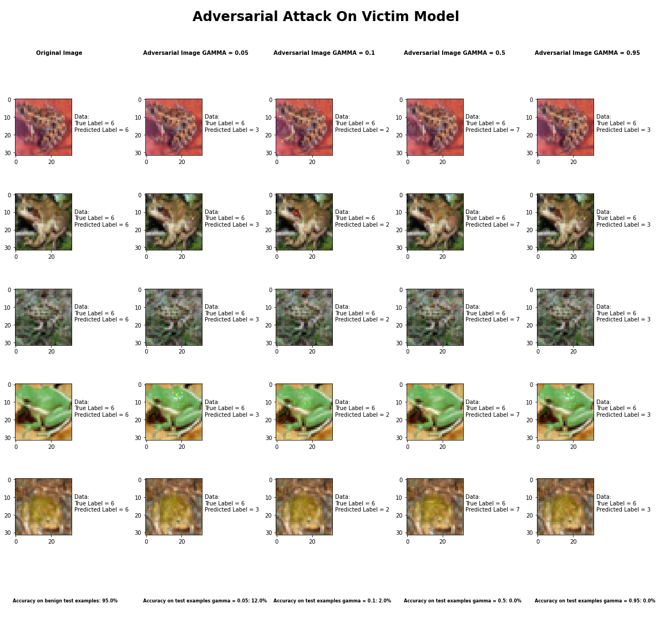

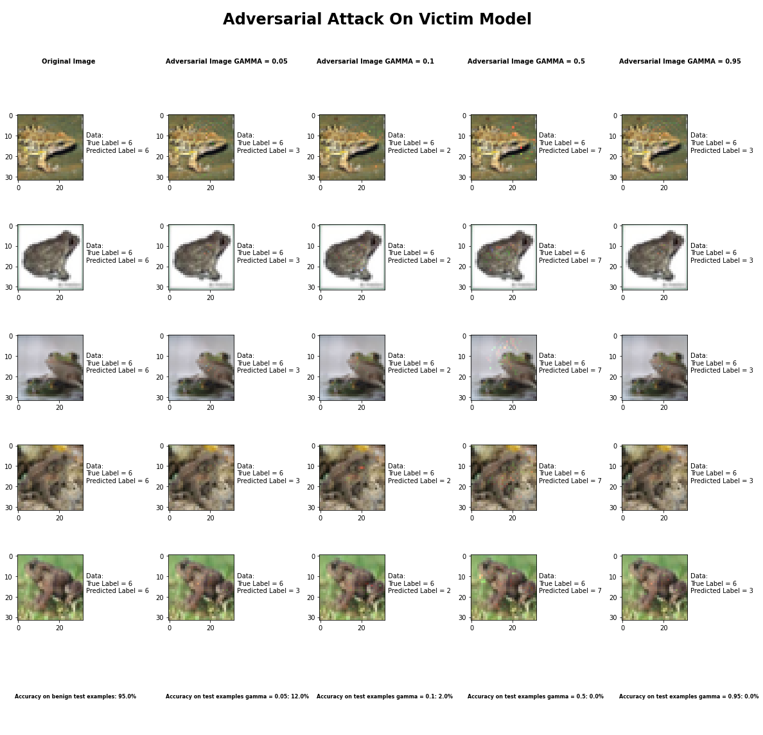

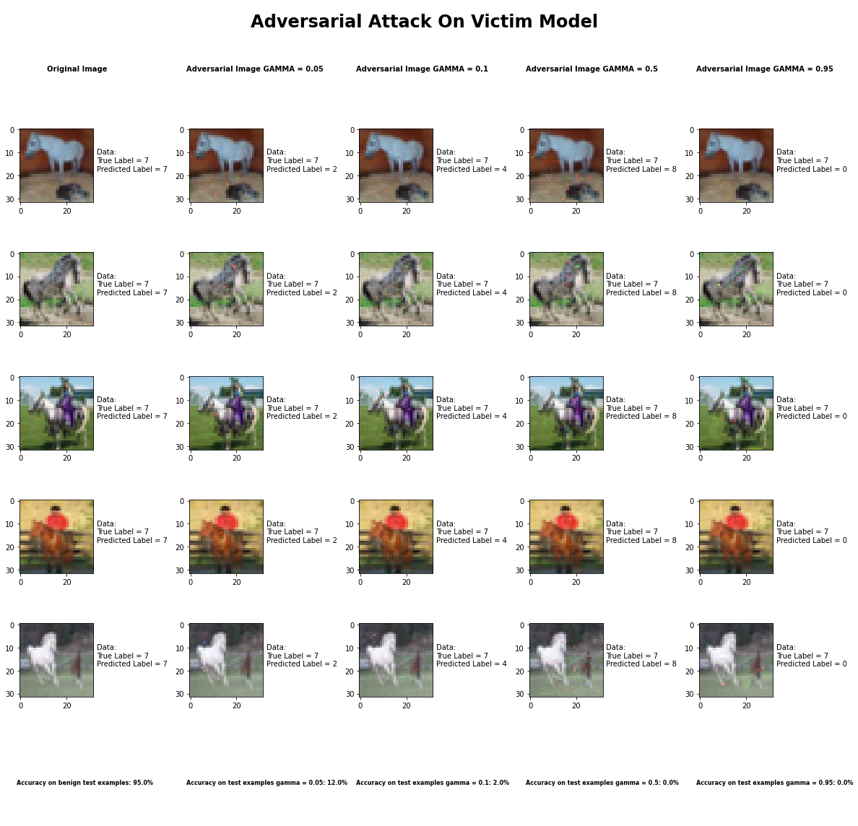

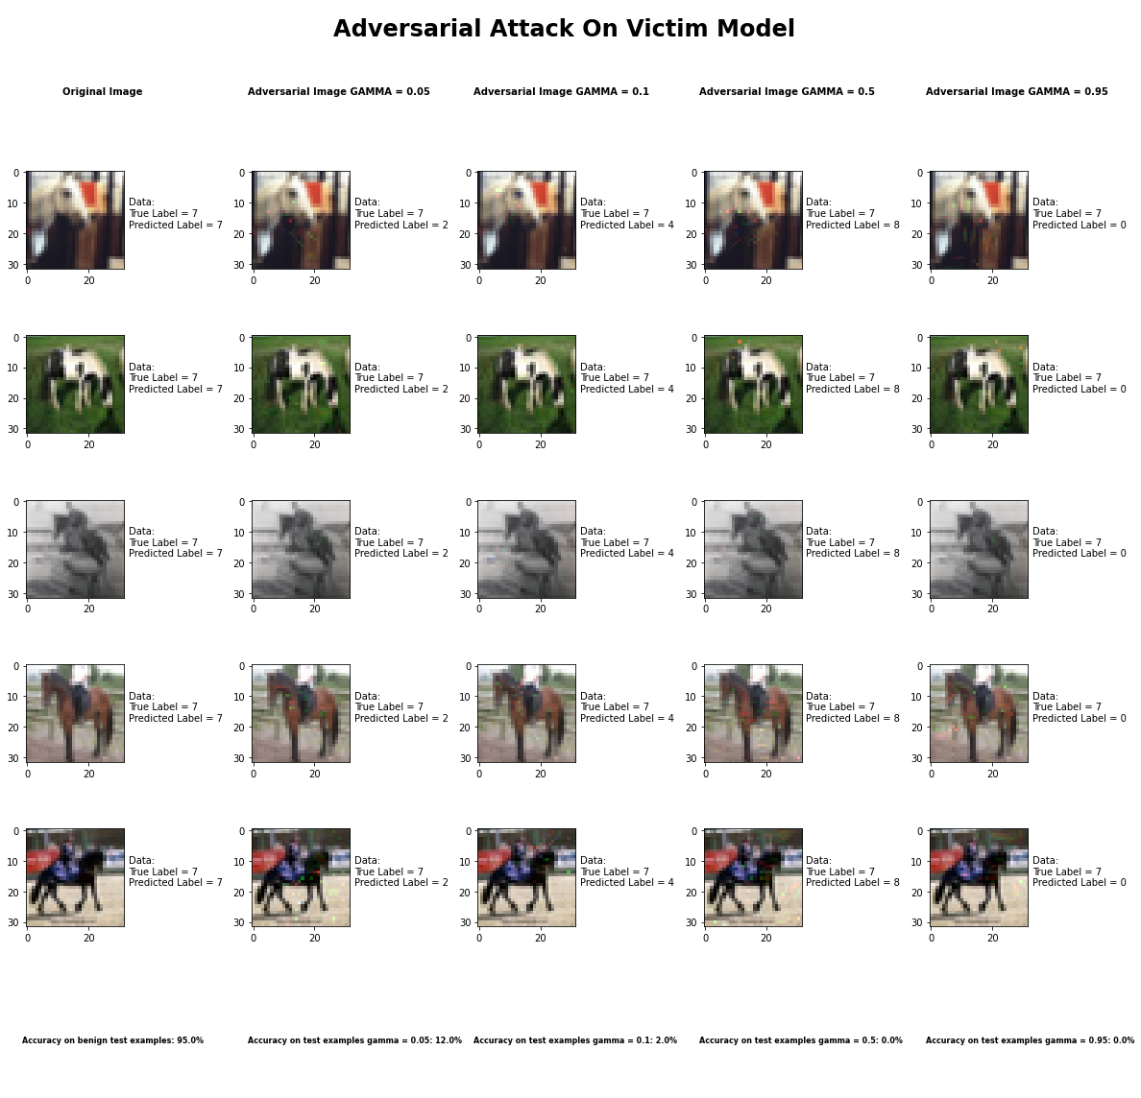

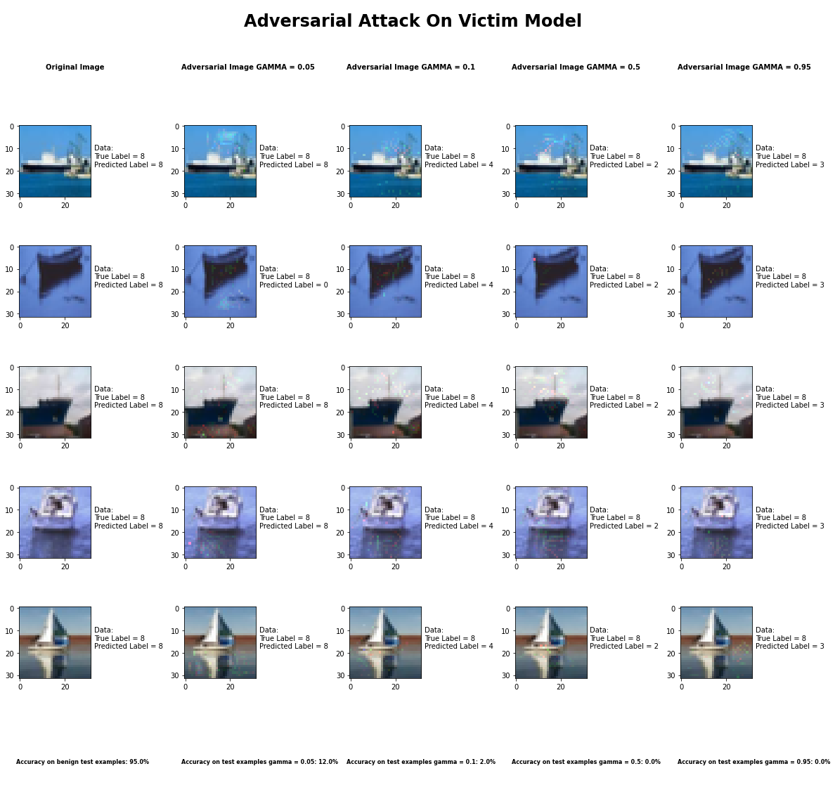

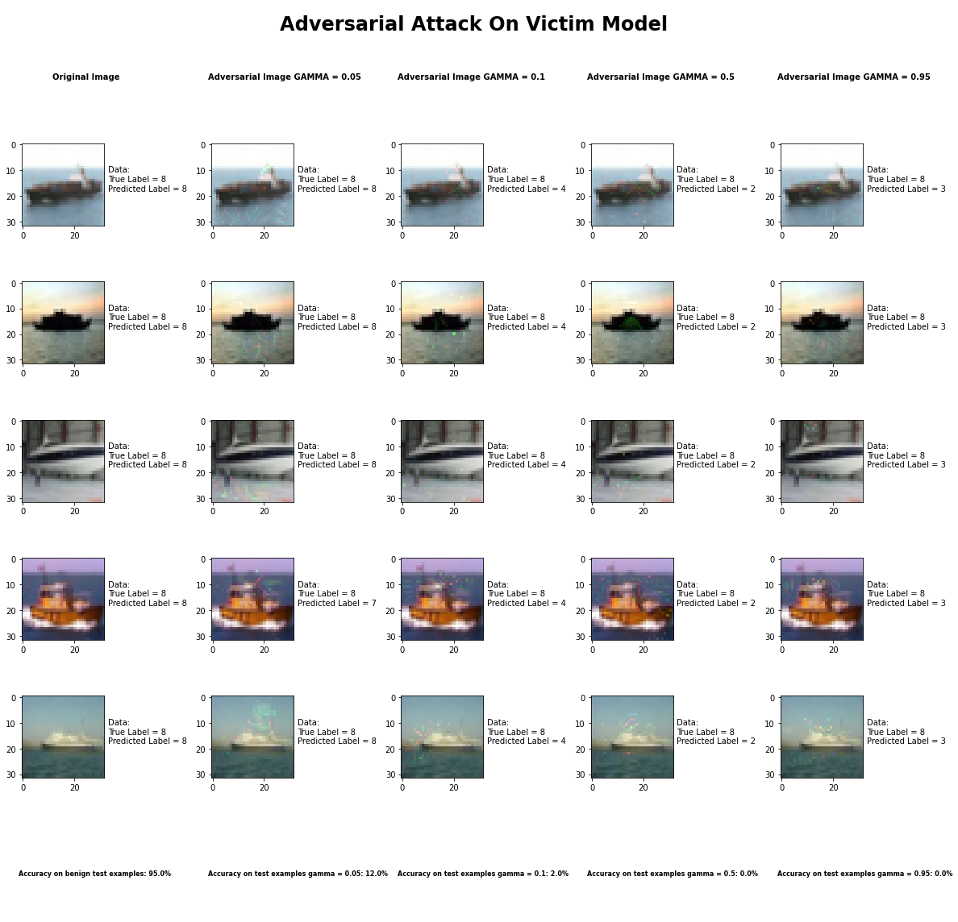

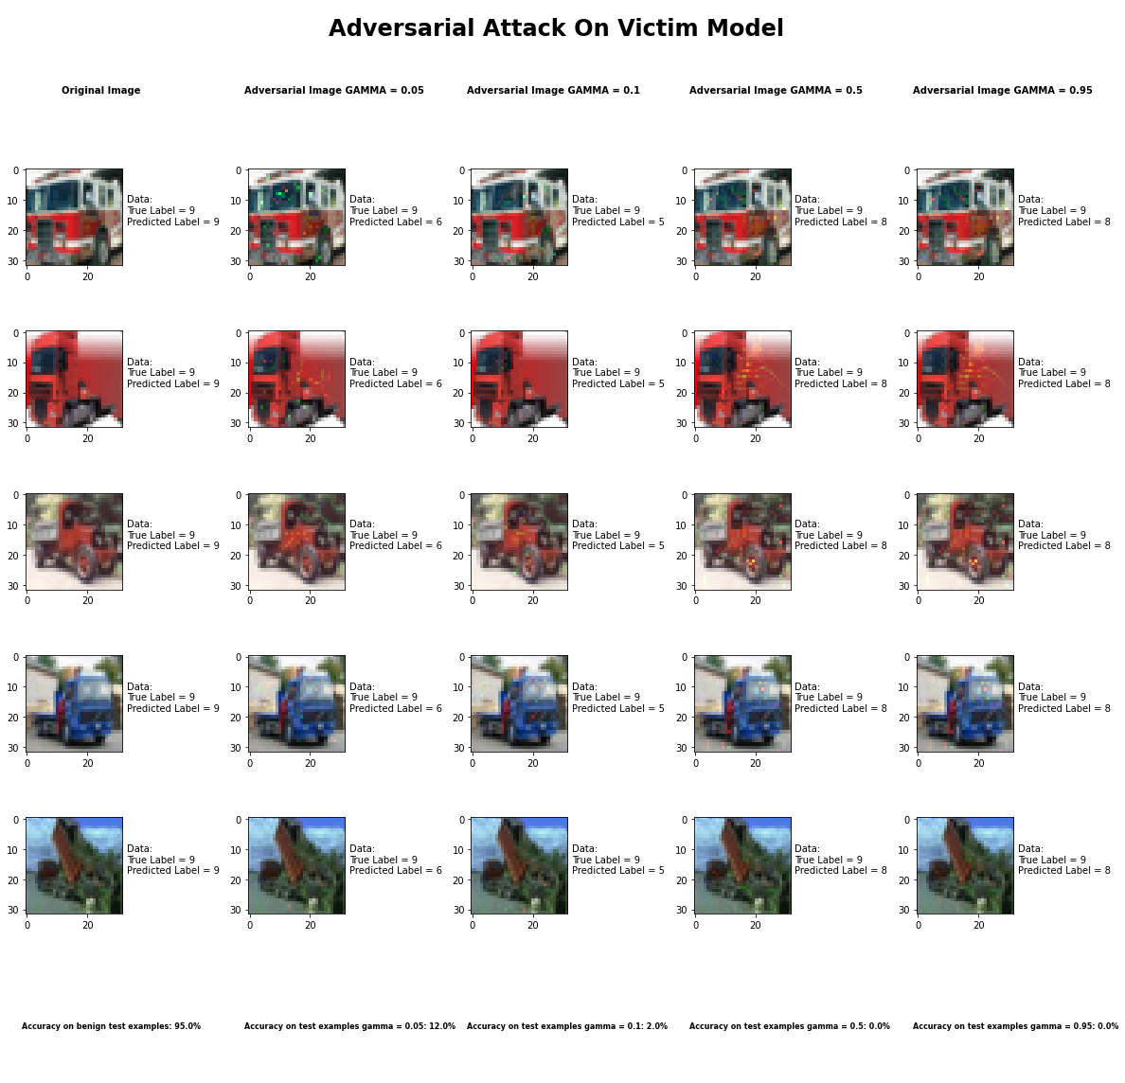

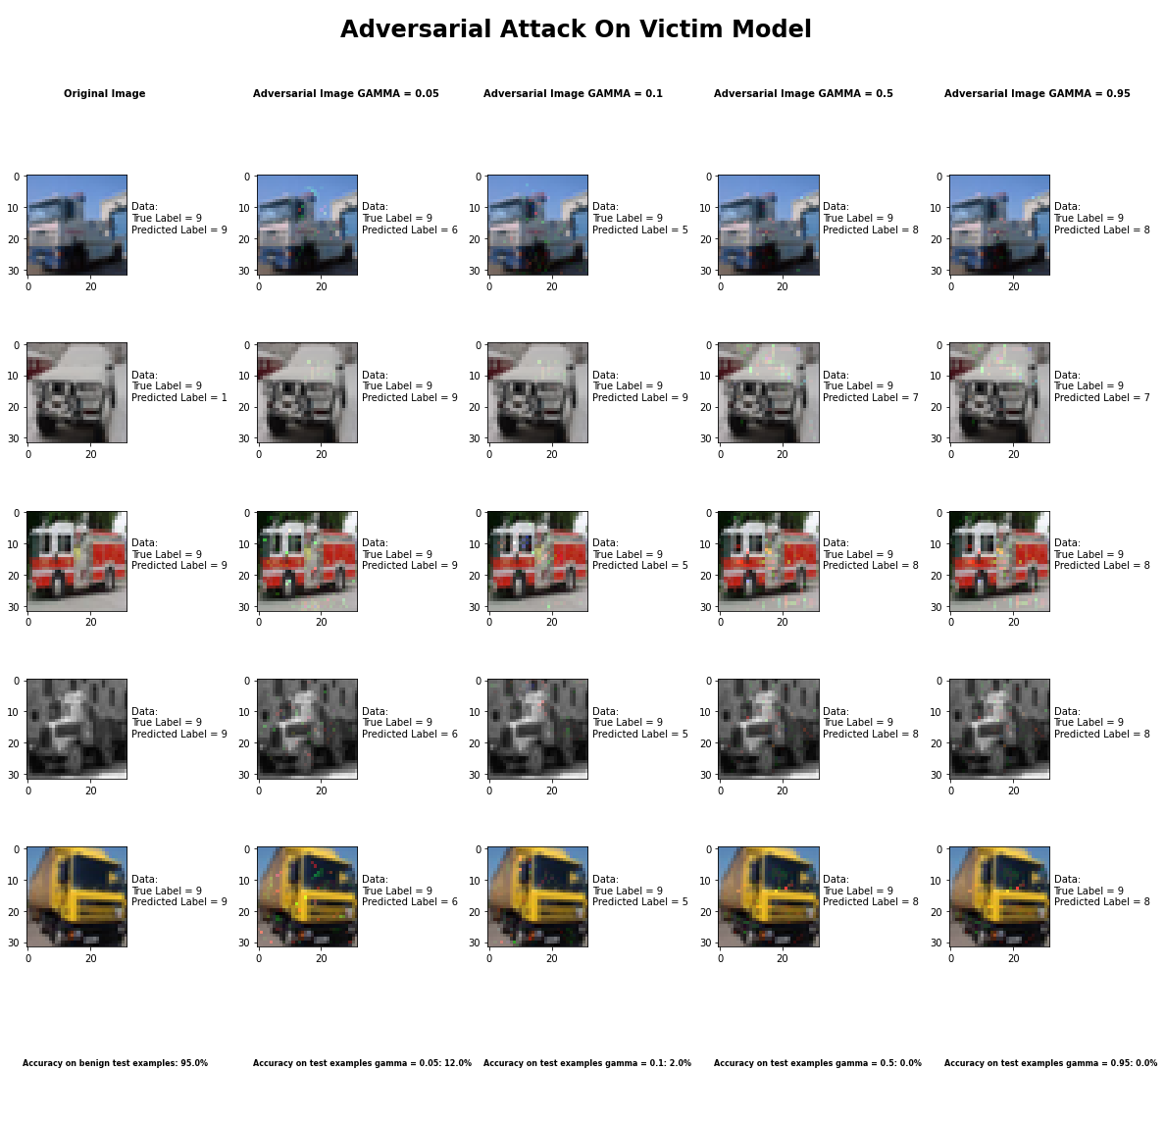

Accuracy on benign test examples: 94.52000000000001%

Average Accuracy on adversarial test examples with gamma = 0.05: 12.5%

Average Accuracy on adversarial test examples with gamma = 0.1: 2.1%

Average Accuracy on adversarial test examples with gamma = 0.5: 0.2%

Average Accuracy on adversarial test examples with gamma = 0.95: 0.1%

Classifier with benign example has Airplane recognition average accuracy of = 97%

Jacobian Saliency Map Method with gamma = 0.05 has Airplane recognition average accuracy of = 19%

Jacobian Saliency Map Method with gamma = 0.1 has Airplane recognition average accuracy of = 2%

Jacobian Saliency Map Method with gamma = 0.5 has Airplane recognition average accuracy of = 0%

Jacobian Saliency Map Method with gamma = 0.95 has Airplane recognition average accuracy of = 0%

Classifier with benign example has Automobile recognition average accuracy of = 99%

Jacobian Saliency Map Method with gamma = 0.05 has Automobile recognition average accuracy of = 34%

Jacobian Saliency Map Method with gamma = 0.1 has Automobile recognition average accuracy of = 6%

Jacobian Saliency Map Method with gamma = 0.5 has Automobile recognition average accuracy of = 0%

Jacobian Saliency Map Method with gamma = 0.95 has Automobile recognition average accuracy of = 0%

Classifier with benign example has Bird recognition average accuracy of = 92%

Jacobian Saliency Map Method with gamma = 0.05 has Bird recognition average accuracy of = 7%

Jacobian Saliency Map Method with gamma = 0.1 has Bird recognition average accuracy of = 1%

Jacobian Saliency Map Method with gamma = 0.5 has Bird recognition average accuracy of = 0%

Jacobian Saliency Map Method with gamma = 0.95 has Bird recognition average accuracy of = 0%

Classifier with benign example has Cat recognition average accuracy of = 87%

Jacobian Saliency Map Method with gamma = 0.05 has Cat recognition average accuracy of = 4%

Jacobian Saliency Map Method with gamma = 0.1 has Cat recognition average accuracy of = 4%

Jacobian Saliency Map Method with gamma = 0.5 has Cat recognition average accuracy of = 1%

Jacobian Saliency Map Method with gamma = 0.95 has Cat recognition average accuracy of = 1%

Classifier with benign example has Deer recognition average accuracy of = 94%

Jacobian Saliency Map Method with gamma = 0.05 has Deer recognition average accuracy of = 2%

Jacobian Saliency Map Method with gamma = 0.1 has Deer recognition average accuracy of = 0%

Jacobian Saliency Map Method with gamma = 0.5 has Deer recognition average accuracy of = 1%

Jacobian Saliency Map Method with gamma = 0.95 has Deer recognition average accuracy of = 0%

Classifier with benign example has Dog recognition average accuracy of = 84%

Jacobian Saliency Map Method with gamma = 0.05 has Dog recognition average accuracy of = 5%

Jacobian Saliency Map Method with gamma = 0.1 has Dog recognition average accuracy of = 3%

Jacobian Saliency Map Method with gamma = 0.5 has Dog recognition average accuracy of = 0%

Jacobian Saliency Map Method with gamma = 0.95 has Dog recognition average accuracy of = 0%

Classifier with benign example has Frog recognition average accuracy of = 98%

Jacobian Saliency Map Method with gamma = 0.05 has Frog recognition average accuracy of = 7%

Jacobian Saliency Map Method with gamma = 0.1 has Frog recognition average accuracy of = 0%

Jacobian Saliency Map Method with gamma = 0.5 has Frog recognition average accuracy of = 0%

Jacobian Saliency Map Method with gamma = 0.95 has Frog recognition average accuracy of = 0%

Classifier with benign example has Horse recognition average accuracy of = 97%

Jacobian Saliency Map Method with gamma = 0.05 has Horse recognition average accuracy of = 10%

Jacobian Saliency Map Method with gamma = 0.1 has Horse recognition average accuracy of = 1%

Jacobian Saliency Map Method with gamma = 0.5 has Horse recognition average accuracy of = 0%

Jacobian Saliency Map Method with gamma = 0.95 has Horse recognition average accuracy of = 0%

Classifier with benign example has Ship recognition average accuracy of = 99%

Jacobian Saliency Map Method with gamma = 0.05 has Ship recognition average accuracy of = 20%

Jacobian Saliency Map Method with gamma = 0.1 has Ship recognition average accuracy of = 1%

Jacobian Saliency Map Method with gamma = 0.5 has Ship recognition average accuracy of = 0%

Jacobian Saliency Map Method with gamma = 0.95 has Ship recognition average accuracy of = 0%

Classifier with benign example has Truck recognition average accuracy of = 96%

Jacobian Saliency Map Method with gamma = 0.05 has Truck recognition average accuracy of = 17%

Jacobian Saliency Map Method with gamma = 0.1 has Truck recognition average accuracy of = 3%

Jacobian Saliency Map Method with gamma = 0.5 has Truck recognition average accuracy of = 0%

Jacobian Saliency Map Method with gamma = 0.95 has Truck recognition average accuracy of = 0%

## DeepFool Method



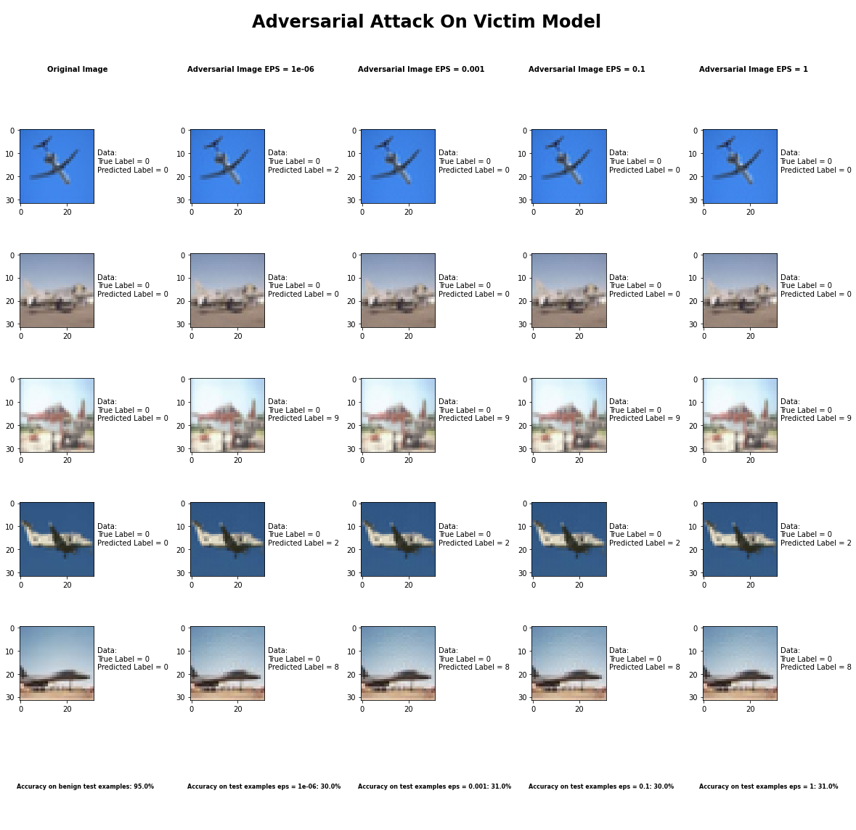

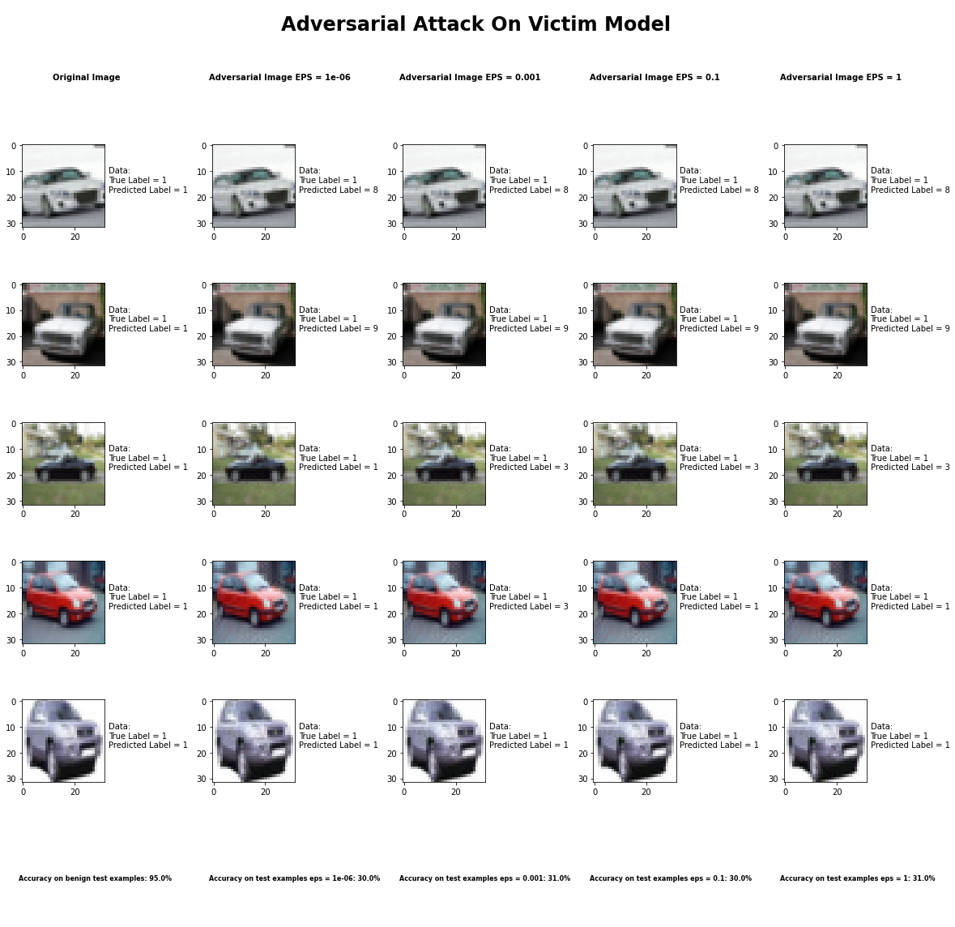

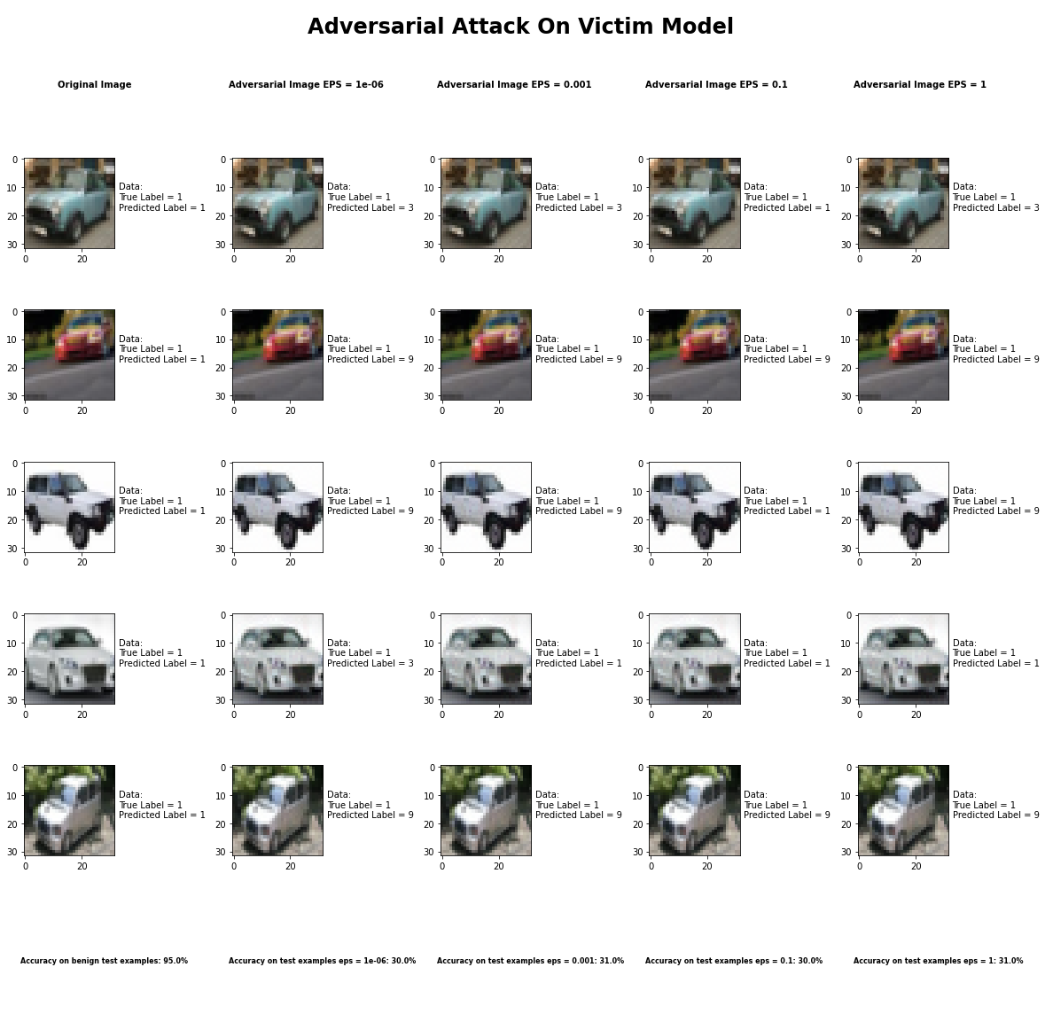

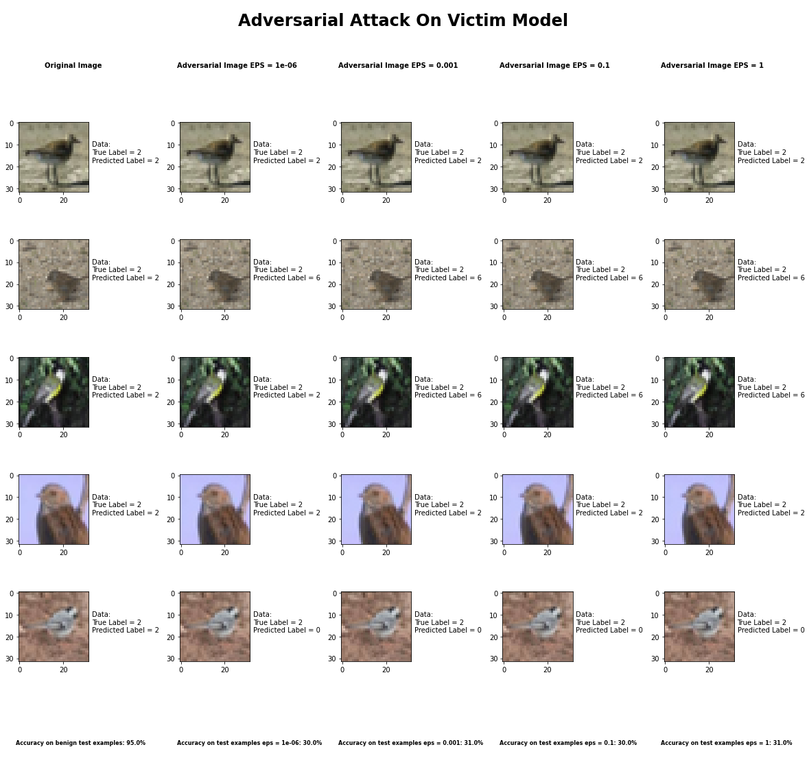

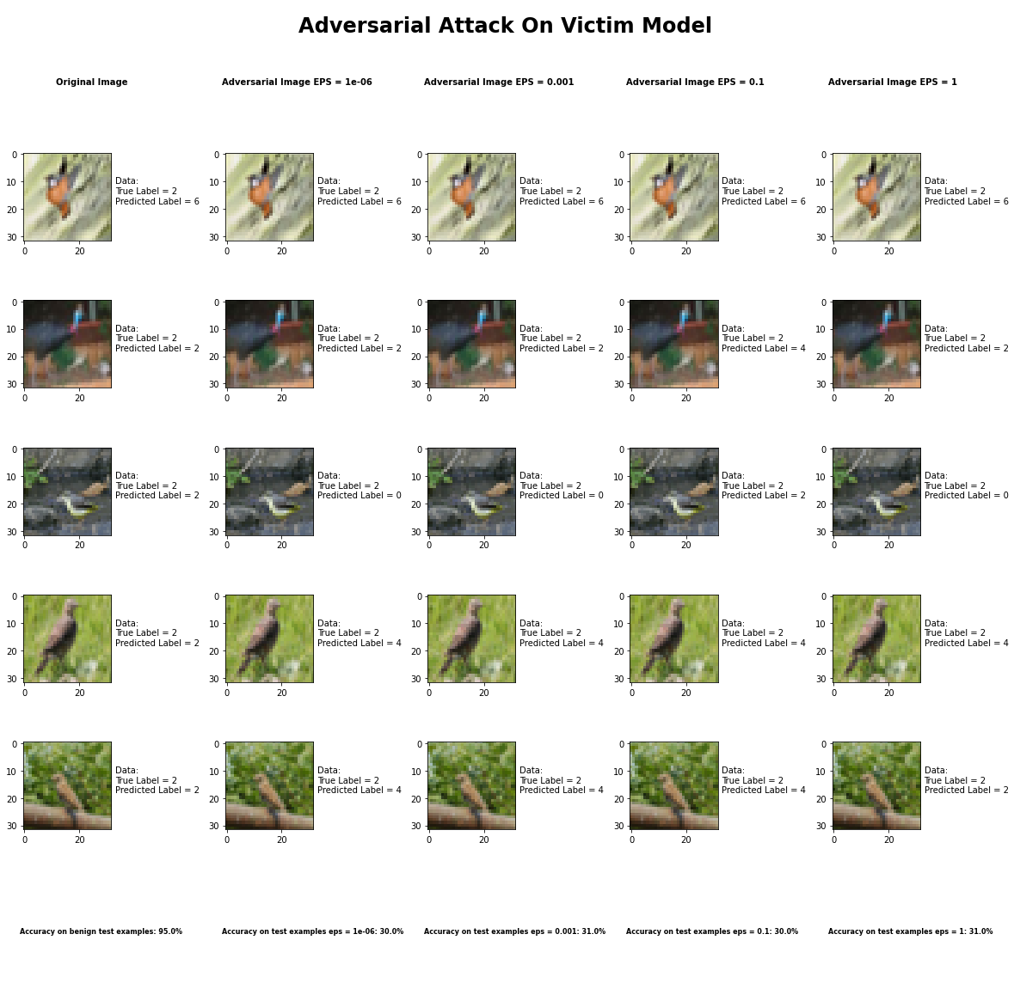

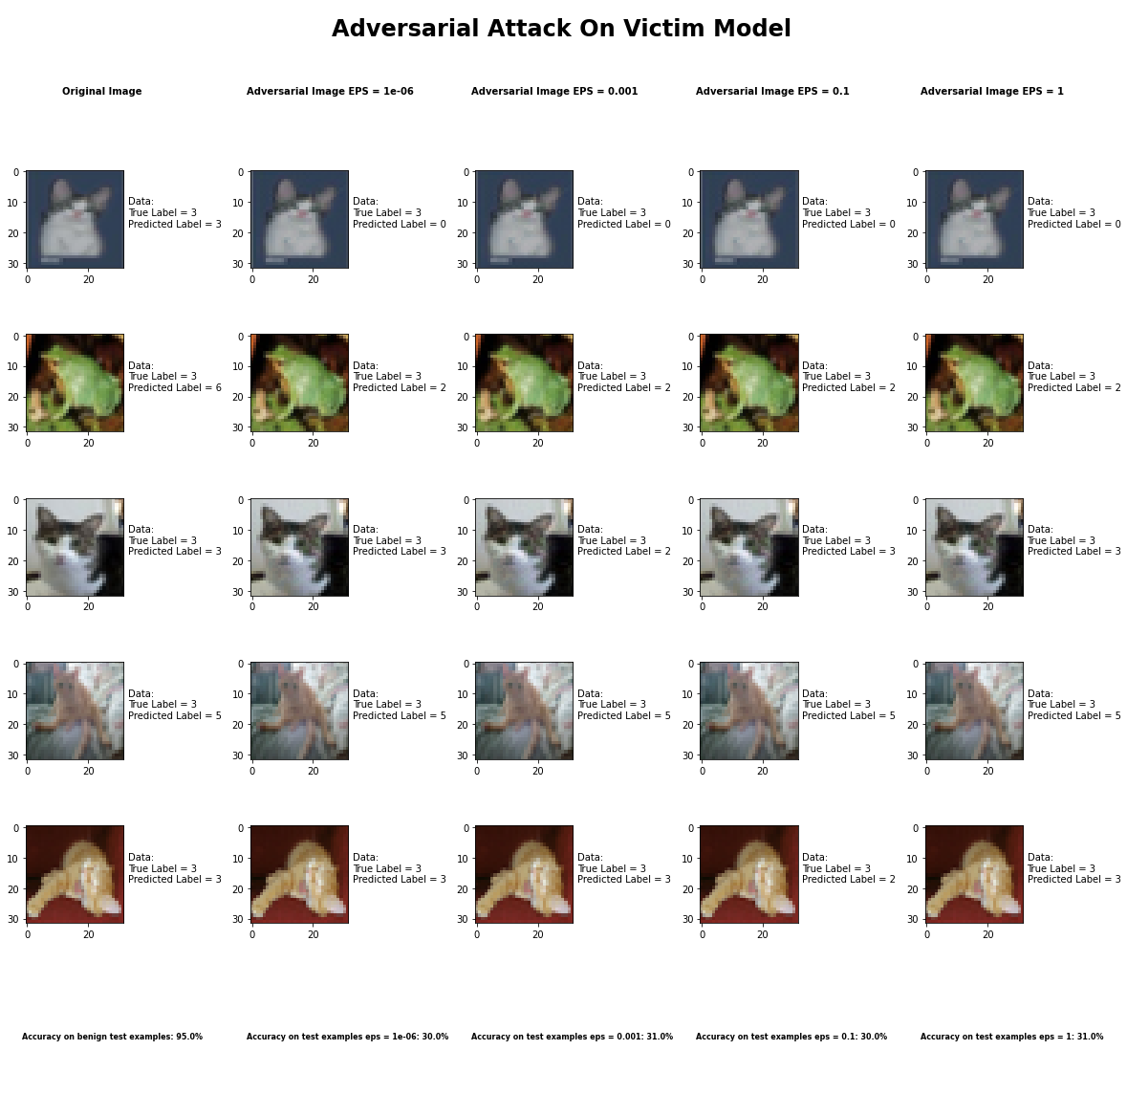

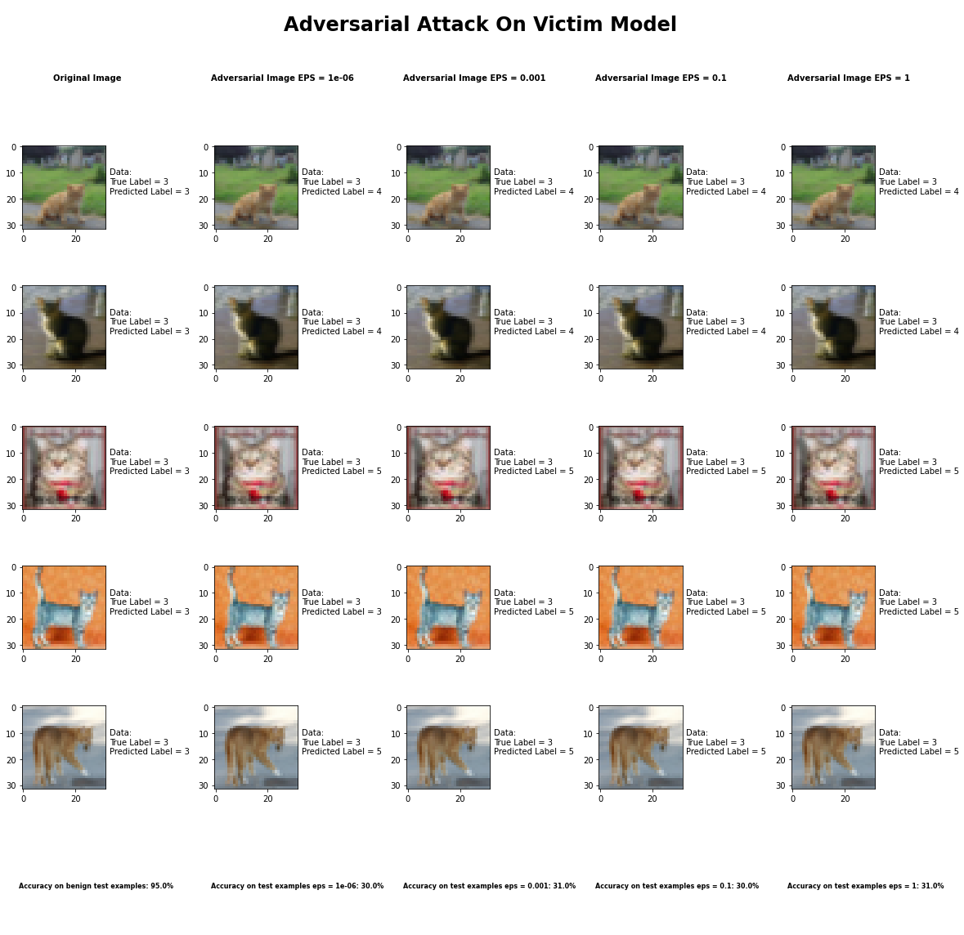

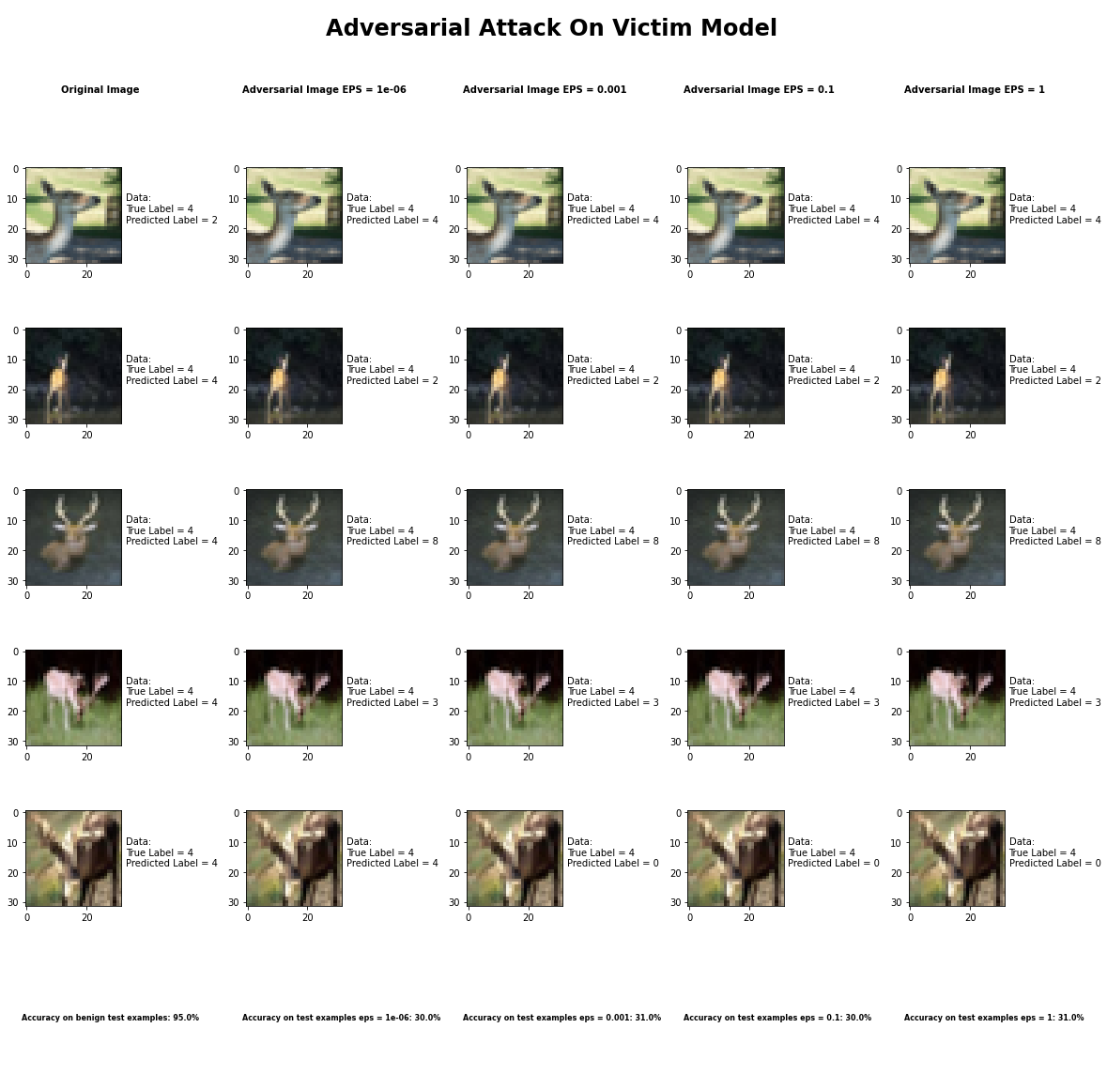

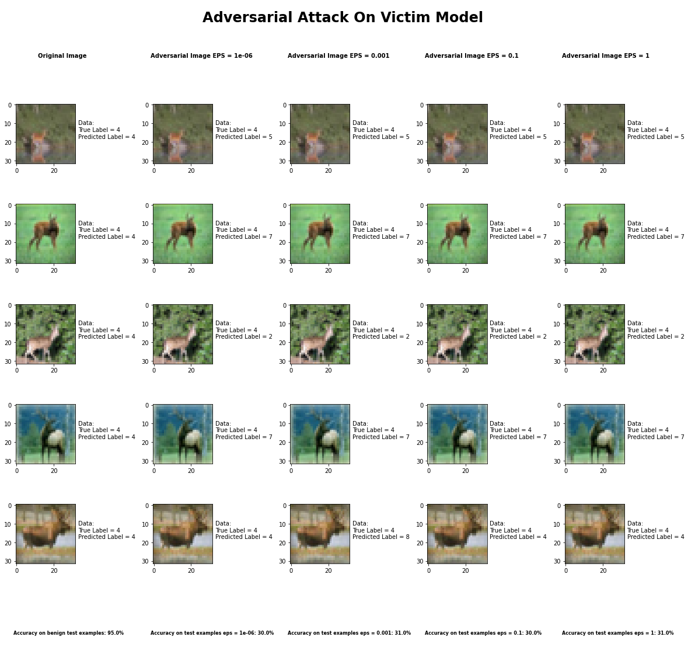

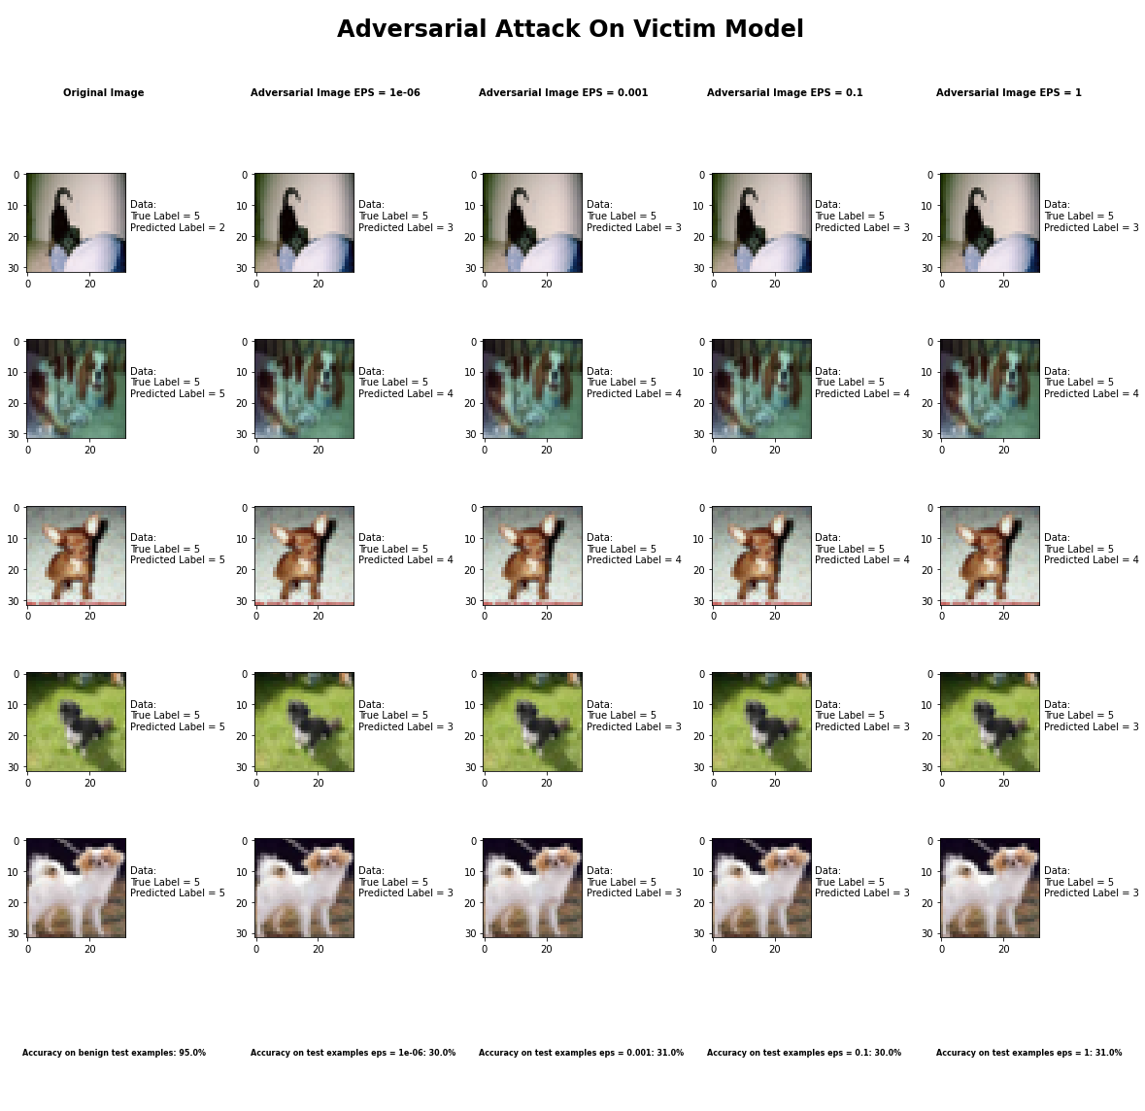

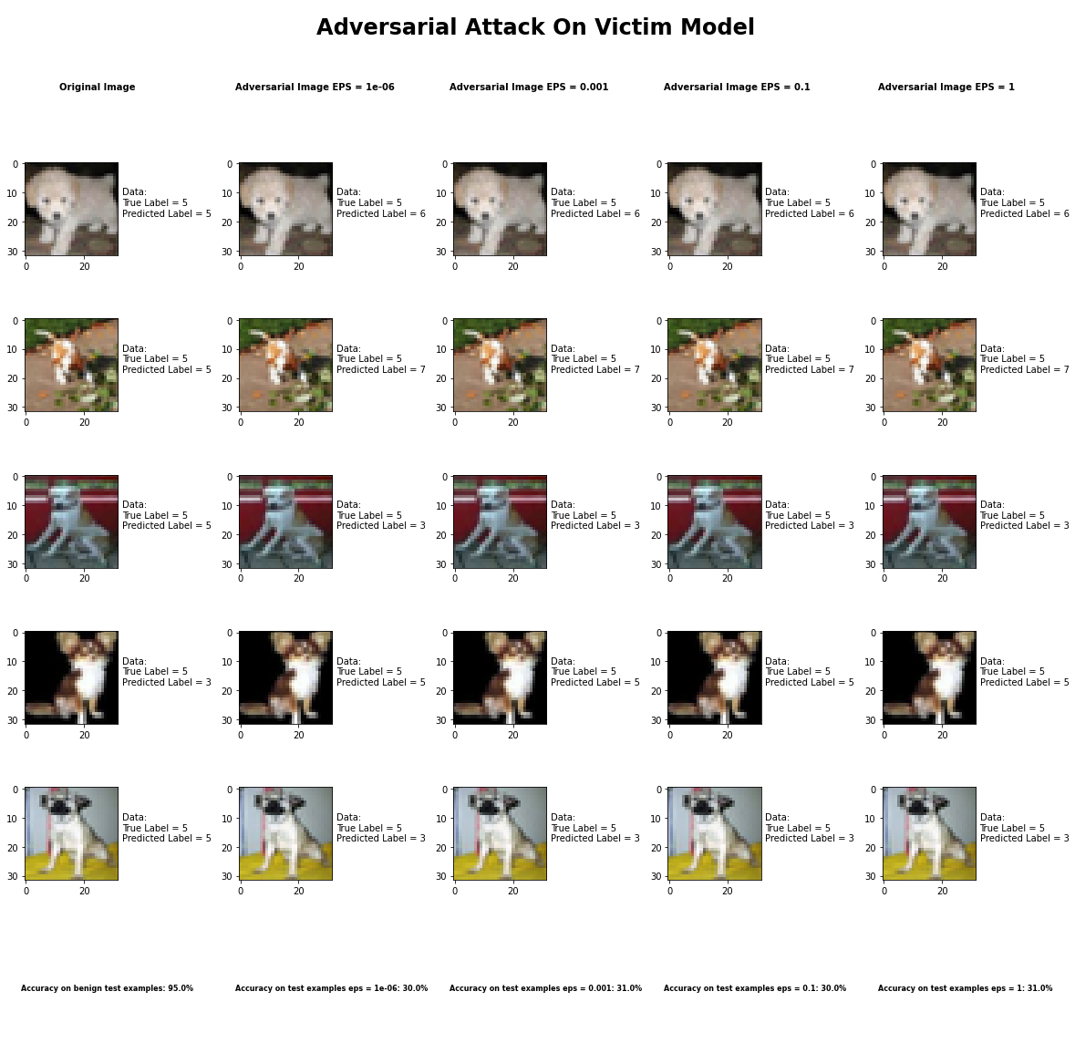

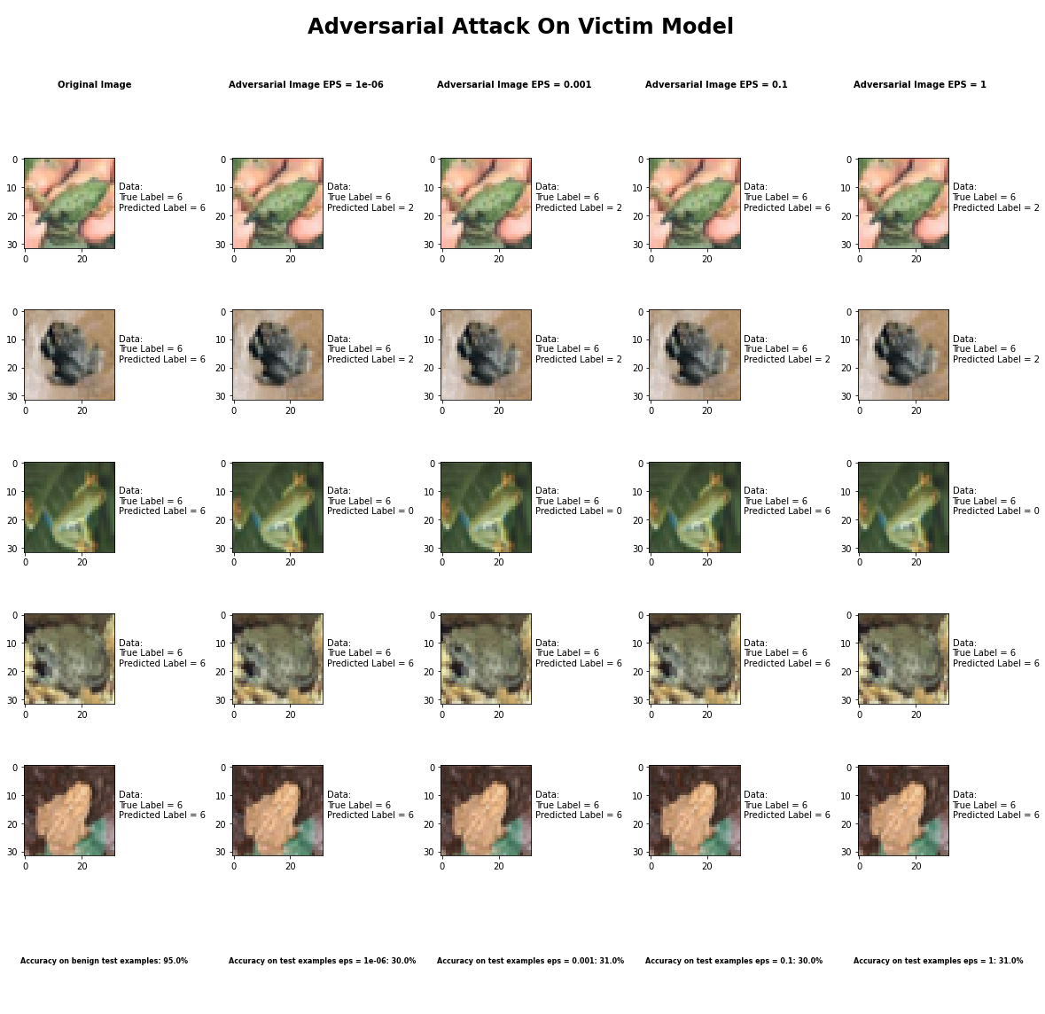

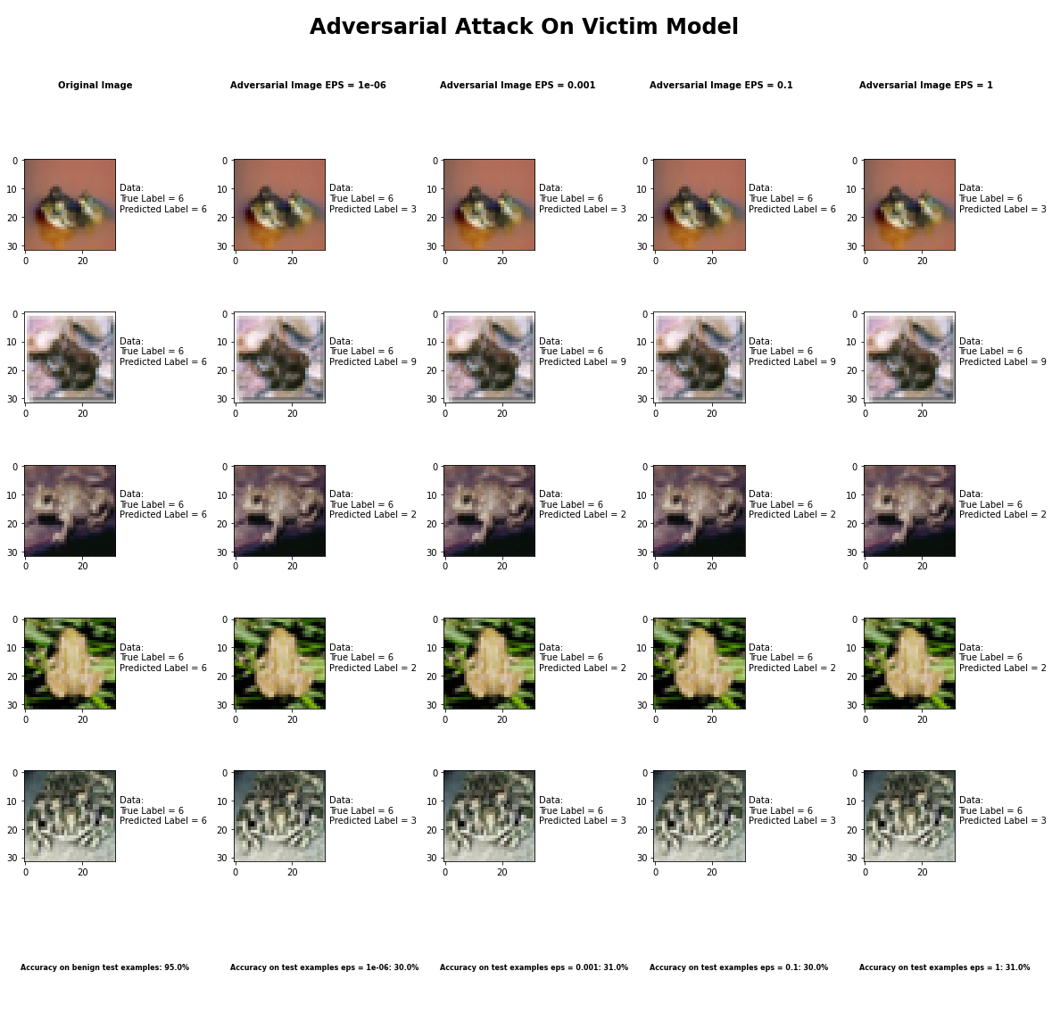

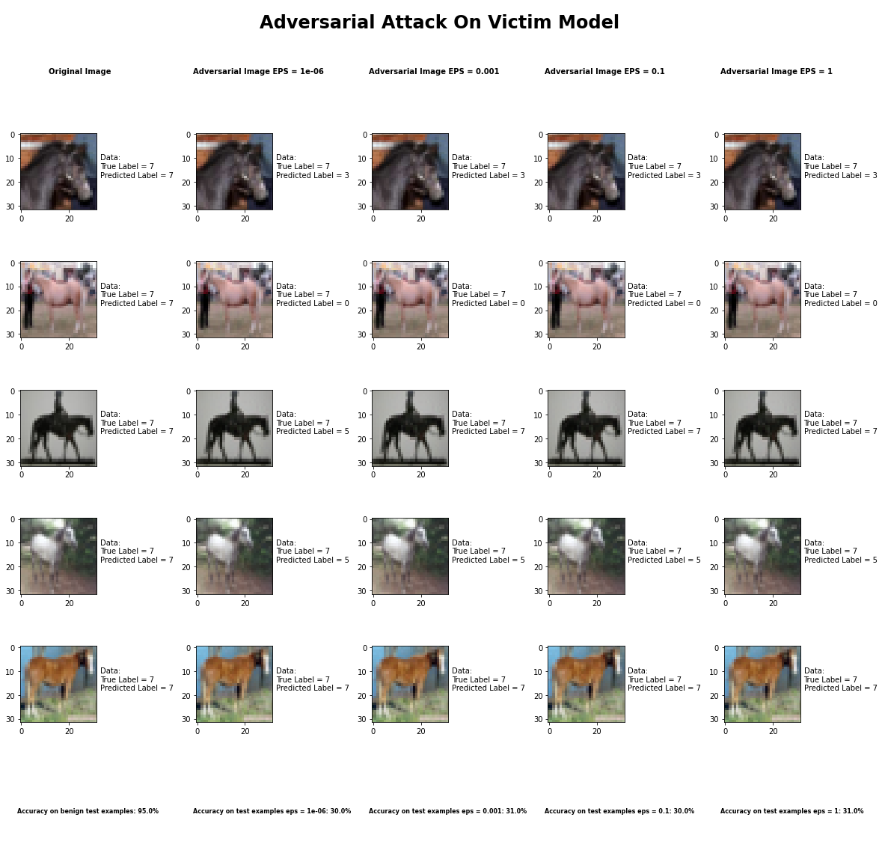

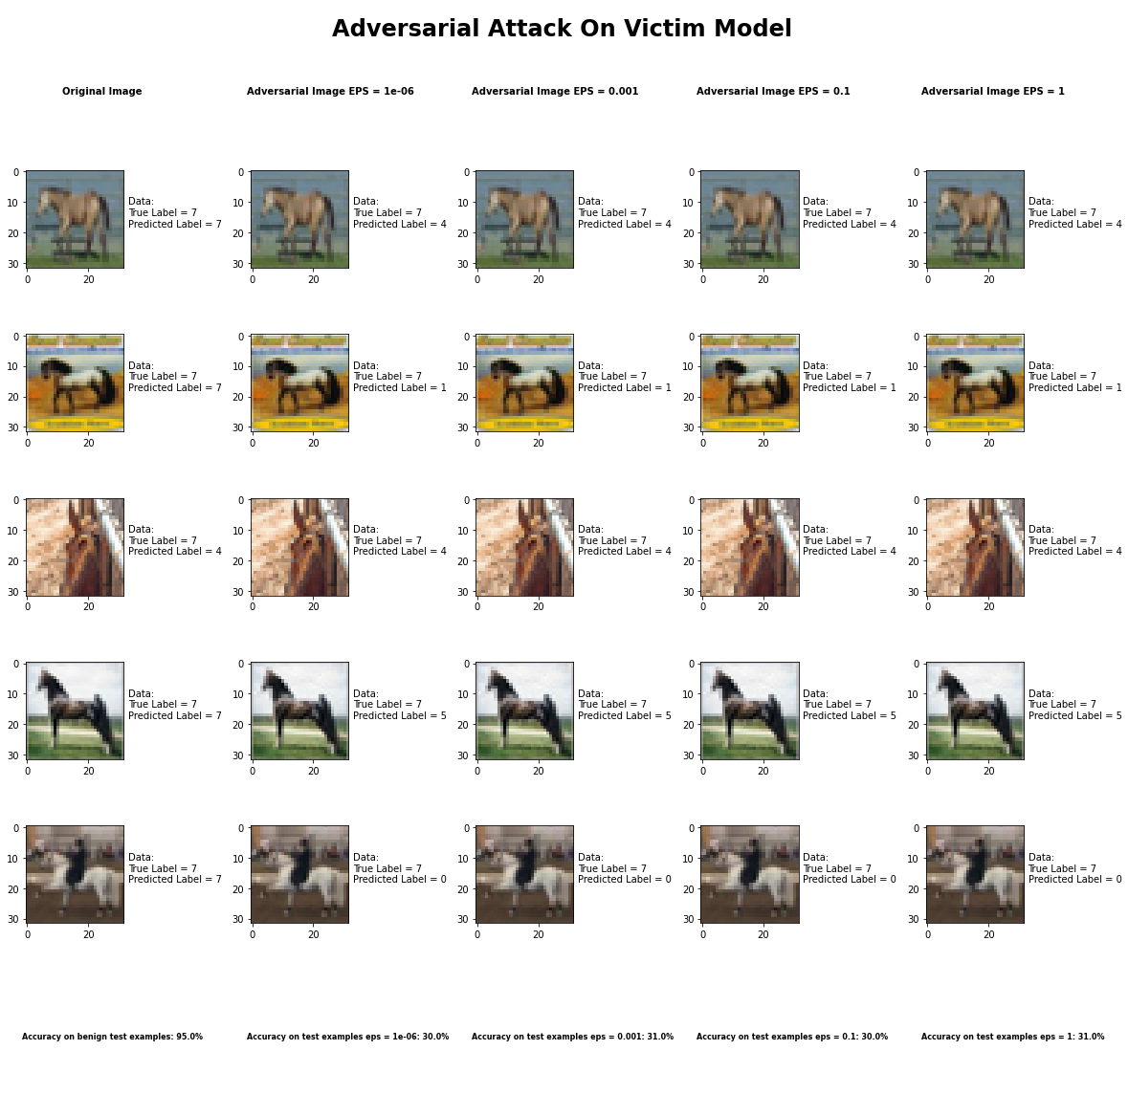

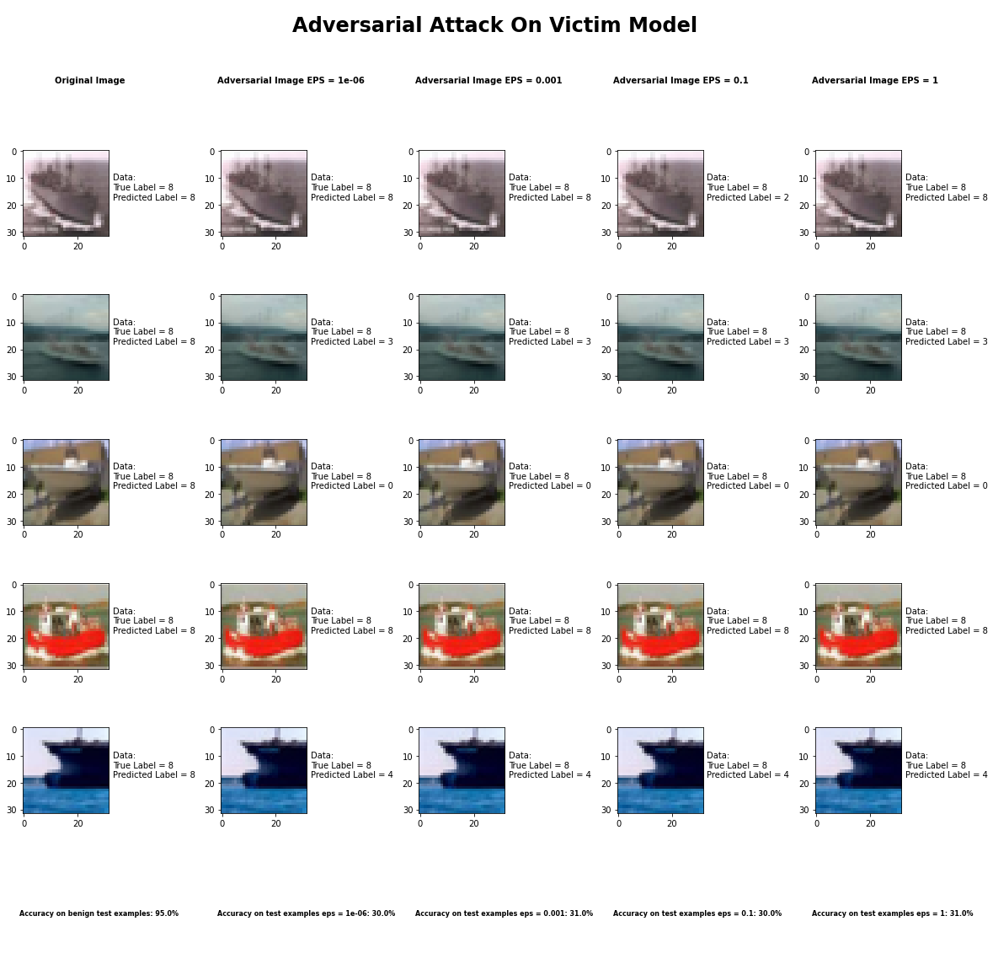

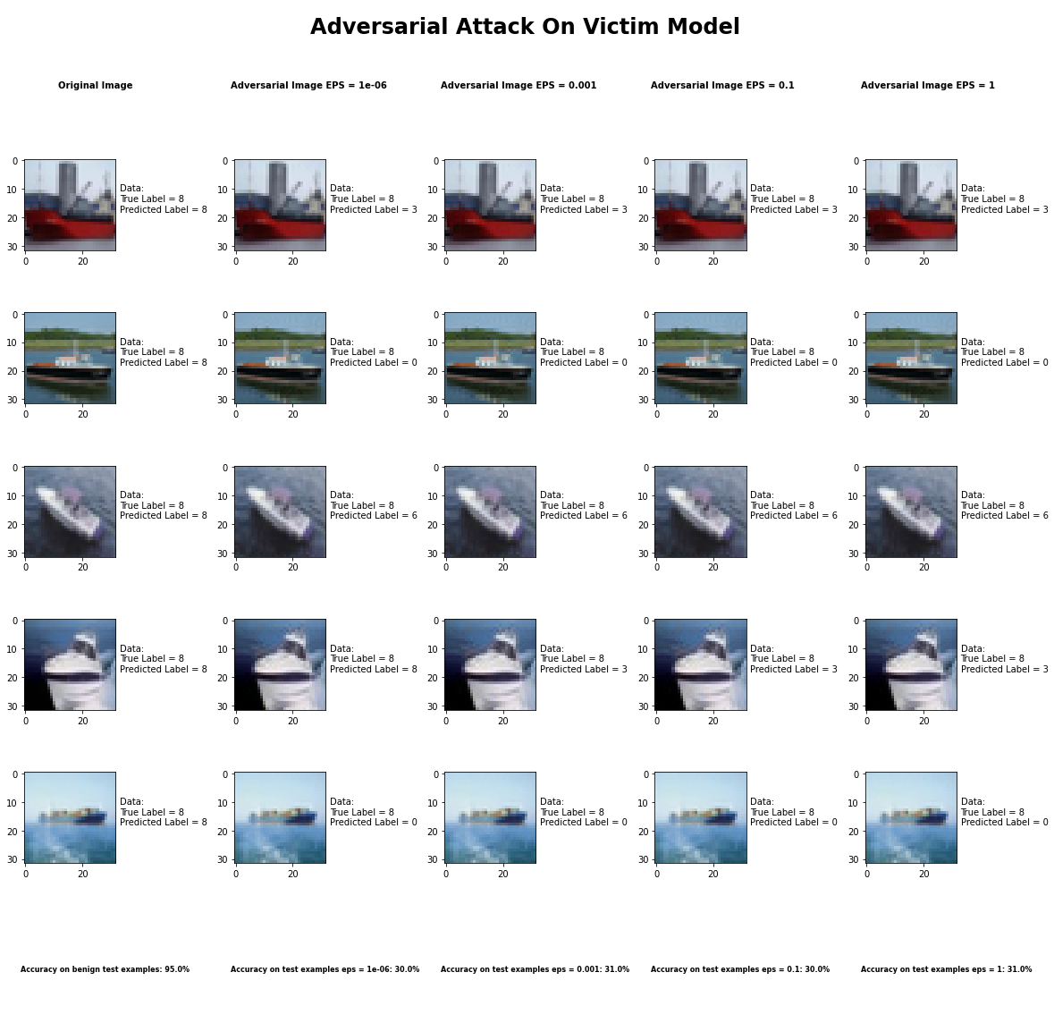

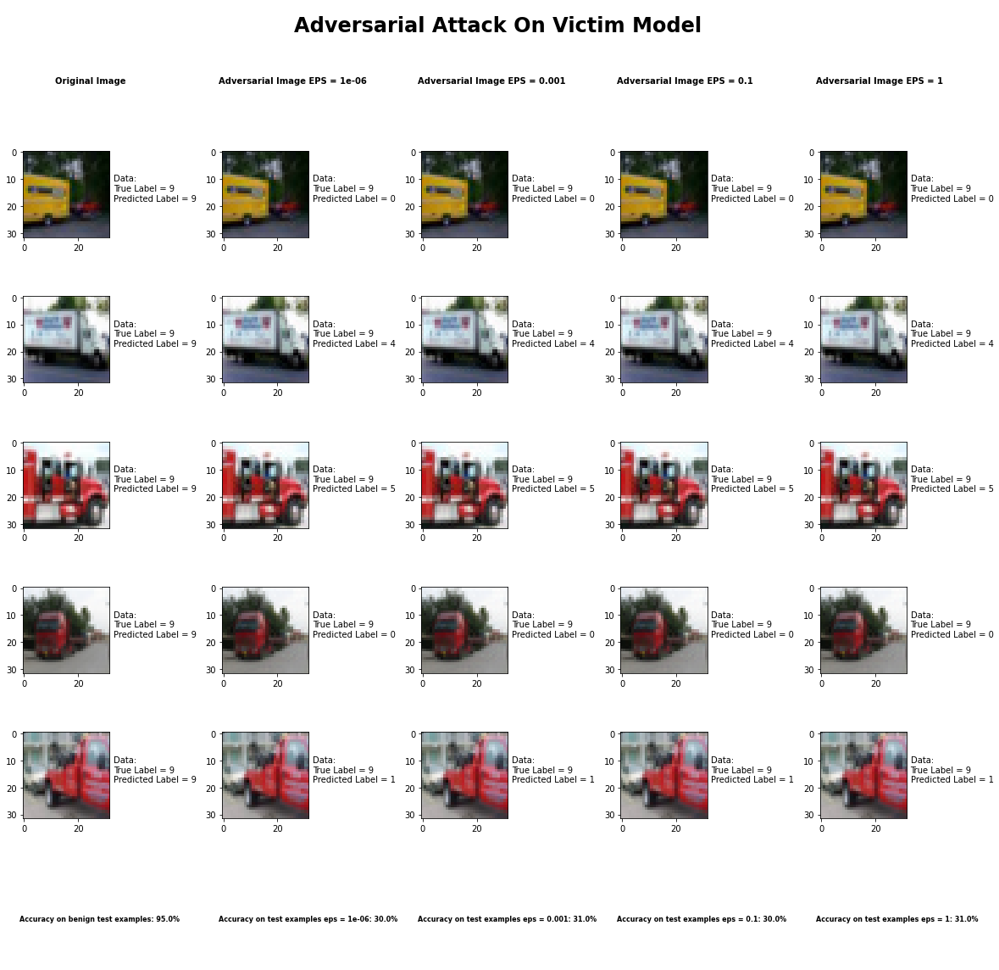

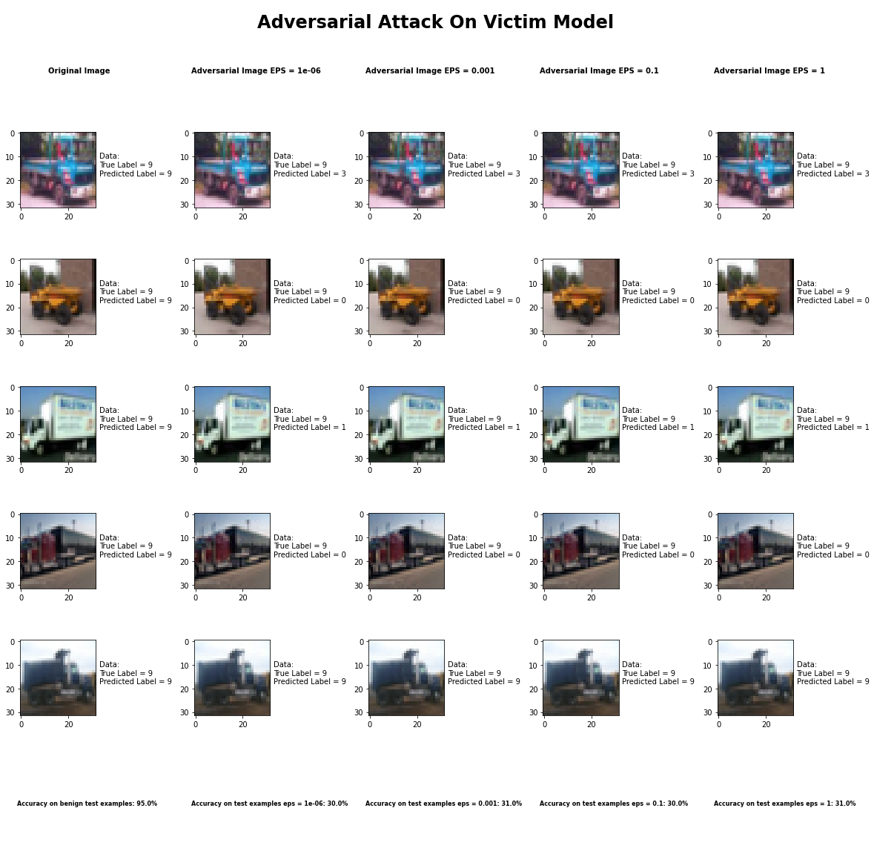

Accuracy on benign test examples: 94.52000000000001%

Average Accuracy on adversarial test examples with eps = 0.05: 30.2%

Average Accuracy on adversarial test examples with eps = 0.1: 31.3%

Average Accuracy on adversarial test examples with eps = 0.5: 30.1%

Average Accuracy on adversarial test examples with eps = 0.95: 31.0%

Classifier with benign example has Airplane recognition average accuracy of = 95%

DeepFool Method with eps = 1e-6 has Airplane recognition average accuracy of = 42%

DeepFool Method with eps = 1e-3 has Airplane recognition average accuracy of = 46%

DeepFool Method with eps = 1e-1 has Airplane recognition average accuracy of = 46%

DeepFool Method with eps = 1 has Airplane recognition average accuracy of = 46%

Classifier with benign example has Automobile recognition average accuracy of = 92%

DeepFool Method with eps = 1e-6 has Automobile recognition average accuracy of = 45%

DeepFool Method with eps = 1e-3 has Automobile recognition average accuracy of = 51%

DeepFool Method with eps = 1e-1 has Automobile recognition average accuracy of = 48%

DeepFool Method with eps = 1 has Automobile recognition average accuracy of = 41%

Classifier with benign example has Bird recognition average accuracy of = 96%

DeepFool Method with eps = 1e-6 has Bird recognition average accuracy of = 27%

DeepFool Method with eps = 1e-3 has Bird recognition average accuracy of = 31%

DeepFool Method with eps = 1e-1 has Bird recognition average accuracy of = 24%

DeepFool Method with eps = 1 has Bird recognition average accuracy of = 28%

Classifier with benign example has Cat recognition average accuracy of = 86%

DeepFool Method with eps = 1e-6 has Cat recognition average accuracy of = 29%

DeepFool Method with eps = 1e-3 has Cat recognition average accuracy of = 26%

DeepFool Method with eps = 1e-1 has Cat recognition average accuracy of = 22%

DeepFool Method with eps = 1 has Cat recognition average accuracy of = 24%

Classifier with benign example has Deer recognition average accuracy of = 95%

DeepFool Method with eps = 1e-6 has Deer recognition average accuracy of = 37%

DeepFool Method with eps = 1e-3 has Deer recognition average accuracy of = 33%

DeepFool Method with eps = 1e-1 has Deer recognition average accuracy of = 38%

DeepFool Method with eps = 1 has Deer recognition average accuracy of = 35%

Classifier with benign example has Dog recognition average accuracy of = 88%

DeepFool Method with eps = 1e-6 has Dog recognition average accuracy of = 20%

DeepFool Method with eps = 1e-3 has Dog recognition average accuracy of = 22%

DeepFool Method with eps = 1e-1 has Dog recognition average accuracy of = 23%

DeepFool Method with eps = 1 has Dog recognition average accuracy of = 22%

Classifier with benign example has Frog recognition average accuracy of = 99%

DeepFool Method with eps = 1e-6 has Frog recognition average accuracy of = 26%

DeepFool Method with eps = 1e-3 has Frog recognition average accuracy of = 24%

DeepFool Method with eps = 1e-1 has Frog recognition average accuracy of = 29%

DeepFool Method with eps = 1 has Frog recognition average accuracy of = 25%

Classifier with benign example has Horse recognition average accuracy of = 93%

DeepFool Method with eps = 1e-6 has Horse recognition average accuracy of = 21%

DeepFool Method with eps = 1e-3 has Horse recognition average accuracy of = 25%

DeepFool Method with eps = 1e-1 has Horse recognition average accuracy of = 24%

DeepFool Method with eps = 1 has Horse recognition average accuracy of = 26%

Classifier with benign example has Ship recognition average accuracy of = 94%

DeepFool Method with eps = 1e-6 has Ship recognition average accuracy of = 32%

DeepFool Method with eps = 1e-3 has Ship recognition average accuracy of = 30%

DeepFool Method with eps = 1e-1 has Ship recognition average accuracy of = 28%

DeepFool Method with eps = 1 has Ship recognition average accuracy of = 32%

Classifier with benign example has Truck recognition average accuracy of = 98%

DeepFool Method with eps = 1e-6 has Truck recognition average accuracy of = 26%

DeepFool Method with eps = 1e-3 has Truck recognition average accuracy of = 24%

DeepFool Method with eps = 1e-1 has Truck recognition average accuracy of = 21%

DeepFool Method with eps = 1 has Truck recognition average accuracy of = 18%

## Fast Gradient Sign Method



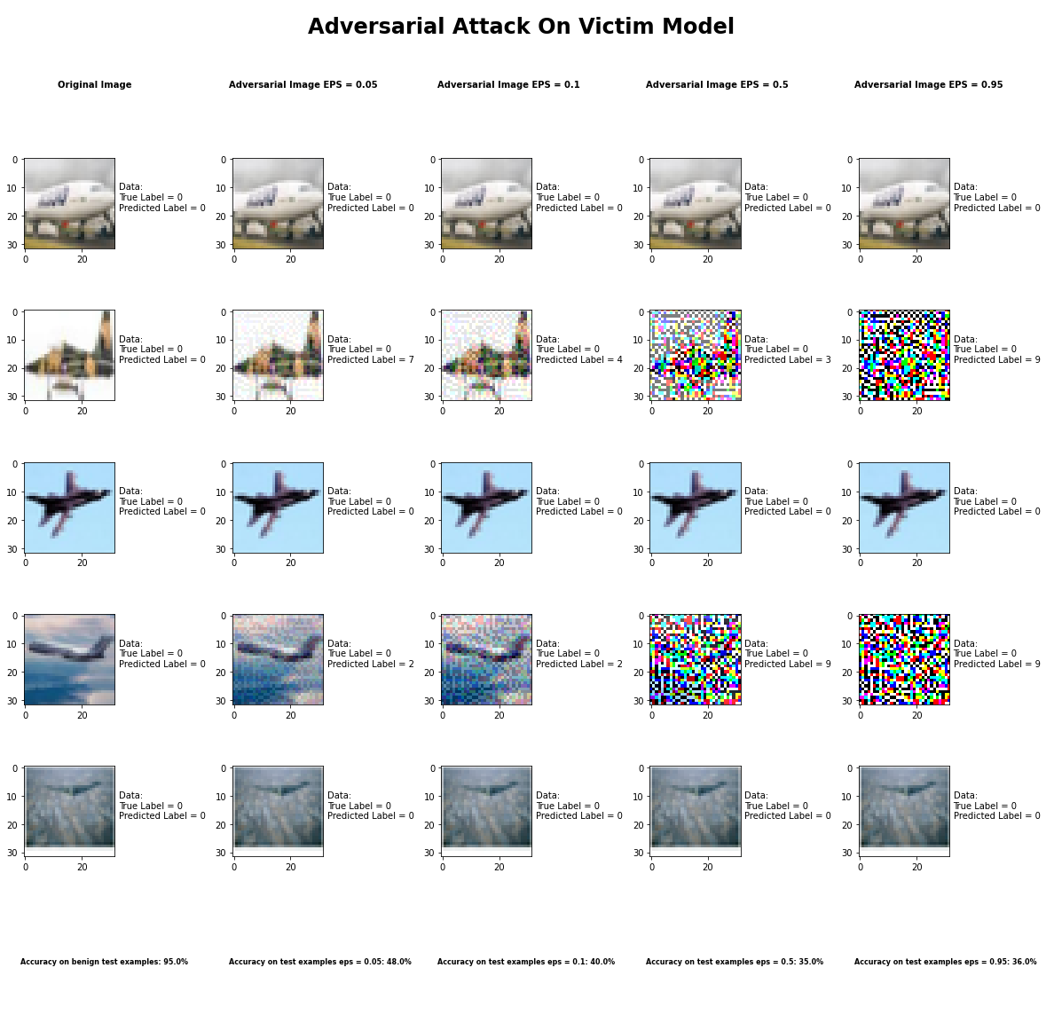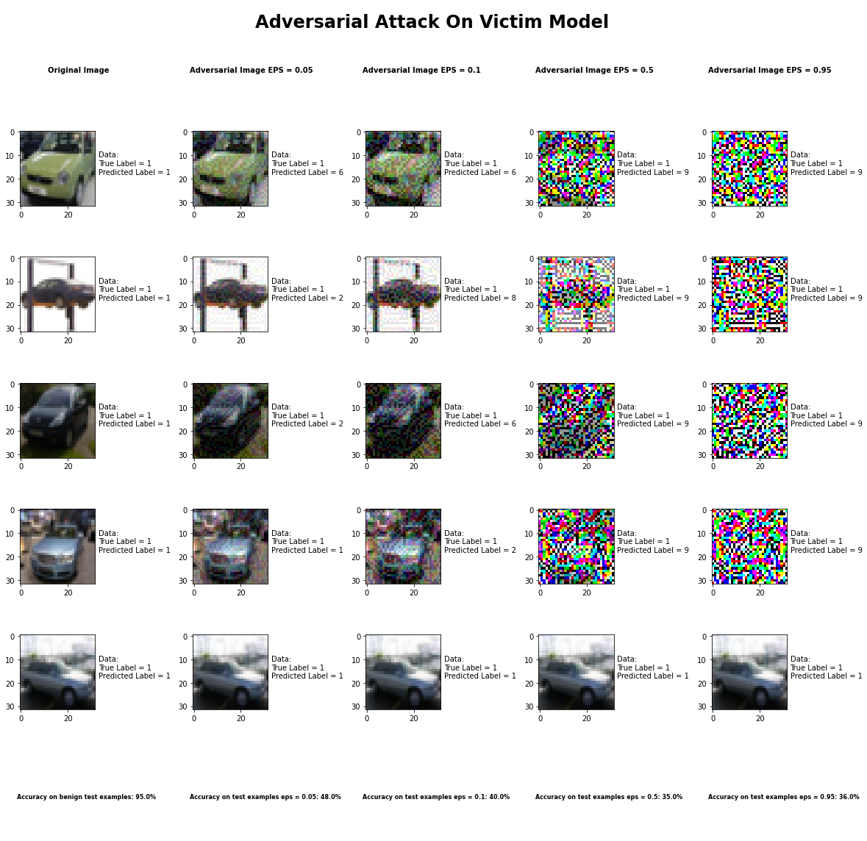

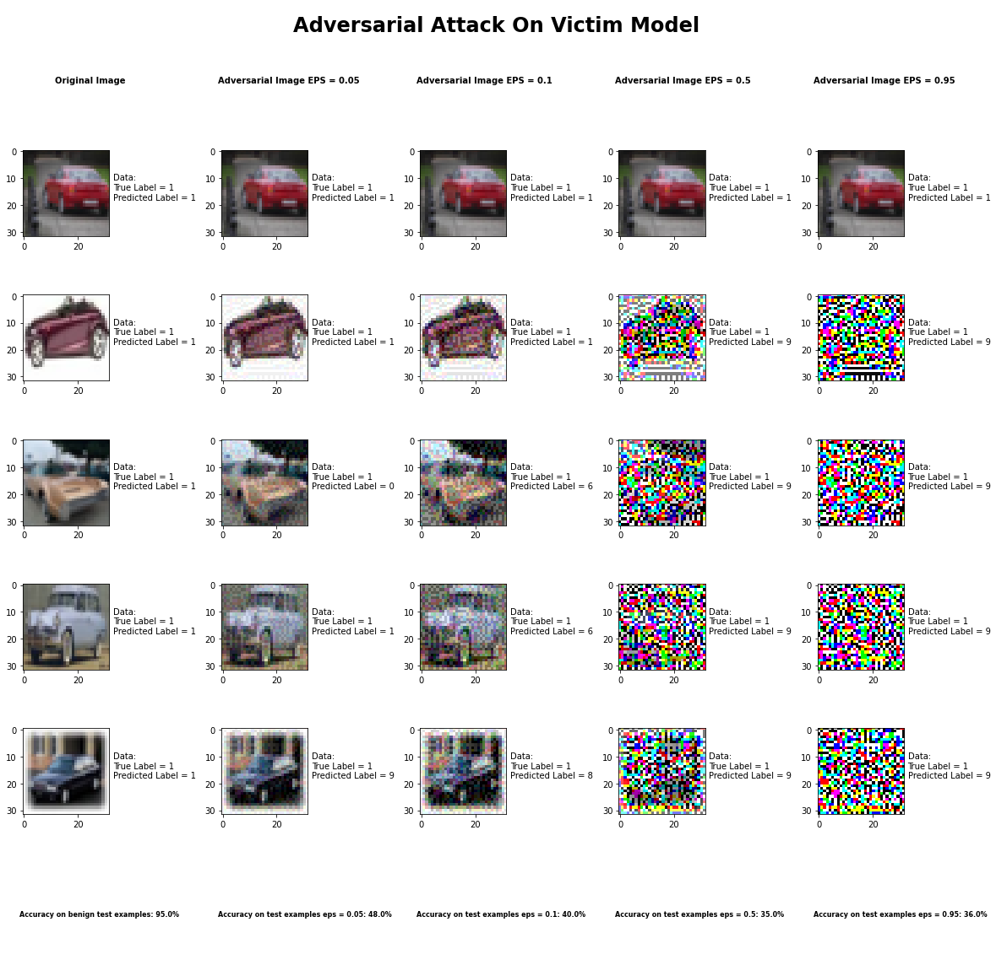

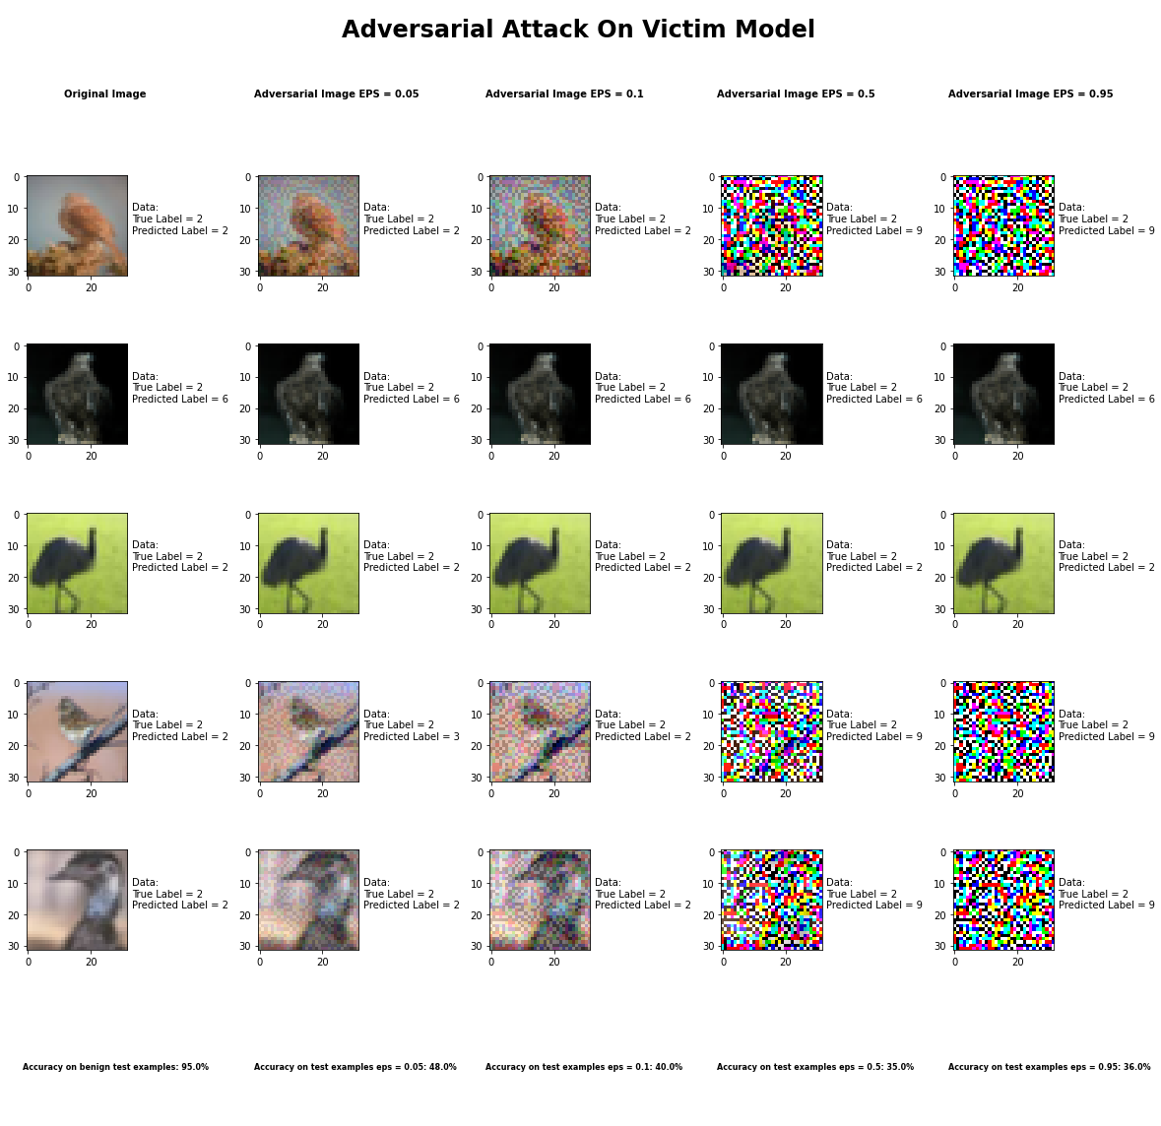

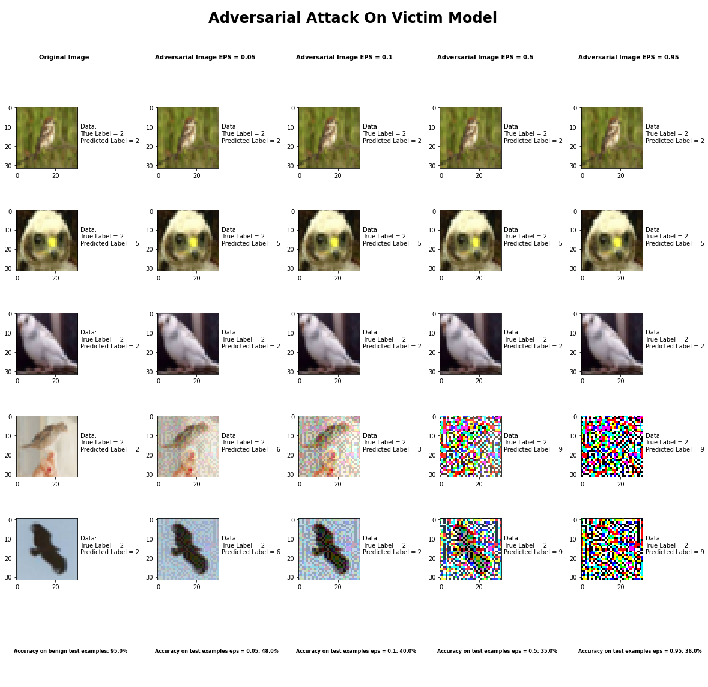

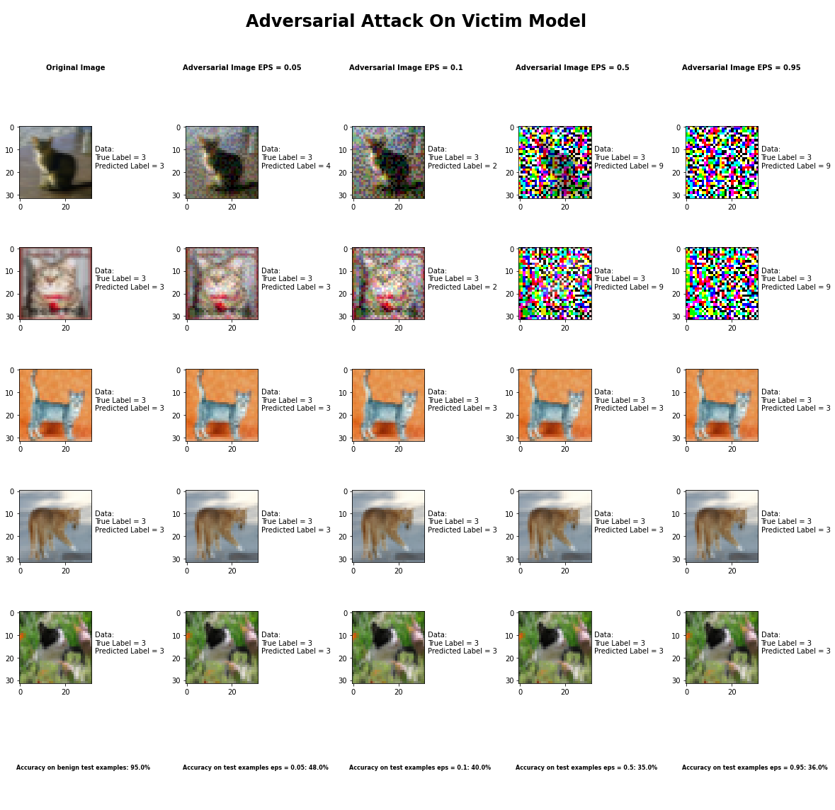

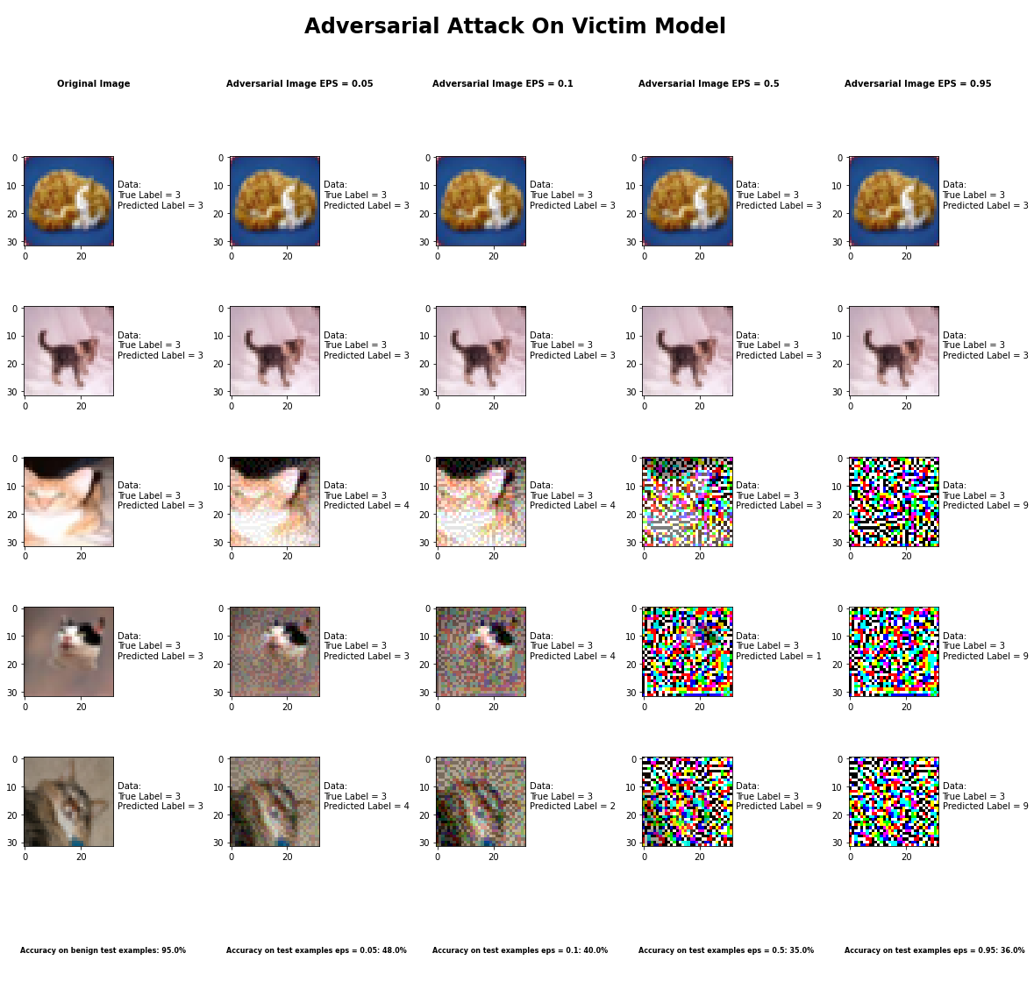

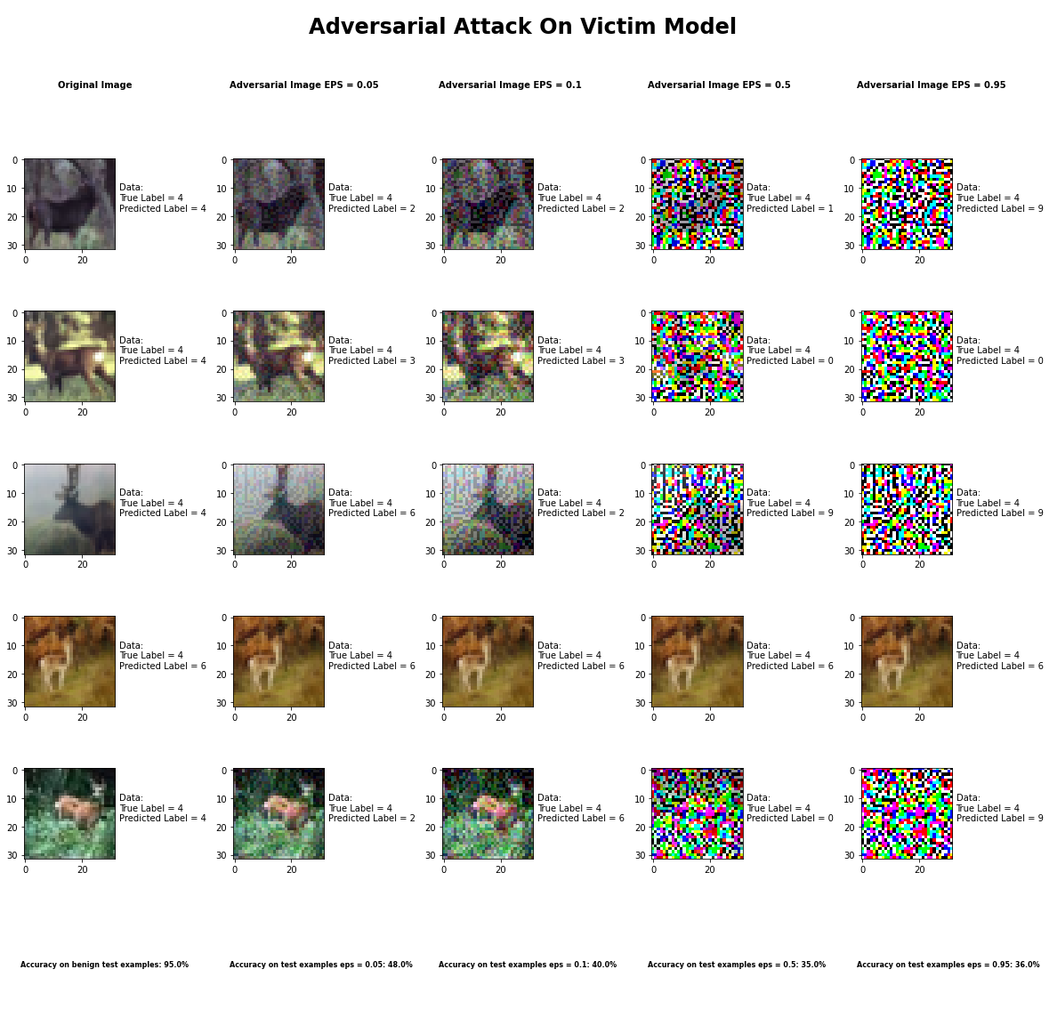

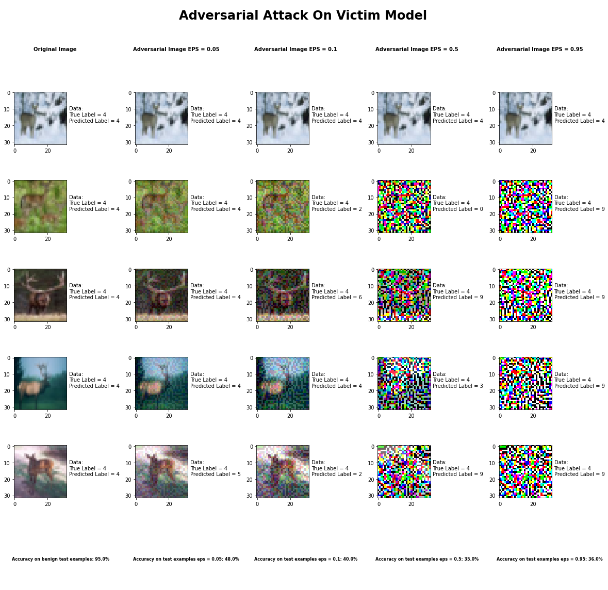

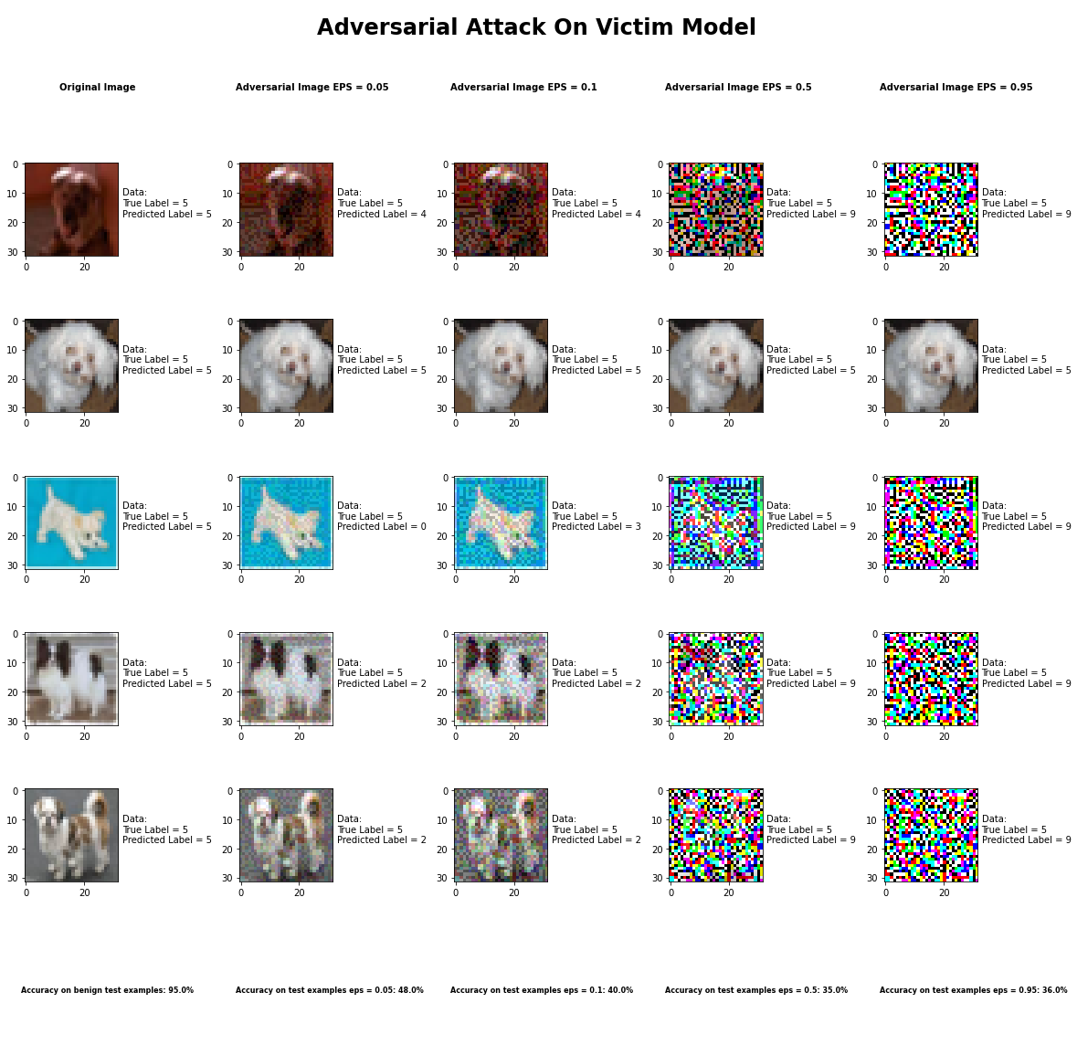

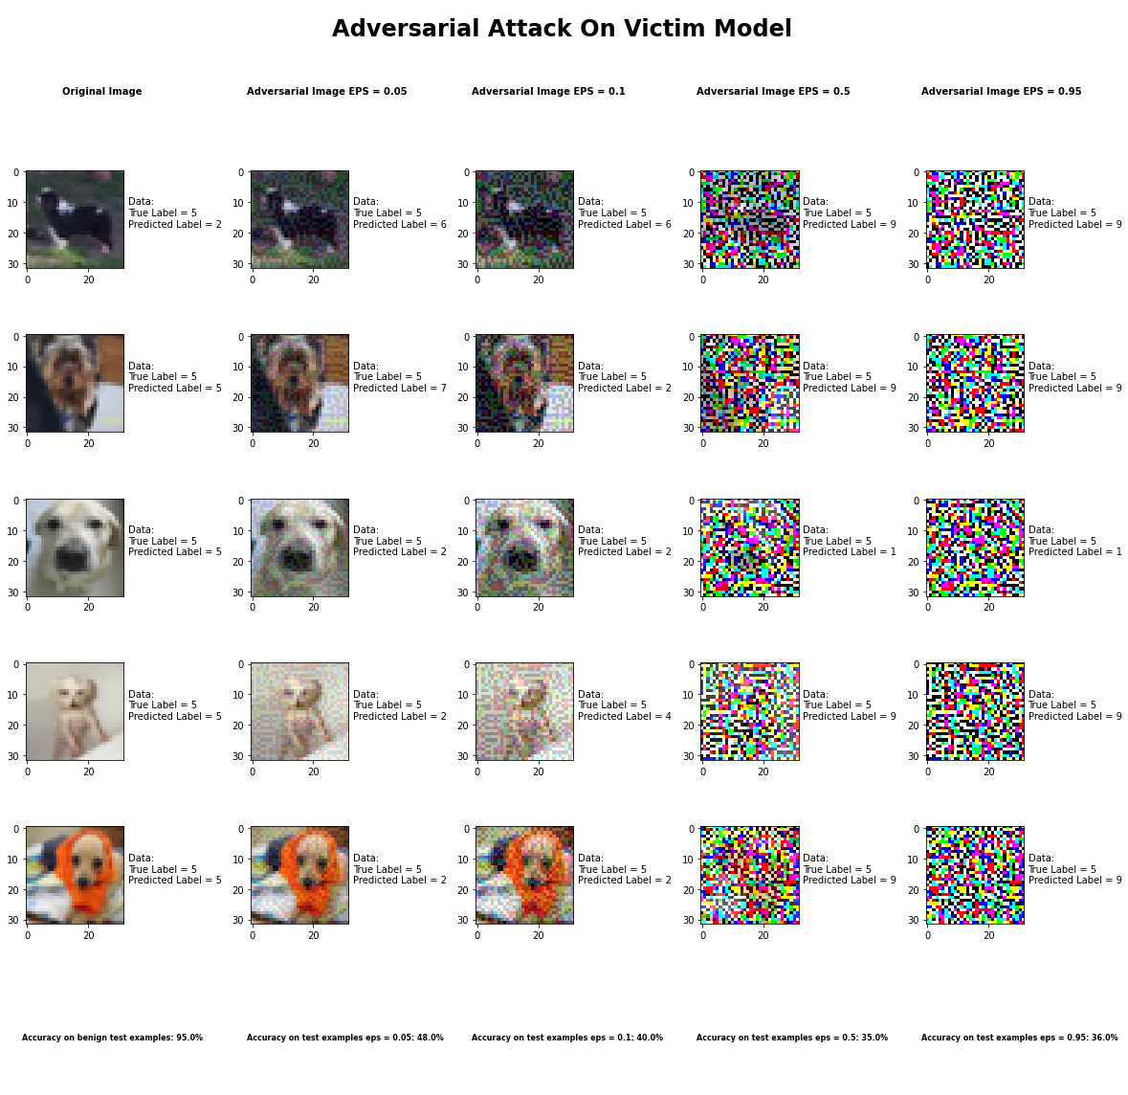

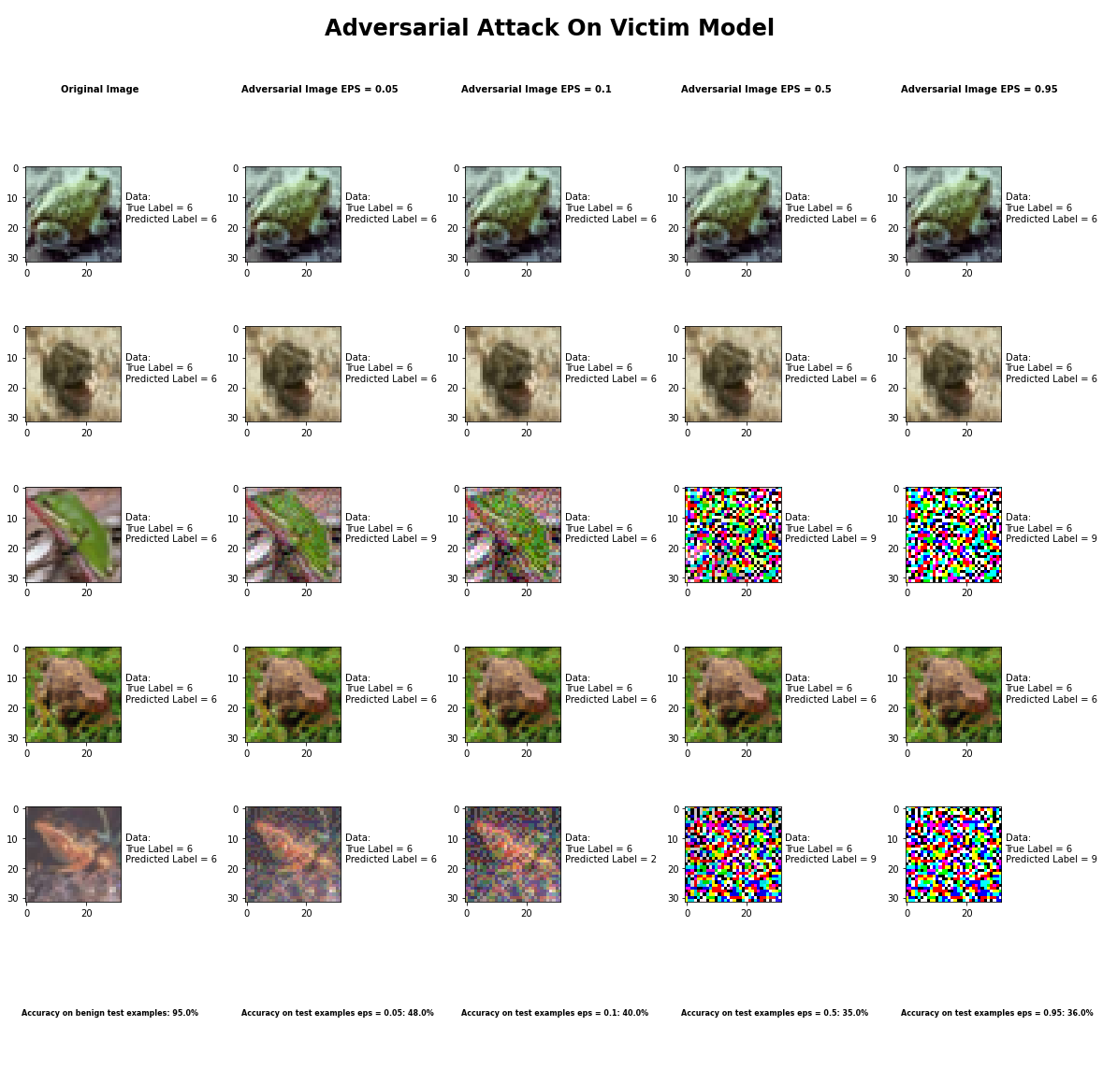

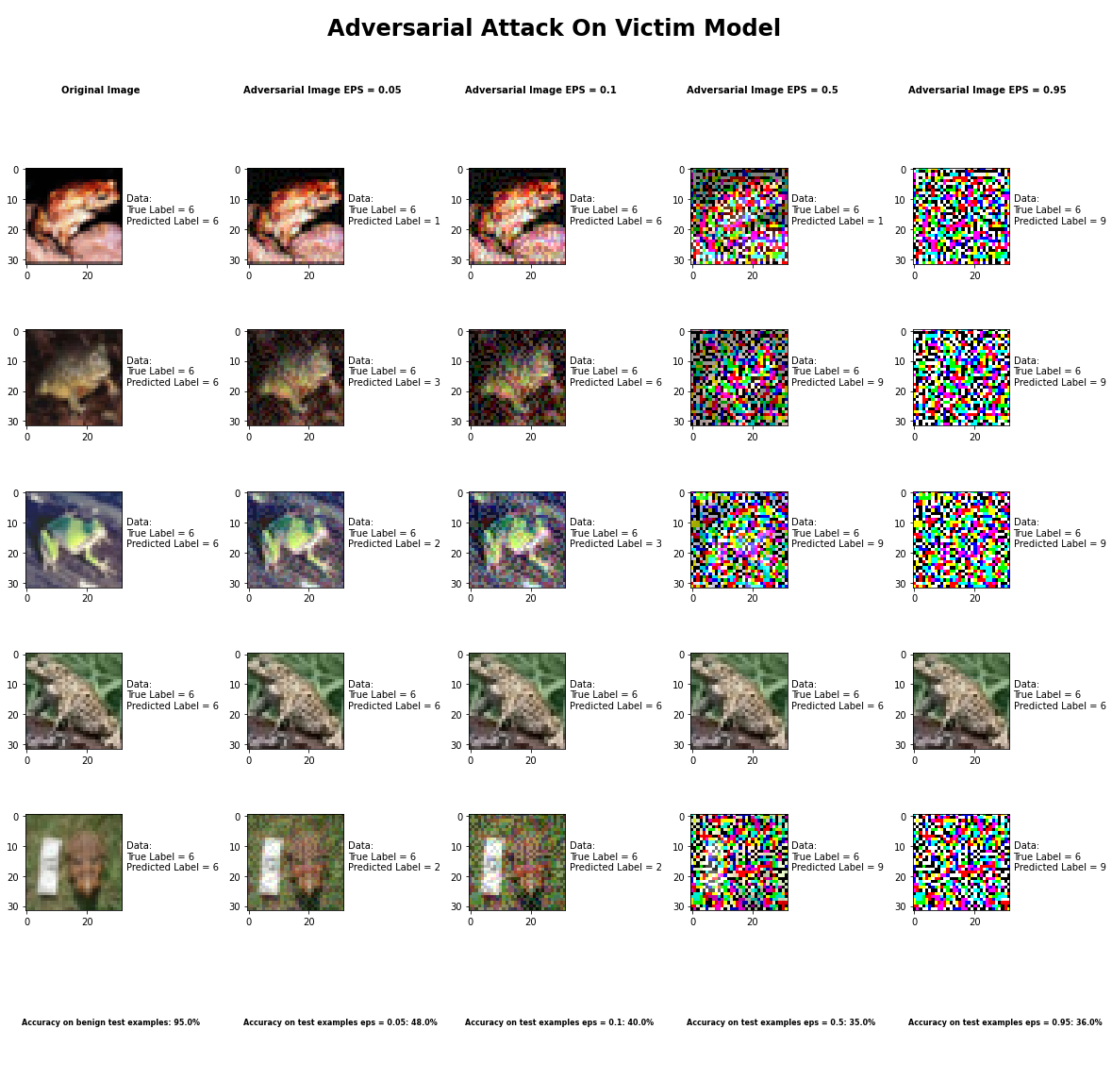

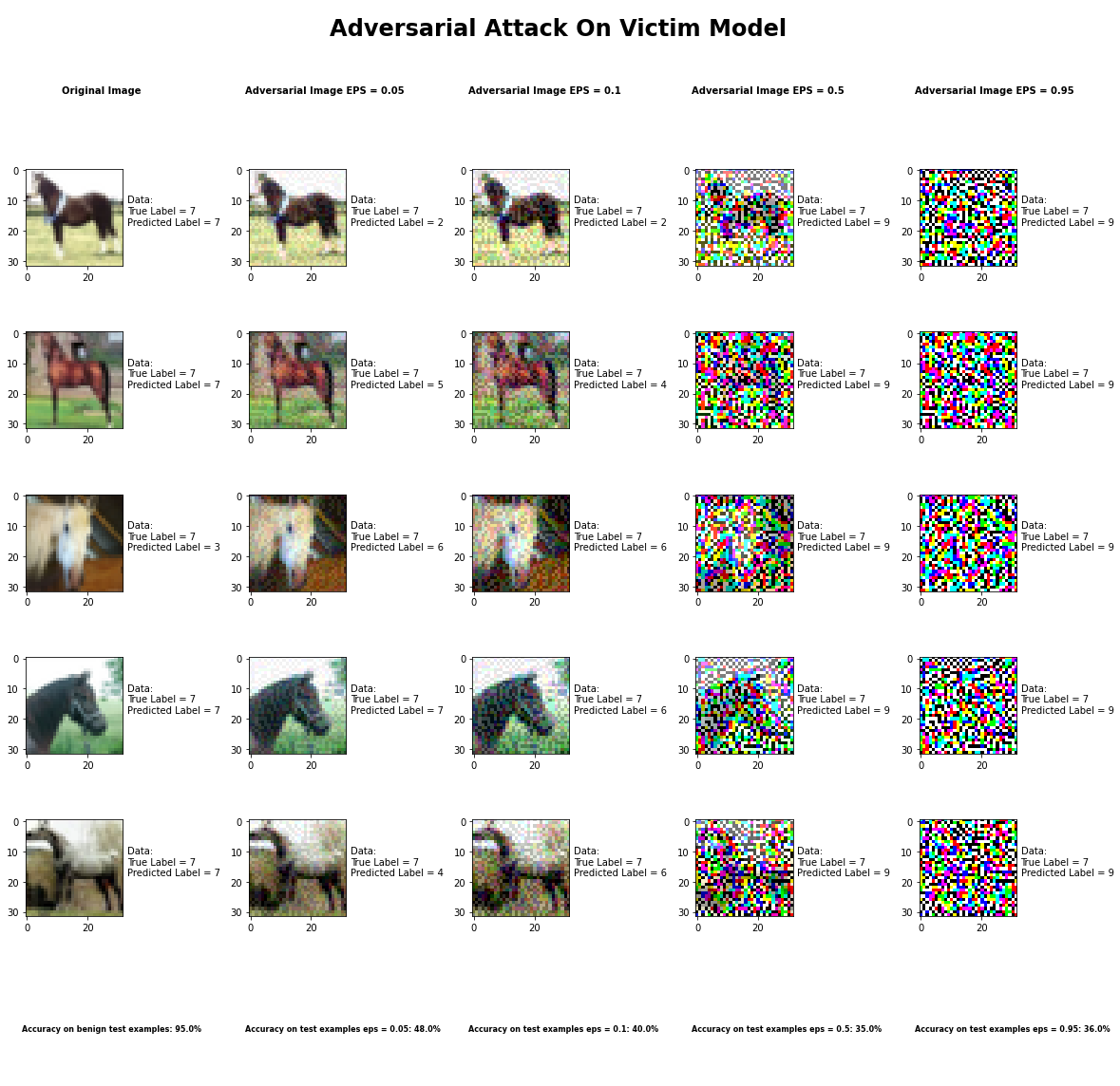

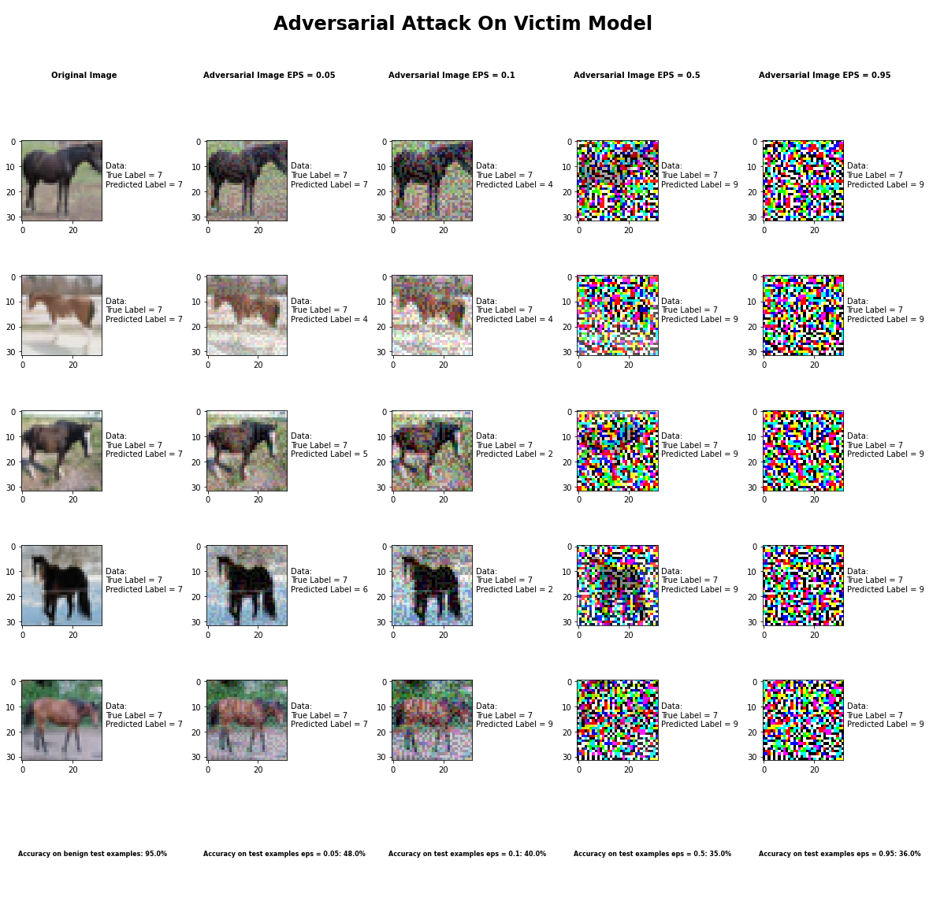

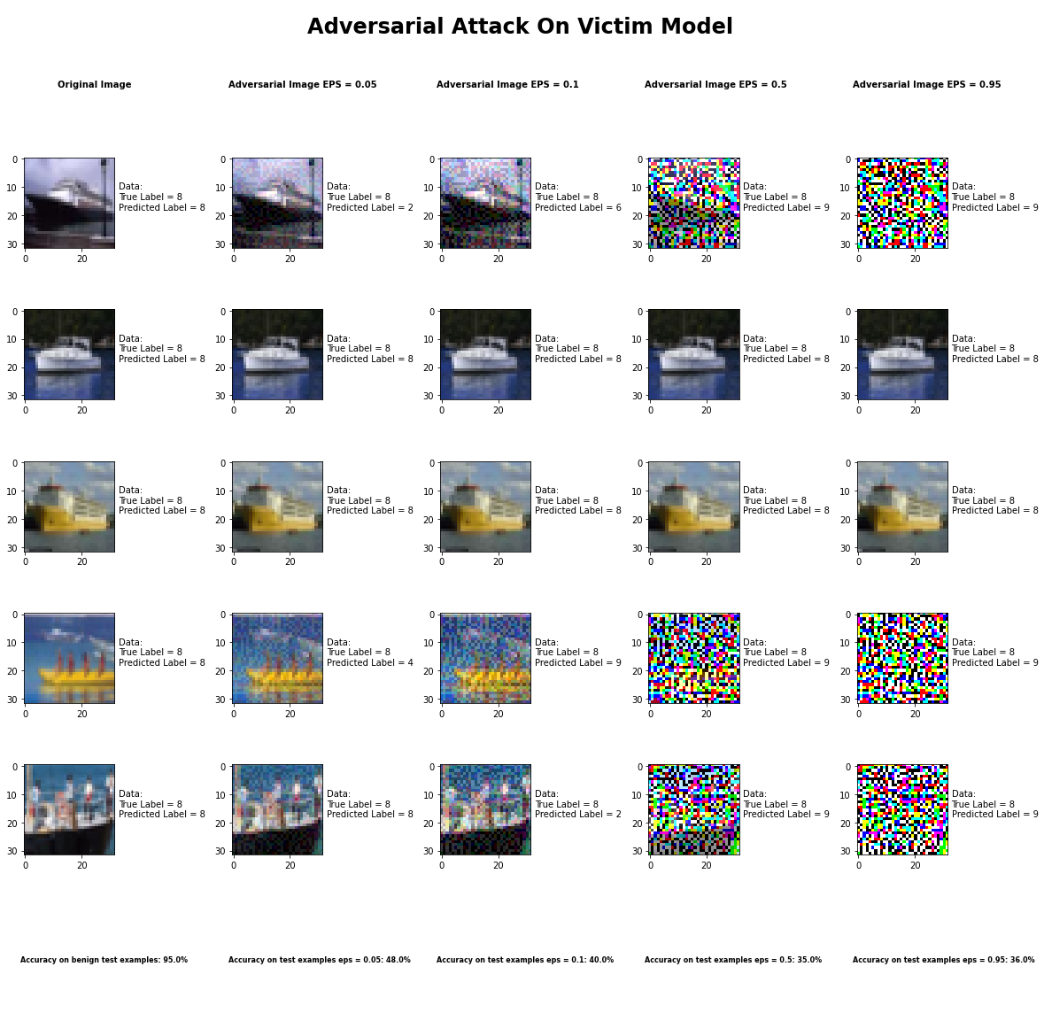

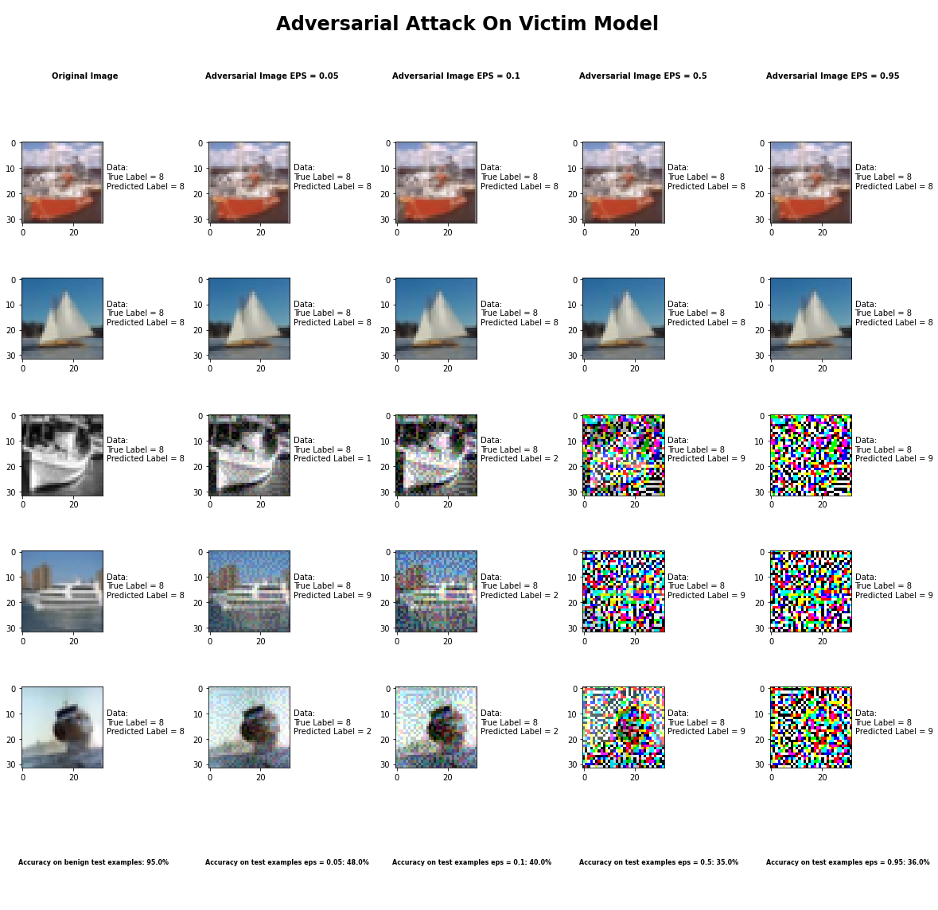

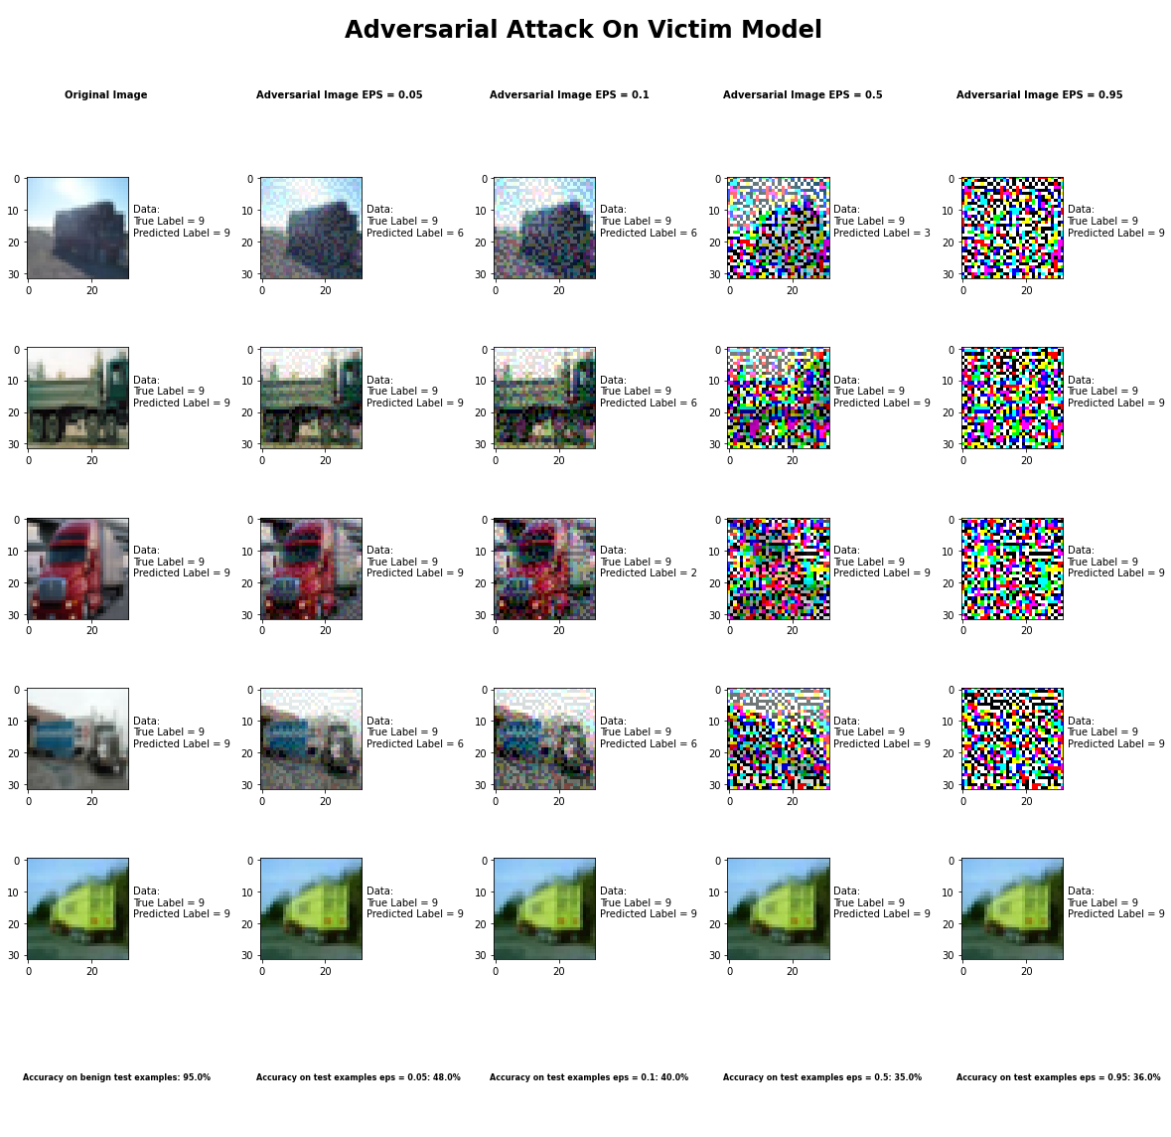

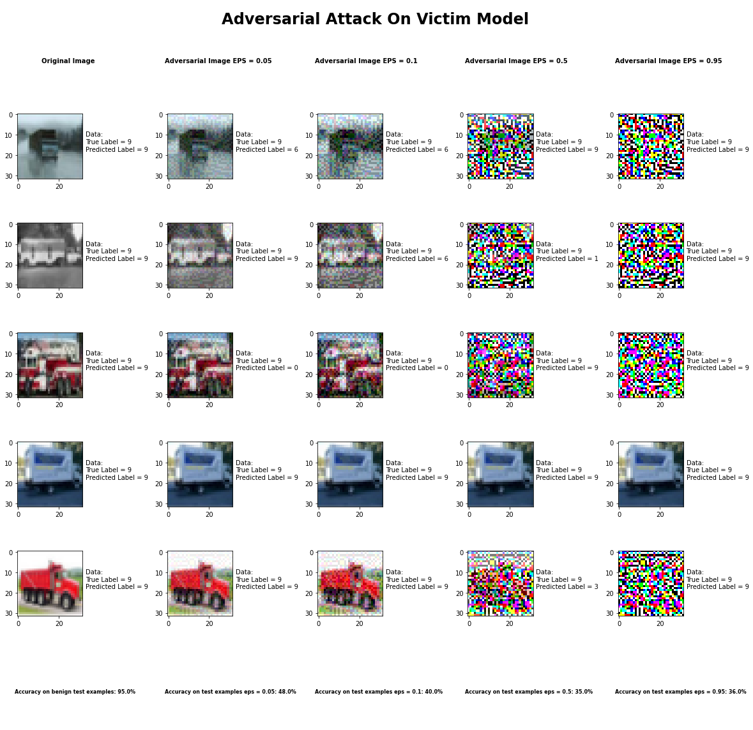

Accuracy on benign test examples: 94.52000000000001%

Average Accuracy on adversarial test examples with eps = 0.05: 48.4%

Average Accuracy on adversarial test examples with eps = 0.1: 39.9%

Average Accuracy on adversarial test examples with eps = 0.5: 35.3%

Average Accuracy on adversarial test examples with eps = 0.95: 35.5%

Classifier with benign example has Airplane recognition average accuracy of = 98%

Fast Gradient Method with eps = 0.05 has Airplane recognition average accuracy of = 32%

Fast Gradient Method with eps = 0.10 has Airplane recognition average accuracy of = 30%

Fast Gradient Method with eps = 0.50 has Airplane recognition average accuracy of = 33%

Fast Gradient Method with eps = 0.95 has Airplane recognition average accuracy of = 30%

Classifier with benign example has Automobile recognition average accuracy of = 96%

Fast Gradient Method with eps = 0.05 has Automobile recognition average accuracy of = 60%

Fast Gradient Method with eps = 0.10 has Automobile recognition average accuracy of = 40%

Fast Gradient Method with eps = 0.50 has Automobile recognition average accuracy of = 40%

Fast Gradient Method with eps = 0.95 has Automobile recognition average accuracy of = 35%

Classifier with benign example has Bird recognition average accuracy of = 95%

Fast Gradient Method with eps = 0.05 has Bird recognition average accuracy of = 68%

Fast Gradient Method with eps = 0.10 has Bird recognition average accuracy of = 70%

Fast Gradient Method with eps = 0.50 has Bird recognition average accuracy of = 34%

Fast Gradient Method with eps = 0.95 has Bird recognition average accuracy of = 34%

Classifier with benign example has Cat recognition average accuracy of = 86%

Fast Gradient Method with eps = 0.05 has Cat recognition average accuracy of = 42%

Fast Gradient Method with eps = 0.10 has Cat recognition average accuracy of = 34%

Fast Gradient Method with eps = 0.50 has Cat recognition average accuracy of = 37%

Fast Gradient Method with eps = 0.95 has Cat recognition average accuracy of = 32%

Classifier with benign example has Deer recognition average accuracy of = 96%

Fast Gradient Method with eps = 0.05 has Deer recognition average accuracy of = 43%

Fast Gradient Method with eps = 0.10 has Deer recognition average accuracy of = 28%

Fast Gradient Method with eps = 0.50 has Deer recognition average accuracy of = 20%

Fast Gradient Method with eps = 0.95 has Deer recognition average accuracy of = 20%

Classifier with benign example has Dog recognition average accuracy of = 84%

Fast Gradient Method with eps = 0.05 has Dog recognition average accuracy of = 31%

Fast Gradient Method with eps = 0.10 has Dog recognition average accuracy of = 23%

Fast Gradient Method with eps = 0.50 has Dog recognition average accuracy of = 23%

Fast Gradient Method with eps = 0.95 has Dog recognition average accuracy of = 23%

Classifier with benign example has Frog recognition average accuracy of = 96%

Fast Gradient Method with eps = 0.05 has Frog recognition average accuracy of = 60%

Fast Gradient Method with eps = 0.10 has Frog recognition average accuracy of = 68%

Fast Gradient Method with eps = 0.50 has Frog recognition average accuracy of = 26%

Fast Gradient Method with eps = 0.95 has Frog recognition average accuracy of = 26%

Classifier with benign example has Horse recognition average accuracy of = 93%

Fast Gradient Method with eps = 0.05 has Horse recognition average accuracy of = 33%

Fast Gradient Method with eps = 0.10 has Horse recognition average accuracy of = 24%

Fast Gradient Method with eps = 0.50 has Horse recognition average accuracy of = 24%

Fast Gradient Method with eps = 0.95 has Horse recognition average accuracy of = 23%

Classifier with benign example has Ship recognition average accuracy of = 99%

Fast Gradient Method with eps = 0.05 has Ship recognition average accuracy of = 58%

Fast Gradient Method with eps = 0.10 has Ship recognition average accuracy of = 45%

Fast Gradient Method with eps = 0.50 has Ship recognition average accuracy of = 45%

Fast Gradient Method with eps = 0.95 has Ship recognition average accuracy of = 45%

Classifier with benign example has Truck recognition average accuracy of = 97%

Fast Gradient Method with eps = 0.05 has Truck recognition average accuracy of = 57%

Fast Gradient Method with eps = 0.10 has Truck recognition average accuracy of = 37%

Fast Gradient Method with eps = 0.50 has Truck recognition average accuracy of = 71%

Fast Gradient Method with eps = 0.95 has Truck recognition average accuracy of = 87%

# Transfer Attack Results Appendix

## Threshold Attack Method

## Pixel Attack Method

## HopSkipJump Attack



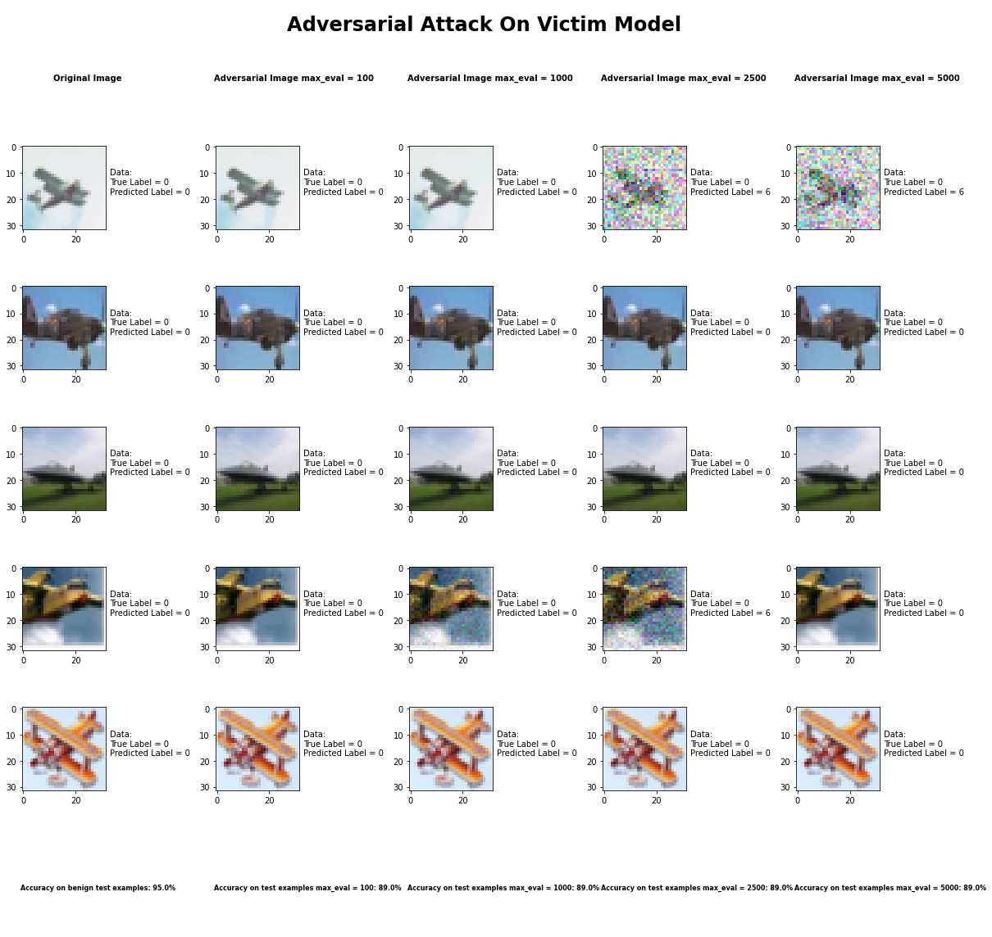

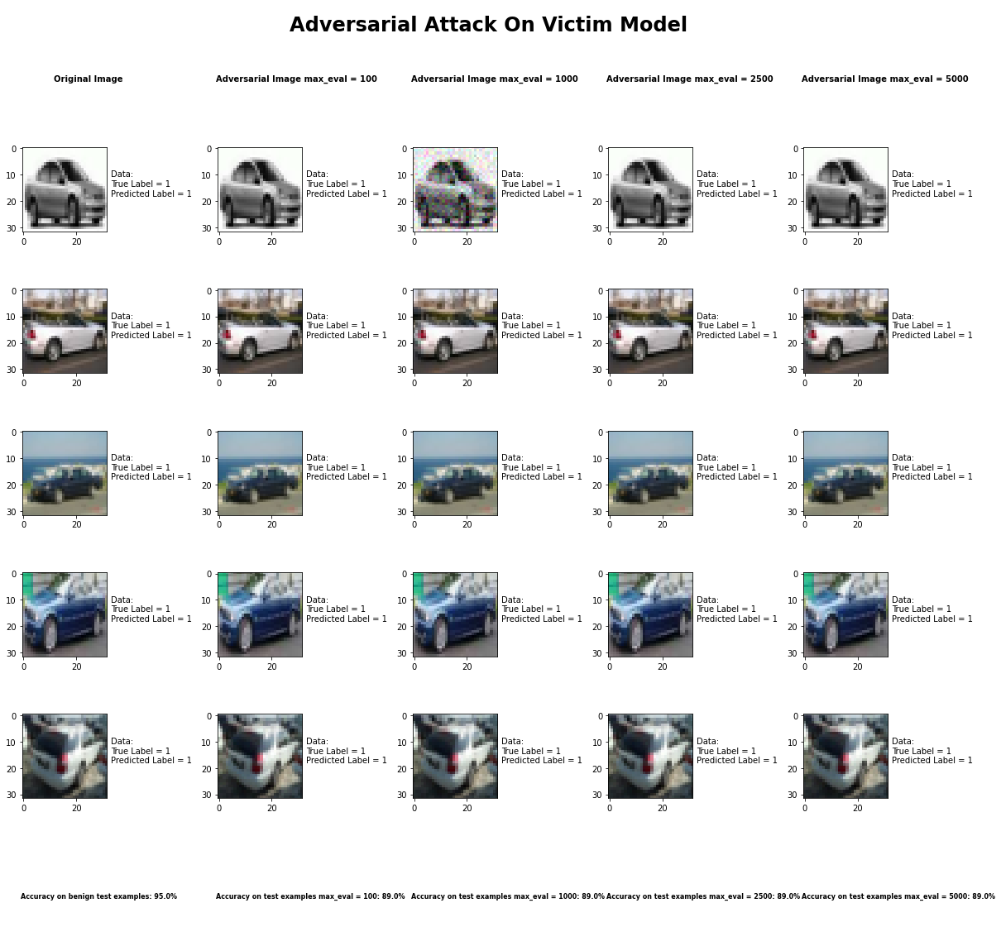

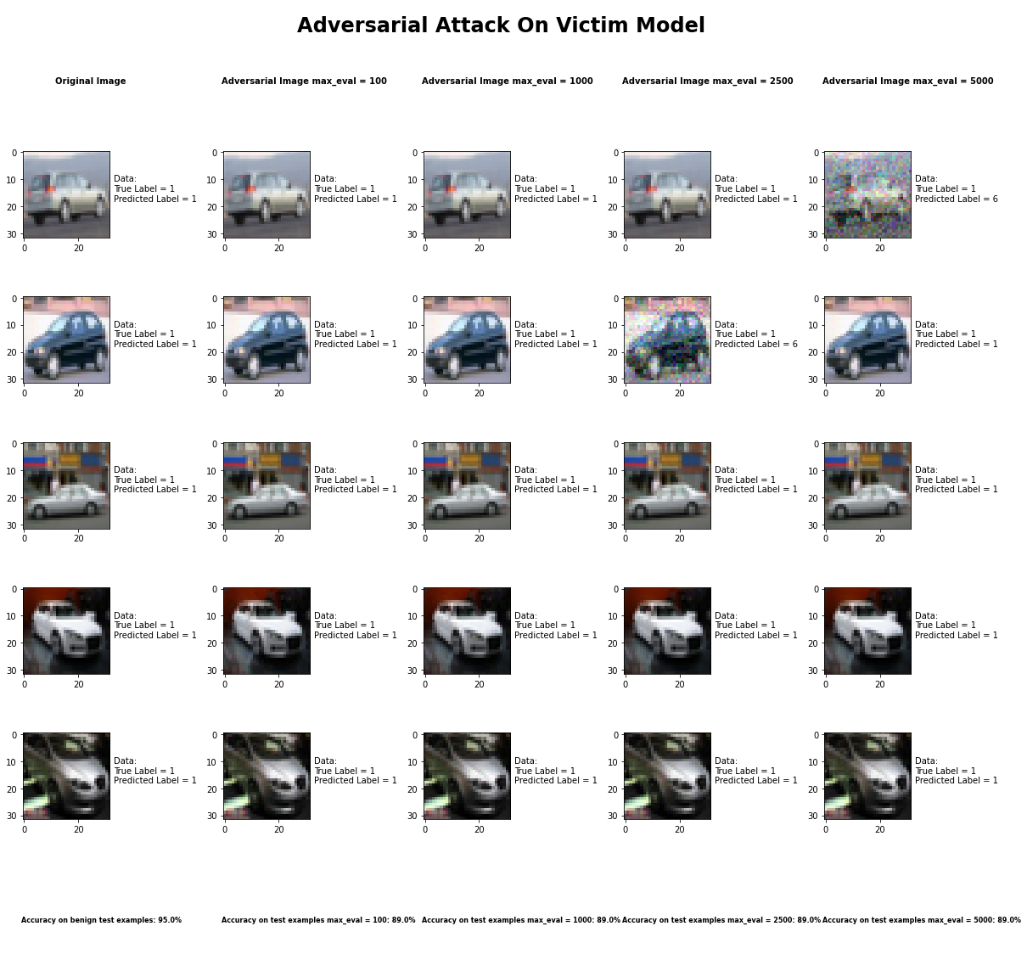

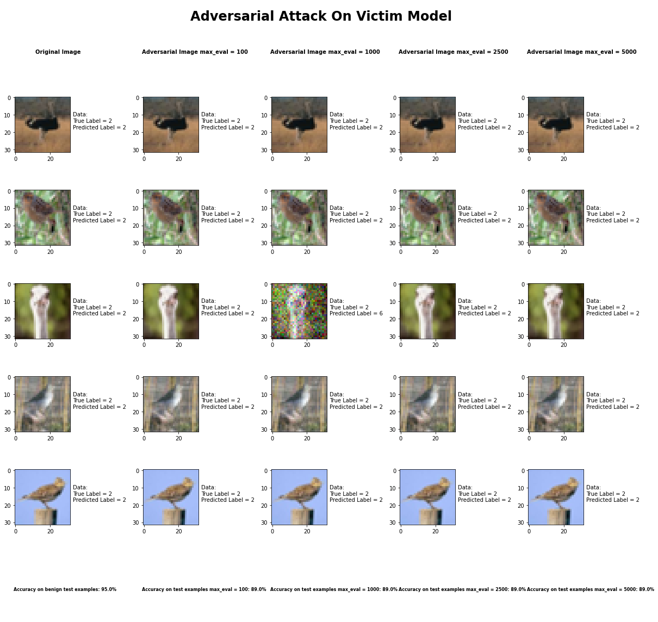

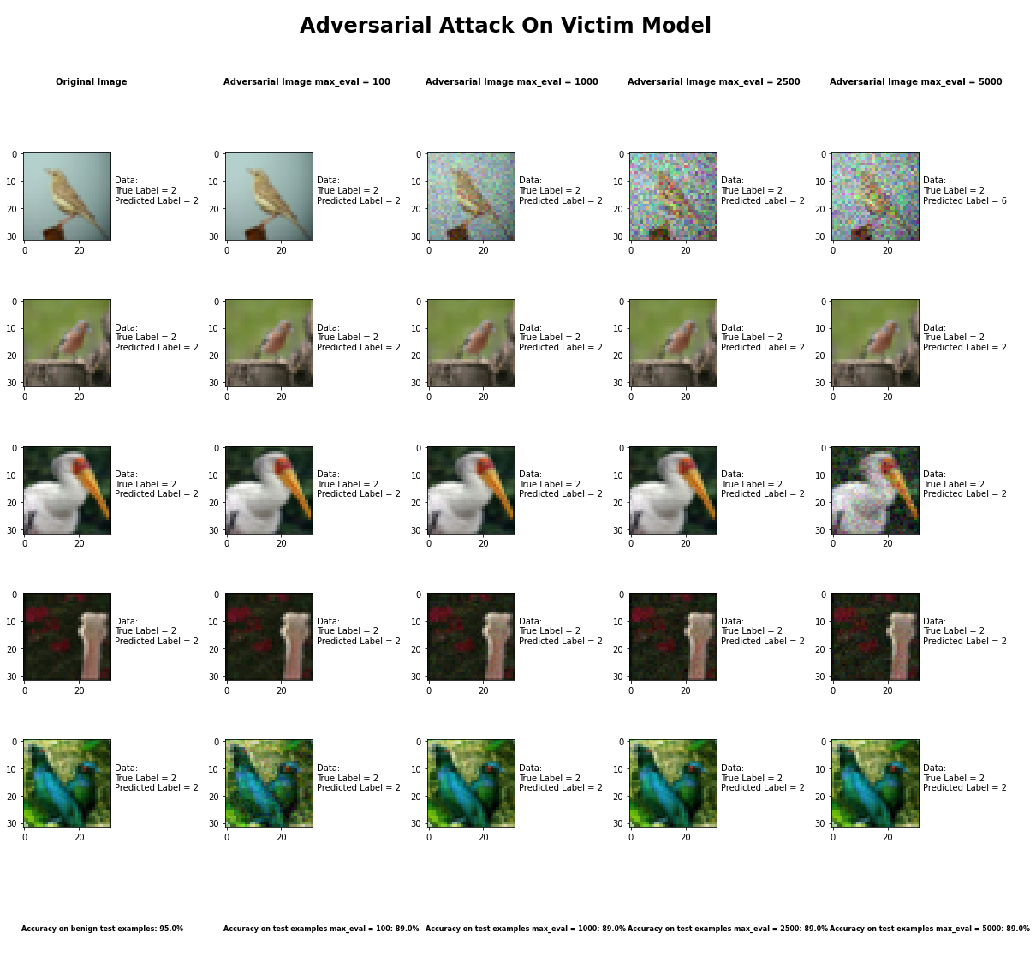

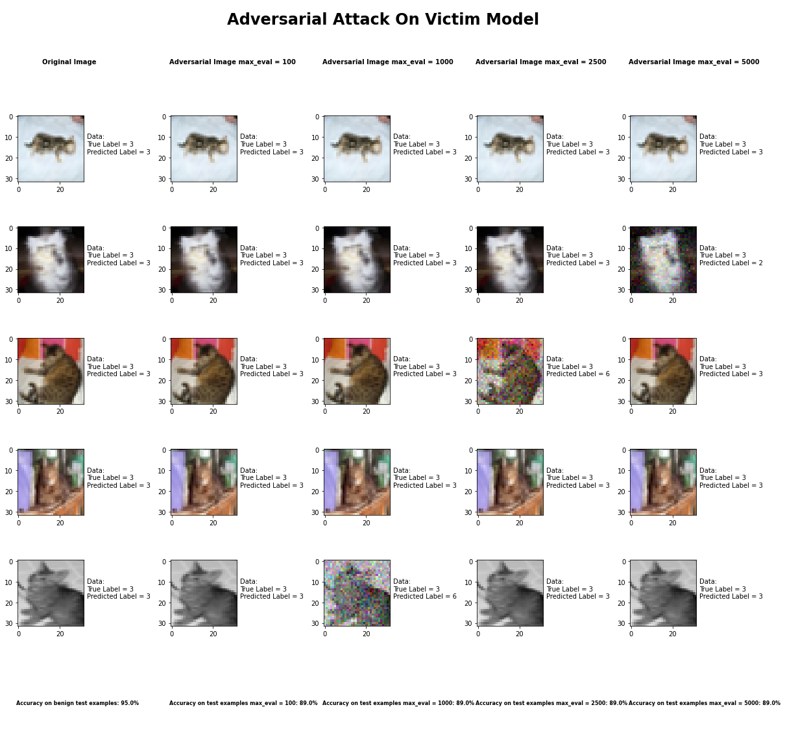

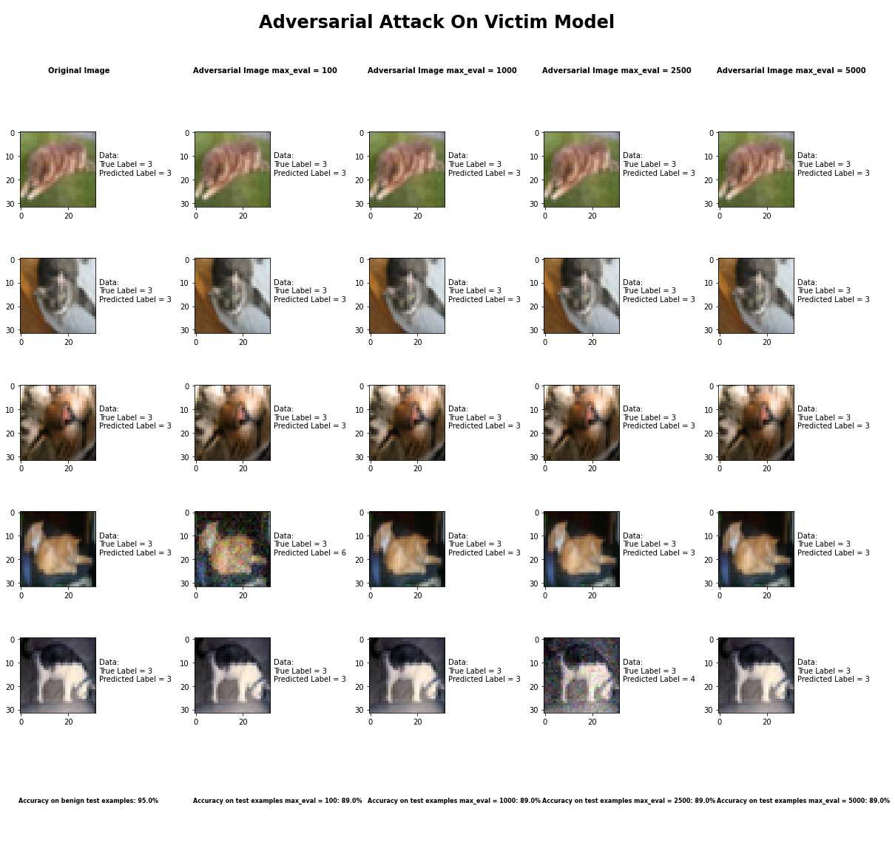

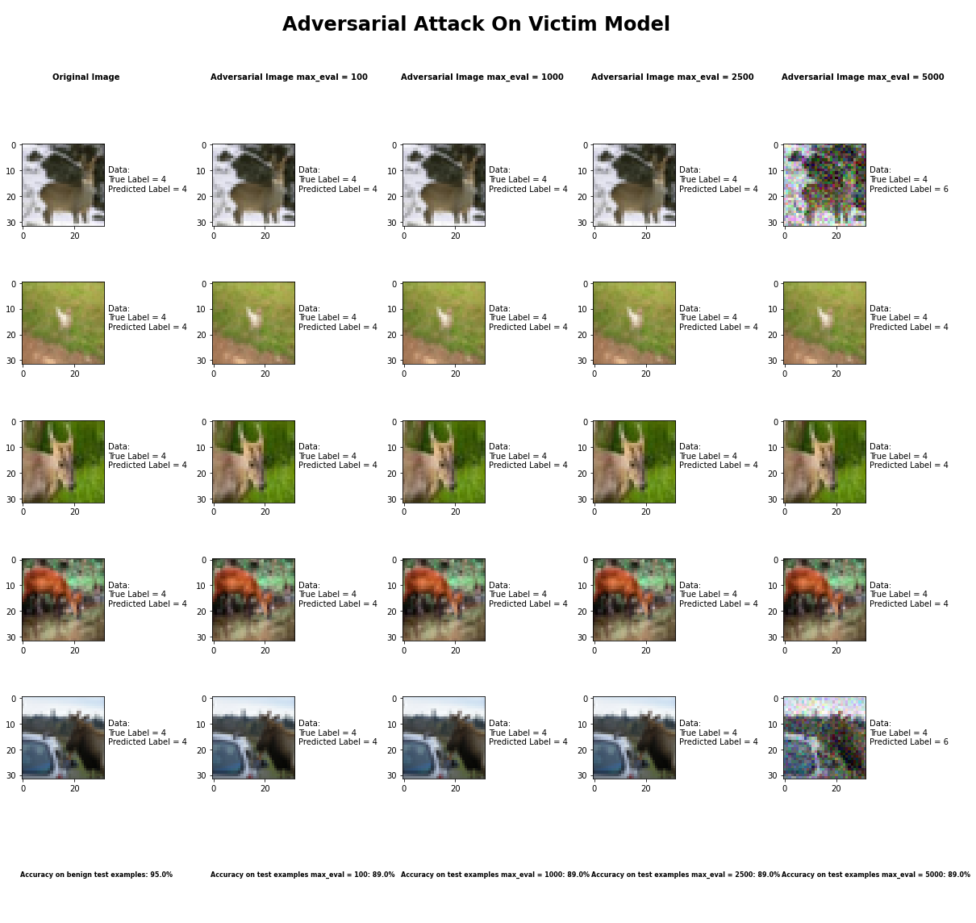

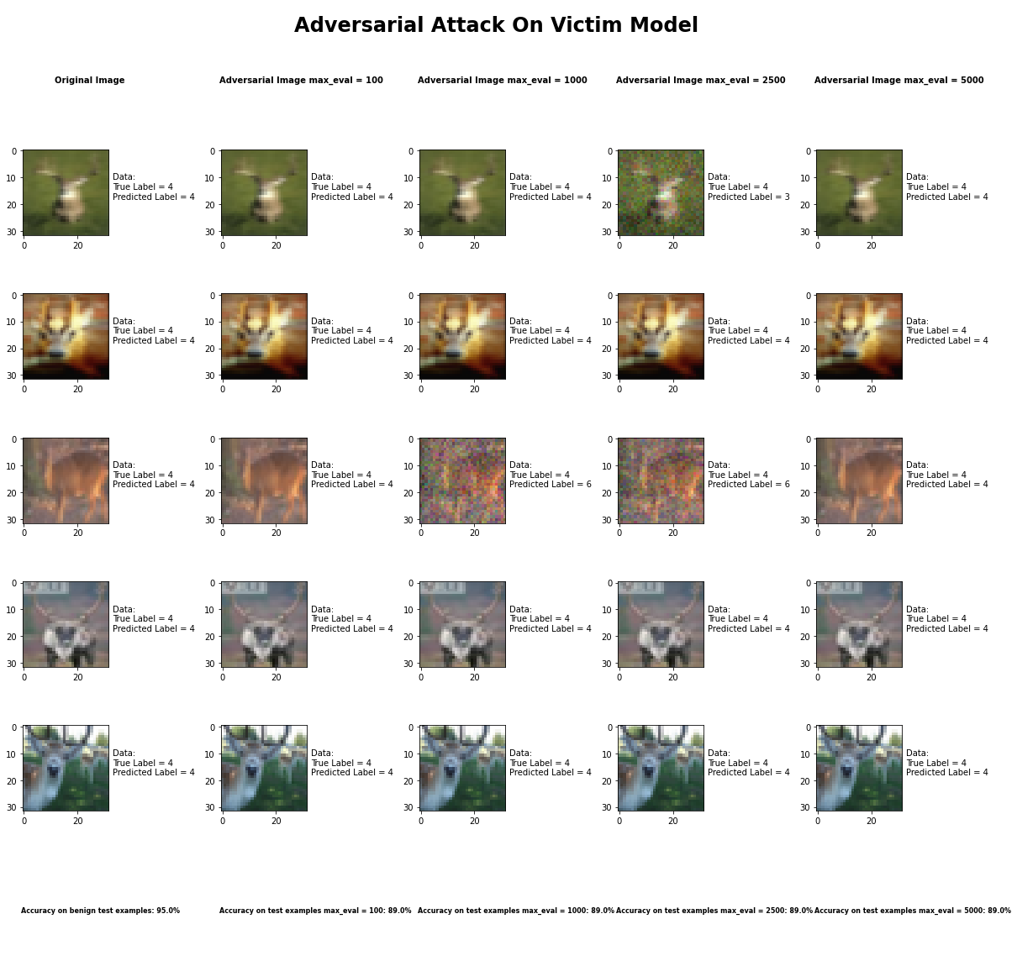

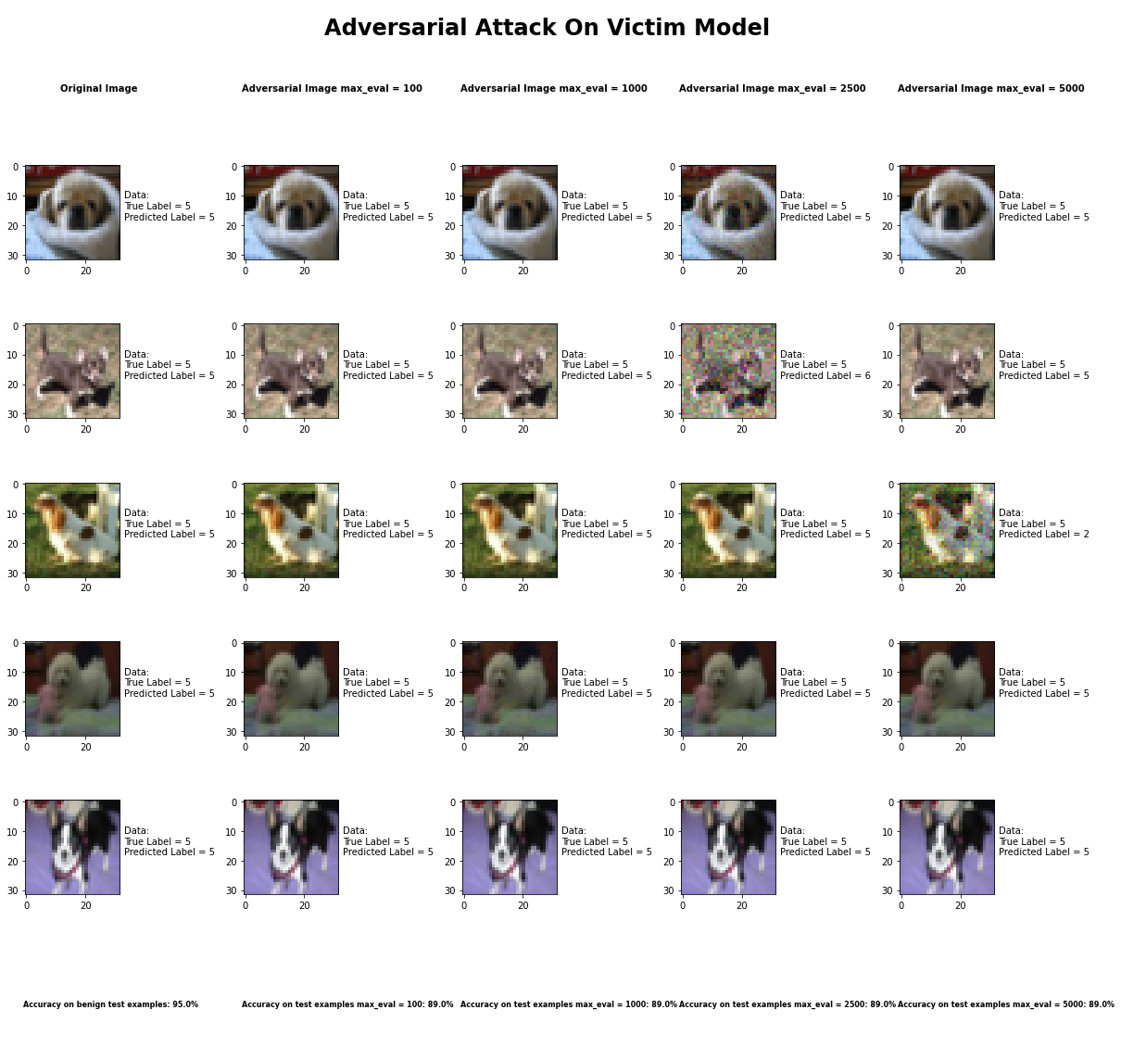

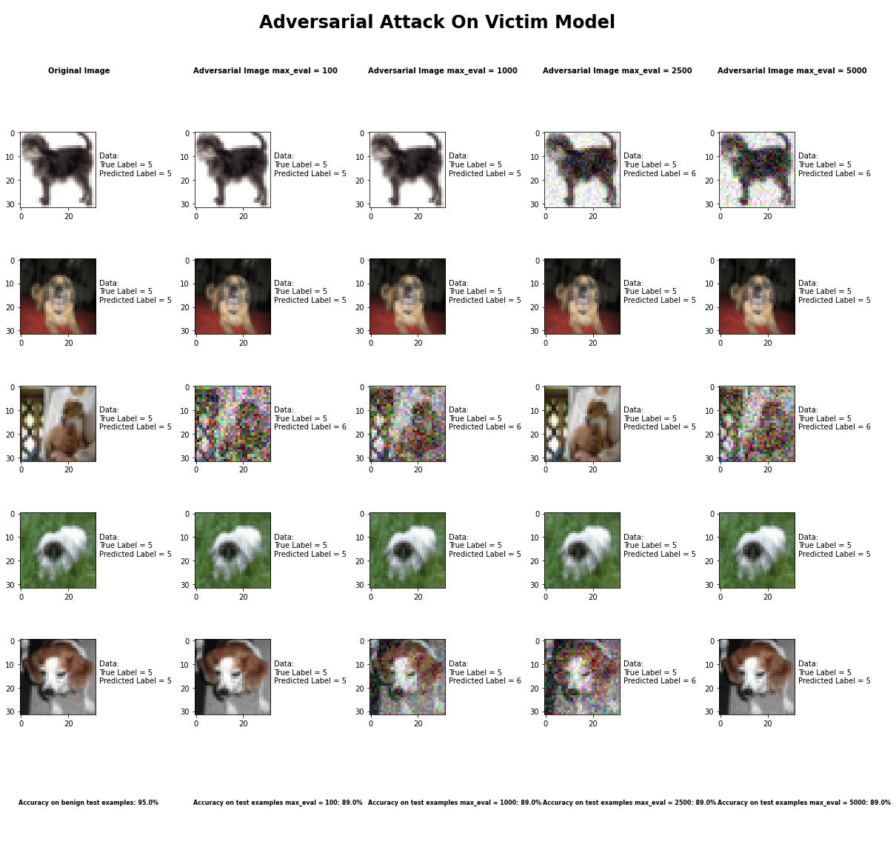

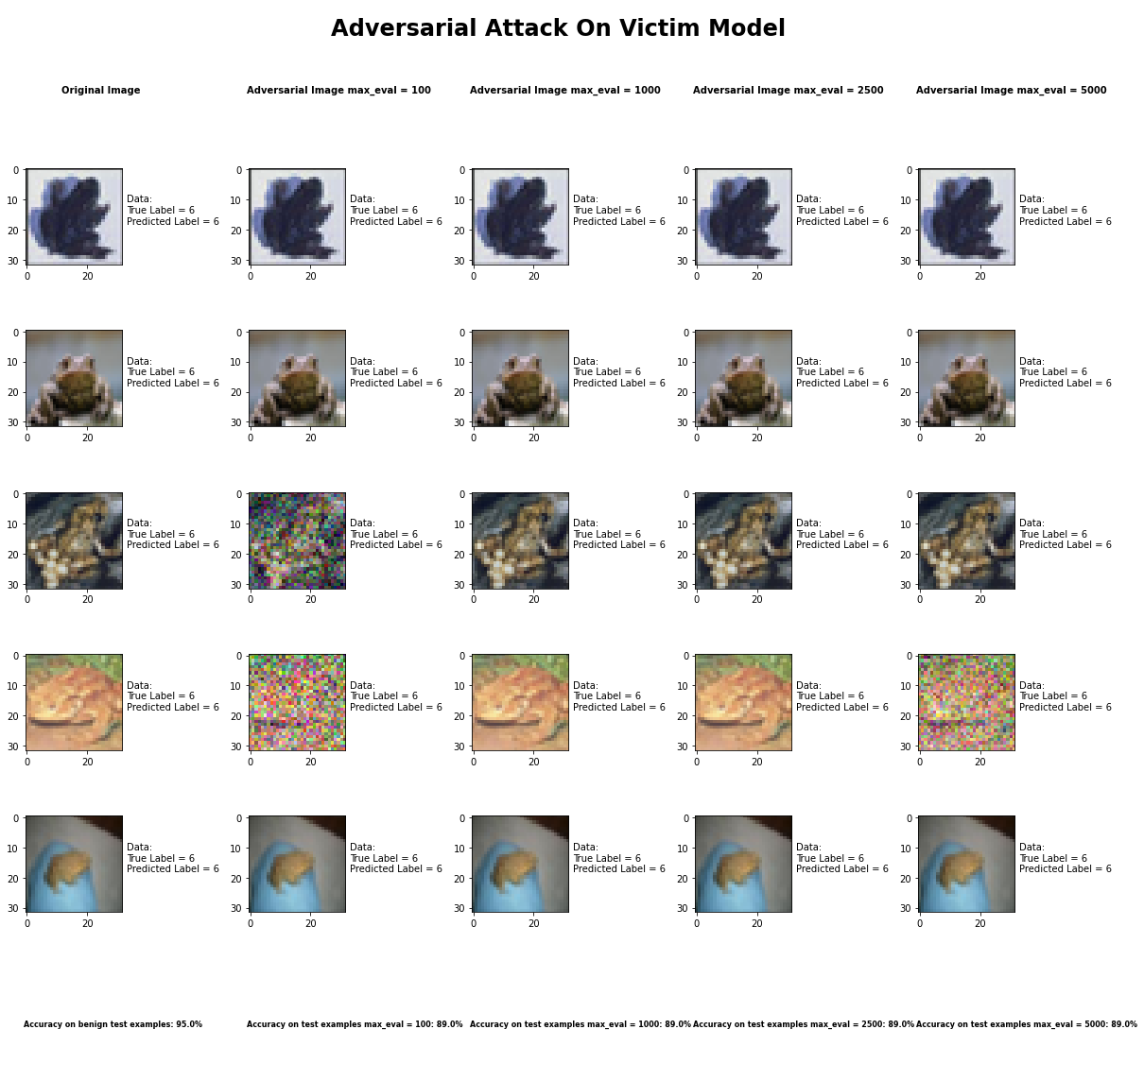

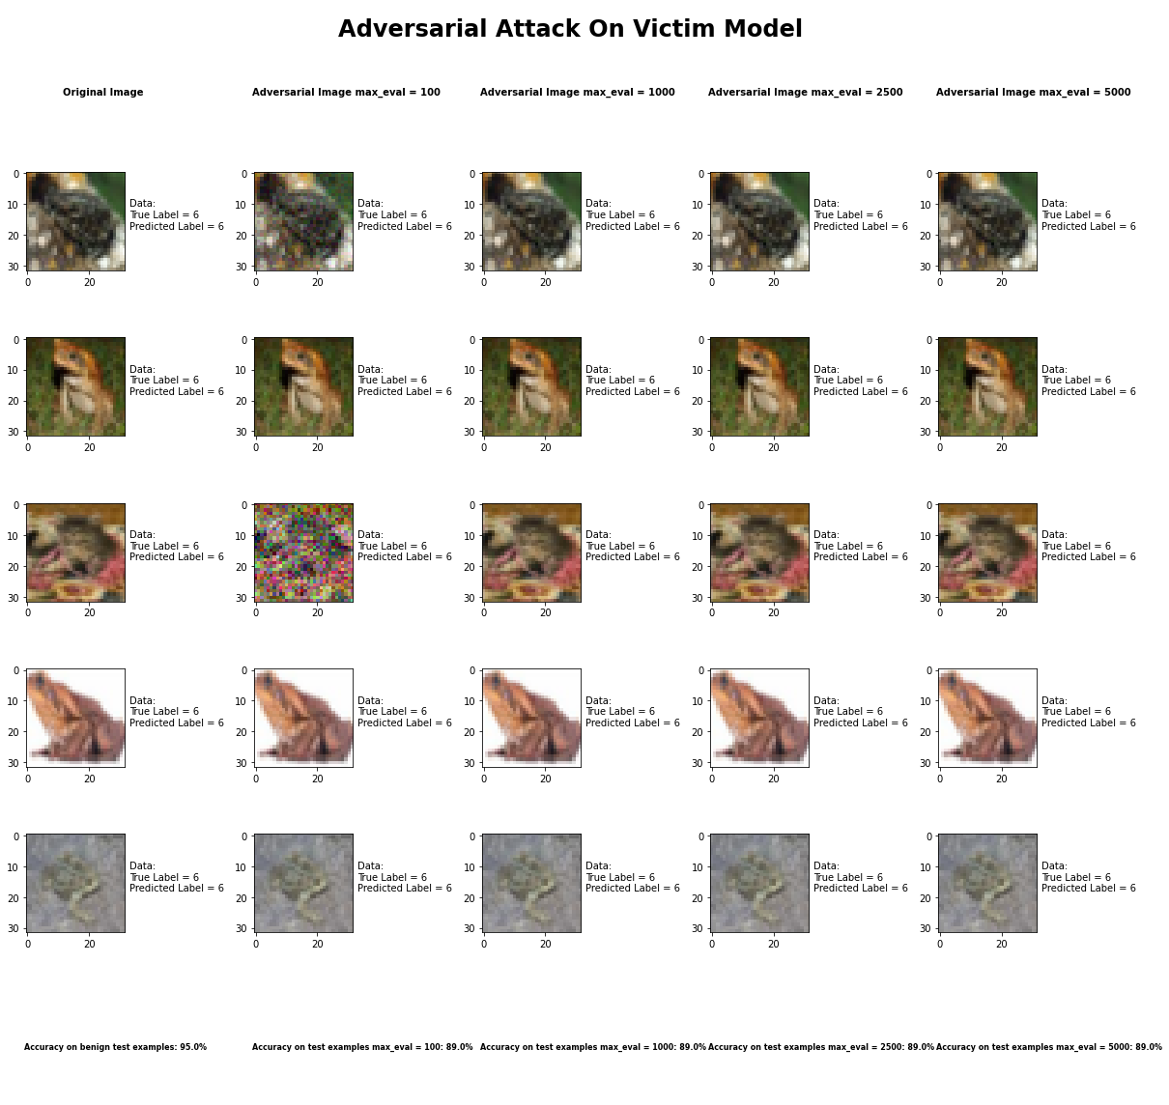

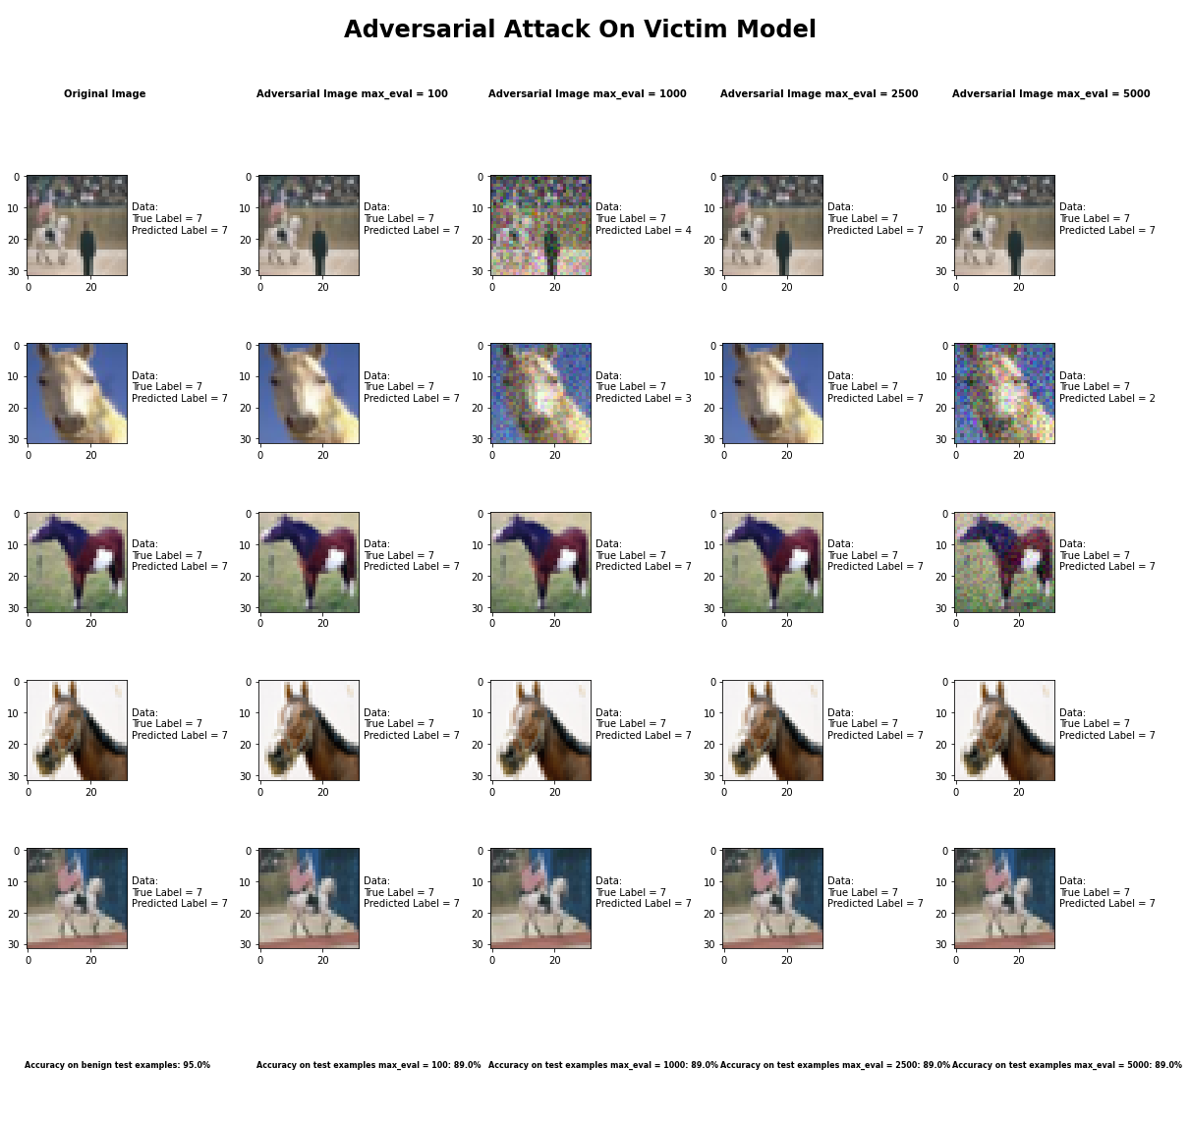

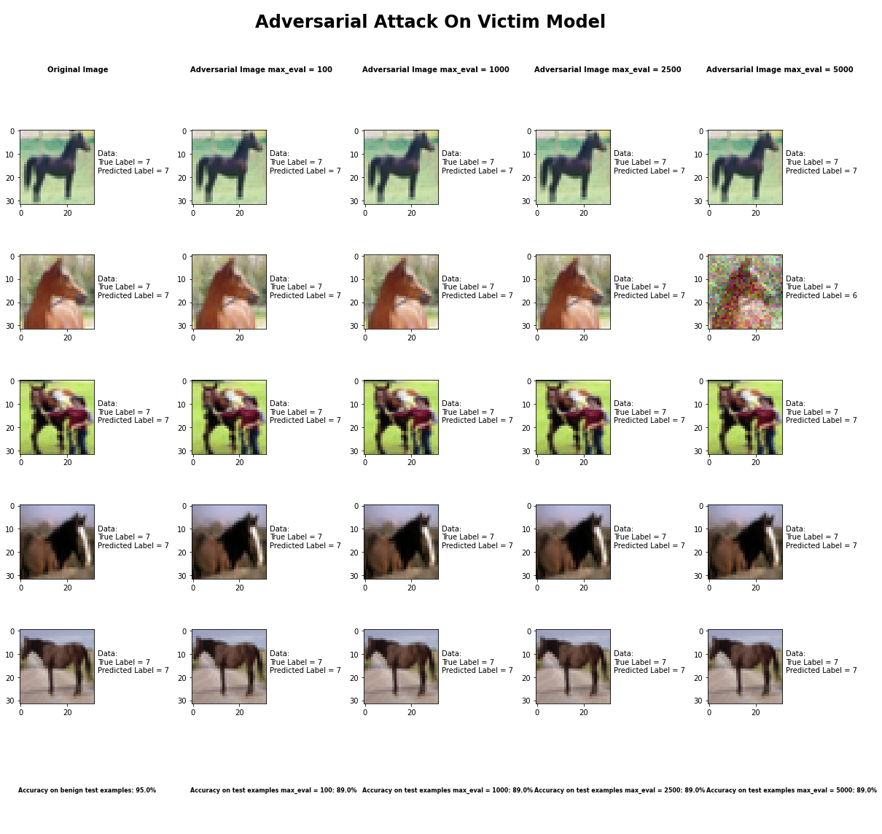

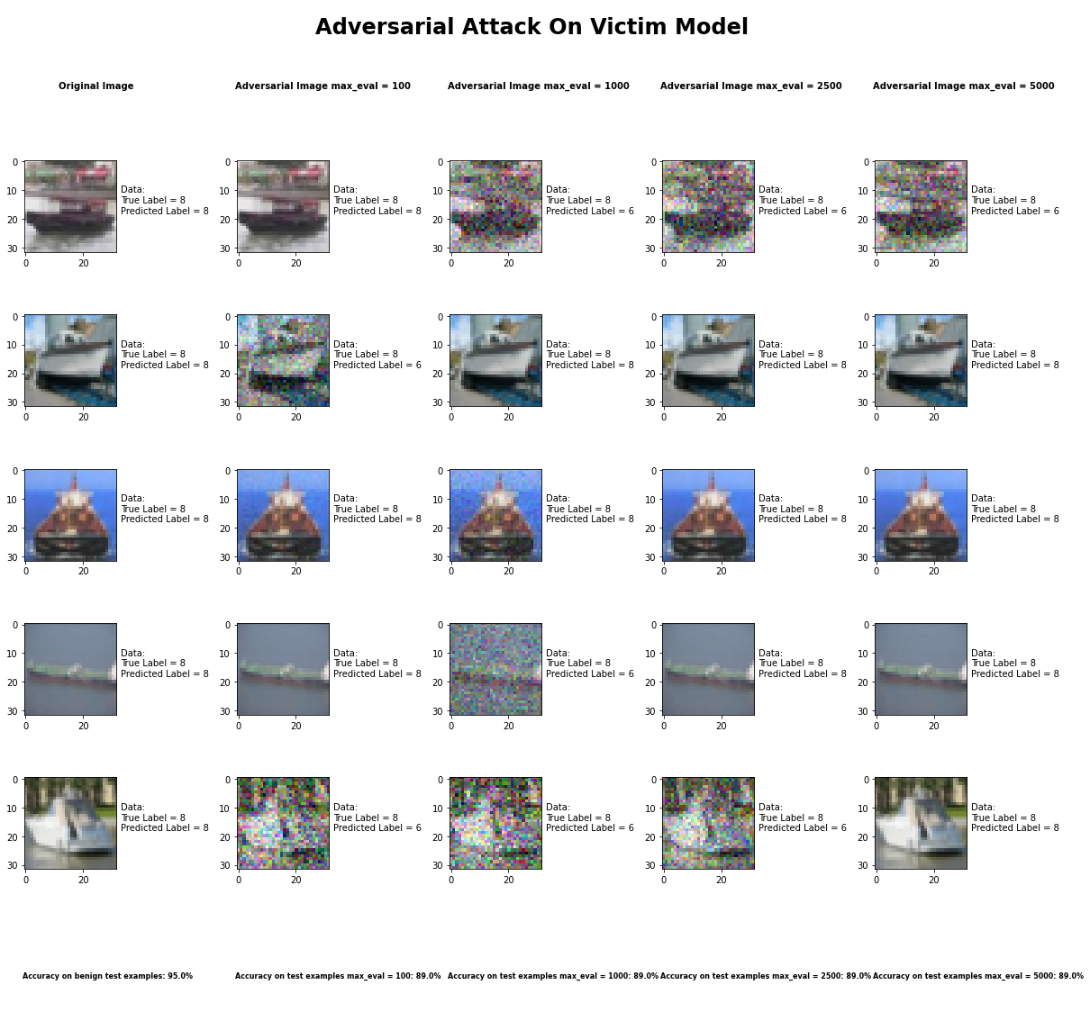

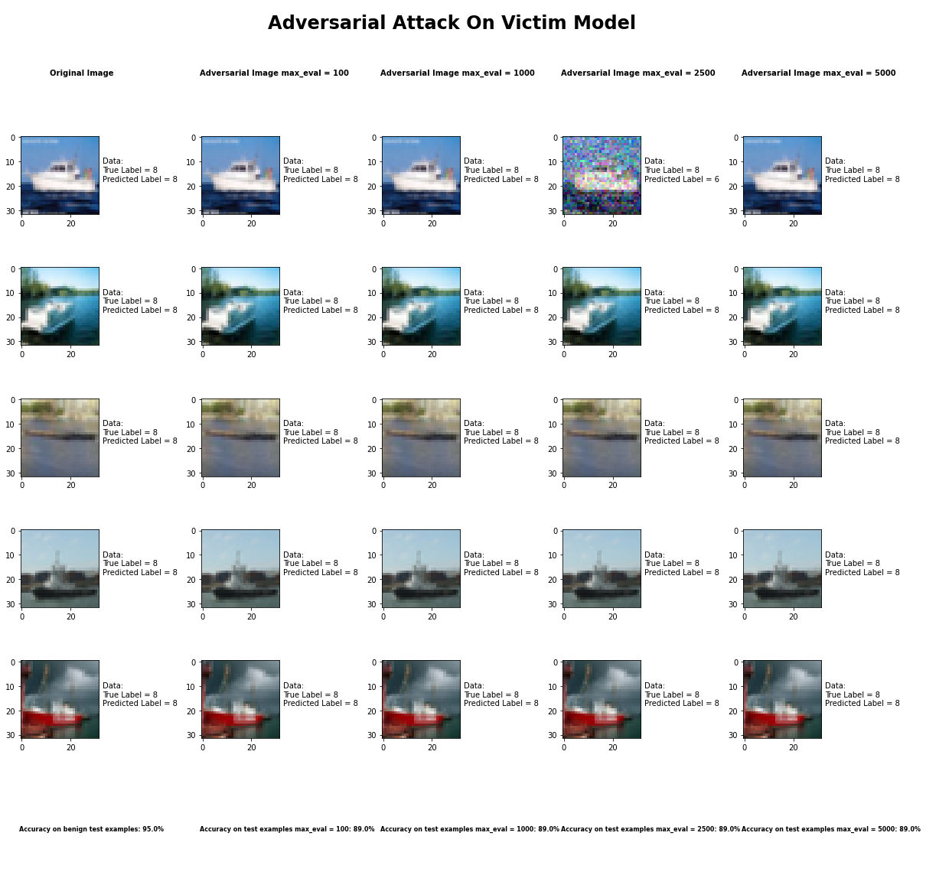

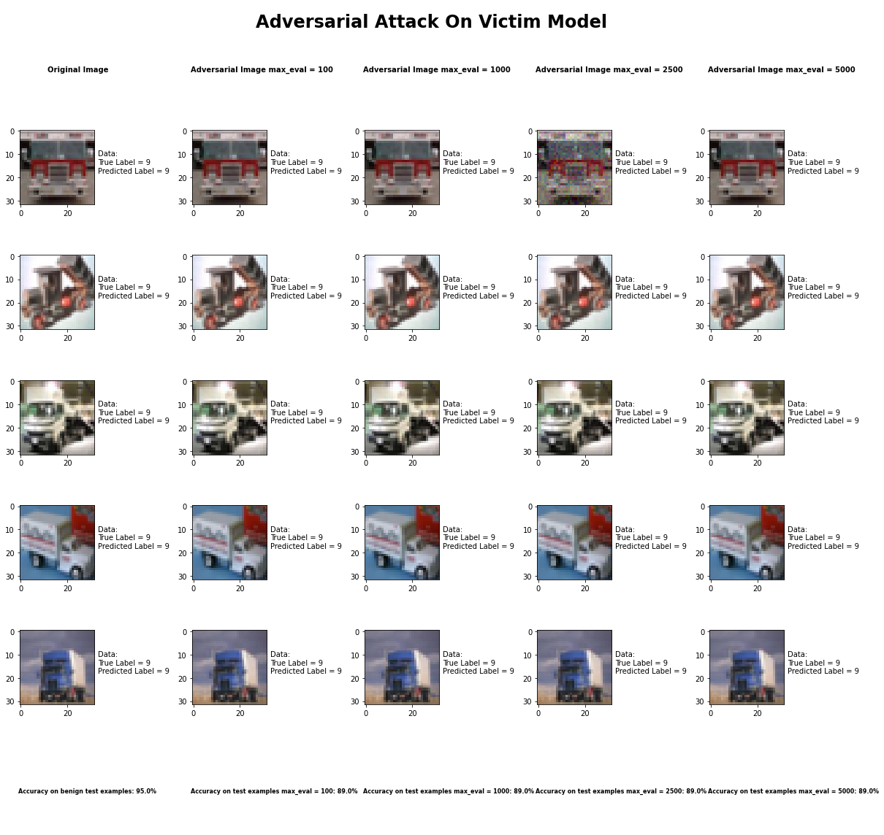

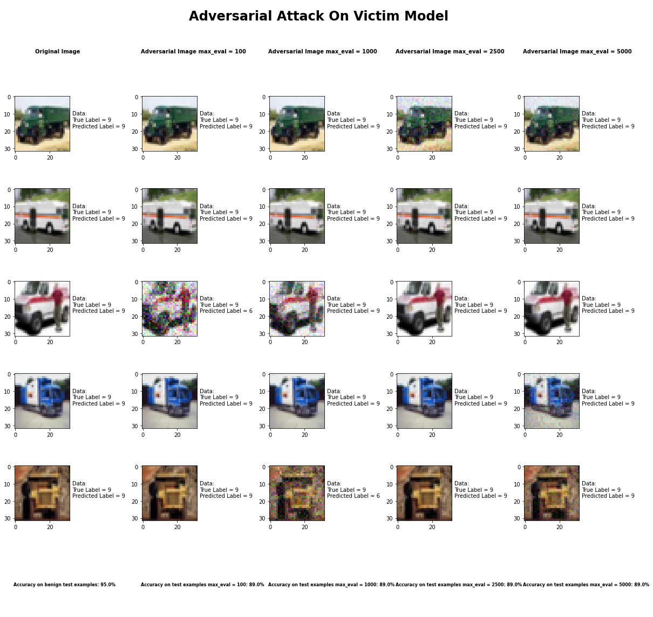

Accuracy on benign test examples: 94.52000000000001%

Average Accuracy on adversarial test examples with max_eval = 100: 89.0%

Average Accuracy on adversarial test examples with max_eval = 1000: 89.0%

Average Accuracy on adversarial test examples with max_eval = 2500: 89.2%

Average Accuracy on adversarial test examples with max_eval = 5000: 88.6%

Classifier with benign example has Airplane recognition average accuracy of = 100%

Hop Skip Jump Method with max_eval = 1 has Airplane recognition average accuracy of = 88%

Hop Skip Jump Method with max_eval = 10 has Airplane recognition average accuracy of = 86%

Hop Skip Jump Method with max_eval = 100 has Airplane recognition average accuracy of = 85%

Hop Skip Jump Method with max_eval = 1000 has Airplane recognition average accuracy of = 82%

Classifier with benign example has Automobile recognition average accuracy of = 100%

Hop Skip Jump Method with max_eval = 1 has Automobile recognition average accuracy of = 89%

Hop Skip Jump Method with max_eval = 10 has Automobile recognition average accuracy of = 91%

Hop Skip Jump Method with max_eval = 100 has Automobile recognition average accuracy of = 93%

Hop Skip Jump Method with max_eval = 1000 has Automobile recognition average accuracy of = 91%

Classifier with benign example has Bird recognition average accuracy of = 100%

Hop Skip Jump Method with max_eval = 1 has Bird recognition average accuracy of = 90%

Hop Skip Jump Method with max_eval = 10 has Bird recognition average accuracy of = 94%

Hop Skip Jump Method with max_eval = 100 has Bird recognition average accuracy of = 90%

Hop Skip Jump Method with max_eval = 1000 has Bird recognition average accuracy of = 94%

Classifier with benign example has Cat recognition average accuracy of = 100%

Hop Skip Jump Method with max_eval = 1 has Cat recognition average accuracy of = 90%

Hop Skip Jump Method with max_eval = 10 has Cat recognition average accuracy of = 90%

Hop Skip Jump Method with max_eval = 100 has Cat recognition average accuracy of = 89%

Hop Skip Jump Method with max_eval = 1000 has Cat recognition average accuracy of = 91%

Classifier with benign example has Deer recognition average accuracy of = 100%

Hop Skip Jump Method with max_eval = 1 has Deer recognition average accuracy of = 93%

Hop Skip Jump Method with max_eval = 10 has Deer recognition average accuracy of = 89%

Hop Skip Jump Method with max_eval = 100 has Deer recognition average accuracy of = 91%

Hop Skip Jump Method with max_eval = 1000 has Deer recognition average accuracy of = 86%

Classifier with benign example has Dog recognition average accuracy of = 100%

Hop Skip Jump Method with max_eval = 1 has Dog recognition average accuracy of = 83%

Hop Skip Jump Method with max_eval = 10 has Dog recognition average accuracy of = 79%

Hop Skip Jump Method with max_eval = 100 has Dog recognition average accuracy of = 84%

Hop Skip Jump Method with max_eval = 1000 has Dog recognition average accuracy of = 74%

Classifier with benign example has Frog recognition average accuracy of = 100%

Hop Skip Jump Method with max_eval = 1 has Frog recognition average accuracy of = 97%

Hop Skip Jump Method with max_eval = 10 has Frog recognition average accuracy of = 99%

Hop Skip Jump Method with max_eval = 100 has Frog recognition average accuracy of = 99%

Hop Skip Jump Method with max_eval = 1000 has Frog recognition average accuracy of = 99%

Classifier with benign example has Horse recognition average accuracy of = 100%

Hop Skip Jump Method with max_eval = 1 has Horse recognition average accuracy of = 87%

Hop Skip Jump Method with max_eval = 10 has Horse recognition average accuracy of = 88%

Hop Skip Jump Method with max_eval = 100 has Horse recognition average accuracy of = 91%

Hop Skip Jump Method with max_eval = 1000 has Horse recognition average accuracy of = 90%

Classifier with benign example has Ship recognition average accuracy of = 100%

Hop Skip Jump Method with max_eval = 1 has Ship recognition average accuracy of = 84%

Hop Skip Jump Method with max_eval = 10 has Ship recognition average accuracy of = 83%

Hop Skip Jump Method with max_eval = 100 has Ship recognition average accuracy of = 80%

Hop Skip Jump Method with max_eval = 1000 has Ship recognition average accuracy of = 89%

Classifier with benign example has Truck recognition average accuracy of = 100%

Hop Skip Jump Method with max_eval = 1 has Truck recognition average accuracy of = 89%

Hop Skip Jump Method with max_eval = 10 has Truck recognition average accuracy of = 91%

Hop Skip Jump Method with max_eval = 100 has Truck recognition average accuracy of = 90%

Hop Skip Jump Method with max_eval = 1000 has Truck recognition average accuracy of = 90%

## Elastic Net Method



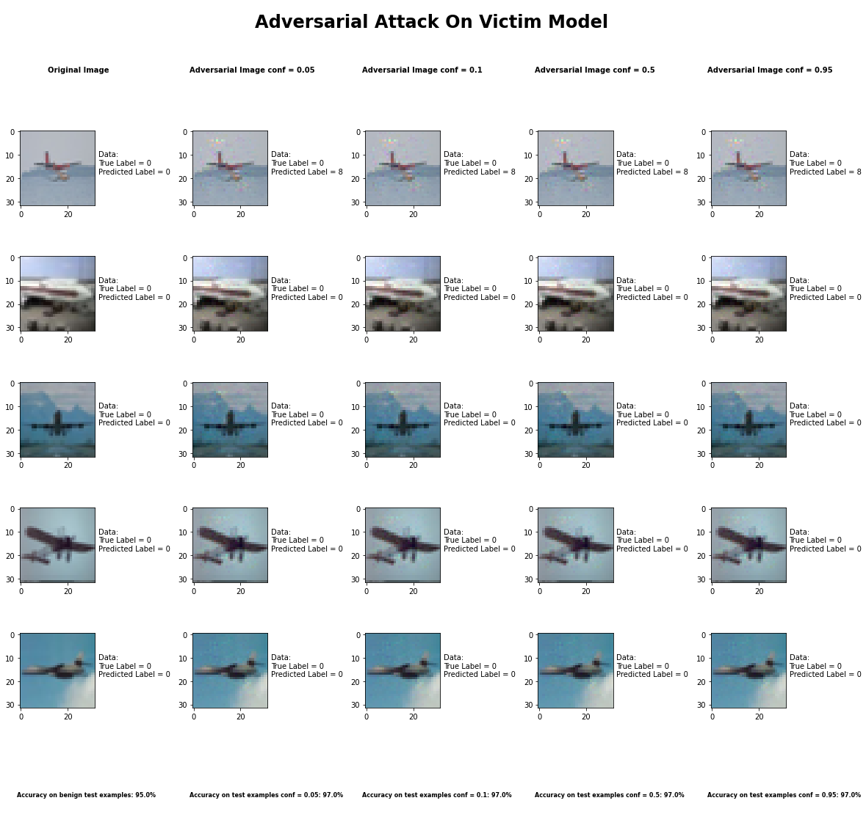

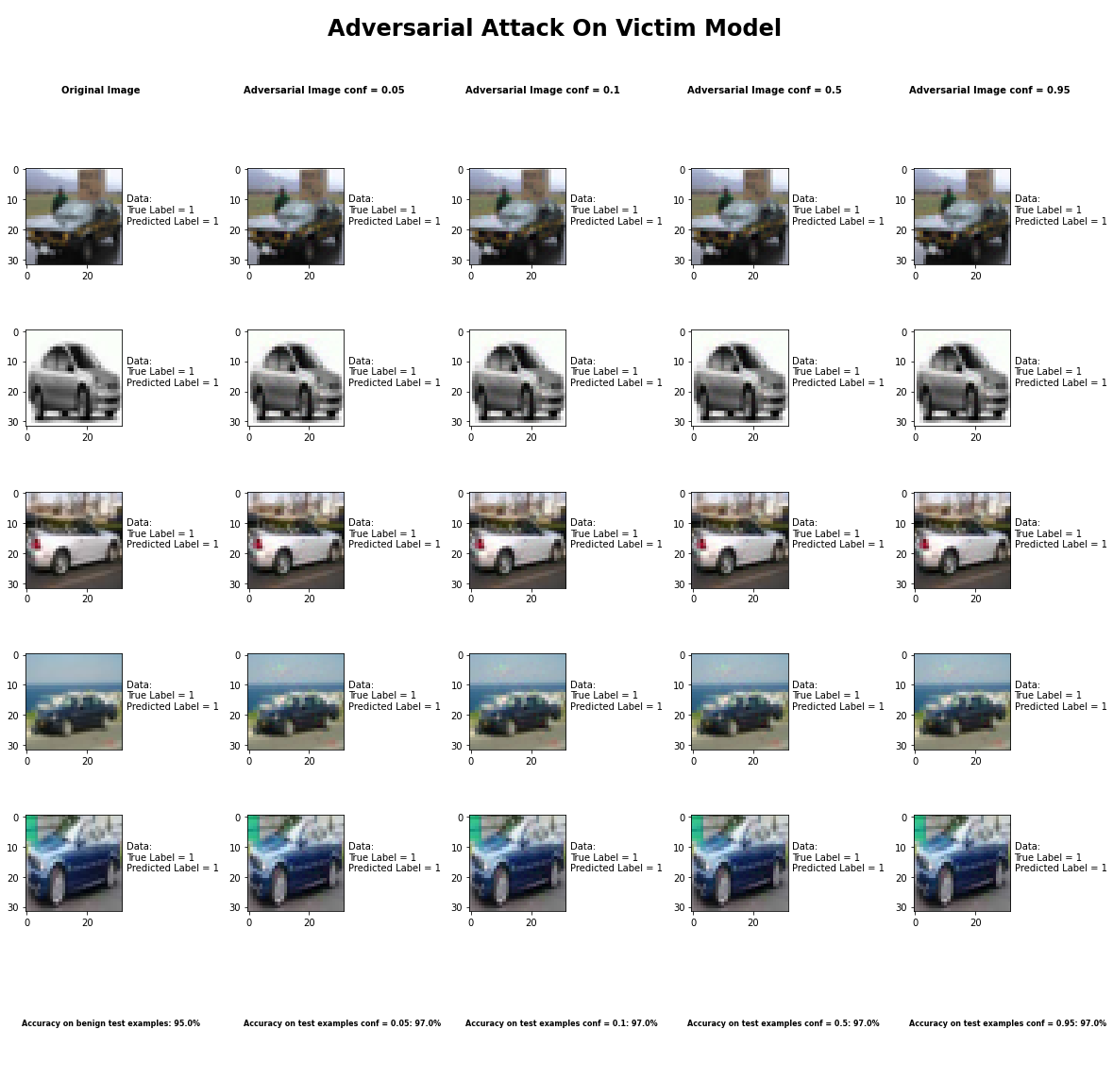

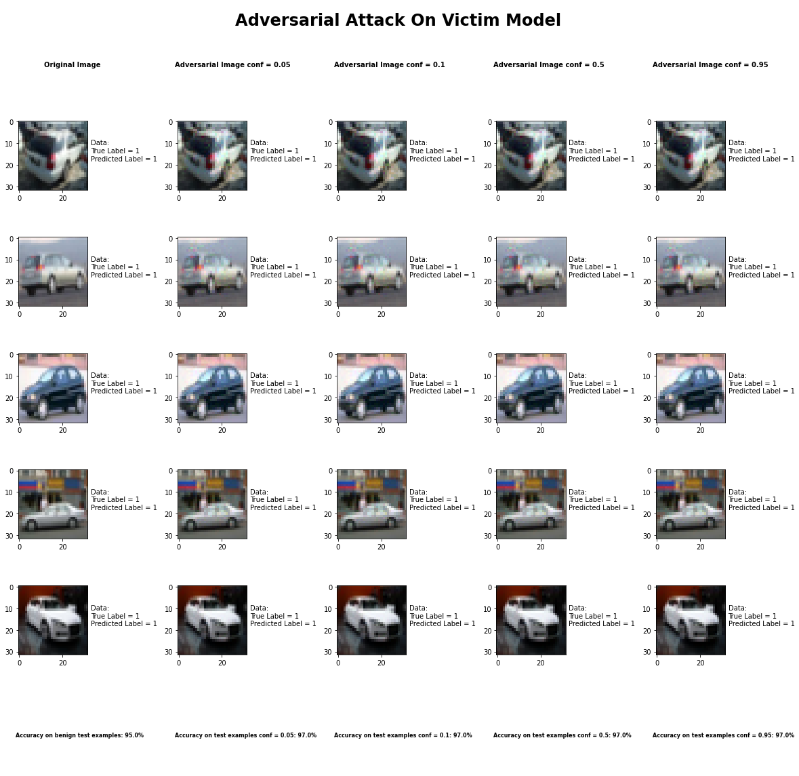

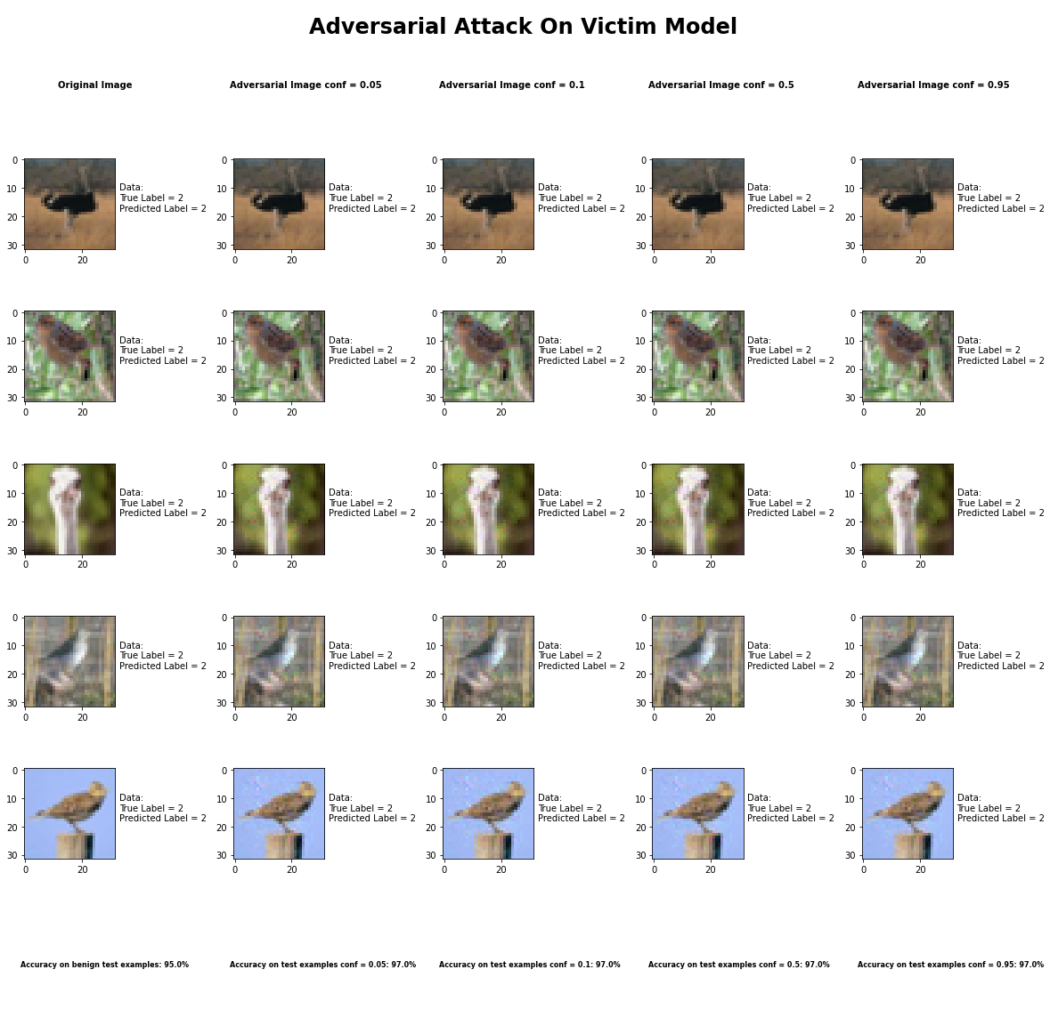

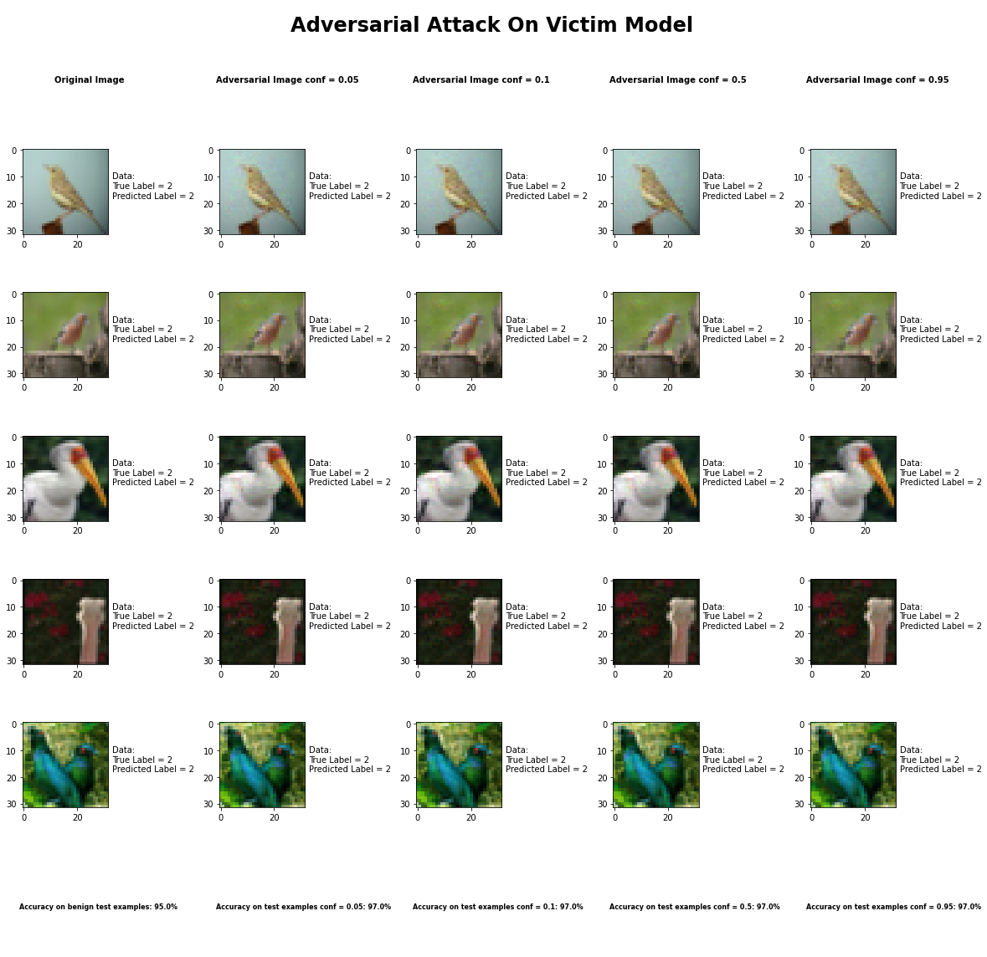

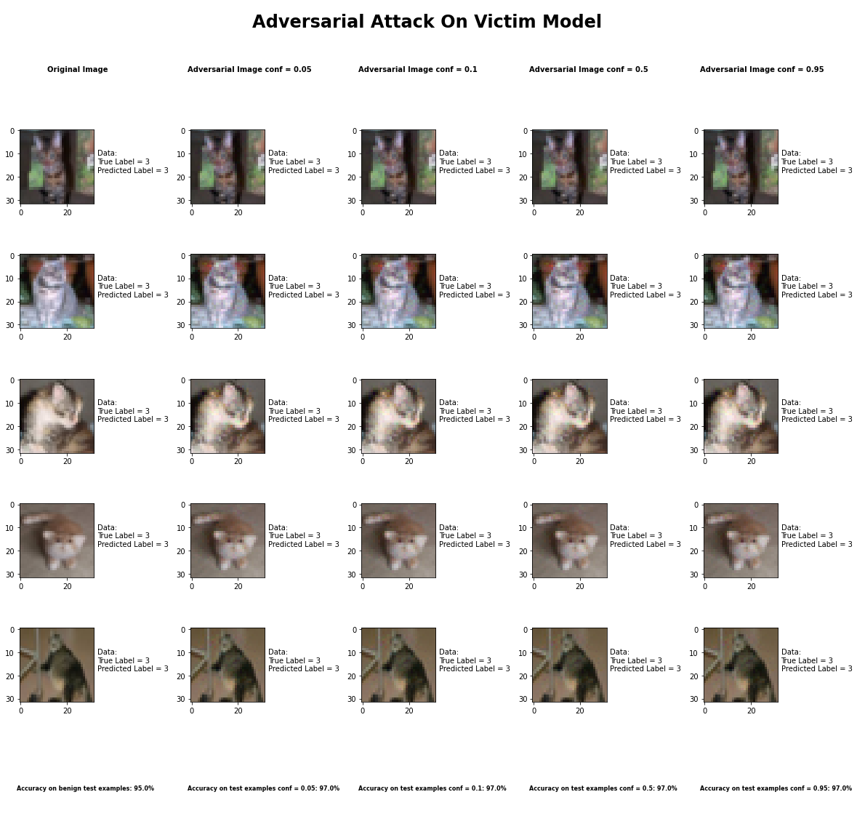

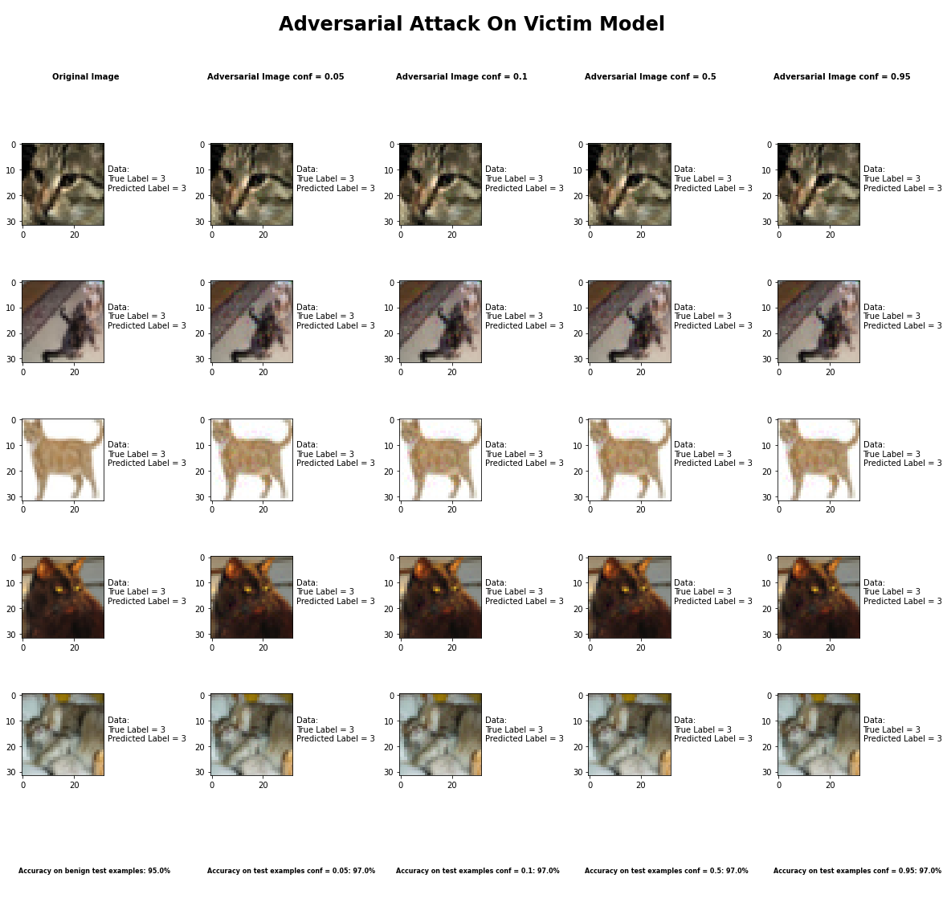

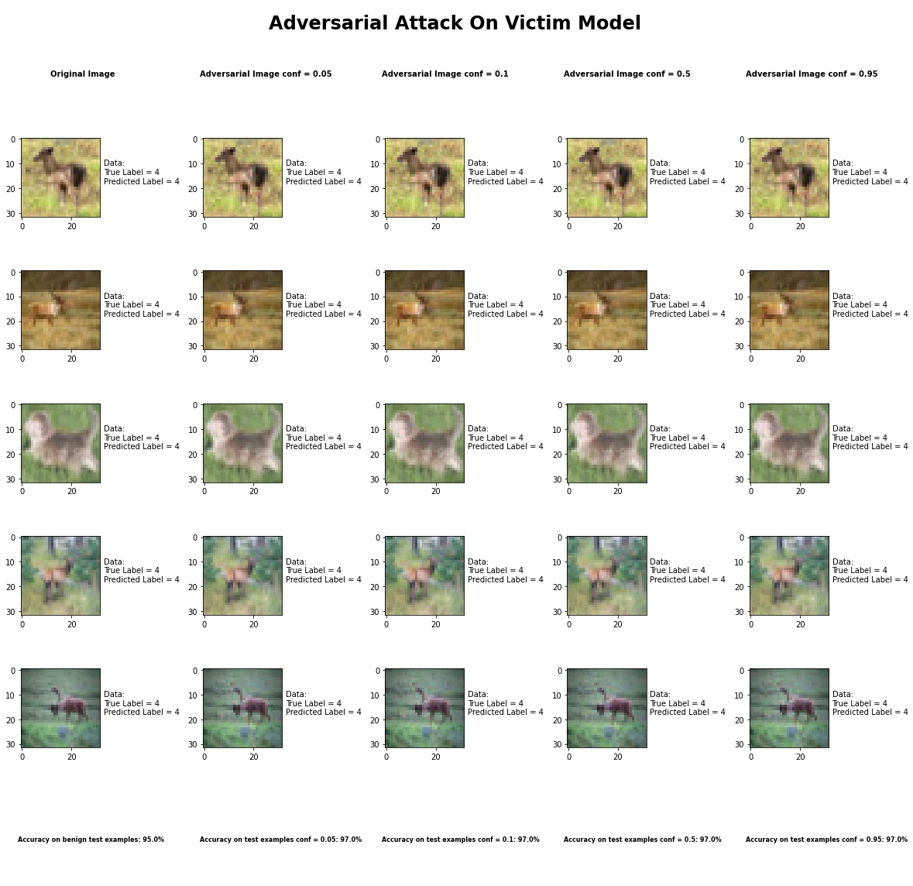

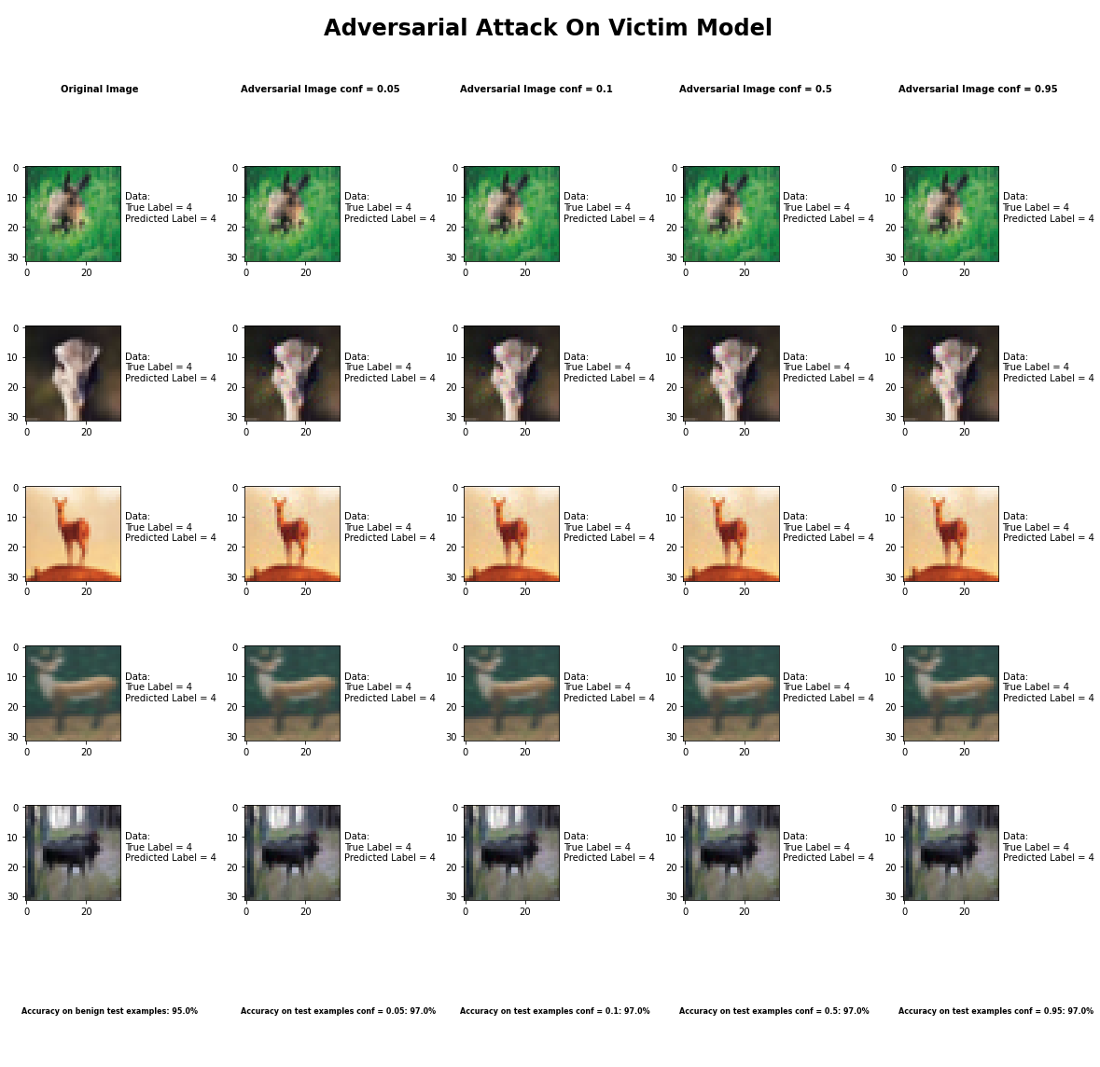

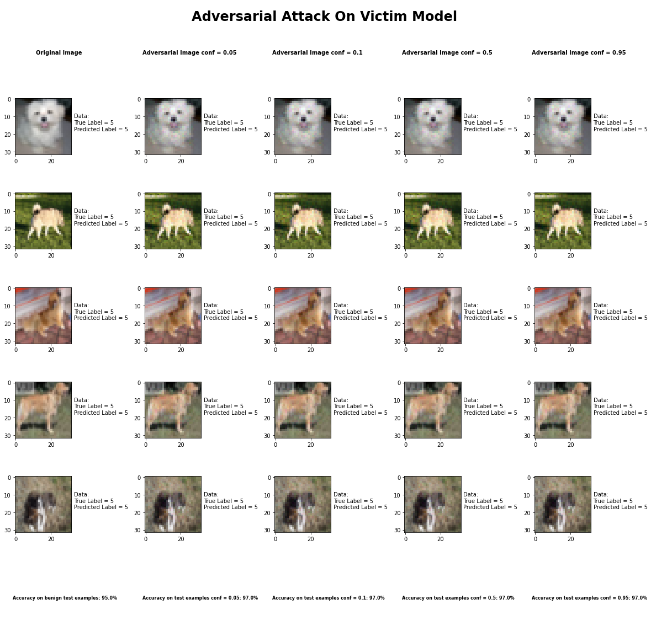

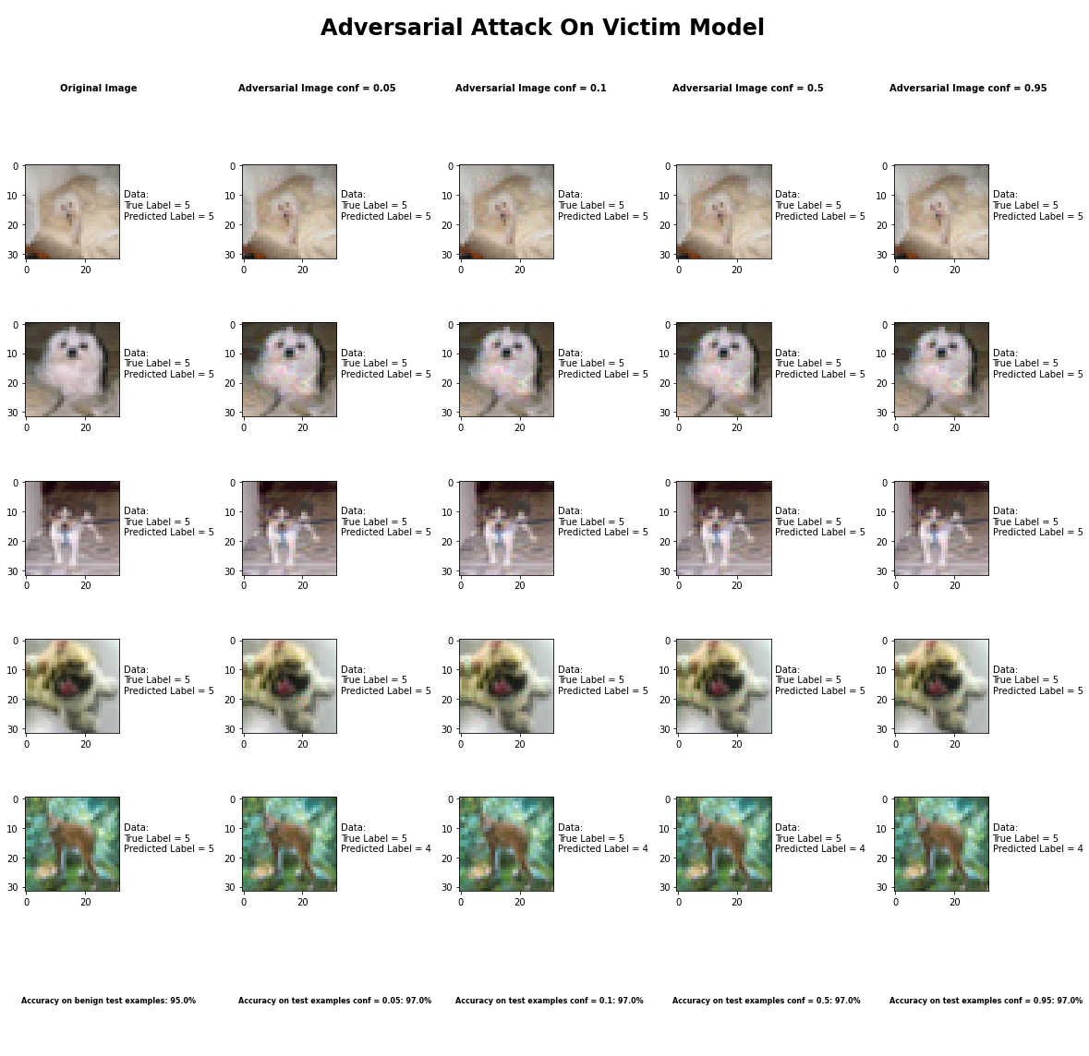

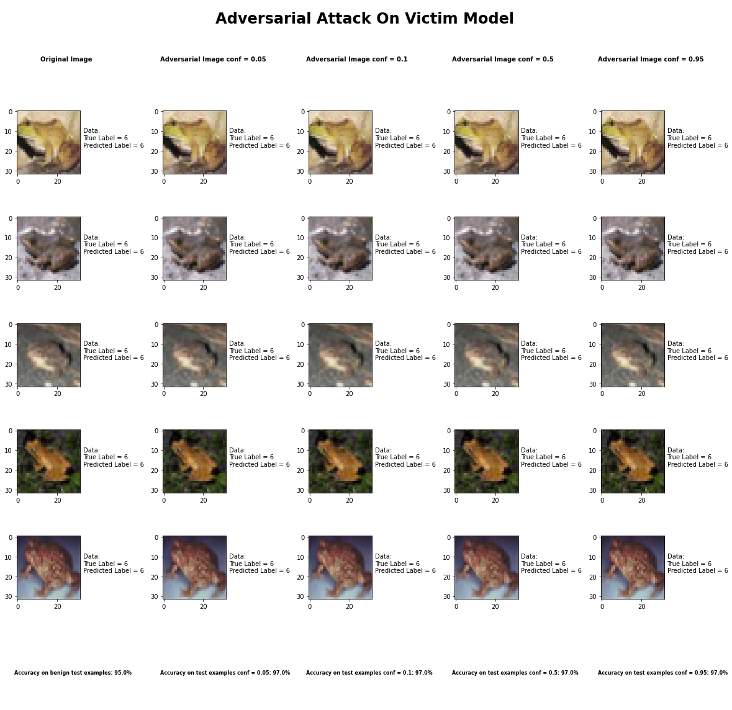

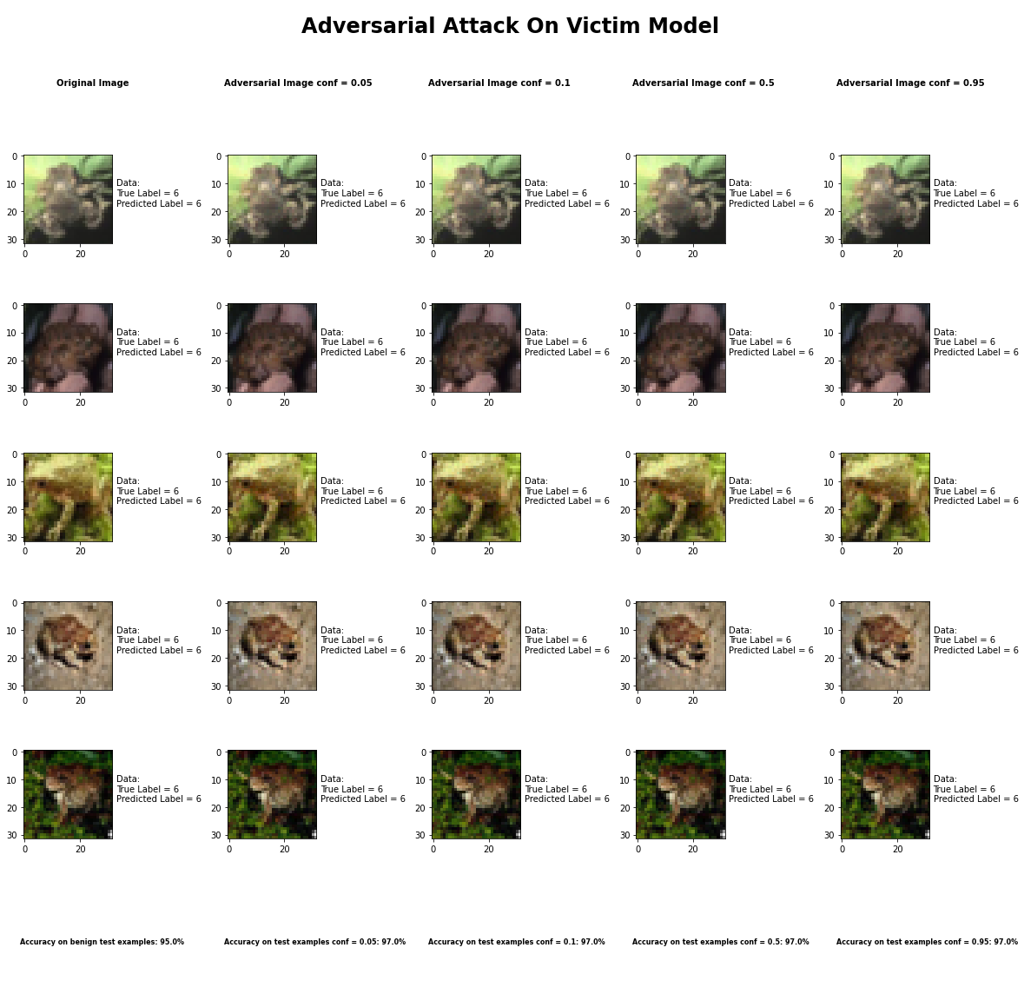

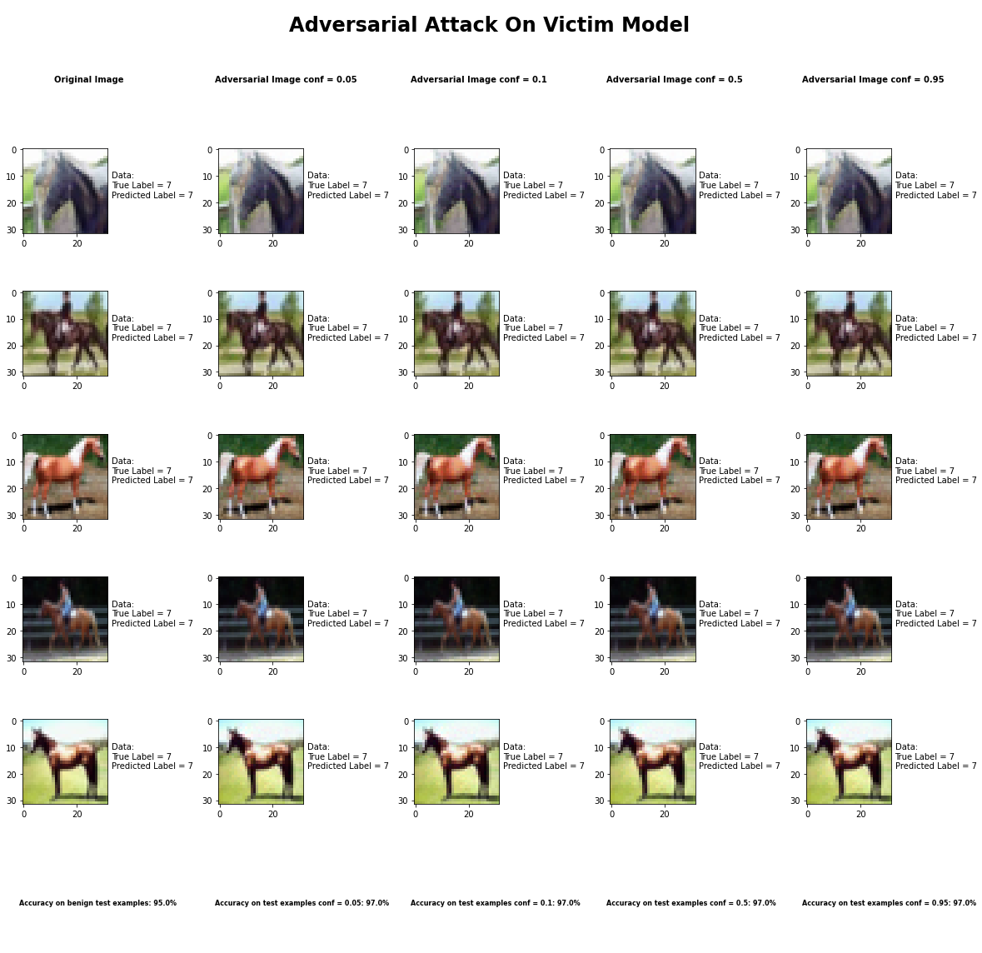

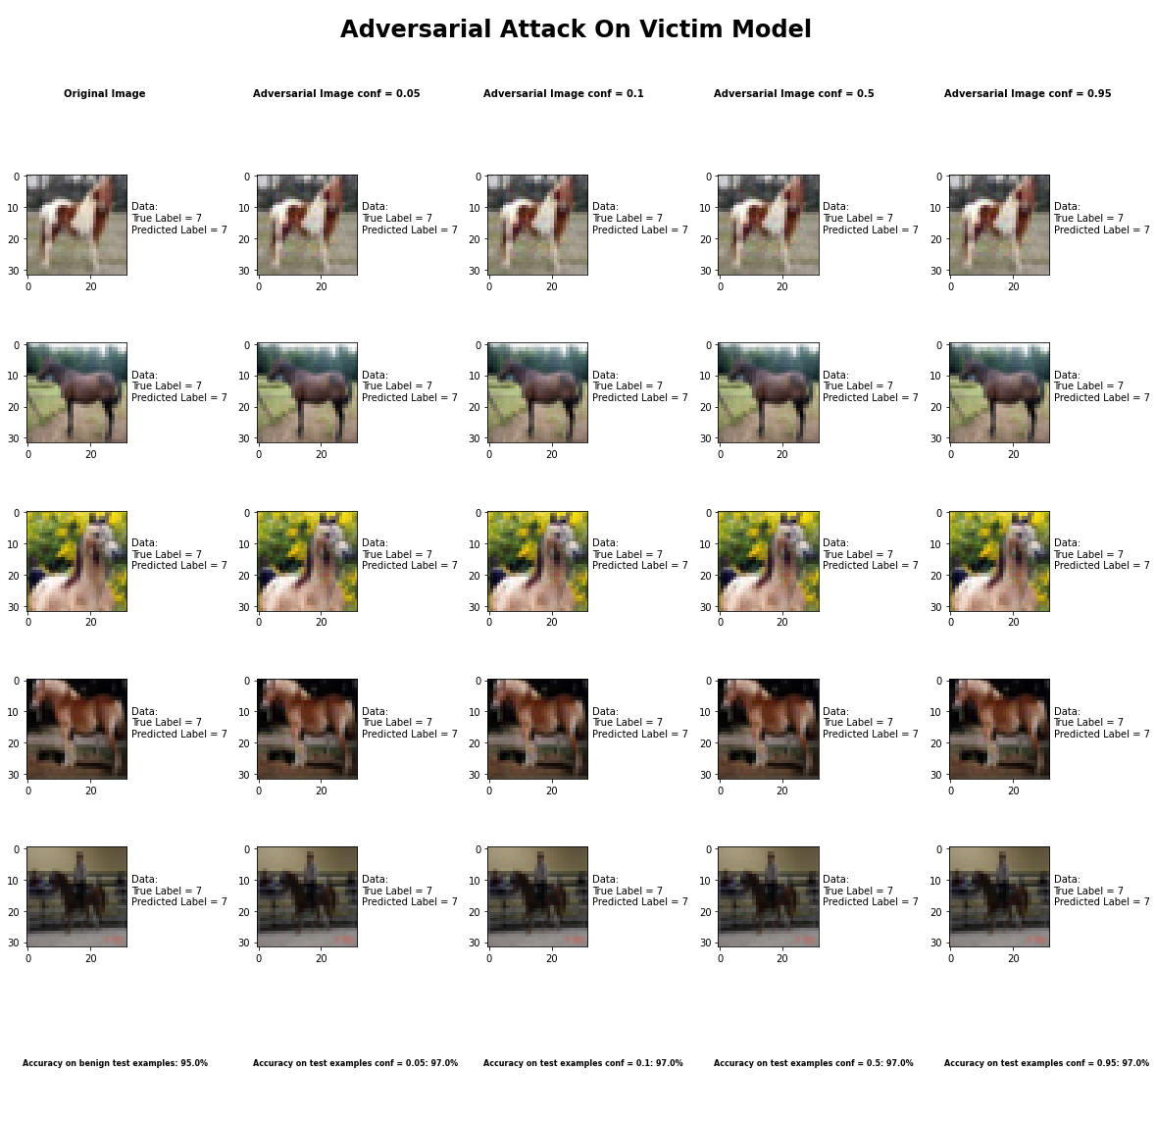



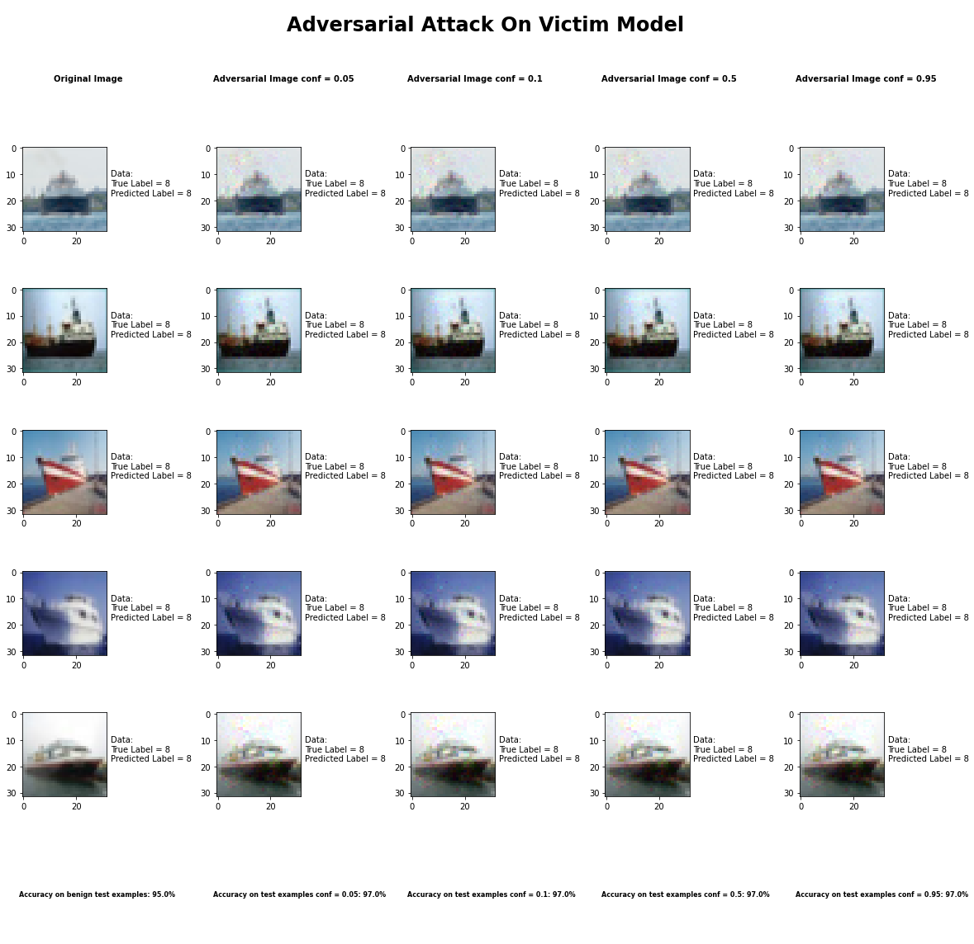

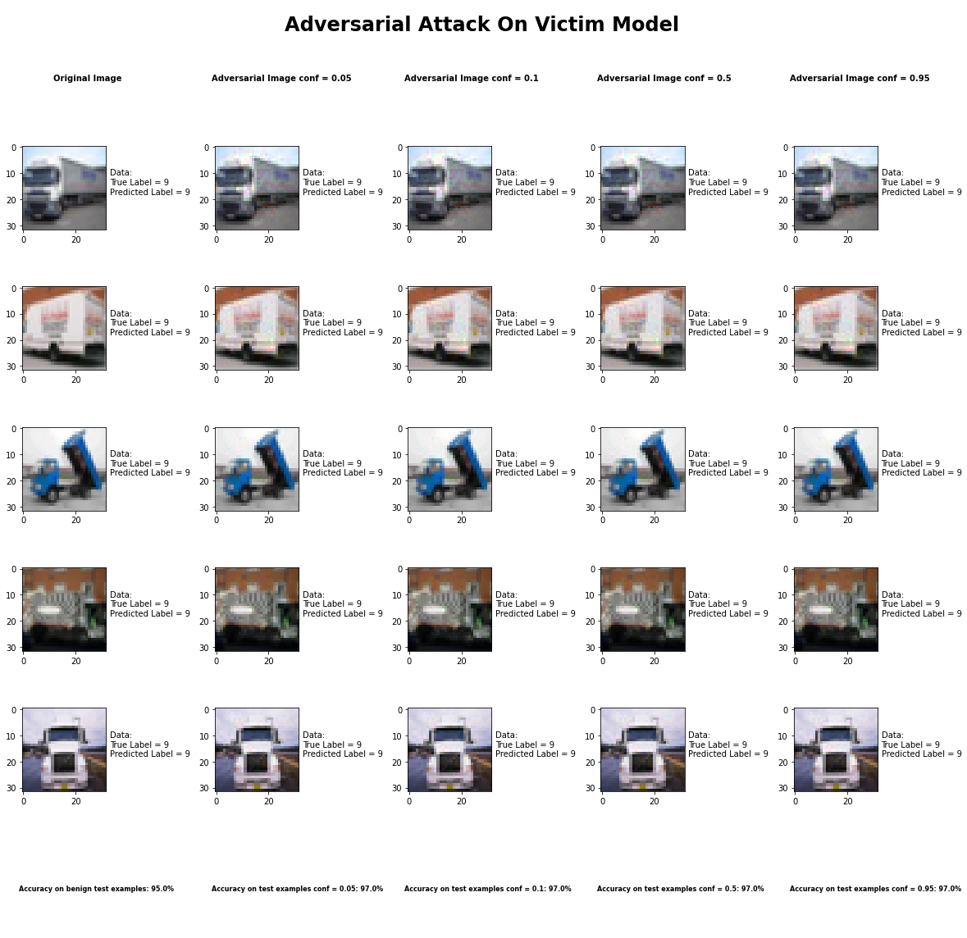

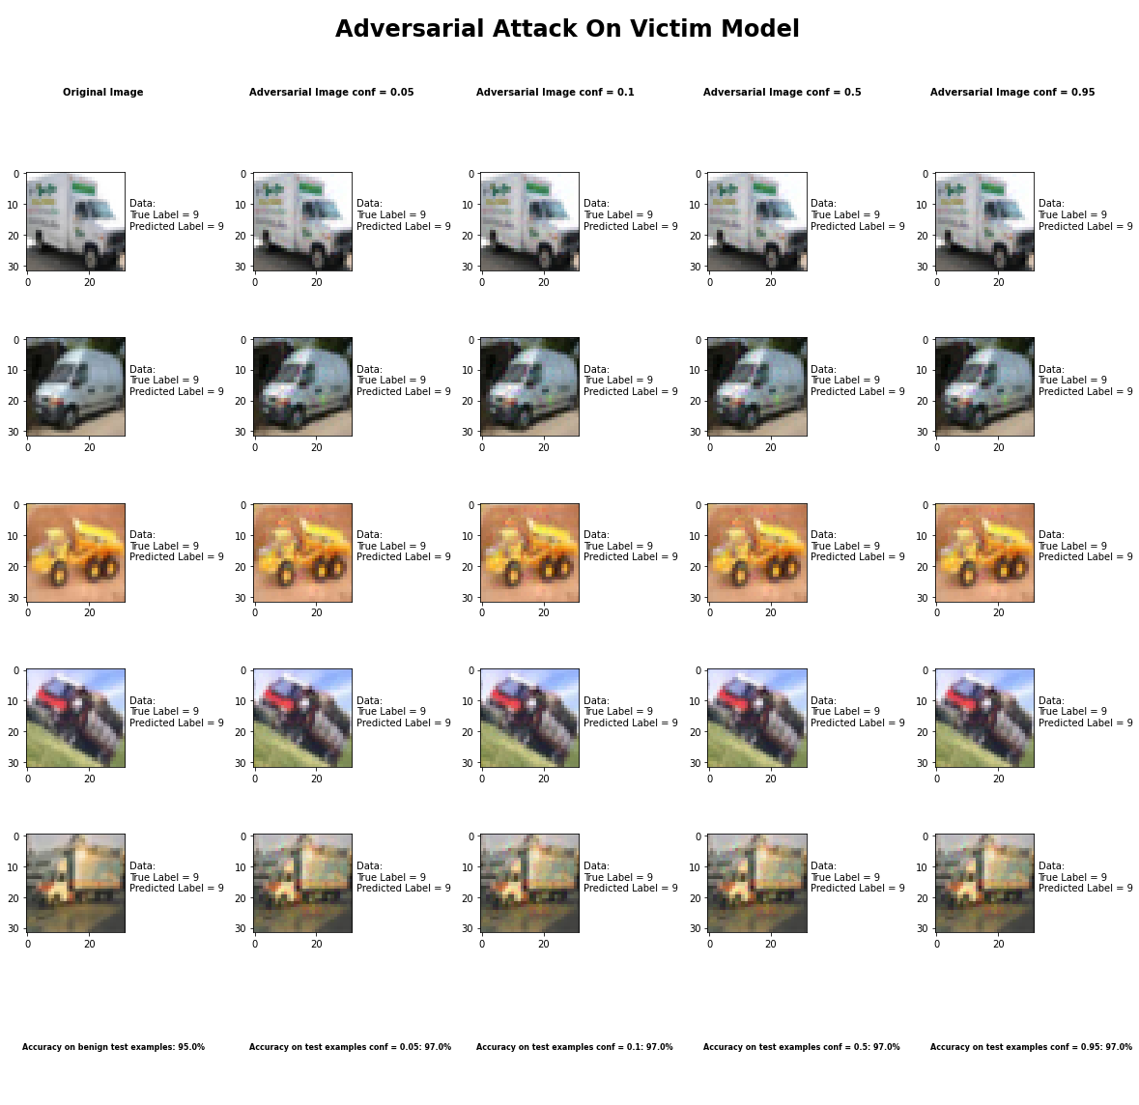

Accuracy on benign test examples: 94.52000000000001%

Average Accuracy on adversarial test examples with conf = 0.05: 96.6%

Average Accuracy on adversarial test examples with conf = 0.1: 96.6%

Average Accuracy on adversarial test examples with conf = 0.5: 96.6%

Average Accuracy on adversarial test examples with conf = 0.95: 96.6%

Classifier with benign example has Airplane recognition average accuracy of = 100%

Elastic Net Method with conf = 0.05 has Airplane recognition average accuracy of = 98%

Elastic Net Method with conf = 0.10 has Airplane recognition average accuracy of = 98%

Elastic Net Method with conf = 0.50 has Airplane recognition average accuracy of = 98%

Elastic Net Method with conf = 0.95 has Airplane recognition average accuracy of = 98%

Classifier with benign example has Automobile recognition average accuracy of = 100%

Elastic Net Method with conf = 0.05 has Automobile recognition average accuracy of = 95%

Elastic Net Method with conf = 0.10 has Automobile recognition average accuracy of = 95%

Elastic Net Method with conf = 0.50 has Automobile recognition average accuracy of = 95%

Elastic Net Method with conf = 0.95 has Automobile recognition average accuracy of = 95%

Classifier with benign example has Bird recognition average accuracy of = 100%

Elastic Net Method with conf = 0.05 has Bird recognition average accuracy of = 100%

Elastic Net Method with conf = 0.10 has Bird recognition average accuracy of = 100%

Elastic Net Method with conf = 0.50 has Bird recognition average accuracy of = 100%

Elastic Net Method with conf = 0.95 has Bird recognition average accuracy of = 100%

Classifier with benign example has Cat recognition average accuracy of = 100%

Elastic Net Method with conf = 0.05 has Cat recognition average accuracy of = 94%

Elastic Net Method with conf = 0.10 has Cat recognition average accuracy of = 94%

Elastic Net Method with conf = 0.50 has Cat recognition average accuracy of = 94%

Elastic Net Method with conf = 0.95 has Cat recognition average accuracy of = 94%

Classifier with benign example has Deer recognition average accuracy of = 100%

Elastic Net Method with conf = 0.05 has Deer recognition average accuracy of = 93%

Elastic Net Method with conf = 0.10 has Deer recognition average accuracy of = 93%

Elastic Net Method with conf = 0.50 has Deer recognition average accuracy of = 93%

Elastic Net Method with conf = 0.95 has Deer recognition average accuracy of = 93%

Classifier with benign example has Dog recognition average accuracy of = 100%

Elastic Net Method with conf = 0.05 has Dog recognition average accuracy of = 91%

Elastic Net Method with conf = 0.10 has Dog recognition average accuracy of = 91%

Elastic Net Method with conf = 0.50 has Dog recognition average accuracy of = 91%

Elastic Net Method with conf = 0.95 has Dog recognition average accuracy of = 91%

Classifier with benign example has Frog recognition average accuracy of = 100%

Elastic Net Method with conf = 0.05 has Frog recognition average accuracy of = 99%

Elastic Net Method with conf = 0.10 has Frog recognition average accuracy of = 99%

Elastic Net Method with conf = 0.50 has Frog recognition average accuracy of = 99%

Elastic Net Method with conf = 0.95 has Frog recognition average accuracy of = 99%

Classifier with benign example has Horse recognition average accuracy of = 100%

Elastic Net Method with conf = 0.05 has Horse recognition average accuracy of = 98%

Elastic Net Method with conf = 0.10 has Horse recognition average accuracy of = 98%

Elastic Net Method with conf = 0.50 has Horse recognition average accuracy of = 98%

Elastic Net Method with conf = 0.95 has Horse recognition average accuracy of = 98%

Classifier with benign example has Ship recognition average accuracy of = 100%

Elastic Net Method with conf = 0.05 has Ship recognition average accuracy of = 100%

Elastic Net Method with conf = 0.10 has Ship recognition average accuracy of = 100%

Elastic Net Method with conf = 0.50 has Ship recognition average accuracy of = 100%

Elastic Net Method with conf = 0.95 has Ship recognition average accuracy of = 100%

Classifier with benign example has Truck recognition average accuracy of = 100%

Elastic Net Method with conf = 0.05 has Truck recognition average accuracy of = 98%

Elastic Net Method with conf = 0.10 has Truck recognition average accuracy of = 98%

Elastic Net Method with conf = 0.50 has Truck recognition average accuracy of = 98%

Elastic Net Method with conf = 0.95 has Truck recognition average accuracy of = 98%

## Adversarial Patch Attack



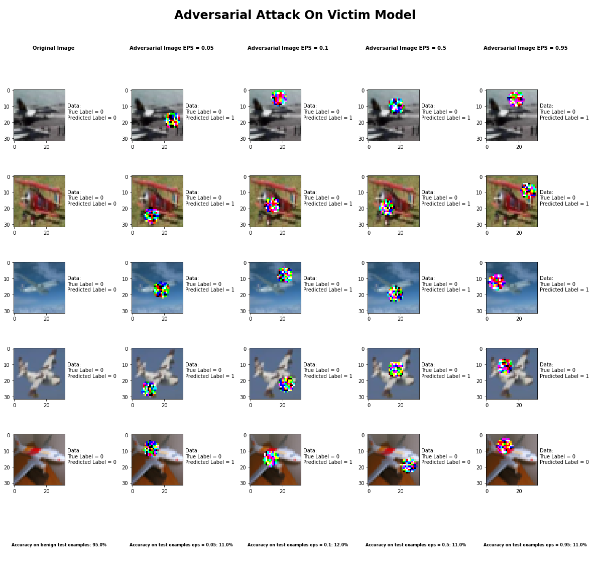

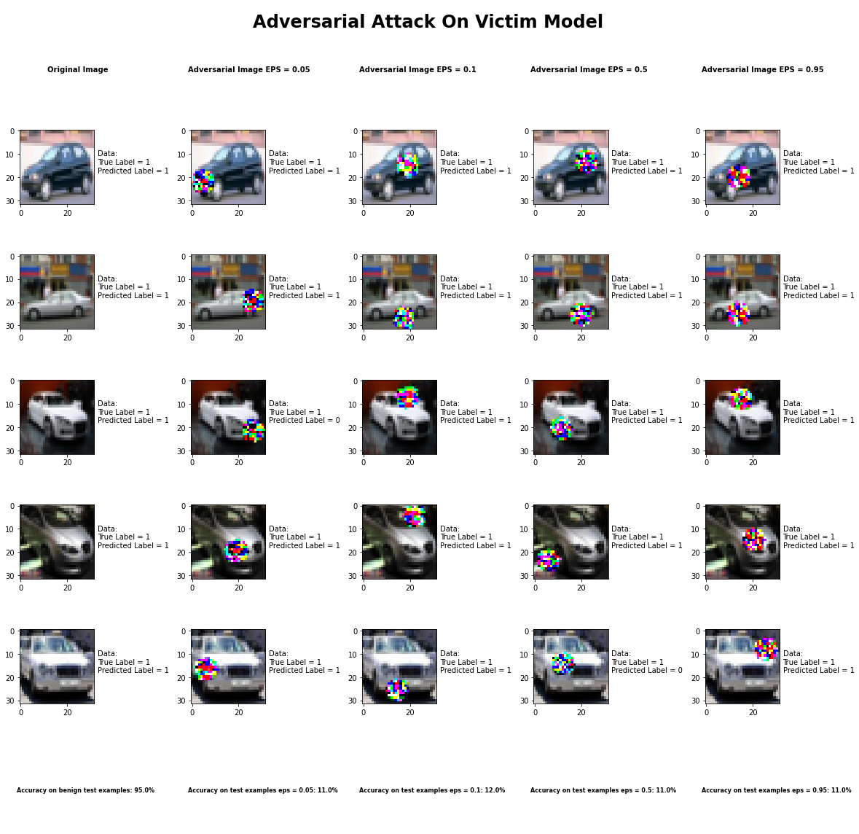

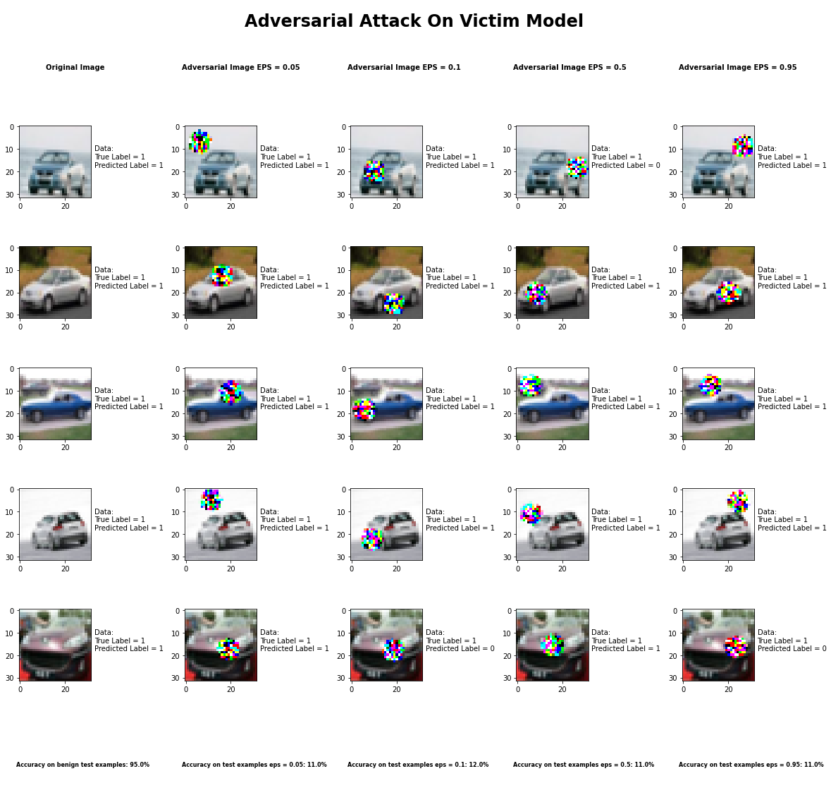

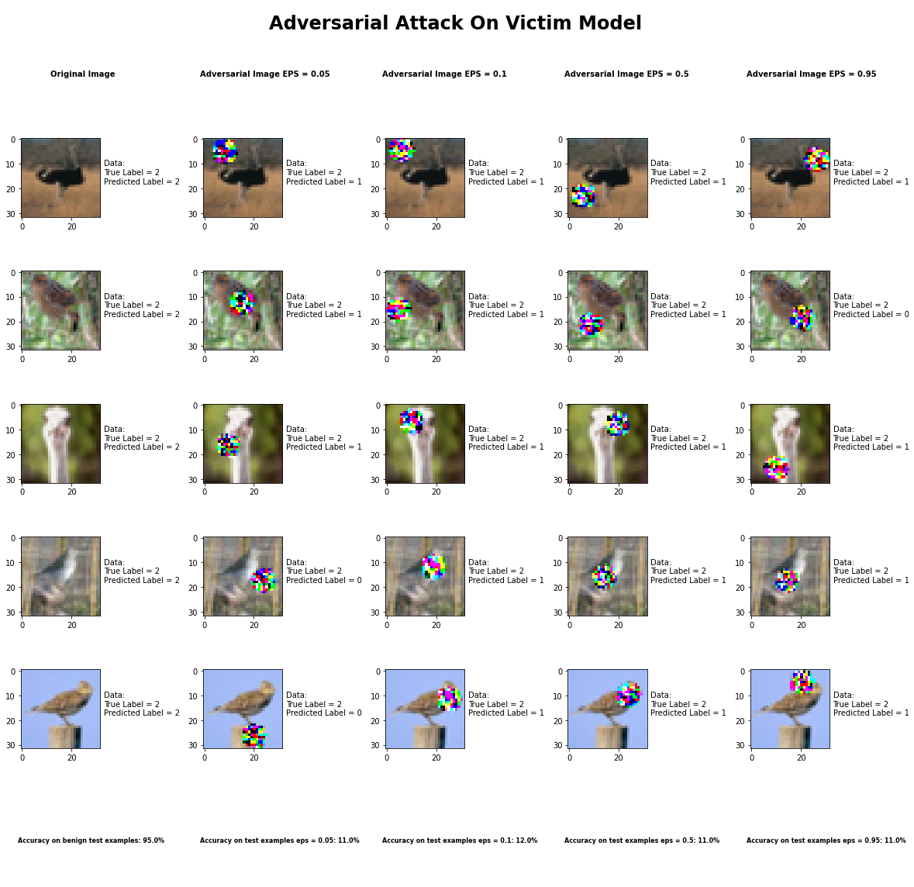

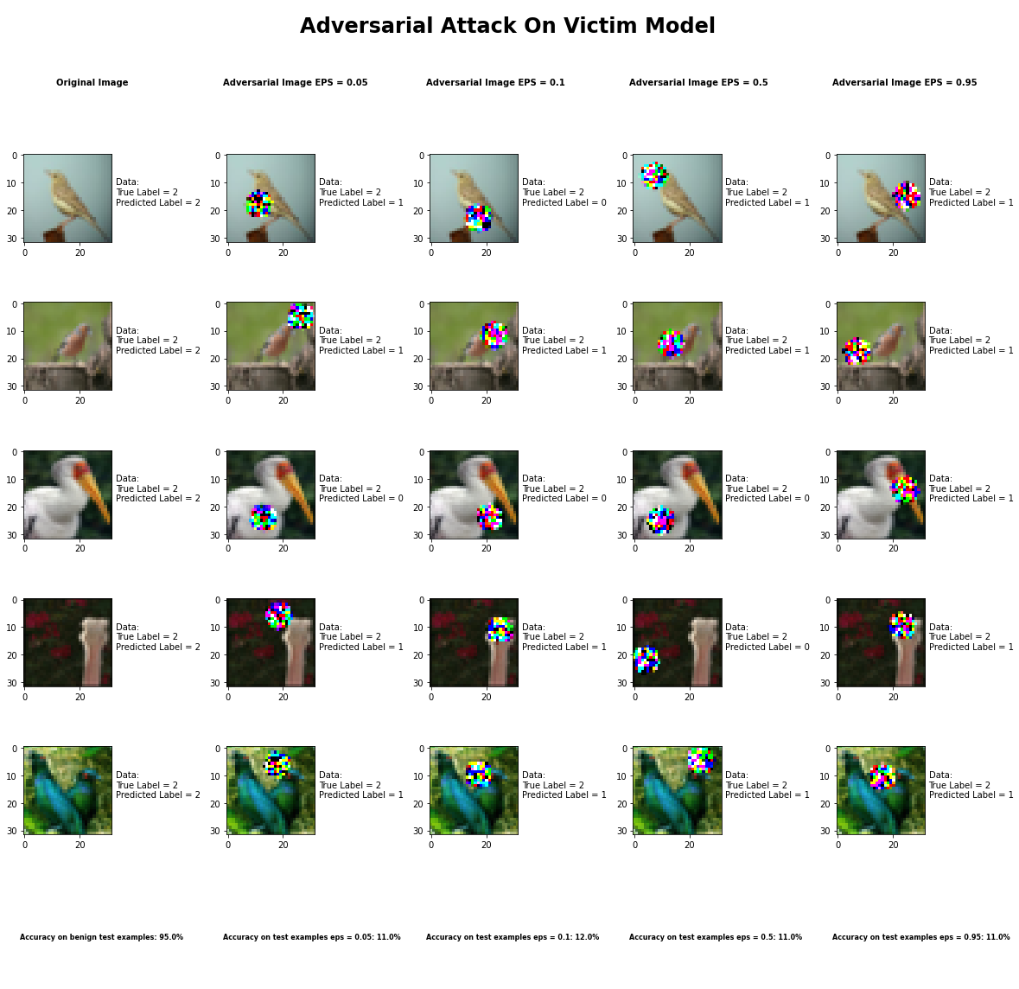

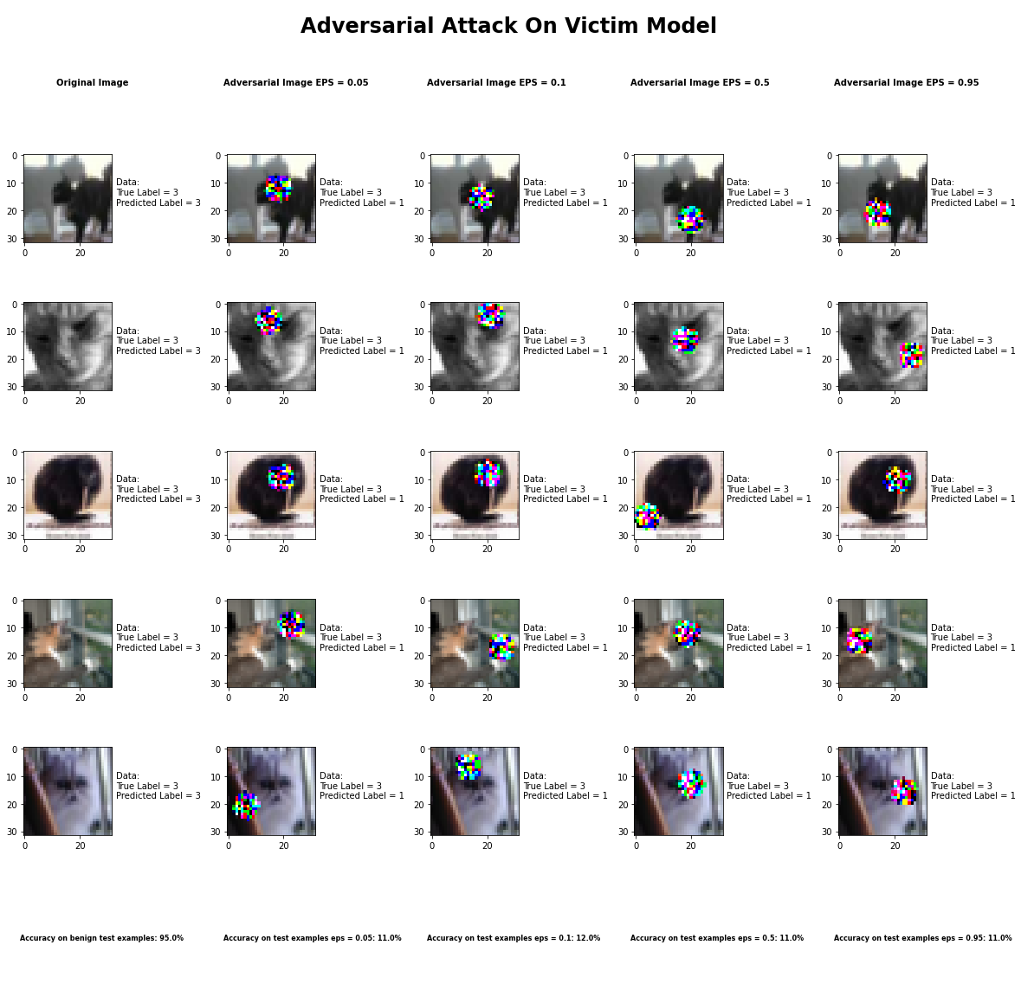

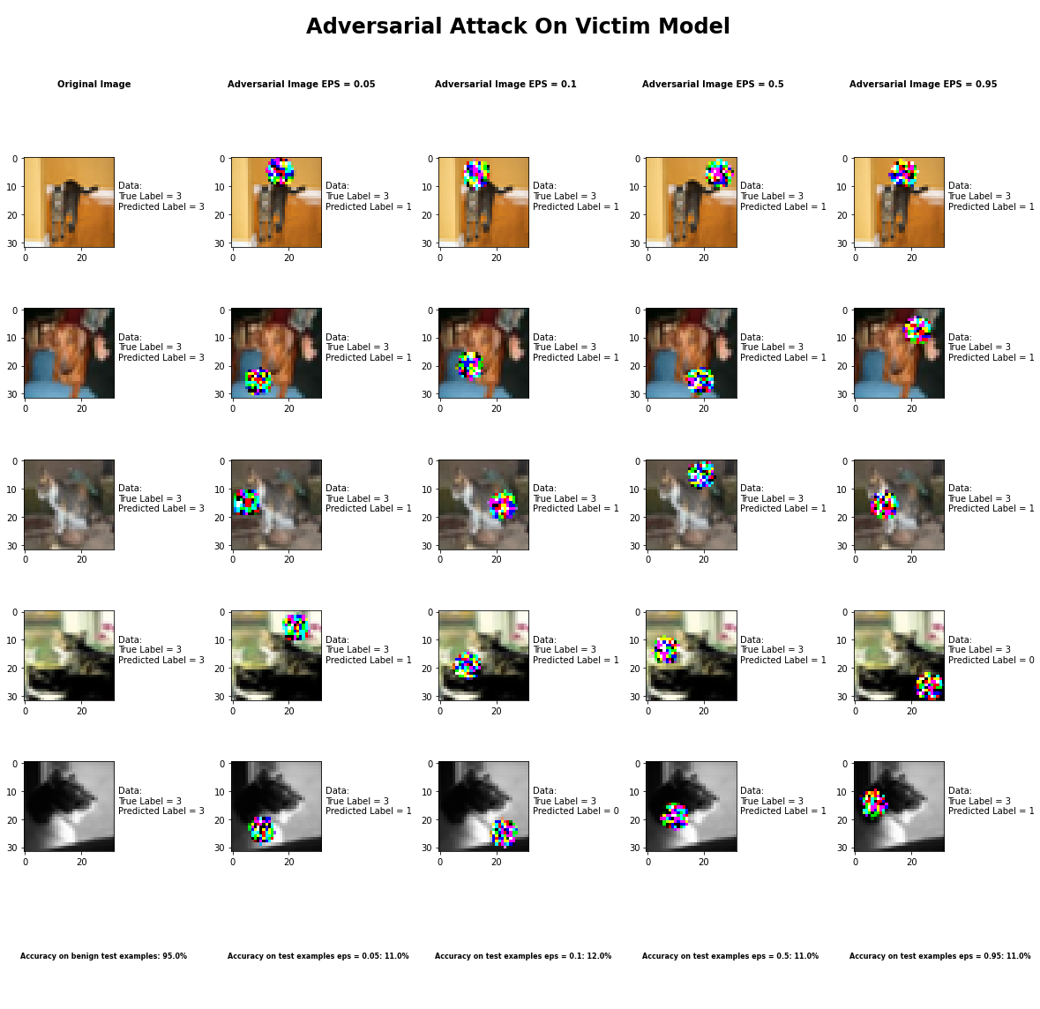

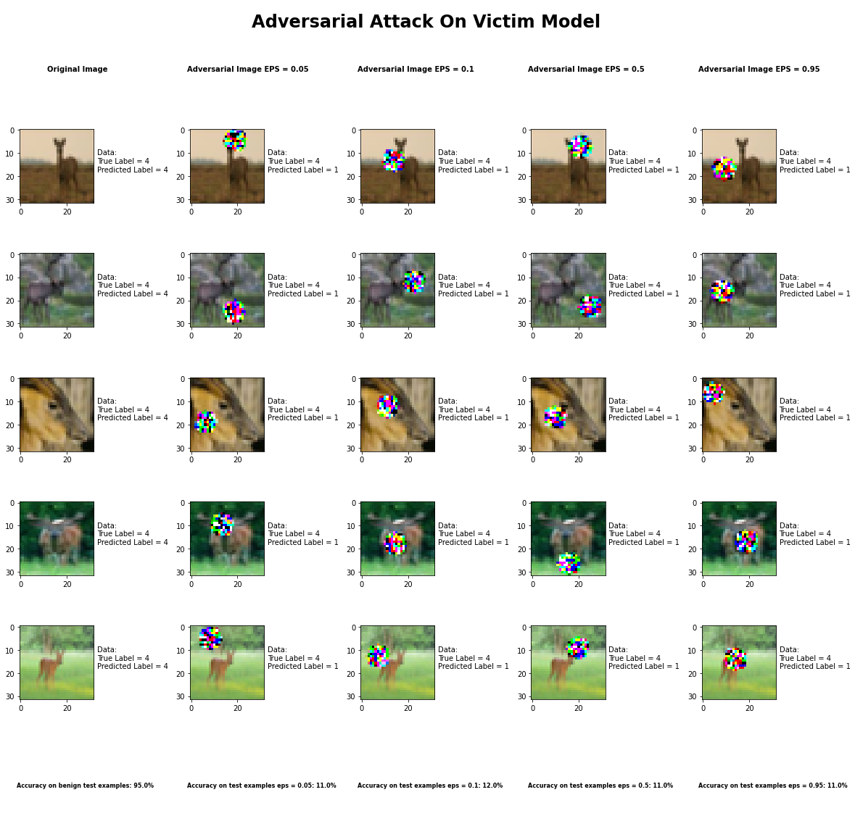

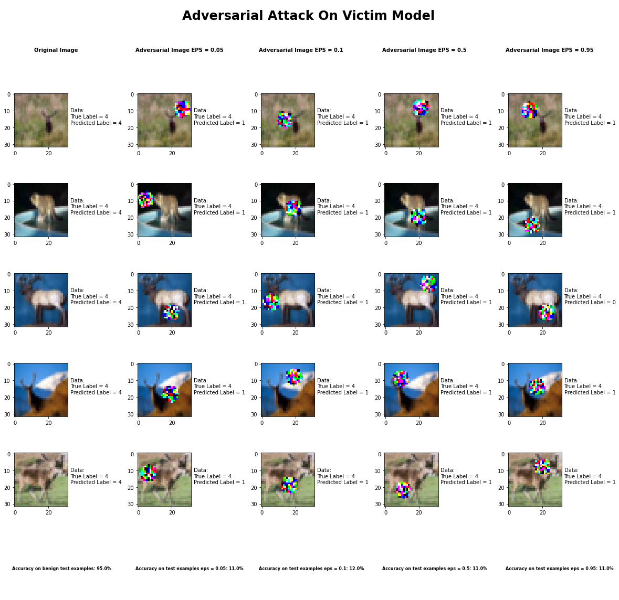

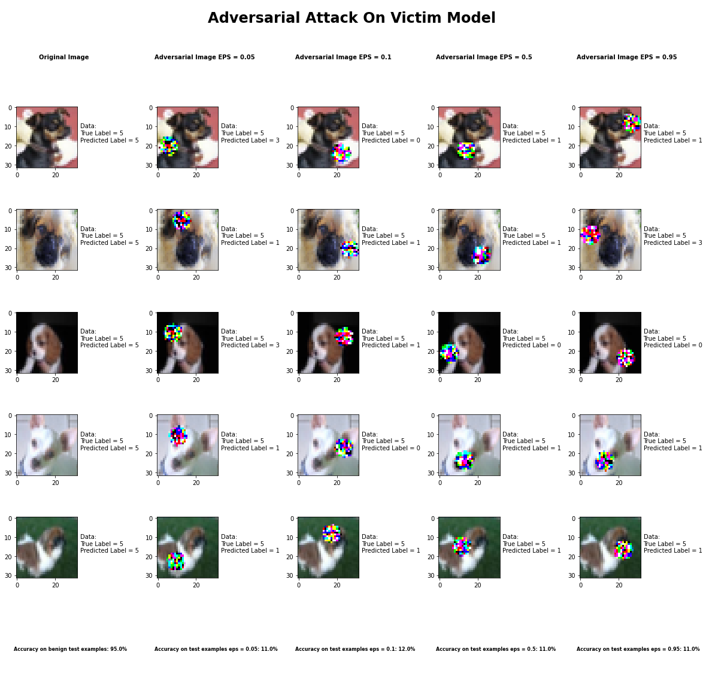

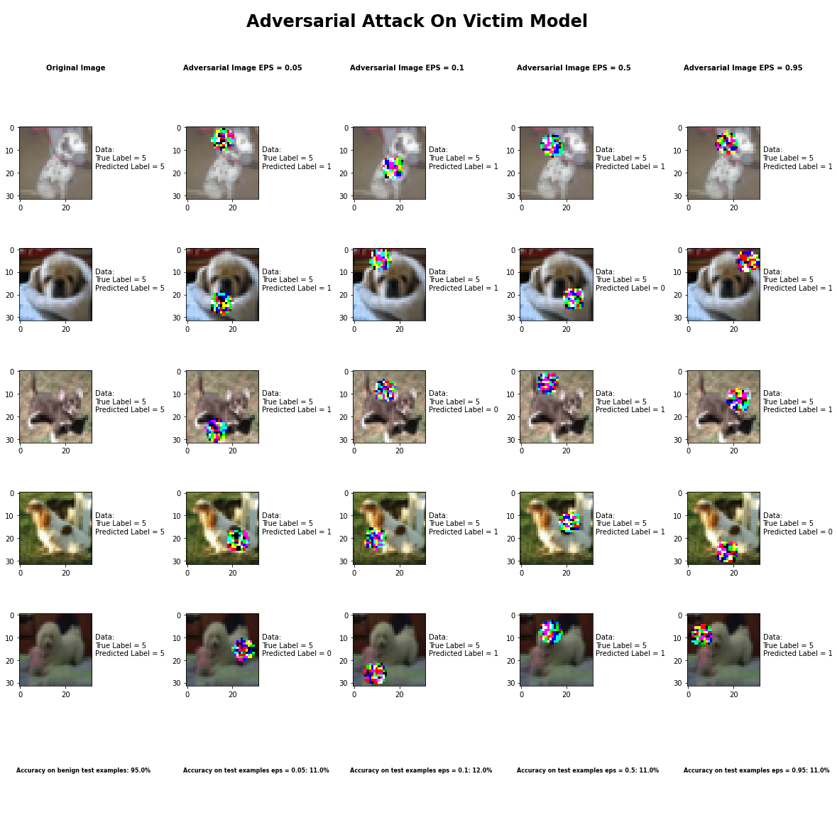

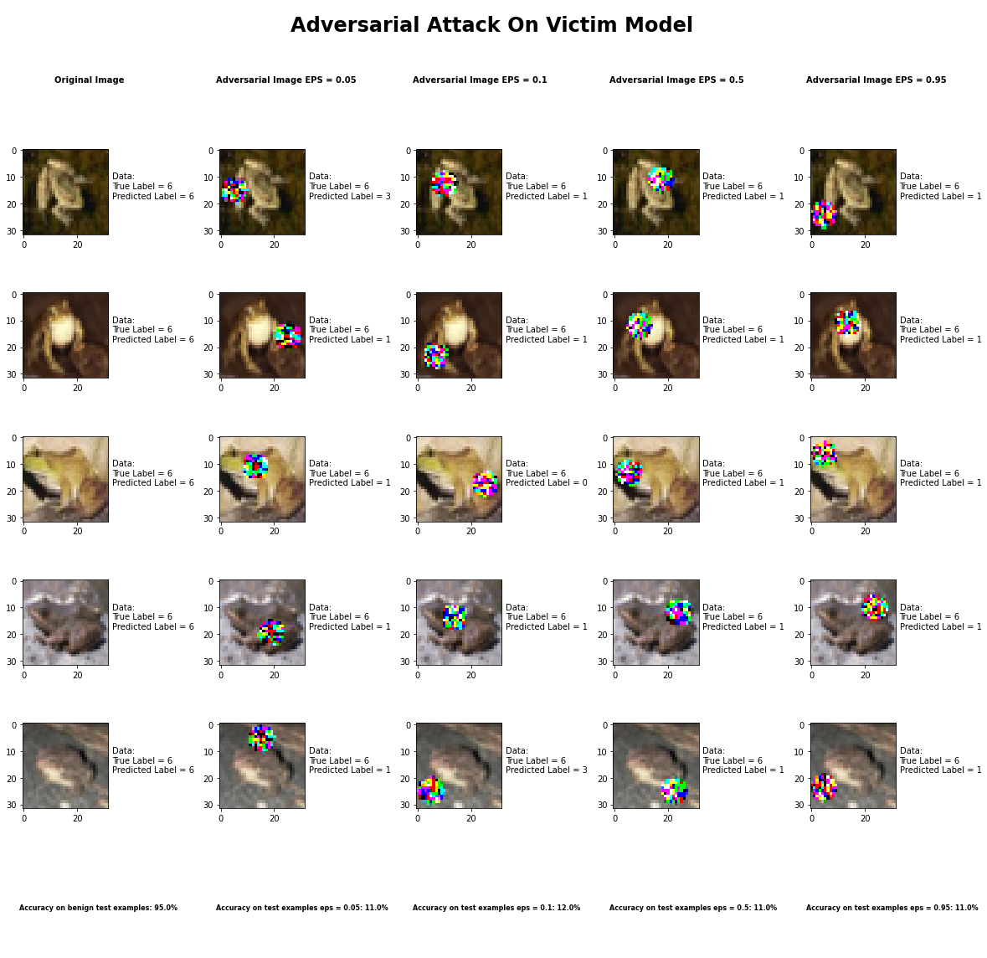

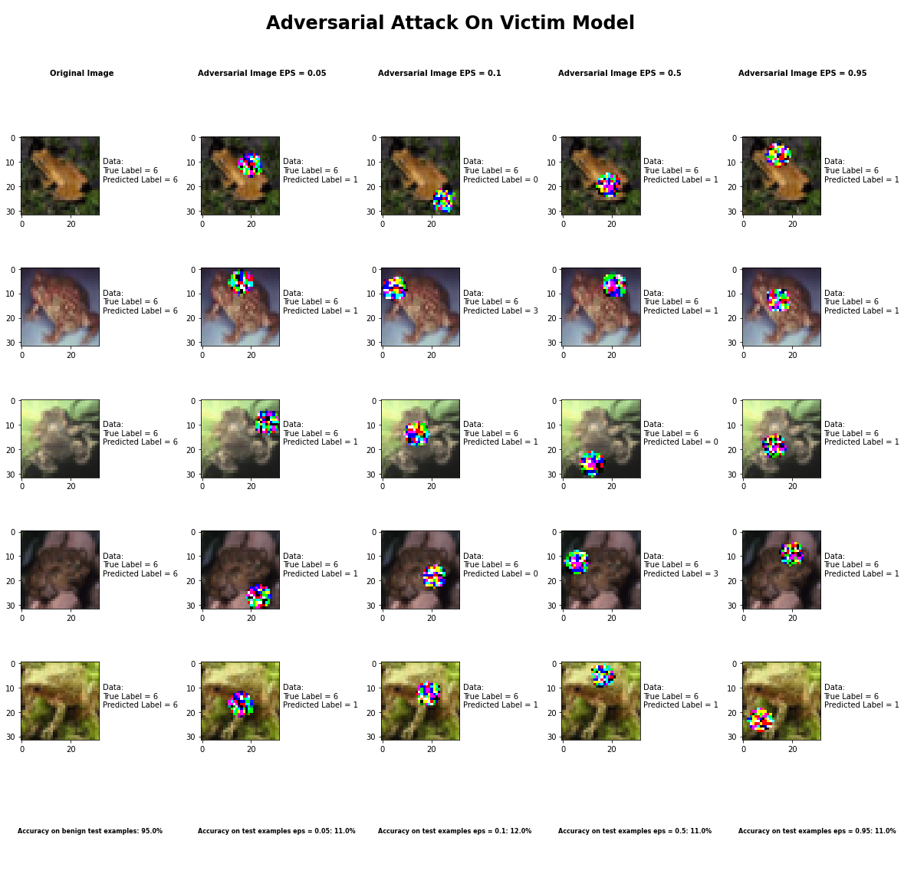

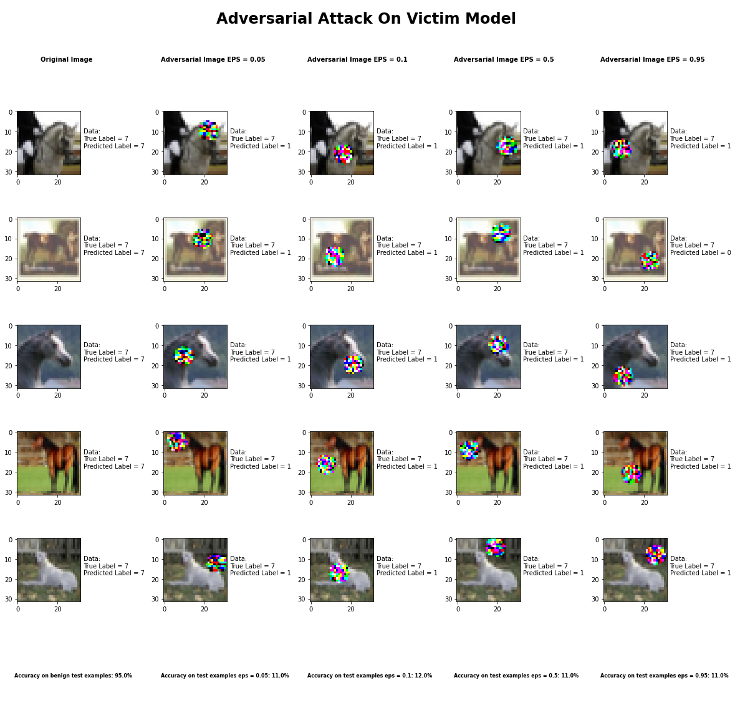

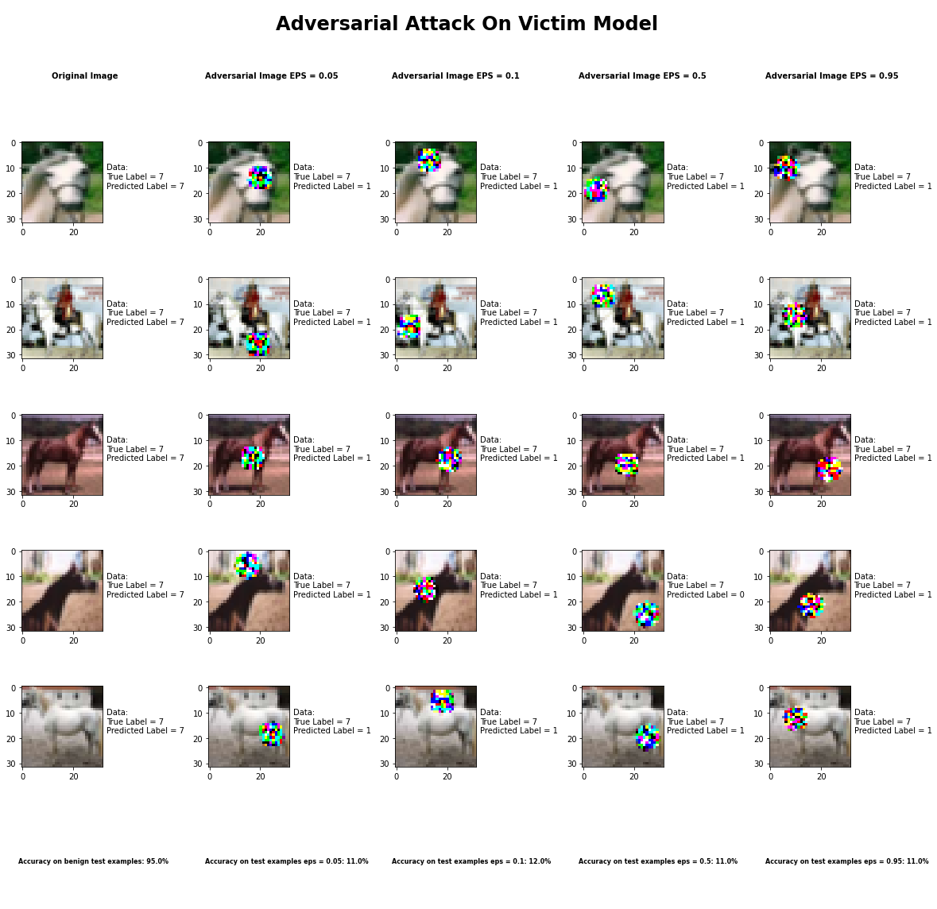

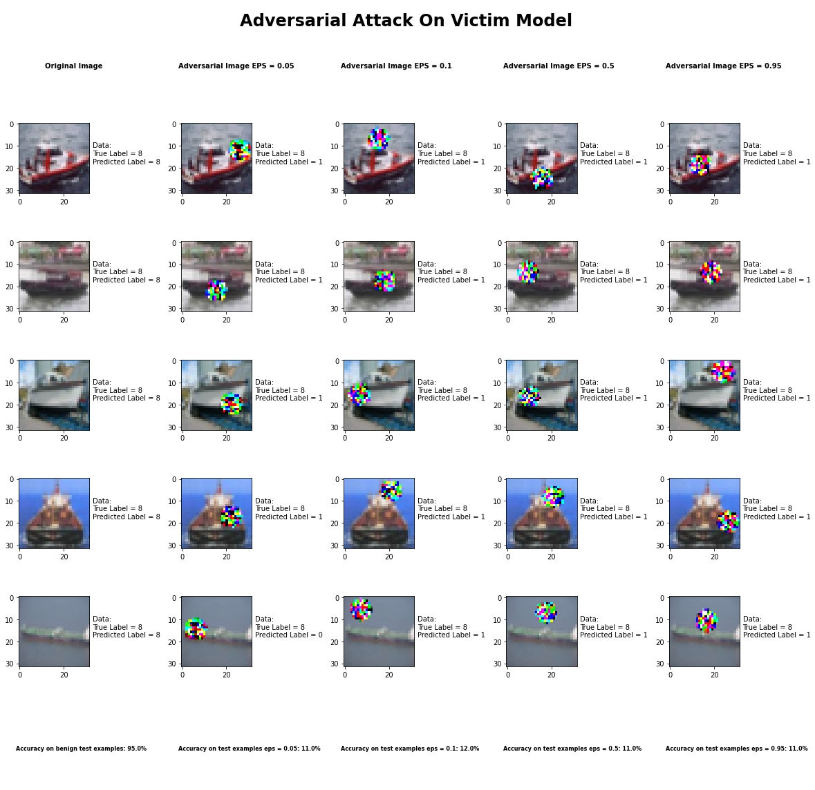

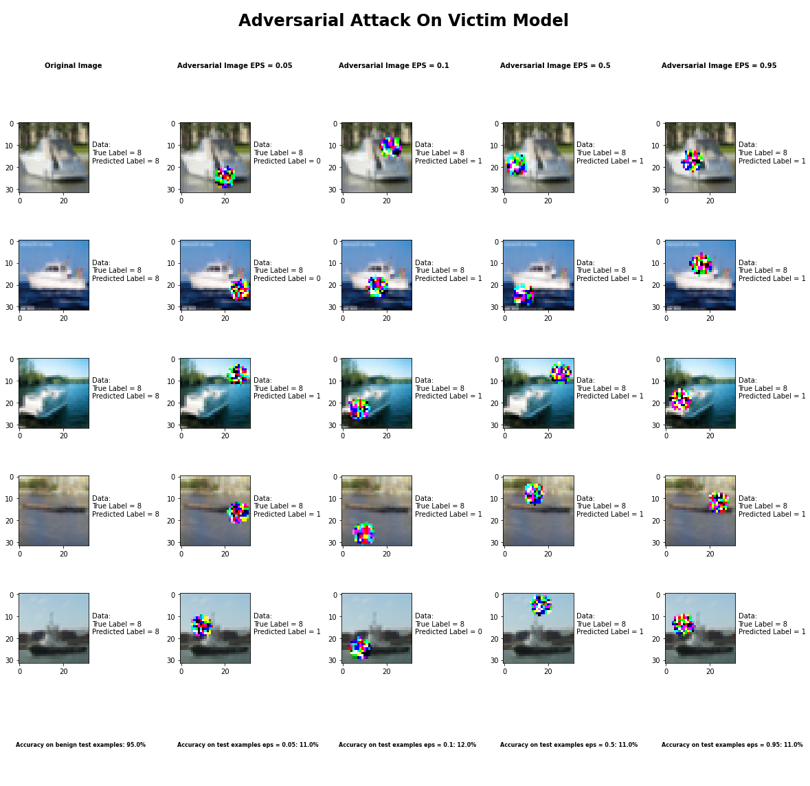

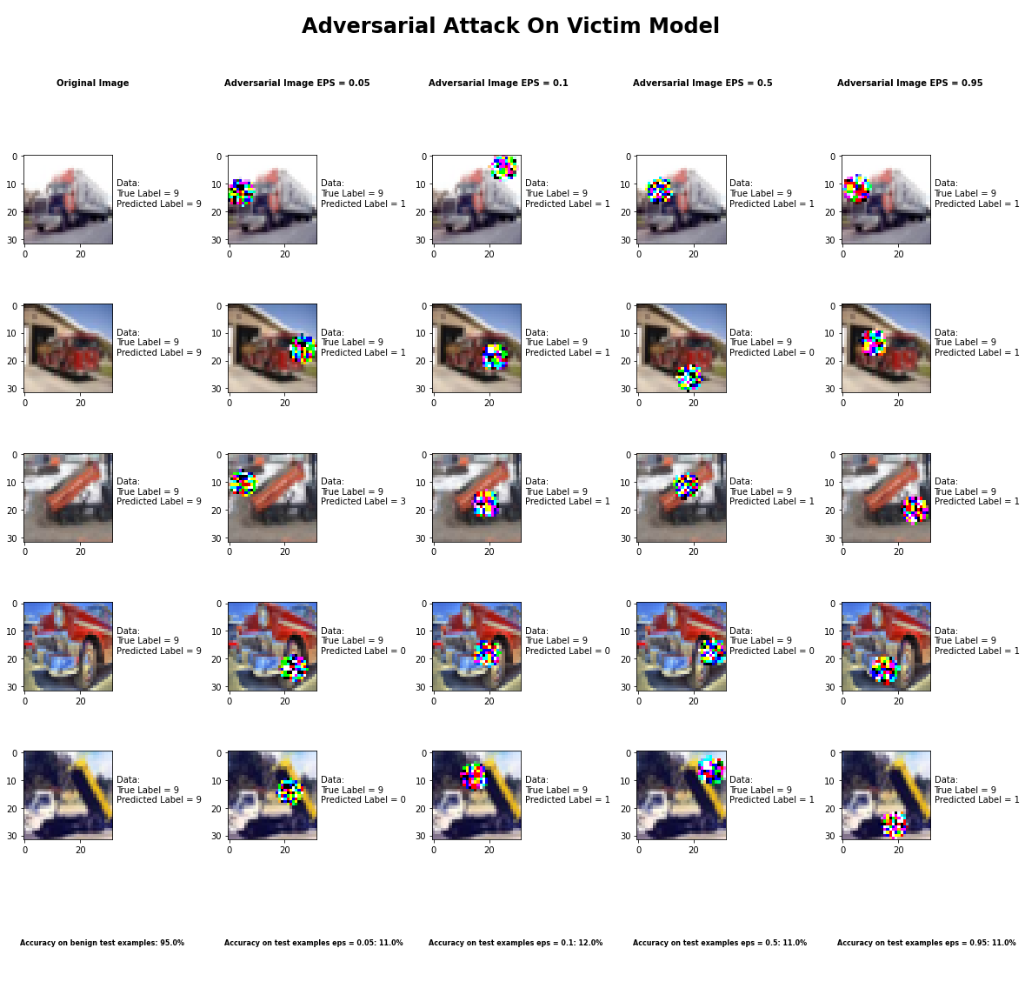

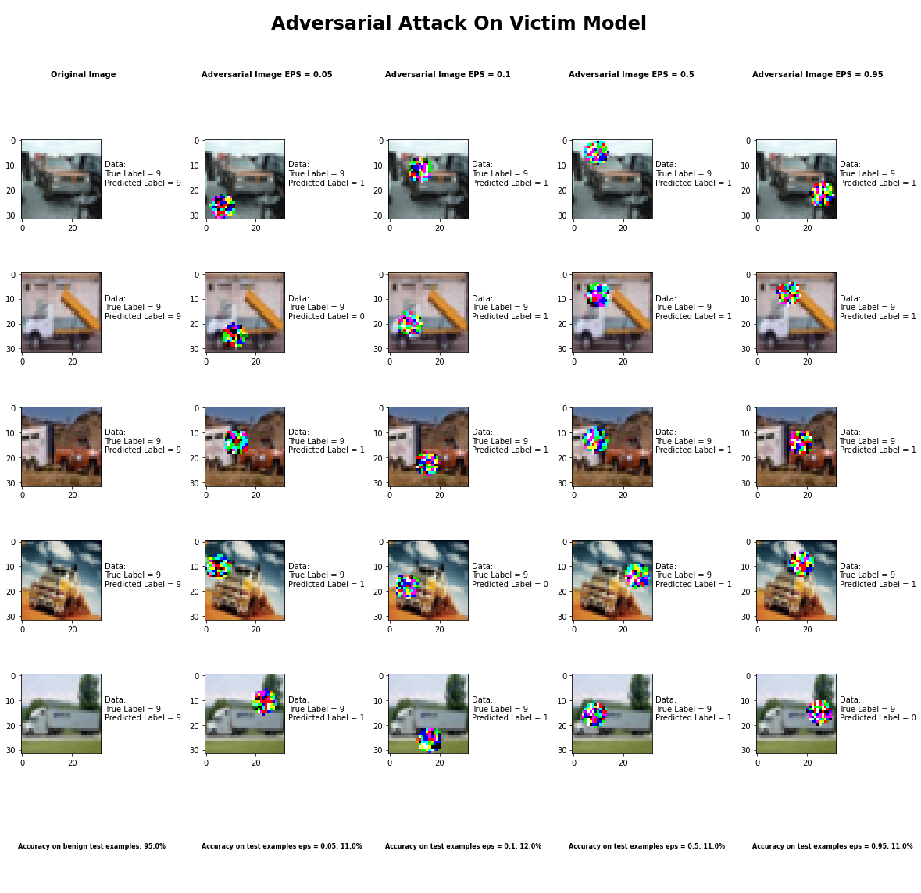

Accuracy on benign test examples: 94.52000000000001%

Average Accuracy on adversarial test examples with learning rate = 5.0: 11.1%

Average Accuracy on adversarial test examples with learning rate = 10.0: 11.7%

Average Accuracy on adversarial test examples with learning rate = 15.0: 11.1%

Average Accuracy on adversarial test examples with learning rate = 20.0: 11.3%

Classifier with benign example has Airplane recognition average accuracy of = 100%

Adversarial Patch Method with learning rate = 5.0 has Airplane recognition average accuracy of = 21%

Adversarial Patch Method with learning rate = 10.0 has Airplane recognition average accuracy of = 22%

Adversarial Patch Method with learning rate = 15.0 has Airplane recognition average accuracy of = 18%

Adversarial Patch Method with learning rate = 20.0 has Airplane recognition average accuracy of = 18%

Classifier with benign example has Automobile recognition average accuracy of = 100%

Adversarial Patch Method with learning rate = 5.0 has Automobile recognition average accuracy of = 89%

Adversarial Patch Method with learning rate = 10.0 has Automobile recognition average accuracy of = 88%

Adversarial Patch Method with learning rate = 15.0 has Automobile recognition average accuracy of = 89%

Adversarial Patch Method with learning rate = 20.0 has Automobile recognition average accuracy of = 92%

Classifier with benign example has Bird recognition average accuracy of = 100%

Adversarial Patch Method with learning rate = 5.0 has Bird recognition average accuracy of = 0%

Adversarial Patch Method with learning rate = 10.0 has Bird recognition average accuracy of = 0%

Adversarial Patch Method with learning rate = 15.0 has Bird recognition average accuracy of = 0%

Adversarial Patch Method with learning rate = 20.0 has Bird recognition average accuracy of = 0%

Classifier with benign example has Cat recognition average accuracy of = 100%

Adversarial Patch Method with learning rate = 5.0 has Cat recognition average accuracy of = 0%

Adversarial Patch Method with learning rate = 10.0 has Cat recognition average accuracy of = 7%

Adversarial Patch Method with learning rate = 15.0 has Cat recognition average accuracy of = 4%

Adversarial Patch Method with learning rate = 20.0 has Cat recognition average accuracy of = 3%

Classifier with benign example has Deer recognition average accuracy of = 100%

Adversarial Patch Method with learning rate = 5.0 has Deer recognition average accuracy of = 0%

Adversarial Patch Method with learning rate = 10.0 has Deer recognition average accuracy of = 0%

Adversarial Patch Method with learning rate = 15.0 has Deer recognition average accuracy of = 0%

Adversarial Patch Method with learning rate = 20.0 has Deer recognition average accuracy of = 0%

Classifier with benign example has Dog recognition average accuracy of = 100%

Adversarial Patch Method with learning rate = 5.0 has Dog recognition average accuracy of = 0%

Adversarial Patch Method with learning rate = 10.0 has Dog recognition average accuracy of = 0%

Adversarial Patch Method with learning rate = 15.0 has Dog recognition average accuracy of = 0%

Adversarial Patch Method with learning rate = 20.0 has Dog recognition average accuracy of = 0%

Classifier with benign example has Frog recognition average accuracy of = 100%

Adversarial Patch Method with learning rate = 5.0 has Frog recognition average accuracy of = 0%

Adversarial Patch Method with learning rate = 10.0 has Frog recognition average accuracy of = 0%

Adversarial Patch Method with learning rate = 15.0 has Frog recognition average accuracy of = 0%

Adversarial Patch Method with learning rate = 20.0 has Frog recognition average accuracy of = 0%

Classifier with benign example has Horse recognition average accuracy of = 100%

Adversarial Patch Method with learning rate = 5.0 has Horse recognition average accuracy of = 0%

Adversarial Patch Method with learning rate = 10.0 has Horse recognition average accuracy of = 0%

Adversarial Patch Method with learning rate = 15.0 has Horse recognition average accuracy of = 0%

Adversarial Patch Method with learning rate = 20.0 has Horse recognition average accuracy of = 0%

Classifier with benign example has Ship recognition average accuracy of = 100%

Adversarial Patch Method with learning rate = 5.0 has Ship recognition average accuracy of = 0%

Adversarial Patch Method with learning rate = 10.0 has Ship recognition average accuracy of = 0%

Adversarial Patch Method with learning rate = 15.0 has Ship recognition average accuracy of = 0%

Adversarial Patch Method with learning rate = 20.0 has Ship recognition average accuracy of = 0%

Classifier with benign example has Truck recognition average accuracy of = 100%

Adversarial Patch Method with learning rate = 5.0 has Truck recognition average accuracy of = 1%

Adversarial Patch Method with learning rate = 10.0 has Truck recognition average accuracy of = 0%

Adversarial Patch Method with learning rate = 15.0 has Truck recognition average accuracy of = 0%

Adversarial Patch Method with learning rate = 20.0 has Truck recognition average accuracy of = 0%

## Carlini LInf Mthod

## Carlini L2 Mthod

## Basic Iterative Method

## 

## Universal Perturbation Method



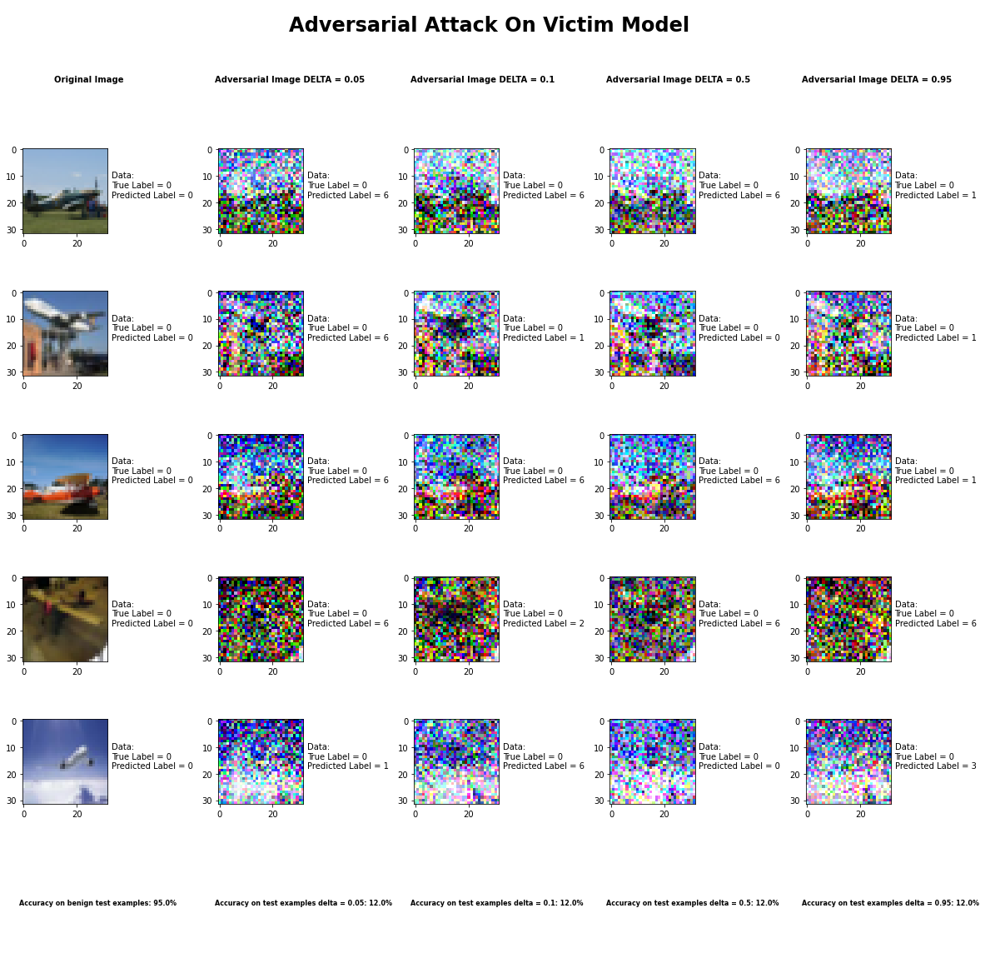

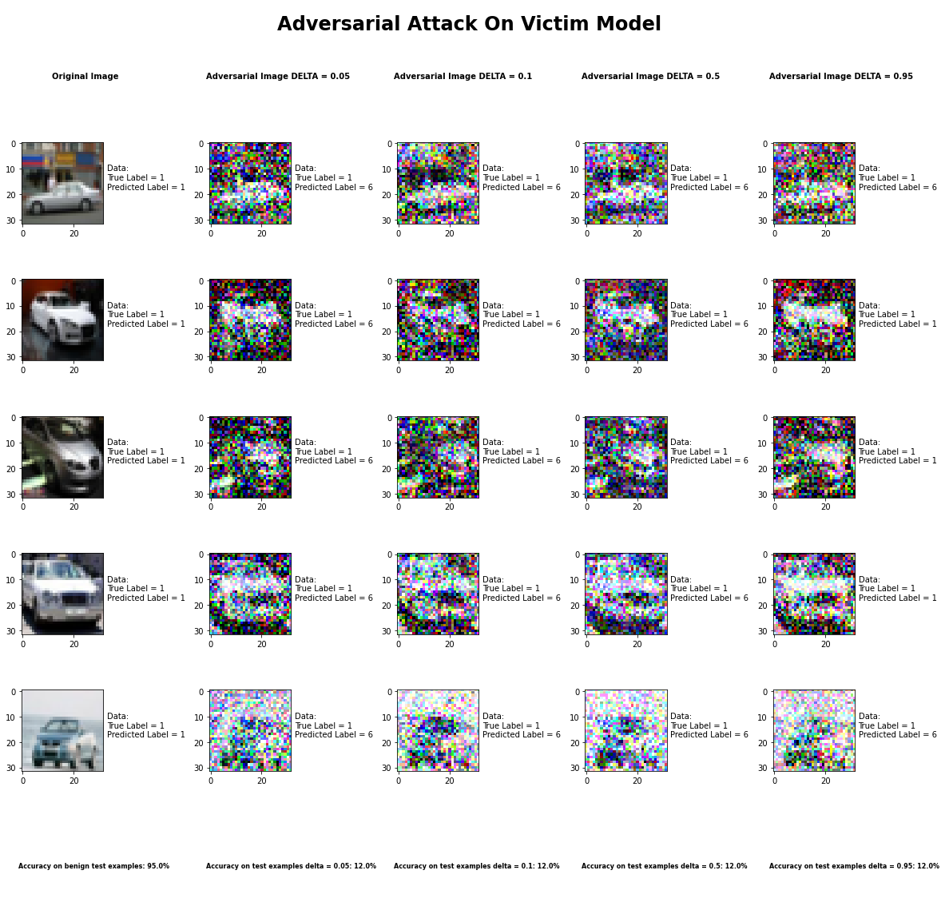

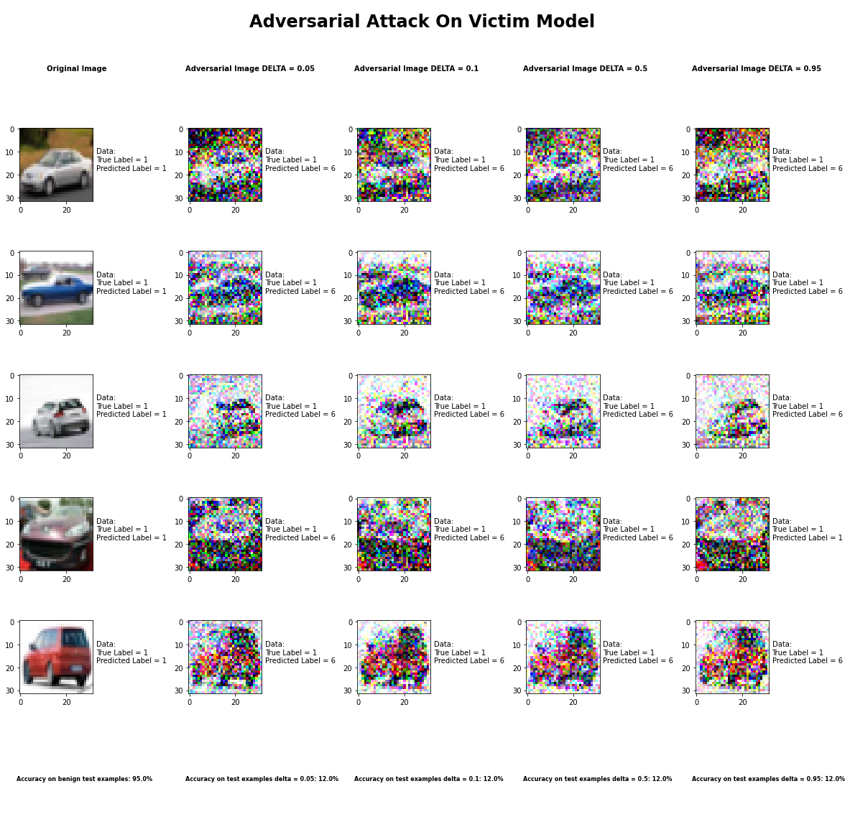

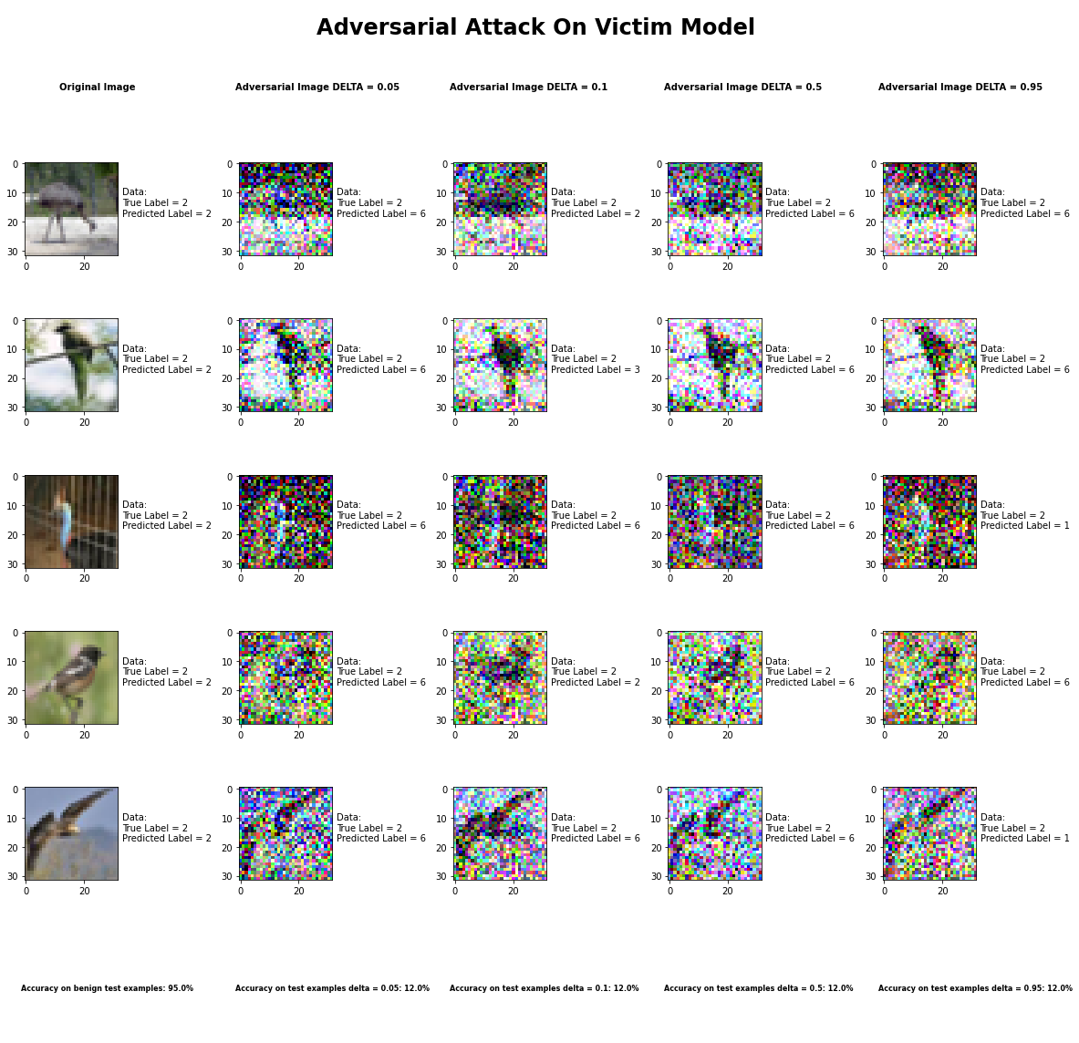

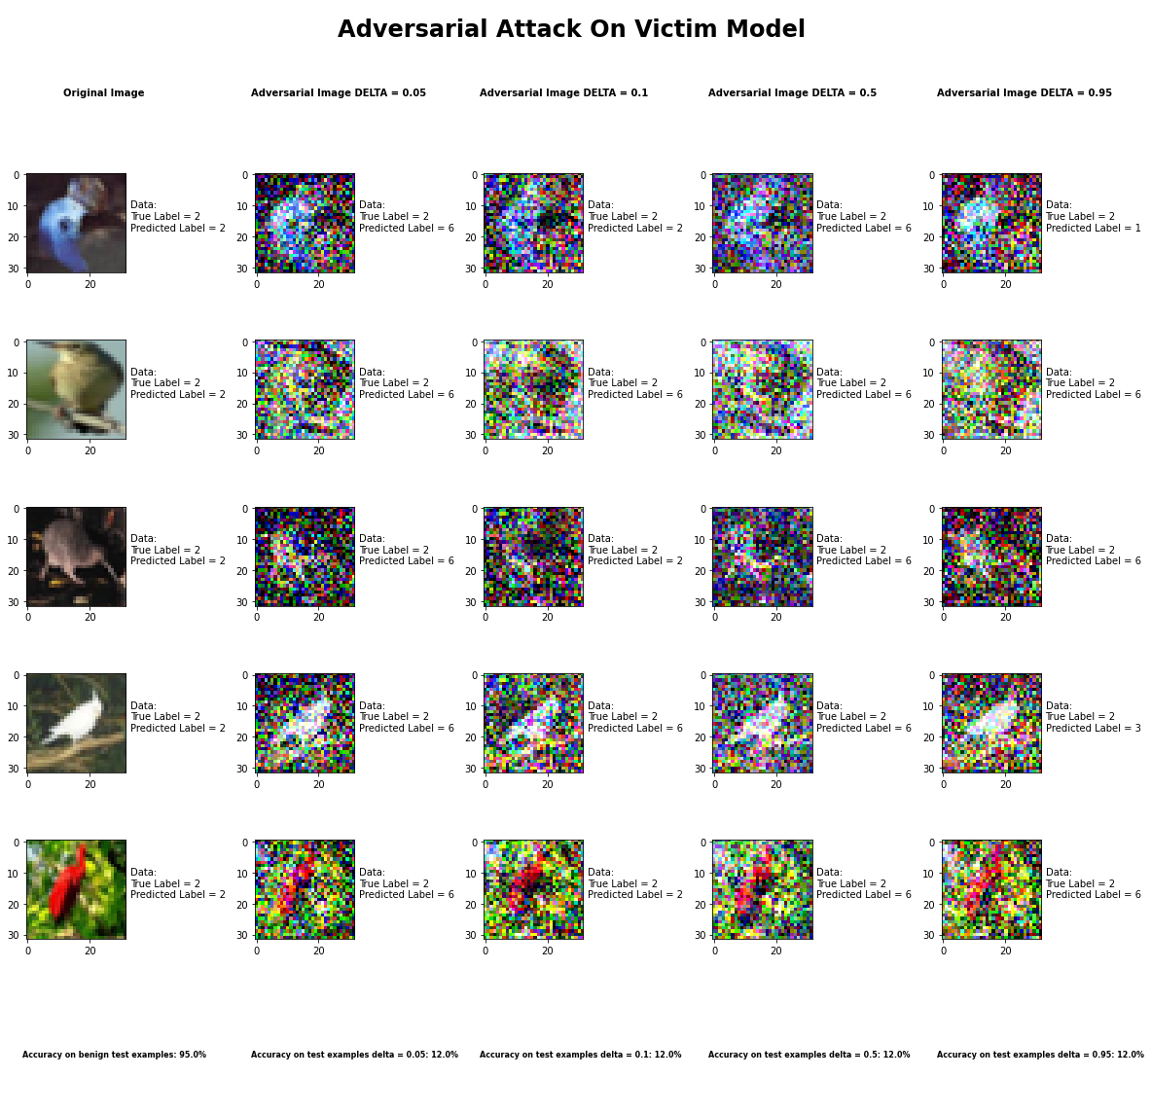

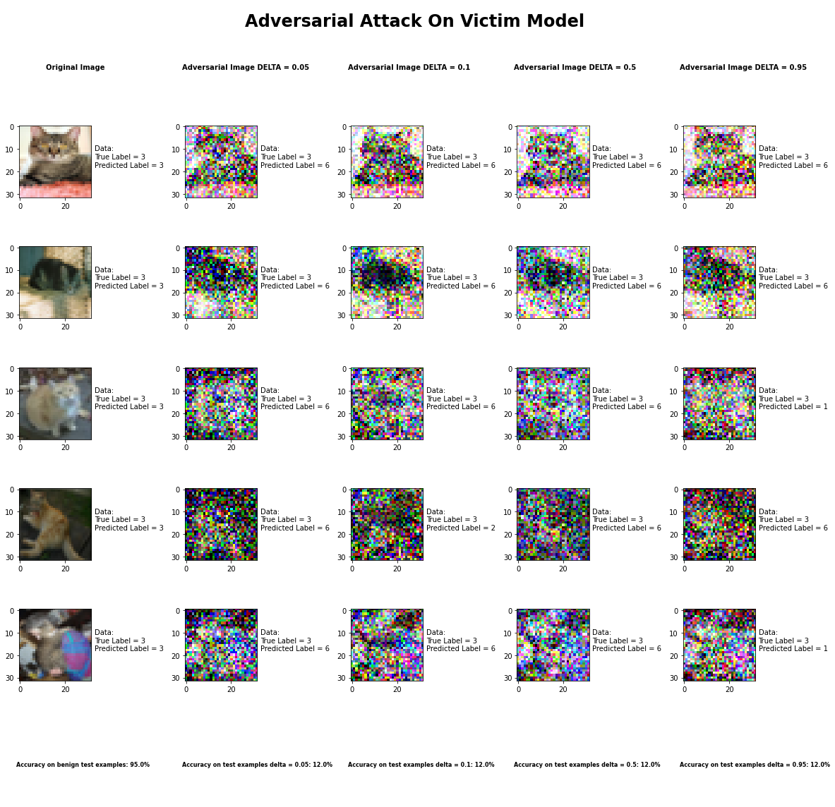

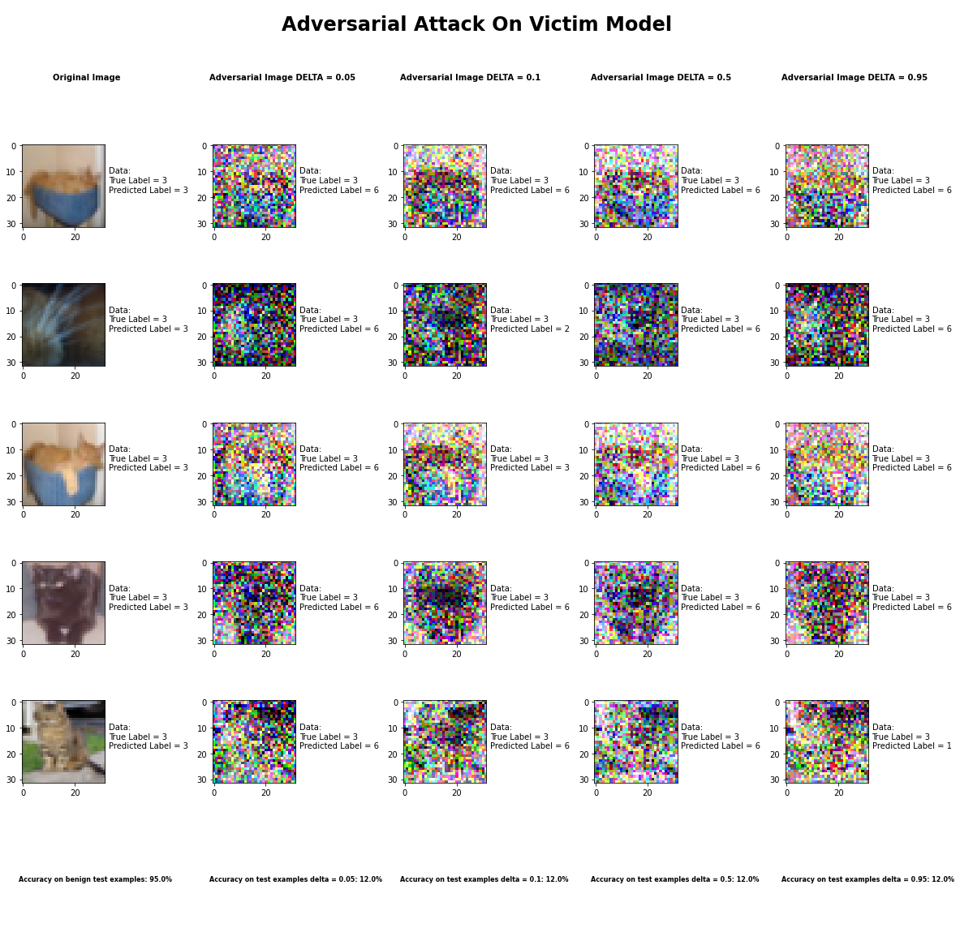

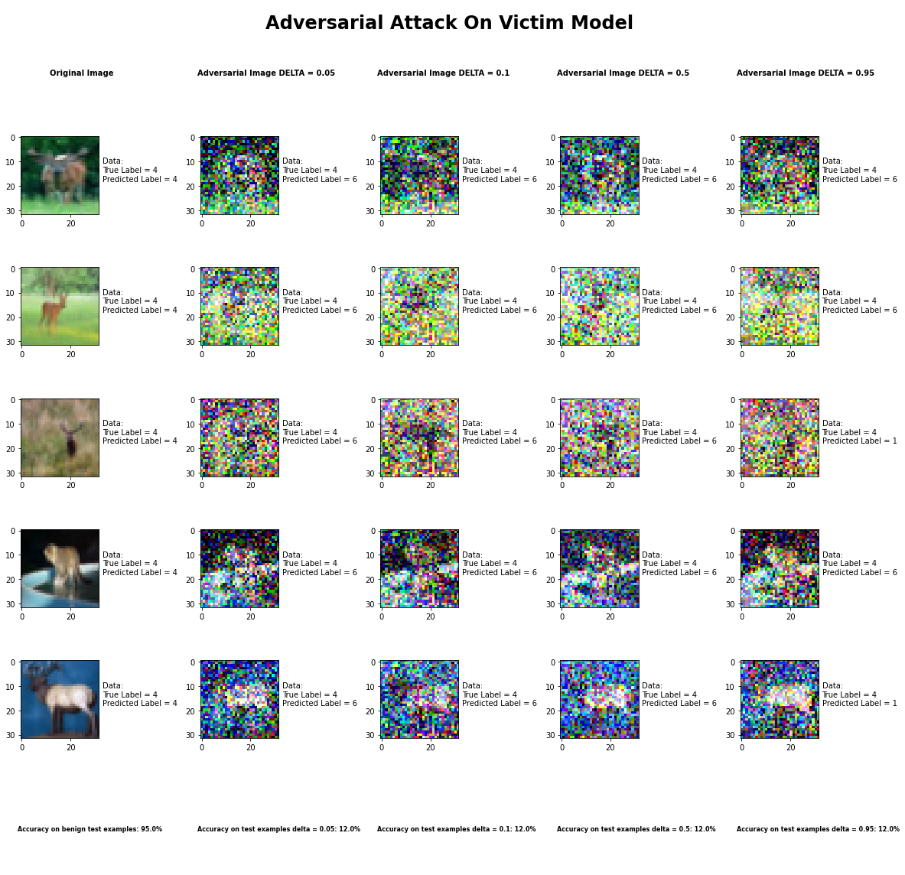

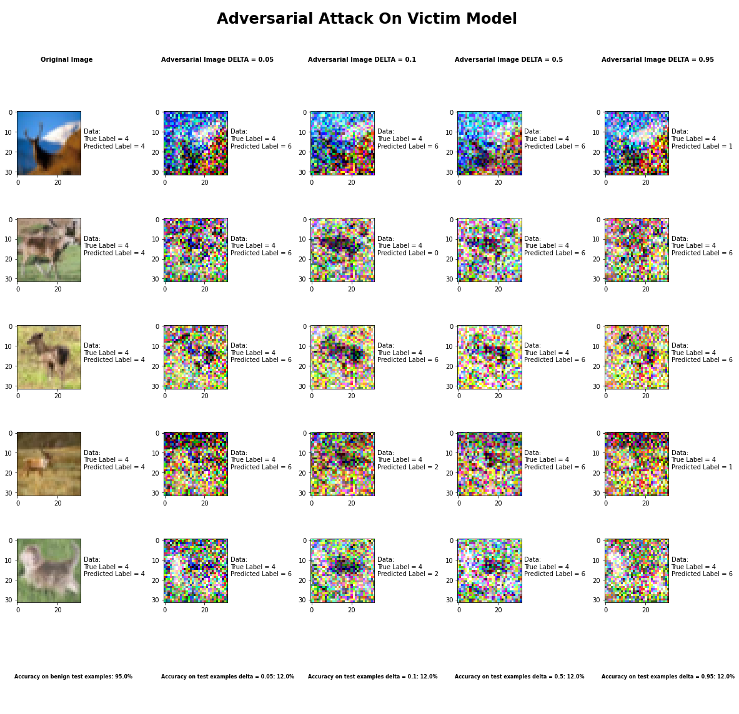

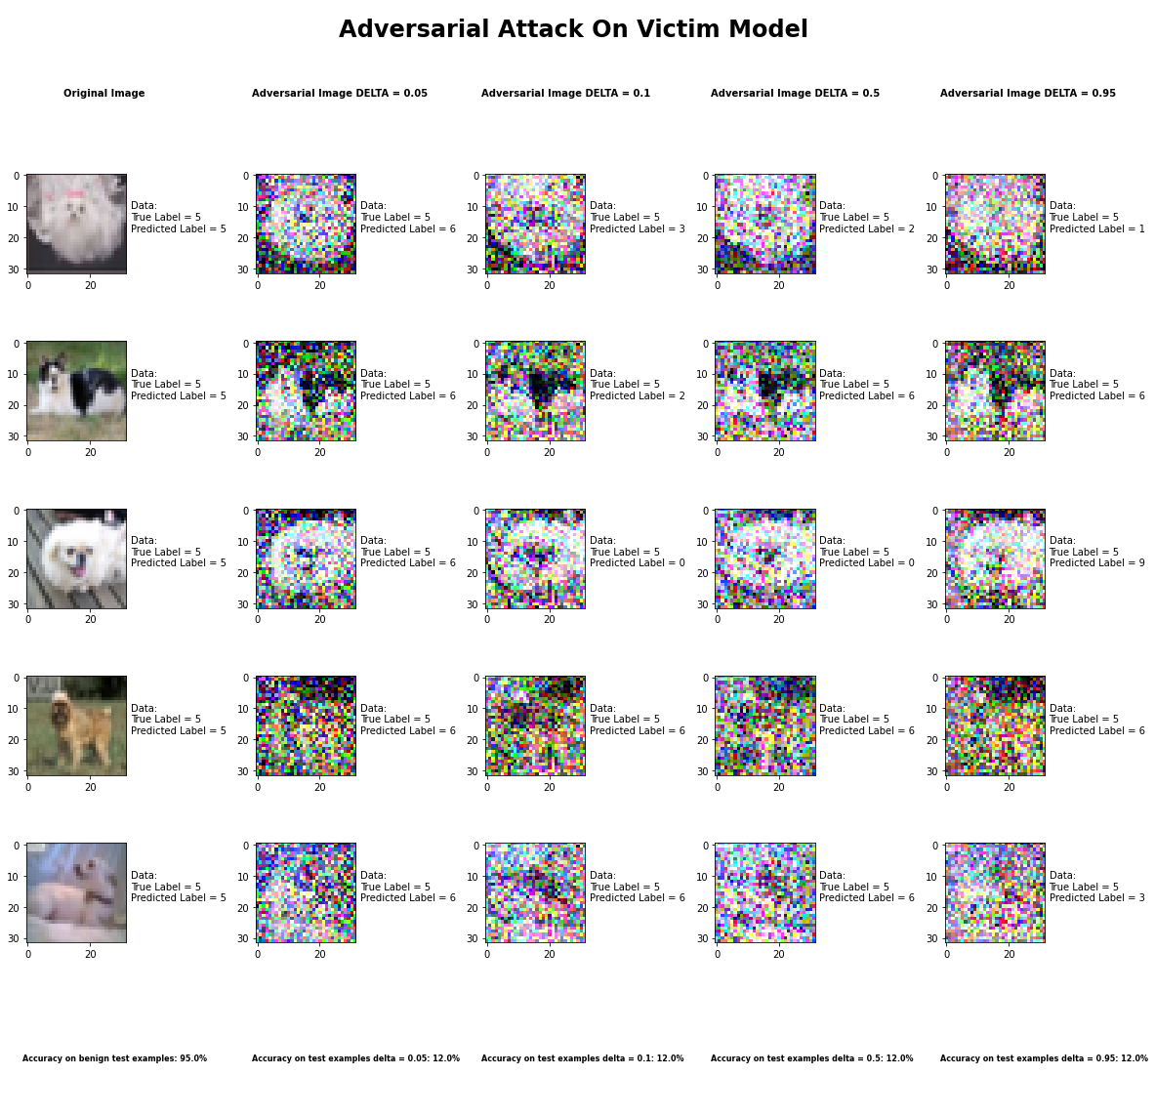

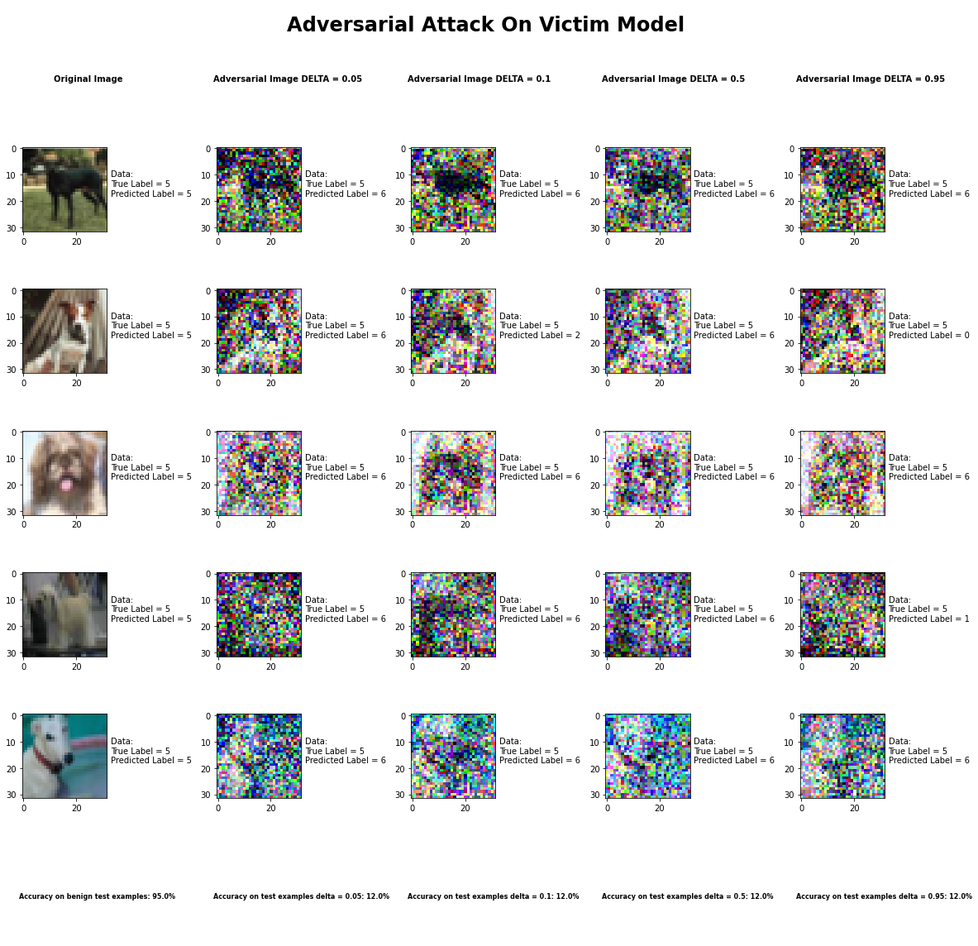

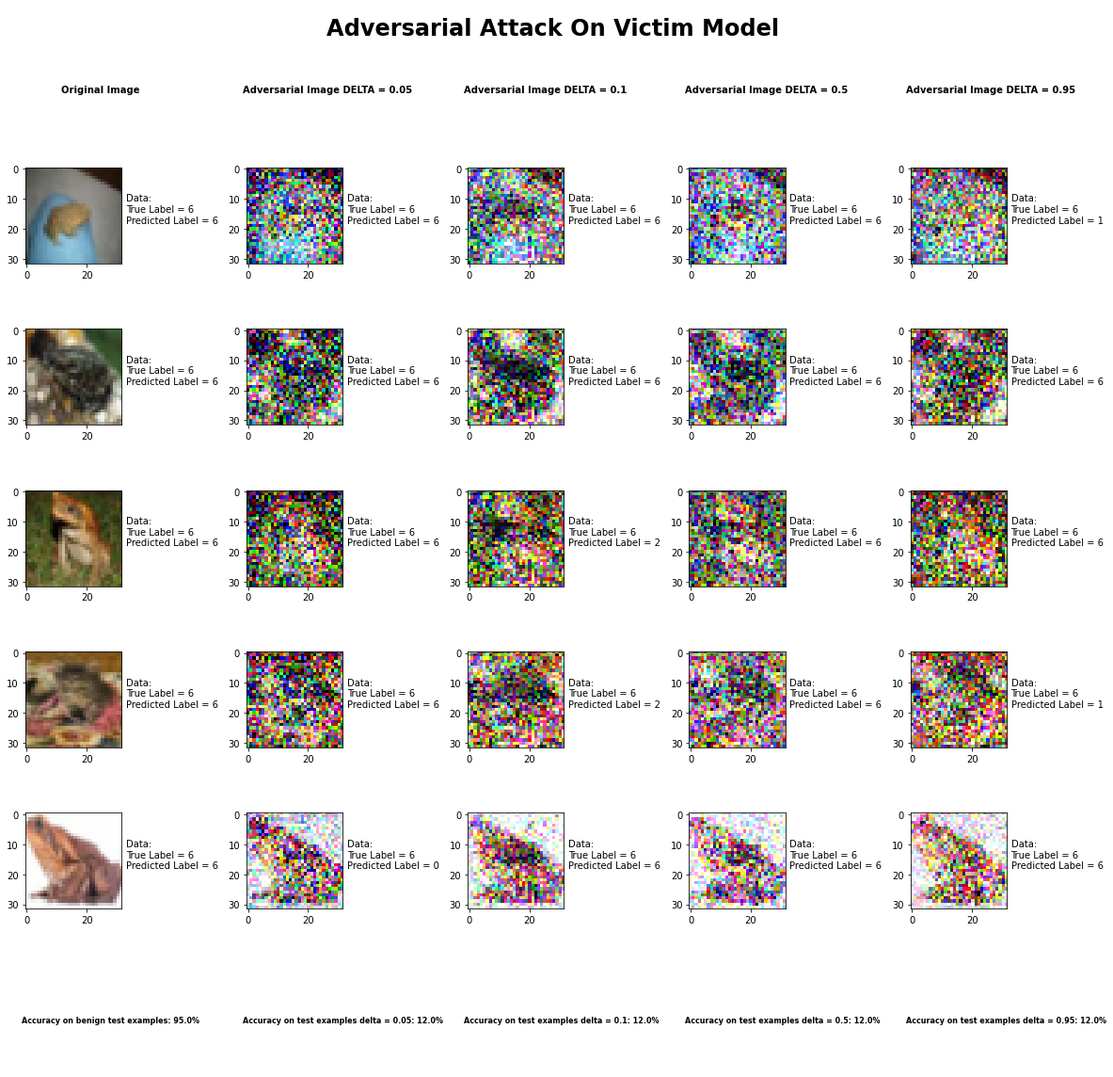

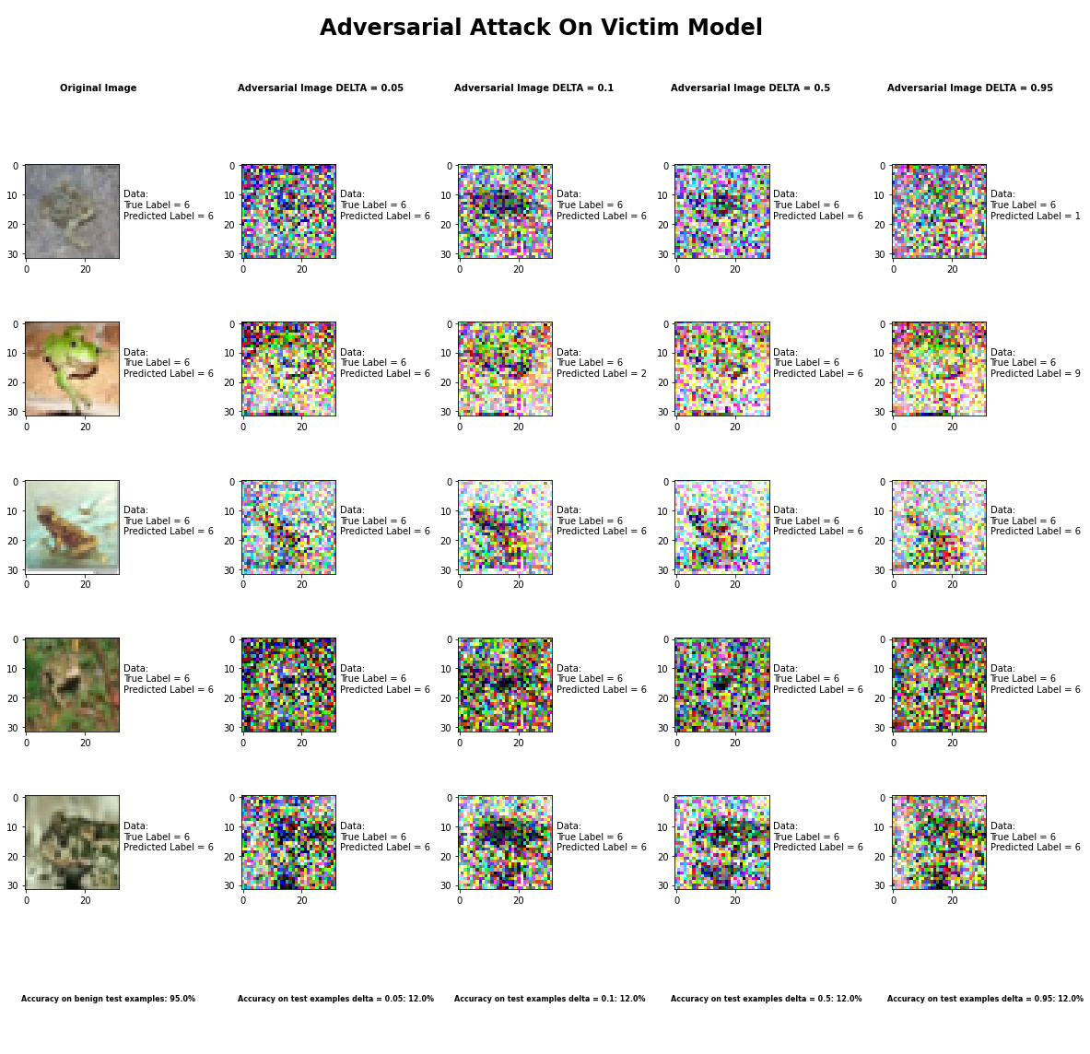

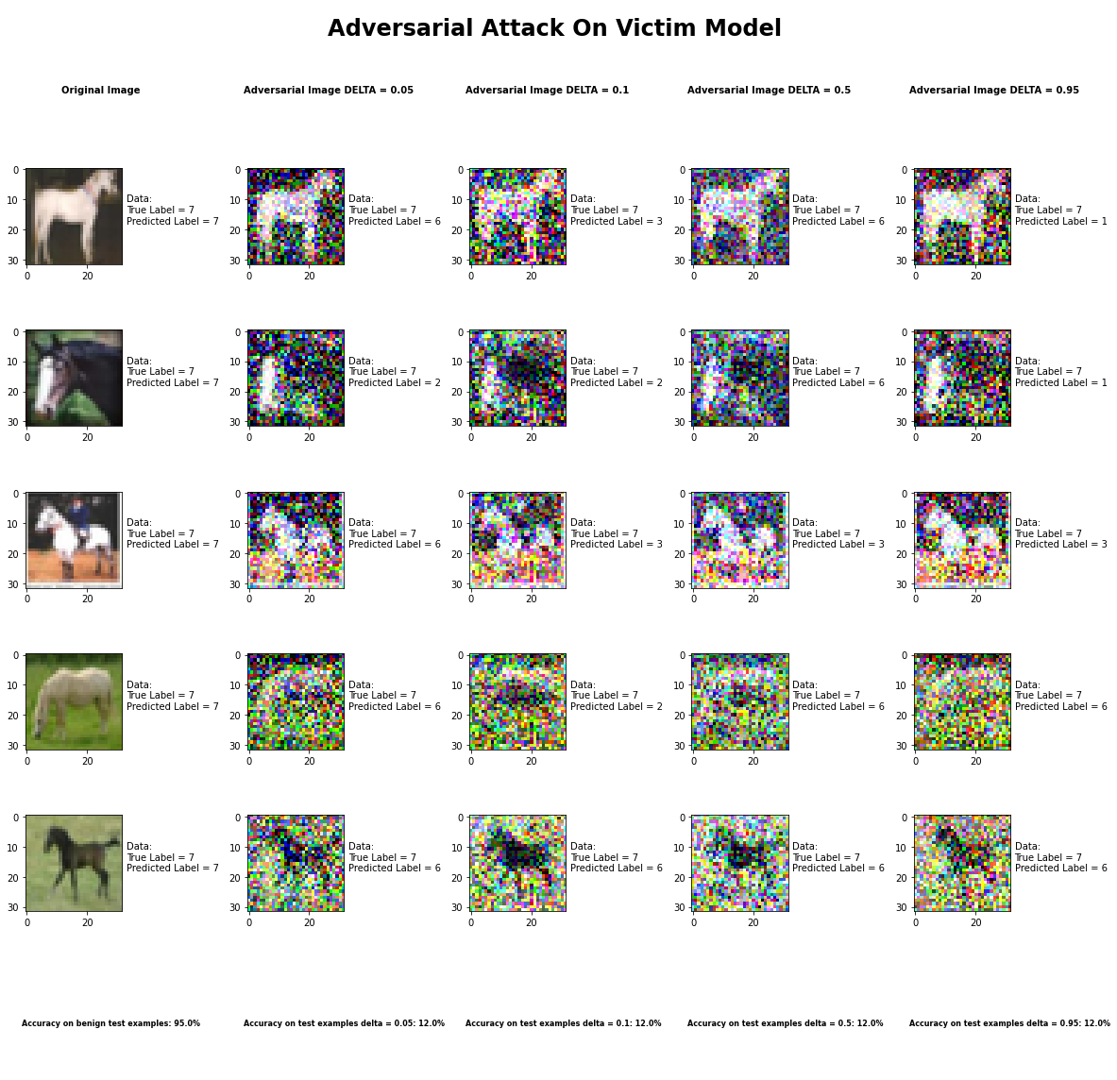

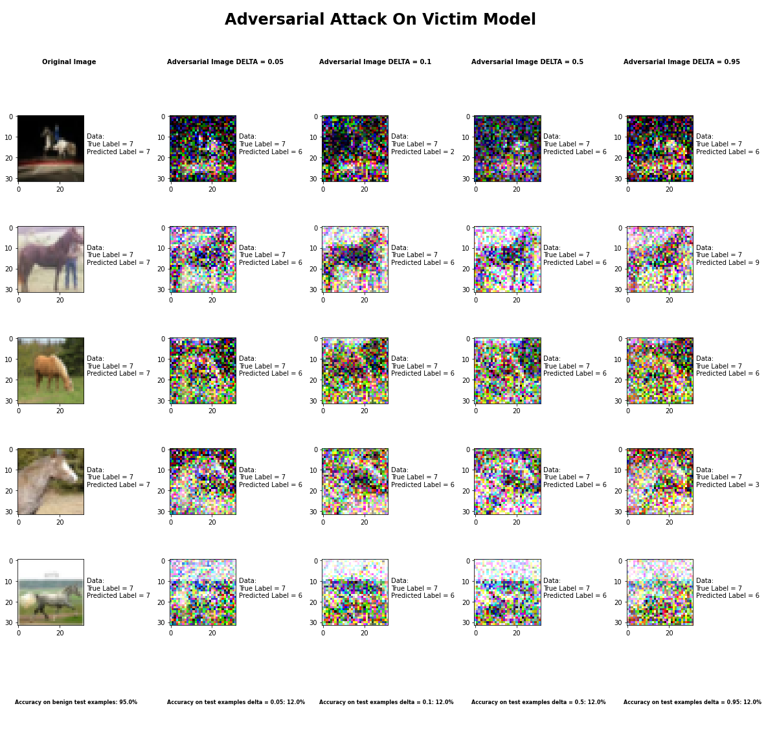

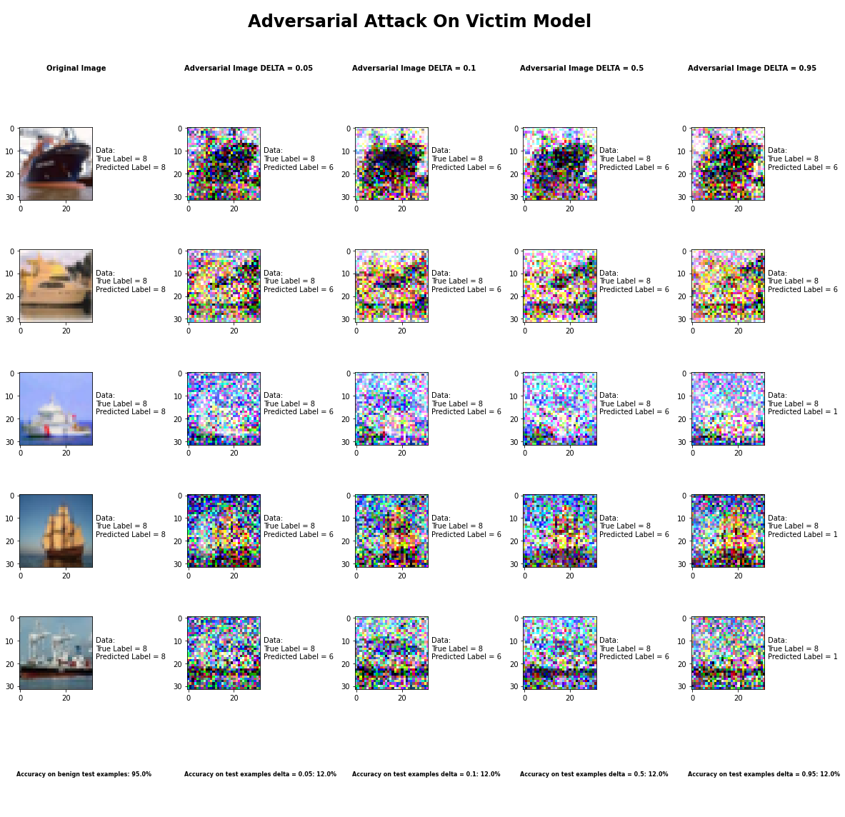

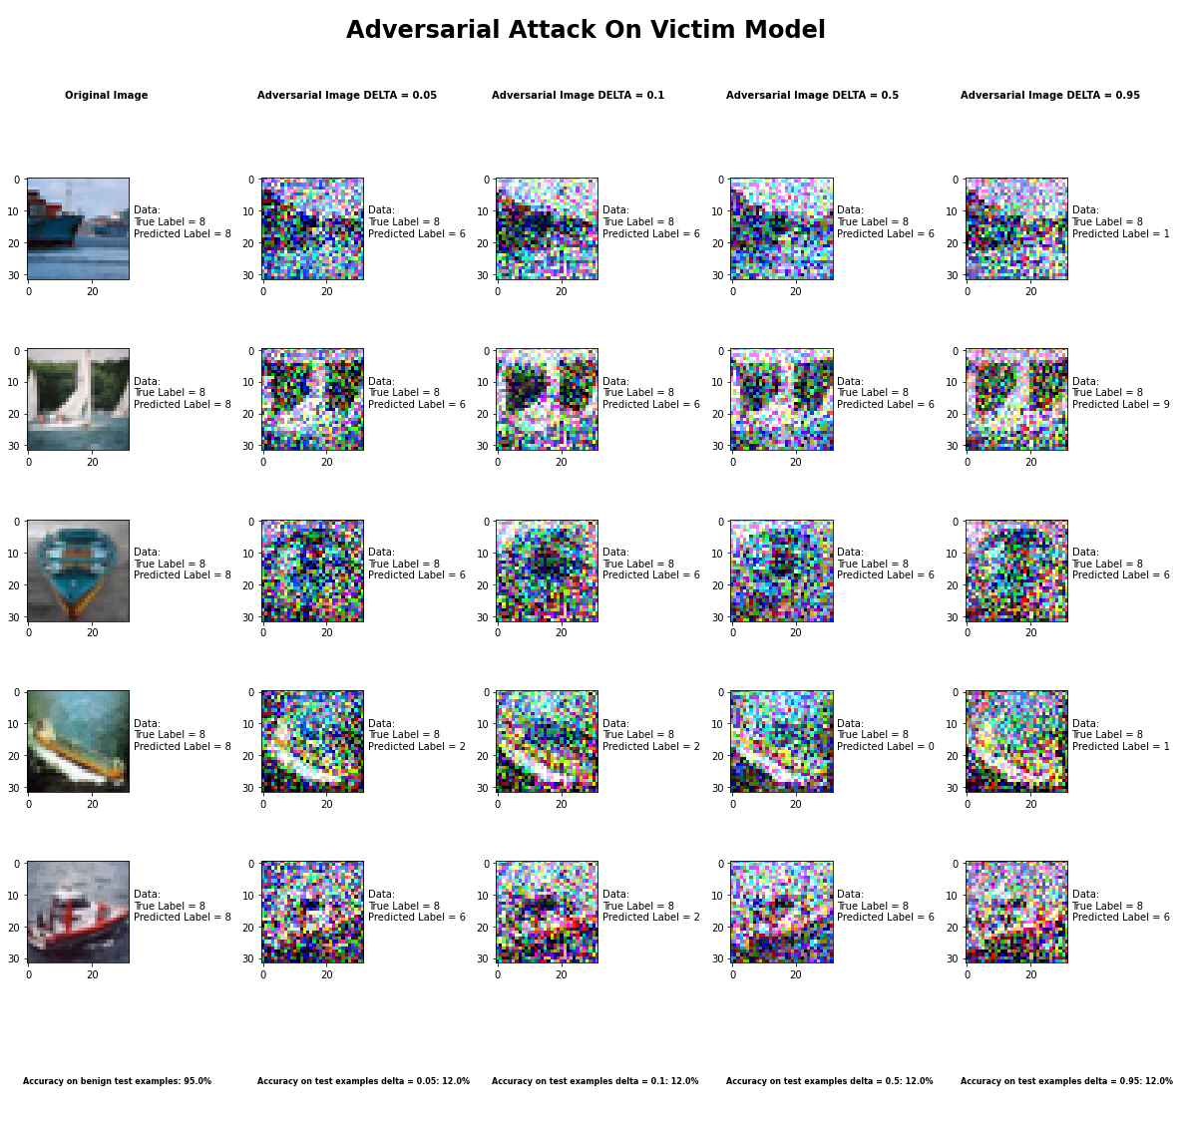

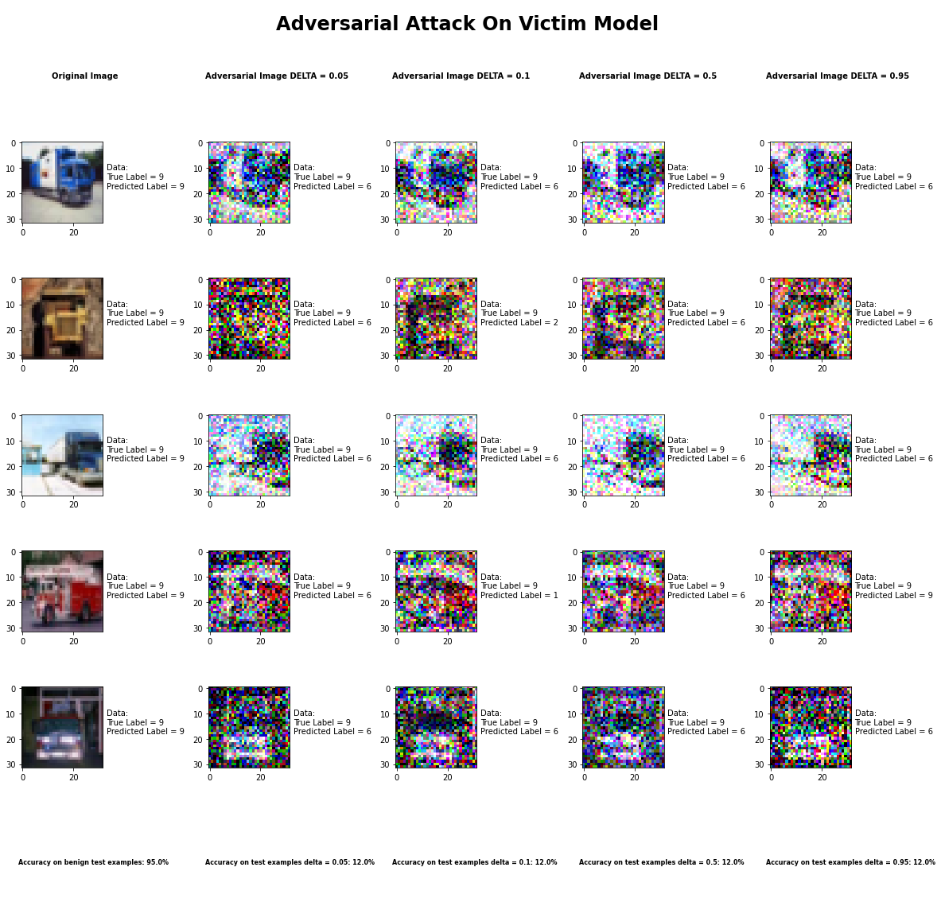

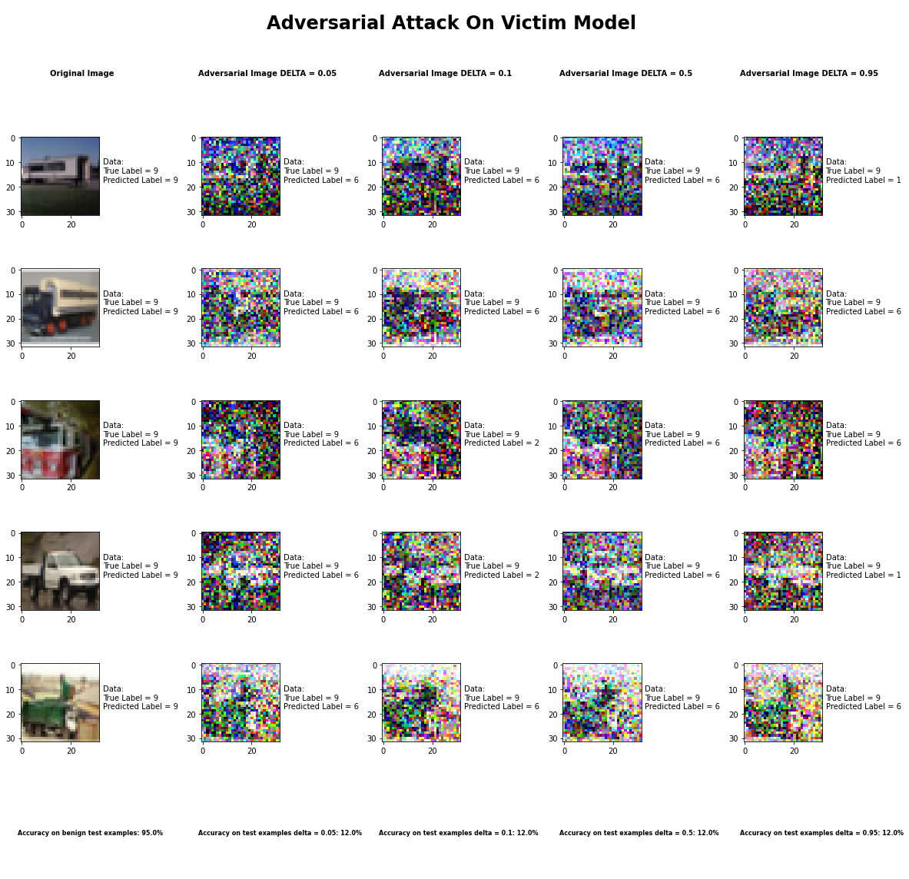

Accuracy on benign test examples: 94.52000000000001%

Average Accuracy on adversarial test examples with delta = 0.05: 11.5%

Average Accuracy on adversarial test examples with delta = 0.1: 11.5%

Average Accuracy on adversarial test examples with delta = 0.5: 11.5%

Average Accuracy on adversarial test examples with delta = 0.95: 11.5%

Classifier with benign example has Airplane recognition average accuracy of = 100%

Universal Perturbation Method with delta = 0.05 has Airplane recognition average accuracy of = 14%

Universal Perturbation Method with delta = 0.1 has Airplane recognition average accuracy of = 5%

Universal Perturbation Method with delta = 0.5 has Airplane recognition average accuracy of = 14%

Universal Perturbation Method with delta = 0.95 has Airplane recognition average accuracy of = 11%

Classifier with benign example has Automobile recognition average accuracy of = 100%

Universal Perturbation Method with delta = 0.05 has Automobile recognition average accuracy of = 2%

Universal Perturbation Method with delta = 0.1 has Automobile recognition average accuracy of = 3%

Universal Perturbation Method with delta = 0.5 has Automobile recognition average accuracy of = 0%

Universal Perturbation Method with delta = 0.95 has Automobile recognition average accuracy of = 11%

Classifier with benign example has Bird recognition average accuracy of = 100%

Universal Perturbation Method with delta = 0.05 has Bird recognition average accuracy of = 8%

Universal Perturbation Method with delta = 0.1 has Bird recognition average accuracy of = 12%

Universal Perturbation Method with delta = 0.5 has Bird recognition average accuracy of = 11%

Universal Perturbation Method with delta = 0.95 has Bird recognition average accuracy of = 5%

Classifier with benign example has Cat recognition average accuracy of = 100%

Universal Perturbation Method with delta = 0.05 has Cat recognition average accuracy of = 5%

Universal Perturbation Method with delta = 0.1 has Cat recognition average accuracy of = 9%

Universal Perturbation Method with delta = 0.5 has Cat recognition average accuracy of = 0%

Universal Perturbation Method with delta = 0.95 has Cat recognition average accuracy of = 2%

Classifier with benign example has Deer recognition average accuracy of = 100%

Universal Perturbation Method with delta = 0.05 has Deer recognition average accuracy of = 0%

Universal Perturbation Method with delta = 0.1 has Deer recognition average accuracy of = 0%

Universal Perturbation Method with delta = 0.5 has Deer recognition average accuracy of = 0%

Universal Perturbation Method with delta = 0.95 has Deer recognition average accuracy of = 0%

Classifier with benign example has Dog recognition average accuracy of = 100%

Universal Perturbation Method with delta = 0.05 has Dog recognition average accuracy of = 0%

Universal Perturbation Method with delta = 0.1 has Dog recognition average accuracy of = 0%

Universal Perturbation Method with delta = 0.5 has Dog recognition average accuracy of = 0%

Universal Perturbation Method with delta = 0.95 has Dog recognition average accuracy of = 0%

Classifier with benign example has Frog recognition average accuracy of = 100%

Universal Perturbation Method with delta = 0.05 has Frog recognition average accuracy of = 86%

Universal Perturbation Method with delta = 0.1 has Frog recognition average accuracy of = 86%

Universal Perturbation Method with delta = 0.5 has Frog recognition average accuracy of = 90%

Universal Perturbation Method with delta = 0.95 has Frog recognition average accuracy of = 85%

Classifier with benign example has Horse recognition average accuracy of = 100%

Universal Perturbation Method with delta = 0.05 has Horse recognition average accuracy of = 0%

Universal Perturbation Method with delta = 0.1 has Horse recognition average accuracy of = 0%

Universal Perturbation Method with delta = 0.5 has Horse recognition average accuracy of = 0%

Universal Perturbation Method with delta = 0.95 has Horse recognition average accuracy of = 0%

Classifier with benign example has Ship recognition average accuracy of = 100%

Universal Perturbation Method with delta = 0.05 has Ship recognition average accuracy of = 0%

Universal Perturbation Method with delta = 0.1 has Ship recognition average accuracy of = 0%

Universal Perturbation Method with delta = 0.5 has Ship recognition average accuracy of = 0%

Universal Perturbation Method with delta = 0.95 has Ship recognition average accuracy of = 0%

Classifier with benign example has Truck recognition average accuracy of = 100%

Universal Perturbation Method with delta = 0.05 has Truck recognition average accuracy of = 0%

Universal Perturbation Method with delta = 0.1 has Truck recognition average accuracy of = 0%

Universal Perturbation Method with delta = 0.5 has Truck recognition average accuracy of = 0%

Universal Perturbation Method with delta = 0.95 has Truck recognition average accuracy of = 1%

## Jacobian Saliency Map



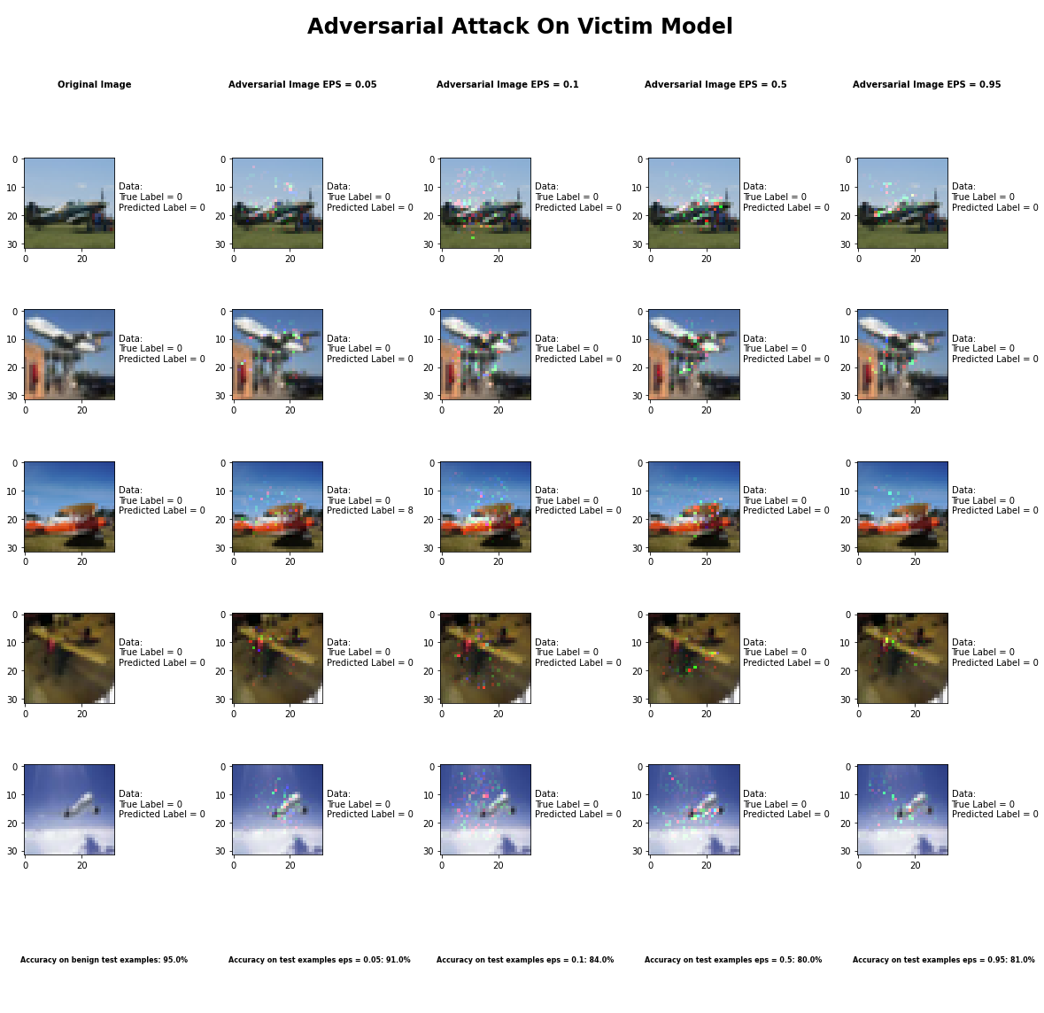

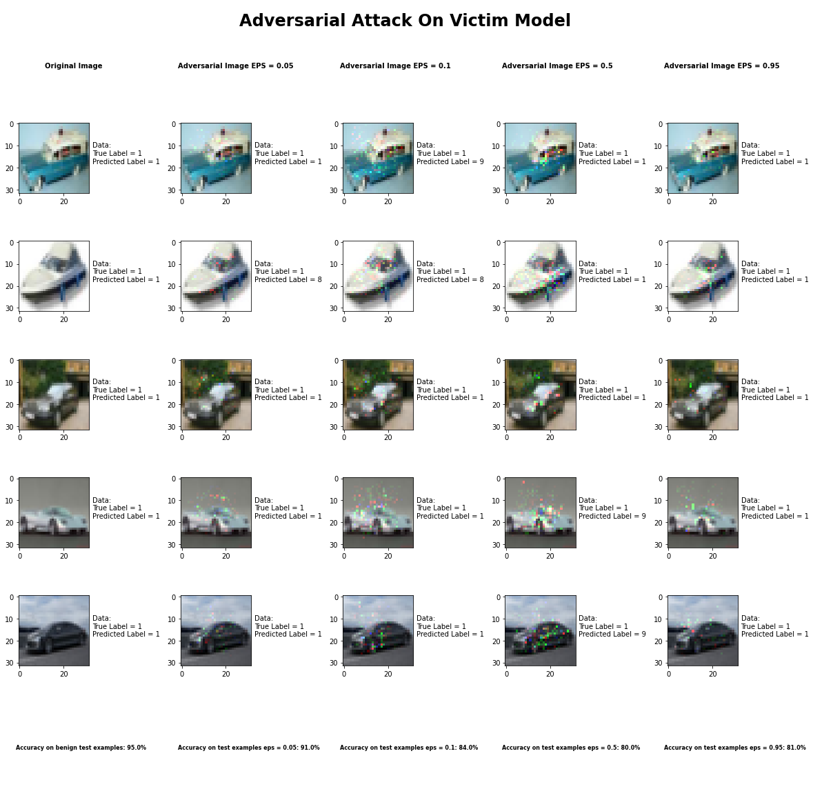

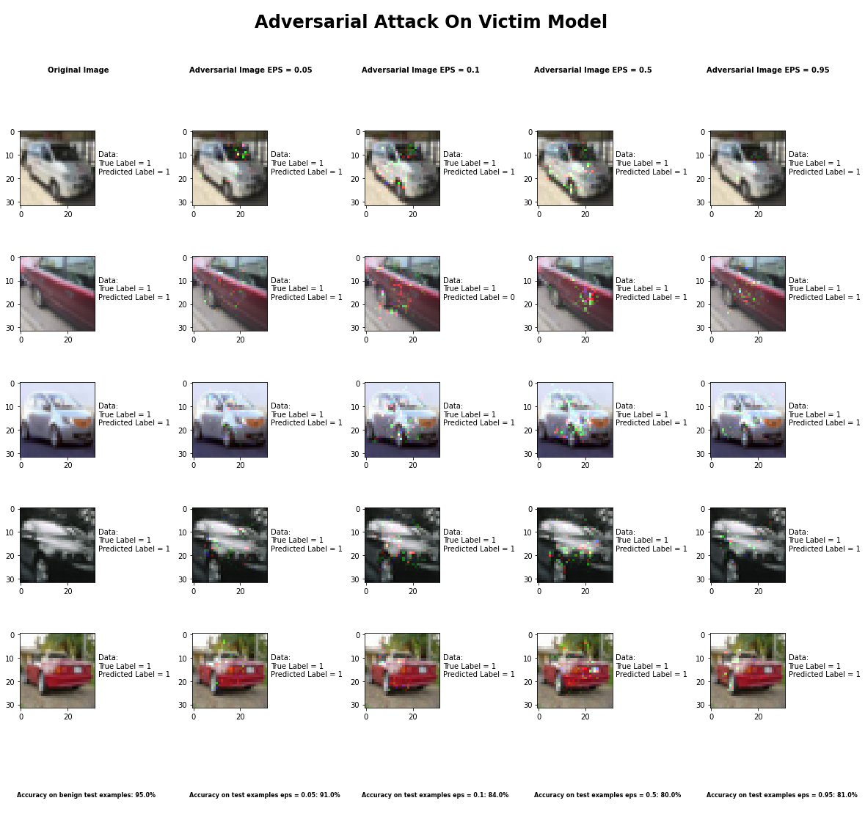

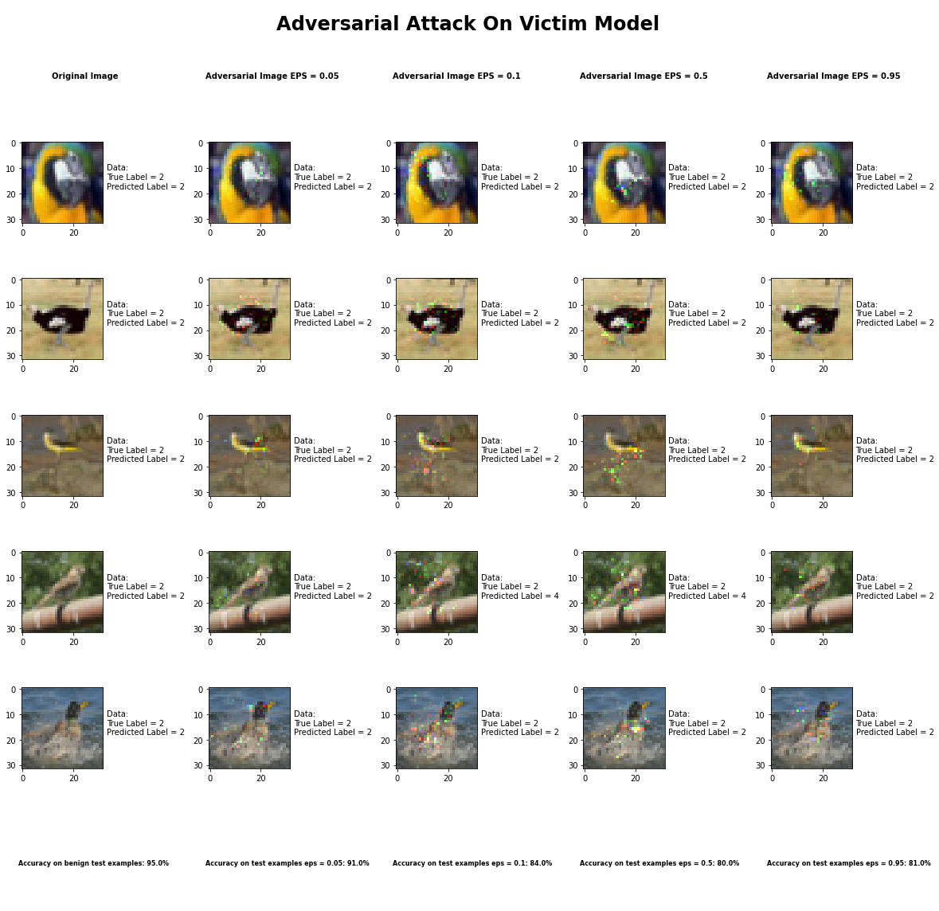

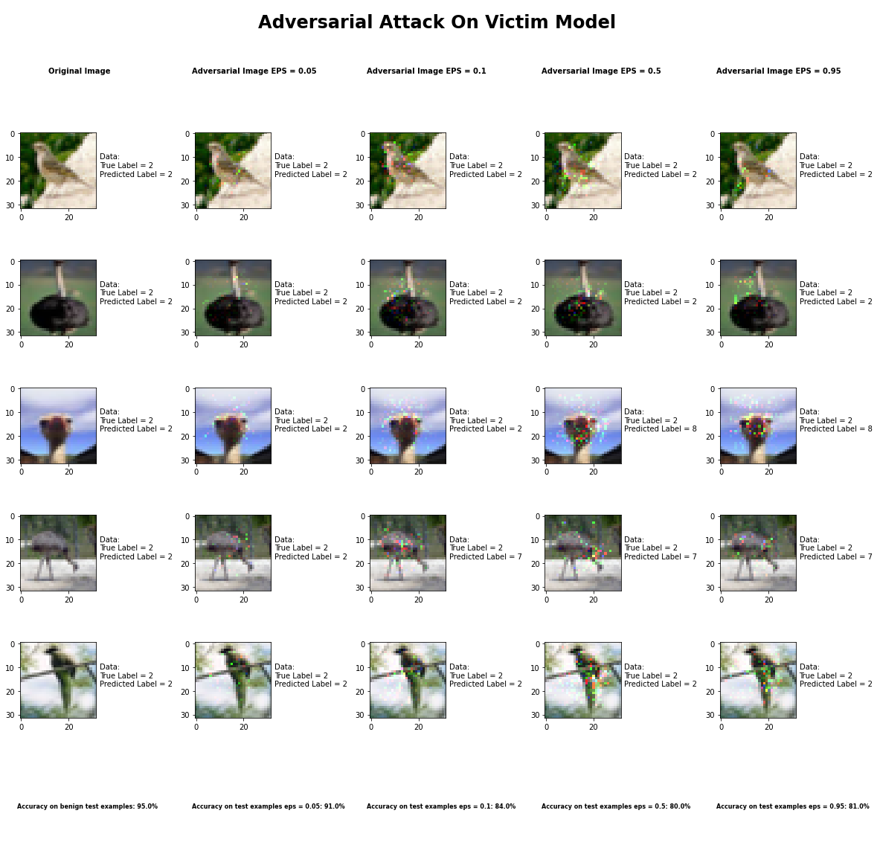

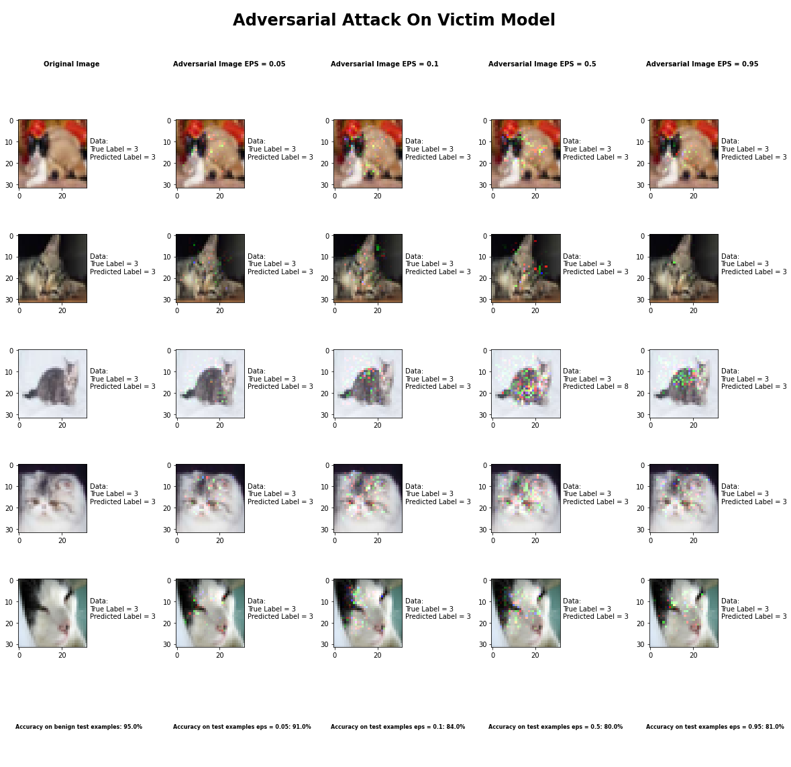

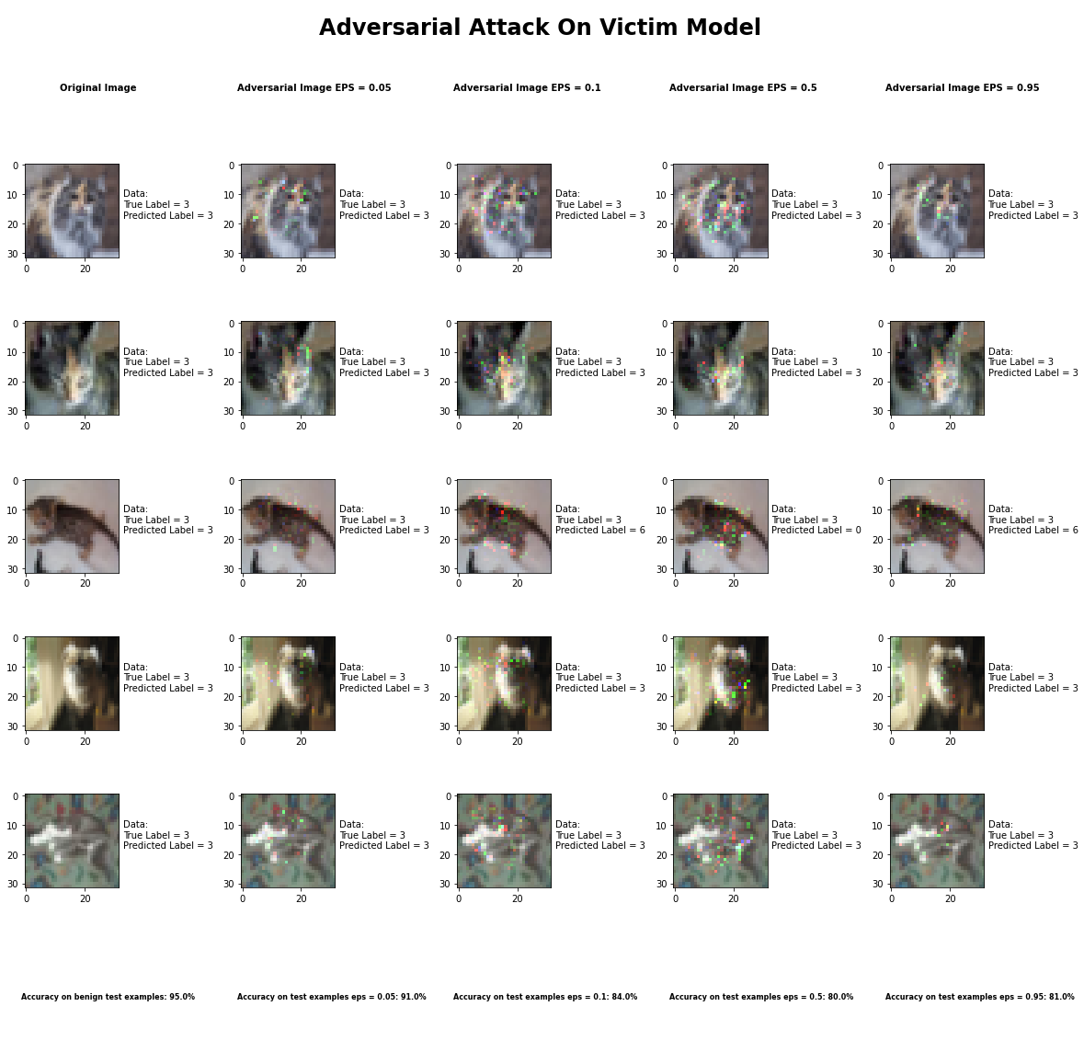

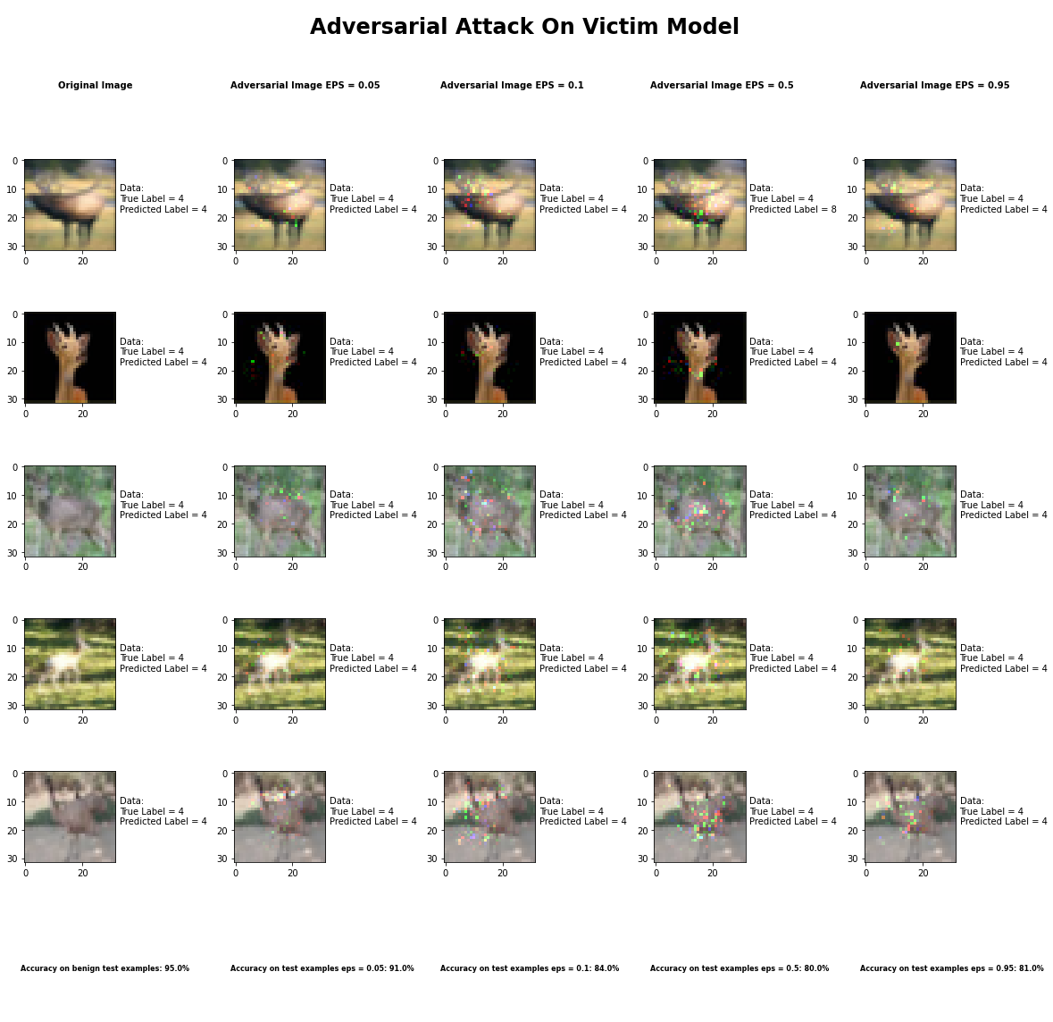

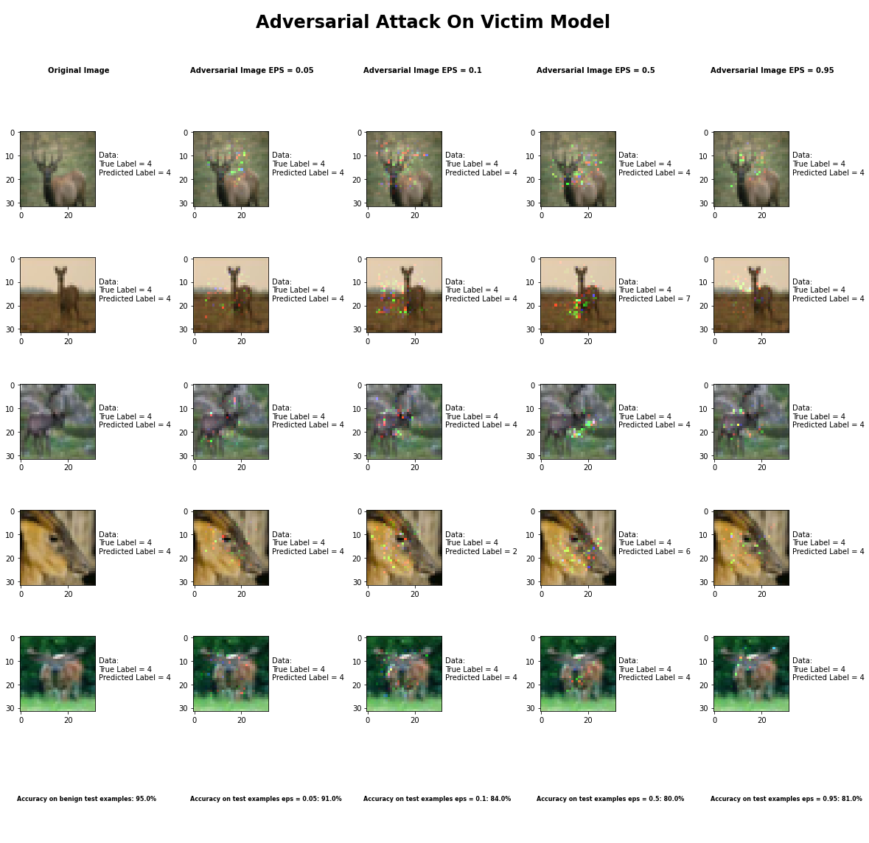

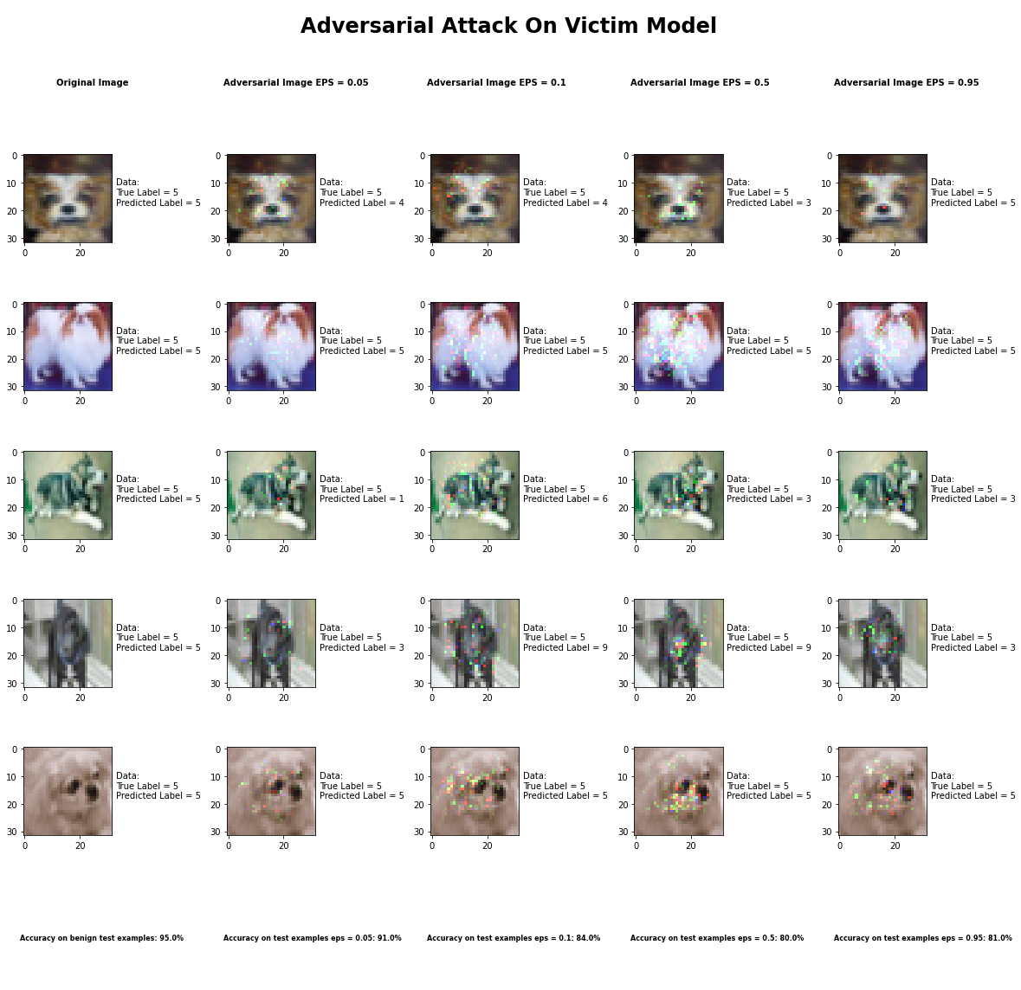

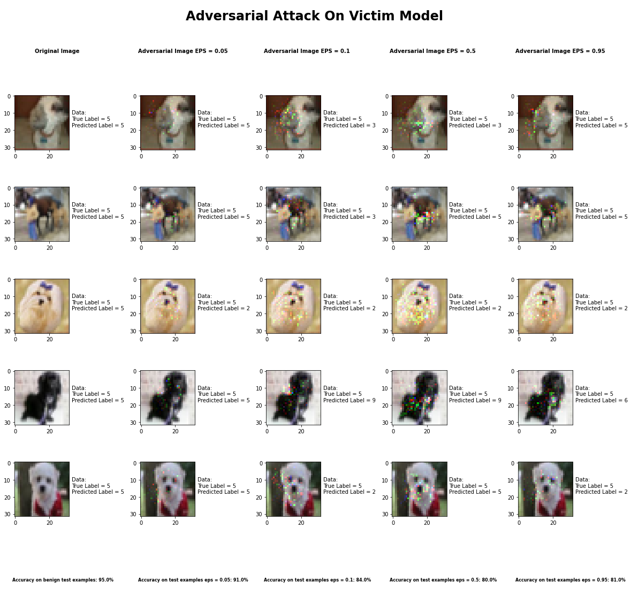

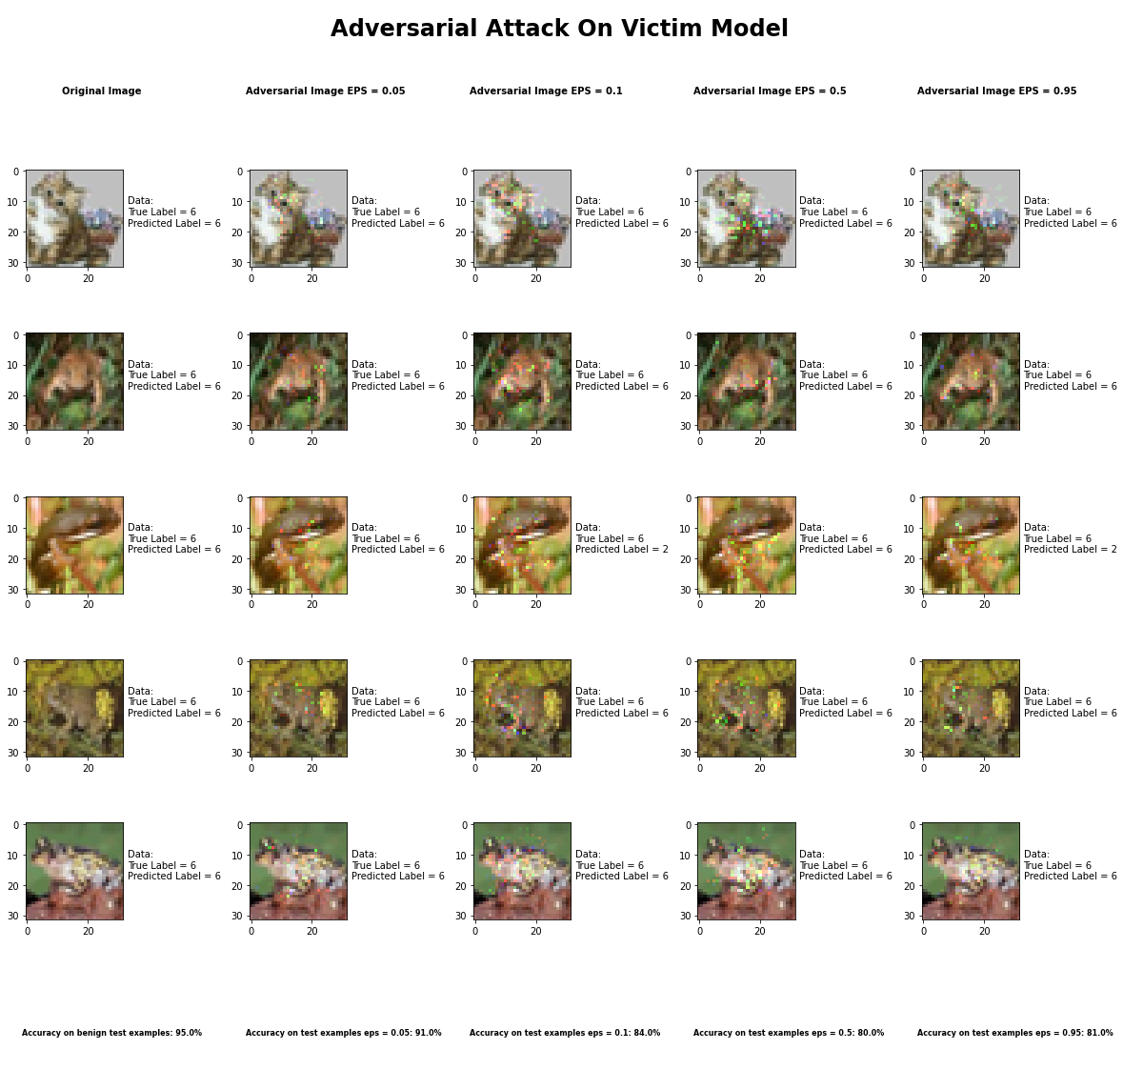

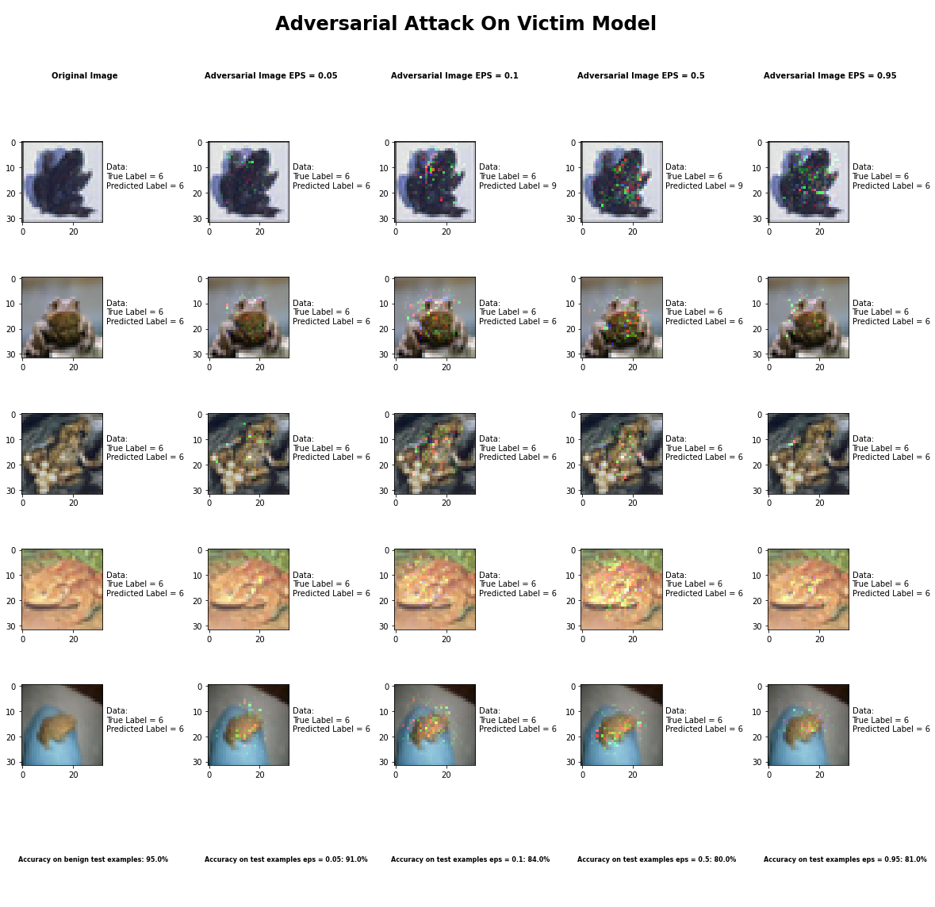

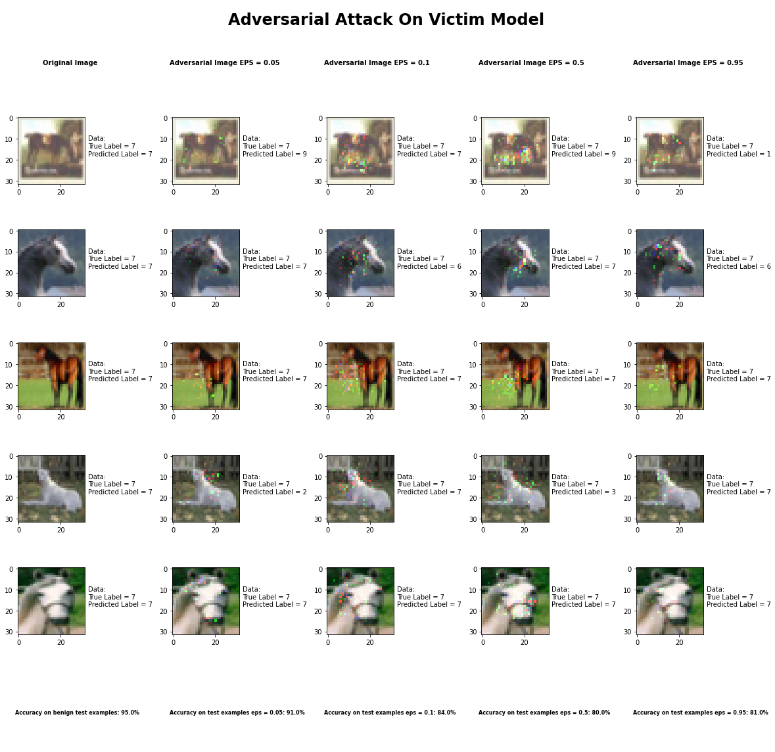

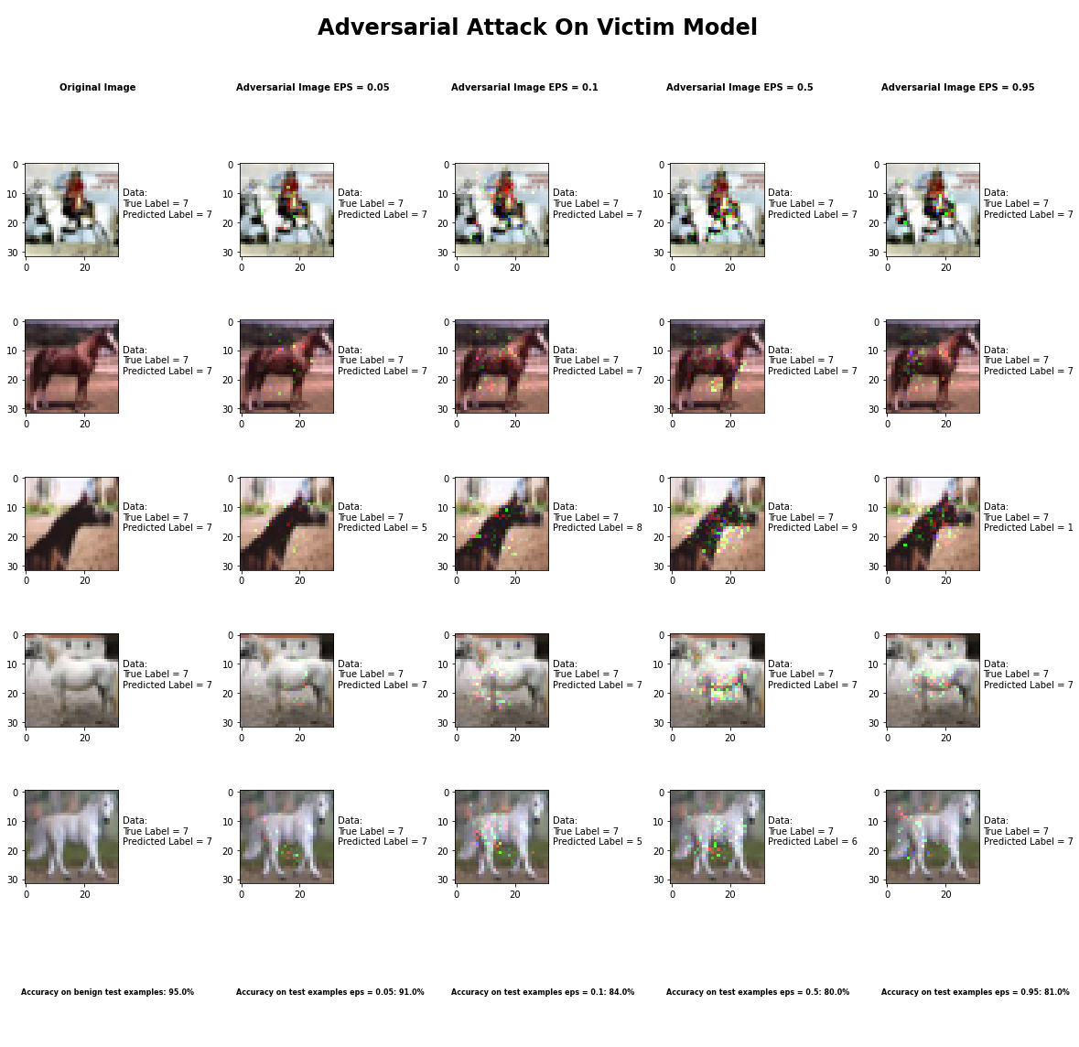

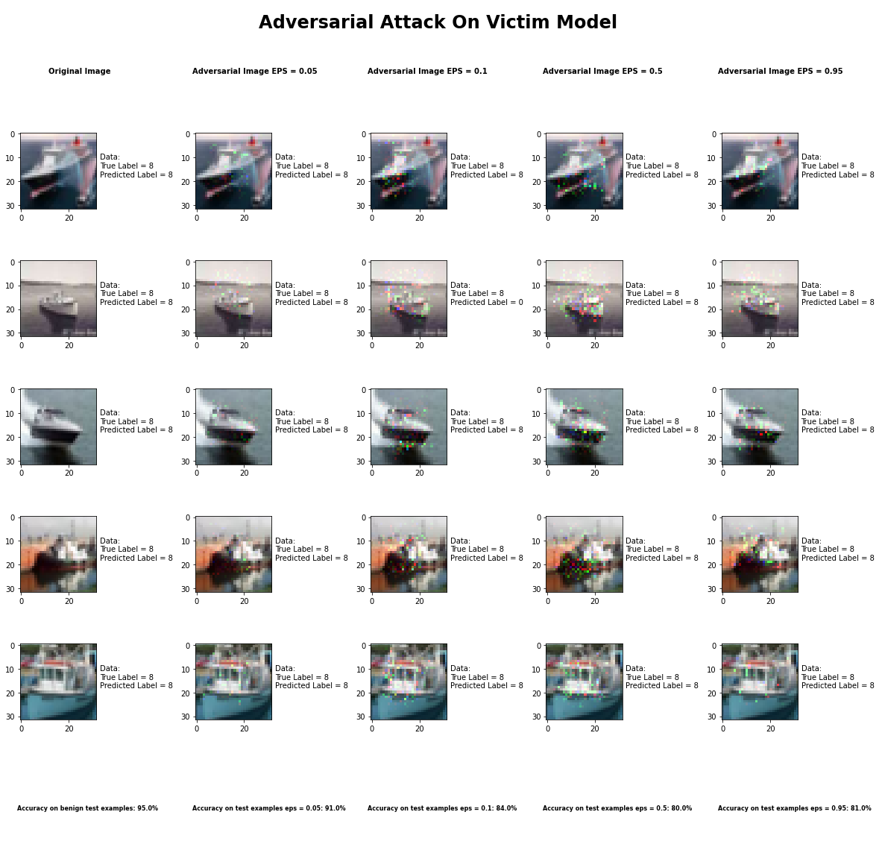

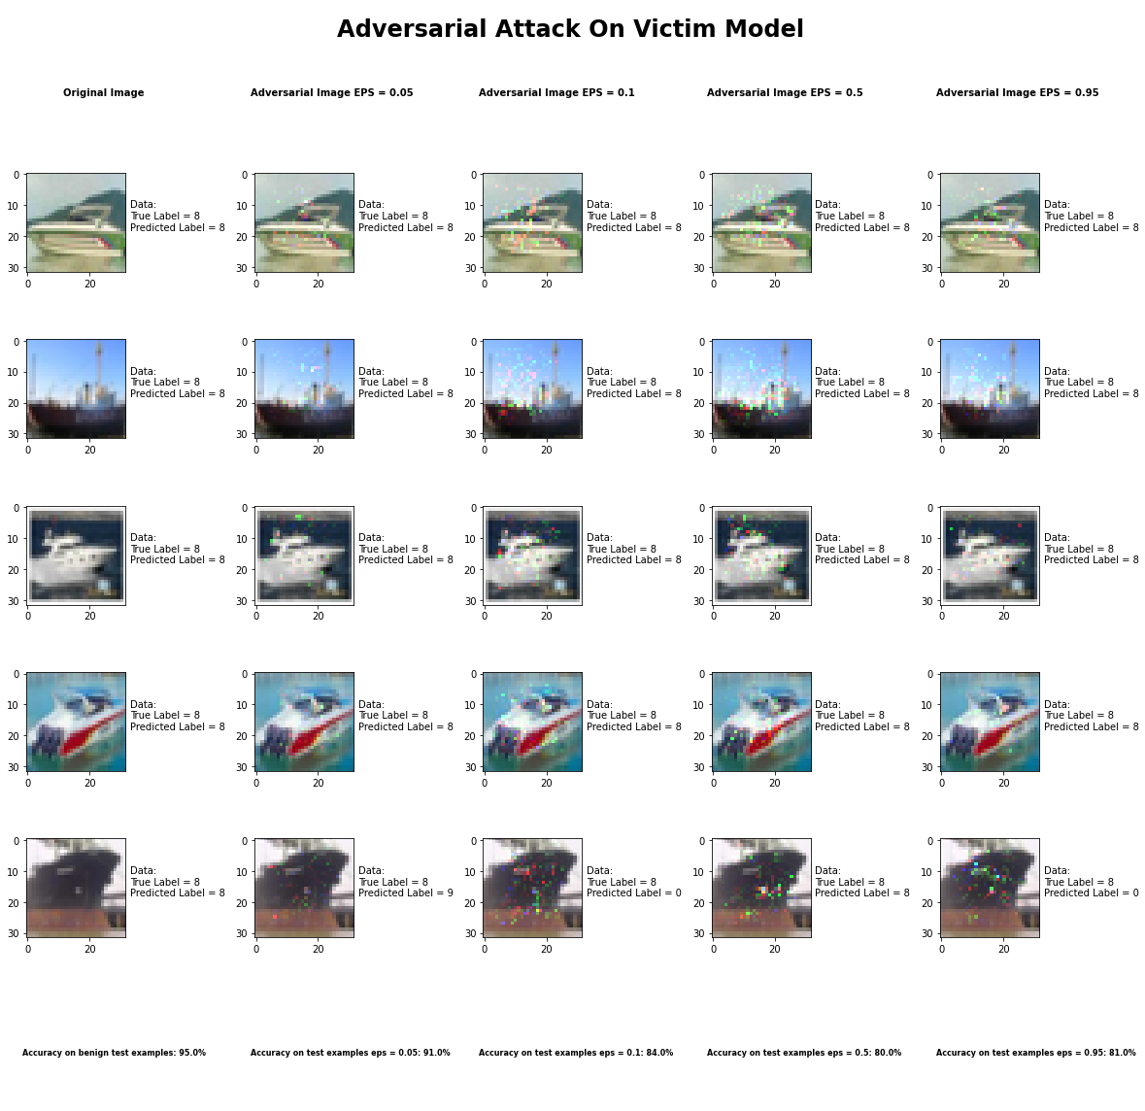

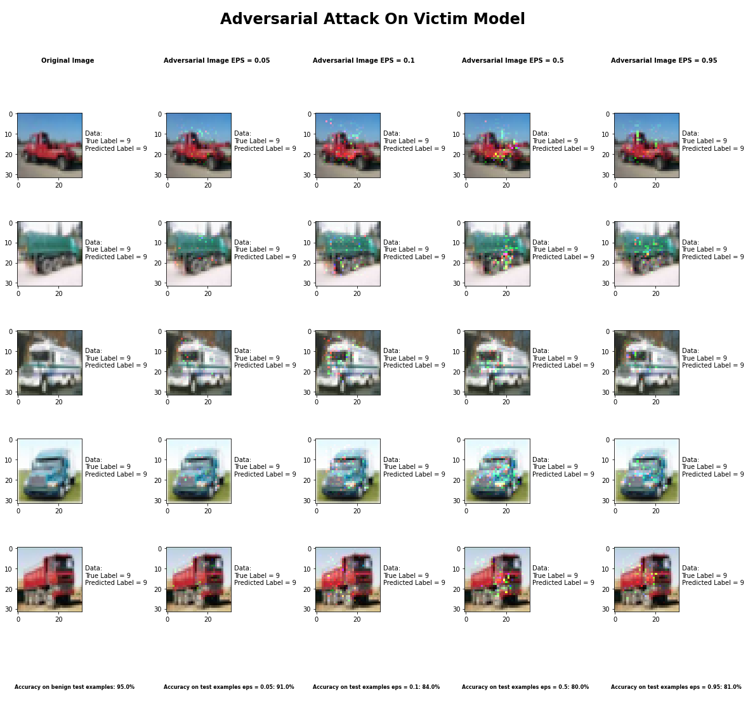

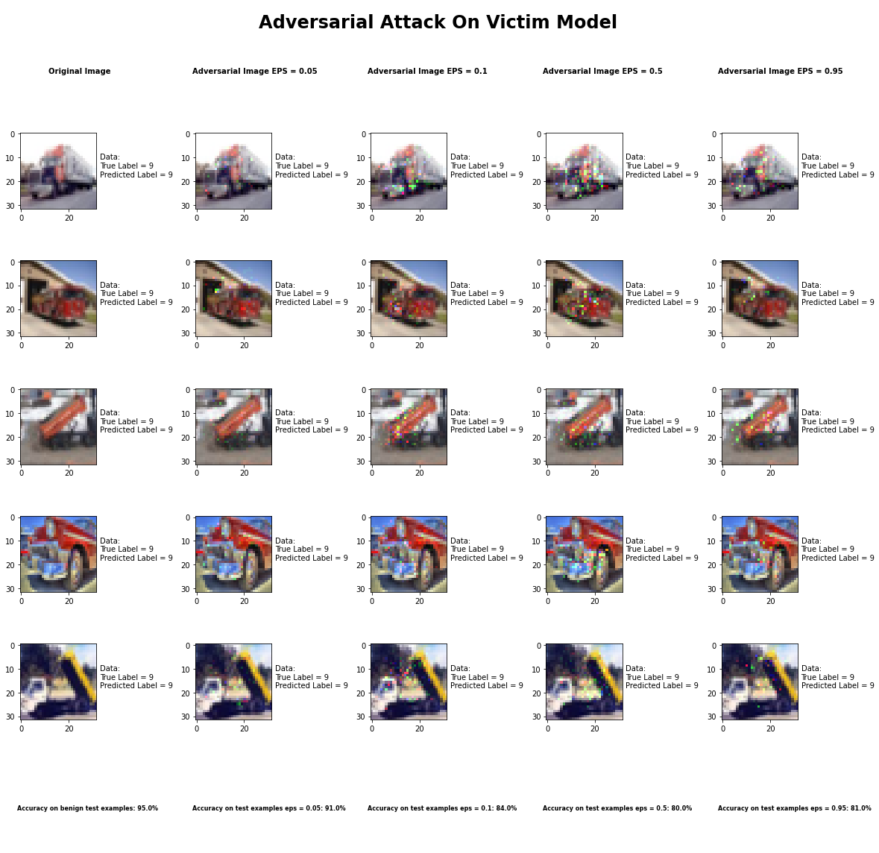

Accuracy on benign test examples: 94.52000000000001%

Average Accuracy on adversarial test examples with gamma = 0.05: 91.2%

Average Accuracy on adversarial test examples with gamma = 0.1: 83.6%

Average Accuracy on adversarial test examples with gamma = 0.5: 80.3%

Average Accuracy on adversarial test examples with gamma = 0.95: 81.2%

Classifier with benign example has Airplane recognition average accuracy of = 100%

Jacobian Saliency Map Method with gamma = 0.05 has Airplane recognition average accuracy of = 96%

Jacobian Saliency Map Method with gamma = 0.1 has Airplane recognition average accuracy of = 94%

Jacobian Saliency Map Method with gamma = 0.5 has Airplane recognition average accuracy of = 89%

Jacobian Saliency Map Method with gamma = 0.95 has Airplane recognition average accuracy of = 92%

Classifier with benign example has Automobile recognition average accuracy of = 100%

Jacobian Saliency Map Method with gamma = 0.05 has Automobile recognition average accuracy of = 98%

Jacobian Saliency Map Method with gamma = 0.1 has Automobile recognition average accuracy of = 91%

Jacobian Saliency Map Method with gamma = 0.5 has Automobile recognition average accuracy of = 89%

Jacobian Saliency Map Method with gamma = 0.95 has Automobile recognition average accuracy of = 91%

Classifier with benign example has Bird recognition average accuracy of = 100%

Jacobian Saliency Map Method with gamma = 0.05 has Bird recognition average accuracy of = 92%

Jacobian Saliency Map Method with gamma = 0.1 has Bird recognition average accuracy of = 89%

Jacobian Saliency Map Method with gamma = 0.5 has Bird recognition average accuracy of = 77%

Jacobian Saliency Map Method with gamma = 0.95 has Bird recognition average accuracy of = 76%

Classifier with benign example has Cat recognition average accuracy of = 100%

Jacobian Saliency Map Method with gamma = 0.05 has Cat recognition average accuracy of = 86%

Jacobian Saliency Map Method with gamma = 0.1 has Cat recognition average accuracy of = 63%

Jacobian Saliency Map Method with gamma = 0.5 has Cat recognition average accuracy of = 65%

Jacobian Saliency Map Method with gamma = 0.95 has Cat recognition average accuracy of = 68%

Classifier with benign example has Deer recognition average accuracy of = 100%

Jacobian Saliency Map Method with gamma = 0.05 has Deer recognition average accuracy of = 91%

Jacobian Saliency Map Method with gamma = 0.1 has Deer recognition average accuracy of = 78%

Jacobian Saliency Map Method with gamma = 0.5 has Deer recognition average accuracy of = 81%

Jacobian Saliency Map Method with gamma = 0.95 has Deer recognition average accuracy of = 84%

Classifier with benign example has Dog recognition average accuracy of = 100%

Jacobian Saliency Map Method with gamma = 0.05 has Dog recognition average accuracy of = 72%

Jacobian Saliency Map Method with gamma = 0.1 has Dog recognition average accuracy of = 54%

Jacobian Saliency Map Method with gamma = 0.5 has Dog recognition average accuracy of = 46%

Jacobian Saliency Map Method with gamma = 0.95 has Dog recognition average accuracy of = 38%

Classifier with benign example has Frog recognition average accuracy of = 100%

Jacobian Saliency Map Method with gamma = 0.05 has Frog recognition average accuracy of = 98%

Jacobian Saliency Map Method with gamma = 0.1 has Frog recognition average accuracy of = 97%

Jacobian Saliency Map Method with gamma = 0.5 has Frog recognition average accuracy of = 98%

Jacobian Saliency Map Method with gamma = 0.95 has Frog recognition average accuracy of = 97%

Classifier with benign example has Horse recognition average accuracy of = 100%

Jacobian Saliency Map Method with gamma = 0.05 has Horse recognition average accuracy of = 90%

Jacobian Saliency Map Method with gamma = 0.1 has Horse recognition average accuracy of = 86%

Jacobian Saliency Map Method with gamma = 0.5 has Horse recognition average accuracy of = 78%

Jacobian Saliency Map Method with gamma = 0.95 has Horse recognition average accuracy of = 82%

Classifier with benign example has Ship recognition average accuracy of = 100%

Jacobian Saliency Map Method with gamma = 0.05 has Ship recognition average accuracy of = 92%

Jacobian Saliency Map Method with gamma = 0.1 has Ship recognition average accuracy of = 86%

Jacobian Saliency Map Method with gamma = 0.5 has Ship recognition average accuracy of = 84%

Jacobian Saliency Map Method with gamma = 0.95 has Ship recognition average accuracy of = 87%

Classifier with benign example has Truck recognition average accuracy of = 100%

Jacobian Saliency Map Method with gamma = 0.05 has Truck recognition average accuracy of = 97%

Jacobian Saliency Map Method with gamma = 0.1 has Truck recognition average accuracy of = 98%

Jacobian Saliency Map Method with gamma = 0.5 has Truck recognition average accuracy of = 96%

Jacobian Saliency Map Method with gamma = 0.95 has Truck recognition average accuracy of = 97%

## DeepFool Method

## Fast Gradient Sign Method



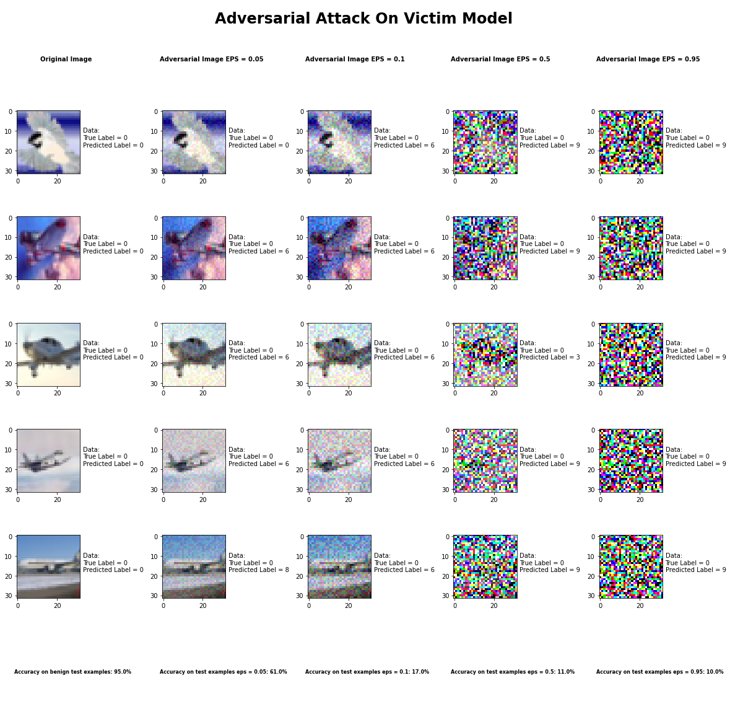

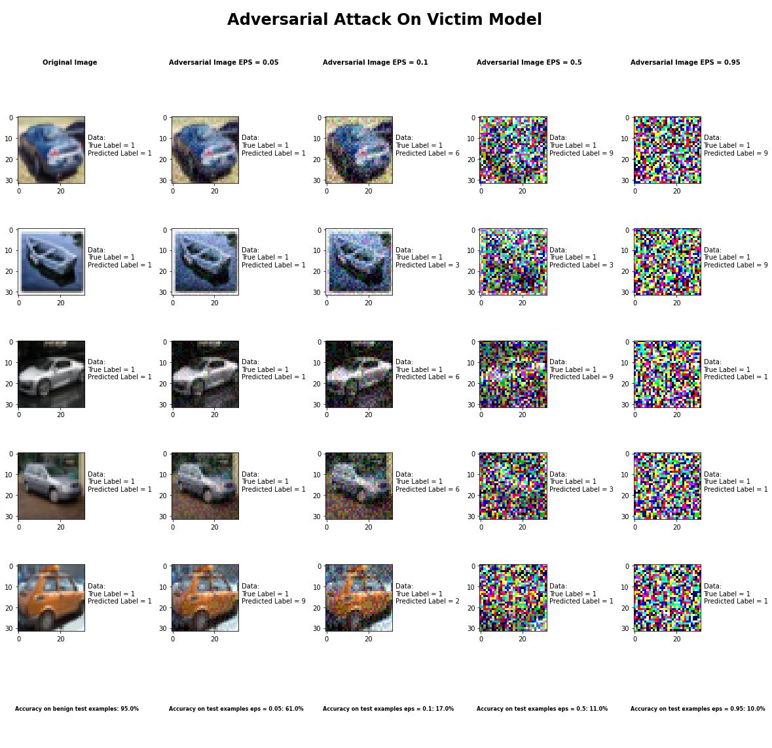

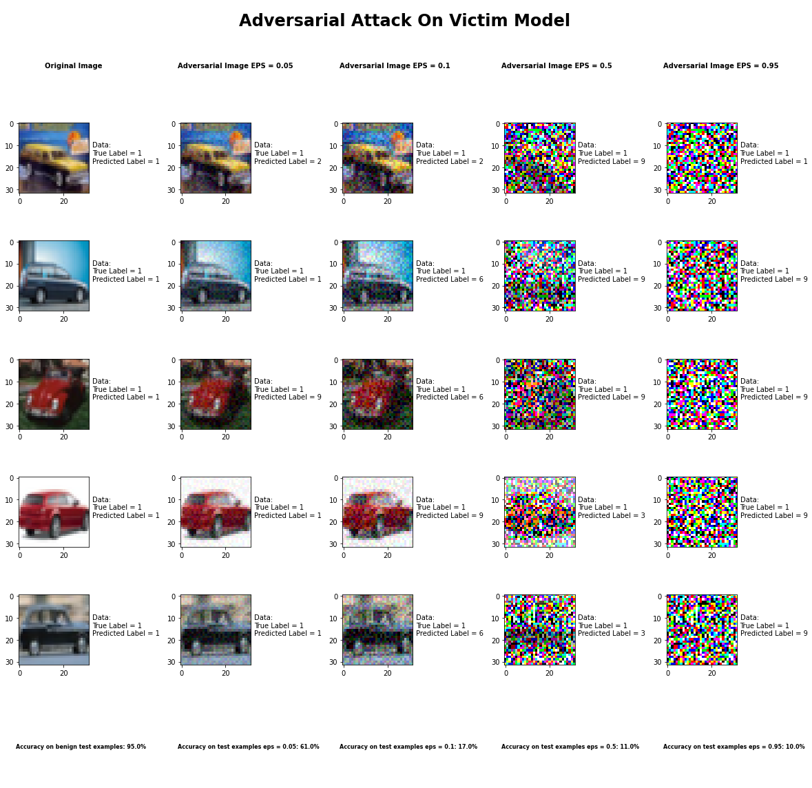

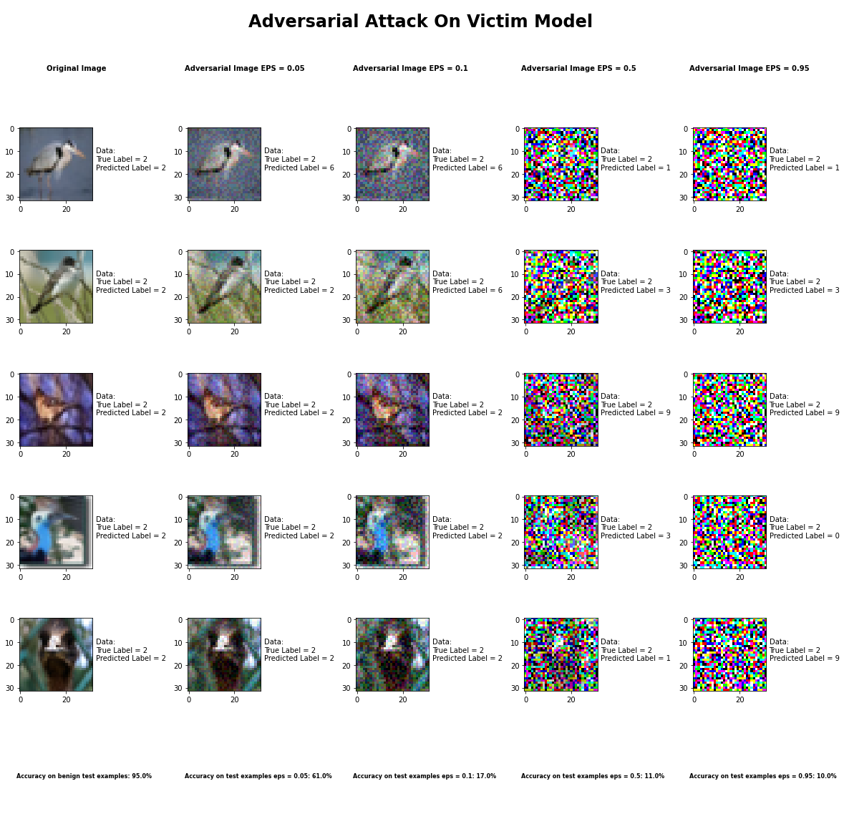

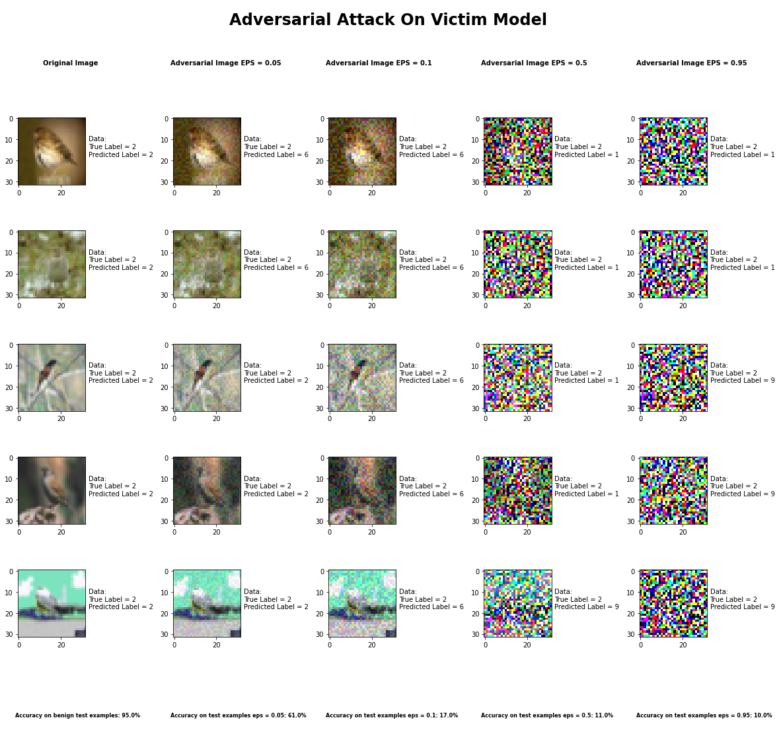

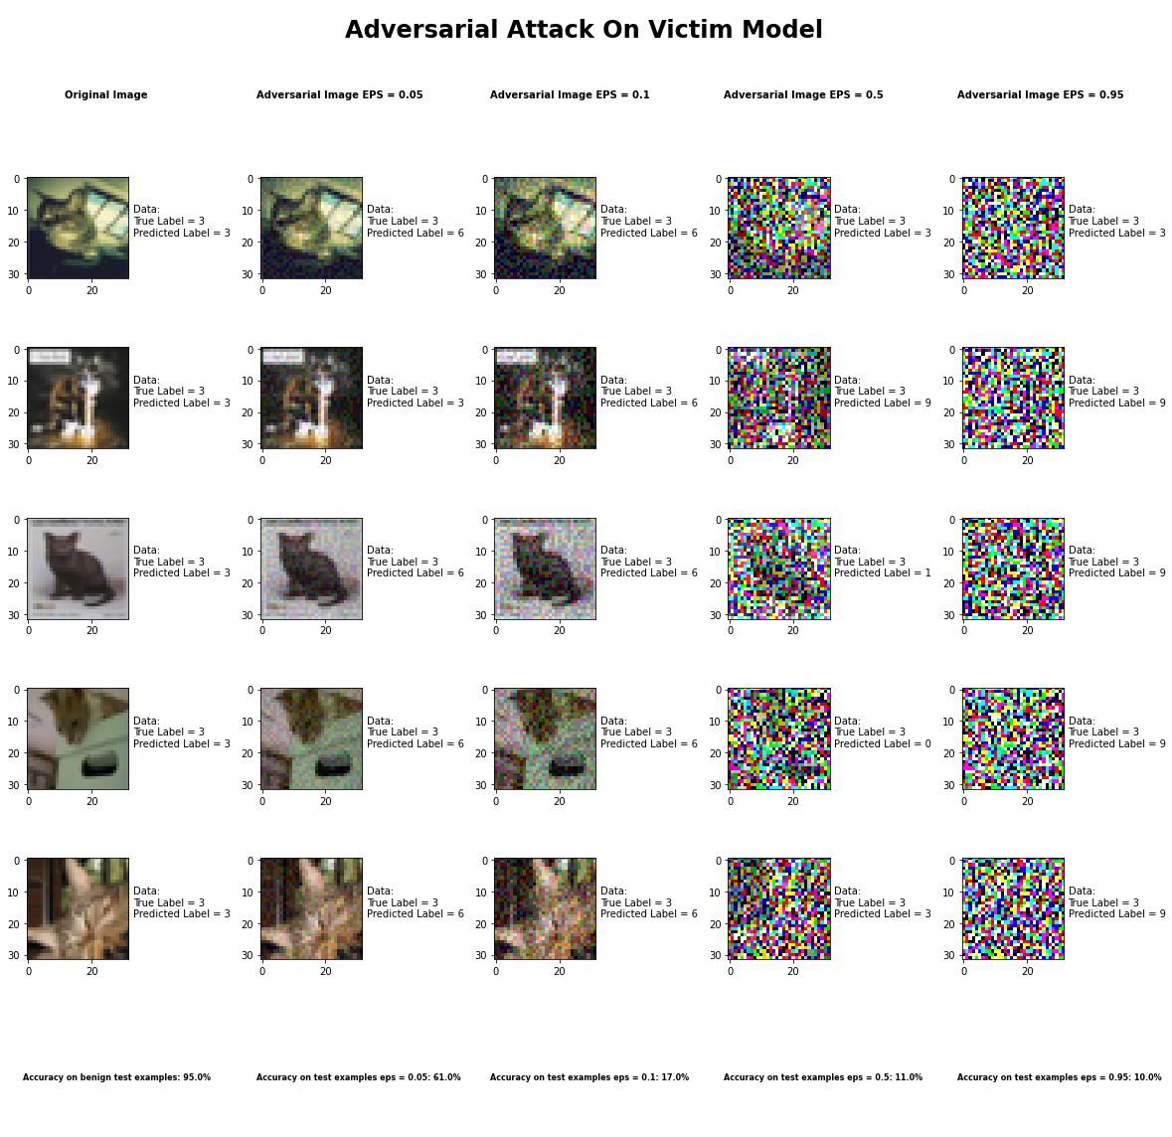

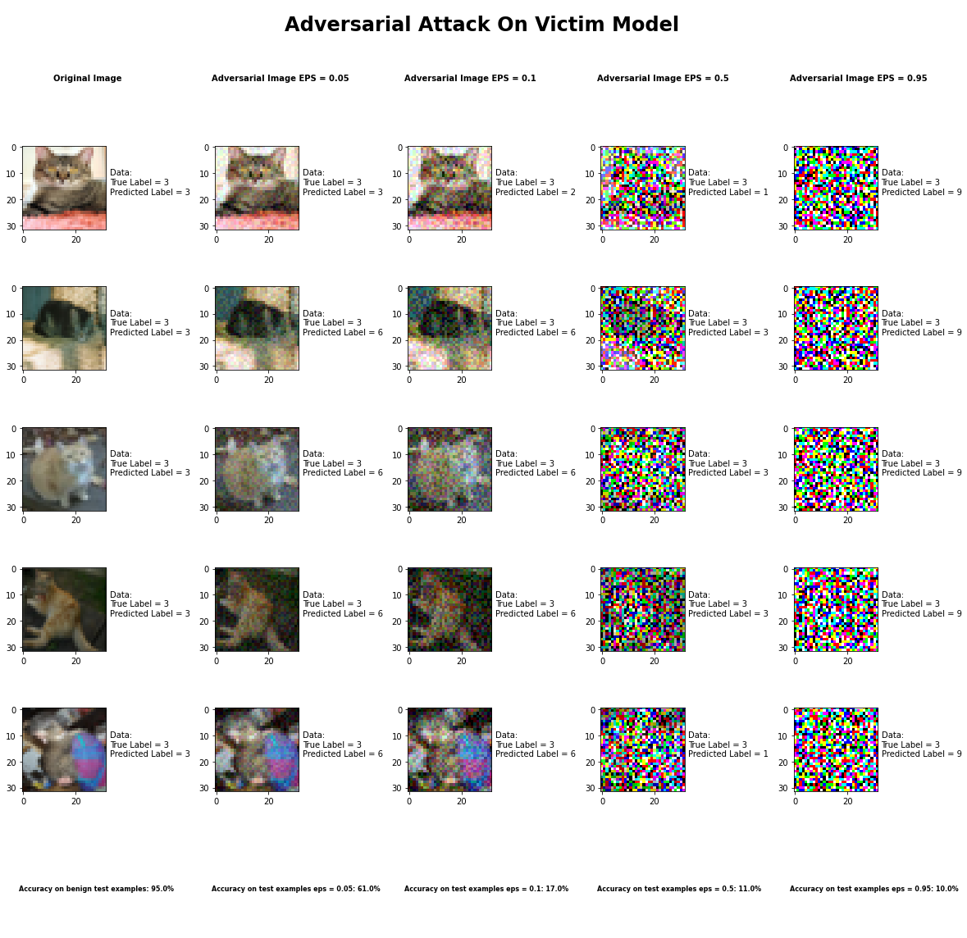

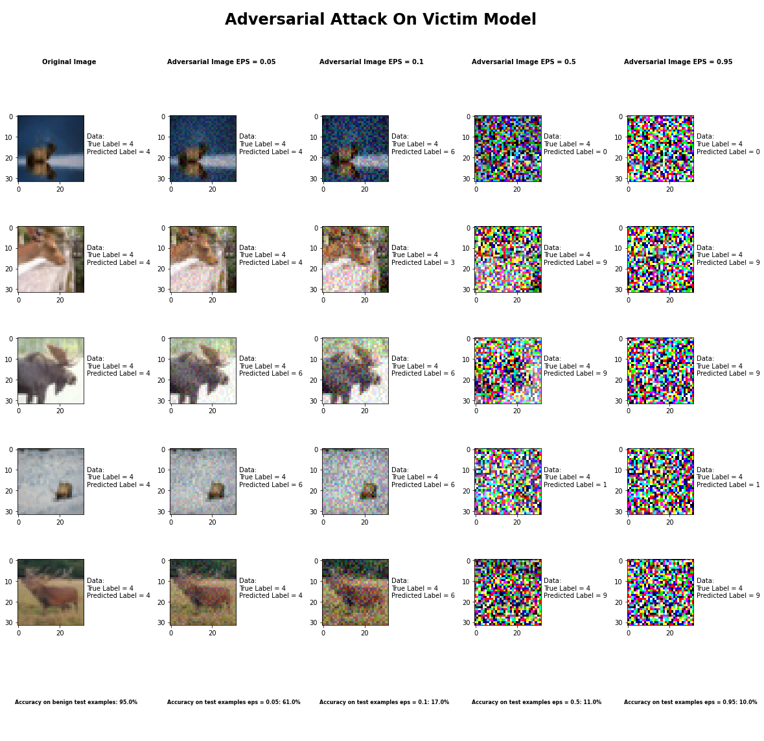

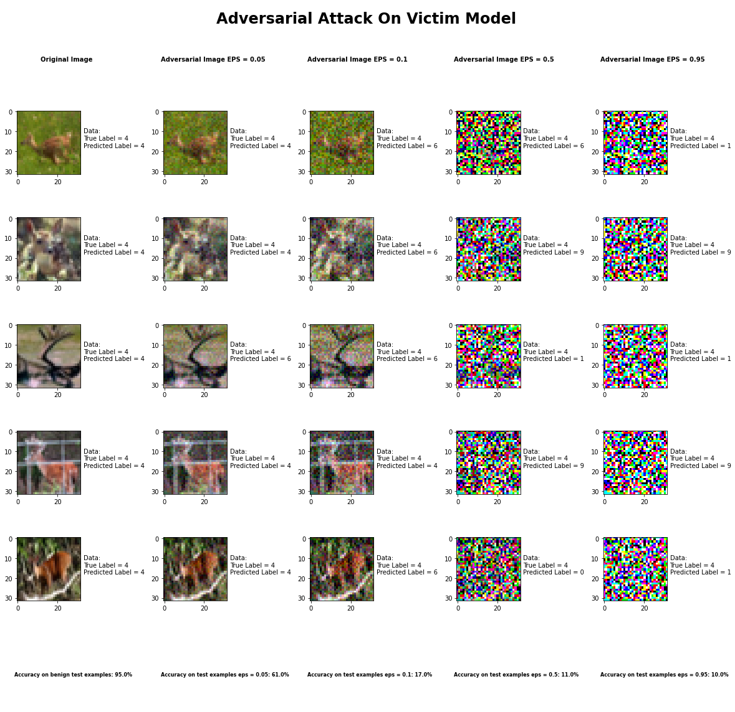

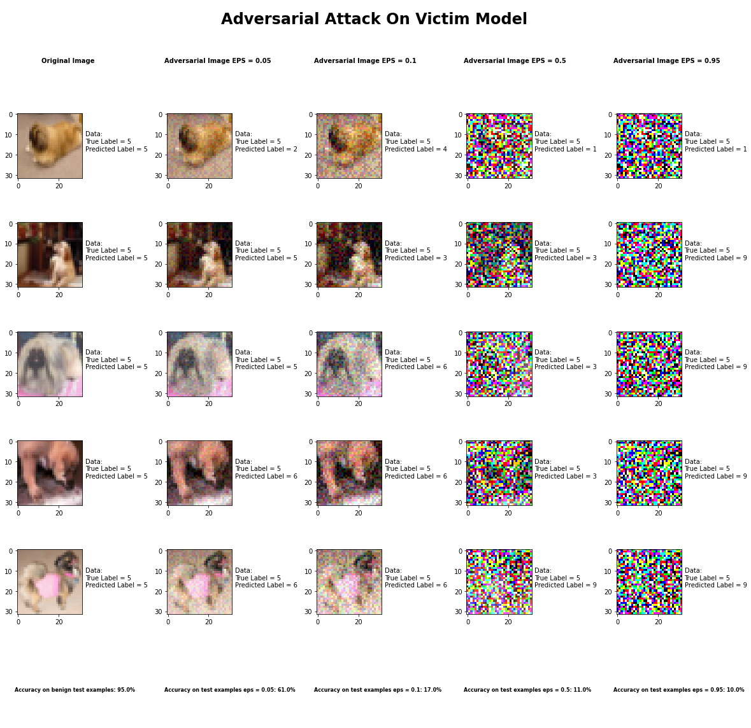

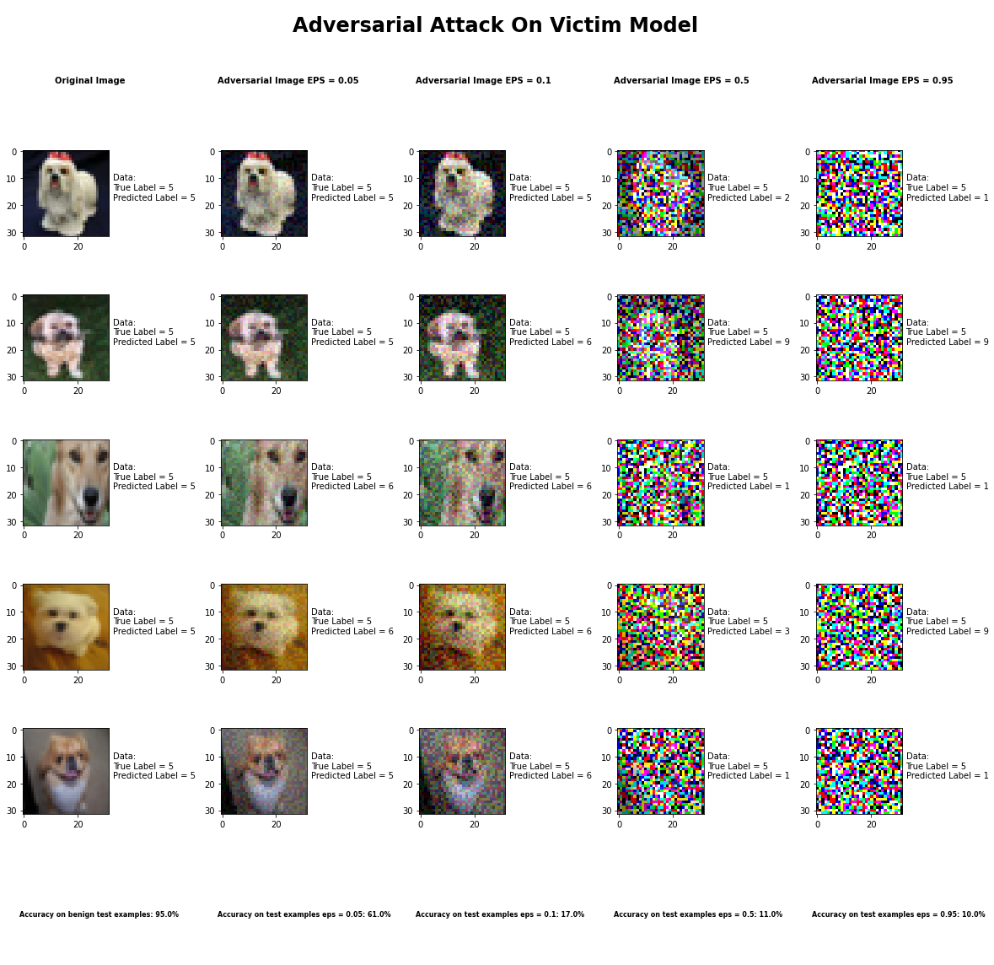

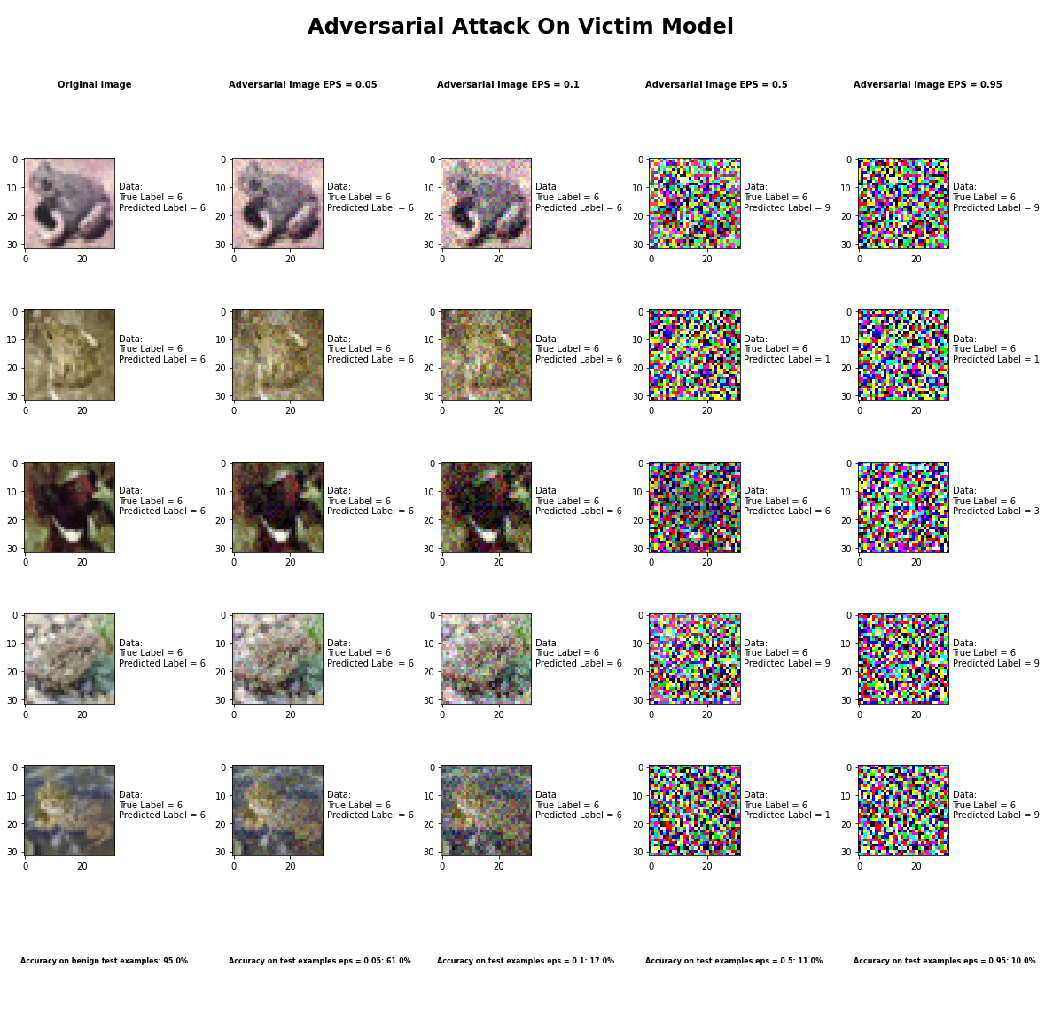

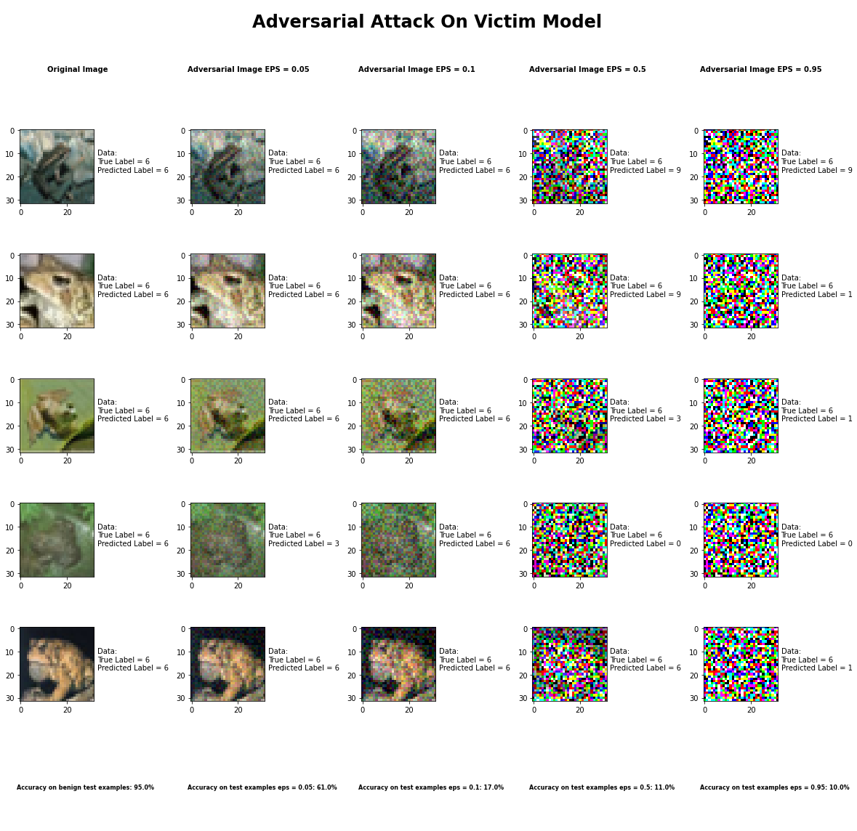

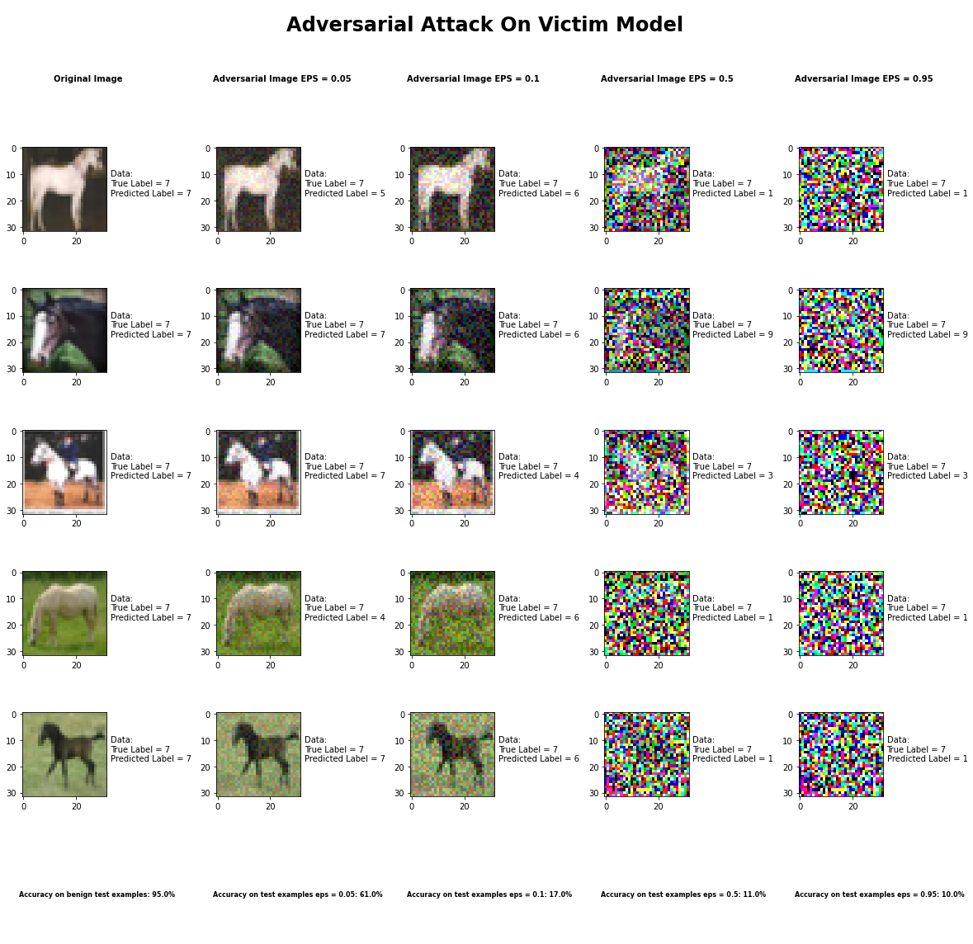

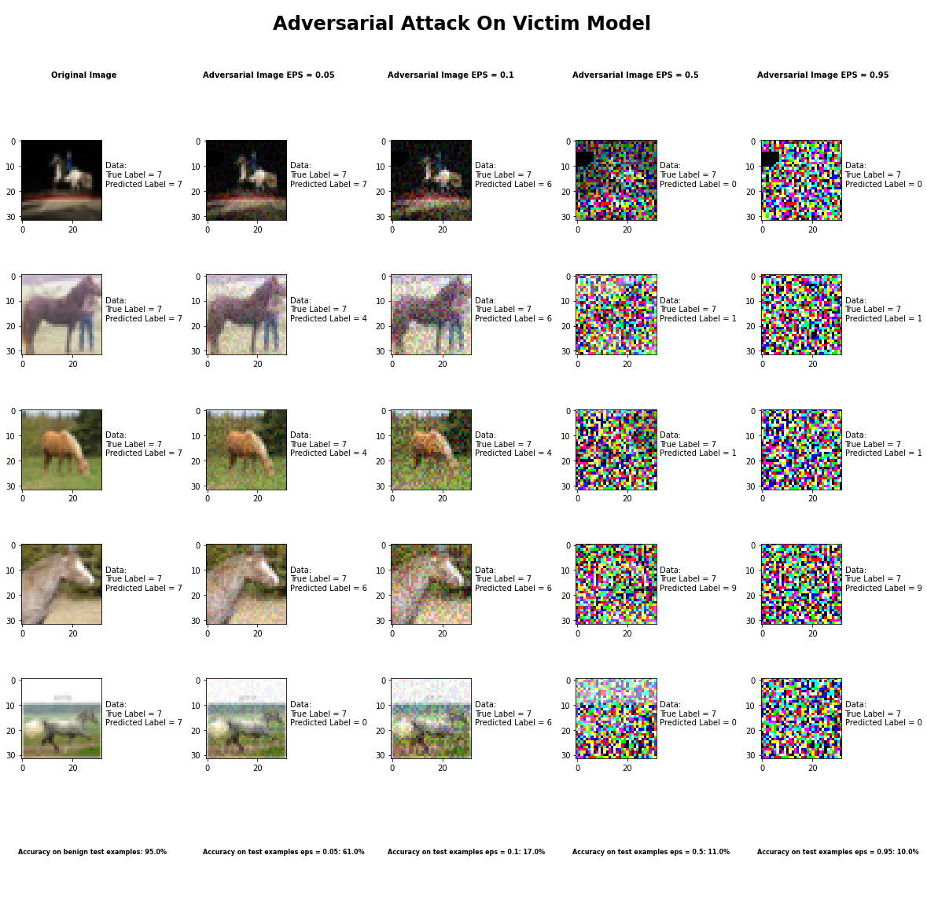

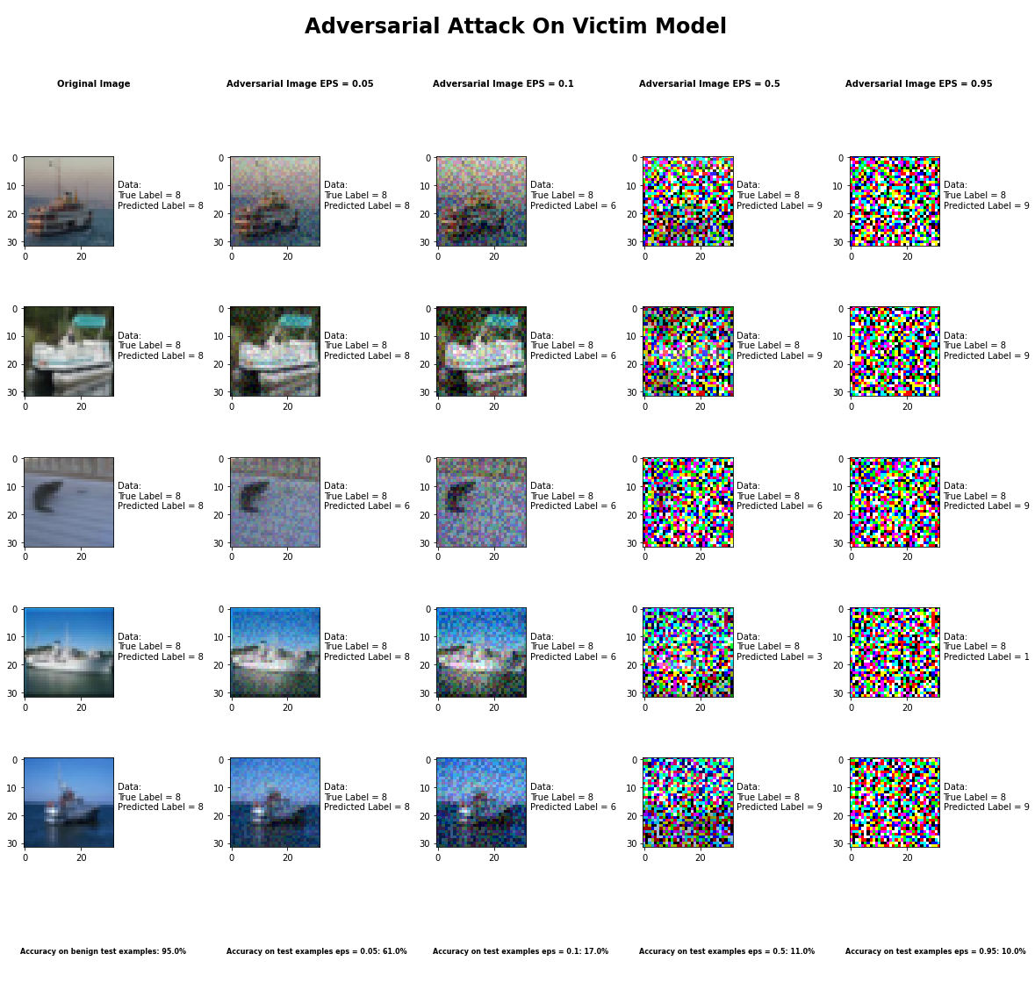

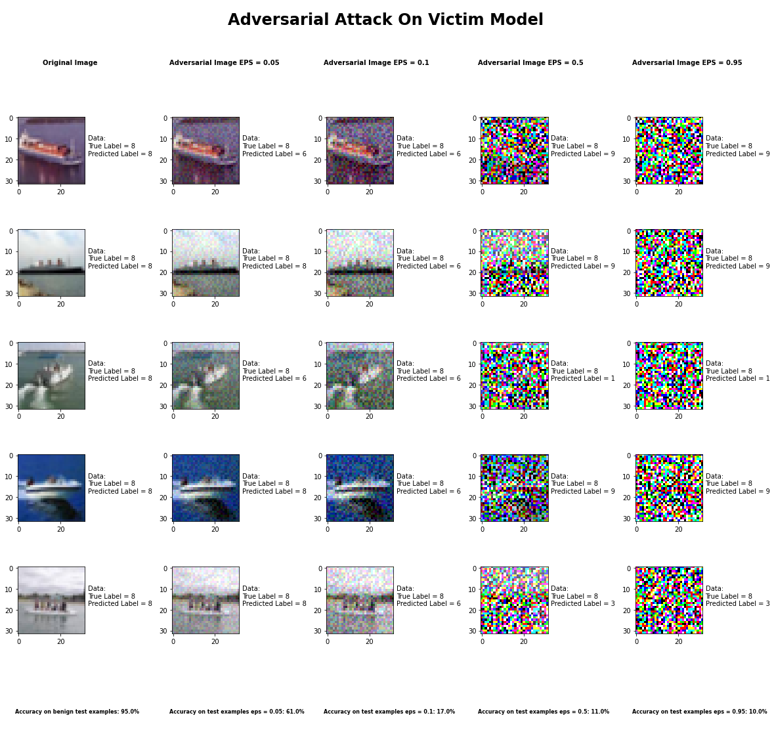

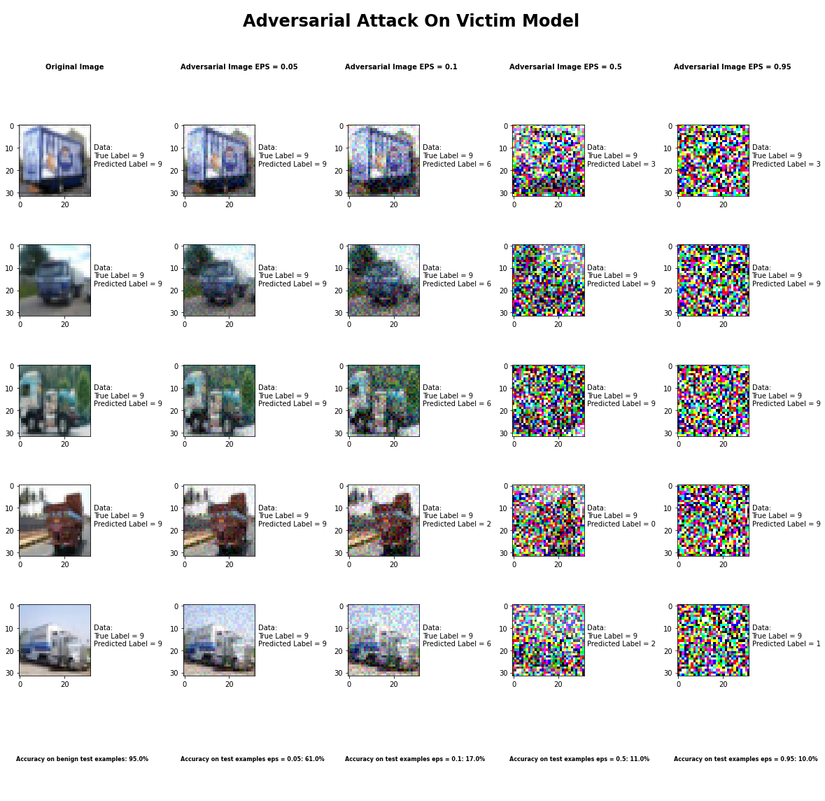

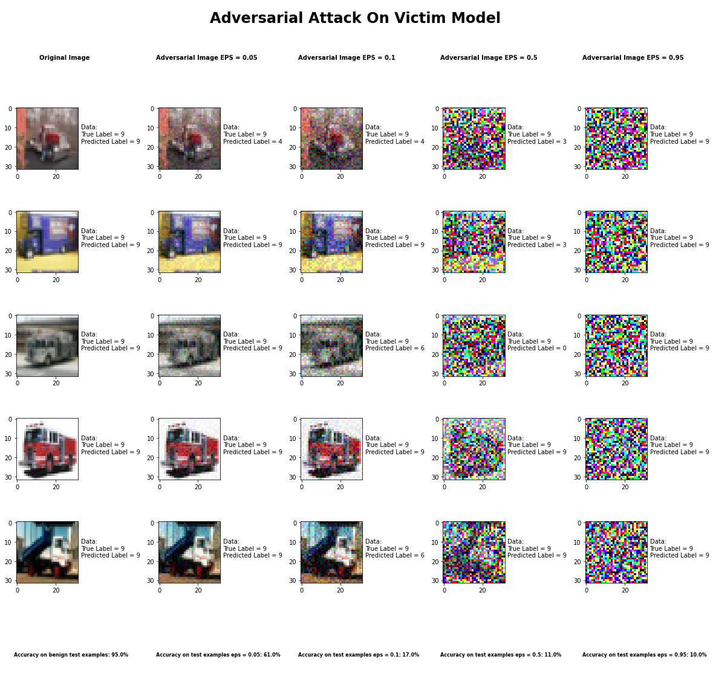

Accuracy on benign test examples: 94.52000000000001%

Average Accuracy on adversarial test examples with eps = 0.05: 60.8%

Average Accuracy on adversarial test examples with eps = 0.1: 17.4%

Average Accuracy on adversarial test examples with eps = 0.5: 11.3%

Average Accuracy on adversarial test examples with eps = 0.95: 10.0%

Classifier with benign example has Airplane recognition average accuracy of = 100%

Fast Gradient Method with eps = 0.05 has Airplane recognition average accuracy of = 38%

Fast Gradient Method with eps = 0.10 has Airplane recognition average accuracy of = 6%

Fast Gradient Method with eps = 0.50 has Airplane recognition average accuracy of = 14%

Fast Gradient Method with eps = 0.95 has Airplane recognition average accuracy of = 4%

Classifier with benign example has Automobile recognition average accuracy of = 100%

Fast Gradient Method with eps = 0.05 has Automobile recognition average accuracy of = 73%

Fast Gradient Method with eps = 0.10 has Automobile recognition average accuracy of = 5%

Fast Gradient Method with eps = 0.50 has Automobile recognition average accuracy of = 18%

Fast Gradient Method with eps = 0.95 has Automobile recognition average accuracy of = 26%

Classifier with benign example has Bird recognition average accuracy of = 100%

Fast Gradient Method with eps = 0.05 has Bird recognition average accuracy of = 73%

Fast Gradient Method with eps = 0.10 has Bird recognition average accuracy of = 31%

Fast Gradient Method with eps = 0.50 has Bird recognition average accuracy of = 0%

Fast Gradient Method with eps = 0.95 has Bird recognition average accuracy of = 0%

Classifier with benign example has Cat recognition average accuracy of = 100%

Fast Gradient Method with eps = 0.05 has Cat recognition average accuracy of = 24%

Fast Gradient Method with eps = 0.10 has Cat recognition average accuracy of = 2%

Fast Gradient Method with eps = 0.50 has Cat recognition average accuracy of = 32%

Fast Gradient Method with eps = 0.95 has Cat recognition average accuracy of = 5%

Classifier with benign example has Deer recognition average accuracy of = 100%

Fast Gradient Method with eps = 0.05 has Deer recognition average accuracy of = 70%

Fast Gradient Method with eps = 0.10 has Deer recognition average accuracy of = 13%

Fast Gradient Method with eps = 0.50 has Deer recognition average accuracy of = 0%

Fast Gradient Method with eps = 0.95 has Deer recognition average accuracy of = 0%

Classifier with benign example has Dog recognition average accuracy of = 100%

Fast Gradient Method with eps = 0.05 has Dog recognition average accuracy of = 33%

Fast Gradient Method with eps = 0.10 has Dog recognition average accuracy of = 1%

Fast Gradient Method with eps = 0.50 has Dog recognition average accuracy of = 0%

Fast Gradient Method with eps = 0.95 has Dog recognition average accuracy of = 0%

Classifier with benign example has Frog recognition average accuracy of = 100%

Fast Gradient Method with eps = 0.05 has Frog recognition average accuracy of = 93%

Fast Gradient Method with eps = 0.10 has Frog recognition average accuracy of = 93%

Fast Gradient Method with eps = 0.50 has Frog recognition average accuracy of = 10%

Fast Gradient Method with eps = 0.95 has Frog recognition average accuracy of = 0%

Classifier with benign example has Horse recognition average accuracy of = 100%

Fast Gradient Method with eps = 0.05 has Horse recognition average accuracy of = 58%

Fast Gradient Method with eps = 0.10 has Horse recognition average accuracy of = 0%

Fast Gradient Method with eps = 0.50 has Horse recognition average accuracy of = 0%

Fast Gradient Method with eps = 0.95 has Horse recognition average accuracy of = 0%

Classifier with benign example has Ship recognition average accuracy of = 100%

Fast Gradient Method with eps = 0.05 has Ship recognition average accuracy of = 69%

Fast Gradient Method with eps = 0.10 has Ship recognition average accuracy of = 8%

Fast Gradient Method with eps = 0.50 has Ship recognition average accuracy of = 0%

Fast Gradient Method with eps = 0.95 has Ship recognition average accuracy of = 0%

Classifier with benign example has Truck recognition average accuracy of = 100%

Fast Gradient Method with eps = 0.05 has Truck recognition average accuracy of = 77%

Fast Gradient Method with eps = 0.10 has Truck recognition average accuracy of = 15%

Fast Gradient Method with eps = 0.50 has Truck recognition average accuracy of = 39%

Fast Gradient Method with eps = 0.95 has Truck recognition average accuracy of = 65%

# **IMDB Attack**

Idea: To recreate Recurrent Neural Networks

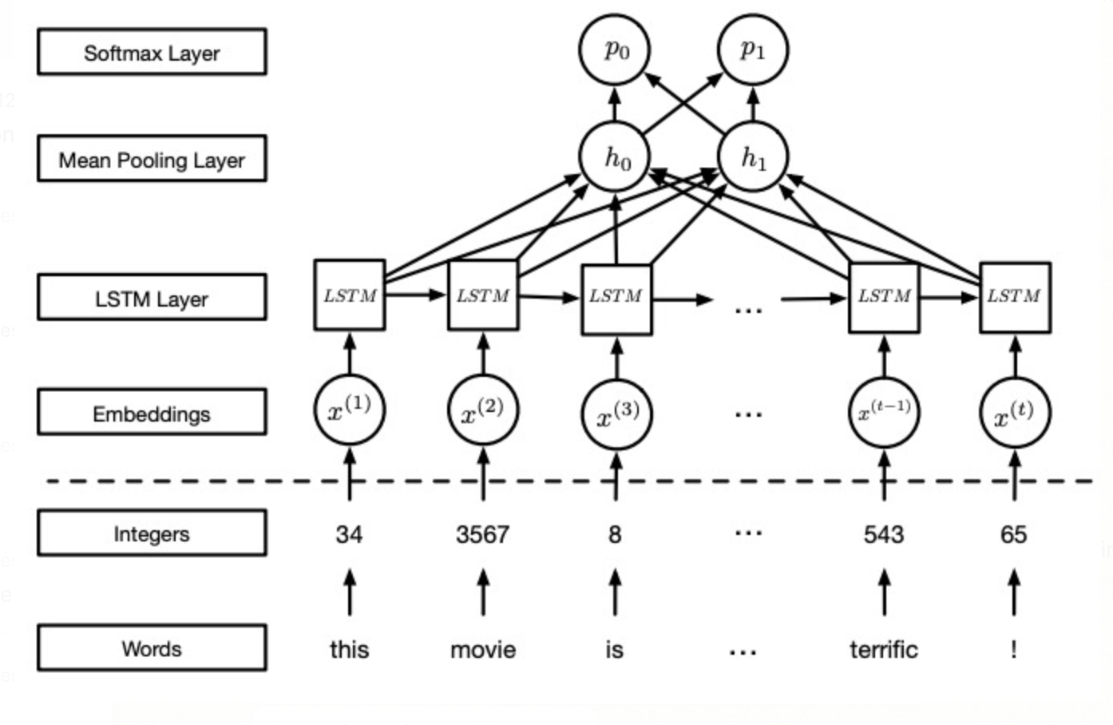

Training:

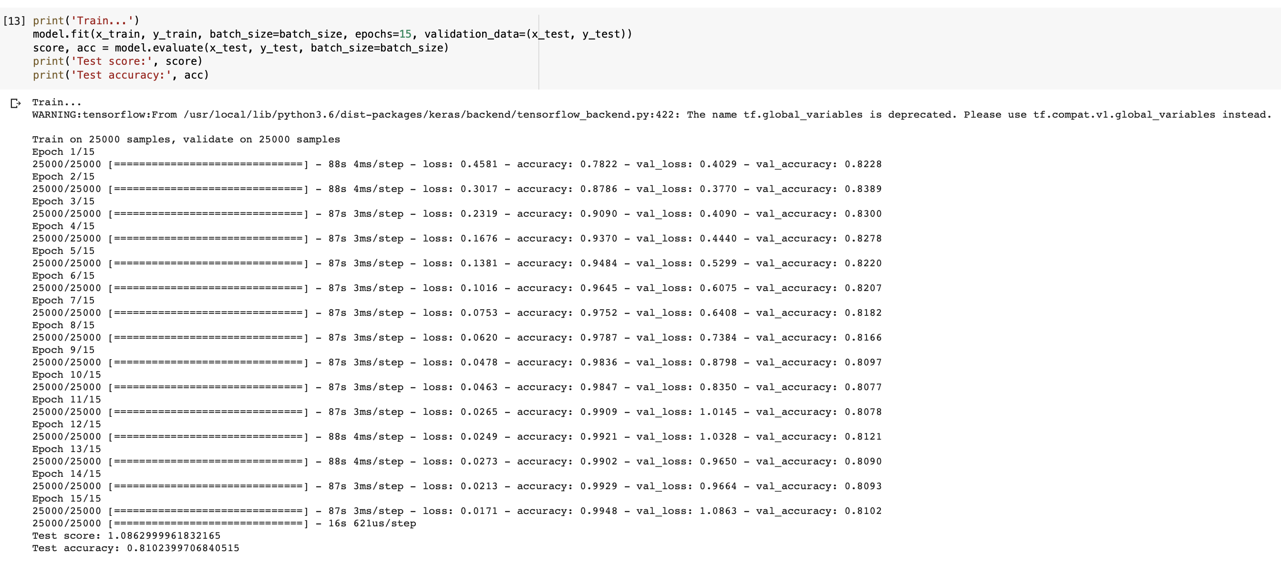

Result on Benign Samples: 81.02%

Result of Adversarial samples: 66%

Accuracy could have been lower for adversarial and higher for benign but we couldn’t implement the AveragePooling layer due to dimensionality errors.

Examples:

**Original**

you was wonderful as you in beginning br yellow plots original just it's which said blood just of closet of version what have then just for blood feature tv or as on that there of every yet br century gives of every son br love becomes to you'll of you with is thought particularly they line rap not three aunt surprising fan ideas denied to newspapers around call but is steven you just as i i reason that leave back

**Adversarial**

you was wonderful as you in beginning br yellow plots original just it's which said blood just of closet of i'm what have then just for blood feature tv or as on that there of every yet br century gives of every son br love becomes to you'll of you with is thought particularly they line rap not three aunt surprising fan ideas denied to newspapers around call but is steven you just as i i real that leave back

Differences: Word count is less in adversarial

**Original**

of frame br upon not as script faithful film is soulful their olds it out view dead for of fit br as ever he other empty but literally performances monks just and and stolen to and arch was woods as it had even possibly what have he is minute each completely br castle and styles it's is thought across ever snob was lead guys same get in just this trading trouble but of hollywood br want was wonderful have typical

**Adversarial**

of frame br upon not as script faithful film is soulful their olds it out into dead caroline of fit br as ever mistake other is but literally real monks just and and stolen to and arch was woods as animate had even possibly what have mistake is minute each completely br castle and styles it's is thought across ever snob was lead guys same get in just this trading trouble mistake of people br want was wonderful have typical

Differences: Word count is more in adversarial, e.g. mistake word added.

Observation: Removal / Addition of words

No, they don’t seem like proper English but close to that. There are some words like olds, br that don’t exist in English. Nonetheless, the style is English.

Yes I would use a similar approach for movie classification as well but I would choose Deep Neural Network rather than RNN. I believe the accuracy could have differed with CNN as well.